Terrain Induced Rotor Experiment 2006 (T-REX)
Quality Controlled Mobile GAUS Radiosonde Data Set

1.0 Mobile GAUS Dataset Overview

The Terrain Induced Rotor Experiment (T-REX) was conducted during March and April 2006, during which time 87 radiosondes were launched using a mobile sounding system at three locations (Visalia (71), Madera (9) and Delano (7)) in the California Central Valley (Figure 1). TREX is the second phase of a coordinated effort to explore the structure and evolution of atmospheric rotors, which typically occur parallel to, and downstream from, mountain ridge crests. The first phase was a project conducted in 2004 called the Sierra Rotors Project. Both phases included upwind radiosonde launches from the central valley, used to help predict the onset of events likely to produce rotors on the West side of the Sierra Nevada Mountain Range. In order to capture the structure of the rotors, additional instruments were set up in California’s Owens Valley. For more information on the TREX project, please visit: http://www.atd.ucar.edu/projects/trex/

The new EOL GPS Advanced Upper-air Sounding System (GAUS) was developed to replace the GPS LORAN Atmospheric Sounding System (GLASS). GAUS incorporates Vaisala RS92 next generation radiosondes, has portability, built-in test capability and flexibility for multiple channel operations, and delivers users high precision GPS measurements of radiosonde positions. The Vaisala RS92 radiosonde delivers high quality wind measurements from the ground with code-correlating GPS technology, as well as pressure, temperature and humidity measurements all transmitted digitally to the receiving station. Digital technology will reduce missing data due to noise and increase overall reliability of the system. The Vaisala RS92 provides much better humidity measurements with a heated twin-sensor design and incorporates a new reconditioning procedure before launch.

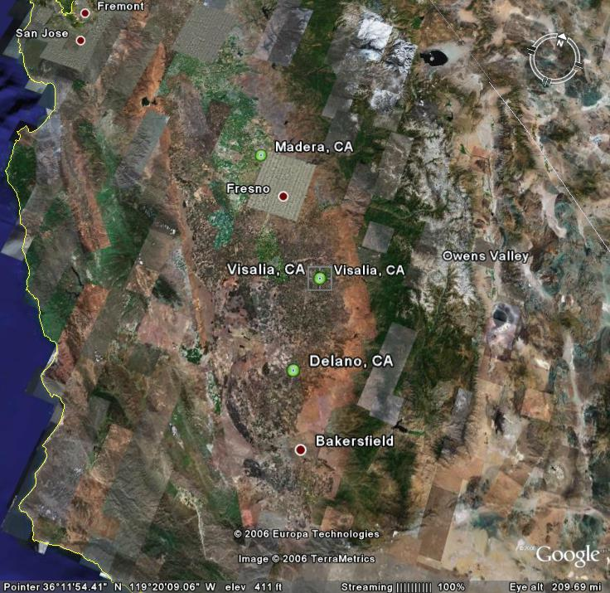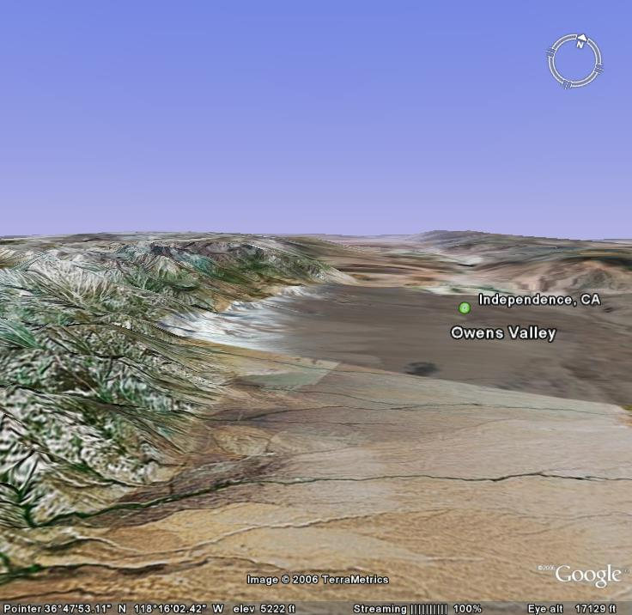

Figure 1 Map of mobile GAUS site locations (left), indicated by green circles, where upwind radiosondes were launched. Map on the right shows topography of Owens Valley, near Independence CA, where rotors generate as winds pass over Sierra Nevada Mountain range on the left.

1.1 Contacts

Contacts: Data Quality
June Wang
junhong@ucar.edu

Kate Young
kbeierle@ucar.edu

System/Software
Dean Lauritsen
lauritsn@ucar.edu

Mailing Address: NCAR/Earth Observing Laboratory
P.O. Box 3000
1850 Table Mesa Drive
Boulder, CO 80307; USA

For more information on the NCAR Earth Observing Laboratory GAUS System (formally GLASS) please visit the following site:
http://www.eol.ucar.edu/facilities/gaus.html

2.0 NCAR/EOL Detailed Data Description

2.1 Detailed Format Description

All upper air soundings were converted to National Center for Atmospheric Research/Earth Observing Laboratory (NCAR/EOL) Sounding Composite Format (ESC). ESC is a version of the National Center for Atmospheric Research (NCAR) CLASS format and is an ASCII format consisting of 15 header records for each sounding followed by the data records with associated QC information.

Header Records

The header records (15 total records) contain data type, project ID, site ID, site location, release time, sonde type, meteorological and wind data processors, and the operator's name and comments. The first five header lines contain information identifying the sounding, and have a rigidly defined form. The following 7 header lines are used for auxiliary information and comments about the sounding, and may vary from dataset to dataset. The last 3 header records contain header information for the data columns. Line 13 holds the field names, line 14 the field units, and line 15 contains dashes ('-' characters) delineating the extent of the field.

The five standard header lines are as follows:

Line Label (Padded to 35 chars) | Contents
1 Data Type: | Description of type and resolution of data.
2 Project ID: | ID of weather project.
3 Release Site Type/Site ID: | Description of release site.
4 Release Location (lon,lat,alt): | Position of release site, in format described below.
5 UTC Release Time (y,m,d,h,m,s): | Time of release, in format: yyyy, mm, dd, hh:mm:ss

The release location is given as: lon (deg min), lat (deg min), lon (dec. deg), lat (dec. deg), alt (m)

Longitude in deg min is in the format: ddd mm.mm'W where ddd is the number of degrees from True North (with leading zeros if necessary), mm.mm is the decimal number of minutes, and W represents W or E for west or east longitude, respectively. Latitude has the same format as longitude, except there are only two digits for degrees and N or S for north/south latitude. The decimal equivalent of longitude and latitude and station elevation follow.

The seven non-standard header lines may contain any label and contents. The labels are padded to 35 characters to match the standard header lines. Records for this dataset include the following three non-standard header lines.

Line Label (Padded to 35 chars) | Contents
6 Post Processing Comments: | Comments about NCAR/EOL post processing
7 Reference Launch Data Source/Time:
8 Sonde Id/Sonde Type: | Information on the Radiosonde used
9 System Operator/Comments: | Comments provided by site operators.
12 Nominal Release Time (y,m,d,h,m,s): | Nominal time of release, in format: yyyy, mm, dd, hh:mm:ss

Data Records

The data records each contain time from release, pressure, temperature, dew point, relative humidity, U and V wind components, wind speed and direction, ascent rate, balloon position data, altitude, and quality control flags (see the QC code description). Each data line contains 21 fields, separated by spaces, with a total width of 130 characters. The data are right-justified within the fields. All fields have one decimal place of precision, with the exception of latitude and longitude, which have three decimal places of precision. The contents and sizes of the 21 fields that appear in each data record are as follows:

Field No. | Format Width | Parameter | Units Value | Missing
1 | 6 F6.1 | Time | Seconds | 9999.0
2 | 6 F6.1 | Pressure | Millibars | 9999.0
3 | 5 F5.1 | Dry-bulb Temperature | Degrees C | 999.0
4 | 5 F5.1 | Dew Point Temperature | Degrees C | 999.0
5 | 5 F5.1 | Relative Humidity | Percent | 999.0
6 | 6 F6.1 | U Wind Component | Meters / Second | 9999.0
7 | 6 F6.1 | V Wind Component | Meters / Second | 9999.0
8 | 5 F5.1 | Wind Speed | Meters / Second | 999.0
9 | 5 F5.1 | Wind Direction | Degrees | 999.0
10 | 5 F5.1 | Ascent Rate | Meters / Second | 999.0
11 | 8 F8.3 | Longitude | Degrees | 9999.0
12 | 7 F7.3 | Latitude | Degrees | 999.0
13 | 5 F5.1 | Range | Kilometers | 999.0
14 | 5 F5.1 | Angle | Degrees | 999.0
15 | 7 F7.1 | Altitude | Meters | 99999.0
16 | 4 F4.1 | QC for Pressure | Code (see below) | 99.0
17 | 4 F4.1 | QC for Temperature | Code (see below) | 99.0
18 | 4 F4.1 | QC for Humidity | Code (see below) | 99.0
19 | 4 F4.1 | QC for U Component | Code (see below) | 99.0
20 | 4 F4.1 | QC for V Component | Code (see below) | 99.0
21 | 4 F4.1 | QC for Ascension Rate | Code (see below) | 99.0

Fields 16 through 21 contain the Quality Control information derived at the NCAR Earth Observing Laboratory (NCAR/EOL). Any QC information from the original sounding is replaced by the following NCAR/EOL codes:

Code | Description
99.0 | Unchecked (QC information is “missing”) (“UNCHECKED”)
1.0 | Checked, datum seems physically reasonable. (“GOOD”)
2.0 | Checked, datum seems questionable on physical basis. (“MAYBE”)
3.0 | Checked, datum seems to be in error. (“BAD”)
4.0 | Checked, datum is interpolated. (“ESTIMATED”)
9.0 | Checked, datum was missing in original file. (“MISSING”)

Sample Data

The following is a sample record of T-REX Sounding Rawinsonde MGAUS upper air data in NCAR/EOL CLASS format. The data portion is much longer than the page width and, therefore, wraps around to a second line. See section 2.1 for an exact format specification

Data Type: NCAR GAUS
Project ID: TREX
Release Site Type/Site ID: Station Description
Release Location (lon,lat,alt): 119 20.88'W, 36 19.74'N, -119.348, 36.329, 91.0
UTC Release Time (y,m,d,h,m,s): 2006, 03, 02, 08:33:34
Post Processing Comments: Aspen Version
Reference Launch Data Source/Time: Vaisala WXT510/08
Sonde Id/Sonde Type: 043937408/Vaisala RS92-SGP (ccGPS)
System Operator/Comments: Vic/Tim, Good Sounding
/
/
Nominal Release Time (y,m,d,h,m,s): 2006, 03, 02, 08:33:34
Time Press Temp Dewpt RH Ucmp Vcmp spd dir Wcmp Lon Lat Ele Azi Alt Qp Qt Qrh Qu Qv QdZ
sec mb C C % m/s m/s m/s deg m/s deg deg deg deg m code code code code code code
------ ------ ----- ----- ----- ------ ------ ----- ----- ----- -------- ------- ----- ----- ------- ---- ---- ---- ---- ---- ----
-1.0 1008.0 7.4 3.0 73.3 0.1 -0.2 0.2 323.0 999.0 -119.348 36.329 999.0 999.0 91.0 3.0 3.0 3.0 99.0 99.0 9.0
0.0 9999.0 7.8 3.4 73.7 -1.8 -0.1 1.8 87.3 999.0 -119.348 36.329 999.0 999.0 99999.0 9.0 3.0 3.0 99.0 99.0 9.0
1.0 1008.0 8.0 3.6 73.4 -1.9 -0.1 1.9 87.8 3.0 -119.348 36.329 999.0 999.0 91.2 3.0 3.0 3.0 99.0 99.0 99.0
2.0 1007.4 8.3 3.7 72.8 -1.9 -0.1 1.9 88.3 4.3 -119.348 36.329 999.0 999.0 95.5 3.0 3.0 3.0 99.0 99.0 99.0
3.0 1006.8 8.5 3.8 72.0 -2.0 -0.1 2.0 88.7 5.4 -119.348 36.329 999.0 999.0 101.2 3.0 3.0 3.0 99.0 99.0 99.0
4.0 1006.0 8.8 3.8 70.8 -2.0 -0.0 2.0 89.1 6.1 -119.348 36.329 999.0 999.0 107.6 2.0 99.0 99.0 99.0 99.0 99.0

2.2 Data Remarks

2.3 Station List

ID | SITE | STATE | LONG | LAT | ELEV (m)
MGAUS | Mobile GAUS | CA | -999.000 | 999.000 | -999.0

3.0 NCAR/EOL Quality Control Processing

This dataset underwent an automated QC process. The dataset underwent internal consistency checks which included two types of checks, gross limit checks on all parameters and rate-of-change checks on temperature, pressure and ascension rate. Some further information on the QC processing conducted by NCAR/EOL can be found in Loehrer et al. (1996) and Loehrer et al. (1998).

3.1 Gross Limit Checks

These checks were conducted on each sounding and data were automatically flagged as appropriate. Only the data point under examination was flagged. NCAR/EOL conducted the following gross limit checks on the T-REX MGAUS sounding datasets. In the table P = pressure, T = temperature, RH = relative humidity, U = U wind component, V = V wind component, B = bad, and Q = questionable.

Parameter | Parameters(s)  Gross Limit Check | Flag  Flagged | Applied
Pressure | < 0 mb or > 1050 mb | P | B
Altitude | < 0 m or > 40000 m | P, T, RH | Q
Temperature | < -90C or > 45C | T | Q
Dew Point | < -99.9C or > 33C  > Temperature | RH  T,RH | Q  Q
Relative Humidity | < 0% or > 100% | RH | B
Wind Speed | < 0 m/s or > 100 m/s  > 150 m/s | U,V  U,V | Q  B
U Wind Component | < 0 m/s or > 100 m/s  > 150 m/s | U  U | Q  B
V Wind Component | < 0 m/s or > 100 m/s  > 150 m/s | V  V | Q  B
Wind Direction | < 0 deg or > 360 deg | U,V | B
Ascent Rate | < -10 m/s or > 10 m/s | P,T,RH | Q

3.2 Vertical Consistency Checks

These checks were conducted on each sounding and data were automatically flagged as appropriate. These checks were started at the lowest level of the sounding and compared neighboring data points (except at pressures less than 100 mb where 30-sec average values were used. In the case of checks ensuring that the values increased/decreased as expected, only the data point under examination was flagged. However, for the other checks, all of the data points used in the examination were flagged. All items within the table are as previously defined.

Parameter | Vertical Consistency Check | Parameter(s)  Flagged | Flag  Applied
Time | decreasing/equal | None | None
Altitude | decreasing/equal | P,T,RH | Q
Pressure | increasing/equal  > 1 mb/s or < -1 mb/s  > 2 mb/s or < -2 mb/s | P,T,RH  P,T,RH  P,T,RH | Q  Q  B
Temperature | < -15 C/km  < -30 C/km (not applied at p < 250 mb)  > 50 C/km (not applied at p < 250 mb)  > 100 C/km (not applied at p < 250 mb) | P,T,RH  P,T,RH  P,T,RH  P,T,RH | Q  B  Q  B
Ascent Rate | Change of > 3 m/s or < -3 m/s  Change of > 5 m/s or < -5 m/s | P  P | Q  B

3.3 Data Quality Issues

4.0 NCAR/EOL Data File Specifics

The files contain data calculated at one-second intervals. The variables pressure, temperature, and relative humidity are calibrated values from measurements made by the radiosonde. The dew point is calculated from the relative humidity. The geopotential altitude is calculated from the hydrostatic equation using pressure, temperature, and relative humidity. The rate of ascent is calculated but the position (lat, lon, GPSAlt) come directly from the GPS sensor. All wind data are computed from GPS navigation signals received from the radiosonde. The raw wind values are calculated at a one second data rate by a commercial processing card. These raw values are subjected to a digital filter to remove low frequency oscillations due to the sonde pendulum motion beneath the balloon.

5.0 NCAR/EOL Data Quality Control

The raw soundings are first run through the Atmospheric Sounding Processing ENvironment (ASPEN), which analyzes the data, performs smoothing, and removes suspect data points. The soundings are then visually evaluated for outliers, or any other obvious problems. Scatter plots of the data are created to check the range in values of pressure, temperature and relative humidity. Lastly, we create profiles of temperature and RH, and wind speed and direction, in order to check for any major inconsistencies.

6.0 NCAR/EOL Important Note to Users

The raw soundings are first subjected to a radiation correction that takes into account the solar angle at launch time, and removes solar heating that could skew the temperature measurements. They are then run through the Atmospheric Sounding Processing ENvironment (ASPEN) software, which analyzes the data, performs smoothing, and removes suspect data points. Scatter plots (Figures 3) of the data are created to check differences in pressure, temperature and RH between the surface met data and the last available surface radiosonde measurement before launch. Lastly, we create profiles of temperature, RH, wind speed and wind direction, which enable us to visually evaluate the soundings for outliers, or any other obvious problems. Performing the QC steps above allows us to identify and, in some cases, correct errors that could potentially impact research performed using these data sets. Below are some important things to note about TREX data from the Mobile GAUS system:

1. A number of soundings had to be corrected for errors in the launch time. These errors are caused when not enough surface pre-launch radiosonde data is collected, resulting in the sounding system being unable to determine an accurate launch time. In these cases both the filename and launch time, indicated in the files, were changed.

2. There were several instances where weakening of the sonde signal, at high altitudes, resulted in the sounding system locking up. This caused numerous problems in the sounding files. The filenames were incorrect, the files did not contain surface met data, there were no launch detect lines, nor any auxiliary information about the soundings contained in the tail end of the raw file. These soundings were identified and have been corrected.

3. The first data line in each sounding, denoted by a time stamp of -1.0 second, typically represents data collected from an independent surface met station. It is used as a reference to determine the accuracy of the radiosonde pressure, temperature and relative humidity measurements. At various times during the project, the surface met sensor experienced problems. When this occurred, in place of the surface met measurements, data from the radiosonde was entered in as the surface observation. The soundings affected were:

IOP5/D20060306_015347
IOP5/D20060306_045303
IOP5/D20060306_051119
IOP5/D20060306_080000
IOP5/D20060306_110001
IOP8/D20060331_230000
IOP8/D20060331_045504
IOP8/D20060401_015715
IOP9/D20060402_195959
IOP9/D20060402_135959
IOP9/D20060402_170743
IOP9/D20060402_195959

4. The RS-92 radiosondes are equipped with two hygrometers that measure alternately during the ascent of the radiosonde. These measurements are then merged into one profile. By examining the relative humidity profiles (Figure 2), it was determined that one radiosonde hygrometer partially failed and one completely failed. These failures resulted in the sondes measuring intermittently during the flight, and caused gaps of missing data in the profiles.

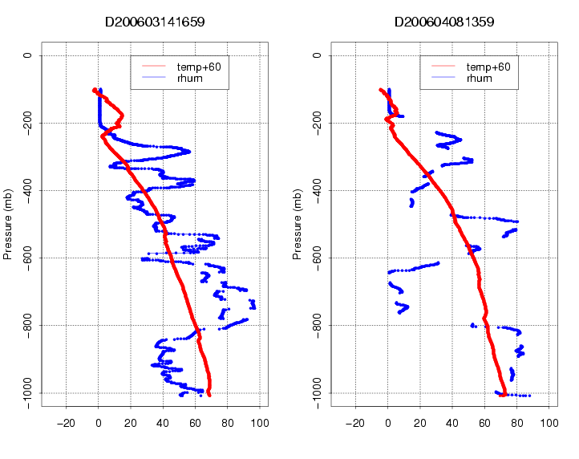
Figure 2. Profiles of relative humidity (blue), show partial failure (black circle on left plot) and complete failure (right plot) of one hygrometer on each of the sondes. Temperature profiles (red) are also shown.

4. One sounding (D20060303_044228_P.1) lost signal during flight. It was later recaptured, with data from the tail end of the sounding stored in a new file (D20060303_054126). The two files were merged into one.

5. The surface altitudes in the soundings were originally obtained from a GPS, but because of the nature of the GPS and accuracy of the sensor, the altitudes varied from sounding to sounding. These values were changed to a fixed altitude (the first value in the GPS altitude column) to reflect that while the GAUS system moved between 3 cites, it was positioned at the same site each time it was moved.

6. Differences between the surface met sensor and the last radiosonde surface measurement before launch (from raw sounding files), versus local standard time, can be seen in Figure 3 below. These plots show a clear difference between temperature and humidity measured by the radiosonde and by the surface met. After further examination, it was determined that the surface met sensor was reporting cooler temperatures and more moist RH likely as a result of being set up in a grassy area approximately 3 meters above the surface, while the radiosonde was launched from an asphalt parking lot approximately 1 meter above the surface.

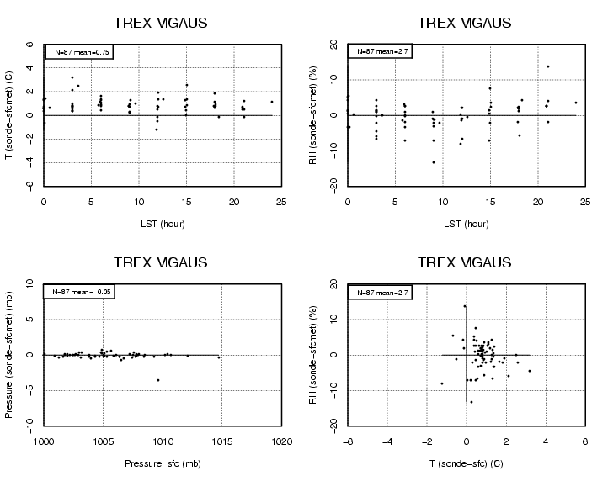

Figure 3. Difference between surface met sensor measurements and last surface radiosonde measurement before launch. Upper most plots, show slightly warmer and drier radiosonde measurements than surface met. Red circle on lower left-hand plot shows difference of -3.5 mb apparently caused by sonde pressure sensor measuring too low.

