Terrain Induced Rotor Experiment 2006 (T-REX)
Quality Controlled Mobile GAUS Radiosonde Data Set

Contents:
I. GAUS Data Set Overview
II. File Naming Conventions
III. **NEW** EOL Sounding File Format
IV. Data File Specifics
V. Data Quality Control and Important Information for Users

Contacts: Data Quality
June Wang
junhong@ucar.edu

Kate Young
kbeierle@ucar.edu

System/Software
Dean Lauritsen
lauritsn@ucar.edu

Mailing Address: NCAR/Earth Observing Laboratory
P.O. Box 3000
1850 Table Mesa Drive
Boulder, CO 80307; USA

For more information on the NCAR Earth Observing Laboratory GAUS System (formally GLASS) please visit the following site:
http://www.eol.ucar.edu/facilities/gaus.html

I. Mobile GAUS Dataset Overview

The Terrain Induced Rotor Experiment (T-REX) was conducted during March and April 2006, during which time 87 radiosondes were launched using a mobile sounding system at three locations (Visalia (71), Madera (9) and Delano (7)) in the California Central Valley (Figure 1). TREX is the second phase of a coordinated effort to explore the structure and evolution of atmospheric rotors, which typically occur parallel to, and downstream from, mountain ridge crests. The first phase was a project conducted in 2004 called the Sierra Rotors Project. Both phases included upwind radiosonde launches from the central valley, used to help predict the onset of events likely to produce rotors on the West side of the Sierra Nevada Mountain Range. In order to capture the structure of the rotors, additional instruments were set up in California’s Owens Valley. For more information on the TREX project, please visit: http://www.atd.ucar.edu/projects/trex/

The new EOL GPS Advanced Upper-air Sounding System (GAUS) was developed to replace the GPS LORAN Atmospheric Sounding System (GLASS). GAUS incorporates Vaisala RS92 next generation radiosondes, has portability, built-in test capability and flexibility for multiple channel operations, and delivers users high precision GPS measurements of radiosonde positions. The Vaisala RS92 radiosonde delivers high quality wind measurements from the ground with code-correlating GPS technology, as well as pressure, temperature and humidity measurements all transmitted digitally to the receiving station. Digital technology will reduce missing data due to noise and increase overall reliability of the system. The Vaisala RS92 provides much better humidity measurements with a heated twin-sensor design and incorporates a new reconditioning procedure before launch.

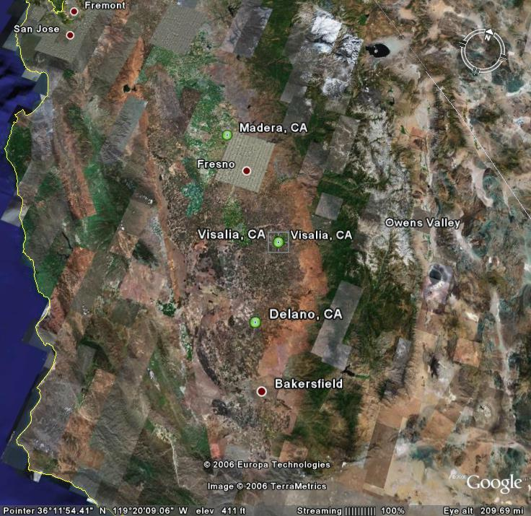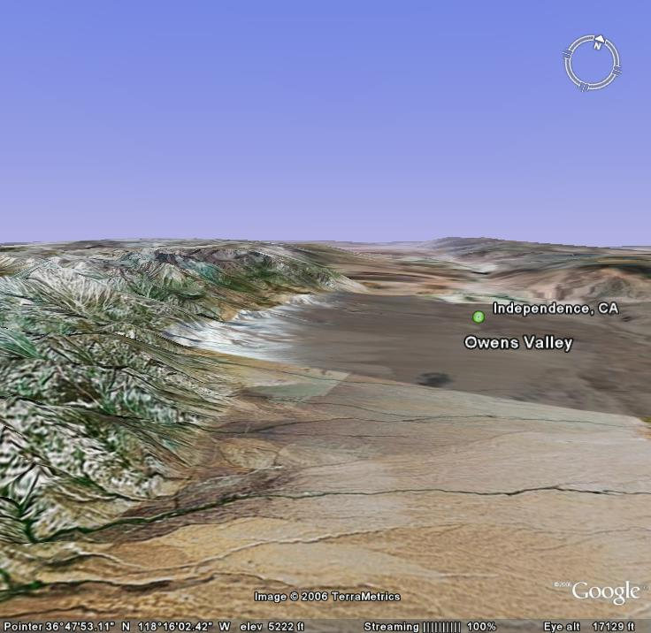

Figure 1 Map of mobile GAUS site locations (left), indicated by green circles, where upwind radiosondes were launched. Map on the right shows topography of Owens Valley, near Independence CA, where rotors generate as winds pass over Sierra Nevada Mountain range on the left.

II File Naming Conventions

The "D" files are one second, ascii format data files with appropriate corrections and quality control measures applied. The naming convention for these files is - "D", followed by "yyyymmdd_hhmmss_P.1QC.eol" where yyyy = year, mm = month, hh = hour of the day UTC, mm = minute of the hour, ss = second of the hour and “.eol” refers to the file format type.

III. ***New EOL File Format***

EOL has introduced a new ascii “EOL file format” for all radiosonde and dropsonde sounding files. This new file format is similar to the CLASS format, used in the past, but has been improved to include a revised header with more detailed sounding information, addition of UTC time, an increase in accuracy of the longitude and latitude to six decimal places, and GPS altitude is now also provided in addition to geopotential altitude.

The header records now consist of 14 lines which contain information such as data type, project name, site location, actual release time, and other specialized information. The first seven header lines contain information identifying the sounding. The following three header lines contain information about the surface met station used and auxiliary information and comments about the sounding. The last 3 header lines contain header information for the data columns. Line 12 holds the field names, line 13 the field units, and line 14 contains dashes (--- characters) signifying the end of the header.

The release location is given as : lon (deg min), lon (dec. deg), lat (deg min), lat (dec. deg), altitude (meters)

Longitude in deg min is in the format: ddd mm.mm'W where ddd is the number of degrees from True North (with leading zeros if necessary), mm.mm is the decimal number of minutes, and W represents W or E for west or east longitude, respectively. Latitude has the same format as longitude, except there are only two digits for degrees and N or S for north/south latitude.

Data Type/Direction: GAUS/Ascending
File Format/Version: EOL Sounding Format/1.0
Project Name/Platform: T-REX/NCAR GAUS
Launch Site: IOP01 08z mgaus
Launch Location (lon,lat,alt): 119 20.88'W -119.347997, 36 19.74'N 36.328918, 90.98
UTC Launch Time (y,m,d,h,m,s): 2006, 03, 02, 08:33:34
Sonde Id/Sonde Type: 043937408/Vaisala RS92-SGP (ccGPS)
Reference Launch Data Source/Time: Vaisala WXT510/08:33:32.80
System Operator/Comments: Vic/Tim, Good Sounding
Post Processing Comments: Aspen Version
/
Time -- UTC -- Press Temp Dewpt RH Uwind Vwind Wspd Dir dZ GeoPoAlt Lon Lat GPSAlt
sec hh mm ss mb C C % m/s m/s m/s deg m/s m deg deg m
------- -- -- ----- ------- ------- ------- ------- ------- ------- ------- ------- ------- -------- ----------- ----------- --------
-1.0 8 33 33.00 1008.00 7.40 2.96 73.30 0.12 -0.16 0.20 323.00 -999.00 90.98 -119.347997 36.328918 91.00
0.0 8 33 34.00 -999.00 7.78 3.39 73.65 -1.77 -0.08 1.77 87.26 -999.00 -999.00 -119.348006 36.328917 70.52
1.0 8 33 35.00 1007.98 8.03 3.59 73.37 -1.86 -0.07 1.86 87.85 2.99 91.16 -119.348026 36.328916 72.53
2.0 8 33 36.00 1007.45 8.29 3.72 72.81 -1.94 -0.06 1.95 88.32 4.27 95.47 -119.348048 36.328916 79.10
3.0 8 33 37.00 1006.76 8.53 3.79 71.95 -2.01 -0.05 2.01 88.70 5.36 101.16 -119.348070 36.328915 85.54

Field Parameter Units Missing Value
No.
1 Time Seconds -------------
2 UTC Hour Hours -------------
3 UTC Minute Minutes -------------
4 UTC Second Seconds -------------
5 Pressure Millibars -999.00
6 Dry-bulb Temp Degrees C -999.00
7 Dewpoint Temp Degrees C -999.00
8 Relative Humidity Percent -999.00
9 U Wind Component Meters/Second -999.00
10 V Wind Component Meters/Second -999.00
11 Wind Speed Meters/Second -999.00
12 Wind Direction Degrees -999.00
13 Ascension Rate Meters/Second -999.00
14 Geopotential Altitude Meters -999.00
15 Longitude Degrees -999.00
16 Latitude Degrees -999.00
17 GPS Altitude Meters -999.00

V. Data File Specifics

The files contain data calculated at one-second intervals. The variables pressure, temperature, and relative humidity are calibrated values from measurements made by the radiosonde. The dew point is calculated from the relative humidity. The geopotential altitude is calculated from the hydrostatic equation using pressure, temperature, and relative humidity. The rate of ascent is calculated but the position (lat, lon, GPSAlt) come directly from the GPS sensor. All wind data are computed from GPS navigation signals received from the radiosonde. The raw wind values are calculated at a one second data rate by a commercial processing card. These raw values are subjected to a digital filter to remove low frequency oscillations due to the sonde pendulum motion beneath the balloon.

VI. Data Quality Control and Important Information for Users

The raw soundings are first subjected to a radiation correction that takes into account the solar angle at launch time, and removes solar heating that could skew the temperature measurements. They are then run through the Atmospheric Sounding Processing ENvironment (ASPEN) software, which analyzes the data, performs smoothing, and removes suspect data points. Scatter plots (Figures 3) of the data are created to check differences in pressure, temperature and RH between the surface met data and the last available surface radiosonde measurement before launch. Lastly, we create profiles of temperature, RH, wind speed and wind direction, which enable us to visually evaluate the soundings for outliers, or any other obvious problems. Performing the QC steps above allows us to identify and, in some cases, correct errors that could potentially impact research performed using these data sets. Below are some important things to note about TREX data from the Mobile GAUS system:

1. A number of soundings had to be corrected for errors in the launch time. These errors are caused when not enough surface pre-launch radiosonde data is collected, resulting in the sounding system being unable to determine an accurate launch time. In these cases both the filename and launch time, indicated in the files, were changed.

2. There were several instances where weakening of the sonde signal, at high altitudes, resulted in the sounding system locking up. This caused numerous problems in the sounding files. The filenames were incorrect, the files did not contain surface met data, there were no launch detect lines, nor any auxiliary information about the soundings contained in the tail end of the raw file. These soundings were identified and have been corrected.

3. The first data line in each sounding, denoted by a time stamp of -1.0 second, typically represents data collected from an independent surface met station. It is used as a reference to determine the accuracy of the radiosonde pressure, temperature and relative humidity measurements. At various times during the project, the surface met sensor experienced problems. When this occurred, in place of the surface met measurements, data from the radiosonde was entered in as the surface observation. The soundings affected were:

IOP5/D20060306_015347
IOP5/D20060306_045303
IOP5/D20060306_051119
IOP5/D20060306_080000
IOP5/D20060306_110001
IOP8/D20060331_230000
IOP8/D20060331_045504
IOP8/D20060401_015715
IOP9/D20060402_195959
IOP9/D20060402_135959
IOP9/D20060402_170743
IOP9/D20060402_195959

4. The RS-92 radiosondes are equipped with two hygrometers that measure alternately during the ascent of the radiosonde. These measurements are then merged into one profile. By examining the relative humidity profiles (Figure 2), it was determined that one radiosonde hygrometer partially failed and one completely failed. These failures resulted in the sondes measuring intermittently during the flight, and caused gaps of missing data in the profiles.

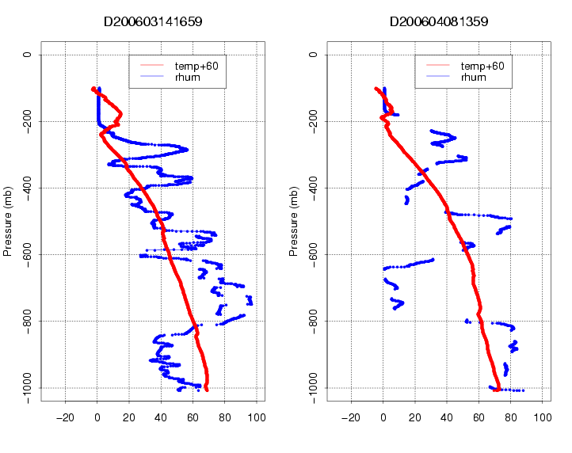
Figure 2. Profiles of relative humidity (blue), show partial failure (black circle on left plot) and complete failure (right plot) of one hygrometer on each of the sondes. Temperature profiles (red) are also shown.

4. One sounding (D20060303_044228_P.1) lost signal during flight. It was later recaptured, with data from the tail end of the sounding stored in a new file (D20060303_054126). The two files were merged into one.

5. The surface altitudes in the soundings were originally obtained from a GPS, but because of the nature of the GPS and accuracy of the sensor, the altitudes varied from sounding to sounding. These values were changed to a fixed altitude (the first value in the GPS altitude column) to reflect that while the GAUS system moved between 3 cites, it was positioned at the same site each time it was moved.

6. Differences between the surface met sensor and the last radiosonde surface measurement before launch (from raw sounding files), versus local standard time, can be seen in Figure 3 below. These plots show a clear difference between temperature and humidity measured by the radiosonde and by the surface met. After further examination, it was determined that the surface met sensor was reporting cooler temperatures and more moist RH likely as a result of being set up in a grassy area approximately 3 meters above the surface, while the radiosonde was launched from an asphalt parking lot approximately 1 meter above the surface.

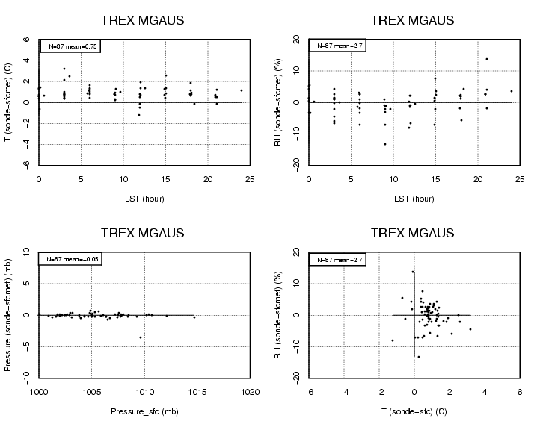

Figure 3. Difference between surface met sensor measurements and last surface radiosonde measurement before launch. Upper most plots, show slightly warmer and drier radiosonde measurements than surface met. Red circle on lower left-hand plot shows difference of -3.5 mb apparently caused by sonde pressure sensor measuring too low.

