NAME 2004 Quality Controlled Radiosonde Data Set

Contents:
I. Contacts
II. ISS and GLASS Data Set Overview
III. File Naming Conventions
IV. Header Information
V. Data Records
VI. Data File Specifics
VII. Data Quality Control

Contacts: Bill Brown (ISS)
wbrown@ucar.edu

June Wang (GLASS)
junhong@ucar.edu

Kate Young (ISS or GLASS)
kbeierle@ucar.edu

Mailing Address: NCAR/Atmospheric Technology Division
P.O. Box 3000
1850 Table Mesa Drive
Boulder, CO 80307; USA

For more information on the NCAR ISS or GLASS Systems please visit the following sites:
http://www.atd.ucar.edu/rtf/facilities/iss/iss.html
http://www.atd.ucar.edu/rtf/facilities/class/class.html

II. ISS and GLASS Dataset Overview

The Integrated Sounding System (ISS) radiosonde data sets consist of 462 soundings launched from three sites in Mexico; Port Penasco (ISS2), Kino Bay (ISS3) and Los Mochis (ISS4), between July 3 and August 15, 2004. The GPS Loran Atmospheric Sounding System (GLASS) data set contains 176 soundings launched from Loreto, Mexico between July 9 and August 15, 2004. There are two soundings, one from ISS4 (D200407231138.IS4) and one from GLASS (D200408130112.NLO), which contain large gaps of missing data and need to be reprocessed. They are currently being worked on and will be released in the near future.

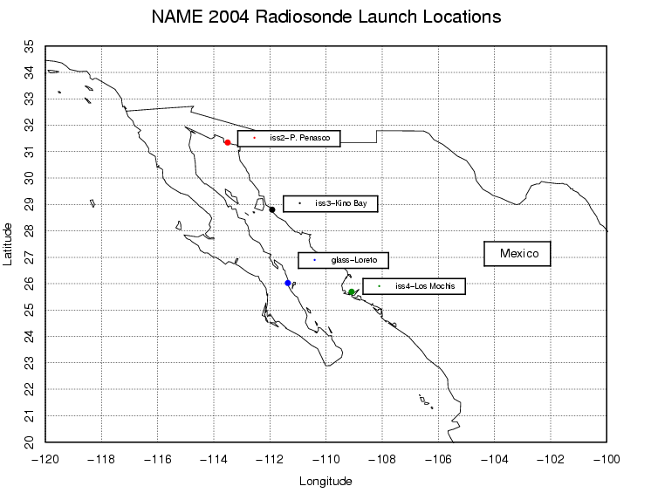

Fig. 1 - Map of NAME radiosonde launch locations for all sites.

III File Naming Conventions

The "D" files are one second data files with appropriate corrections and quality control measures applied. The naming convention for these files is basically the same from project to project - "D", followed by "yyyymmdd_hhmmssQC.cls" where yyyy = year, mm = month, hh = hour of the day GMT, mm = minute of the hour, ss = second of the hour, QC refers to Quality Controlled, and ".cls" refers to the NCAR CLASS format.

IV. Header Information

The header records contain data type, project ID, site ID, site location, actual release time, and possibly other specialized information. The first five header lines contain information identifying the sounding, and have a rigidly defined form. The following 6 header lines contain auxiliary information and comments about the sounding, and they can vary from data set to data set. The last 3 header records contain header information for the data columns. Line 13 holds the field names, line 14 the field units, and line 15 contains dashes (--- characters) signifying the end of the header.

The five standard header lines are as follows:

Line Label (fixed to 35 chars in length) Contents

1. Data Type: Description of type and resolution of
data.
2. Project ID: ID of weather project.
3. Launch Site Type/Site ID: Description of launch site.
4. Launch Location (lon,lat,alt): Position of launch
5. GMT Launch: Time of release, in format:
yyyy, mm, dd, hh:mm:ss

The release location is given as : lon (deg min), lat (deg min), lon (dec. deg), lat (dec. deg), alt (m).

Longitude in deg min is in the format: ddd mm.mm'W where ddd is the number of degrees from True North (with leading zeros if necessary), mm.mm is the decimal number of minutes, and W represents W or E for west or east longitude, respectively. Latitude has the same format as longitude, except there are only two digits for degrees and N or S for north/south latitude. The decimal equivalent of longitude and latitude and station elevation follow.

The six non-standard header lines may contain any label and contents. The label is fixed to 35 characters to match the standard header lines.

V. Data Records

The data records each contain time from release, pressure, temperature, dew point, relative humidity, U and V wind components, wind speed and direction, ascent rate, balloon position data, altitude, and quality control flags.

Field Parameter Units Missing Value
No.
1 Time Seconds 9999.0
2 Pressure Millibars 9999.0
3 Dry-bulb Temp Degrees C 999.0
4 Dew Point Temp Degrees C 999.0
5 Relative Humidity Percent 999.0
6 U Wind Component Meters/Second 999.0
7 V Wind Component Meters/Second 999.0
8 Wind Speed Meters/Second 999.0
9 Wind Direction Degrees 999.0
10 Ascension Rate Meters/Second 999.0
11 Longitude Degrees 999.0
12 Latitude Degrees 999.0
13 Range Kilometers 999.0
14 Angle Degrees 999.0
15 Altitude Meters 99999.0
16 QC flag for Pressure 99.0
17 QC flag for Temp 99.0
18 QC flag for Humidity 99.0
19 QC flag for U Component 99.0
20 QC flag for V Component 99.0
21 QC flag for Horizontal Wind 99.0

VI. Data File Specifics

The files contain data calculated at one-second intervals. The variables pressure, temperature, and relative humidity are calibrated values from measurements made by the radiosonde. The dew point is calculated from the relative humidity. The altitude is calculated from the hydrostatic equation using pressure, temperature, and dew point. The rate of ascent is obtained from the altitude difference between two successive time steps. The position (lat, lon) are computed by using horizontal winds to integrate location from the initial launch position.

All wind data are computed from GPS navigation signals received from the radiosonde. The raw wind values are calculated at a one-half second data rate by a commercial processing card. These raw values are subjected to a digital filter to remove low frequency oscillations due to the sonde pendulum motion beneath the balloon. The resolution of the data is reduced to one second. This time record is used in the interpolation of the pressure, temperature, and humidity data.

VII. Data Quality Control

The raw soundings are first run through the Atmospheric Sounding Processing ENvironment (ASPEN), which analyzes the data, performs smoothing, and removes suspect data points. The soundings are then visually evaluated for outliers, or any other obvious problems. Scatter plots of the data are created to check the range in values of pressure, temperature and relative humidity. Lastly, we create profiles of temperature and RH, and wind speed and direction, in order to check for any major inconsistencies.

VIII. Important Note to Users
The first data line in each sounding, denoted by a time stamp of -1.0 second, typically represents data collected from an independent surface met station. During the quality control process this data is used as a reference to determine the accuracy of the radiosondes pressure, temperature and relative humidity measurements. The surface met sensors at the Loreto GLASS site failed to work during the project, so in place of the surface met data, pre-launch pressure, temperature and RH measured by the sonde and human estimated winds were entered into the first line of each sounding. A major concern is that if sensor arm heating (which is a common problem during projects where sondes are launched in warm weather without proper ventilation, as was the case at Loreto) occurred, there is either no way to detect it or the extent of it. From looking at the scatter plots, shown in figure 2 below, and visually comparing the GLASS data with that collected at the ISS sites, there seems to be no evidence of sensor arm heating. However, we wanted to make the users were aware of what had been done and to warn them to be skeptical about the accuracy of the GLASS radiosonde data near the surface.
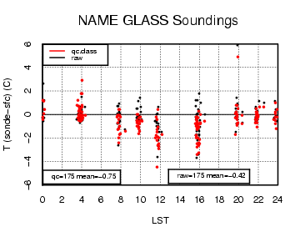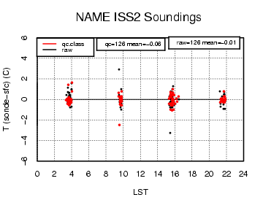
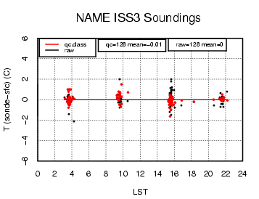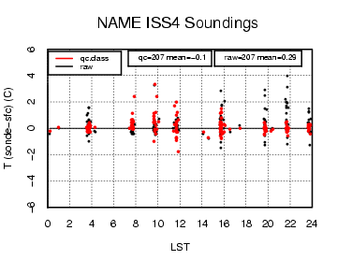

Figure 2 – Scatter plots of temperature differences (ºC) between sonde and surface for both the quality controlled and raw datasets.

