NAME 2004 Quality Controlled Radiosonde Data Set

1.0 ISS and GLASS Dataset Overview

The Integrated Sounding System (ISS) radiosonde data sets consist of 462 soundings launched from three sites in Mexico; Port Penasco (ISS2), Kino Bay (ISS3) and Los Mochis (ISS4), between July 3 and August 15, 2004. The GPS Loran Atmospheric Sounding System (GLASS) data set contains 176 soundings launched from Loreto, Mexico between July 9 and August 15, 2004. These data were provided by the National Center for Atmospheric Research/Environmental Observation Laboratory (NCAR/EOL).

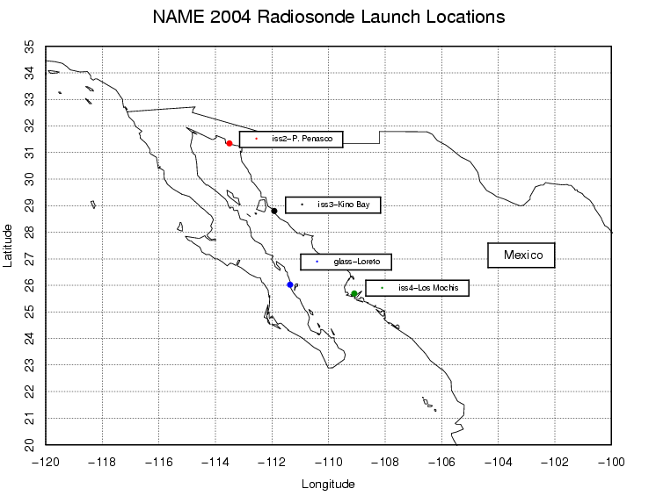

Fig. 1 - Map of NAME radiosonde launch locations for all sites.

2.1 Contacts

Bill Brown (ISS)
wbrown@ucar.edu

June Wang (GLASS)
junhong@ucar.edu

Kate Young (ISS or GLASS)
kbeierle@ucar.edu

Mailing Address: NCAR/Atmospheric Technology Division
P.O. Box 3000
1850 Table Mesa Drive
Boulder, CO 80307; USA

For more information on the NCAR ISS or GLASS Systems please visit the following sites:
http://www.atd.ucar.edu/rtf/facilities/iss/iss.html
http://www.atd.ucar.edu/rtf/facilities/class/class.html

2.0 UCAR/JOSS Detailed Data Description

2.1 Detailed Format Description

All upper air soundings were converted to University Corporation for Atmospheric Research/Joint Office for Science Support (UCAR/JOSS) Cross Chain LORAN Atmospheric Sounding System (CLASS) Format (JCF). JCF is a version of the National Center for Atmospheric Research (NCAR) CLASS format and is an ASCII format consisting of 15 header records for each sounding followed by the data records with associated QC information.

Header Records

The header records (15 total records) contain data type, project ID, site ID, site location, release time, sonde type, meteorological and wind data processors, and the operator's name and comments. The first five header lines contain information identifying the sounding, and have a rigidly defined form. The following 7 header lines are used for auxiliary information and comments about the sounding, and may vary from dataset to dataset. The last 3 header records contain header information for the data columns. Line 13 holds the field names, line 14 the field units, and line 15 contains dashes ('-' characters) delineating the extent of the field.

The five standard header lines are as follows:

Line Label (Padded to 35 chars) | Contents
1 Data Type: | Description of type and resolution of data.
2 Project ID: | ID of weather project.
3 Release Site Type/Site ID: | Description of release site.
4 Release Location (lon,lat,alt): | Position of release site, in format described below.
5 UTC Release Time (y,m,d,h,m,s): | Time of release, in format: yyyy, mm, dd, hh:mm:ss

The release location is given as: lon (deg min), lat (deg min), lon (dec. deg), lat (dec. deg), alt (m)

Longitude in deg min is in the format: ddd mm.mm'W where ddd is the number of degrees from True North (with leading zeros if necessary), mm.mm is the decimal number of minutes, and W represents W or E for west or east longitude, respectively. Latitude has the same format as longitude, except there are only two digits for degrees and N or S for north/south latitude. The decimal equivalent of longitude and latitude and station elevation follow.

The seven non-standard header lines may contain any label and contents. The labels are padded to 35 characters to match the standard header lines. Records for this dataset include the following three non-standard header lines.

Line Label (Padded to 35 chars) | Contents
6 Radiosonde Manufacturer: | Radiosonde manufacturer and type
7 Radiosonde Serial Number: | Radiosonde serial number
8 System Operator/Comments: | Comments provided by site operators.
12 Nominal Release Time (y,m,d,h,m,s): | Nominal time of release, in format: yyyy, mm, dd, hh:mm:ss

Data Records

The data records each contain time from release, pressure, temperature, dew point, relative humidity, U and V wind components, wind speed and direction, ascent rate, balloon position data, altitude, and quality control flags (see the QC code description). Each data line contains 21 fields, separated by spaces, with a total width of 130 characters. The data are right-justified within the fields. All fields have one decimal place of precision, with the exception of latitude and longitude, which have three decimal places of precision. The contents and sizes of the 21 fields that appear in each data record are as follows:

Field No. | Format Width | Parameter | Units Value | Missing
1 | 6 F6.1 | Time | Seconds | 9999.0
2 | 6 F6.1 | Pressure | Millibars | 9999.0
3 | 5 F5.1 | Dry-bulb Temperature | Degrees C | 999.0
4 | 5 F5.1 | Dew Point Temperature | Degrees C | 999.0
5 | 5 F5.1 | Relative Humidity | Percent | 999.0
6 | 6 F6.1 | U Wind Component | Meters / Second | 9999.0
7 | 6 F6.1 | V Wind Component | Meters / Second | 9999.0
8 | 5 F5.1 | Wind Speed | Meters / Second | 999.0
9 | 5 F5.1 | Wind Direction | Degrees | 999.0
10 | 5 F5.1 | Ascent Rate | Meters / Second | 999.0
11 | 8 F8.3 | Longitude | Degrees | 9999.0
12 | 7 F7.3 | Latitude | Degrees | 999.0
13 | 5 F5.1 | Range | Kilometers | 999.0
14 | 5 F5.1 | Angle | Degrees | 999.0
15 | 7 F7.1 | Altitude | Meters | 99999.0
16 | 4 F4.1 | QC for Pressure | Code (see below) | 99.0
17 | 4 F4.1 | QC for Temperature | Code (see below) | 99.0
18 | 4 F4.1 | QC for Humidity | Code (see below) | 99.0
19 | 4 F4.1 | QC for U Component | Code (see below) | 99.0
20 | 4 F4.1 | QC for V Component | Code (see below) | 99.0
21 | 4 F4.1 | QC for Ascension Rate | Code (see below) | 99.0

Fields 16 through 21 contain the Quality Control information derived at the UCAR Joint Office for Science Support (UCAR/JOSS). Any QC information from the original sounding is replaced by the following UCAR/JOSS codes:

Code | Description
99.0 | Unchecked (QC information is “missing”) (“UNCHECKED”)
1.0 | Checked, datum seems physically reasonable. (“GOOD”)
2.0 | Checked, datum seems questionable on physical basis. (“MAYBE”)
3.0 | Checked, datum seems to be in error. (“BAD”)
4.0 | Checked, datum is interpolated. (“ESTIMATED”)
9.0 | Checked, datum was missing in original file. (“MISSING”)

Sample Data

The following is a sample record of NAME Sounding Rawinsonde GLASS upper air data in UCAR/JOSS CLASS format. The data portion is much longer than the page width and, therefore, wraps around to a second line. See section 2.1 for an exact format specification

Data Type: NCAR GLASS
Project ID: NAME
Release Site Type/Site ID: NLO Loreto, MX
Release Location (lon,lat,alt): 111 20.64'W, 26 01.14'N, -111.34400, 26.01900, 2.0
UTC Release Time (y,m,d,h,m,s): 2004, 08, 07, 07:18:13
Radiosonde Manufacturer: VAISALA RS80-15GH
Radiosonde Serial Number: 408402014
System Operator/Comments: loretoops,team, peterson/spowart. normal launch, buenas noches!
/
/
/
Nominal Release Time (y,m,d,h,m,s):2004, 08, 07, 09:00:00
Time Press Temp Dewpt RH Ucmp Vcmp spd dir Wcmp Lon Lat Rng Az Alt Qp Qt Qrh Qu Qv QdZ
sec mb C C % m/s m/s m/s deg m/s deg deg km deg m code code code code code code
------ ------ ----- ----- ----- ------ ------ ----- ----- ----- -------- ------- ----- ----- ------- ---- ---- ---- ---- ---- ----
-1.0 1010.5 29.8 23.9 70.3 -0.1 1.0 1.0 175.0 999.0 -111.344 26.019 999.0 999.0 2.0 99.0 99.0 99.0 99.0 99.0 9.0
0.0 9999.0 999.0 999.0 999.0 -0.1 0.3 0.3 159.3 999.0 -110.460 25.943 999.0 999.0 99999.0 9.0 9.0 9.0 99.0 99.0 9.0
1.0 9999.0 999.0 999.0 999.0 -0.2 -0.0 0.2 86.7 999.0 -111.344 26.019 999.0 999.0 99999.0 9.0 9.0 9.0 99.0 99.0 9.0
2.0 1010.1 999.0 999.0 999.0 9999.0 9999.0 999.0 999.0 5.0 9999.000 999.000 999.0 999.0 5.3 2.0 9.0 9.0 9.0 9.0 99.0
3.0 1009.3 999.0 999.0 71.4 9999.0 9999.0 999.0 999.0 7.4 9999.000 999.000 999.0 999.0 12.4 2.0 9.0 99.0 9.0 9.0 99.0
4.0 1008.4 29.6 24.0 71.4 9999.0 9999.0 999.0 999.0 8.0 9999.000 999.000 999.0 999.0 20.9 2.0 99.0 99.0 9.0 9.0 99.0

2.2 Data Remarks

2.3 Station List

ID | SITE | COUNTRY | LONG | LAT | ELEV (m)
BKN | Kino Bay | MX | -111.927 | 28.814 | 2.0
IS4 | Los Mochis | MX | -109.082 | 25.689 | 3.0
NLO | Loreto | MX | -111.344 | 26.019 | 2.0
NPP | Puerto Penasco | MX | -113.509 | 31.344 | 2.0

3.0 UCAR/JOSS Quality Control Processing

This dataset underwent an automated QC process. The dataset underwent internal consistency checks which included two types of checks, gross limit checks on all parameters and rate-of-change checks on temperature, pressure and ascension rate. Some further information on the QC processing conducted by UCAR/JOSS can be found in Loehrer et al. (1996) and Loehrer et al. (1998).

3.1 Gross Limit Checks

These checks were conducted on each sounding and data were automatically flagged as appropriate. Only the data point under examination was flagged. UCAR/JOSS conducted the following gross limit checks on the NAME ISS and GLASS sounding datasets. In the table P = pressure, T = temperature, RH = relative humidity, U = U wind component, V = V wind component, B = bad, and Q = questionable.

Parameter | Parameters(s)  Gross Limit Check | Flag  Flagged | Applied
Pressure | < 0 mb or > 1050 mb | P | B
Altitude | < 0 m or > 40000 m | P, T, RH | Q
Temperature | < -90C or > 45C | T | Q
Dew Point | < -99.9C or > 33C  > Temperature | RH  T,RH | Q  Q
Relative Humidity | < 0% or > 100% | RH | B
Wind Speed | < 0 m/s or > 100 m/s  > 150 m/s | U,V  U,V | Q  B
U Wind Component | < 0 m/s or > 100 m/s  > 150 m/s | U  U | Q  B
V Wind Component | < 0 m/s or > 100 m/s  > 150 m/s | V  V | Q  B
Wind Direction | < 0 deg or > 360 deg | U,V | B
Ascent Rate | < -10 m/s or > 10 m/s | P,T,RH | Q

3.2 Vertical Consistency Checks

These checks were conducted on each sounding and data were automatically flagged as appropriate. These checks were started at the lowest level of the sounding and compared neighboring data points (except at pressures less than 100 mb where 30-sec average values were used. In the case of checks ensuring that the values increased/decreased as expected, only the data point under examination was flagged. However, for the other checks, all of the data points used in the examination were flagged. All items within the table are as previously defined.

Parameter | Vertical Consistency Check | Parameter(s)  Flagged | Flag  Applied
Time | decreasing/equal | None | None
Altitude | decreasing/equal | P,T,RH | Q
Pressure | increasing/equal  > 1 mb/s or < -1 mb/s  > 2 mb/s or < -2 mb/s | P,T,RH  P,T,RH  P,T,RH | Q  Q  B
Temperature | < -15 C/km  < -30 C/km (not applied at p < 250 mb)  > 50 C/km (not applied at p < 250 mb)  > 100 C/km (not applied at p < 250 mb) | P,T,RH  P,T,RH  P,T,RH  P,T,RH | Q  B  Q  B
Ascent Rate | Change of > 3 m/s or < -3 m/s  Change of > 5 m/s or < -5 m/s | P  P | Q  B

3.3 Data Quality Issues

4.0 NCAR/EOL Data File Specifics

The files contain data calculated at one-second intervals. The variables pressure, temperature, and relative humidity are calibrated values from measurements made by the radiosonde. The dew point is calculated from the relative humidity. The altitude is calculated from the hydrostatic equation using pressure, temperature, and dew point. The rate of ascent is obtained from the altitude difference between two successive time steps. The position (lat, lon) are computed by using horizontal winds to integrate location from the initial launch position.

All wind data are computed from GPS navigation signals received from the radiosonde. The raw wind values are calculated at a one-half second data rate by a commercial processing card. These raw values are subjected to a digital filter to remove low frequency oscillations due to the sonde pendulum motion beneath the balloon. The resolution of the data is reduced to one second. This time record is used in the interpolation of the pressure, temperature, and humidity data.

5.0 NCAR/EOL Data Quality Control

The raw soundings are first run through the Atmospheric Sounding Processing ENvironment (ASPEN), which analyzes the data, performs smoothing, and removes suspect data points. The soundings are then visually evaluated for outliers, or any other obvious problems. Scatter plots of the data are created to check the range in values of pressure, temperature and relative humidity. Lastly, we create profiles of temperature and RH, and wind speed and direction, in order to check for any major inconsistencies.

6.0 NCAR/EOL Important Note to Users

The first data line in each sounding, denoted by a time stamp of -1.0 second, typically represents data collected from an independent surface met station. During the quality control process this data is used as a reference to determine the accuracy of the radiosondes pressure, temperature and relative humidity measurements. The surface met sensors at the Loreto GLASS site failed to work during the project, so in place of the surface met data, pre-launch pressure, temperature and RH measured by the sonde and human estimated winds were entered into the first line of each sounding. A major concern is that if sensor arm heating (which is a common problem during projects where sondes are launched in warm weather without proper ventilation, as was the case at Loreto) occurred, there is either no way to detect it or the extent of it. From looking at the scatter plots, shown in figure 2 below, and visually comparing the GLASS data with that collected at the ISS sites, there seems to be no evidence of sensor arm heating. However, we wanted to make the users were aware of what had been done and to warn them to be skeptical about the accuracy of the GLASS radiosonde data near the surface.
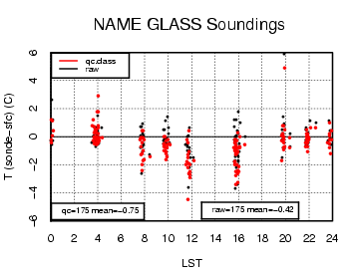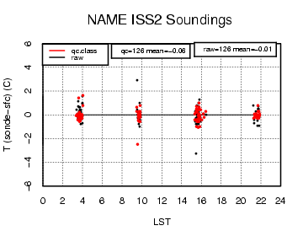
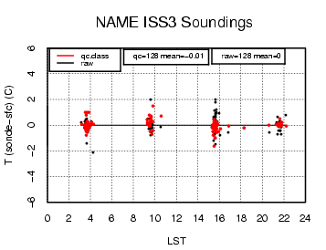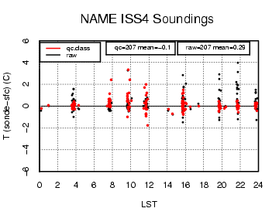
Figure 2 – Scatter plots of temperature differences (ºC) between sonde and surface for both the quality controlled and raw datasets.

7.0 References

Loehrer, S. M., T. A. Edmands, and J. A. Moore, 1996: TOGA COARE upper-air sounding data archive: development and quality control procedures. Bull. Amer. Meteor. Soc., 77, 2651-2671.

Loehrer, S. M., S. F. Williams, and J. A. Moore, 1998: Results from UCAR/JOSS quality control of atmospheric soundings from field projects. Preprints, Tenth Symposium on Meteorological Observations and Instrumentation, Phoenix, AZ, Amer. Meteor. Soc., 1-6.

