Terrain Induced Rotor Experiment 2006 (T-REX)
Quality Controlled ISS GAUS Radiosonde Data Set

1.0 ISS GAUS Dataset Overview

The Terrain Induced Rotor Experiment (T-REX) was conducted during March and April 2006, during which time 102 radiosondes were launched using a fix sounding system located near Independence, California (Figure 1). TREX is the second phase of a coordinated effort to explore the structure and evolution of atmospheric rotors, which typically occur parallel to, and downstream from, mountain ridge crests. The first phase was a project conducted in 2004 called the Sierra Rotors Project. Both phases included upwind radiosonde launches, from the California Central Valley, used to help predict the onset of events likely to produce rotors on the lee side of the Sierra Nevada Mountain Range. Soundings were also launched in the Owens Valley from an Integrated Sounding System (ISS). These and many other instruments were deployed in order to capture the vertical structure of the atmosphere in the valley over a two month period. For more information on the TREX project, please visit: http://www.atd.ucar.edu/projects/trex/

The new EOL GPS Advanced Upper-air Sounding System (GAUS) was developed to replace the GPS LORAN Atmospheric Sounding System (GLASS). GAUS incorporates Vaisala RS92 next generation radiosondes, has portability, built-in test capability and flexibility for multiple channel operations, and delivers users high precision GPS measurements of radiosonde positions. The Vaisala RS92 radiosonde delivers high quality wind measurements from the ground with code-correlating GPS technology, as well as pressure, temperature and humidity measurements all transmitted digitally to the receiving station. Digital technology will reduce missing data due to noise and increase overall reliability of the system. The Vaisala RS92 provides much better humidity measurements with a heated twin-sensor design and incorporates a new reconditioning procedure before launch.

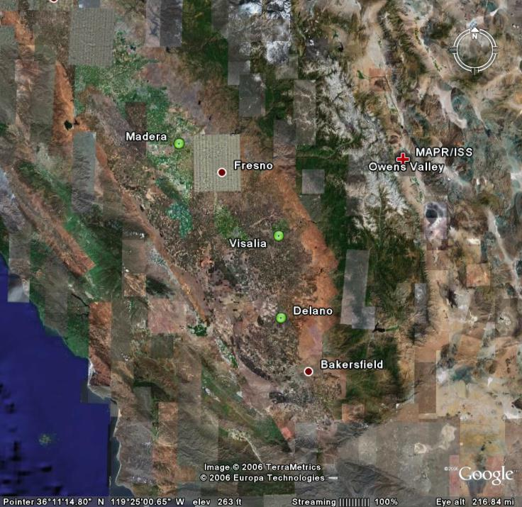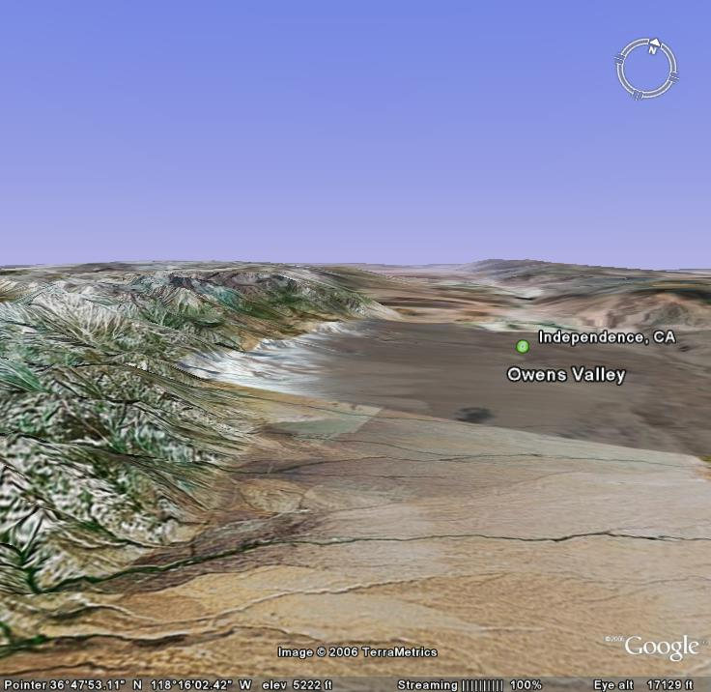

Figure 1 Map of radiosonde launch locations (left). Red cross indicates location of the ISS/MAPR site in Owens Valley. Green circles show where upwind radiosondes were launched. Map on the right shows topography of Owens Valley, near Independence CA. Rotors tend to generate as winds pass over Sierra Nevada Mountain range on the left.

1.1 Contacts

Contacts: Data Quality
June Wang
junhong@ucar.edu

Kate Young
kbeierle@ucar.edu

System/Software
Bill Brown
wbrown@ucar.edu

Mailing Address: NCAR/Earth Observing Laboratory
P.O. Box 3000
1850 Table Mesa Drive
Boulder, CO 80307; USA

For more information on the NCAR Earth Observing Laboratory GAUS System (formally GLASS) please visit the following site: http://www.eol.ucar.edu/facilities/gaus.html

2.0 NCAR/EOL Detailed Data Description

2.1 Detailed Format Description

All upper air soundings were converted to National Center for Atmospheric Research/Earth Observing Laboratory (NCAR/EOL) Sounding Composite Format (ESC). ESC is a version of the National Center for Atmospheric Research (NCAR) CLASS format and is an ASCII format consisting of 15 header records for each sounding followed by the data records with associated QC information.

Header Records

The header records (15 total records) contain data type, project ID, site ID, site location, release time, sonde type, meteorological and wind data processors, and the operator's name and comments. The first five header lines contain information identifying the sounding, and have a rigidly defined form. The following 7 header lines are used for auxiliary information and comments about the sounding, and may vary from dataset to dataset. The last 3 header records contain header information for the data columns. Line 13 holds the field names, line 14 the field units, and line 15 contains dashes ('-' characters) delineating the extent of the field.

The five standard header lines are as follows:

Line Label (Padded to 35 chars) | Contents
1 Data Type: | Description of type and resolution of data.
2 Project ID: | ID of weather project.
3 Release Site Type/Site ID: | Description of release site.
4 Release Location (lon,lat,alt): | Position of release site, in format described below.
5 UTC Release Time (y,m,d,h,m,s): | Time of release, in format: yyyy, mm, dd, hh:mm:ss

The release location is given as: lon (deg min), lat (deg min), lon (dec. deg), lat (dec. deg), alt (m)

Longitude in deg min is in the format: ddd mm.mm'W where ddd is the number of degrees from True North (with leading zeros if necessary), mm.mm is the decimal number of minutes, and W represents W or E for west or east longitude, respectively. Latitude has the same format as longitude, except there are only two digits for degrees and N or S for north/south latitude. The decimal equivalent of longitude and latitude and station elevation follow.

The seven non-standard header lines may contain any label and contents. The labels are padded to 35 characters to match the standard header lines. Records for this dataset include the following three non-standard header lines.

Line Label (Padded to 35 chars) | Contents
6 Post Processing Comments: | Comments about NCAR/EOL post processing
7 Reference Launch Data Source/Time:
8 Sonde Id/Sonde Type: | Information on the Radiosonde used
9 System Operator/Comments: | Comments provided by site operators.
12 Nominal Release Time (y,m,d,h,m,s): | Nominal time of release, in format: yyyy, mm, dd, hh:mm:ss

Data Records

The data records each contain time from release, pressure, temperature, dew point, relative humidity, U and V wind components, wind speed and direction, ascent rate, balloon position data, altitude, and quality control flags (see the QC code description). Each data line contains 21 fields, separated by spaces, with a total width of 130 characters. The data are right-justified within the fields. All fields have one decimal place of precision, with the exception of latitude and longitude, which have three decimal places of precision. The contents and sizes of the 21 fields that appear in each data record are as follows:

Field No. | Format Width | Parameter | Units Value | Missing
1 | 6 F6.1 | Time | Seconds | 9999.0
2 | 6 F6.1 | Pressure | Millibars | 9999.0
3 | 5 F5.1 | Dry-bulb Temperature | Degrees C | 999.0
4 | 5 F5.1 | Dew Point Temperature | Degrees C | 999.0
5 | 5 F5.1 | Relative Humidity | Percent | 999.0
6 | 6 F6.1 | U Wind Component | Meters / Second | 9999.0
7 | 6 F6.1 | V Wind Component | Meters / Second | 9999.0
8 | 5 F5.1 | Wind Speed | Meters / Second | 999.0
9 | 5 F5.1 | Wind Direction | Degrees | 999.0
10 | 5 F5.1 | Ascent Rate | Meters / Second | 999.0
11 | 8 F8.3 | Longitude | Degrees | 9999.0
12 | 7 F7.3 | Latitude | Degrees | 999.0
13 | 5 F5.1 | Range | Kilometers | 999.0
14 | 5 F5.1 | Angle | Degrees | 999.0
15 | 7 F7.1 | Altitude | Meters | 99999.0
16 | 4 F4.1 | QC for Pressure | Code (see below) | 99.0
17 | 4 F4.1 | QC for Temperature | Code (see below) | 99.0
18 | 4 F4.1 | QC for Humidity | Code (see below) | 99.0
19 | 4 F4.1 | QC for U Component | Code (see below) | 99.0
20 | 4 F4.1 | QC for V Component | Code (see below) | 99.0
21 | 4 F4.1 | QC for Ascension Rate | Code (see below) | 99.0

Fields 16 through 21 contain the Quality Control information derived at the NCAR Earth Observing Laboratory (NCAR/EOL). Any QC information from the original sounding is replaced by the following NCAR/EOL codes:

Code | Description
99.0 | Unchecked (QC information is “missing”) (“UNCHECKED”)
1.0 | Checked, datum seems physically reasonable. (“GOOD”)
2.0 | Checked, datum seems questionable on physical basis. (“MAYBE”)
3.0 | Checked, datum seems to be in error. (“BAD”)
4.0 | Checked, datum is interpolated. (“ESTIMATED”)
9.0 | Checked, datum was missing in original file. (“MISSING”)

Sample Data

The following is a sample record of T-REX Sounding Rawinsonde ISS upper air data in NCAR/EOL CLASS format. The data portion is much longer than the page width and, therefore, wraps around to a second line. See section 2.1 for an exact format specification

Data Type: NCAR ISS
Project ID: T-REX
Release Site Type/Site ID: IOP 1
Release Location (lon,lat,alt): 118 10.68'W, 36 47.28'N, -118.178, 36.788, 1196.6
UTC Release Time (y,m,d,h,m,s): 2006, 03, 02, 02:13:08
Post Processing Comments: Aspen Version
Reference Launch Data Source/Time: Manual Entry/02:05:01.06
Sonde Id/Sonde Type: 054530647/Vaisala RS92-SGP (ccGPS)
System Operator/Comments: Bill & Flea & Barbara/Surface station data entered manually, Good Sounding
/
/
Nominal Release Time (y,m,d,h,m,s): 2006, 03, 02, 02:13:08
Time Press Temp Dewpt RH Ucmp Vcmp spd dir Wcmp Lon Lat Ele Azi Alt Qp Qt Qrh Qu Qv QdZ
sec mb C C % m/s m/s m/s deg m/s deg deg deg deg m code code code code code code
------ ------ ----- ----- ----- ------ ------ ----- ----- ----- -------- ------- ----- ----- ------- ---- ---- ---- ---- ---- ----
-1.0 879.9 10.0 -4.3 36.0 -1.4 3.4 3.7 157.0 999.0 -118.178 36.788 999.0 999.0 1196.6 99.0 99.0 99.0 99.0 99.0 9.0
0.0 9999.0 999.0 999.0 40.5 0.2 2.8 2.8 183.6 999.0 -118.178 36.788 999.0 999.0 99999.0 9.0 9.0 99.0 99.0 99.0 9.0
1.0 9999.0 9.1 -3.3 41.4 0.1 3.4 3.4 182.4 999.0 -118.178 36.788 999.0 999.0 99999.0 9.0 99.0 99.0 99.0 99.0 9.0
2.0 879.6 999.0 999.0 41.3 0.1 3.9 3.9 181.4 2.4 -118.178 36.788 999.0 999.0 1199.3 99.0 9.0 99.0 99.0 99.0 99.0
3.0 879.2 999.0 999.0 40.6 0.1 4.4 4.4 180.6 3.1 -118.178 36.788 999.0 999.0 1203.1 99.0 9.0 99.0 99.0 99.0 99.0
4.0 878.8 9.7 -3.3 39.7 -0.0 4.9 4.9 179.8 3.7 -118.178 36.788 999.0 999.0 1206.9 99.0 99.0 99.0 99.0 99.0 99.0

2.2 Data Remarks

2.3 Station List

ID | SITE | STATE | LONG | LAT | ELEV (m)
ISS | ISS | CA | -118.178 | 36.788 | 1196.6
ISS | ISS | CA | -118.178 | 36.788 | 1197.0

3.0 NCAR/EOL Quality Control Processing

This dataset underwent an automated QC process. The dataset underwent internal consistency checks which included two types of checks, gross limit checks on all parameters and rate-of-change checks on temperature, pressure and ascension rate. Some further information on the QC processing conducted by NCAR/EOL can be found in Loehrer et al. (1996) and Loehrer et al. (1998).

3.1 Gross Limit Checks

These checks were conducted on each sounding and data were automatically flagged as appropriate. Only the data point under examination was flagged. NCAR/EOL conducted the following gross limit checks on the T-REX ISS sounding datasets. In the table P = pressure, T = temperature, RH = relative humidity, U = U wind component, V = V wind component, B = bad, and Q = questionable.

Parameter | Parameters(s)  Gross Limit Check | Flag  Flagged | Applied
Pressure | < 0 mb or > 1050 mb | P | B
Altitude | < 0 m or > 40000 m | P, T, RH | Q
Temperature | < -90C or > 45C | T | Q
Dew Point | < -99.9C or > 33C  > Temperature | RH  T,RH | Q  Q
Relative Humidity | < 0% or > 100% | RH | B
Wind Speed | < 0 m/s or > 100 m/s  > 150 m/s | U,V  U,V | Q  B
U Wind Component | < 0 m/s or > 100 m/s  > 150 m/s | U  U | Q  B
V Wind Component | < 0 m/s or > 100 m/s  > 150 m/s | V  V | Q  B
Wind Direction | < 0 deg or > 360 deg | U,V | B
Ascent Rate | < -10 m/s or > 10 m/s | P,T,RH | Q

3.2 Vertical Consistency Checks

These checks were conducted on each sounding and data were automatically flagged as appropriate. These checks were started at the lowest level of the sounding and compared neighboring data points (except at pressures less than 100 mb where 30-sec average values were used. In the case of checks ensuring that the values increased/decreased as expected, only the data point under examination was flagged. However, for the other checks, all of the data points used in the examination were flagged. All items within the table are as previously defined.

Parameter | Vertical Consistency Check | Parameter(s)  Flagged | Flag  Applied
Time | decreasing/equal | None | None
Altitude | decreasing/equal | P,T,RH | Q
Pressure | increasing/equal  > 1 mb/s or < -1 mb/s  > 2 mb/s or < -2 mb/s | P,T,RH  P,T,RH  P,T,RH | Q  Q  B
Temperature | < -15 C/km  < -30 C/km (not applied at p < 250 mb)  > 50 C/km (not applied at p < 250 mb)  > 100 C/km (not applied at p < 250 mb) | P,T,RH  P,T,RH  P,T,RH  P,T,RH | Q  B  Q  B
Ascent Rate | Change of > 3 m/s or < -3 m/s  Change of > 5 m/s or < -5 m/s | P  P | Q  B

3.3 Data Quality Issues

4.0 NCAR/EOL Data File Specifics

The files contain data calculated at one-second intervals. The variables pressure, temperature, and relative humidity are calibrated values from measurements made by the radiosonde. The dew point is calculated from the relative humidity. The geopotential altitude is calculated from the hydrostatic equation using pressure, temperature, and relative humidity. The rate of ascent is calculated but the position (lat, lon, GPSAlt) comes directly from the GPS sensor. All wind data are computed from GPS navigation signals received from the radiosonde. The GPS measured altitude (GPSAlt) is not quality-controlled and may contain some erroneous data points. Therefore, we recommend the users to use the geopotential altitude (GeoPoAlt). The raw wind values are calculated at a one second data rate by a commercial processing card. When run through ASPEN, the raw values are subjected to a digital filter to remove low frequency oscillations due to the sonde pendulum motion beneath the balloon.

5.0 NCAR/EOL Data Quality Control and Important Note for Users

The following QC procedures were made to T-REX ISS GAUS data.
1. Temperature and vertical velocity profiles of raw soundings were first examined to determine if the radiosondes had encountered vertical downdrafts strong enough to result in altitude loss (Figures 2 and 3). This was done because EOL’s post processing software can only handle either ascending or descending data, but not both, and will throw away any data collected if the radiosonde descends.
2. Scatter plots (Figures 4) of the raw data were then created to check differences in pressure, temperature and RH between the surface met data and the last available surface radiosonde measurement before launch.
3. All of the soundings were then subjected to a radiation correction that takes into account the solar angle at launch time, and removes solar heating that could skew the temperature measurements.
4. The soundings that did not encounter strong vertical downdrafts were run through the Atmospheric Sounding Processing ENvironment (ASPEN) software, which analyzes the data, performs smoothing, and removes suspect data points.
5. The remaining soundings were manually converted into the EOL format to avoid any loss of the vertical structure, the pressure was smoothed and dewpoint, dz/dt and geopotential height were calculated.
6. Lastly, profiles were created of temperature, RH, wind speed and wind direction from the QC data files. The profiles enable us to visually evaluate the soundings for outliers, or any other obvious problems.

Performing the QC steps above allows us to identify and, in some cases, correct errors that could potentially impact research performed using these data sets. Below are some important things to note about TREX data from the ISS GAUS system:

- There were 16 soundings that contained evidence of strong vertical downdrafts that resulted in brief loss of altitude. These files were manually QCed rather than being processed through ASPEN in order to retain those features.
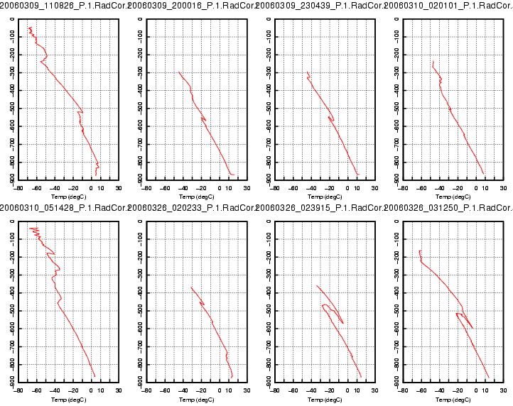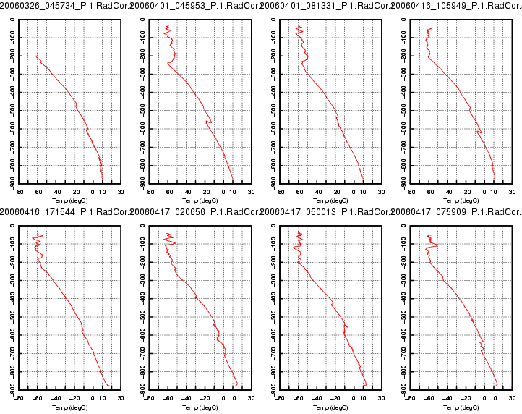
Figure 2. Temperature profiles (ºC) show brief descent of radiosondes caused by strong vertical downdrafts

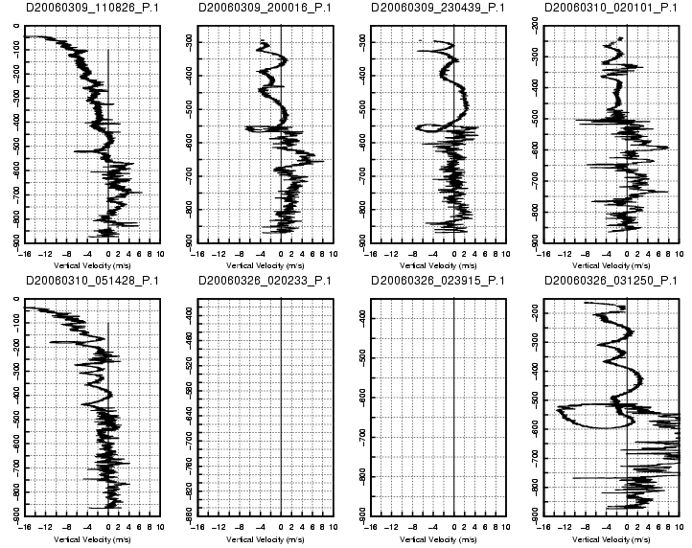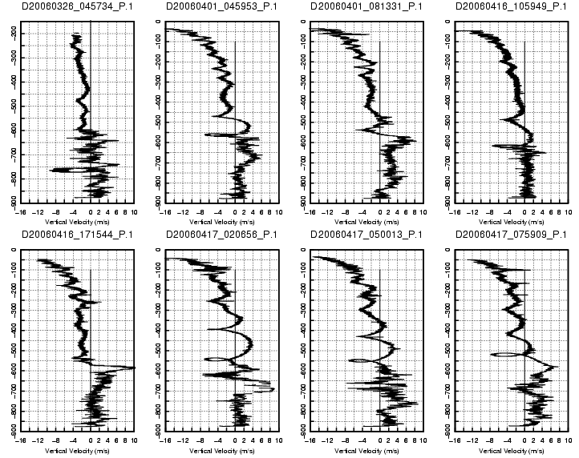
No GPS Data
No GPS Data

Figure 3. Profiles of calculated vertical velocity from raw sounding, show vertical downdrafts strong enough to force radiosonde downward.

2. Pressure differences between the surface met sensor and the last radiosonde surface measurement before launch can be seen in Figure 4 in the bottom left-hand corner circled in red. The reason for the difference was that the radiosondes were launched from a depression and the surface met sensor was positioned on a ridge approximately 10 m above the launch site. The location for the surface met tower was chosen in hopes of obtaining more precise measurements of the area. This was a problem during post-processing because ASPEN takes the surface met measurement as “truth” so any pressure values measuring greater than that will be thrown out. As a result, there were portions of radiosonde data near the surface that were removed In order to correct this, 1.5 mb were added to each of surface pressure values in the sounding files before they were run through ASPEN. New pressure differences, between the sonde and surface met, after the correction can be seen in right-hand plot below.

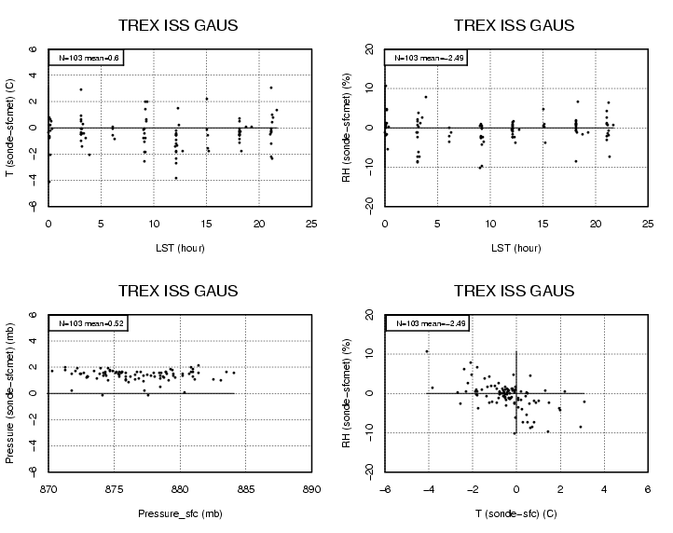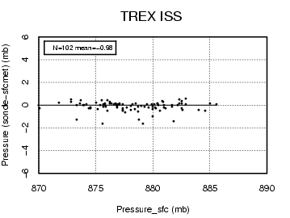

Figure 4. Left-hand plots show difference between surface met sensor measurements and last surface radiosonde measurement before launch. Left upper-most plot shows slightly warmer surface met measurements than radiosonde. Red circle on lower left-hand plot shows differences of approximately 1.5-2 mb caused by positioning instruments at different altitudes. Right-hand plot shows improvement in pressure difference after 1.5 mb is added to each surface met pressure measurement.

3 The RS-92 radiosondes are equipped with two hygrometers that measure alternately during the ascent of the radiosonde. These measurements are then merged into one profile contained in the RH column of the sounding file. By examining the relative humidity profiles (Figure 5), it was determined that one of two hygrometers for two soundings failed or malfunctioned during flight. These failures resulted in one sonde measuring intermittently during the flight (left), and the other measuring incorrectly (right).
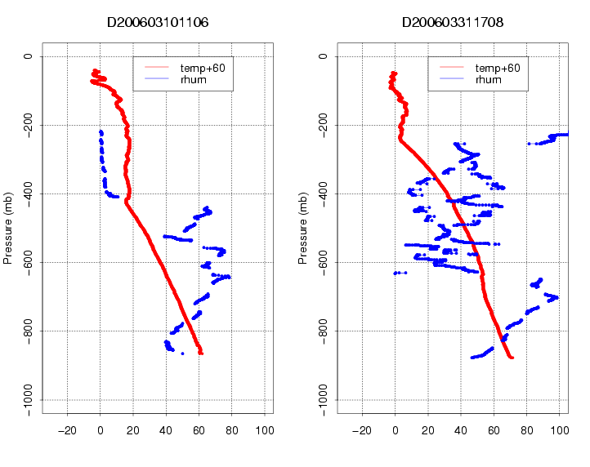

Figure 5. Profiles of relative humidity (blue) show complete failure of one hygrometer on the left, and incorrect humidity measurement from another hygrometer on the right. Temperature profiles (red) are also shown.

