Terrain Induced Rotor Experiment 2006 (T-REX)
Quality Controlled ISS GAUS Radiosonde Data Set

Contents:
I. GAUS Data Set Overview
II. File Naming Conventions
III. **NEW** EOL Sounding File Format
IV. Data File Specifics
V. Data Quality Control and Important Information for Users

Contacts: Data Quality
June Wang
junhong@ucar.edu

Kate Young
kbeierle@ucar.edu

System/Software
Bill Brown
wbrown@ucar.edu

Mailing Address: NCAR/Earth Observing Laboratory
P.O. Box 3000
1850 Table Mesa Drive
Boulder, CO 80307; USA

For more information on the NCAR Earth Observing Laboratory GAUS System (formally GLASS) please visit the following site:
http://www.eol.ucar.edu/facilities/gaus.html

I. TREX ISS GAUS Dataset Overview

The Terrain Induced Rotor Experiment (T-REX) was conducted during March and April 2006, during which time 102 radiosondes were launched using a fix sounding system located near Independence, California (Figure 1). TREX is the second phase of a coordinated effort to explore the structure and evolution of atmospheric rotors, which typically occur parallel to, and downstream from, mountain ridge crests. The first phase was a project conducted in 2004 called the Sierra Rotors Project. Both phases included upwind radiosonde launches, from the California Central Valley, used to help predict the onset of events likely to produce rotors on the lee side of the Sierra Nevada Mountain Range. Soundings were also launched in the Owens Valley from an Integrated Sounding System (ISS). These and many other instruments were deployed in order to capture the vertical structure of the atmosphere in the valley over a two month period. For more information on the TREX project, please visit: http://www.atd.ucar.edu/projects/trex/

The new EOL GPS Advanced Upper-air Sounding System (GAUS) was developed to replace the GPS LORAN Atmospheric Sounding System (GLASS). GAUS incorporates Vaisala RS92 next generation radiosondes, has portability, built-in test capability and flexibility for multiple channel operations, and delivers users high precision GPS measurements of radiosonde positions. The Vaisala RS92 radiosonde delivers high quality wind measurements from the ground with code-correlating GPS technology, as well as pressure, temperature and humidity measurements all transmitted digitally to the receiving station. Digital technology will reduce missing data due to noise and increase overall reliability of the system. The Vaisala RS92 provides much better humidity measurements with a heated twin-sensor design and incorporates a new reconditioning procedure before launch.

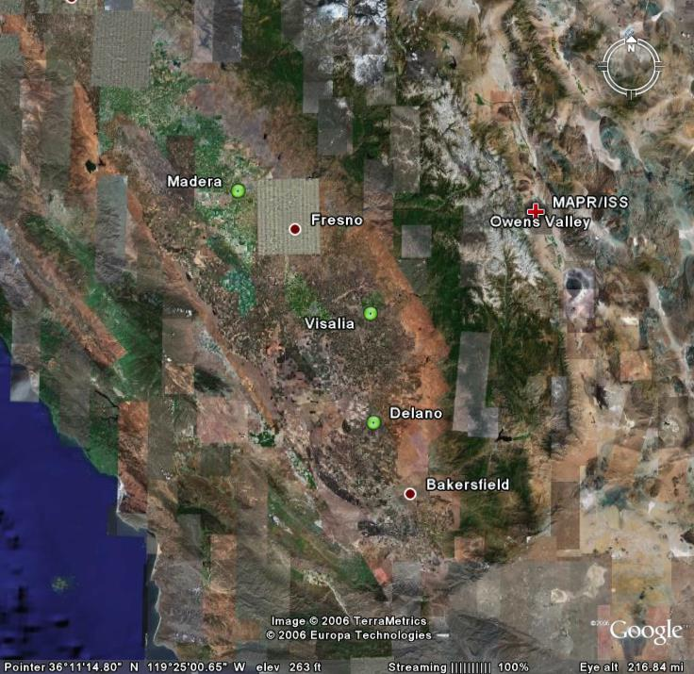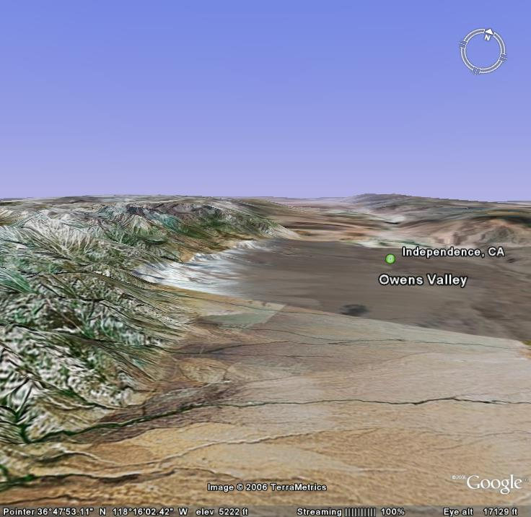

Figure 1 Map of radiosonde launch locations (left). Red cross indicates location of the ISS/MAPR site in Owens Valley. Green circles show where upwind radiosondes were launched. Map on the right shows topography of Owens Valley, near Independence CA. Rotors tend to generate as winds pass over Sierra Nevada Mountain range on the left.

II File Naming Conventions

The "D" files are one second, ascii format data files with appropriate corrections and quality control measures applied. The naming convention for these files is - "D", followed by "yyyymmdd_hhmmss_P.1QC.eol" where yyyy = year, mm = month, hh = hour of the day UTC, mm = minute of the hour, ss = second of the hour and “.eol” refers to the file format type.

III. ***New EOL File Format***

EOL has introduced a new ascii “EOL file format” for all radiosonde and dropsonde sounding files. This new file format is similar to the CLASS format, used in the past, but has been improved to include a revised header with more detailed sounding information, addition of UTC time, an increase in accuracy of the longitude and latitude to six decimal places, and GPS altitude is now also provided in addition to geopotential altitude. See below for an example of the EOF file format. The definition of each parameter is listed in the table below.

The header records now consist of 14 lines which contain information such as data type, project name, site location, actual release time, and other specialized information. The first seven header lines contain information identifying the sounding. The following three header lines contain information about the surface met station used and auxiliary information and comments about the sounding. The last 3 header lines contain header information for the data columns. Line 12 holds the field names, line 13 the field units, and line 14 contains dashes (--- characters) signifying the end of the header.

The release location is given as : lon (deg min), lon (dec. deg), lat (deg min), lat (dec. deg), altitude (meters). Longitude in deg min is in the format: ddd mm.mm'W where ddd is the number of degrees from True North (with leading zeros if necessary), mm.mm is the decimal number of minutes, and W represents W or E for west or east longitude, respectively. Latitude has the same format as longitude, except there are only two digits for degrees and N or S for north/south latitude.

Data Type/Direction: GAUS/Ascending
File Format/Version: EOL Sounding Format/1.0
Project Name/Platform: T-REX/NCAR GAUS
Launch Site: IOP01 08z
Launch Location (lon,lat,alt): 119 20.88'W -119.347997, 36 19.74'N 36.328918, 90.98
UTC Launch Time (y,m,d,h,m,s): 2006, 03, 02, 08:33:34
Sonde Id/Sonde Type: 043937408/Vaisala RS92-SGP (ccGPS)
Reference Launch Data Source/Time: Vaisala WXT510/08:33:32.80
System Operator/Comments: Vic/Tim, Good Sounding
Post Processing Comments: Aspen Version
/
Time -- UTC -- Press Temp Dewpt RH Uwind Vwind Wspd Dir dZ GeoPoAlt Lon Lat GPSAlt
sec hh mm ss mb C C % m/s m/s m/s deg m/s m deg deg m
---- -- -- ----- ------- ------- ------- ------- ------- ------- ------- ------- ------- -------- ----------- ----------- --------
-1.0 8 33 33.00 1008.00 7.40 2.96 73.30 0.12 -0.16 0.20 323.00 -999.00 90.98 -119.347997 36.328918 91.00
0.0 8 33 34.00 -999.00 7.78 3.39 73.65 -1.77 -0.08 1.77 87.26 -999.00 -999.00 -119.348006 36.328917 70.52
1.0 8 33 35.00 1007.98 8.03 3.59 73.37 -1.86 -0.07 1.86 87.85 2.99 91.16 -119.348026 36.328916 72.53
2.0 8 33 36.00 1007.45 8.29 3.72 72.81 -1.94 -0.06 1.95 88.32 4.27 95.47 -119.348048 36.328916 79.10
3.0 8 33 37.00 1006.76 8.53 3.79 71.95 -2.01 -0.05 2.01 88.70 5.36 101.16 -119.348070 36.328915 85.54

No.
1 Time Seconds ------------
2 Hour Hours ------------
3 UTC Minute Minutes ------------
4 UTC Second Seconds -----------
5 Pressure Millibars -999.00
6 Dry-bulb Temp Degrees C -999.00
7 Dewpoint Temp Degrees C -999.00
8 Relative Humidity Percent -999.00
9 U Wind Component Meters/Second -999.00
10 V Wind Component Meters/Second -999.00
11 Wind Speed Meters/Second -999.00
12 Wind Direction Degrees -999.00
13 Ascension Rate Meters/Second -999.00
14 Geopotential Altitude Meters -999.00
15 Longitude Degrees -999.00
16 Latitude Degrees -999.00
17 GPS Altitude Meters -999.00

V. Data File Specifics

The files contain data calculated at one-second intervals. The variables pressure, temperature, and relative humidity are calibrated values from measurements made by the radiosonde. The dew point is calculated from the relative humidity. The geopotential altitude is calculated from the hydrostatic equation using pressure, temperature, and relative humidity. The rate of ascent is calculated but the position (lat, lon, GPSAlt) comes directly from the GPS sensor. All wind data are computed from GPS navigation signals received from the radiosonde. The GPS measured altitude (GPSAlt) is not quality-controlled and may contain some erroneous data points. Therefore, we recommend the users to use the geopotential altitude (GeoPoAlt). The raw wind values are calculated at a one second data rate by a commercial processing card. When run through ASPEN, the raw values are subjected to a digital filter to remove low frequency oscillations due to the sonde pendulum motion beneath the balloon.

VI. Data Quality Control and Important Information for Users

The following QC procedures were made to T-REX ISS GAUS data.
1. Temperature and vertical velocity profiles of raw soundings were first examined to determine if the radiosondes had encountered vertical downdrafts strong enough to result in altitude loss (Figures 2 and 3). This was done because EOL’s post processing software can only handle either ascending or descending data, but not both, and will throw away any data collected if the radiosonde descends.
2. Scatter plots (Figures 4) of the raw data were then created to check differences in pressure, temperature and RH between the surface met data and the last available surface radiosonde measurement before launch.
3. All of the soundings were then subjected to a radiation correction that takes into account the solar angle at launch time, and removes solar heating that could skew the temperature measurements.
4. The soundings that did not encounter strong vertical downdrafts were run through the Atmospheric Sounding Processing ENvironment (ASPEN) software, which analyzes the data, performs smoothing, and removes suspect data points.
5. The remaining soundings were manually converted into the EOL format to avoid any loss of the vertical structure, the pressure was smoothed and dewpoint, dz/dt and geopotential height were calculated.
6. Lastly, profiles were created of temperature, RH, wind speed and wind direction from the QC data files. The profiles enable us to visually evaluate the soundings for outliers, or any other obvious problems.

Performing the QC steps above allows us to identify and, in some cases, correct errors that could potentially impact research performed using these data sets. Below are some important things to note about TREX data from the ISS GAUS system:

- There were 16 soundings that contained evidence of strong vertical downdrafts that resulted in brief loss of altitude. These files were manually QCed rather than being processed through ASPEN in order to retain those features.
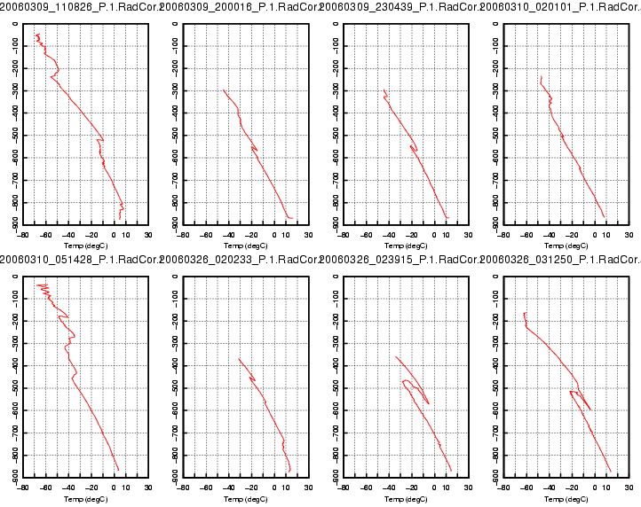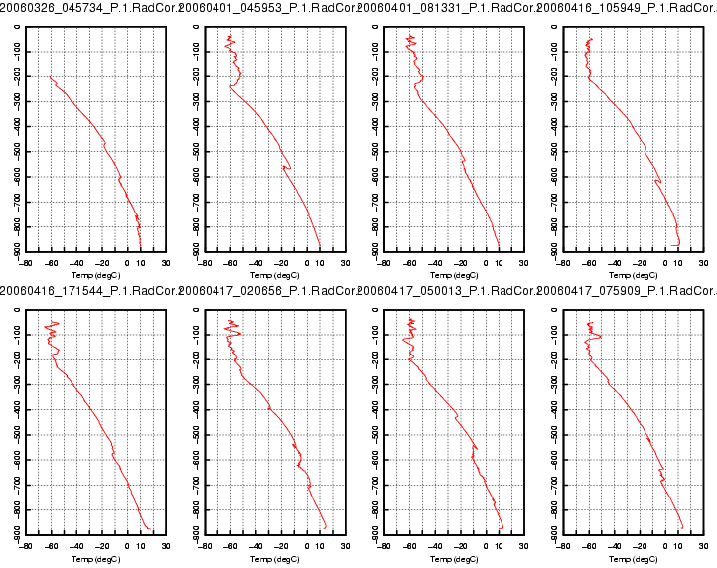
Figure 2. Temperature profiles (ºC) show brief descent of radiosondes caused by strong vertical downdrafts

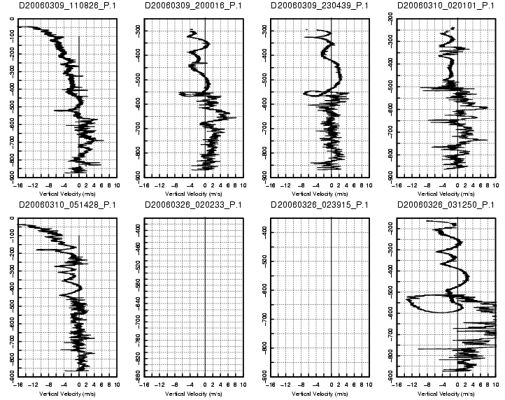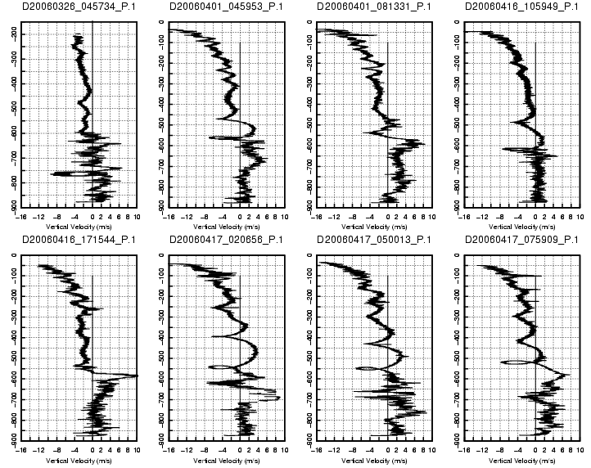
No GPS Data
No GPS Data

Figure 3. Profiles of calculated vertical velocity from raw sounding, show vertical downdrafts strong enough to force radiosonde downward.

2. Pressure differences between the surface met sensor and the last radiosonde surface measurement before launch can be seen in Figure 4 in the bottom left-hand corner circled in red. The reason for the difference was that the radiosondes were launched from a depression and the surface met sensor was positioned on a ridge approximately 10 m above the launch site. The location for the surface met tower was chosen in hopes of obtaining more precise measurements of the area. This was a problem during post-processing because ASPEN takes the surface met measurement as “truth” so any pressure values measuring greater than that will be thrown out. As a result, there were portions of radiosonde data near the surface that were removed In order to correct this, 1.5 mb were added to each of surface pressure values in the sounding files before they were run through ASPEN. New pressure differences, between the sonde and surface met, after the correction can be seen in right-hand plot below.

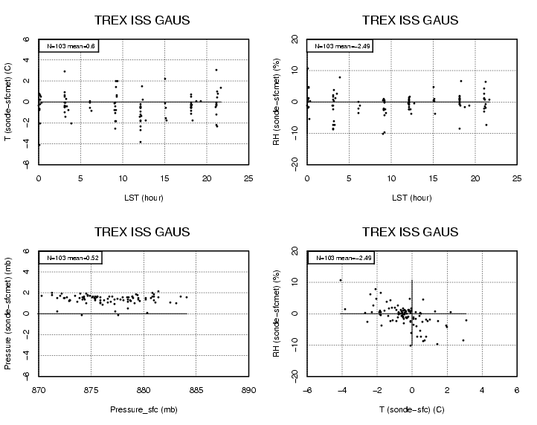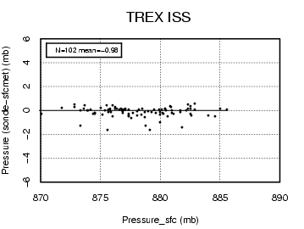

Figure 4. Left-hand plots show difference between surface met sensor measurements and last surface radiosonde measurement before launch. Left upper-most plot shows slightly warmer surface met measurements than radiosonde. Red circle on lower left-hand plot shows differences of approximately 1.5-2 mb caused by positioning instruments at different altitudes. Right-hand plot shows improvement in pressure difference after 1.5 mb is added to each surface met pressure measurement.

3 The RS-92 radiosondes are equipped with two hygrometers that measure alternately during the ascent of the radiosonde. These measurements are then merged into one profile contained in the RH column of the sounding file. By examining the relative humidity profiles (Figure 5), it was determined that one of two hygrometers for two soundings failed or malfunctioned during flight. These failures resulted in one sonde measuring intermittently during the flight (left), and the other measuring incorrectly (right).
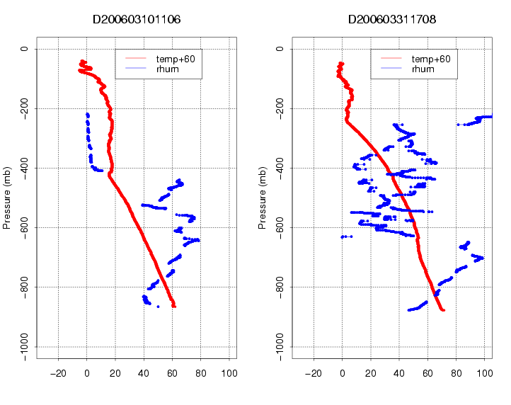

Figure 5. Profiles of relative humidity (blue) show complete failure of one hygrometer on the left, and incorrect humidity measurement from another hygrometer on the right. Temperature profiles (red) are also shown.

