METEOROLOGICAL DATA REPORT

NAME CRUISES I & II
B/O FRANCISCO DE ULLOA

- NAME CRUISE I: 4 – 21 June, 2004

- Continuous measurements (1 second interval) from a weather station mounted on the ship's upper deck.

Ship's track as recorded in the weather station's GPS data.
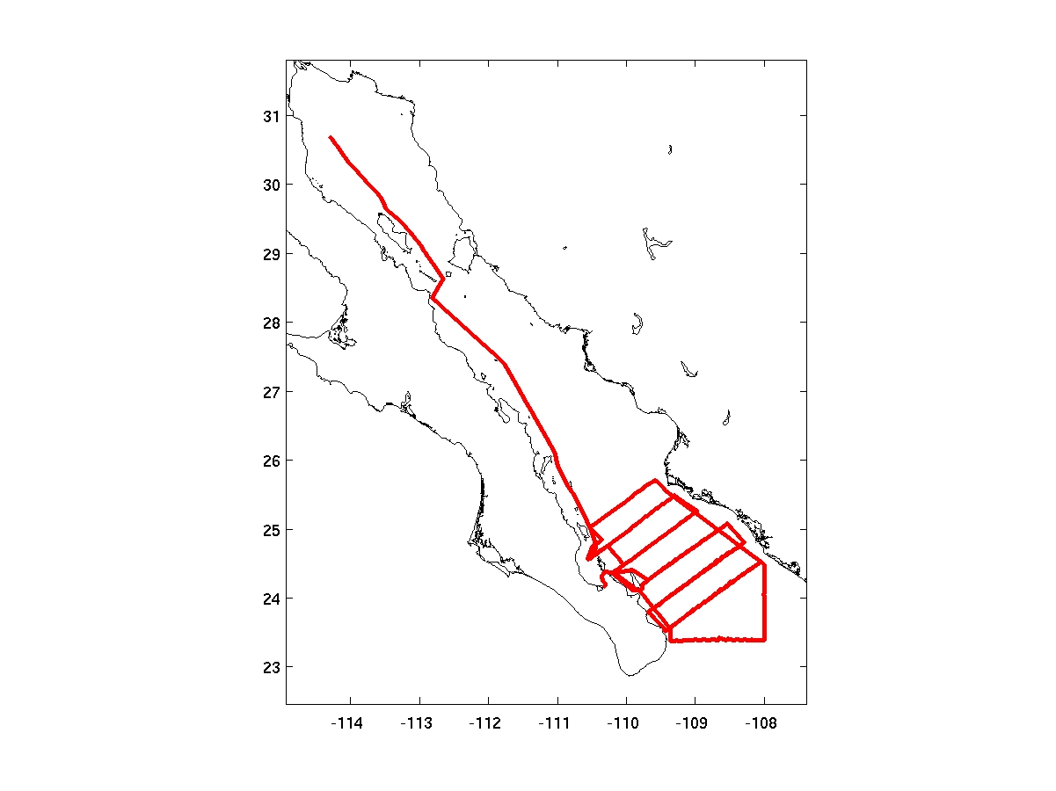
NAME CRUISE I, 4 – 21 June, 2004

The weather station recorded the following variables:

GPS Time
GPS Latitude (deg, min, sec)
GPS Longitude (deg, min, sec)
GPS Magnetic Declination
GPS Speed over ground (SOG)
GPS Course over ground (COG)
Ship heading relative to Magnetic North from Climatronics Compass
Raw sonic anemometer wind speed
Raw sonic anemometer wind direction
True wind speed (estimated)
True wind direction (estimated)
Aspirated air temperature
Aspirated relative humidity
Pressure less 1000 hPa
Battery voltage

- Radiosonde soundings, with and without wind profiles:

Radiosonde locations, indicating which soundings have wind data.
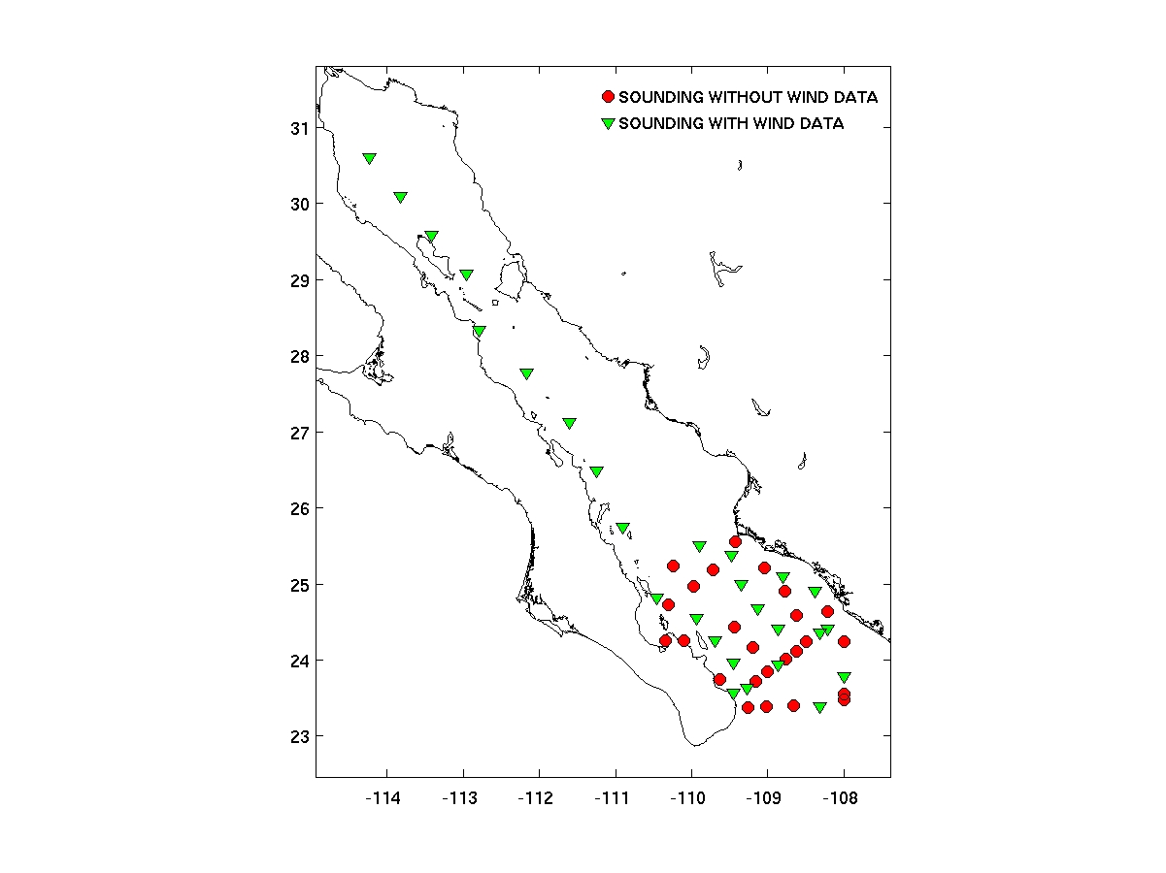
NAME CRUISE I, 4 – 21 June, 2004

All the radiosonde soundings recorded the following variables:
Elapsed time since beginning of sounding
Ascent rate
Height over Mean Sea Level
Pressure
Air Temperature
Relative Humidity
Dew Point Temperature

Additionally, some soundings recorded:
Wind Direction
Wind Speed

- NAME CRUISE II: 6 - 22 August, 2004

- Continuous measurements (1 second interval) from a weather station mounted on the ship's upper deck.

Ship's track as recorded in the weather station's GPS data.
NAME CRUISE II, 6 – 22 August, 2004
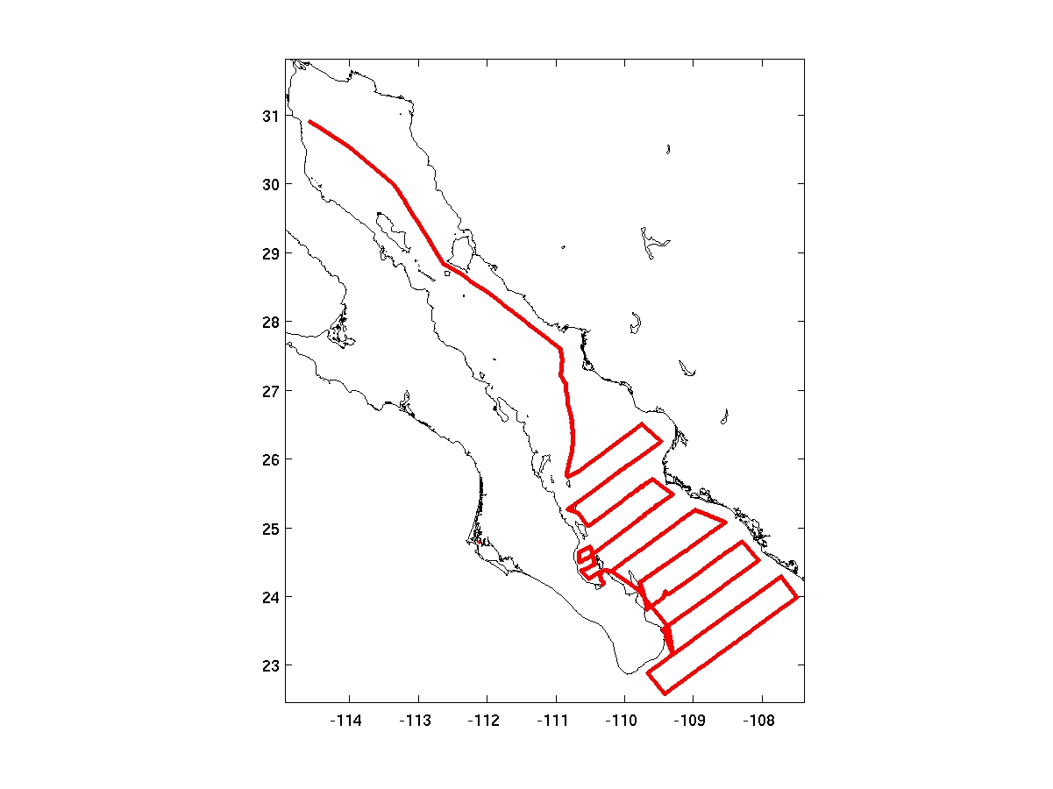
The weather station recorded the following variables:

GPS Time
GPS Latitude (deg, min, sec)
GPS Longitude (deg, min, sec)
GPS Magnetic Declination
GPS Speed over ground (SOG)
GPS Course over ground (COG)
Ship heading relative to Magnetic North from Climatronics Compass
Raw sonic anemometer wind speed
Raw sonic anemometer wind direction
True wind speed (estimated)
True wind direction (estimated)
Aspirated air temperature
Aspirated relative humidity
Pressure less 1000 hPa
Battery voltage

- Radiosonde and Tetherson soundings, with and without wind profiles:

Radiosonde locations, indicating which soundings have wind data.
NAME CRUISE II, 6 – 22 August, 2004
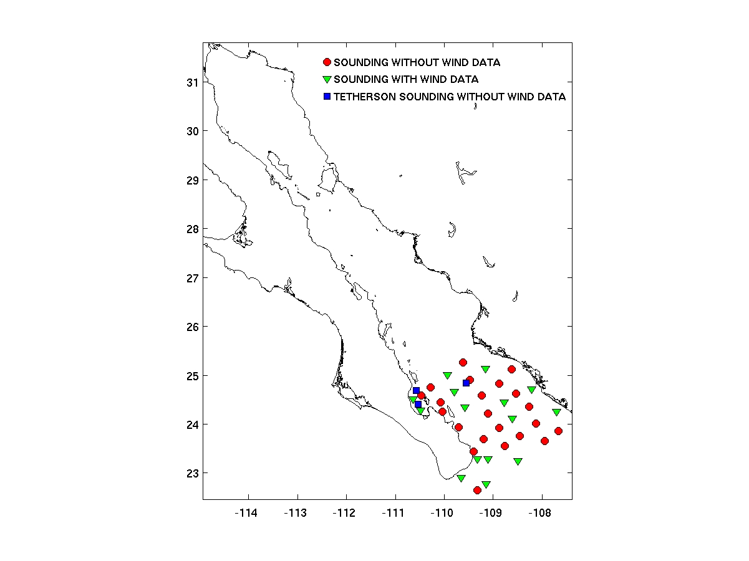

All the radiosonde and tetherson soundings recorded the following variables:
Elapsed time since beginning of sounding
Ascent rate
Height over Mean Sea Level
Pressure
Air Temperature
Relative Humidity
Dew Point Temperature

Additionally, some radiosonde soundings recorded:
Wind Direction
Wind Speed

