Terrain Induced Rotor Experiment 2006 (T-REX)
Quality Controlled HIAPER (GV) Dropsonde Data Set

1.0 HIAPER (GV) Dropsonde Dataset Overview

The Terrain Induced Rotor Experiment (T-REX) was conducted during March and April 2006, during which time 306 dropsondes were launched from the NCAR G-V aircraft during eleven research flights (Figure 1). TREX marks the first project where dropsondes were deployed from NCAR’s newest aircraft. TREX is the second phase of a coordinated effort to explore the structure and evolution of atmospheric rotors, which typically occur parallel to, and downstream from, mountain ridge crests. The first phase was a project conducted in 2004 called the Sierra Rotors Project. Both phases included radiosonde launches from the California Central Valley and Owens Valley, however only the second phase included the use of dropsondes (Figure 2). For more information on the TREX project, please visit: http://www.eol.ucar.edu/projects/trex/

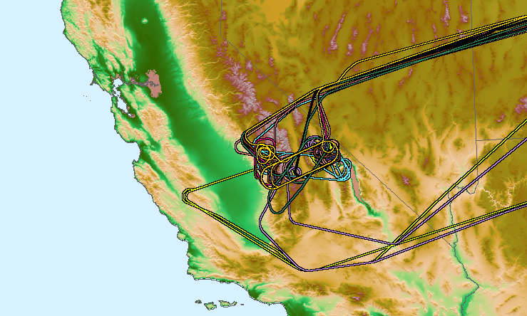
Figure 1 Map of G-V flight tracks. Different flights are distinguished by different colors.

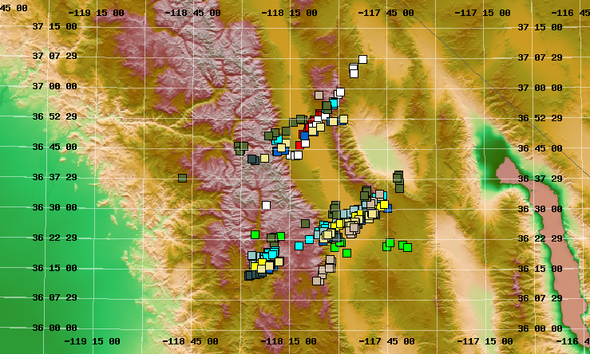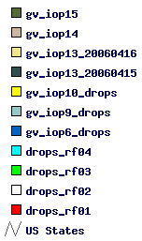
Figure 2 Map of Owens Valley California shows launch location of dropsondes. Different flights are distinguished by different colors.

1.1 Contacts

Contacts: Data Quality
Kate Young
kbeierle@ucar.edu

Junhong (June) Wang
junhong@ucar.edu

System/Software
Dean Lauritsen
lauritsn@ucar.edu

Mailing Address: NCAR/Earth Observing Laboratory
P.O. Box 3000
1850 Table Mesa Drive
Boulder, CO 80307; USA

For more information on the NCAR GPS Dropsonde System please visit the following site:
http://www.atd.ucar.edu/rtf/facilities/dropsonde

2.0 NCAR/EOL Detailed Data Description

2.1 Detailed Format Description

All upper air soundings were converted to National Center for Atmospheric Research/Earth Observing Laboratory (NCAR/EOL) Sounding Composite Format (ESC). ESC is a version of the National Center for Atmospheric Research (NCAR) CLASS format and is an ASCII format consisting of 15 header records for each sounding followed by the data records with associated QC information.

Header Records

The header records (15 total records) contain data type, project ID, site ID, site location, release time, sonde type, meteorological and wind data processors, and the operator's name and comments. The first five header lines contain information identifying the sounding, and have a rigidly defined form. The following 7 header lines are used for auxiliary information and comments about the sounding, and may vary from dataset to dataset. The last 3 header records contain header information for the data columns. Line 13 holds the field names, line 14 the field units, and line 15 contains dashes ('-' characters) delineating the extent of the field.

The five standard header lines are as follows:

Line Label (Padded to 35 chars) | Contents
1 Data Type: | Description of type and resolution of data.
2 Project ID: | ID of weather project.
3 Release Site Type/Site ID: | Description of release site.
4 Release Location (lon,lat,alt): | Position of release site, in format described below.
5 UTC Release Time (y,m,d,h,m,s): | Time of release, in format: yyyy, mm, dd, hh:mm:ss

The release location is given as: lon (deg min), lat (deg min), lon (dec. deg), lat (dec. deg), alt (m)

Longitude in deg min is in the format: ddd mm.mm'W where ddd is the number of degrees from True North (with leading zeros if necessary), mm.mm is the decimal number of minutes, and W represents W or E for west or east longitude, respectively. Latitude has the same format as longitude, except there are only two digits for degrees and N or S for north/south latitude. The decimal equivalent of longitude and latitude and station elevation follow.

The seven non-standard header lines may contain any label and contents. The labels are padded to 35 characters to match the standard header lines. Records for this dataset include the following three non-standard header lines.

Line Label (Padded to 35 chars) | Contents
6 Post Processing Comments: | Comments about NCAR/EOL post processing
7 Reference Launch Data Source/Time:
8 Sonde Id/Sonde Type: | Information on the Radiosonde used
9 System Operator/Comments: | Comments provided by site operators.
12 Nominal Release Time (y,m,d,h,m,s): | Nominal time of release, in format: yyyy, mm, dd, hh:mm:ss

Data Records

The data records each contain time from release, pressure, temperature, dew point, relative humidity, U and V wind components, wind speed and direction, ascent rate, balloon position data, altitude, and quality control flags (see the QC code description). Each data line contains 21 fields, separated by spaces, with a total width of 130 characters. The data are right-justified within the fields. All fields have one decimal place of precision, with the exception of latitude and longitude, which have three decimal places of precision. The contents and sizes of the 21 fields that appear in each data record are as follows:

Field No. | Format Width | Parameter | Units Value | Missing
1 | 6 F6.1 | Time | Seconds | 9999.0
2 | 6 F6.1 | Pressure | Millibars | 9999.0
3 | 5 F5.1 | Dry-bulb Temperature | Degrees C | 999.0
4 | 5 F5.1 | Dew Point Temperature | Degrees C | 999.0
5 | 5 F5.1 | Relative Humidity | Percent | 999.0
6 | 6 F6.1 | U Wind Component | Meters / Second | 9999.0
7 | 6 F6.1 | V Wind Component | Meters / Second | 9999.0
8 | 5 F5.1 | Wind Speed | Meters / Second | 999.0
9 | 5 F5.1 | Wind Direction | Degrees | 999.0
10 | 5 F5.1 | Ascent Rate | Meters / Second | 999.0
11 | 8 F8.3 | Longitude | Degrees | 9999.0
12 | 7 F7.3 | Latitude | Degrees | 999.0
13 | 5 F5.1 | Range | Kilometers | 999.0
14 | 5 F5.1 | Angle | Degrees | 999.0
15 | 7 F7.1 | Altitude | Meters | 99999.0
16 | 4 F4.1 | QC for Pressure | Code (see below) | 99.0
17 | 4 F4.1 | QC for Temperature | Code (see below) | 99.0
18 | 4 F4.1 | QC for Humidity | Code (see below) | 99.0
19 | 4 F4.1 | QC for U Component | Code (see below) | 99.0
20 | 4 F4.1 | QC for V Component | Code (see below) | 99.0
21 | 4 F4.1 | QC for Ascension Rate | Code (see below) | 99.0

Fields 16 through 21 contain the Quality Control information derived at the NCAR Earth Observing Laboratory (NCAR/EOL). Any QC information from the original sounding is replaced by the following NCAR/EOL codes:

Code | Description
99.0 | Unchecked (QC information is “missing”) (“UNCHECKED”)
1.0 | Checked, datum seems physically reasonable. (“GOOD”)
2.0 | Checked, datum seems questionable on physical basis. (“MAYBE”)
3.0 | Checked, datum seems to be in error. (“BAD”)
4.0 | Checked, datum is interpolated. (“ESTIMATED”)
9.0 | Checked, datum was missing in original file. (“MISSING”)

Sample Data

The following is a sample record of T-REX Sounding Dropsonde HIAPER upper air data in NCAR/EOL CLASS format. The data portion is much longer than the page width and, therefore, wraps around to a second line. See section 2.1 for an exact format specification

Data Type: RF1/Gulfstream V, N677F Dropsonde
Project ID: T-REX
Release Site Type/Site ID: Gulfstream V, N677F RF1
Release Location (lon,lat,alt): 118 14.04'W, 36 46.04'N, -118.234, 36.767, 12439.2
UTC Release Time (y,m,d,h,m,s): 2006, 03, 02, 18:00:30
Post Processing Comments: Aspen Version
Reference Launch Data Source/Time: NCAR G-V (ADS)
Sonde Id/Sonde Type: 053116003/Vaisala RSS903 & Ublox TIM-Lx
System Operator/Comments: emk/none, Good Drop
/
/
Nominal Release Time (y,m,d,h,m,s): 2006, 03, 02, 18:00:30
Time Press Temp Dewpt RH Ucmp Vcmp spd dir Wcmp Lon Lat Ele Azi Alt Qp Qt Qrh Qu Qv QdZ
sec mb C C % m/s m/s m/s deg m/s deg deg deg deg m code code code code code code
------ ------ ----- ----- ----- ------ ------ ----- ----- ----- -------- ------- ----- ----- ------- ---- ---- ---- ---- ---- ----
-1.0 178.8 -61.1 -99.9 0.2 28.4 23.2 36.7 230.8 999.0 -118.234 36.767 999.0 999.0 12439.2 99.0 99.0 99.0 99.0 99.0 9.0
0.4 9999.0 999.0 999.0 999.0 9999.0 9999.0 999.0 999.0 999.0 9999.000 999.000 999.0 999.0 99999.0 9.0 9.0 9.0 9.0 9.0 9.0
0.9 9999.0 999.0 999.0 0.7 9999.0 9999.0 999.0 999.0 999.0 9999.000 999.000 999.0 999.0 99999.0 9.0 9.0 99.0 9.0 9.0 9.0
1.4 9999.0 999.0 999.0 0.7 9999.0 9999.0 999.0 999.0 999.0 9999.000 999.000 999.0 999.0 99999.0 9.0 9.0 99.0 9.0 9.0 9.0
1.9 9999.0 999.0 999.0 0.7 9999.0 9999.0 999.0 999.0 999.0 9999.000 999.000 999.0 999.0 99999.0 9.0 9.0 99.0 9.0 9.0 9.0
2.4 9999.0 999.0 999.0 0.6 9999.0 9999.0 999.0 999.0 999.0 9999.000 999.000 999.0 999.0 99999.0 9.0 9.0 99.0 9.0 9.0 9.0

2.2 Data Remarks

2.3 Station List

ID | SITE | STATE | LONG | LAT | ELEV (m)
N677F | HIAPER | CA | -999.000 | 999.000 | -999.0

3.0 NCAR/EOL Quality Control Processing

This dataset underwent an automated QC process. The dataset underwent internal consistency checks which included two types of checks, gross limit checks on all parameters and rate-of-change checks on temperature, pressure and ascension rate. Some further information on the QC processing conducted by NCAR/EOL can be found in Loehrer et al. (1996) and Loehrer et al. (1998).

3.1 Gross Limit Checks

These checks were conducted on each sounding and data were automatically flagged as appropriate. Only the data point under examination was flagged. NCAR/EOL conducted the following gross limit checks on the T-REX HIAPER sounding datasets. In the table P = pressure, T = temperature, RH = relative humidity, U = U wind component, V = V wind component, B = bad, and Q = questionable.

Parameter | Parameters(s)  Gross Limit Check | Flag  Flagged | Applied
Pressure | < 0 mb or > 1050 mb | P | B
Altitude | < 0 m or > 40000 m | P, T, RH | Q
Temperature | < -90C or > 45C | T | Q
Dew Point | < -99.9C or > 33C  > Temperature | RH  T,RH | Q  Q
Relative Humidity | < 0% or > 100% | RH | B
Wind Speed | < 0 m/s or > 100 m/s  > 150 m/s | U,V  U,V | Q  B
U Wind Component | < 0 m/s or > 100 m/s  > 150 m/s | U  U | Q  B
V Wind Component | < 0 m/s or > 100 m/s  > 150 m/s | V  V | Q  B
Wind Direction | < 0 deg or > 360 deg | U,V | B
Ascent Rate | < -10 m/s or > 10 m/s | P,T,RH | Q

3.2 Vertical Consistency Checks

These checks were conducted on each sounding and data were automatically flagged as appropriate. These checks were started at the lowest level of the sounding and compared neighboring data points (except at pressures less than 100 mb where 30-sec average values were used. In the case of checks ensuring that the values increased/decreased as expected, only the data point under examination was flagged. However, for the other checks, all of the data points used in the examination were flagged. All items within the table are as previously defined.

Parameter | Vertical Consistency Check | Parameter(s)  Flagged | Flag  Applied
Time | decreasing/equal | None | None
Altitude | decreasing/equal | P,T,RH | Q
Pressure | increasing/equal  > 1 mb/s or < -1 mb/s  > 2 mb/s or < -2 mb/s | P,T,RH  P,T,RH  P,T,RH | Q  Q  B
Temperature | < -15 C/km  < -30 C/km (not applied at p < 250 mb)  > 50 C/km (not applied at p < 250 mb)  > 100 C/km (not applied at p < 250 mb) | P,T,RH  P,T,RH  P,T,RH  P,T,RH | Q  B  Q  B
Ascent Rate | Change of > 3 m/s or < -3 m/s  Change of > 5 m/s or < -5 m/s | P  P | Q  B

3.3 Data Quality Issues

4.0 NCAR/EOL Data File Specifics

The files contain data collected at half-second intervals. The variables pressure, temperature, and relative humidity are calibrated values from measurements made by the dropsonde. The dew point is calculated from the relative humidity. The geopotential altitude value is calculated from the hydrostatic equation using first available pressure, temperature, and relative humidity. For the dropsondes specifically, if the sonde is launched over water and transmits data to the surface, the height is calculated by integrating from the surface (sea level) upward. However, if the sonde failed to transmit data to the surface or if the dropsonde is launched over land, because of unknown surface elevations, we integrate from the flight level down. The descent rate of the dropsonde is computed using the time-differentiated hydrostatic equation. The position (lat, lon) comes directly from the GPS sensor. All wind data are computed from GPS navigation signals received from the sonde. The raw wind values are calculated at a one half second data rate by a commercial processing card.

5.0 NCAR/EOL Data Quality Control

- The raw soundings are first run through the Atmospheric Sounding Processing ENvironment (ASPEN) software, which analyzes the data, performs smoothing, and removes suspect data points. For the TREX dropsonde dataset, geopotential heights were integrated from flight level down because the drops were made over land, and surface altitudes are unknown.
- The soundings were then visually evaluated for outliers, and bad surface measurements collected after the sonde hit the surface were removed.
- Time series plots of temperature (Figure 3), RH (Figure 4) and wind speed (Figure 5), with regard to altitude, were used to examine the consistency of soundings launched during each flight, and to show the variability of soundings from different missions.
- Histograms of pressure, temperature, relative humidity, wind speed and wind direction were created to examine the distribution, range, and characteristics of each parameter.

In performing the QC procedures described above, we found that:

- Fifteen soundings experienced problems with the launch detect, where launch was either detected early, late, or not at all (Table 3). As a result, the filenames and launch times were changed to reflect the actual time of deployment of the dropsonde determined by a change in pressure. The aircraft data, denoted by -1.0 sec in the first data line of each quality controlled sounding file, should be measured just prior to launch. When launch detect is either early or late the aircraft reference data may not accurately represent atmospheric conditions at the time of launch. The correct aircraft data at launch time was retrieved and used in place the original aircraft data. In cases where the launch detect failed completely, the sounding did not contain either launch or aircraft data lines, which caused ASPEN to fail. These lines were added in and the soundings were reprocessed.

Flight Number | New Launch Time | Original Launch Time
RF08 | D20060408_191622 | D20060408_185517
RF09 | D20060415_214404 | D20060415_214932
RF09 | D20060415_223926 | D20060415_224336
RF09 | D20060415_233144 | D20060415_233212
RF09 | D20060415_233539 | D20060415_232402
RF09 | D20060416_005544 | D20060416_004453
RF10 | D20040416_222537 | D20040416_222245
RF10 | D20060416_222822 | D20060416_222839
RF10 | D20060416_225245 | D20060416_225917
RF10 | D20040417_000021 | D20040416_234629
RF10 | D20040417_002812 | D20040417_001258
RF11 | D20060421_174238 | D20060421_173333
RF12 | D20060426_162945 | D20060426_162126
RF12 | D20060426_183532 | D20060426_182331
RF12 | D20060426_190132 | D20060426_184455
Table 3 Lists soundings where the launch detect mechanism experienced problems. Column one lists the flight number, column 2 lists the new filename with corrected launch time (last six digits), column 3 lists the original filename of the sounding.

- Ten sounding files did not contain data because either the dropsondes were not launched, or the files contained no PTU data. These files were excluded from the final dataset.

- 8 sounding files (Table 4) contained little or no wind data. These files are included in the final dataset.

Flight # | Little/No Winds
RF01 | D20060302_184508
RF03 | D20060309_222651
RF03 | D20060309_000455
RF03 | D20060309_015020
RF05 | D20060325_195746
RF06 | D20060402_180224
RF06 | D20060402_190412
RF06 | D20060402_202937
Table 4 List soundings with or no wind data.

- 15 dropsondes were classified as “fast fall” (Table 5). This occurs when the parachute fails to deploy, resulting in the dropsonde falling at approximately twice the normal speed (Figure 6). Fast fall soundings have a much lower vertical resolution and wind data may not be as clean because of tumbling of the dropsondes as they fall.

Flight # | Fast Fall Drops
RF01 | D20060302_184508
RF01 | D20060302_194522
RF01 | D20060302_222843
RF02 | D20060306_002629
RF03 | D20060309_222651
RF03 | D20060310_000455
RF03 | D20060310_015020
RF05 | D20060325_195746
RF06 | D20060402_180224
RF06 | D20060402_190412
RF06 | D20060402_202937
RF06 | D20060402_203035
RF10 | D20060416_222537
RF10 | D20060417_002812
RF12 | D20060426_182016
Table 5 Lists dropsondes classified as “fast fall”.
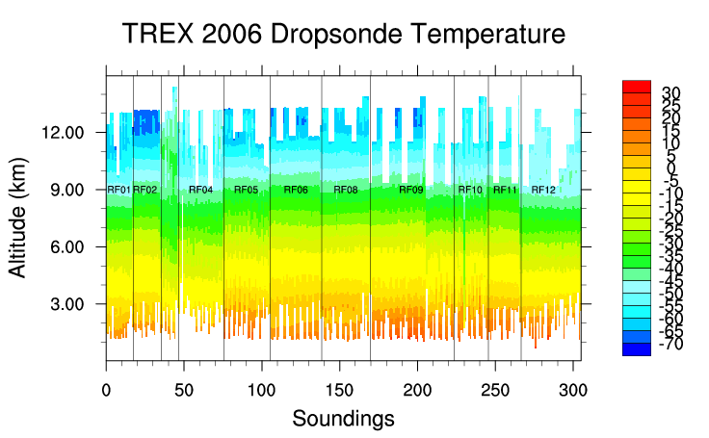
Figure 3 – Time series of dropsonde temperature (deg C) profiles. Sounding files are labeled along x-axis and RF# indicates the flight number.
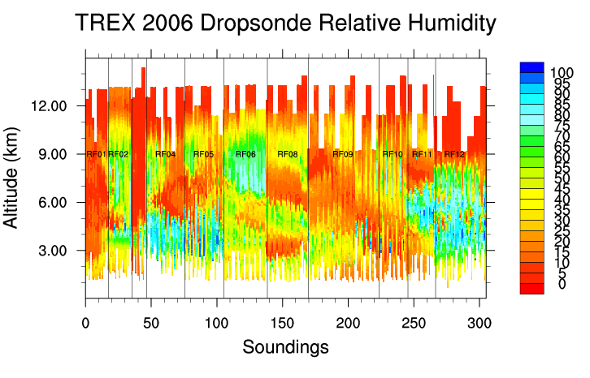
Figure 4 –Time series of dropsonde relative humidity (%) profiles. Sounding files are labeled along x-axis and RF# indicates the flight number.
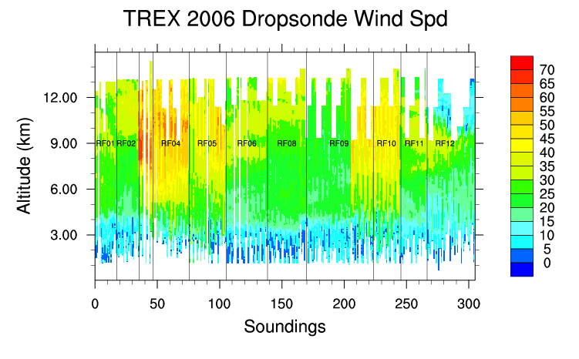

Figure 5 –Time series of dropsonde wind speed profiles (m/s). Sounding files are labeled along x-axis and RF# indicates the flight number.

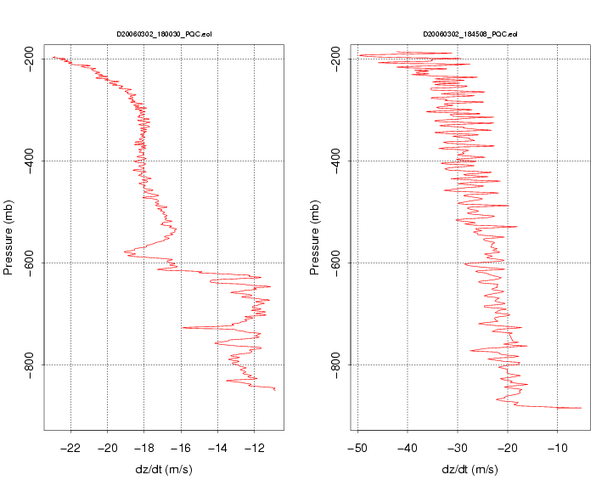

Figure 6. Plots above show normal descent speed of dropsonde with a parachute (left), and the descent speed of a “fast fall” dropsonde (right) where the parachute failed to deploy.

