Terrain Induced Rotor Experiment 2006 (T-REX)
Quality Controlled Dropsonde Data Set

Contents:
I. Data Set Overview
II. File Naming Conventions
III. **NEW** EOL Sounding File Format
IV. Data File Specifics
V. Data Quality Control and Important Information for Users

I. Contacts: Data Quality
Kate Young
kbeierle@ucar.edu

Junhong (June) Wang
junhong@ucar.edu

System/Software
Dean Lauritsen
lauritsn@ucar.edu

Mailing Address: NCAR/Earth Observing Laboratory
P.O. Box 3000
1850 Table Mesa Drive
Boulder, CO 80307; USA

For more information on the NCAR GPS Dropsonde System please visit the following site:
http://www.atd.ucar.edu/rtf/facilities/dropsonde

I. Dataset Overview

The Terrain Induced Rotor Experiment (T-REX) was conducted during March and April 2006, during which time 306 dropsondes were launched from the NCAR G-V aircraft during eleven research flights (Figure 1). TREX marks the first project where dropsondes were deployed from NCAR’s newest aircraft. TREX is the second phase of a coordinated effort to explore the structure and evolution of atmospheric rotors, which typically occur parallel to, and downstream from, mountain ridge crests. The first phase was a project conducted in 2004 called the Sierra Rotors Project. Both phases included radiosonde launches from the California Central Valley and Owens Valley, however only the second phase included the use of dropsondes (Figure 2). For more information on the TREX project, please visit: http://www.eol.ucar.edu/projects/trex/

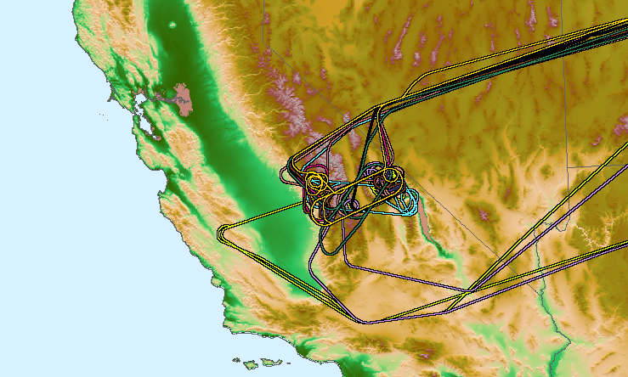
Figure 1 Map of G-V flight tracks. Different flights are distinguished by different colors.

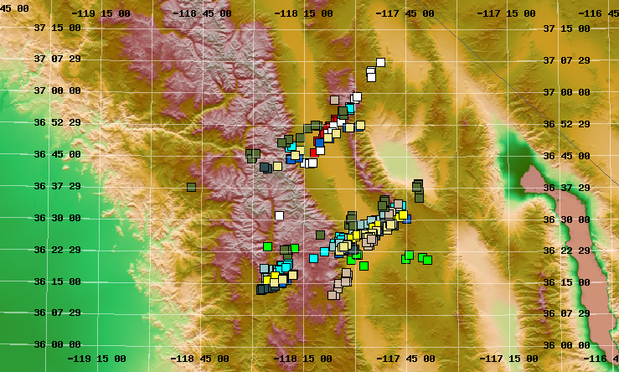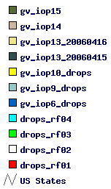
Figure 2 Map of Owens Valley California shows launch location of dropsondes. Different flights are distinguished by different colors.

III. ***New EOL File Format***

EOL has introduced a new ascii “EOL file format” for all radiosonde and dropsonde sounding files. This new file format is similar to the CLASS format, used in the past, but has been improved to include a revised header with more detailed sounding information, addition of UTC time, an increase in precision of the longitude and latitude to six decimal places, and GPS altitude is now also provided in addition to geopotential altitude (Table 1). Additionally, all missing values are now set to -999.

The "D" files are half-second data files with appropriate corrections and quality control measures applied. The naming convention for these files is - "D", followed by "yyyymmdd_hhmmssQC.eol" where yyyy = year, mm = month, hh = hour of the day GMT, mm = minute of the hour, ss = second of the hour, QC refers to Quality Controlled, and ".eol" refers to the file format type.

The header records now consist of 14 lines which contain information such as data type, project name, site location, actual release time, and other specialized information. The first seven header lines contain information identifying the sounding. The release location is given as : lon (deg min), lon (dec. deg), lat (deg min), lat (dec. deg), altitude (meters)
Longitude in deg min is in the format: ddd mm.mm'W where ddd is the number of degrees from True North (with leading zeros if necessary), mm.mm is the decimal number of minutes, and W represents W or E for west or east longitude, respectively. Latitude has the same format as longitude, except there are only two digits for degrees and N or S for north/south latitude. The following three header lines contain information about the aircraft data system and auxiliary information and comments about the sounding. The last 3 header lines contain header information for the data columns. Line 12 holds the field names, line 13 the field units, and line 14 contains dashes (--- characters) signifying the end of the header. Data fields are listed below in Table 2.

Data Type/Direction: AVAPS SOUNDING DATA, Channel 4/Descending
File Format/Version: EOL Sounding Format/1.0
Project Name/Platform: T-REX, RF1/Gulfstream V, N677F
Launch Site:
Launch Location (lon,lat,alt): 118 14.04'W -118.234000, 36 46.04'N 36.767400, 12439.20
UTC Launch Time (y,m,d,h,m,s): 2006, 03, 02, 18:00:30
Sonde Id/Sonde Type: 053116003/Vaisala RSS903 & Ublox TIM-Lx
Reference Launch Data Source/Time: NCAR G-V (ADS)/18:00/29
System Operator/Comments: emk/none, Good Drop
Post Processing Comments: Aspen Version
/
Time -- UTC -- Press Temp Dewpt RH Uwind Vwind Wspd Dir dZ GeoPoAlt Lon Lat GPSAlt
sec hh mm ss mb C C % m/s m/s m/s deg m/s m deg deg m
------- -- -- ----- ------- ------- ------- ------- ------- ------- ------- ------- ------- -------- ----------- ----------- --------
-1.0 18 0 29.00 178.80 -61.10 -102.59 0.20 28.44 23.18 36.69 230.81 -999.00 12439.20 -118.234000 36.767400 12446.20
0.4 18 0 30.40 -999.00 -999.00 -999.00 -999.00 -999.00 -999.00 -999.00 -999.00 -999.00 -999.00 -999.000000 -999.000000 12416.27
0.9 18 0 30.90 -999.00 -999.00 -999.00 0.72 -999.00 -999.00 -999.00 -999.00 -999.00 -999.00 -999.000000 -999.000000 12416.94

Table 1 Example of new EOL format used for both dropsonde and radiosonde sounding files.

Field Parameter Units Measured/Calculated
No.
1 Time Seconds -------------
2 UTC Hour Hours -------------
3 UTC Minute Minutes -------------
4 UTC Second Seconds -------------
5 Pressure Millibars Measured
6 Dry-bulb Temp Degrees C Measured
7 Dewpoint Temp Degrees C Calculated
8 Relative Humidity Percent Measured
9 U Wind Component Meters/Second Calculated
10 V Wind Component Meters/Second Calculated
11 Wind Speed Meters/Second Calculated
12 Wind Direction Degrees Calculated
13 Ascension Rate Meters/Second Calculated
14 Geopotential Altitude Meters Calculated
15 Longitude Degrees Measured
16 Latitude Degrees Measured
17 GPS Altitude Meters Measured
Table 2 Lists data fields provided in the EOL format ascii soundings.

IV. Data File Specifics

The files contain data collected at half-second intervals. The variables pressure, temperature, and relative humidity are calibrated values from measurements made by the dropsonde. The dew point is calculated from the relative humidity. The geopotential altitude value is calculated from the hydrostatic equation using first available pressure, temperature, and relative humidity. For the dropsondes specifically, if the sonde is launched over water and transmits data to the surface, the height is calculated by integrating from the surface (sea level) upward. However, if the sonde failed to transmit data to the surface or if the dropsonde is launched over land, because of unknown surface elevations, we integrate from the flight level down. The descent rate of the dropsonde is computed using the time-differentiated hydrostatic equation. The position (lat, lon) comes directly from the GPS sensor. All wind data are computed from GPS navigation signals received from the sonde. The raw wind values are calculated at a one half second data rate by a commercial processing card.

V. Data Quality Control

- The raw soundings are first run through the Atmospheric Sounding Processing ENvironment (ASPEN) software, which analyzes the data, performs smoothing, and removes suspect data points. For the TREX dropsonde dataset, geopotential heights were integrated from flight level down because the drops were made over land, and surface altitudes are unknown.
- The soundings were then visually evaluated for outliers, and bad surface measurements collected after the sonde hit the surface were removed.
- Time series plots of temperature (Figure 3), RH (Figure 4) and wind speed (Figure 5), with regard to altitude, were used to examine the consistency of soundings launched during each flight, and to show the variability of soundings from different missions.
- Histograms of pressure, temperature, relative humidity, wind speed and wind direction were created to examine the distribution, range, and characteristics of each parameter.

In performing the QC procedures described above, we found that:

- Fifteen soundings experienced problems with the launch detect, where launch was either detected early, late, or not at all (Table 3). As a result, the filenames and launch times were changed to reflect the actual time of deployment of the dropsonde determined by a change in pressure. The aircraft data, denoted by -1.0 sec in the first data line of each quality controlled sounding file, should be measured just prior to launch. When launch detect is either early or late the aircraft reference data may not accurately represent atmospheric conditions at the time of launch. The correct aircraft data at launch time was retrieved and used in place the original aircraft data. In cases where the launch detect failed completely, the sounding did not contain either launch or aircraft data lines, which caused ASPEN to fail. These lines were added in and the soundings were reprocessed.

Flight Number | New Launch Time | Original Launch Time
RF08 | D20060408_191622 | D20060408_185517
RF09 | D20060415_214404 | D20060415_214932
RF09 | D20060415_223926 | D20060415_224336
RF09 | D20060415_233144 | D20060415_233212
RF09 | D20060415_233539 | D20060415_232402
RF09 | D20060416_005544 | D20060416_004453
RF10 | D20040416_222537 | D20040416_222245
RF10 | D20060416_222822 | D20060416_222839
RF10 | D20060416_225245 | D20060416_225917
RF10 | D20040417_000021 | D20040416_234629
RF10 | D20040417_002812 | D20040417_001258
RF11 | D20060421_174238 | D20060421_173333
RF12 | D20060426_162945 | D20060426_162126
RF12 | D20060426_183532 | D20060426_182331
RF12 | D20060426_190132 | D20060426_184455
Table 3 Lists soundings where the launch detect mechanism experienced problems. Column one lists the flight number, column 2 lists the new filename with corrected launch time (last six digits), column 3 lists the original filename of the sounding.

- Ten sounding files did not contain data because either the dropsondes were not launched, or the files contained no PTU data. These files were excluded from the final dataset.

- 8 sounding files (Table 4) contained little or no wind data. These files are included in the final dataset.

Flight # | Little/No Winds
RF01 | D20060302_184508
RF03 | D20060309_222651
RF03 | D20060309_000455
RF03 | D20060309_015020
RF05 | D20060325_195746
RF06 | D20060402_180224
RF06 | D20060402_190412
RF06 | D20060402_202937
Table 4 List soundings with or no wind data.

- 15 dropsondes were classified as “fast fall” (Table 5). This occurs when the parachute fails to deploy, resulting in the dropsonde falling at approximately twice the normal speed (Figure 6). Fast fall soundings have a much lower vertical resolution and wind data may not be as clean because of tumbling of the dropsondes as they fall.

Flight # | Fast Fall Drops
RF01 | D20060302_184508
RF01 | D20060302_194522
RF01 | D20060302_222843
RF02 | D20060306_002629
RF03 | D20060309_222651
RF03 | D20060310_000455
RF03 | D20060310_015020
RF05 | D20060325_195746
RF06 | D20060402_180224
RF06 | D20060402_190412
RF06 | D20060402_202937
RF06 | D20060402_203035
RF10 | D20060416_222537
RF10 | D20060417_002812
RF12 | D20060426_182016
Table 5 Lists dropsondes classified as “fast fall”.
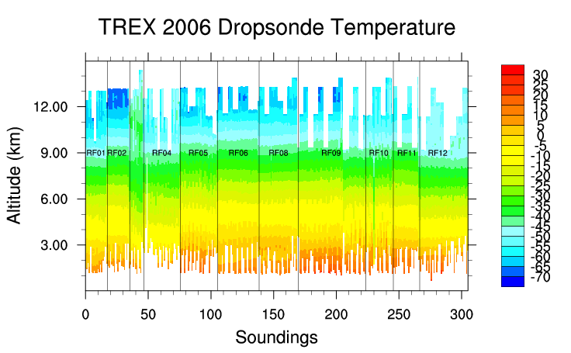
Figure 3 – Time series of dropsonde temperature (deg C) profiles. Sounding files are labeled along x-axis and RF# indicates the flight number.
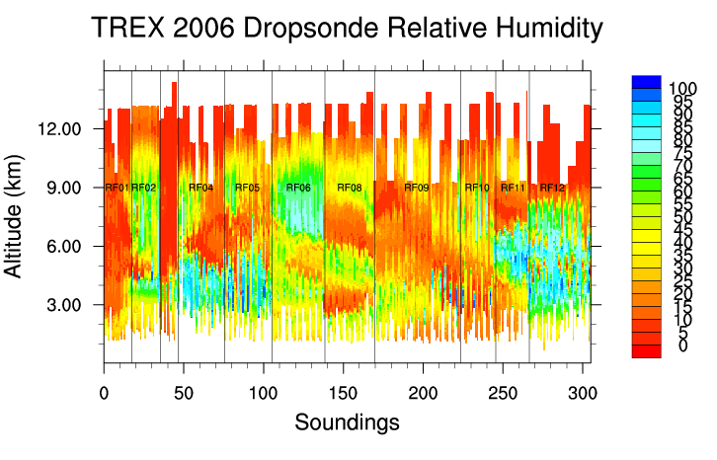
Figure 4 –Time series of dropsonde relative humidity (%) profiles. Sounding files are labeled along x-axis and RF# indicates the flight number.
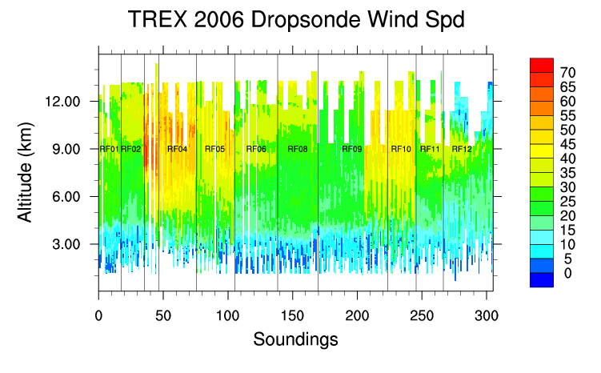

Figure 5 –Time series of dropsonde wind speed profiles (m/s). Sounding files are labeled along x-axis and RF# indicates the flight number.

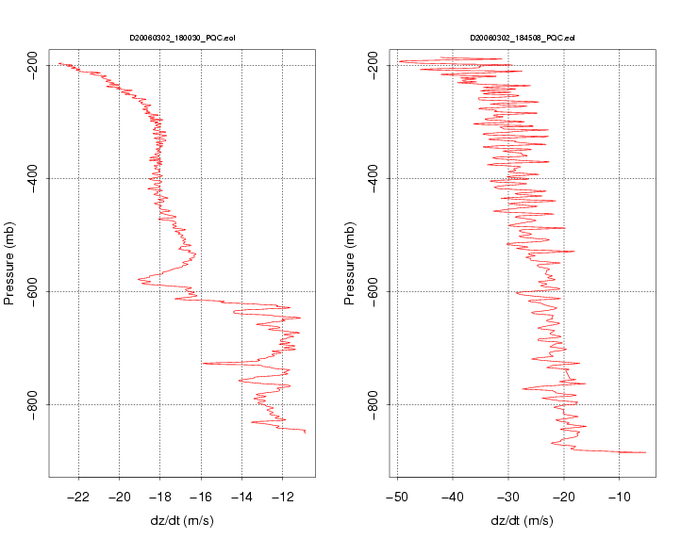

Figure 6. Plots above show normal descent speed of dropsonde with a parachute (left), and the descent speed of a “fast fall” dropsonde (right) where the parachute failed to deploy.

