RAINEX 2005 Quality Controlled Dropsonde Data Set

1.0 Dataset Overview

The Hurricane RAinband and INtensity change EXperiment (RAINEX), which took place from August 27 to November 23, 2005, deployed 198 dropsondes from the NRL P-3 aircraft, during nine missions near Florida (Figure 1). The final RAINEX dropsonde data set consists of 197 quality controlled soundings. One sounding (D20050911_231406.1) was removed from the final dataset because it contained no pressure data after launch.

This program used a new version of the dropsonde Rev. F. where previous field programs have been using Rev D. The new Rev F dropsondes use a new GPS receiver based upon u-Blox GPS receiver technology. The new GPS receiver is a full up code correlating GPS receiver providing a 12 channel receiver with significant improved tracking performance and reliability over the previous codeless GPS receiver used in Rev D dropsondes. The improved performance is necessary for eye-wall drops where the environment is very extreme. The new GPS receiver module also provides superior latitude, longitude and altitude information.

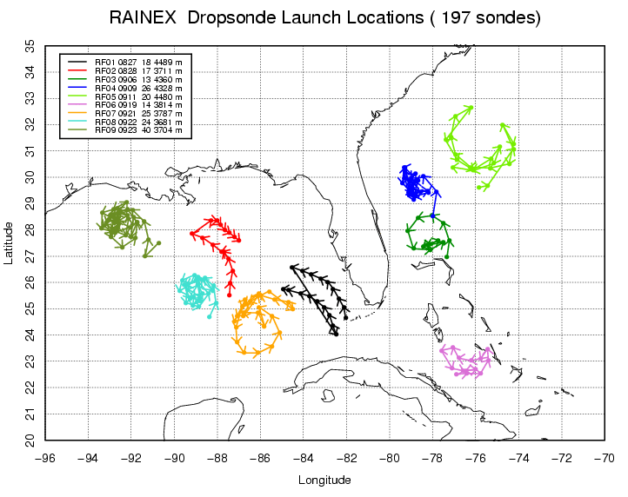

Figure 1 - Map of dropsonde locations (dots) for all missions with arrows representing flight directions. Different flights are distinguished by different colors. Flight names, dates (mmdd), number of soundings and mean flight altitudes for each flight are given in the legend.

1.1. Contacts: Terry Hock
hock@ucar.edu

Junhong Wang
junhong@ucar.edu

Kate Young
kbeierle@ucar.edu

Mailing Address: NCAR/Earth Observing Laboratory
P.O. Box 3000
1850 Table Mesa Drive
Boulder, CO 80307; USA

For more information on the NCAR GPS Dropsonde System please visit the following site:
http://www.atd.ucar.edu/rtf/facilities/dropsonde

2.0 NCAR/EOL Detailed Data Description

2.1 Detailed Format Description

All upper air soundings were converted to National Center for Atmospheric Research/Earth Observing Laboratory (NCAR/EOL) Sounding Composite Format (ESC). ESC is a version of the National Center for Atmospheric Research (NCAR) CLASS format and is an ASCII format consisting of 15 header records for each sounding followed by the data records with associated QC information.

Header Records

The header records (15 total records) contain data type, project ID, site ID, site location, release time, sonde type, meteorological and wind data processors, and the operator's name and comments. The first five header lines contain information identifying the sounding, and have a rigidly defined form. The following 7 header lines are used for auxiliary information and comments about the sounding, and may vary from dataset to dataset. The last 3 header records contain header information for the data columns. Line 13 holds the field names, line 14 the field units, and line 15 contains dashes ('-' characters) delineating the extent of the field.

The five standard header lines are as follows:

Line Label (Padded to 35 chars) | Contents
1 Data Type: | Description of type and resolution of data.
2 Project ID: | ID of weather project.
3 Release Site Type/Site ID: | Description of release site.
4 Release Location (lon,lat,alt): | Position of release site, in format described below.
5 UTC Release Time (y,m,d,h,m,s): | Time of release, in format: yyyy, mm, dd, hh:mm:ss

The release location is given as: lon (deg min), lat (deg min), lon (dec. deg), lat (dec. deg), alt (m)

Longitude in deg min is in the format: ddd mm.mm'W where ddd is the number of degrees from True North (with leading zeros if necessary), mm.mm is the decimal number of minutes, and W represents W or E for west or east longitude, respectively. Latitude has the same format as longitude, except there are only two digits for degrees and N or S for north/south latitude. The decimal equivalent of longitude and latitude and station elevation follow.

The seven non-standard header lines may contain any label and contents. The labels are padded to 35 characters to match the standard header lines. Records for this dataset include the following three non-standard header lines.

Line Label (Padded to 35 chars) | Contents
6 Dropsonde Serial Number: | Dropsonde serial number
7 Flight Number: | Number of flight the dropsonde was released
8 System Operator/Comments: | Comments provided by site operators.
12 Nominal Release Time (y,m,d,h,m,s): | Nominal time of release, in format: yyyy, mm, dd, hh:mm:ss

Data Records

The data records each contain time from release, pressure, temperature, dew point, relative humidity, U and V wind components, wind speed and direction, ascent rate, balloon position data, altitude, and quality control flags (see the QC code description). Each data line contains 21 fields, separated by spaces, with a total width of 130 characters. The data are right-justified within the fields. All fields have one decimal place of precision, with the exception of latitude and longitude, which have three decimal places of precision. The contents and sizes of the 21 fields that appear in each data record are as follows:

Field No. | Format Width | Parameter | Units Value | Missing
1 | 6 F6.1 | Time | Seconds | 9999.0
2 | 6 F6.1 | Pressure | Millibars | 9999.0
3 | 5 F5.1 | Dry-bulb Temperature | Degrees C | 999.0
4 | 5 F5.1 | Dew Point Temperature | Degrees C | 999.0
5 | 5 F5.1 | Relative Humidity | Percent | 999.0
6 | 6 F6.1 | U Wind Component | Meters / Second | 9999.0
7 | 6 F6.1 | V Wind Component | Meters / Second | 9999.0
8 | 5 F5.1 | Wind Speed | Meters / Second | 999.0
9 | 5 F5.1 | Wind Direction | Degrees | 999.0
10 | 5 F5.1 | Ascent Rate | Meters / Second | 999.0
11 | 8 F8.3 | Longitude | Degrees | 9999.0
12 | 7 F7.3 | Latitude | Degrees | 999.0
13 | 5 F5.1 | Range | Kilometers | 999.0
14 | 5 F5.1 | Angle | Degrees | 999.0
15 | 7 F7.1 | Altitude | Meters | 99999.0
16 | 4 F4.1 | QC for Pressure | Code (see below) | 99.0
17 | 4 F4.1 | QC for Temperature | Code (see below) | 99.0
18 | 4 F4.1 | QC for Humidity | Code (see below) | 99.0
19 | 4 F4.1 | QC for U Component | Code (see below) | 99.0
20 | 4 F4.1 | QC for V Component | Code (see below) | 99.0
21 | 4 F4.1 | QC for Ascension Rate | Code (see below) | 99.0

Fields 16 through 21 contain the Quality Control information derived at the NCAR Earth Observing Laboratory (NCAR/EOL). Any QC information from the original sounding is replaced by the following NCAR/EOL codes:

Code | Description
99.0 | Unchecked (QC information is “missing”) (“UNCHECKED”)
1.0 | Checked, datum seems physically reasonable. (“GOOD”)
2.0 | Checked, datum seems questionable on physical basis. (“MAYBE”)
3.0 | Checked, datum seems to be in error. (“BAD”)
4.0 | Checked, datum is interpolated. (“ESTIMATED”)
9.0 | Checked, datum was missing in original file. (“MISSING”)

Sample Data

The following is a sample record of RAINEX Sounding Dropsonde NRL P-3 upper air data in NCAR/EOL ESC format. The data portion is much longer than the page width and, therefore, wraps around to a second line. See section 2.1 for an exact format specification

Data Type: AVAPS SOUNDING DATA, Channel 2
Project ID: RAINEX
Release Site Type/Site ID: Lockheed P-3D, 154587
Release Location (lon,lat,alt): 82 07.21'W, 25 02.87'N, -82.12015, 25.04784, 4479.0
UTC Release Time (y,m,d,h,m,s): 2005, 08, 27, 16:26:39
Dropsonde Serial Number: 051926251
Flight Number: RF01
System Operator/Comments: ,
/
/
/
Nominal Release Time (y,m,d,h,m,s): 2005, 08, 27, 16:26:39
Time Press Temp Dewpt RH Ucmp Vcmp spd dir Wcmp Lon Lat Rng Az Alt Qp Qt Qrh Qu Qv QdZ
sec mb C C % m/s m/s m/s deg m/s deg deg km deg m code code code code code code
------ ------ ----- ----- ----- ------ ------ ----- ----- ----- -------- ------- ----- ----- ------- ---- ---- ---- ---- ---- ----
361.5 1005.9 28.9 24.7 77.6 9999.0 9999.0 999.0 999.0 999.0 9999.000 999.000 999.0 999.0 0.0 99.0 99.0 99.0 9.0 9.0 9.0
361.0 1005.2 28.9 24.7 77.6 -7.8 12.4 14.6 148.0 -11.3 -82.154 25.112 999.0 999.0 6.1 99.0 99.0 99.0 99.0 99.0 99.0
360.5 1004.5 28.9 24.5 76.9 -7.8 12.6 14.9 148.2 -11.3 -82.154 25.112 999.0 999.0 11.6 99.0 99.0 99.0 99.0 99.0 99.0
360.0 1003.9 28.8 24.4 76.4 -7.9 12.8 15.1 148.4 -11.4 -82.154 25.112 999.0 999.0 17.2 99.0 99.0 99.0 99.0 99.0 99.0
359.5 1003.3 28.8 24.2 76.1 -8.0 13.0 15.3 148.5 -11.5 -82.154 25.112 999.0 999.0 22.9 99.0 99.0 99.0 99.0 99.0 99.0

2.2 Data Remarks

2.3 Station List

ID | SITE | COUNTRY | LONG | LAT | ELEV (m)
154587 | Lockheed P-3D | US | 999.000 | 999.000 | 999.0

3.0 NCAR/EOL Data File Specifics

The files contain data calculated at half-second intervals. The variables pressure, temperature, and relative humidity are calibrated values from measurements made by the dropsonde. The dew point is calculated from the relative humidity. The altitude value is calculated from the hydrostatic equation using first available pressure, temperature, and dew point. For the dropsondes specifically, if the sonde is launched over water and transmits data to the surface, the height is calculated by integrating from the surface (sea level) upward. However, if the sonde failed to transmit data to the surface or if the dropsonde is launched over land, because of unknown surface elevations, we integrate from the flight level down. The descent rate of the dropsonde is computed using the time-differentiated hydrostatic equation. The position (lat, lon) are integrated from the initial launch position using the horizontal winds. If a time gap of greater than 60 seconds occurs in the wind measurements, the integration terminates.

All wind data are computed from GPS navigation signals received from the sonde. The raw wind values are calculated at a one half second data rate by a commercial processing card. The resolution of the data is half second.

4.0 NCAR/EOL Important Note to Users

- Copies of the raw soundings are first run through the Atmospheric Sounding Processing ENvironment (ASPEN), which analyzes the data, removes suspect data points and performs smoothing; 5 second smoothing for pressure, temperature and RH, and 10 second smoothing for winds. Time series plots of temperature (Figure 2), RH (Figure 3) and wind speed (Figure 4), with regard to altitude, are used to examine the consistency of soundings launched during each flight, and to show the variability of soundings from different missions. The soundings are then visually evaluated for outliers, or any other obvious problems. Histograms of pressure, temperature, relative humidity, wind speed and wind direction are created to examine the distribution, range, and characteristics of each parameter. Lastly, the percentage of good PTU and wind data from each sounding is checked, along with the amount of time elapsed, in seconds, between the launch and the first available wind measurement (Figure 5). In a comparison done while the project was still underway, 36 dropsondes were examined and compared with 200 dropsondes from a project called RICO, where the Rev D dropsondes were used. The results showed that the percentage of good PTU and GPS data increased from 62% (median value) at RICO to 93% at RAINEX. The percentage of bad GPS data decreased from 37% at RICO to 7% at RAINEX, and the time at the 1st available wind after launch decreased from 31 seconds at RICO to 2 seconds at RAINEX.

In performing the QC procedures described above, we found that:
- 14 sounding files did not contain any data because the dropsondes were not launched. These files were excluded from the final dataset.
- 1 sounding (D20050827_165604QC.cls) has an incorrect altitude of 4151 meters in the header. Judging from dropsondes launched during the same flight, the flight altitude should be closer to 3800 meters.
- 9 soundings failed to transmit data to the surface and had to be re-run with ASPEN calculating altitude from flight level downward. These soundings were: D20050828_211143QC.cls, D20050909_143329QC.cls, D20050909_175719QC.cls, D20050909_181811QC.cls, D20050909_182746QC.cls, D20050919_192459QC.cls,
D20050921_170900QC.cls, D20050922_184636QC.cls and D20050923_213326QC.cls. Two of these can be seen in the temperature time series plot (Figure 2) indicated by the blue arrows. The others came too close to the surface to be distinguishable in the time series.
- 1 sounding (D20050911_215606QC.cls) had data removed at the surface because it began transmitting unreasonable data after hitting the water.
- 6 sounding files did not contain any wind speed data.
- During 5 dropsonde flights the soundings were interrupted when the operator accidentally started up a new dropsonde on the same frequency while it was on the aircraft. These soundings were: D20050921_181905QC.cls, D20050921_191500QC.cls, D20050922_185234QC.cls, D20050922_192458QC.cls and D20050923_213133QC.cls. This error caused the dropsonde in flight to terminate and the dropsonde on the plane to begin transmitting data, both of which were collected in the same data file. For these files, the data from the second sonde was removed from the sounding file. These sounding files are indicated by the black arrows on the temperature time series plot (Figure 2).
- During Flight 5 (RF05) a dropsonde (D20050911_211006QC.cls), shown in Figure 3 by the black arrow, was launched much higher and recorded humidities much drier than other soundings collected during that same flight. The reason for the difference in altitude between drops was the aircraft needed to ascend to avoid turbulence. The air was noticeably drier because of a strong in-flow coming down from the North.
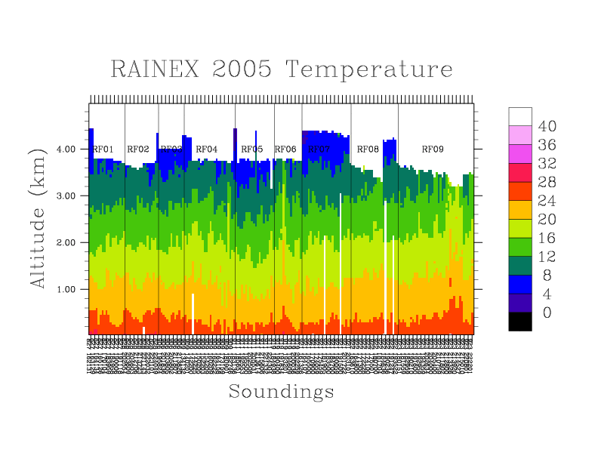
Figure 2 – Time series of dropsonde temperature (deg C) profiles. Sounding files are labeled along x-axis by month, day, hour, minute. rf# indicates the flight number. Blue arrows indicate where the sounding failed to transmit data to the surface. Black arrows indicate operator error of starting up another sonde on the same frequency when previous one was still in flight.
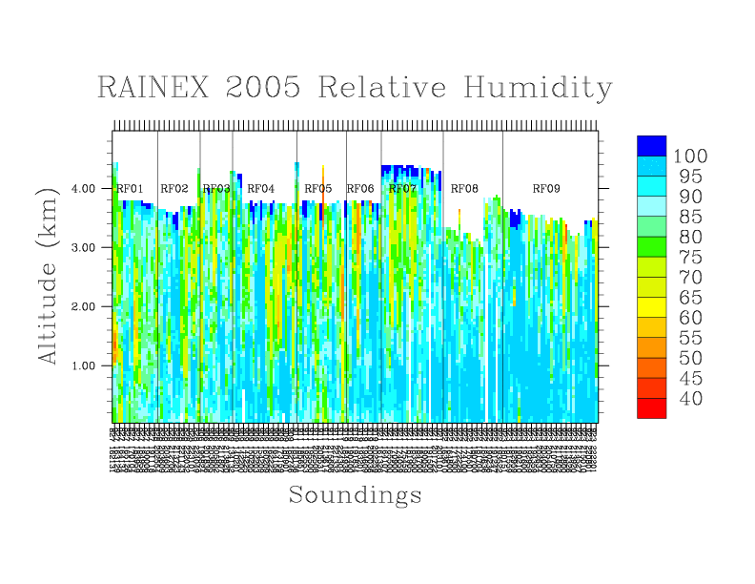
Figure 3 – Time series of dropsonde relative humidity (%) profiles. Sounding files are labeled along x-axis by month, day, hour, minute. rf# indicates the flight number. Black arrow indicates sounding where dry air in-flow occurred.
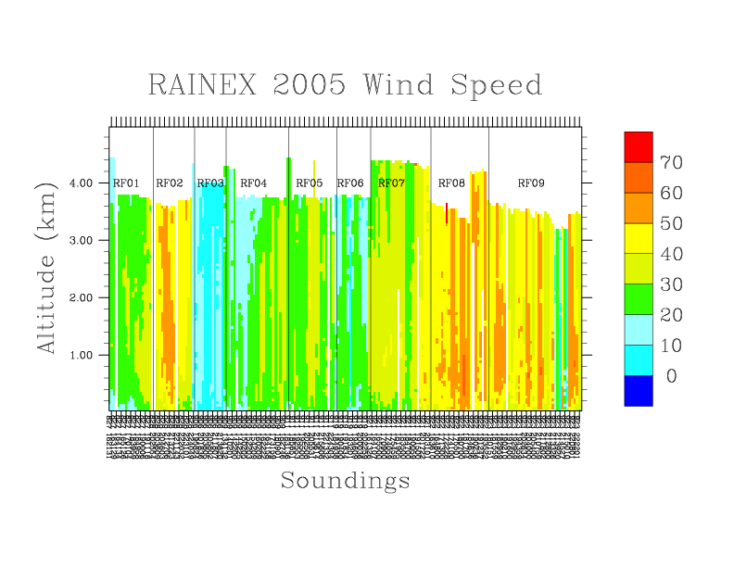

Figure 4 - Time series of dropsonde wind speed profiles (m/s). Sounding files are labeled along x-axis by month, day, hour, minute. rf# indicates the flight number.

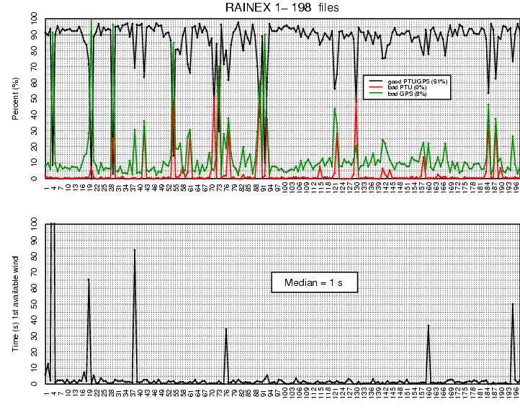

Figure 5. Percentages of good/bad data points from each sounding are shown in the first plot. The second plot shows the time elapsed between launch and the first available wind measurement.

5.0 NCAR/EOL Quality Control Processing

This dataset underwent an automated QC process. The dataset underwent internal consistency checks which included two types of checks, gross limit checks on all parameters and rate-of-change checks on temperature, pressure and ascension rate. Some further information on the QC processing conducted by NCAR/EOL can be found in Loehrer et al. (1996) and Loehrer et al. (1998).

5.1 Gross Limit Checks

These checks were conducted on each sounding and data were automatically flagged as appropriate. Only the data point under examination was flagged. NCAR/EOL conducted the following gross limit checks on the RAINEX aircraft drop sounding datasets. In the table P = pressure, T = temperature, RH = relative humidity, U = U wind component, V = V wind component, B = bad, and Q = questionable.

Parameter | Parameters(s)  Gross Limit Check | Flag  Flagged | Applied
Pressure | < 0 mb or > 1050 mb | P | B
Altitude | < 0 m or > 40000 m | P, T, RH | Q
Temperature | < -90C or > 45C | T | Q
Dew Point | < -99.9C or > 33C  > Temperature | RH  T,RH | Q  Q
Relative Humidity | < 0% or > 100% | RH | B
Wind Speed | < 0 m/s or > 100 m/s  > 150 m/s | U,V  U,V | Q  B
U Wind Component | < 0 m/s or > 100 m/s  > 150 m/s | U  U | Q  B
V Wind Component | < 0 m/s or > 100 m/s  > 150 m/s | V  V | Q  B
Wind Direction | < 0 deg or > 360 deg | U,V | B
Ascent Rate | < -20 m/s or > 20 m/s | P,T,RH | Q

5.2 Vertical Consistency Checks

These checks were conducted on each sounding and data were automatically flagged as appropriate. These checks were started at the lowest level of the sounding and compared neighboring data points (except at pressures less than 100 mb where 30-sec average values were used. In the case of checks ensuring that the values increased/decreased as expected, only the data point under examination was flagged. However, for the other checks, all of the data points used in the examination were flagged. All items within the table are as previously defined.

Parameter | Vertical Consistency Check | Parameter(s)  Flagged | Flag  Applied
Time | decreasing/equal | None | None
Altitude | decreasing/equal | P,T,RH | Q
Pressure | increasing/equal  > 1.5 mb/s or < -1.5 mb/s  > 3 mb/s or < -3 mb/s | P,T,RH  P,T,RH  P,T,RH | Q  Q  B
Temperature | < -15 C/km  < -30 C/km (not applied at p < 250 mb)  > 50 C/km (not applied at p < 250 mb)  > 100 C/km (not applied at p < 250 mb) | P,T,RH  P,T,RH  P,T,RH  P,T,RH | Q  B  Q  B
Ascent Rate | Change of > 5 m/s or < -5 m/s  Change of > 9 m/s or < -9 m/s | P  P | Q  B

6.0 References

Loehrer, S. M., T. A. Edmands, and J. A. Moore, 1996: TOGA COARE upper-air sounding data archive: development and quality control procedures. Bull. Amer. Meteor. Soc., 77, 2651-2671.
Loehrer, S. M., S. F. Williams, and J. A. Moore, 1998: Results from UCAR/JOSS quality control of atmospheric soundings from field projects. Preprints, Tenth Symposium on Meteorological Observations and Instrumentation, Phoenix, AZ, Amer. Meteor. Soc., 1-6.

