Geopotential Height Correction for IHOP Dropsonde Data
By Junhong Wang and Kathryn Beierle as of April 22, 2003

1. Background

In the IHOP dropsonde data released in October 2002, the geopotential height values were calculated integrating from flight level down, using the hydrostatic equation, because unlike with dropsondes launched over the ocean the surface altitude of the land is unknown. We recommended not using geopotential height data in files from either the IHOP Falcon or the Lear jet for two reasons. First, there are uncertainties in the flight level heights which are used as a reference by ASPEN (our QC software) to integrate geopotential heights. Second, there are no flight level PTU data for any of the Lear jet soundings because there were no PTU sensors on board, and for Falcon soundings there is no flight level pressure data for 37 of the 88 soundings. For the Falcon soundings with flight level PTU data, the data were manually entered and therefore its accuracy is unknown.
A systematic ~200-300 m height difference was found between co-located dropsondes and radiosondes at the Homestead site by Ed Browell’s group (see Fig. 1). We found that the ~200-300 m offset is due to the fact that ASPEN uses flight-level height, but first available pressure data for soundings without flight-level PTU data to integrate geopotential height from the flight-level to the surface. The first PTU data point in the file is available approximately 20 seconds after the launch of a sonde because of the time lag of the temperature sensor. The descending speed of the dropsonde is about 10-15 m/s which would explain the ~200-300 m offset.

2. Corrections

As suggested by Ed Browell, we obtained the 1-km elevation data from NOAA's National Geophysical Data Center, found the elevation of the dropsonde locations from the dataset, integrated geopotential height from the surface to the flight level and inserted the new geopotential height values into the data. The surface elevation can be found on line 12 (“Surface Elevation (m):”) in the header of the dropsonde data. In this calculation, the last available dropsonde data point is assumed to be the surface data.
After corrections, the new data reduced the difference between co-located dropsonde and radiosonde geopotential heights to less than 30 m (Fig. 1). However, a time series analysis of dropsonde data for each mission showed that 27 of dropsondes from the Lear jet lost data before reaching the ground, so integrating from the surface upward produced incorrect geopotential heights. For these soundings, the geopotential heights were calculated, integrating downward from the flight level, by incorporating flight-level PTU data using the following approach. We found the first available pressure measurement after launch in the raw data file, which most of the time is less than 2 seconds after launch, and manually inserted it into the flight-level data line. We were able to do this because the pressure sensor does not have the time lag error. The first available temperature and humidity after launch, from the ASPEN-QCed data at ~20 seconds, are assumed to be the flight-level data and were input into the raw file on the flight-level data line. The raw dropsonde data files were then re-run through ASPEN to produce the new corrected QCed data. (Note: the assumption of a constant temperature for the first 20 seconds has minor impacts on the geopotential height calculation). After corrections, a time series analysis showed reasonable patterns of temperature for each flight (Fig. 2). Comparisons of geopotential heights from nine co-located dropsonde and radiosonde soundings show good agreement and validate our corrections.

3. Important Notes

After the extensive efforts, explained above, to improve the IHOP dropsonde geo-potential height data, some uncertainties remain about the accuracy of the data because of uncertainties in the elevation data and flight-level heights, and the assumption of a constant temperature for the first ~20 seconds. In addition, it is possible that the geo-potential heights for some of soundings may still have problems that have yet to be found. Therefore, we recommend taking caution when using the height data. We also recommend not using the flight level data (at time=0s) because of the modifications made to it which were described above. It should also be kept in mind that the data point at the lowest level in the final dataset does not necessarily represent the surface data because some soundings have missing data before reaching the surface.

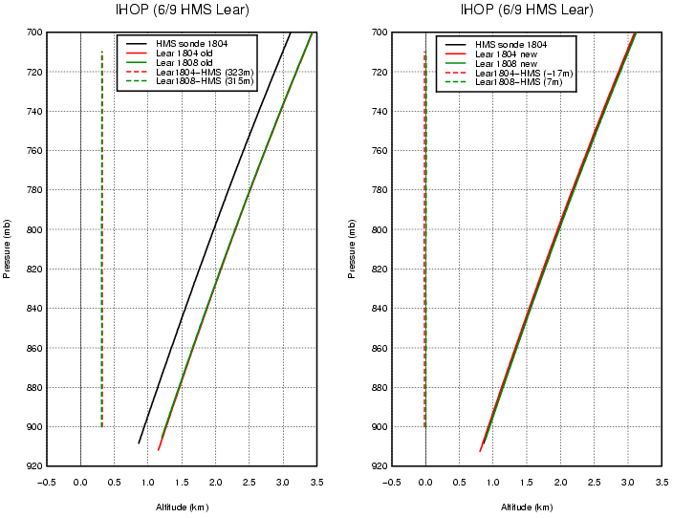

Fig. 1: Comparisons of geo-potential heights from Lear dropsonde data on June 9 at 18:04 and 18:08 UTC and radiosonde data at the Homestead site at 18:04 UTC before (left panel) and after (right panel) corrections. The dashed lines are differences between dropsonde and radiosonde data, and the mean differences are given in parentheses in legends.

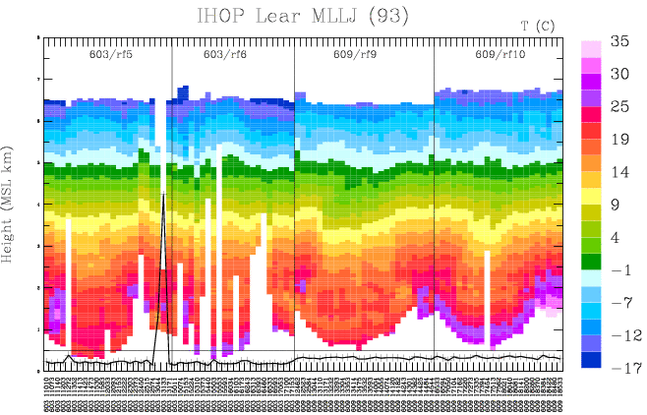

Fig. 2: Temperature profiles for all Lear MLLJ soundings. The black line shows the differences in geo-potential heights at the flight level and at the first available data point (~20 s). Vertical solid black lines separate each flight.

