1. **Contacts:**

**NCAR/EOL Processing and Quality Control:**

Scot Loehrer (NCAR/EOL)

[loehrer@ucar.edu](mailto:loehrer@ucar.edu)

**Original Data Source:**

Kate Young

NCAR/EOL

https://mail.google.com/mail/u/0/images/cleardot.gifkbeierle@ucar.edu

**DOI:** 10.5065/D6ZG6QF7

Sample Citation:

*UCAR/NCAR - Earth Observing Laboratory. 2016.* ***FP5*** *QC Radiosonde Data, Version 1.0. UCAR/NCAR - Earth Observing Laboratory.* [*http://dx.doi.org/10.5065/D6ZG6QF7*](http://dx.doi.org/10.5065/D6ZG6QF7)*. Accessed 15 Mar 2016.*

1. **Dataset Overview**

The National Center for Atmospheric Research/Earth Observing Laboratory (NCAR/EOL) released radiosondes with its Integrated Sounding System (ISS) that was located at the PECAN Fixed PISA (PECAN Integrated Sounding Array) 5 site in Brewster, Kansas (Figure 1). This data set includes the 112 quality controlled high vertical resolution (1 second) PECAN Fixed PISA 5 NCAR/EOL soundings released during PECAN field phase (2 June to 16 July 2015) Intensive Observing Periods (IOPs).

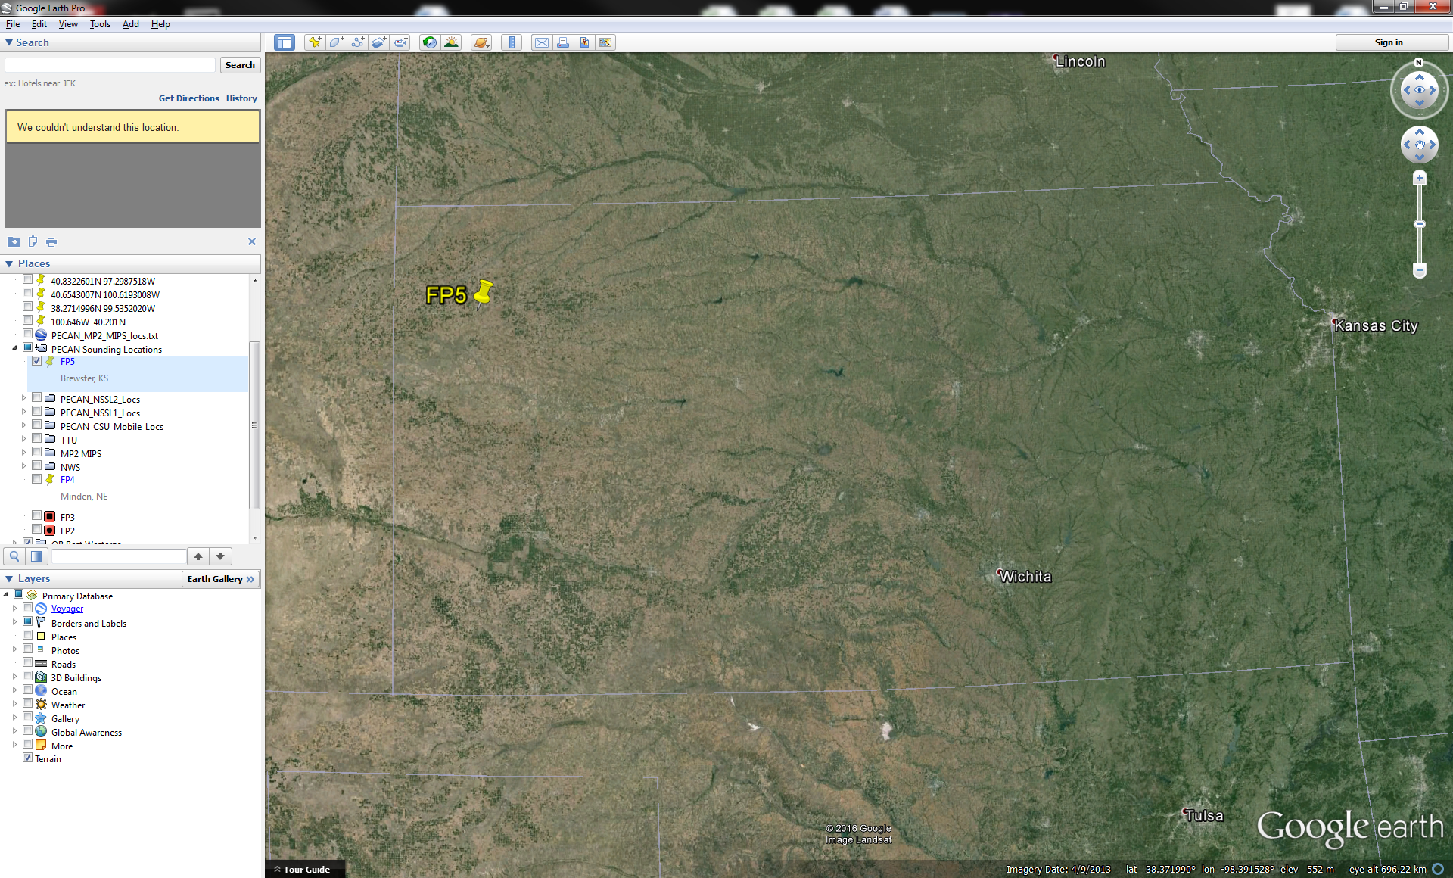

Figure 1. FP5 Brewster, Kansas radiosonde release site during PECAN.

1. **Project Overview**

Plains Elevated Convection At Night (PECAN) was a multi-agency project designed to advance the understanding of continental, nocturnal, warm season precipitation. It focused on nocturnal convection in conditions over the central United States plains states with a stable boundary layer (SBL), a nocturnal low-level jet and the largest convective available potential energy located above the SBL. Three aircraft (University of Wyoming King Air, NOAA P-3, and NASA DC-8) as well as a large array of fixed and mobile ground instrumentation were deployed out of Kansas from 1 June to 15 July 2015. Further information on PECAN is available at the PECAN web site: <https://www.eol.ucar.edu/field_projects/pecan> and information on PECAN operations is available at the PECAN Field Catalog: <http://catalog.eol.ucar.edu/pecan>.

1. **EOL Sounding Composite (ESC) File Format Description**

The ESC is a columnar ASCII format consisting of 15 header records for each sounding followed by the data records with associated data quality flags.

**3.1 Header Records**

The header records (15 total records) contain a variety of metadata about the sounding (i.e. location, time, radiosonde type, etc). The first five header lines contain information identifying the sounding, and have a rigidly defined form. The following 7 header lines are used for auxiliary information and comments about the sounding, and may vary from dataset to dataset. The last 3 header records contain header information for the data columns. Line 13 holds the field names, line 14 the field units, and line 15 contains dashes ('-' characters) delineating the extent of the field.

The file standard header lines are as follows:

|  |  |  |
| --- | --- | --- |
| **Line** | **Label (padded to 35 char)** | **Contents** |
| 1 | Data Type: | Description of the type and resolution of data |
| 2 | Project ID: | Short name for the field project |
| 3 | Release Site Type/Site ID: | Description of the release site. |
| 4 | Release Location (lon,lat,alt): | Location of the release site. |
| 5 | UTC Release Time (y,m,d,h,m,s): | Time of release. |

The release location is given as:

lon (deg min), lat (deg min), lon (dec. deg), lat (dec. deg), alt (m)

Longitude in deg min is in the format: ddd mm.mm'W where ddd is the number of degrees (with leading zeros if necessary), mm.mm is the decimal number of minutes, and W represents W or E for west or east longitude, respectively. Latitude has the same format as longitude, except there are only two digits for degrees and N or S for north/south latitude.

The time of release is given as: yyyy, mm, dd, hh:nn:ss.

Where yyyy is the year, mm is the month, dd is the day of month, and hh:nn:ss are the UTC hour, minute, and second respectively.

The seven non-standard header lines may contain any label and contents. The labels are padded to 35 characters to match the standard header lines. Records for this data set include the following non-standard header lines:

|  |  |  |
| --- | --- | --- |
| **Line** | **Label (padded to 35 char)** | **Contents** |
| 6 | Sonde Id/Sonde Type |  |
| 7 | Reference Launch Data Source/Time |  |
| 8 | System Operator/Comments |  |
| 9 | Post Processing Comments |  |

**3.2 Data Records**

The data records each contain time from release, pressure, temperature, dew point, relative humidity, U and V wind components, wind speed and direction, ascent rate, balloon position data, altitude, and quality control flags (see the QC code description). Each data line contains 21 fields, separated by spaces, with a total width of 130 characters. The data are right-justified within the fields. All fields have one decimal place of precision, with the exception of latitude and longitude, which have three decimal places of precision. The contents and sizes of the 21 fields that appear in each data record are as follows:

|  |  |  |  |  |  |
| --- | --- | --- | --- | --- | --- |
| **Field** | **Width** | **Format** | **Parameter** | **Units** | **Missing**  **Value** |
| 1 | 6 | F6.1 | Time since release | Seconds | 9999.0 |
| 2 | 6 | F6.1 | Pressure | Millibars | 9999.0 |
| 3 | 5 | F5.1 | Dry-bulb Temperature | Degrees C | 999.0 |
| 4 | 5 | F5.1 | Dew Point Temperature | Degrees C | 999.0 |
| 5 | 5 | F5.1 | Relative Humidity | Percent | 999.0 |
| 6 | 6 | F6.1 | U Wind Comp | m/s | 9999.0 |
| 7 | 6 | F6.1 | V Wind Comp | m/s | 9999.0 |
| 8 | 5 | F5.1 | Wind speed | m/s | 999.0 |
| 9 | 5 | F5.1 | Wind direction | Degrees | 999.0 |
| 10 | 5 | F5.1 | Ascent Rate | m/s | 999.0 |
| 11 | 8 | F8.3 | Longitude | Degrees | 9999.0 |
| 12 | 7 | F7.3 | Latitude | Degrees | 999.0 |
| 13 | 5 | F5.1 | Elevation Angle | Degrees | 999.0 |
| 14 | 5 | F5.1 | Azimuth Angle | Degrees | 999.0 |
| 15 | 7 | F7.1 | Altitude | Meters | 99999.0 |
| 16 | 4 | F4.1 | QC for Pressure | Code | 99.0 |
| 17 | 4 | F4.1 | QC for Temperature | Code | 99.0 |
| 18 | 4 | F4.1 | QC for Humidity | Code | 99.0 |
| 19 | 4 | F4.1 | QC for U Wind | Code | 99.0 |
| 20 | 4 | F4.1 | QC for V Wind | Code | 99.0 |
| 21 | 4 | F4.1 | QC for Ascent Rate | Code | 99.0 |

Fields 16 through 21 contain the data quality flags from the NCAR/Earth Observing Laboratory (EOL) sounding quality control procedures. The data quality flags are defined as follows:

|  |  |
| --- | --- |
| **Code** | **Description** |
| 1.0 | Checked, datum seems physically reasonable. (“GOOD”) |
| 2.0 | Checked, datum seems questionable on a physical basis. (“MAYBE”) |
| 3.0 | Checked, datum seems to be in error. (“BAD”) |
| 4.0 | Checked, datum is interpolated. (“ESTIMATED”) |
| 9.0 | Checked, datum is missing. (“MISSING”) |
| 99.0 | Unchecked (QC information is “missing”.) (“UNCHECKED”) |

**3.3 Data Specifics**

The files contain data at one-second intervals.

The data are in files by day, so all soundings for a particular day are concatenated into a single file ordered by time. The file naming convention is:

BREWSTER_yyyymmdd.cls where yyyy is the year, mm is the month, and dd is the day of the month.

The NCAR/EOL ISS Brewster, Kansas site used Vaisala RS92-SGP radiosondes during PECAN.

**3.4 Sample Data**

The following is a sample of the PECAN NCAR/EOL FP4 Minden, Nebraska high resolution radiosonde data in ESC format.

Data Type: GAUS SOUNDING DATA/Ascending

Project ID: PECAN

Release Site Type/Site ID: 20150601

Release Location (lon,lat,alt): 101 22.24'W, 39 21.45'N, -101.371, 39.358, 1036.0

UTC Release Time (y,m,d,h,m,s): 2015, 06, 02, 03:00:07

Sonde Id/Sonde Type: 144863114/Vaisala RS92-SGP (ccGPS)

Reference Launch Data Source/Time: Campbell Scientific CR10/03:00:15.00

System Operator/Comments: Leslie/Matt, Good Sounding

Post Processing Comments: Aspen V3.2-172; Created on 04 Mar 2016 23:57 UTC; Configuration upsonde-1s

/

/

Nominal Release Time (y,m,d,h,m,s):2015, 06, 02, 03:00:07

Time Press Temp Dewpt RH Ucmp Vcmp spd dir Wcmp Lon Lat Ele Azi Alt Qp Qt Qrh Qu Qv QdZ

sec mb C C % m/s m/s m/s deg m/s deg deg deg deg m code code code code code code

------ ------ ----- ----- ----- ------ ------ ----- ----- ----- -------- ------- ----- ----- ------- ---- ---- ---- ---- ---- ----

-1.0 897.2 20.9 17.6 81.2 -3.2 -3.7 4.9 41.1 999.0 -101.371 39.357 999.0 999.0 1038.2 2.0 2.0 2.0 99.0 99.0 9.0

0.0 897.2 20.9 18.0 83.3 -2.9 0.6 3.0 101.4 2.3 -101.371 39.358 999.0 999.0 1038.1 2.0 2.0 2.0 99.0 99.0 99.0

1.0 896.9 21.1 18.2 83.3 -3.2 1.4 3.6 114.1 3.0 -101.371 39.358 999.0 999.0 1040.5 2.0 2.0 2.0 99.0 99.0 99.0

**3.5 Station List**

|  |  |  |  |  |  |  |
| --- | --- | --- | --- | --- | --- | --- |
| **Site ID** | **WMO ID** | **Site Name** | **State** | **Latitude** | **Longitude** | **Elev (m)** |
| BREW | N/A | Brewster | KS | 39.357 | -101.371 | 1036 |

**4.0 Data Quality Control Procedures**

1. Each sounding was converted from its original format into the ESC format described above.
2. Each sounding was passed through a set of automated data quality checks which included basic gross limit checks as well as rate of change checks. This is further described in Section 4.1.
3. Each sounding was visually examined utilizing the NCAR/EOL XQC sounding quality control software. This is further described in Section 4.2.

The processing on the original EOL formatted data is in a separated readme file also included with this data set.

**4.1 Automated Data Quality Checks**

This data set was passed through a set of automated data quality checks. This procedure includes both gross limit checks on all parameters as well as rate-of-change checks on temperature, pressure, and ascent rate. A version of these checks is described in Loehrer et al. (1996) and Loehrer et al. (1998).

**4.1.1 Gross Limit Checks**

These checks were conducted on each sounding and the data quality flags in the ESC files were adjusted as appropriate. Only the data point under examination was flagged. All checks also produced warning messages that specified the location of the problem and the severity of the issue. These warning messages where then summarized statistically and examined to determine any consistent issues.

For this data set NCAR/EOL conducted the following gross limit checks. In the table P = pressure, T = temperature, RH = relative humidity, U = U wind component, V = V wind component, B= bad, and Q = questionable.

|  |  |  |  |
| --- | --- | --- | --- |
| **Parameter** | **Check** | **Parameter(s) Flagged** | **Flag Applied** |
| Pressure | <0 or > 1050 | P | B |
| Altitude | < 0 or >40000 | P, T, RH | Q |
| Temperature | < -90 or > 45 | T | B |
| Dew Point | < -99.9 or > 33  > T | RH  T, RH | Q  Q |
| Wind Speed | < 0 or > 100  > 150 | U, V  U, V | Q  B |
| U Wind | < 0 or > 100  > 150 | U  U | Q  B |
| V Wind | < 0 or > 100  > 150 | V  V | Q  B |
| Wind Direction | < 0 or > 360 | U, V | B |
| Ascent Rate | < -10 or > 10 | P, T, RH | Q |

**4.1.2 Vertical Consistency Checks**

These checks were conducted on each sounding and the data quality flags in the ESC files were adjusted as appropriate. These checks were started at the surface and compared each neighboring data record. In the case of checks that ensured that the values increased/decreased as expected, only the data point under examination was flagged. However, for the other checks, all of the data points used in the examination were flagged. All items within the table are as previously defined. All checks also produced warning messages that specified the location of the problem and the severity of the issue. These warning messages where then summarized statistically and examined to determine any consistent issues.

|  |  |  |  |
| --- | --- | --- | --- |
| **Parameter** | **Check** | **Parameter(s) Flagged** | **Flag Applied** |
| Time | Decreasing/equal | None | None. |
| Altitude | Decreasing/equal | P, T, RH | Q |
| Pressure | Increasing/equal  > 1mb/s or < -1mb/s  > 2mb/s or < -2mb/s | P, T, TH  P, T, TH  P, T, TH | Q  Q  B |
| Temperature | < -15oC/km  < -30oC/km  > 50oC/km  > 100oC/km | P, T, RH  P, T, RH  P, T, RH  P, T, RH | Q  B  Q  B |
| Ascent Rate | > 3m/s or < -3m/s  > 5m/s or < -5m/s | P  P | Q  B |

**4.2 Visual Data Quality Checks**

Each sounding was visually examined using the NCAR/EOL XQC sounding data quality control software. This software allows the user to view a skew-t/log-p diagram of each sounding and apply data quality flags as appropriate. The user can zoom in on sections of soundings for detailed examination and can adjust the data quality flags for an individual point, sections of soundings, or entire soundings for each parameter individually. The software also allows the user to override the quality flags applied by the automated procedure.

**4.3 Data Quality Issues of Note**

The data quality control procedures outlined above allows us to identify and, in some cases, resolve issues that could potentially impact research performed using these data sets. The following issues were noted in these soundings.

**Limited Data** –

201507112356 – no wind above 800mb

201507150559 – no data above 581mb

**Updraft Sounding –**

201506260417

201507060259

**Other Items -**

201507160601 – long period of descent 594-677mb.

**5.0 References**

Loehrer, S. M., T. A. Edmands, and J. A. Moore, 1996: TOGA COARE upper-air sounding data archive: development and quality control procedures. Bull. Amer. Meteor. Soc., 77, 2651-2671.

Loehrer, S. M., S. F. Williams, and J. A. Moore, 1998: Results from UCAR/JOSS quality control of atmospheric soundings from field projects. Preprints, Tenth Symposium on Meteorological Observations and Instrumentation, Phoenix, AZ, Amer. Meteor. Soc., 1-6.