1. **Contacts:**

**NCAR/EOL Processing and Quality Control:**

Scot Loehrer (NCAR/EOL)

[loehrer@ucar.edu](mailto:loehrer@ucar.edu)

**Original Data Source:**

Kate Young (NCAR/EOL)

[kbeierle@ucar.edu](mailto:kbeierle@ucar.edu)

**2.0 Dataset Overview**

The National Center for Atmospheric Research/Earth Observing Laboratory (NCAR/EOL) operated a GPS Advanced Upper-air Sounding System (GAUS) radiosonde system as part of its Integrated Sounding System (ISS) site at the Southern Oxidant and Aerosol Study (SOAS) National Weather Service (NWS) site which was located near the Centerville (CTR), Alabama super site (Figure 1). Soundings were typically released twice daily at 15 and 21 UTC from 30 May to 15 July 2013. There were some periods of more intensive sounding operations. This SAS final data set includes a total of 105 quality controlled, high vertical resolution (1-second) soundings.

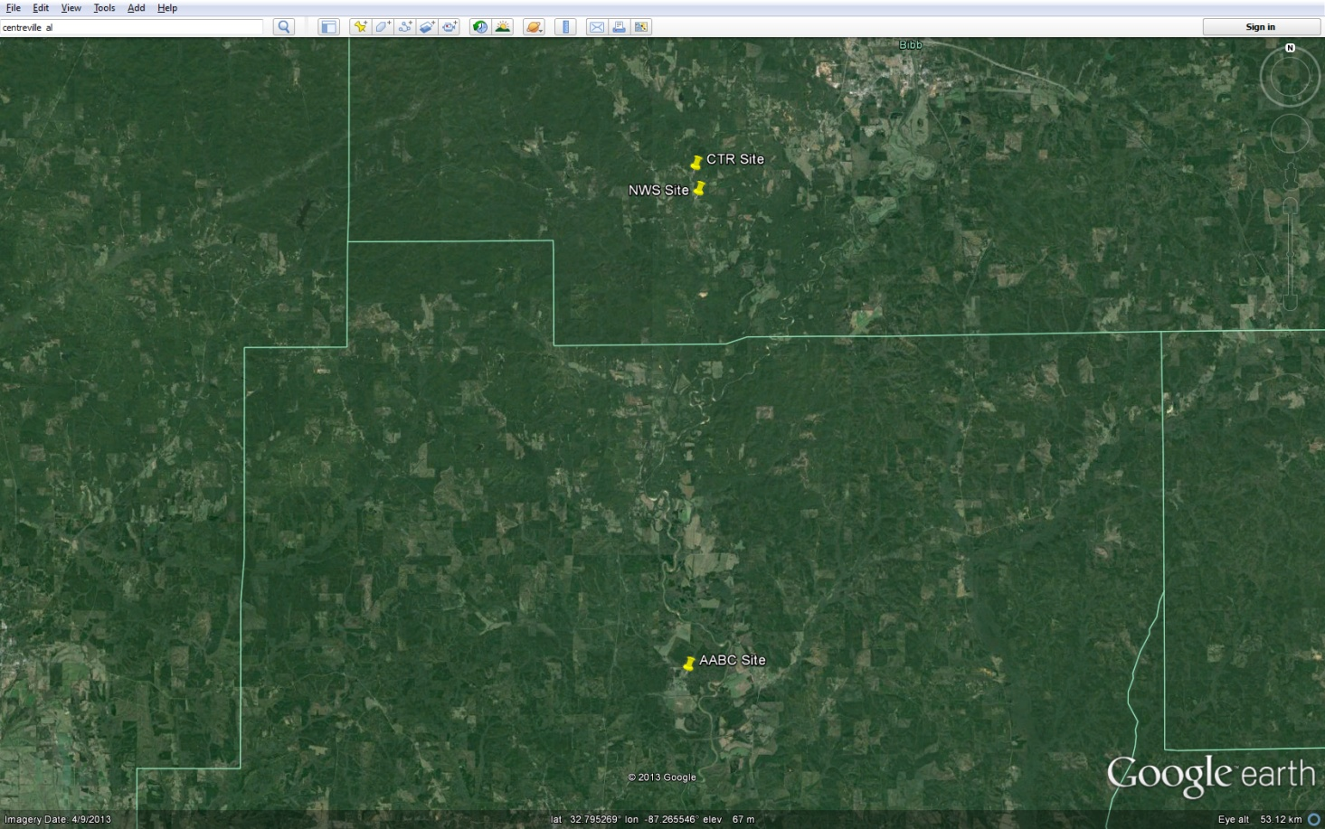

Figure 1. SOAS instrumentation sites in central Alabama.

SOAS was a field campaign aimed at gaining a better understanding of biosphere-atmosphere interactions and establishing the links between atmospheric composition, air quality, and climate change. The SOAS ground component consisted of three observation sites in central Alabama, the primary location was the CTR (Centreville) site that contained a large assortment of instrumentation and a tall tower, the NWS site contained the ISS instrumentation, and the AABC (Alabama Aquatic Biodiversity Center) site was in the thick cover of the Talladega National Forest. SOAS was one of several projects contained within the Southeast Atmosphere Study (SAS). Further information on SAS is available at the SAS web site: <https://www.eol.ucar.edu/field_projects/sas> and information on SAS operations are available at the SAS Field Catalog: <http://catalog.eol.ucar.edu/sas/>.

**3.0 EOL Sounding Composite (ESC) File Format Description**

The ESC is a columnar ASCII format consisting of 15 header records for each sounding followed by the data records with associated data quality flags.

**3.1 Header Records**

The header records (15 total records) contain a variety of metadata about the sounding (i.e. location, time, radiosonde type, etc). The first five header lines contain information identifying the sounding, and have a rigidly defined form. The following 7 header lines are used for auxiliary information and comments about the sounding, and may vary from dataset to dataset. The last 3 header records contain header information for the data columns. Line 13 holds the field names, line 14 the field units, and line 15 contains dashes ('-' characters) delineating the extent of the field.

The file standard header lines are as follows:

|  |  |  |
| --- | --- | --- |
| **Line** | **Label (padded to 35 char)** | **Contents** |
| 1 | Data Type: | Description of the type and resolution of data |
| 2 | Project ID: | Short name for the field project |
| 3 | Release Site Type/Site ID: | Description of the release site. |
| 4 | Release Location (lon,lat,alt): | Location of the release site. |
| 5 | UTC Release Time (y,m,d,h,m,s): | Time of release. |

The release location is given as:

lon (deg min), lat (deg min), lon (dec. deg), lat (dec. deg), alt (m)

Longitude in deg min is in the format: ddd mm.mm'W where ddd is the number of degrees (with leading zeros if necessary), mm.mm is the decimal number of minutes, and W represents W or E for west or east longitude, respectively. Latitude has the same format as longitude, except there are only two digits for degrees and N or S for north/south latitude.

The time of release is given as: yyyy, mm, dd, hh:nn:ss.

Where yyyy is the year, mm is the month, dd is the day of month, and hh:nn:ss are the UTC hour, minute, and second respectively.

The seven non-standard header lines may contain any label and contents. The labels are padded to 35 characters to match the standard header lines. Records for this data set include the following non-standard header lines:

|  |  |  |
| --- | --- | --- |
| **Line** | **Label (padded to 35 char)** | **Contents** |
| 6 | Sonde Id/Sonde Type: | Radiosonde type |
| 7 | Reference Launch Data Source/Time: | Source of initial data |
| 8 | System Operator/Comments: | Comments |
| 9 | Post Processing Comments: | Processing comments |
| 10 |  |  |
| 11 |  |  |
| 12 | Nominal Release Time (y,m,d,h,m,s): | Nominal release time |

The nominal release time for most of these soundings was 1500 or 2100 UTC.

**3.2 Data Records**

The data records each contain time from release, pressure, temperature, dew point, relative humidity, U and V wind components, wind speed and direction, ascent rate, balloon position data, altitude, and quality control flags (see the QC code description). Each data line contains 21 fields, separated by spaces, with a total width of 130 characters. The data are right-justified within the fields. All fields have one decimal place of precision, with the exception of latitude and longitude, which have three decimal places of precision. The contents and sizes of the 21 fields that appear in each data record are as follows:

|  |  |  |  |  |  |
| --- | --- | --- | --- | --- | --- |
| **Field** | **Width** | **Format** | **Parameter** | **Units** | **Missing**  **Value** |
| 1 | 6 | F6.1 | Time since release | Seconds | 9999.0 |
| 2 | 6 | F6.1 | Pressure | Millibars | 9999.0 |
| 3 | 5 | F5.1 | Dry-bulb Temperature | Degrees C | 999.0 |
| 4 | 5 | F5.1 | Dew Point Temperature | Degrees C | 999.0 |
| 5 | 5 | F5.1 | Relative Humidity | Percent | 999.0 |
| 6 | 6 | F6.1 | U Wind Comp | m/s | 9999.0 |
| 7 | 6 | F6.1 | V Wind Comp | m/s | 9999.0 |
| 8 | 5 | F5.1 | Wind speed | m/s | 999.0 |
| 9 | 5 | F5.1 | Wind direction | Degrees | 999.0 |
| 10 | 5 | F5.1 | Ascent Rate | m/s | 999.0 |
| 11 | 8 | F8.3 | Longitude | Degrees | 9999.0 |
| 12 | 7 | F7.3 | Latitude | Degrees | 999.0 |
| 13 | 5 | F5.1 | Elevation Angle | Degrees | 999.0 |
| 14 | 5 | F5.1 | Azimuth Angle | Degrees | 999.0 |
| 15 | 7 | F7.1 | Altitude | Meters | 99999.0 |
| 16 | 4 | F4.1 | QC for Pressure | Code | 99.0 |
| 17 | 4 | F4.1 | QC for Temperature | Code | 99.0 |
| 18 | 4 | F4.1 | QC for Humidity | Code | 99.0 |
| 19 | 4 | F4.1 | QC for U Wind | Code | 99.0 |
| 20 | 4 | F4.1 | QC for V Wind | Code | 99.0 |
| 21 | 4 | F4.1 | QC for Ascent Rate | Code | 99.0 |

Fields 16 through 21 contain the data quality flags from the NCAR/Earth Observing Laboratory (EOL) sounding quality control procedures. The data quality flags are defined as follows:

|  |  |
| --- | --- |
| **Code** | **Description** |
| 1.0 | Checked, datum seems physically reasonable. (“GOOD”) |
| 2.0 | Checked, datum seems questionable on a physical basis. (“MAYBE”) |
| 3.0 | Checked, datum seems to be in error. (“BAD”) |
| 4.0 | Checked, datum is interpolated. (“ESTIMATED”) |
| 9.0 | Checked, datum is missing. (“MISSING”) |
| 99.0 | Unchecked (QC information is “missing”.) (“UNCHECKED”) |

**3.3 Data Specifics**

The files contain data at 1 second vertical levels.

The data are in files by day, so all soundings for a particular day are concatenated into a single file ordered by time. The file naming convention is:

NCAR_GAUS_yyyymmdd.cls where yyyy is the year, mm is the month, and dd is the day of the month.

The NCAR/EOL GAUS platform utilized Vaisala RS92-SGP radiosondes with GPS windfinding during SAS.

Complete information on the original NCAR/EOL data quality control processing and findings are available in the original data set readme file:

<http://data.eol.ucar.edu/codiac/dss/id=373.013>

**3.4 Sample Data**

The following is a sample of the SAS NCAR/EOL GAUS high resolution radiosonde data in ESC format.

Data Type: NCAR GAUS/Ascending

Project ID: SAS/SOAS

Release Site Type/Site ID: NCAR ISS GAUS

Release Location (lon,lat,alt): 087 14.94'W, 32 53.52'N, -87.249, 32.892, 121.9

UTC Release Time (y,m,d,h,m,s): 2013, 05, 30, 15:30:08

Sonde Id/Sonde Type: 094420217/Vaisala RS92-SGP (ccGPS)

Reference Launch Data Source/Time: Campbell Scientific CR10/15:30:03.25

System Operator/Comments: lou/none, Good Sounding

Post Processing Comments: Aspen Version 3.1; Created on 11 Nov 2013 21:40 UTC; Configuration upsonde-1s

/

/

Nominal Release Time (y,m,d,h,m,s):2013, 05, 30, 15:30:08

Time Press Temp Dewpt RH Ucmp Vcmp spd dir Wcmp Lon Lat Ele Azi Alt Qp Qt Qrh Qu Qv QdZ

sec mb C C % m/s m/s m/s deg m/s deg deg deg deg m code code code code code code

------ ------ ----- ----- ----- ------ ------ ----- ----- ----- -------- ------- ----- ----- ------- ---- ---- ---- ---- ---- ----

-1.0 1003.3 26.6 20.2 67.5 -1.9 2.7 3.3 145.5 999.0 -87.249 32.893 999.0 999.0 133.9 1.0 1.0 1.0 1.0 1.0 9.0

0.0 9999.0 26.3 19.9 67.5 -0.8 2.8 2.9 163.0 999.0 -87.249 32.893 999.0 999.0 99999.0 9.0 99.0 99.0 99.0 99.0 9.0

1.0 1003.0 26.1 19.8 67.8 -0.8 3.1 3.2 165.7 3.3 -87.249 32.893 999.0 999.0 136.5 1.0 1.0 1.0 1.0 1.0 99.0

**3.5 Station List**

|  |  |  |  |  |  |
| --- | --- | --- | --- | --- | --- |
| **ID** | **Site Name** | **State** | **Longitude** | **Latitude** | **Elev (m)** |
| GAUS | NWS Site | AL | -87.249 | 32.892 | 121.9 |

**4.0 Data Quality Control Procedures**

1. Each sounding underwent a quality control process led by Kate Young of NCAR/EOL and that process and findings are available from that data set (see Section 3.3 above)
2. Each sounding was converted from its original format (columnar ASCII) into the ESC format described above.
3. Each sounding was passed through a set of automated data quality checks which included basic gross limit checks as well as rate of change checks. This is further described in Section 4.1.
4. Each sounding was visually examined utilizing the NCAR/EOL XQC sounding quality control software. This is further described in Section 4.2.

**4.1 Automated Data Quality Checks**

This data set was passed through a set of automated data quality checks. This procedure includes both gross limit checks on all parameters as well as rate-of-change checks on temperature, pressure, and ascent rate. A version of these checks is described in Loehrer et al. (1996) and Loehrer et al. (1998).

**4.1.1 Gross Limit Checks**

These checks were conducted on each sounding and the data quality flags in the ESC files were adjusted as appropriate. Only the data point under examination was flagged. All checks also produced warning messages that specified the location of the problem and the severity of the issue. These warning messages where then summarized statistically and examined to determine any consistent issues.

For this data set NCAR/EOL conducted the following gross limit checks. In the table P = pressure, T = temperature, RH = relative humidity, U = U wind component, V = V wind component, B= bad, and Q = questionable.

|  |  |  |  |
| --- | --- | --- | --- |
| **Parameter** | **Check** | **Parameter(s) Flagged** | **Flag Applied** |
| Pressure | <0 or > 1050 | P | B |
| Altitude | < 0 or >40000 | P, T, RH | Q |
| Temperature | < -90 or > 45 | T | B |
| Dew Point | < -99.9 or > 33  > T | RH  T, RH | Q  Q |
| Wind Speed | < 0 or > 100  > 150 | U, V  U, V | Q  B |
| U Wind | < 0 or > 100  > 150 | U  U | Q  B |
| V Wind | < 0 or > 100  > 150 | V  V | Q  B |
| Wind Direction | < 0 or > 360 | U, V | B |
| Ascent Rate | < -10 or > 10m/s | P, T, RH | Q |

**4.1.2 Vertical Consistency Checks**

These checks were conducted on each sounding and the data quality flags in the ESC files were adjusted as appropriate. These checks were started at the surface and compared each neighboring data record. In the case of checks that ensured that the values increased/decreased as expected, only the data point under examination was flagged. However, for the other checks, all of the data points used in the examination were flagged. All items within the table are as previously defined. All checks also produced warning messages that specified the location of the problem and the severity of the issue. These warning messages where then summarized statistically and examined to determine any consistent issues.

|  |  |  |  |
| --- | --- | --- | --- |
| **Parameter** | **Check** | **Parameter(s) Flagged** | **Flag Applied** |
| Time | Decreasing/equal | None | None. |
| Altitude | Increasing/equal | P, T, RH | Q |
| Pressure | Decreasing/equal  > 1mb/s or < -1mb/s  > 2mb/s or < -2mb/s | P, T, TH  P, T, TH  P, T, TH | Q  Q  B |
| Temperature | < -15oC/km  < -30oC/km  > 50oC/km  > 100oC/km | P, T, RH  P, T, RH  P, T, RH  P, T, RH | Q  B  Q  B |
| Ascent Rate | > 3m/s or < -3m/s  > 5m/s or < -5m/s | P  P | Q  B |

**4.2 Visual Data Quality Checks**

Each sounding was visually examined using the NCAR/EOL XQC sounding data quality control software. This software allows the user to view a skew-t/log-p diagram of each sounding and apply data quality flags as appropriate. The user can zoom in on sections of soundings for detailed examination and can adjust the data quality flags for an individual point, sections of soundings, or entire soundings for each parameter individually. The software also allows the user to override the quality flags applied by the automated procedure.

**4.3 Data Quality Issues of Note**

See the readme of the original data set for detailed quality control findings:

<http://data.eol.ucar.edu/codiac/dss/id=373.013>

**No GPS Data**

201306071504

201306072100

201306081500

**Wetbulbing**

201306152057 – 790mb

201306182048 – 635mb

**No RH Data**

201307061458

**Other Issues**

201306241505 – As described in the original data set readme file, this sounding does not contain any surface or near surface data (the first data point is ~70mb above the surface). However, the surface geopotential attitude value was applied to that first recorded data. Thus, the geopotential altitude data in this file are in error and should not be used in an absolute sense.

**5.0 References**

Loehrer, S. M., T. A. Edmands, and J. A. Moore, 1996: TOGA COARE upper-air sounding data archive: development and quality control procedures. Bull. Amer. Meteor. Soc., 77, 2651-2671.

Loehrer, S. M., S. F. Williams, and J. A. Moore, 1998: Results from UCAR/JOSS quality control of atmospheric soundings from field projects. Preprints, Tenth Symposium on Meteorological Observations and Instrumentation, Phoenix, AZ, Amer. Meteor. Soc., 1-6.

Young, K, J. Wang, W. Brown, and D. Lauritsen, 2013: SOAS 2013 Quality Controlled Radiosonde Data Quality Report. Available on-line at: <http://data.eol.ucar.edu/datafile/nph-get/373.013/readme.SOAS.ISS.radiosondes.pdf>