1. **Contacts and DOI:**

**NCAR/EOL Processing and Quality Control:**

Scot Loehrer (NCAR/EOL)

[loehrer@ucar.edu](mailto:loehrer@ucar.edu)

**Original Data Sources:**

Conrad Ziegler (NOAA/NSSL)

[conrad.ziegler@noaa.gov](mailto:conrad.ziegler@noaa.gov)

Mike Coniglio (NOAA/NSSL)

[michael.coniglio@noaa.gov](mailto:michael.coniglio@noaa.gov)

Matt Parker (NCSU)

[mdparker@ncsu.edu](mailto:mdparker@ncsu.edu)

Russ Schumacher (CSU)

[russ.schumacher@colostate.edu](mailto:russ.schumacher@colostate.edu)

**DOI:** doi:10.5065/D6W66HXN

1. **Dataset Overview**

During PECAN, Colorado State University (CSU) and the NOAA/National Severe Storms Laboratory in conjunction with North Carolina State University (NCSU) operated three Mobile GPS Advanced Upper-Air Sounding (MGAUS) radiosonde systems that released soundings during PECAN Intensive Observation Periods (IOP) around the central United States (Figure 1). During the IOPs, the MGAUS soundings would typically be released starting after 00 UTC and continue during the nights operations. A total of 251 (CSU-84, NSSL1-83, and NSSL2-84) quality-controlled, high vertical resolution (1-second) soundings are contained in the final PECAN data set.

This readme file covers the processing done to the CSU EOL Sounding Composite (ESC) format files and EOL Sounding format files as well as the NSSL/NCSU ESC format files. The NCAR/EOL processing conducted by Kate Young on the NSSL/NCSU EOL Sounding format files is described in a separate readme file.

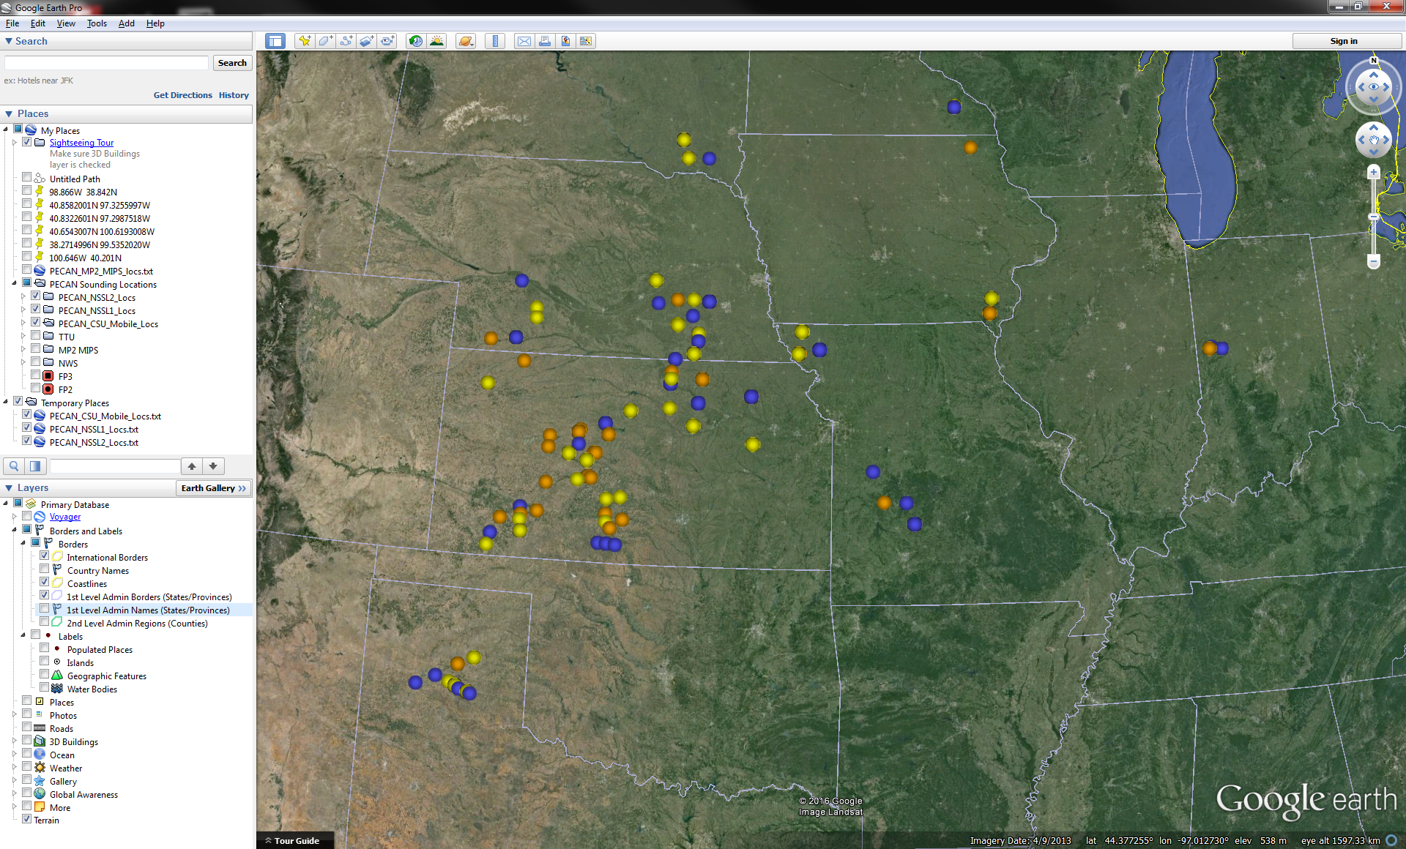

Figure 1. CSU (yellow), NSSL1 (blue), and NSSL2 (orange) MGAUS release locations during PECAN.

1. **Project Overview**

Plains Elevated Convection At Night (PECAN) was a multi-agency project designed to advance the understanding of continental, nocturnal, warm season precipitation. It focused on nocturnal convection in conditions over the central United States plains states with a stable boundary layer (SBL), a nocturnal low-level jet and the largest convective available potential energy located above the SBL. Three aircraft (University of Wyoming King Air, NOAA P-3, and NASA DC-8) as well as a large array of fixed and mobile ground instrumentation were deployed out of Kansas from 1 June to 15 July 2015. Further information on PECAN is available at the PECAN web site: <https://www.eol.ucar.edu/field_projects/pecan> and information on PECAN operations is available at the PECAN Field Catalog: <http://catalog.eol.ucar.edu/pecan>.

1. **File Format Description**

These data were available in either the EOL Sounding Composite (ESC) format or the EOL sounding format (EOL).

**4.1 EOL Sounding Composite Format**

The ESC is a columnar ASCII format consisting of 15 header records for each sounding followed by the data records with associated data quality flags.

The data are in files by day, so all soundings for a particular day are concatenated into a single file ordered by time. The file naming convention is:

SITE_yyyymmdd.cls where SITE is CSU_Mobile/NSSL1/NSSL2, yyyy is the year, mm is the month, and dd is the day of the month.

**4.1.1 Header Records**

The header records (15 total records) contain a variety of metadata about the sounding (i.e. location, time, radiosonde type, etc). The first five header lines contain information identifying the sounding, and have a rigidly defined form. The following 7 header lines are used for auxiliary information and comments about the sounding, and may vary from dataset to dataset. The last 3 header records contain header information for the data columns. Line 13 holds the field names, line 14 the field units, and line 15 contains dashes ('-' characters) delineating the extent of the field.

The file standard header lines are as follows:

|  |  |  |
| --- | --- | --- |
| **Line** | **Label (padded to 35 char)** | **Contents** |
| 1 | Data Type: | Description of the type and resolution of data |
| 2 | Project ID: | Short name for the field project |
| 3 | Release Site Type/Site ID: | Description of the release site. |
| 4 | Release Location (lon,lat,alt): | Location of the release site. |
| 5 | UTC Release Time (y,m,d,h,m,s): | Time of release. |

The release location is given as:

lon (deg min), lat (deg min), lon (dec. deg), lat (dec. deg), alt (m)

Longitude in deg min is in the format: ddd mm.mm'W where ddd is the number of degrees (with leading zeros if necessary), mm.mm is the decimal number of minutes, and W represents W or E for west or east longitude, respectively. Latitude has the same format as longitude, except there are only two digits for degrees and N or S for north/south latitude.

The time of release is given as: yyyy, mm, dd, hh:nn:ss.

Where yyyy is the year, mm is the month, dd is the day of month, and hh:nn:ss are the UTC hour, minute, and second respectively.

The seven non-standard header lines may contain any label and contents. The labels are padded to 35 characters to match the standard header lines. Records for the CSU soundings in this data set include the following non-standard header lines:

|  |  |  |
| --- | --- | --- |
| **Line** | **Label (padded to 35 char)** | **Contents** |
| 6 | Radiosonde Type |  |
| 7 | Radiosonde Serial Number |  |
| 8 | Ground Station Software |  |
| 9 | Ground Check Pressure Corr |  |
| 10 | Ground Check Temperature Corr |  |
| 11 | Ground Check Humidity Corr |  |

Records for the NSSL1 and NSSL2 soundings in this data set include the following non-standard header lines:

|  |  |  |
| --- | --- | --- |
| **Line** | **Label (padded to 35 char)** | **Contents** |
| 6 | Sonde Id/Sonde Type |  |
| 7 | Reference Launch Data Source/Time |  |
| 8 | System Operator/Comments |  |
| 9 | Post Processing Comments |  |

**4.1.2 Data Records**

The data records each contain time from release, pressure, temperature, dew point, relative humidity, U and V wind components, wind speed and direction, ascent rate, balloon position data, altitude, and quality control flags (see the QC code description). Each data line contains 21 fields, separated by spaces, with a total width of 130 characters. The data are right-justified within the fields. All fields have one decimal place of precision, with the exception of latitude and longitude, which have three decimal places of precision. The contents and sizes of the 21 fields that appear in each data record are as follows:

|  |  |  |  |  |  |
| --- | --- | --- | --- | --- | --- |
| **Field** | **Width** | **Format** | **Parameter** | **Units** | **Missing**  **Value** |
| 1 | 6 | F6.1 | Time since release | Seconds | 9999.0 |
| 2 | 6 | F6.1 | Pressure | Millibars | 9999.0 |
| 3 | 5 | F5.1 | Dry-bulb Temperature | Degrees C | 999.0 |
| 4 | 5 | F5.1 | Dew Point Temperature | Degrees C | 999.0 |
| 5 | 5 | F5.1 | Relative Humidity | Percent | 999.0 |
| 6 | 6 | F6.1 | U Wind Comp | m/s | 9999.0 |
| 7 | 6 | F6.1 | V Wind Comp | m/s | 9999.0 |
| 8 | 5 | F5.1 | Wind speed | m/s | 999.0 |
| 9 | 5 | F5.1 | Wind direction | Degrees | 999.0 |
| 10 | 5 | F5.1 | Ascent Rate | m/s | 999.0 |
| 11 | 8 | F8.3 | Longitude | Degrees | 9999.0 |
| 12 | 7 | F7.3 | Latitude | Degrees | 999.0 |
| 13 | 5 | F5.1 | Elevation Angle | Degrees | 999.0 |
| 14 | 5 | F5.1 | Azimuth Angle | Degrees | 999.0 |
| 15 | 7 | F7.1 | Altitude | Meters | 99999.0 |
| 16 | 4 | F4.1 | QC for Pressure | Code | 99.0 |
| 17 | 4 | F4.1 | QC for Temperature | Code | 99.0 |
| 18 | 4 | F4.1 | QC for Humidity | Code | 99.0 |
| 19 | 4 | F4.1 | QC for U Wind | Code | 99.0 |
| 20 | 4 | F4.1 | QC for V Wind | Code | 99.0 |
| 21 | 4 | F4.1 | QC for Ascent Rate | Code | 99.0 |

Fields 16 through 21 contain the data quality flags from the NCAR/Earth Observing Laboratory (EOL) sounding quality control procedures. The data quality flags are defined as follows:

|  |  |
| --- | --- |
| **Code** | **Description** |
| 1.0 | Checked, datum seems physically reasonable. (“GOOD”) |
| 2.0 | Checked, datum seems questionable on a physical basis. (“MAYBE”) |
| 3.0 | Checked, datum seems to be in error. (“BAD”) |
| 4.0 | Checked, datum is interpolated. (“ESTIMATED”) |
| 9.0 | Checked, datum is missing. (“MISSING”) |
| 99.0 | Unchecked (QC information is “missing”.) (“UNCHECKED”) |

**4.1.3 Sample ESC Formatted Data**

The following is a sample of the PECAN CSU/NCSU/MSSL MGAUS high resolution radiosonde data in ESC format.

Data Type: CSU Mobile Radiosonde/Ascending

Project ID: PECAN

Release Site Type/Site ID: Mobile/CSU_Mobile

Release Location (lon,lat,alt): 097 18.66'W, 40 53.85'N, -97.311, 40.898, 485.0

UTC Release Time (y,m,d,h,m,s): 2015, 06, 11, 01:55:00

Radiosonde Type: RS92-SGP

Radiosonde Serial Number: K2133295

Ground Station Software: Digicora MW41 2.1.0

Ground Check Pressure Corr: 0.23

Ground Check Temperature Corr: -0.15

Ground Check Humidity Corr: U1: 0.4/U2: 0.5

Nominal Release Time (y,m,d,h,m,s):2015, 06, 11, 01:55:00

Time Press Temp Dewpt RH Ucmp Vcmp spd dir Wcmp Lon Lat Ele Azi Alt Qp Qt Qrh Qu Qv QdZ

sec mb C C % m/s m/s m/s deg m/s deg deg deg deg m code code code code code code

------ ------ ----- ----- ----- ------ ------ ----- ----- ----- -------- ------- ----- ----- ------- ---- ---- ---- ---- ---- ----

0.0 950.7 22.6 16.0 66.0 -0.8 -7.5 7.5 6.0 999.0 -97.311 40.898 999.0 999.0 485.0 99.0 99.0 99.0 99.0 99.0 9.0

1.0 950.0 22.6 16.3 68.0 -0.1 -6.7 6.7 1.0 6.4 -97.311 40.898 999.0 999.0 491.4 2.0 2.0 2.0 99.0 99.0 99.0

2.0 948.9 22.6 16.6 69.0 0.5 -6.5 6.5 356.0 10.1 -97.311 40.899 999.0 999.0 501.6 2.0 2.0 2.0 99.0 99.0 99.0

3.0 948.0 22.5 16.7 70.0 0.7 -6.6 6.6 354.0 8.3 -97.311 40.899 999.0 999.0 509.9 99.0 99.0 99.0 99.0 99.0 99.0

**4.2 EOL Sounding Format**

The EOL format is an ASCII text format that includes a header (Table 1), with detailed project and sounding information, and seventeen columns of high resolution data (Table 2).

The naming convention for these files is "D", followed by "yyyymmdd_hhmmss_P.1.eol" where yyyy = year, mm = month, hh = hour of the day UTC, mm = minute of the hour, ss = second of the hour (which refer to the launch time of the radiosonde).

The header (Table 1) contains information including data type, project name, site location, actual release time, and other specialized information. The first seven header lines contain information identifying the sounding. The release location is given as: lon (deg min), lon (dec. deg), lat (deg min), lat (dec. deg), altitude (meters). Longitude in deg min is in the format: ddd mm.mm'W where ddd is the number of degrees from True North (with leading zeros if necessary), mm.mm is the decimal number of minutes, and W represents W or E for west or east longitude, respectively. Latitude has the same format as longitude, except there are only two digits for degrees and N or S for north/south latitude. The following three header lines contain information about the data system and auxiliary information and comments about the sounding. The last 3 header lines contain header information for the data columns. Line 12 holds the field names, line 13 the field units, and line 14 contains dashes (--- characters) signifying the end of the header.

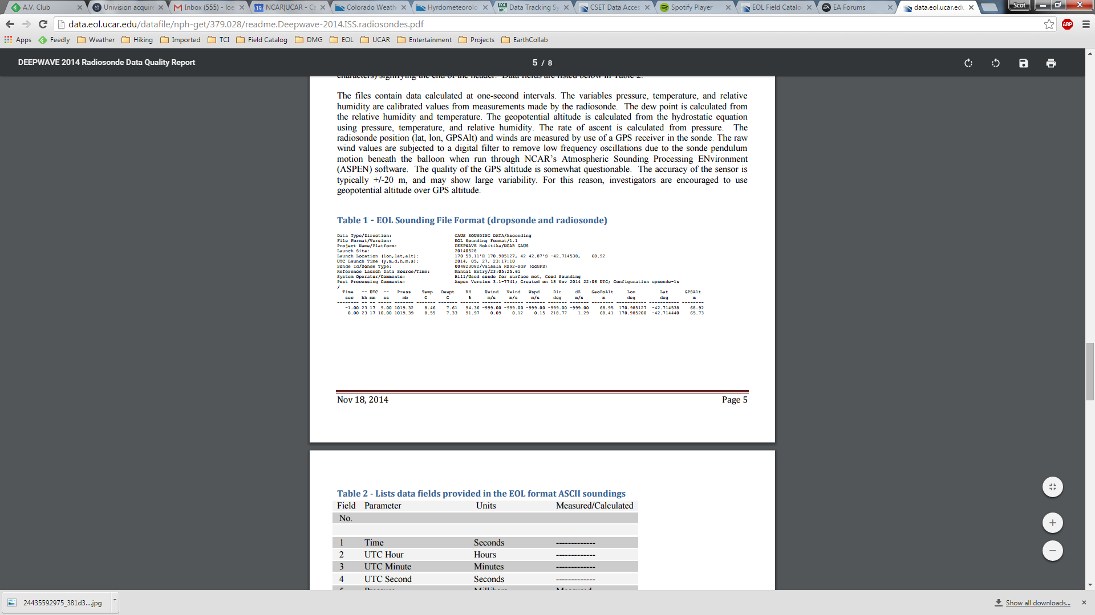

Data fields are listed below in Table 2.

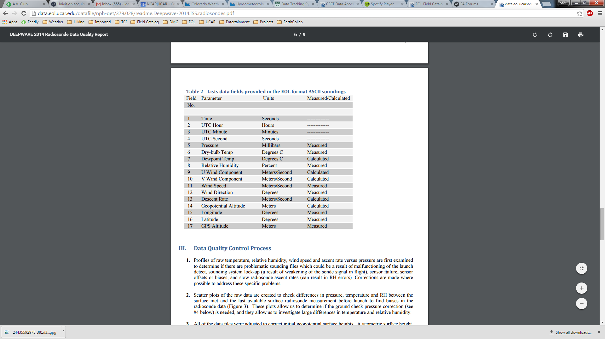

**4.3 Data Specifics**

The files contain data at one-second intervals.

The CSU/NCSU/NSSL MGAUS used Vaisala RS92-SGP radiosondes during PECAN.

An additional file is included in this data set that contains release notes from the CSU Mobile crew: PECAN_CSU_Mobile_Launch_Notes.xlsx

One of the CSU Mobile soundings (CSU_Mobile_201506110404) had an incorrect release location and thus incorrect altitude data. The correct location was obtained using the radiosonde GPS location (once the values settled in) and the surface elevation for that location was obtained from Google Earth. The geopotential heights in the file were then derived using this new surface value. For consistency, the same geopotential height calculations were run for every CSU Mobile sounding. Note that due to limited data resolution, there are issues with point to point variability in the height values above ~175mb.

**4.5 Station List**

|  |  |  |  |  |  |  |
| --- | --- | --- | --- | --- | --- | --- |
| **Site ID** | **WMO ID** | **Site Name** | **State** | **Latitude** | **Longitude** | **Elev (m)** |
| CSU_Mobile | N/A | CSU Mobile | Mobile | Mobile | Mobile | Mobile |
| NSSL1 | N/A | NSSL1 Mobile | Mobile | Mobile | Mobile | Mobile |
| NSSL2 | N/A | NSSL2 Mobile | Mobile | Mobile | Mobile | Mobile |

**5.0 Data Quality Control Procedures**

1. Each sounding was converted from its original format into the ESC format described above.
2. Each sounding was passed through a set of automated data quality checks which included basic gross limit checks as well as rate of change checks. This is further described in Section 4.1.
3. Each sounding was visually examined utilizing the NCAR/EOL XQC sounding quality control software. This is further described in Section 4.2.

**5.1 Automated Data Quality Checks**

This data set was passed through a set of automated data quality checks. This procedure includes both gross limit checks on all parameters as well as rate-of-change checks on temperature, pressure, and ascent rate. A version of these checks is described in Loehrer et al. (1996) and Loehrer et al. (1998).

**5.1.1 Gross Limit Checks**

These checks were conducted on each sounding and the data quality flags in the ESC files were adjusted as appropriate. Only the data point under examination was flagged. All checks also produced warning messages that specified the location of the problem and the severity of the issue. These warning messages where then summarized statistically and examined to determine any consistent issues.

For this data set NCAR/EOL conducted the following gross limit checks. In the table P = pressure, T = temperature, RH = relative humidity, U = U wind component, V = V wind component, B= bad, and Q = questionable.

|  |  |  |  |
| --- | --- | --- | --- |
| **Parameter** | **Check** | **Parameter(s) Flagged** | **Flag Applied** |
| Pressure | <0 or > 1050 | P | B |
| Altitude | < 0 or >40000 | P, T, RH | Q |
| Temperature | < -90 or > 45 | T | B |
| Dew Point | < -99.9 or > 33  > T | RH  T, RH | Q  Q |
| Wind Speed | < 0 or > 100  > 150 | U, V  U, V | Q  B |
| U Wind | < 0 or > 100  > 150 | U  U | Q  B |
| V Wind | < 0 or > 100  > 150 | V  V | Q  B |
| Wind Direction | < 0 or > 360 | U, V | B |
| Ascent Rate | < -10 or > 10 | P, T, RH | Q |

**5.1.2 Vertical Consistency Checks**

These checks were conducted on each sounding and the data quality flags in the ESC files were adjusted as appropriate. These checks were started at the surface and compared each neighboring data record. In the case of checks that ensured that the values increased/decreased as expected, only the data point under examination was flagged. However, for the other checks, all of the data points used in the examination were flagged. All items within the table are as previously defined. All checks also produced warning messages that specified the location of the problem and the severity of the issue. These warning messages where then summarized statistically and examined to determine any consistent issues.

|  |  |  |  |
| --- | --- | --- | --- |
| **Parameter** | **Check** | **Parameter(s) Flagged** | **Flag Applied** |
| Time | Decreasing/equal | None | None. |
| Altitude | Decreasing/equal | P, T, RH | Q |
| Pressure | Increasing/equal  > 1mb/s or < -1mb/s  > 2mb/s or < -2mb/s | P, T, TH  P, T, TH  P, T, TH | Q  Q  B |
| Temperature | < -15oC/km  < -30oC/km  > 50oC/km  > 100oC/km | P, T, RH  P, T, RH  P, T, RH  P, T, RH | Q  B  Q  B |
| Ascent Rate | > 3m/s or < -3m/s  > 5m/s or < -5m/s | P  P | Q  B |

**5.2 Visual Data Quality Checks**

Each sounding was visually examined using the NCAR/EOL XQC sounding data quality control software. This software allows the user to view a skew-t/log-p diagram of each sounding and apply data quality flags as appropriate. The user can zoom in on sections of soundings for detailed examination and can adjust the data quality flags for an individual point, sections of soundings, or entire soundings for each parameter individually. The software also allows the user to override the quality flags applied by the automated procedure.

**5.3 Data Quality Issues of Note**

The data quality control procedures outlined above allows us to identify and, in some cases, resolve issues that could potentially impact research performed using these data sets. The following issues were noted in these soundings.

**Updraft Soundings** –

CSU_Mobile_201506110155

CSU_Mobile_201507060350

CSU_Mobile_201507060516

CSU_Mobile_201507090403

CSU_Mobile_201507160357

NSSL1_201507020410 – also periods of slow ascent especially around 580mb

NSSL1_201507130631 – also spotty RH data 878-522mb, no data above 506mb, winds

NSSL1_201507140500 – also spotty RH data 882-480mb

NSSL2_201507020444 – also no RH data

NSSL2_201507130615 – also several periods of descent

NSSL2_201507150622

**Limited Data** –

CSU_Mobile_201506170547 – no data above 812mb.

CSU_Mobile_201506260542 – no GPS/wind data above 726mb

CSU_Mobile_201507090724 – no data above 571mb

CSU_Mobile_201507150722 – no data above 929mb

NSSL1_201506050259 – no data above 534mb

NSSL1_201506110314 – no data above 740mb

NSSL1_201506110408 – no data above 542mb

NSSL1_201506250339 – no data above 767mb

NSSL1_201506260613 – no data above 607mb

NSSL1_201507010900 – little data above 637mb

NSSL1_201507020604 – no data above 781mb

NSSL1_201507060429 – no data above 757mb, little RH data above 824mb

NSSL1_201507090430 – little data above 718mb

NSSL1_201507090621 – spotty RH data 760-470mb

NSSL1_201507090726 – spotty RH data 840-536mb, periods of descent ~529 and 492mb

NSSL1_201507100504 – no data above 620mb

NSSL2_201506110600 – no data above 564mb

NSSL2_201506120742 – no data above 637mb

NSSL2_201507020637 – no RH data

NSSL2_201507060408 – no data above 522mb

NSSL2_201507090726 – no data above 689mb

NSSL2_201507130731 – no data above 573mb

NSSL2_201507150747 – no data above 808mb (little above 872mb)

**Other Items** –

CSU_Mobile_201506250200 – questionable wind speed spike ~150mb.

CSU_Mobile_201506250525 – RH cycling issue for much of sounding, flagged questionable.

NSSL1_201506110200 – wetbulbing ~663 and 551mb

NSSL1_201506110408 – wetbulbing ~710 and 668mb

NSSL1_201506120406 – no RH data

NSSL1_201506120518 – little data above 661mb

NSSL1_201506150208 – no RH data, wetbulbing ~581mb

NSSL1_201507020316 – wetbulbing ~520mb

NSSL2_201506170350 – wetbulbing ~447mb

NSSL2_201506260449 – long period of descent ~310mb, a couple other periods higher up, little RH data 930-505mb

NSSL2_201507090511 – long period of descent 610mb

NSSL2_2015100115 – periods of bad data 268-303 and 492-505 seconds.

**6.0 References**

Loehrer, S. M., T. A. Edmands, and J. A. Moore, 1996: TOGA COARE upper-air sounding data archive: development and quality control procedures. Bull. Amer. Meteor. Soc., 77, 2651-2671.

Loehrer, S. M., S. F. Williams, and J. A. Moore, 1998: Results from UCAR/JOSS quality control of atmospheric soundings from field projects. Preprints, Tenth Symposium on Meteorological Observations and Instrumentation, Phoenix, AZ, Amer. Meteor. Soc., 1-6.