1. **Contacts:**

**NCAR/EOL Processing and Quality Control:**

Scot Loehrer (NCAR/EOL)

[loehrer@ucar.edu](mailto:loehrer@ucar.edu)

**Original Data Source:**

Temple R. Lee (temple.lee@noaa.gov)

Michael Buban (michael.buban@noaa.gov)

Tilden Meyers (tilden.meyers@noaa.gov)

**DOI:**

doi:10.5065/D68K77FN

**Sample Citation:**

Lee, T. R., M. Buban, T. Meyers, 2016. NOAA/ATDD Mobile Radiosonde Data, Version 1.0. http://doi.org/10.5065/D68K77FN. Accessed 21 July 2016.

1. **Dataset Overview**

NOAA/ATDD utilized a mobile radiosonde system to release radiosondes at locations around northern Alabama (Figure 1) during VORTEX-SE_2016 Intensive Observation Periods (IOPs). The choices for the locations and times of the releases were made in collaboration with other VORTEX-SE PIs. During all but one of the IOPs (IOP1 on 13-14 March) there were two separate NOAA/ATDD teams releasing radiosondes. This data set includes the 62 high vertical resolution (1-second), quality controlled NOAA/ATDD mobile soundings released for the VORTEX-SE_2016 field phase (13 March to 1 May 2016).

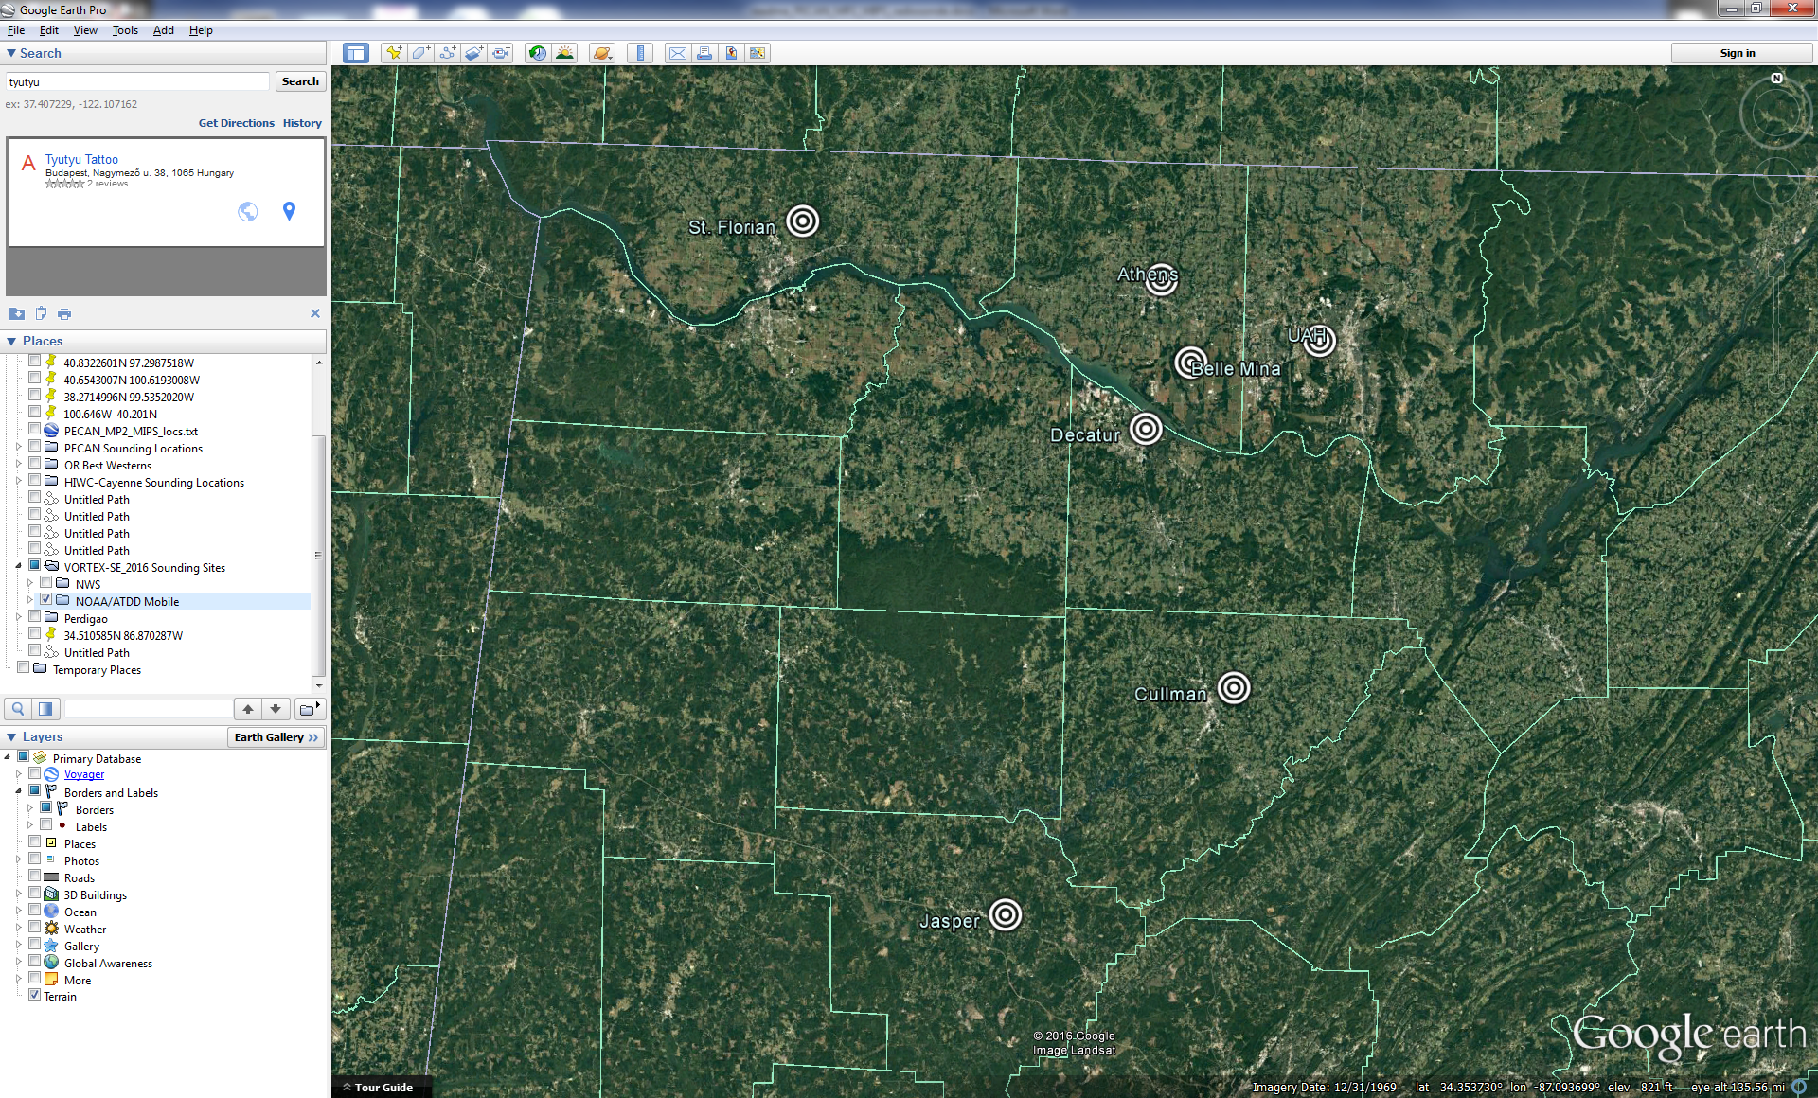

Figure 1. Location of the NOAA/ATDD mobile radiosonde sites.

1. **Project Overview**

The **Verification of the Origins of Rotation in Tornadoes Experiment-Southeast (VORTEX-SE)** is a research program to understand how environmental factors characteristic of the southeastern United States affect the formation, intensity, structure, and path of tornadoes in this region. VORTEX-SE will also determine the best methods for communicating forecast uncertainty related to these events to the public, and evaluate public response. For the 2016 field season a large array of fixed and mobile ground instrumentation were deployed around Huntsville, AL from 1 March to 1 May 2016. Further information on VORTEX-SE is available at the VORTEX-SE web site at NCAR/EOL: <https://www.eol.ucar.edu/field_projects/vortex-se> and information on the VORTEX-SE_2016 deployments is available at the VORTEX-SE_2016 Field Catalog: <http://catalog.eol.ucar.edu/vortex-se_2016>.

1. **EOL Sounding Composite (ESC) File Format Description**

The ESC is a columnar ASCII format consisting of 15 header records for each sounding followed by the data records with associated data quality flags.

**3.1 Header Records**

The header records (15 total records) contain a variety of metadata about the sounding (i.e. location, time, radiosonde type, etc). The first five header lines contain information identifying the sounding, and have a rigidly defined form. The following 7 header lines are used for auxiliary information and comments about the sounding, and may vary from dataset to dataset. The last 3 header records contain header information for the data columns. Line 13 holds the field names, line 14 the field units, and line 15 contains dashes ('-' characters) delineating the extent of the field.

The file standard header lines are as follows:

|  |  |  |
| --- | --- | --- |
| **Line** | **Label (padded to 35 char)** | **Contents** |
| 1 | Data Type: | Description of the type and resolution of data |
| 2 | Project ID: | Short name for the field project |
| 3 | Release Site Type/Site ID: | Description of the release site. |
| 4 | Release Location (lon,lat,alt): | Location of the release site. |
| 5 | UTC Release Time (y,m,d,h,m,s): | Time of release. |

The release location is given as:

lon (deg min), lat (deg min), lon (dec. deg), lat (dec. deg), alt (m)

Longitude in deg min is in the format: ddd mm.mm'W where ddd is the number of degrees (with leading zeros if necessary), mm.mm is the decimal number of minutes, and W represents W or E for west or east longitude, respectively. Latitude has the same format as longitude, except there are only two digits for degrees and N or S for north/south latitude.

The time of release is given as: yyyy, mm, dd, hh:nn:ss.

Where yyyy is the year, mm is the month, dd is the day of month, and hh:nn:ss are the UTC hour, minute, and second respectively.

The seven non-standard header lines may contain any label and contents. The labels are padded to 35 characters to match the standard header lines. Records for this data set include the following non-standard header lines:

|  |  |  |
| --- | --- | --- |
| **Line** | **Label (padded to 35 char)** | **Contents** |
| 6 | Radiosonde Type |  |
| 7 | Ground Station Equipment |  |

**3.2 Data Records**

The data records each contain time from release, pressure, temperature, dew point, relative humidity, U and V wind components, wind speed and direction, ascent rate, balloon position data, altitude, and quality control flags (see the QC code description). Each data line contains 21 fields, separated by spaces, with a total width of 130 characters. The data are right-justified within the fields. All fields have one decimal place of precision, with the exception of latitude and longitude, which have three decimal places of precision. The contents and sizes of the 21 fields that appear in each data record are as follows:

|  |  |  |  |  |  |
| --- | --- | --- | --- | --- | --- |
| **Field** | **Width** | **Format** | **Parameter** | **Units** | **Missing**  **Value** |
| 1 | 6 | F6.1 | Time since release | Seconds | 9999.0 |
| 2 | 6 | F6.1 | Pressure | Millibars | 9999.0 |
| 3 | 5 | F5.1 | Dry-bulb Temperature | Degrees C | 999.0 |
| 4 | 5 | F5.1 | Dew Point Temperature | Degrees C | 999.0 |
| 5 | 5 | F5.1 | Relative Humidity | Percent | 999.0 |
| 6 | 6 | F6.1 | U Wind Comp | m/s | 9999.0 |
| 7 | 6 | F6.1 | V Wind Comp | m/s | 9999.0 |
| 8 | 5 | F5.1 | Wind speed | m/s | 999.0 |
| 9 | 5 | F5.1 | Wind direction | Degrees | 999.0 |
| 10 | 5 | F5.1 | Ascent Rate | m/s | 999.0 |
| 11 | 8 | F8.3 | Longitude | Degrees | 9999.0 |
| 12 | 7 | F7.3 | Latitude | Degrees | 999.0 |
| 13 | 5 | F5.1 | Elevation Angle | Degrees | 999.0 |
| 14 | 5 | F5.1 | Azimuth Angle | Degrees | 999.0 |
| 15 | 7 | F7.1 | Altitude | Meters | 99999.0 |
| 16 | 4 | F4.1 | QC for Pressure | Code | 99.0 |
| 17 | 4 | F4.1 | QC for Temperature | Code | 99.0 |
| 18 | 4 | F4.1 | QC for Humidity | Code | 99.0 |
| 19 | 4 | F4.1 | QC for U Wind | Code | 99.0 |
| 20 | 4 | F4.1 | QC for V Wind | Code | 99.0 |
| 21 | 4 | F4.1 | QC for Ascent Rate | Code | 99.0 |

Fields 16 through 21 contain the data quality flags from the NCAR/Earth Observing Laboratory (EOL) sounding quality control procedures. The data quality flags are defined as follows:

|  |  |
| --- | --- |
| **Code** | **Description** |
| 1.0 | Checked, datum seems physically reasonable. (“GOOD”) |
| 2.0 | Checked, datum seems questionable on a physical basis. (“MAYBE”) |
| 3.0 | Checked, datum seems to be in error. (“BAD”) |
| 4.0 | Checked, datum is interpolated. (“ESTIMATED”) |
| 9.0 | Checked, datum is missing. (“MISSING”) |
| 99.0 | Unchecked (QC information is “missing”.) (“UNCHECKED”) |

**3.3 Data Specifics**

The files contain data at one-second intervals.

The data are in files by day, so all soundings for a particular day are concatenated into a single file ordered by time. The file naming convention is:

ATDD_yyyymmdd.cls where yyyy is the year, mm is the month, and dd is the day of the month.

NOAA/ATDD utilized GRAW DFM-09 radiosondes using GPS for windfinding during VORTEX-SE_2016 and using GRAW software version 5.9.3.10.

**Table 1**: Manufacturer-stated accuracy and resolution for each of the variables sampled by the GRAW DFM-09 rawinsondes (available from <http://www.graw.de/home/products2/radiosondes0/radiosondedfm-090/>)

|  |  |
| --- | --- |
| Temperature resolution | 0.1°C |
| Temperature accuracy | <0.2°C |
| Humidity resolution | 1% |
| Humidity accuracy | <5% |
| Pressure accuracy | <0.3 mb |
| Geopotential height acc | <10 m |
| Wind speed accuracy | <0.2 m s-1 |
| Horizontal position acc | <5 m |

**3.4 Sample Data**

The following is a sample of the NOAA/ATDD mobile high resolution radiosonde data in ESC format.

Data Type: NOAA ATDD Mobile Sounding Data/Ascending

Project ID: VORTEX-SE_2016

Release Site Type/Site ID: UAH SWIRLL, AL

Release Location (lon,lat,alt): 086 38.76'W, 34 43.49'N, -86.646, 34.725, 206.0

UTC Release Time (y,m,d,h,m,s): 2016, 03, 13, 18:00:00

Radiosonde Type: GRAW DFM-09

Ground Station Software: Version 5.9.3.10

/

/

/

/

Nominal Release Time (y,m,d,h,m,s):2016, 03, 13, 18:00:00

Time Press Temp Dewpt RH Ucmp Vcmp spd dir Wcmp Lon Lat Ele MixR Alt Qp Qt Qrh Qu Qv QdZ

sec mb C C % m/s m/s m/s deg m/s deg deg deg g/kg m code code code code code code

------ ------ ----- ----- ----- ------ ------ ----- ----- ----- -------- ------- ----- ----- ------- ---- ---- ---- ---- ---- ----

0.0 9999.0 999.0 999.0 999.0 9999.0 9999.0 999.0 999.0 999.0 -86.646 34.725 999.0 999.0 206.0 9.0 9.0 9.0 9.0 9.0 9.0

1.0 986.5 22.0 15.0 64.2 1.4 1.4 2.0 226.0 4.7 -86.646 34.725 999.0 11.0 210.7 3.0 3.0 3.0 99.0 99.0 99.0

2.0 985.9 21.7 14.8 65.1 1.7 1.6 2.3 226.0 5.3 -86.646 34.725 999.0 10.9 216.0 3.0 3.0 3.0 99.0 99.0 99.0

**3.5 Station List**

|  |  |  |  |  |
| --- | --- | --- | --- | --- |
| **IOP** | **Site Name** | **Latitude** | **Longitude** | **Elev (m)** |
| 3 | Athens, AL | 34.814459 N | 86.941128 W | 209 |
| 1,2,3,4,5,7 | Belle Mina, AL | 34.689060 N | 86.883967 W | 189 |
| 2,4,5,6 | Cullman, AL | 34.194428 N | 86.796954 W | 245 |
| 7 | Decatur, AL | 34.587053 N | 86.965791 W | 185 |
| 6 | Jasper, AL | 33.843538 N | 87.210181 W | 127 |
| 3 | St. Florian, AL | 34.894121 N | 87.608493 W | 207 |

**4.0 Data Quality Control Procedures**

1. NOAA/ATDD did initial post-processing that included filtering times during which the radiosonde was on the ground as well as removing any data after balloon burst as well as obvious outliers.
2. NCAR/EOL converted each sounding from its original format into the ESC format described above.
3. NCAR/EOL passed each sounding through a set of automated data quality checks which included basic gross limit checks as well as rate of change checks. This is further described in Section 4.1.
4. NCAR/EOL visually examined each sounding utilizing the NCAR/EOL XQC sounding quality control software. This is further described in Section 4.2.

**4.1 Automated Data Quality Checks**

This data set was passed through a set of automated data quality checks. This procedure includes both gross limit checks on all parameters as well as rate-of-change checks on temperature, pressure, and ascent rate. A version of these checks is described in Loehrer et al. (1996) and Loehrer et al. (1998).

**4.1.1 Gross Limit Checks**

These checks were conducted on each sounding and the data quality flags in the ESC files were adjusted as appropriate. Only the data point under examination was flagged. All checks also produced warning messages that specified the location of the problem and the severity of the issue. These warning messages where then summarized statistically and examined to determine any consistent issues.

For this data set NCAR/EOL conducted the following gross limit checks. In the table P = pressure, T = temperature, RH = relative humidity, U = U wind component, V = V wind component, B= bad, and Q = questionable.

|  |  |  |  |
| --- | --- | --- | --- |
| **Parameter** | **Check** | **Parameter(s) Flagged** | **Flag Applied** |
| Pressure | <0 or > 1050 | P | B |
| Altitude | < 0 or >40000 | P, T, RH | Q |
| Temperature | < -90 or > 45 | T | B |
| Dew Point | < -99.9 or > 33  > T | RH  T, RH | Q  Q |
| Wind Speed | < 0 or > 100  > 150 | U, V  U, V | Q  B |
| U Wind | < 0 or > 100  > 150 | U  U | Q  B |
| V Wind | < 0 or > 100  > 150 | V  V | Q  B |
| Wind Direction | < 0 or > 360 | U, V | B |
| Ascent Rate | < -10 or > 10 | P, T, RH | Q |

**4.1.2 Vertical Consistency Checks**

These checks were conducted on each sounding and the data quality flags in the ESC files were adjusted as appropriate. These checks were started at the surface and compared each neighboring data record. In the case of checks that ensured that the values increased/decreased as expected, only the data point under examination was flagged. However, for the other checks, all of the data points used in the examination were flagged. All items within the table are as previously defined. All checks also produced warning messages that specified the location of the problem and the severity of the issue. These warning messages where then summarized statistically and examined to determine any consistent issues.

|  |  |  |  |
| --- | --- | --- | --- |
| **Parameter** | **Check** | **Parameter(s) Flagged** | **Flag Applied** |
| Time | Decreasing/equal | None | None. |
| Altitude | Decreasing/equal | P, T, RH | Q |
| Pressure | Increasing/equal  > 1mb/s or < -1mb/s  > 2mb/s or < -2mb/s | P, T, TH  P, T, TH  P, T, TH | Q  Q  B |
| Temperature | < -15oC/km  < -30oC/km  > 50oC/km  > 100oC/km | P, T, RH  P, T, RH  P, T, RH  P, T, RH | Q  B  Q  B |
| Ascent Rate | > 3m/s or < -3m/s  > 5m/s or < -5m/s | P  P | Q  B |

**4.2 Visual Data Quality Checks**

Each sounding was visually examined using the NCAR/EOL XQC sounding data quality control software. This software allows the user to view a skew-t/log-p diagram of each sounding and apply data quality flags as appropriate. The user can zoom in on sections of soundings for detailed examination and can adjust the data quality flags for an individual point, sections of soundings, or entire soundings for each parameter individually. The software also allows the user to override the quality flags applied by the automated procedure.

**4.3 Data Quality Issues of Note**

The data quality control procedures outlined above allows us to identify and, in some cases, resolve issues that could potentially impact research performed using these data sets. The following issues were noted in these soundings.

**Surface data** – No independent surface observations were collected, so the surface data record has missing values other than the geopotential altitude.

**Geopotential altitude data** – The raw data file contained altitude above ground level data. We used the hypsometric equation to derive the geopotential altitude values. Since there was no surface data for the 1 second record the value in the geopotential altitude column is the surface elevation plus the altitude above ground level of that record from the raw data.

**Other issues**

**2016040101 Athens** – Temperature spike at 540mb.

**201604300000 Belle Mina** – no data above 637mb

**201604292200 Cullman** – temperature spike at 450mb

**201604292300 Cullman** – a couple periods of descent first ~788mb and second ~287mb. Temperature spike at 583mb.

**201605011730 Decatur** – Winds bad 269-241mb.

**5.0 References**

Loehrer, S. M., T. A. Edmands, and J. A. Moore, 1996: TOGA COARE upper-air sounding data archive: development and quality control procedures. Bull. Amer. Meteor. Soc., 77, 2651-2671.

Loehrer, S. M., S. F. Williams, and J. A. Moore, 1998: Results from UCAR/JOSS quality control of atmospheric soundings from field projects. Preprints, Tenth Symposium on Meteorological Observations and Instrumentation, Phoenix, AZ, Amer. Meteor. Soc., 1-6.