1. **Contacts:**

**NCAR/EOL Processing and Quality Control:**

Scot Loehrer (NCAR/EOL)

[loehrer@ucar.edu](mailto:loehrer@ucar.edu)

**Original Data Source:**

NOAA/NWS

1. **Dataset Overview**

The National Weather Service (NWS) routinely releases radiosondes at 00 and 12 UTC with occasional special releases at sites throughout the United States. This data set includes the quality controlled NWS soundings released at 18 sites (Figure 1) throughout the central United States region during the TORUS_2019 field phase (15 May to 20 June 2019). Three of the stations were only available at mandatory and significant levels. A total of 1343 soundings are included in the final TORUS_2019 data set, 1128 with 1-second vertical resolution and 215 with mandatory/significant level resolution.

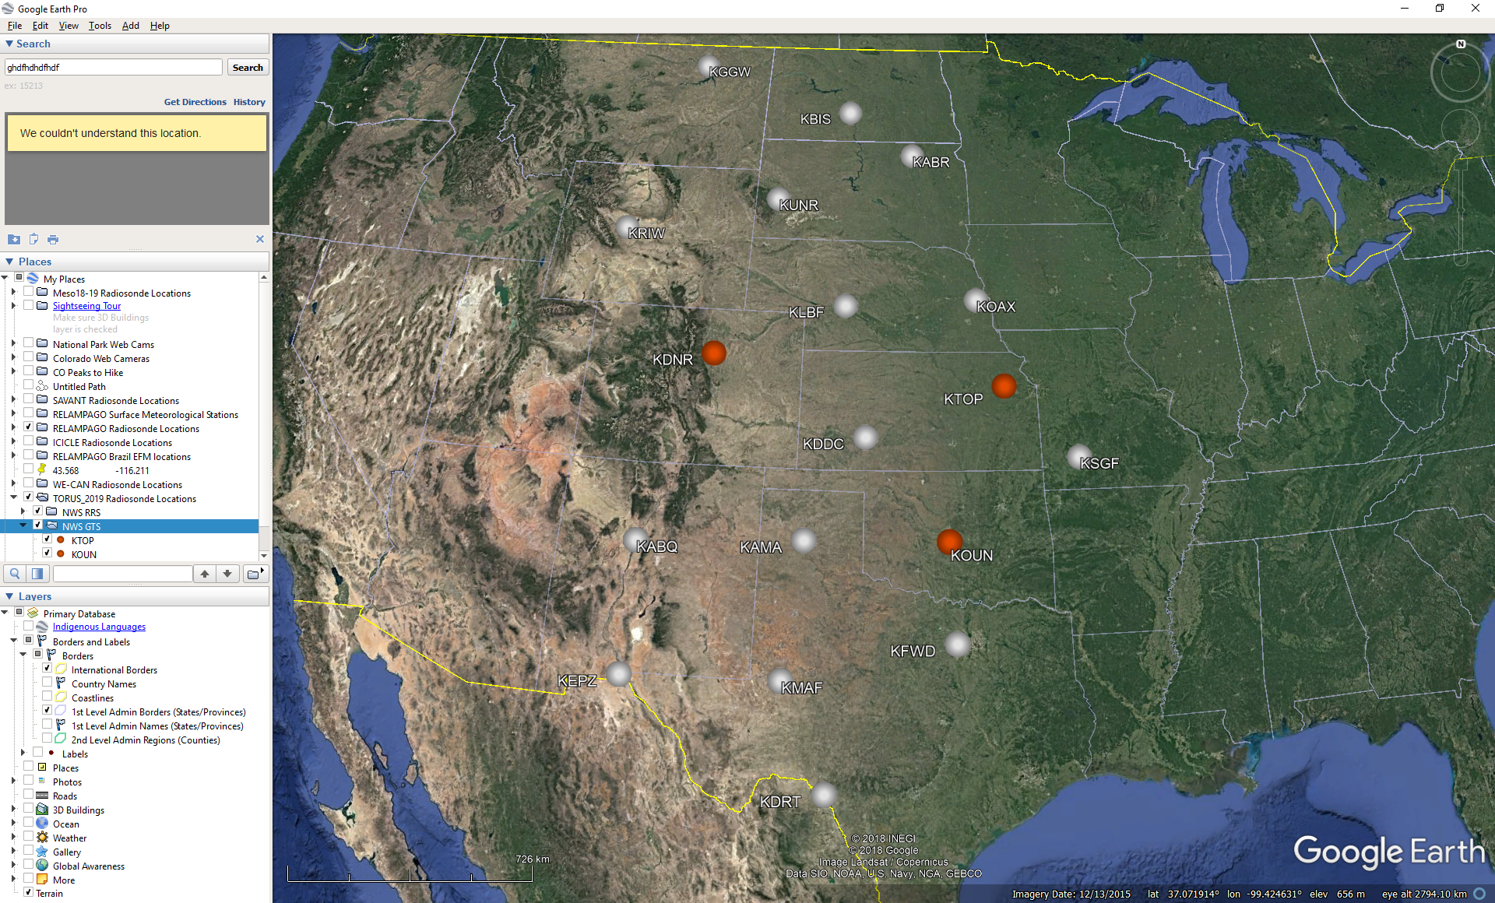

Figure 1. Location of TORUS_2019 NWS radiosonde sites. Stations with a white circle have one second vertical resolution data and those with orange circles have mandatory and significant level data.

1. **Project Overview**

The Targeted Observation by Radars and UAS of Supercells (TORUS) project is a nomadic field campaign during the spring storm seasons (May and June) of 2019 and 2020 over a domain covering much of the central United States where there exists significant point probabilities of tornado-bearing supercell storms. TORUS aims to use the data collected to improve the conceptual model of supercell thunderstorms (the parent storms of the most destructive tornadoes) by exposing how small-scale structures within these storms might lead to tornado formation. These structures are hypothesized to be nearly invisible to all but the most precise research-grade instruments. But by revealing the hidden composition of severe storms and associating it to known characteristics of the regularly-observed larger scale environment, the TORUS project could improve supercell and tornado forecasts. For the 2019 field season the field instrumentation included the NOAA P-3 aircraft, unmanned aircraft systems from the University of Colorado Boulder and the University of Nebraska-Lincoln, Ka band mobile radars from Texas Tech University, the NOAA X-band Polarimetric (NOXP) mobile radar, mobile mesonets as well as a mobile radiosonde and lidar system from NOAA/NSSL. Further information on TORUS is available at the TORUS web site at NCAR/EOL: <https://www.eol.ucar.edu/field_projects/torus> and information on the TORUS_2019 deployments is available at the TORUS_2019 Field Catalog: <http://catalog.eol.ucar.edu/torus_2019>.

1. **EOL Sounding Composite (ESC) File Format Description**

The ESC is a columnar ASCII format consisting of 15 header records for each sounding followed by the data records with associated data quality flags.

**4.1 Header Records**

The header records (15 total records) contain a variety of metadata about the sounding (i.e. location, time, radiosonde type, etc). The first five header lines contain information identifying the sounding, and have a rigidly defined form. The following 7 header lines are used for auxiliary information and comments about the sounding, and may vary from dataset to dataset. The last 3 header records contain header information for the data columns. Line 13 holds the field names, line 14 the field units, and line 15 contains dashes ('-' characters) delineating the extent of the field.

The file standard header lines are as follows:

|  |  |  |
| --- | --- | --- |
| **Line** | **Label (padded to 35 char)** | **Contents** |
| 1 | Data Type: | Description of the type and resolution of data |
| 2 | Project ID: | Short name for the field project |
| 3 | Release Site Type/Site ID: | Description of the release site. |
| 4 | Release Location (lon,lat,alt): | Location of the release site. |
| 5 | UTC Release Time (y,m,d,h,m,s): | Time of release. |

The release location is given as:

lon (deg min), lat (deg min), lon (dec. deg), lat (dec. deg), alt (m)

Longitude in deg min is in the format: ddd mm.mm'W where ddd is the number of degrees (with leading zeros if necessary), mm.mm is the decimal number of minutes, and W represents W or E for west or east longitude, respectively. Latitude has the same format as longitude, except there are only two digits for degrees and N or S for north/south latitude.

The time of release is given as: yyyy, mm, dd, hh:nn:ss.

Where yyyy is the year, mm is the month, dd is the day of month, and hh:nn:ss are the UTC hour, minute, and second respectively.

The seven non-standard header lines may contain any label and contents. The labels are padded to 35 characters to match the standard header lines. Records for this data set include the following non-standard header lines:

|  |  |  |
| --- | --- | --- |
| **Line** | **Label (padded to 35 char)** | **Contents** |
| 6 | Ascension Number | Number sounding this year |
| 7 | Radiosonde Serial Number |  |
| 8 | Balloon Manufacturer/Type |  |
| 9 | Balloon Lot Number/Weight |  |
| 10 | Radiosonde Type/RH Sensor Type |  |
| 11 | Surface Observations |  |

**4.2 Data Records**

The data records each contain time from release, pressure, temperature, dew point, relative humidity, U and V wind components, wind speed and direction, ascent rate, balloon position data, altitude, and quality control flags (see the QC code description). Each data line contains 21 fields, separated by spaces, with a total width of 130 characters. The data are right-justified within the fields. All fields have one decimal place of precision, with the exception of latitude and longitude, which have three decimal places of precision. The contents and sizes of the 21 fields that appear in each data record are as follows:

|  |  |  |  |  |  |
| --- | --- | --- | --- | --- | --- |
| **Field** | **Width** | **Format** | **Parameter** | **Units** | **Missing**  **Value** |
| 1 | 6 | F6.1 | Time since release | Seconds | 9999.0 |
| 2 | 6 | F6.1 | Pressure | Millibars | 9999.0 |
| 3 | 5 | F5.1 | Dry-bulb Temperature | Degrees C | 999.0 |
| 4 | 5 | F5.1 | Dew Point Temperature | Degrees C | 999.0 |
| 5 | 5 | F5.1 | Relative Humidity | Percent | 999.0 |
| 6 | 6 | F6.1 | U Wind Comp | m/s | 9999.0 |
| 7 | 6 | F6.1 | V Wind Comp | m/s | 9999.0 |
| 8 | 5 | F5.1 | Wind speed | m/s | 999.0 |
| 9 | 5 | F5.1 | Wind direction | Degrees | 999.0 |
| 10 | 5 | F5.1 | Ascent Rate | m/s | 999.0 |
| 11 | 8 | F8.3 | Longitude | Degrees | 9999.0 |
| 12 | 7 | F7.3 | Latitude | Degrees | 999.0 |
| 13 | 5 | F5.1 | Elevation Angle | Degrees | 999.0 |
| 14 | 5 | F5.1 | Azimuth Angle | Degrees | 999.0 |
| 15 | 7 | F7.1 | Geopotential Altitude | Meters | 99999.0 |
| 16 | 4 | F4.1 | QC for Pressure | Code | 99.0 |
| 17 | 4 | F4.1 | QC for Temperature | Code | 99.0 |
| 18 | 4 | F4.1 | QC for Humidity | Code | 99.0 |
| 19 | 4 | F4.1 | QC for U Wind | Code | 99.0 |
| 20 | 4 | F4.1 | QC for V Wind | Code | 99.0 |
| 21 | 4 | F4.1 | QC for Ascent Rate | Code | 99.0 |

Fields 16 through 21 contain the data quality flags from the NCAR/Earth Observing Laboratory (EOL) sounding quality control procedures. The data quality flags are defined as follows:

|  |  |
| --- | --- |
| **Code** | **Description** |
| 1.0 | Checked, datum seems physically reasonable. (“GOOD”) |
| 2.0 | Checked, datum seems questionable on a physical basis. (“MAYBE”) |
| 3.0 | Checked, datum seems to be in error. (“BAD”) |
| 4.0 | Checked, datum is interpolated. (“ESTIMATED”) |
| 9.0 | Checked, datum is missing. (“MISSING”) |
| 99.0 | Unchecked (QC information is “missing”.) (“UNCHECKED”) |

**4.3 Data Specifics**

The files contain data at one-second intervals.

The data are in files by day, so all soundings for a particular day are concatenated into a single file ordered by time. The file naming convention is:

NWS_yyyymmdd.cls where yyyy is the year, mm is the month, and dd is the day of the month.

The KABQ, KABR, KAMA, KBIS, KDDC, KDRT, KFWD, KGGW, KLBF, KMAF, KOAX, KRIW, and KUNR stations utilized the Lockheed Martin Sippican LMS-6 Radiosonde with the capacitance RH sensor and GPS windfinding.

KDNR, KOUN, and KTOP utilized the Lockheed Martin Sippican LMS6 with the chip thermistor, external boom mounted capacitance relative humidity sensor, and derived pressure from GPS height.

The KEPZ and KSGF stations utilized the Vaisala RS92-NGP radiosonde with twin alternatively heated Humicap capacitance RH sensors and GPS windfinding.

**4.4 Sample Data**

The following is a sample of the NWS radiosonde data in ESC format.

Data Type: GTS Sounding/Ascending

Project ID: VORTEX-SE Meso18-19

Release Site Type/Site ID: 72357 OUN

Release Location (lon,lat,alt): 097 28.20'W, 35 13.80'N, -97.470, 35.230, 362.0

UTC Release Time (y,m,d,h,m,s): 2018, 10, 31, 23:06:00

/

/

/

/

/

/

Nominal Release Time (y,m,d,h,m,s):2018, 11, 01, 00:00:00

Time Press Temp Dewpt RH Ucmp Vcmp spd dir Wcmp Lon Lat Ele Azi Alt Qp Qt Qrh Qu Qv QdZ

sec mb C C % m/s m/s m/s deg m/s deg deg deg deg m code code code code code code

------ ------ ----- ----- ----- ------ ------ ----- ----- ----- -------- ------- ----- ----- ------- ---- ---- ---- ---- ---- ----

0.0 972.0 10.2 8.0 86.2 0.5 -2.0 2.1 345.0 999.0 -97.470 35.230 999.0 999.0 362.0 2.0 2.0 2.0 99.0 99.0 9.0

9999.0 1000.0 999.0 999.0 999.0 9999.0 9999.0 999.0 999.0 999.0 9999.000 999.000 999.0 999.0 105.0 2.0 9.0 9.0 9.0 9.0 9.0

9999.0 978.2 999.0 999.0 999.0 0.5 -2.0 2.1 345.0 999.0 9999.000 999.000 999.0 999.0 304.0 99.0 9.0 9.0 99.0 99.0 9.0

**4.5 Station List**

|  |  |  |  |  |  |  |
| --- | --- | --- | --- | --- | --- | --- |
| **Site ID** | **WMO ID** | **Site Name** | **State** | **Latitude** | **Longitude** | **Elev (m)** |
| KABQ | 72365 | Albuquerque | NM | 35.038 | -106.623 | 1619 |
| KABR | 72659 | Aberdeen | SD | 45.455 | -98.414 | 398 |
| KAMA | 72363 | Amarillo | TX | 35.233 | -101.709 | 1095 |
| KBIS | 72764 | Bismarck | ND | 46.772 | -100.762 | 506 |
| KDDC | 72451 | Dodge City | KS | 37.762 | -99.969 | 790 |
| KDNR | 72469 | Denver | CO | 39.770 | -104.880 | 1611 |
| KDRT | 72261 | Del Rio | TX | 29.375 | -100.918 | 314 |
| KEPZ | 72364 | El Paso | TX | 31.873 | -106.697 | 1254 |
| KFWD | 72249 | Fort Worth | TX | 32.835 | -97.298 | 195 |
| KGGW | 72768 | Glasgow | MT | 48.206 | -106.627 | 693 |
| KLBF | 72562 | North Platte | NE | 41.134 | -100.700 | 849 |
| KMAF | 72265 | Midland | TX | 31.943 | -102.190 | 874 |
| KOAX | 72558 | Omaha | NE | 41.320 | -96.366 | 351 |
| KOUN | 72357 | Norman | OK | 35.230 | -97.470 | 362 |
| KRIW | 72672 | Riverton | WY | 43.065 | -108.477 | 1699 |
| KSGF | 72440 | Springfield | MO | 37.236 | -93.402 | 391 |
| KTOP | 72456 | Topeka | KS | 39.070 | -95.620 | 268 |
| KUNR | 72662 | Rapid City | SD | 44.073 | -103.210 | 1029 |

**5.0 Data Quality Control Procedures**

1. Each sounding was converted from its original format into the ESC format described above.
2. Each sounding was passed through a set of automated data quality checks which included basic gross limit checks as well as rate of change checks. This is further described in Section 4.1.
3. Each sounding was visually examined utilizing the NCAR/EOL XQC sounding quality control software. This is further described in Section 4.2.

**5.1 Automated Data Quality Checks**

This data set was passed through a set of automated data quality checks. This procedure includes both gross limit checks on all parameters as well as rate-of-change checks on temperature, pressure, and ascent rate. A version of these checks is described in Loehrer et al. (1996) and Loehrer et al. (1998).

**5.1.1 Gross Limit Checks**

These checks were conducted on each sounding and the data quality flags in the ESC files were adjusted as appropriate. Only the data point under examination was flagged. All checks also produced warning messages that specified the location of the problem and the severity of the issue. These warning messages where then summarized statistically and examined to determine any consistent issues.

For this data set NCAR/EOL conducted the following gross limit checks. In the table P = pressure, T = temperature, RH = relative humidity, U = U wind component, V = V wind component, B= bad, and Q = questionable.

|  |  |  |  |
| --- | --- | --- | --- |
| **Parameter** | **Check** | **Parameter(s) Flagged** | **Flag Applied** |
| Pressure | <0 or > 1050 | P | B |
| Altitude | < 0 or >40000 | P, T, RH | Q |
| Temperature | < -90 or > 45 | T | B |
| Dew Point | < -99.9 or > 33  > T | RH  T, RH | Q  Q |
| Wind Speed | < 0 or > 100  > 150 | U, V  U, V | Q  B |
| U Wind | < 0 or > 100  > 150 | U  U | Q  B |
| V Wind | < 0 or > 100  > 150 | V  V | Q  B |
| Wind Direction | < 0 or > 360 | U, V | B |
| Ascent Rate | < -10 or > 10 | P, T, RH | Q |

**5.1.2 Vertical Consistency Checks**

These checks were conducted on each sounding and the data quality flags in the ESC files were adjusted as appropriate. These checks were started at the surface and compared each neighboring data record. In the case of checks that ensured that the values increased/decreased as expected, only the data point under examination was flagged. However, for the other checks, all of the data points used in the examination were flagged. All items within the table are as previously defined. All checks also produced warning messages that specified the location of the problem and the severity of the issue. These warning messages where then summarized statistically and examined to determine any consistent issues.

|  |  |  |  |
| --- | --- | --- | --- |
| **Parameter** | **Check** | **Parameter(s) Flagged** | **Flag Applied** |
| Time | Decreasing/equal | None | None. |
| Altitude | Decreasing/equal | P, T, RH | Q |
| Pressure | Increasing/equal  > 1mb/s or < -1mb/s  > 2mb/s or < -2mb/s | P, T, TH  P, T, TH  P, T, TH | Q  Q  B |
| Temperature | < -15oC/km  < -30oC/km  > 50oC/km  > 100oC/km | P, T, RH  P, T, RH  P, T, RH  P, T, RH | Q  B  Q  B |
| Ascent Rate | > 3m/s or < -3m/s  > 5m/s or < -5m/s | P  P | Q  B |

**5.2 Visual Data Quality Checks**

Each sounding was visually examined using the NCAR/EOL XQC sounding data quality control software. This software allows the user to view a skew-t/log-p diagram of each sounding and apply data quality flags as appropriate. The user can zoom in on sections of soundings for detailed examination and can adjust the data quality flags for an individual point, sections of soundings, or entire soundings for each parameter individually. The software also allows the user to override the quality flags applied by the automated procedure.

**5.3 Data Quality Issues of Note**

The data quality control procedures outlined above allows us to identify and, in some cases, resolve issues that could potentially impact research performed using these data sets. The following issues were noted in these soundings.

**KABR 201906152307** – wetbulbing 608mb

**KAMA 201905232131** – updraft sounding

**KAMA 201905240006** – no data above 775mb

**KAMA 201906152301** – period of falling 315mb

**KDDC 201905232302** – no data above 603mb, no RH 906-784mb, ascent rate oscillation up to 800mb.

**KDDC 201905262354** – no data below 836mb.

**KDDC 201905281102** – no GPS/wind data

**KDDC201906142300** – no GPS/wind data

**KDNR 201905201200 –** temperature spikes ~564 and 500mb flagged bad

**KDNR 201905301200** – no data below 77mb

**KDNR 201906102320** – temperature bad 700mb

**KGGW 201905222301** – no GPS/wind data above 420mb

**KMAF 201906131113** – no GPS/wind data

**KMAF 201906132342** – several temperature spikes above 230mb

**KOAX 201905190006** – no data above 653mb

**KRIW 201905311124** – no data below 740mb

**KTOP 201906162303 –** no data above 613mb

KUNR 201905302322 – no GPS/wind data

**6.0 References**

Loehrer, S. M., T. A. Edmands, and J. A. Moore, 1996: TOGA COARE upper-air sounding data archive: development and quality control procedures. Bull. Amer. Meteor. Soc., 77, 2651-2671.

Loehrer, S. M., S. F. Williams, and J. A. Moore, 1998: Results from UCAR/JOSS quality control of atmospheric soundings from field projects. Preprints, Tenth Symposium on Meteorological Observations and Instrumentation, Phoenix, AZ, Amer. Meteor. Soc., 1-6.