1. **Contacts:**

**NCAR/EOL Processing and Quality Control:**

Scot Loehrer (NCAR/EOL)

[loehrer@ucar.edu](mailto:loehrer@ucar.edu)

**Original Data Source:**

NOAA/NWS

1. **Dataset Overview**

The National Weather Service (NWS) routinely releases radiosondes at 00 and 12 UTC with occasional special releases at sites throughout the United States. This data set includes the quality controlled VORTEX-SE_2017 NWS soundings released at 10 sites (Figure 1) throughout the southeastern United States during the VORTEX-SE_2017 field phase (1 March to 8 May 2017). A total of 1430 quality-controlled, high vertical resolution (1-second) soundings are contained in the final VORTEX-SE_2017 data set.

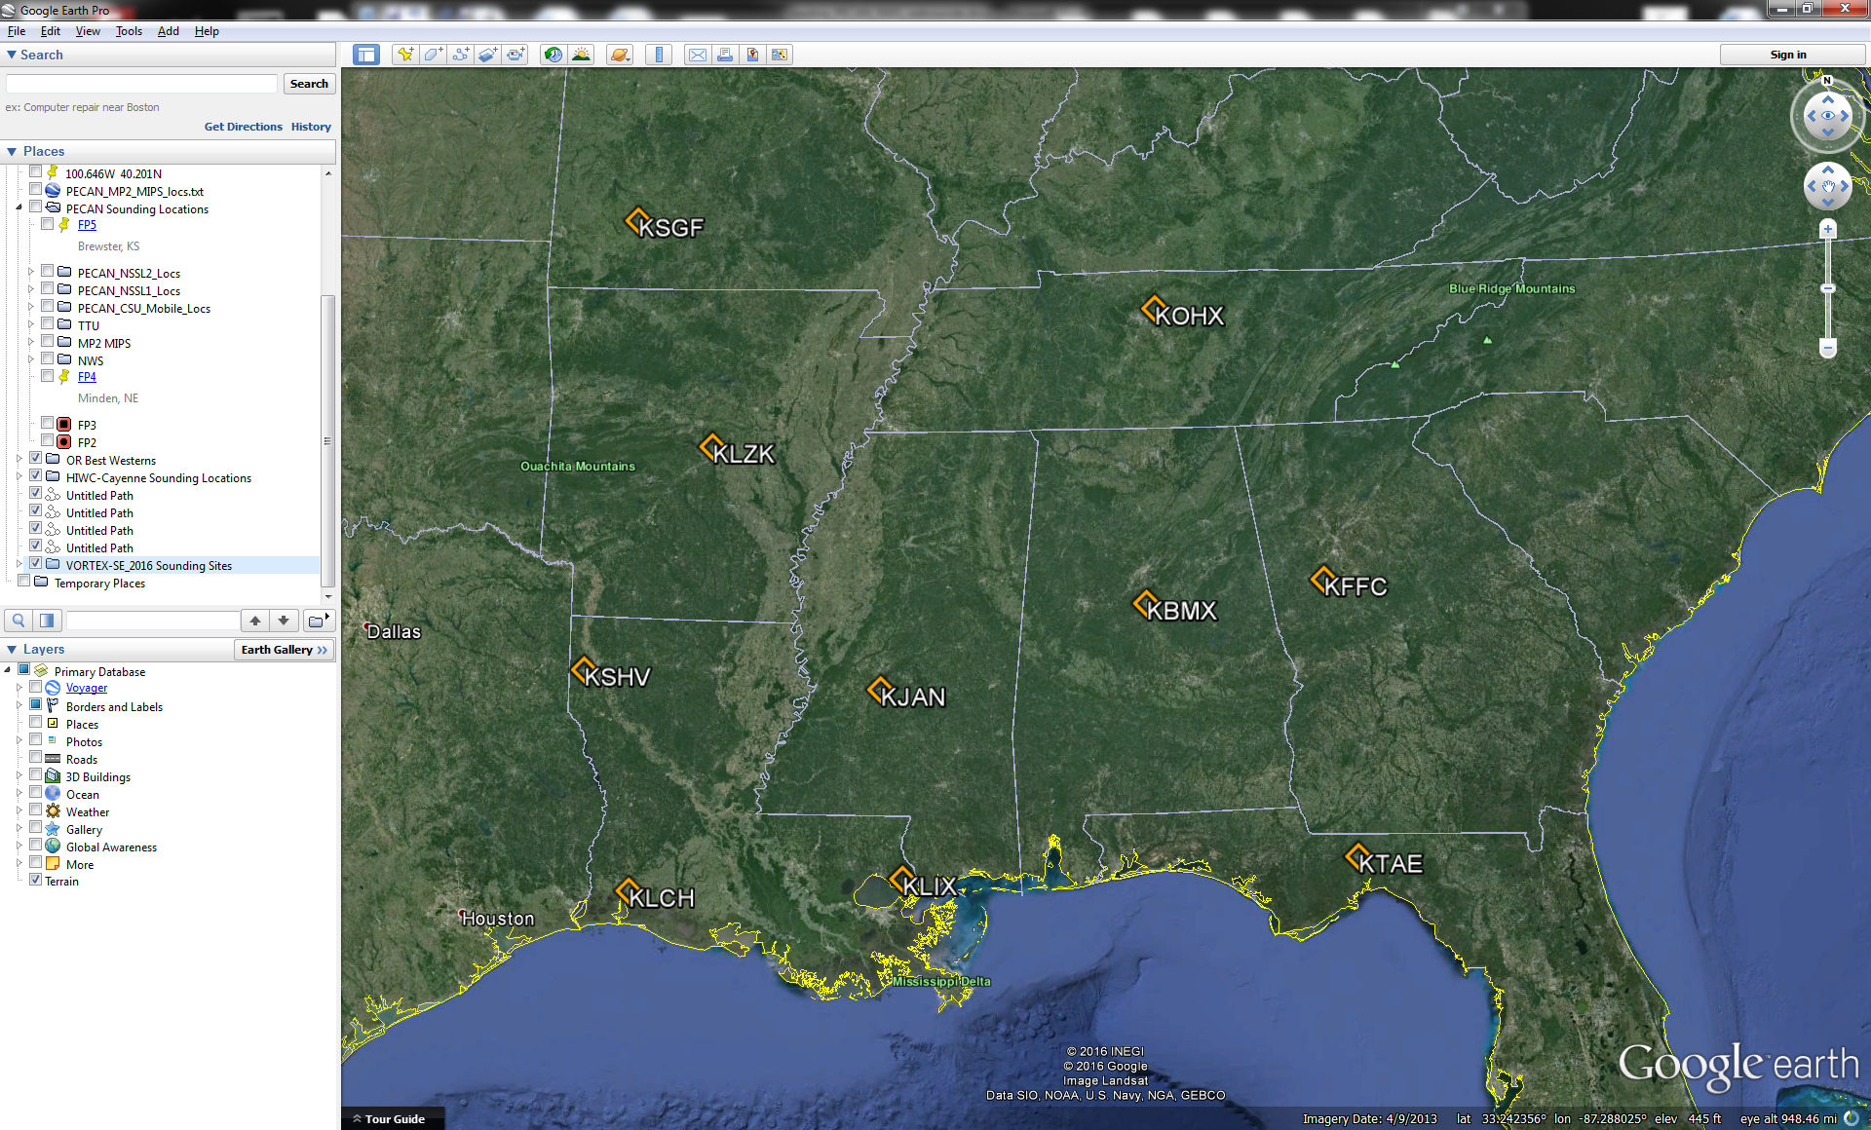

Figure 1. Location of VORTEX-SE_2017 NWS radiosonde sites.

1. **Project Overview**

The **Verification of the Origins of Rotation in Tornadoes Experiment-Southeast (VORTEX-SE)** is a research program to understand how environmental factors characteristic of the southeastern United States affect the formation, intensity, structure, and path of tornadoes in this region. VORTEX-SE will also determine the best methods for communicating forecast uncertainty related to these events to the public, and evaluate public response. For the 2017 field season a large array of fixed and mobile ground instrumentation were deployed around Huntsville, AL from 8 March to 8 May 2017. Further information on VORTEX-SE is available at the VORTEX-SE web site at NCAR/EOL: <https://www.eol.ucar.edu/field_projects/vortex-se> and information on the VORTEX-SE_2017 deployments is available at the VORTEX-SE_2017 Field Catalog: <http://catalog.eol.ucar.edu/vortex-se_2017>.

1. **EOL Sounding Composite (ESC) File Format Description**

The ESC is a columnar ASCII format consisting of 15 header records for each sounding followed by the data records with associated data quality flags.

**3.1 Header Records**

The header records (15 total records) contain a variety of metadata about the sounding (i.e. location, time, radiosonde type, etc). The first five header lines contain information identifying the sounding, and have a rigidly defined form. The following 7 header lines are used for auxiliary information and comments about the sounding, and may vary from dataset to dataset. The last 3 header records contain header information for the data columns. Line 13 holds the field names, line 14 the field units, and line 15 contains dashes ('-' characters) delineating the extent of the field.

The file standard header lines are as follows:

|  |  |  |
| --- | --- | --- |
| **Line** | **Label (padded to 35 char)** | **Contents** |
| 1 | Data Type: | Description of the type and resolution of data |
| 2 | Project ID: | Short name for the field project |
| 3 | Release Site Type/Site ID: | Description of the release site. |
| 4 | Release Location (lon,lat,alt): | Location of the release site. |
| 5 | UTC Release Time (y,m,d,h,m,s): | Time of release. |

The release location is given as:

lon (deg min), lat (deg min), lon (dec. deg), lat (dec. deg), alt (m)

Longitude in deg min is in the format: ddd mm.mm'W where ddd is the number of degrees (with leading zeros if necessary), mm.mm is the decimal number of minutes, and W represents W or E for west or east longitude, respectively. Latitude has the same format as longitude, except there are only two digits for degrees and N or S for north/south latitude.

The time of release is given as: yyyy, mm, dd, hh:nn:ss.

Where yyyy is the year, mm is the month, dd is the day of month, and hh:nn:ss are the UTC hour, minute, and second respectively.

The seven non-standard header lines may contain any label and contents. The labels are padded to 35 characters to match the standard header lines. Records for this data set include the following non-standard header lines:

|  |  |  |
| --- | --- | --- |
| **Line** | **Label (padded to 35 char)** | **Contents** |
| 6 | Ascension Number | Number sounding this year |
| 7 | Radiosonde Serial Number |  |
| 8 | Balloon Manufacturer/Type |  |
| 9 | Balloon Lot Number/Weight |  |
| 10 | Radiosonde Type/RH Sensor Type |  |
| 11 | Surface Observations |  |

**3.2 Data Records**

The data records each contain time from release, pressure, temperature, dew point, relative humidity, U and V wind components, wind speed and direction, ascent rate, balloon position data, altitude, and quality control flags (see the QC code description). Each data line contains 21 fields, separated by spaces, with a total width of 130 characters. The data are right-justified within the fields. All fields have one decimal place of precision, with the exception of latitude and longitude, which have three decimal places of precision. The contents and sizes of the 21 fields that appear in each data record are as follows:

|  |  |  |  |  |  |
| --- | --- | --- | --- | --- | --- |
| **Field** | **Width** | **Format** | **Parameter** | **Units** | **Missing**  **Value** |
| 1 | 6 | F6.1 | Time since release | Seconds | 9999.0 |
| 2 | 6 | F6.1 | Pressure | Millibars | 9999.0 |
| 3 | 5 | F5.1 | Dry-bulb Temperature | Degrees C | 999.0 |
| 4 | 5 | F5.1 | Dew Point Temperature | Degrees C | 999.0 |
| 5 | 5 | F5.1 | Relative Humidity | Percent | 999.0 |
| 6 | 6 | F6.1 | U Wind Comp | m/s | 9999.0 |
| 7 | 6 | F6.1 | V Wind Comp | m/s | 9999.0 |
| 8 | 5 | F5.1 | Wind speed | m/s | 999.0 |
| 9 | 5 | F5.1 | Wind direction | Degrees | 999.0 |
| 10 | 5 | F5.1 | Ascent Rate | m/s | 999.0 |
| 11 | 8 | F8.3 | Longitude | Degrees | 9999.0 |
| 12 | 7 | F7.3 | Latitude | Degrees | 999.0 |
| 13 | 5 | F5.1 | Elevation Angle | Degrees | 999.0 |
| 14 | 5 | F5.1 | Azimuth Angle | Degrees | 999.0 |
| 15 | 7 | F7.1 | Altitude | Meters | 99999.0 |
| 16 | 4 | F4.1 | QC for Pressure | Code | 99.0 |
| 17 | 4 | F4.1 | QC for Temperature | Code | 99.0 |
| 18 | 4 | F4.1 | QC for Humidity | Code | 99.0 |
| 19 | 4 | F4.1 | QC for U Wind | Code | 99.0 |
| 20 | 4 | F4.1 | QC for V Wind | Code | 99.0 |
| 21 | 4 | F4.1 | QC for Ascent Rate | Code | 99.0 |

Fields 16 through 21 contain the data quality flags from the NCAR/Earth Observing Laboratory (EOL) sounding quality control procedures. The data quality flags are defined as follows:

|  |  |
| --- | --- |
| **Code** | **Description** |
| 1.0 | Checked, datum seems physically reasonable. (“GOOD”) |
| 2.0 | Checked, datum seems questionable on a physical basis. (“MAYBE”) |
| 3.0 | Checked, datum seems to be in error. (“BAD”) |
| 4.0 | Checked, datum is interpolated. (“ESTIMATED”) |
| 9.0 | Checked, datum is missing. (“MISSING”) |
| 99.0 | Unchecked (QC information is “missing”.) (“UNCHECKED”) |

**3.3 Data Specifics**

The files contain data at one-second intervals.

The data are in files by day, so all soundings for a particular day are concatenated into a single file ordered by time. The file naming convention is:

NWS_yyyymmdd.cls where yyyy is the year, mm is the month, and dd is the day of the month.

The KBMX, KFFC, KJAN, KLZK, KOHX, KSHV, and KTAE stations utilized the Lockheed Martin Sippican LMS-6 Radiosonde with the capacitance RH sensor and GPS windfinding during VORTEX-SE 2017.

The KLCH, KLIX, and KSGF stations utilized the Vaisala RS92-NGP radiosonde with twin alternatively heated Humicap capacitance RH sensors and GPS windfinding during VORTEX-SE 2017.

**3.4 Sample Data**

The following is a sample of the VORTEX-SE_2017 NWS high resolution radiosonde data in ESC format.

Data Type: National Weather Service Sounding/Ascending

Project ID: VORTEX-SE_2017

Release Site Type/Site ID: KBMX Birmingham, AL / 72230

Release Location (lon,lat,alt): 086 46.96'W, 33 10.81'N, -86.783, 33.180, 174.0

UTC Release Time (y,m,d,h,m,s): 2017, 02, 29, 23:05:43

Ascension Number: 127

Radiosonde Serial Number: 88110918

Balloon Manufacturer/Type: Totex / GP26

Balloon Lot Number/Weight: 2015 / 0.600

Radiosonde Type/RH Sensor Type: Lockheed Martin Sippican LMS-6 GPS Radiosonde / Capacitance sensor

Surface Observations: P: 997.1, T: 10.6, RH: 43.9, WS: 2.1, WD: 210.0

Nominal Release Time (y,m,d,h,m,s):2017, 03, 01, 00:00:00

Time Press Temp Dewpt RH Ucmp Vcmp spd dir Wcmp Lon Lat Ele Azi Alt Qp Qt Qrh Qu Qv QdZ

sec mb C C % m/s m/s m/s deg m/s deg deg deg deg m code code code code code code

------ ------ ----- ----- ----- ------ ------ ----- ----- ----- -------- ------- ----- ----- ------- ---- ---- ---- ---- ---- ----

0.0 997.2 21.1 8.3 43.7 2.0 -0.4 2.0 281.3 999.0 -86.783 33.180 999.0 999.0 174.0 1.0 1.0 1.0 1.0 1.0 9.0

1.0 996.7 21.1 8.1 43.3 2.2 -0.3 2.2 277.8 4.0 -86.783 33.180 999.0 999.0 178.0 1.0 1.0 1.0 1.0 1.0 99.0

2.0 996.2 21.1 8.1 43.1 2.3 -0.2 2.3 275.0 4.0 -86.783 33.180 999.0 999.0 182.0 1.0 1.0 1.0 1.0 1.0 99.0

**3.5 Station List**

|  |  |  |  |  |  |  |
| --- | --- | --- | --- | --- | --- | --- |
| **Site ID** | **WMO ID** | **Site Name** | **State** | **Latitude** | **Longitude** | **Elev (m)** |
| KBMX | 72230 | Birmingham | AL | 33.180 | -86.783 | 174 |
| KFFC | 72215 | Peachtree City | GA | 33.356 | -84.567 | 245 |
| KJAN | 72235 | Jackson | MS | 32.320 | -90.080 | 91 |
| KLCH | 72240 | Lake Charles | LA | 30.126 | -93.217 | 5 |
| KLIX | 72233 | Slidell | LA | 30.338 | -89.825 | 10 |
| KLZK | 72340 | Little Rock | AR | 34.836 | -92.260 | 173 |
| KOHX | 72327 | Nashville | TN | 36.247 | -86.562 | 180 |
| KSGF | 72440 | Springfield | MO | 37.236 | -93.402 | 391 |
| KSHV | 72248 | Shreveport | LA | 32.452 | -93.842 | 85 |
| KTAE | 72214 | Tallahassee | FL | 30.446 | -84.300 | 53 |

**4.0 Data Quality Control Procedures**

1. Each sounding was converted from its original format into the ESC format described above.
2. Each sounding was passed through a set of automated data quality checks which included basic gross limit checks as well as rate of change checks. This is further described in Section 4.1.
3. Each sounding was visually examined utilizing the NCAR/EOL XQC sounding quality control software. This is further described in Section 4.2.

**4.1 Automated Data Quality Checks**

This data set was passed through a set of automated data quality checks. This procedure includes both gross limit checks on all parameters as well as rate-of-change checks on temperature, pressure, and ascent rate. A version of these checks is described in Loehrer et al. (1996) and Loehrer et al. (1998).

**4.1.1 Gross Limit Checks**

These checks were conducted on each sounding and the data quality flags in the ESC files were adjusted as appropriate. Only the data point under examination was flagged. All checks also produced warning messages that specified the location of the problem and the severity of the issue. These warning messages where then summarized statistically and examined to determine any consistent issues.

For this data set NCAR/EOL conducted the following gross limit checks. In the table P = pressure, T = temperature, RH = relative humidity, U = U wind component, V = V wind component, B= bad, and Q = questionable.

|  |  |  |  |
| --- | --- | --- | --- |
| **Parameter** | **Check** | **Parameter(s) Flagged** | **Flag Applied** |
| Pressure | <0 or > 1050 | P | B |
| Altitude | < 0 or >40000 | P, T, RH | Q |
| Temperature | < -90 or > 45 | T | B |
| Dew Point | < -99.9 or > 33  > T | RH  T, RH | Q  Q |
| Wind Speed | < 0 or > 100  > 150 | U, V  U, V | Q  B |
| U Wind | < 0 or > 100  > 150 | U  U | Q  B |
| V Wind | < 0 or > 100  > 150 | V  V | Q  B |
| Wind Direction | < 0 or > 360 | U, V | B |
| Ascent Rate | < -10 or > 10 | P, T, RH | Q |

**4.1.2 Vertical Consistency Checks**

These checks were conducted on each sounding and the data quality flags in the ESC files were adjusted as appropriate. These checks were started at the surface and compared each neighboring data record. In the case of checks that ensured that the values increased/decreased as expected, only the data point under examination was flagged. However, for the other checks, all of the data points used in the examination were flagged. All items within the table are as previously defined. All checks also produced warning messages that specified the location of the problem and the severity of the issue. These warning messages where then summarized statistically and examined to determine any consistent issues.

|  |  |  |  |
| --- | --- | --- | --- |
| **Parameter** | **Check** | **Parameter(s) Flagged** | **Flag Applied** |
| Time | Decreasing/equal | None | None. |
| Altitude | Decreasing/equal | P, T, RH | Q |
| Pressure | Increasing/equal  > 1mb/s or < -1mb/s  > 2mb/s or < -2mb/s | P, T, TH  P, T, TH  P, T, TH | Q  Q  B |
| Temperature | < -15oC/km  < -30oC/km  > 50oC/km  > 100oC/km | P, T, RH  P, T, RH  P, T, RH  P, T, RH | Q  B  Q  B |
| Ascent Rate | > 3m/s or < -3m/s  > 5m/s or < -5m/s | P  P | Q  B |

**4.2 Visual Data Quality Checks**

Each sounding was visually examined using the NCAR/EOL XQC sounding data quality control software. This software allows the user to view a skew-t/log-p diagram of each sounding and apply data quality flags as appropriate. The user can zoom in on sections of soundings for detailed examination and can adjust the data quality flags for an individual point, sections of soundings, or entire soundings for each parameter individually. The software also allows the user to override the quality flags applied by the automated procedure.

**4.3 Data Quality Issues of Note**

The data quality control procedures outlined above allows us to identify and, in some cases, resolve issues that could potentially impact research performed using these data sets. The following issues were noted in these soundings.

**KBMX 201703011136** – wetbulbing~757mb

**KBMX 201703072338** – no data above 839mb

**KBMX 201704031100** – no data above 570mb

**KBMX 201704051122** – some noisy data from sfc to ~720mb

**KFFC 201703211110** – data from sfc to 876mb bad (interpolated)

**KFFC 201703281107** – wetbulbing ~517mb

**KFFC 201703282313** – wetbulbing ~644mb

**KFFC 201705042303** – no GPS/wind data. Temperature data above ~300mb bad (cold)

**KJAN 201703251101** – no data above 752mb

**KJAN 201703272301** – data questionable ~635-550mb

**KJAN 201703312301** – Winds from sfc to 980mb bad (speed very high)

**KJAN 201704022300** – no data above 855mb

**KJAN 201704161101** – no GPS/wind data

**KJAN 201704281101** – temp data bad ~893-865mb

**KJAN 201705041100** – wetbulbing ~710mb

**KLCH 201703072310** – wetbulbing ~811mb

**KLCH 201703250310** – no data above 656mb

**KLCH 201704021814** – updraft sounding

**KLCH 201704221103** – very limited GPS/wind data above 383mb

**KLCH 201704242303** – very limited GPS/wind data

**KLCH 201704301217** – wetbulbing ~616mb

**KLCH 201705031702** – no data above 660mb

**KLCH 201705052302** – very limited GPS/wind data

**KLIX 201703241103** – wetbulbing ~877mb

**KLIX 201704030500** – wetbulbing ~804mb

**KLIX 201704031152** – wetbulbing ~450mb

**KLIX 201704051102** – wetbulbing ~772mb

**KLZK 201702282308** – no data above 506mb

**KLZK 201704262354** – no data above 925mb

**KOHX 201703072309** – wetbulbing ~903mb

**KOHX 201704182301** – questionable temp rise 670mb

**KSGF 201704292325** – no data above 588mb

**KSHV 201704111100** – no data above 588mb. Temperature data above 663mb bad (cold).

**KSHV 201705040019** – no data above 774mb

**KSHV 201705052303** – no GPS/wind data

**KTAE 201703311103** – wetbulbing ~655mb

**KTAE 201705041223** – no data above 554mb

**5.0 References**

Loehrer, S. M., T. A. Edmands, and J. A. Moore, 1996: TOGA COARE upper-air sounding data archive: development and quality control procedures. Bull. Amer. Meteor. Soc., 77, 2651-2671.

Loehrer, S. M., S. F. Williams, and J. A. Moore, 1998: Results from UCAR/JOSS quality control of atmospheric soundings from field projects. Preprints, Tenth Symposium on Meteorological Observations and Instrumentation, Phoenix, AZ, Amer. Meteor. Soc., 1-6.