1. **Contacts:**

**NCAR/EOL Processing and Quality Control:**

Scot Loehrer (NCAR/EOL)

[loehrer@ucar.edu](mailto:loehrer@ucar.edu)

**Original Data Source:**

NOAA/NWS

1. **Dataset Overview**

The National Weather Service (NWS) routinely releases radiosondes at 00 and 12 UTC with occasional special releases at sites throughout the United States. This data set includes the quality controlled NWS soundings released at nine sites (Figure 1) around Salt Lake City, Utah during the IDEAL field phase (15 October to 15 November 2017). A total of 585 quality-controlled, high vertical resolution (1-second) soundings are contained in the final IDEAL NWS radiosonde data set.

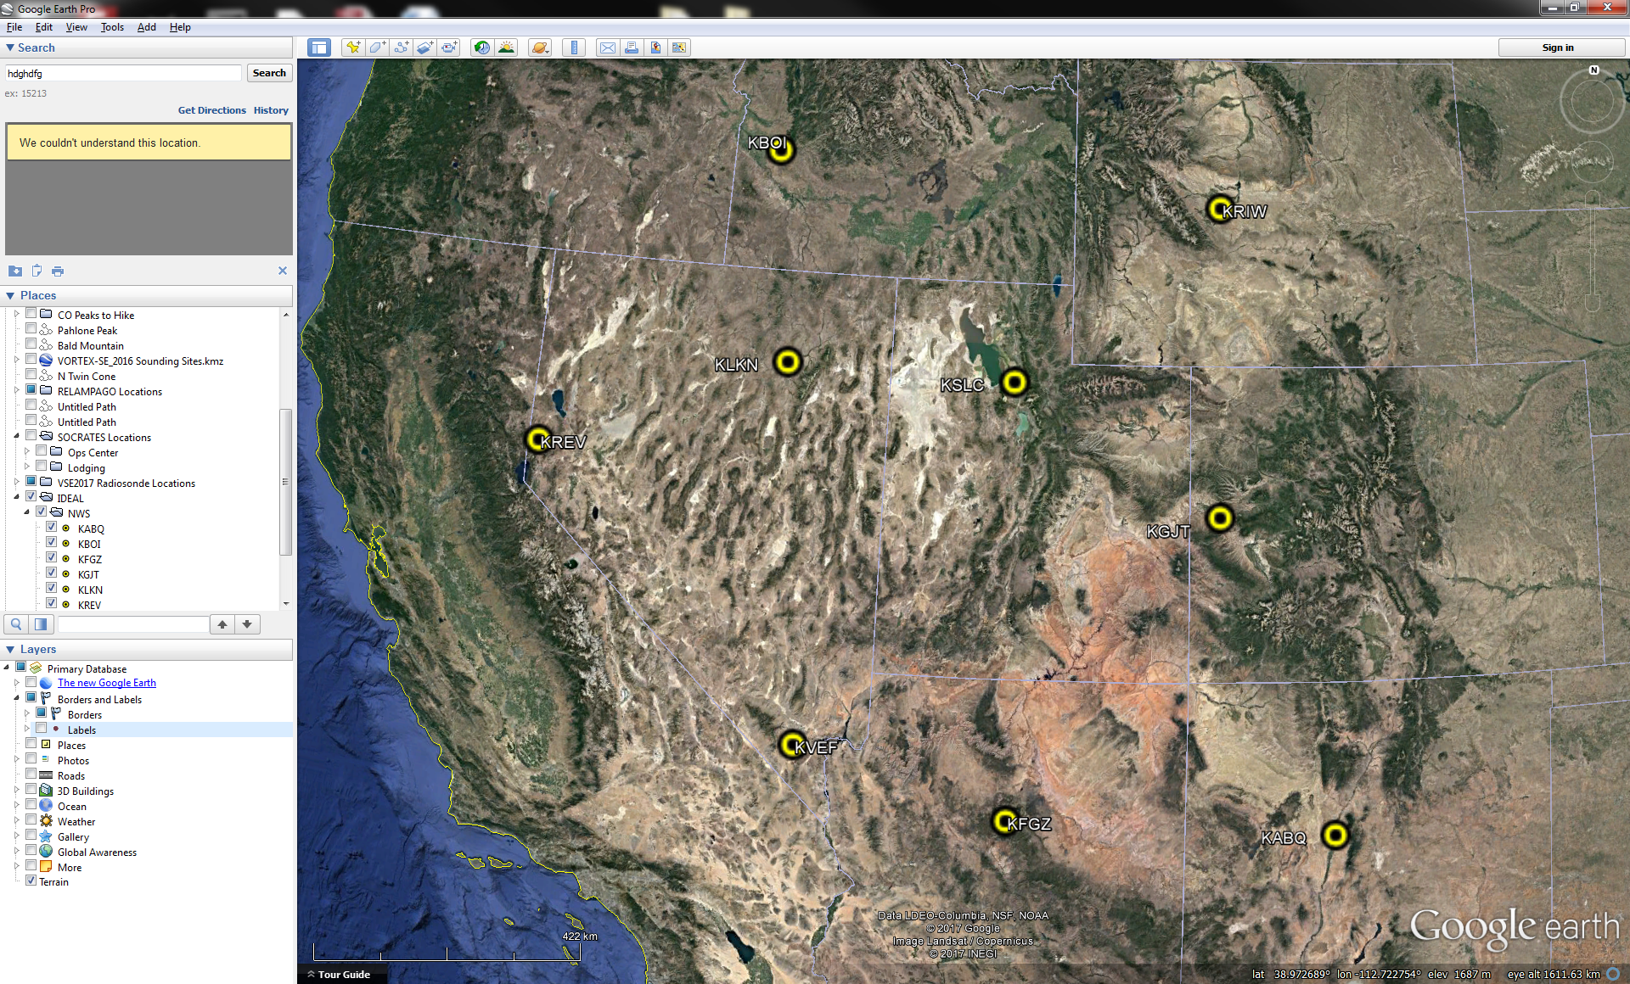

Figure 1. Location of IDEAL NWS radiosonde sites.

1. **Project Overview**

The **Instabilities, Dynamics, and Energetics accompanying Atmospheric Layering (IDEAL)** project combined ground-based in-situ observations with modeling to quantify the understanding of sheet and layer structures, morphologies, and underlying dynamics in the stable stratified lower troposphere. Further information on IDEAL is available at the IDEAL web site at NCAR/EOL: <https://www.eol.ucar.edu/field_projects/ideal>.

1. **EOL Sounding Composite (ESC) File Format Description**

The ESC is a columnar ASCII format consisting of 15 header records for each sounding followed by the data records with associated data quality flags.

**3.1 Header Records**

The header records (15 total records) contain a variety of metadata about the sounding (i.e. location, time, radiosonde type, etc). The first five header lines contain information identifying the sounding, and have a rigidly defined form. The following 7 header lines are used for auxiliary information and comments about the sounding, and may vary from dataset to dataset. The last 3 header records contain header information for the data columns. Line 13 holds the field names, line 14 the field units, and line 15 contains dashes ('-' characters) delineating the extent of the field.

The file standard header lines are as follows:

|  |  |  |
| --- | --- | --- |
| **Line** | **Label (padded to 35 char)** | **Contents** |
| 1 | Data Type: | Description of the type and resolution of data |
| 2 | Project ID: | Short name for the field project |
| 3 | Release Site Type/Site ID: | Description of the release site. |
| 4 | Release Location (lon,lat,alt): | Location of the release site. |
| 5 | UTC Release Time (y,m,d,h,m,s): | Time of release. |

The release location is given as:

lon (deg min), lat (deg min), lon (dec. deg), lat (dec. deg), alt (m)

Longitude in deg min is in the format: ddd mm.mm'W where ddd is the number of degrees (with leading zeros if necessary), mm.mm is the decimal number of minutes, and W represents W or E for west or east longitude, respectively. Latitude has the same format as longitude, except there are only two digits for degrees and N or S for north/south latitude.

The time of release is given as: yyyy, mm, dd, hh:nn:ss.

Where yyyy is the year, mm is the month, dd is the day of month, and hh:nn:ss are the UTC hour, minute, and second respectively.

The seven non-standard header lines may contain any label and contents. The labels are padded to 35 characters to match the standard header lines. Records for this data set include the following non-standard header lines:

|  |  |  |
| --- | --- | --- |
| **Line** | **Label (padded to 35 char)** | **Contents** |
| 6 | Ascension Number | Number sounding this year |
| 7 | Radiosonde Serial Number |  |
| 8 | Balloon Manufacturer/Type |  |
| 9 | Balloon Lot Number/Weight |  |
| 10 | Radiosonde Type/RH Sensor Type |  |
| 11 | Surface Observations |  |

**3.2 Data Records**

The data records each contain time from release, pressure, temperature, dew point, relative humidity, U and V wind components, wind speed and direction, ascent rate, balloon position data, altitude, and quality control flags (see the QC code description). Each data line contains 21 fields, separated by spaces, with a total width of 130 characters. The data are right-justified within the fields. All fields have one decimal place of precision, with the exception of latitude and longitude, which have three decimal places of precision. The contents and sizes of the 21 fields that appear in each data record are as follows:

|  |  |  |  |  |  |
| --- | --- | --- | --- | --- | --- |
| **Field** | **Width** | **Format** | **Parameter** | **Units** | **Missing**  **Value** |
| 1 | 6 | F6.1 | Time since release | Seconds | 9999.0 |
| 2 | 6 | F6.1 | Pressure | Millibars | 9999.0 |
| 3 | 5 | F5.1 | Dry-bulb Temperature | Degrees C | 999.0 |
| 4 | 5 | F5.1 | Dew Point Temperature | Degrees C | 999.0 |
| 5 | 5 | F5.1 | Relative Humidity | Percent | 999.0 |
| 6 | 6 | F6.1 | U Wind Comp | m/s | 9999.0 |
| 7 | 6 | F6.1 | V Wind Comp | m/s | 9999.0 |
| 8 | 5 | F5.1 | Wind speed | m/s | 999.0 |
| 9 | 5 | F5.1 | Wind direction | Degrees | 999.0 |
| 10 | 5 | F5.1 | Ascent Rate | m/s | 999.0 |
| 11 | 8 | F8.3 | Longitude | Degrees | 9999.0 |
| 12 | 7 | F7.3 | Latitude | Degrees | 999.0 |
| 13 | 5 | F5.1 | Elevation Angle | Degrees | 999.0 |
| 14 | 5 | F5.1 | Azimuth Angle | Degrees | 999.0 |
| 15 | 7 | F7.1 | Altitude | Meters | 99999.0 |
| 16 | 4 | F4.1 | QC for Pressure | Code | 99.0 |
| 17 | 4 | F4.1 | QC for Temperature | Code | 99.0 |
| 18 | 4 | F4.1 | QC for Humidity | Code | 99.0 |
| 19 | 4 | F4.1 | QC for U Wind | Code | 99.0 |
| 20 | 4 | F4.1 | QC for V Wind | Code | 99.0 |
| 21 | 4 | F4.1 | QC for Ascent Rate | Code | 99.0 |

Fields 16 through 21 contain the data quality flags from the NCAR/Earth Observing Laboratory (EOL) sounding quality control procedures. The data quality flags are defined as follows:

|  |  |
| --- | --- |
| **Code** | **Description** |
| 1.0 | Checked, datum seems physically reasonable. (“GOOD”) |
| 2.0 | Checked, datum seems questionable on a physical basis. (“MAYBE”) |
| 3.0 | Checked, datum seems to be in error. (“BAD”) |
| 4.0 | Checked, datum is interpolated. (“ESTIMATED”) |
| 9.0 | Checked, datum is missing. (“MISSING”) |
| 99.0 | Unchecked (QC information is “missing”.) (“UNCHECKED”) |

**3.3 Data Specifics**

The files contain data at one-second intervals.

The data are in files by day, so all soundings for a particular day are concatenated into a single file ordered by time. The file naming convention is:

NWS_yyyymmdd.cls where yyyy is the year, mm is the month, and dd is the day of the month.

The KABQ, KBOI, KGJT, KLKN, KREV, KRIW, KSLC, and KVEF stations utilized the Lockheed Martin Sippican LMS-6 Radiosonde with the capacitance RH sensor and GPS windfinding during IDEAL.

The KFGZ station utilized the Vaisala RS92-NGP radiosonde with twin alternatively heated Humicap capacitance RH sensors and GPS windfinding during IDEAL.

**3.4 Sample Data**

The following is a sample of the IDEAL NWS high resolution radiosonde data in ESC format.

Data Type: National Weather Service Sounding/Ascending

Project ID: IDEAL_2017

Release Site Type/Site ID: KABQ Albuquerque, NM / 72365

Release Location (lon,lat,alt): 106 37.37'W, 35 02.29'N, -106.623, 35.038, 1619.0

UTC Release Time (y,m,d,h,m,s): 2017, 10, 14, 23:03:12

Ascension Number: 576

Radiosonde Serial Number: 88201037

Balloon Manufacturer/Type: Totex / GP26

Balloon Lot Number/Weight: 2017 / 0.600

Radiosonde Type/RH Sensor Type: Lockheed Martin Sippican LMS-6 GPS Radiosonde / Capacitance sensor

Surface Observations: P: 839.7, T: 15.6, RH: 9.0, WS: 6.7, WD: 318.0

Nominal Release Time (y,m,d,h,m,s):2017, 10, 15, 00:00:00

Time Press Temp Dewpt RH Ucmp Vcmp spd dir Wcmp Lon Lat Ele Azi Alt Qp Qt Qrh Qu Qv QdZ

sec mb C C % m/s m/s m/s deg m/s deg deg deg deg m code code code code code code

------ ------ ----- ----- ----- ------ ------ ----- ----- ----- -------- ------- ----- ----- ------- ---- ---- ---- ---- ---- ----

0.0 839.8 26.4 -7.7 10.0 2.4 -5.1 5.6 334.8 999.0 -106.623 35.038 999.0 999.0 1619.0 1.0 1.0 1.0 1.0 1.0 9.0

1.0 839.3 26.3 -7.6 10.1 2.5 -5.3 5.9 334.7 5.0 -106.623 35.038 999.0 999.0 1624.0 1.0 3.0 1.0 1.0 1.0 99.0

2.0 838.9 26.1 -7.9 10.0 2.6 -5.5 6.1 334.7 4.0 -106.623 35.038 999.0 999.0 1628.0 1.0 3.0 1.0 1.0 1.0 99.0

**3.5 Station List**

|  |  |  |  |  |  |  |
| --- | --- | --- | --- | --- | --- | --- |
| **Site ID** | **WMO ID** | **Site Name** | **State** | **Latitude** | **Longitude** | **Elev (m)** |
| KABQ | 72365 | Albuquerque | NM | 35.038 | -106.623 | 1619 |
| KBOI | 72681 | Boise | ID | 43.568 | -116.211 | 873 |
| KFGZ | 72376 | Flagstaff | AZ | 35.231 | -111.820 | 2179 |
| KGJT | 72476 | Grand Junction | CO | 39.120 | -108.524 | 1474 |
| KLKN | 72582 | Elko | NV | 40.860 | -115.742 | 1593 |
| KREV | 72489 | Reno | NV | 39.568 | -119.795 | 1518 |
| KRIW | 72672 | Riverton | WY | 43.065 | -108.477 | 1699 |
| KSLC | 72572 | Salt Lake City | UT | 40.773 | -111.955 | 1289 |
| KVEF | 72388 | Las Vegas | NV | 36.047 | -115.185 | 697 |

**4.0 Data Quality Control Procedures**

1. Each sounding was converted from its original format into the ESC format described above.
2. Each sounding was passed through a set of automated data quality checks which included basic gross limit checks as well as rate of change checks. This is further described in Section 4.1.
3. Each sounding was visually examined utilizing the NCAR/EOL XQC sounding quality control software. This is further described in Section 4.2.

**4.1 Automated Data Quality Checks**

This data set was passed through a set of automated data quality checks. This procedure includes both gross limit checks on all parameters as well as rate-of-change checks on temperature, pressure, and ascent rate. A version of these checks is described in Loehrer et al. (1996) and Loehrer et al. (1998).

**4.1.1 Gross Limit Checks**

These checks were conducted on each sounding and the data quality flags in the ESC files were adjusted as appropriate. Only the data point under examination was flagged. All checks also produced warning messages that specified the location of the problem and the severity of the issue. These warning messages where then summarized statistically and examined to determine any consistent issues.

For this data set NCAR/EOL conducted the following gross limit checks. In the table P = pressure, T = temperature, RH = relative humidity, U = U wind component, V = V wind component, B= bad, and Q = questionable.

|  |  |  |  |
| --- | --- | --- | --- |
| **Parameter** | **Check** | **Parameter(s) Flagged** | **Flag Applied** |
| Pressure | <0 or > 1050 | P | B |
| Altitude | < 0 or >40000 | P, T, RH | Q |
| Temperature | < -90 or > 45 | T | B |
| Dew Point | < -99.9 or > 33  > T | RH  T, RH | Q  Q |
| Wind Speed | < 0 or > 100  > 150 | U, V  U, V | Q  B |
| U Wind | < 0 or > 100  > 150 | U  U | Q  B |
| V Wind | < 0 or > 100  > 150 | V  V | Q  B |
| Wind Direction | < 0 or > 360 | U, V | B |
| Ascent Rate | < -10 or > 10 | P, T, RH | Q |

**4.1.2 Vertical Consistency Checks**

These checks were conducted on each sounding and the data quality flags in the ESC files were adjusted as appropriate. These checks were started at the surface and compared each neighboring data record. In the case of checks that ensured that the values increased/decreased as expected, only the data point under examination was flagged. However, for the other checks, all of the data points used in the examination were flagged. All items within the table are as previously defined. All checks also produced warning messages that specified the location of the problem and the severity of the issue. These warning messages where then summarized statistically and examined to determine any consistent issues.

|  |  |  |  |
| --- | --- | --- | --- |
| **Parameter** | **Check** | **Parameter(s) Flagged** | **Flag Applied** |
| Time | Decreasing/equal | None | None. |
| Altitude | Decreasing/equal | P, T, RH | Q |
| Pressure | Increasing/equal  > 1mb/s or < -1mb/s  > 2mb/s or < -2mb/s | P, T, TH  P, T, TH  P, T, TH | Q  Q  B |
| Temperature | < -15oC/km  < -30oC/km  > 50oC/km  > 100oC/km | P, T, RH  P, T, RH  P, T, RH  P, T, RH | Q  B  Q  B |
| Ascent Rate | > 3m/s or < -3m/s  > 5m/s or < -5m/s | P  P | Q  B |

**4.2 Visual Data Quality Checks**

Each sounding was visually examined using the NCAR/EOL XQC sounding data quality control software. This software allows the user to view a skew-t/log-p diagram of each sounding and apply data quality flags as appropriate. The user can zoom in on sections of soundings for detailed examination and can adjust the data quality flags for an individual point, sections of soundings, or entire soundings for each parameter individually. The software also allows the user to override the quality flags applied by the automated procedure.

**4.3 Data Quality Issues of Note**

The data quality control procedures outlined above allows us to identify and, in some cases, resolve issues that could potentially impact research performed using these data sets. The following issues were noted in these soundings.

**KFGZ 201711061213** – No GPS/wind data

**KLKN 201711011101** – wetbulbing 625mb

**KRIW 201710301104** – wetbulbing 606mb

**5.0 References**

Loehrer, S. M., T. A. Edmands, and J. A. Moore, 1996: TOGA COARE upper-air sounding data archive: development and quality control procedures. Bull. Amer. Meteor. Soc., 77, 2651-2671.

Loehrer, S. M., S. F. Williams, and J. A. Moore, 1998: Results from UCAR/JOSS quality control of atmospheric soundings from field projects. Preprints, Tenth Symposium on Meteorological Observations and Instrumentation, Phoenix, AZ, Amer. Meteor. Soc., 1-6.