1. **Contacts:**

**NCAR/EOL Processing and Quality Control:**

Scot Loehrer (NCAR/EOL)

[loehrer@ucar.edu](mailto:loehrer@ucar.edu)

**Original Data Source:**

Scott Steiger

366 Shineman Center

Department of Earth Sciences

SUNY Oswego

Oswego, NY 13126

(315) 312-2802 (phone)

[scott.steiger@oswego.edu](mailto:scott.steiger@oswego.edu)

**2.0 Dataset Overview**

The State University of New York at Oswego (SUNY-Oswego) operated a mobile radiosonde system during lake-effect systems on Lake Ontario. SUNY-Oswego operations were on the east and southeast end of Lake Ontario. This data set includes the quality controlled SUNY-Oswego soundings released (Figure 1 and Section 3.5) for the OWLeS field phase (7 December 2013 to 28 January 2014). A total of 51 quality controlled, high resolution (1-second) soundings are contained in the final OWLeS data set.

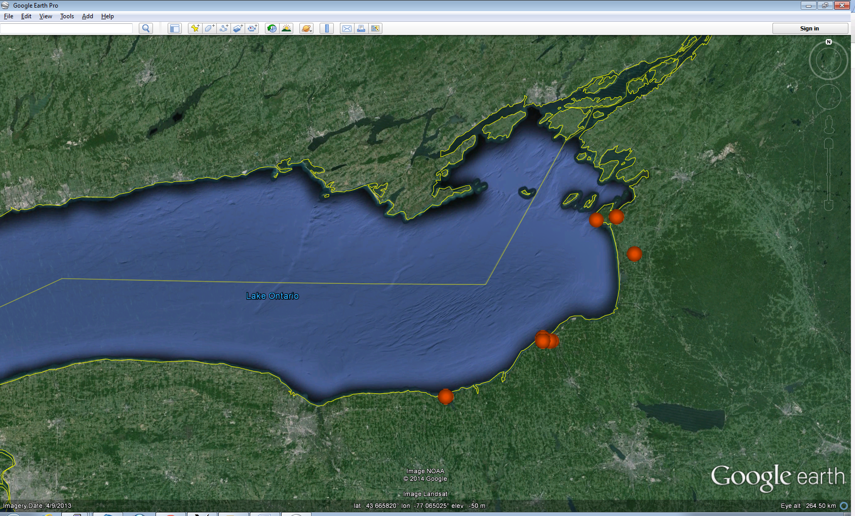

Figure 1. Locations of the SUNY-Oswego mobile radiosonde release locations included in the OWLeS data set.

The Ontario Winter Lake-effect Systems (OWLeS) was a field campaign aimed at investigating the formation mechanisms, cloud microphysics, boundary layer processes, and dynamics of lake-effect systems (LeS) using new observational tools capable of detailing LeS characteristics not observed in previous LeS field experiments. Observations were focused around Lake Ontario because of its geometry and size, the influence of upstream lakes, the frequency of LeS, nearby orography, and its proximity to several participating universities. The University of Wyoming King Air aircraft took part in the experiment as well as several mobile radars and five mobile radiosonde sites. Further information on OWLeS is available at the OWLeS web site: <https://www.eol.ucar.edu/field_projects/owles> and information on OWLeS operations is available at the OWLeS Field Catalog: <http://catalog.eol.ucar.edu/owles/>.

**3.0 EOL Sounding Composite (ESC) File Format Description**

The ESC is a columnar ASCII format consisting of 15 header records for each sounding followed by the data records with associated data quality flags.

**3.1 Header Records**

The header records (15 total records) contain a variety of metadata about the sounding (i.e. location, time, radiosonde type, etc). The first five header lines contain information identifying the sounding, and have a rigidly defined form. The following 7 header lines are used for auxiliary information and comments about the sounding, and may vary from dataset to dataset. The last 3 header records contain header information for the data columns. Line 13 holds the field names, line 14 the field units, and line 15 contains dashes ('-' characters) delineating the extent of the field.

The file standard header lines are as follows:

|  |  |  |
| --- | --- | --- |
| **Line** | **Label (padded to 35 char)** | **Contents** |
| 1 | Data Type: | Description of the type and resolution of data |
| 2 | Project ID: | Short name for the field project |
| 3 | Release Site Type/Site ID: | Description of the release site. |
| 4 | Release Location (lon,lat,alt): | Location of the release site. |
| 5 | UTC Release Time (y,m,d,h,m,s): | Time of release. |

The release location is given as:

lon (deg min), lat (deg min), lon (dec. deg), lat (dec. deg), alt (m)

Longitude in deg min is in the format: ddd mm.mm'W where ddd is the number of degrees (with leading zeros if necessary), mm.mm is the decimal number of minutes, and W represents W or E for west or east longitude, respectively. Latitude has the same format as longitude, except there are only two digits for degrees and N or S for north/south latitude.

The time of release is given as: yyyy, mm, dd, hh:nn:ss.

Where yyyy is the year, mm is the month, dd is the day of month, and hh:nn:ss are the UTC hour, minute, and second respectively.

The seven non-standard header lines may contain any label and contents. The labels are padded to 35 characters to match the standard header lines. Records for this data set include the following non-standard header lines:

|  |  |  |
| --- | --- | --- |
| **Line** | **Label (padded to 35 char)** | **Contents** |
| 6 | Radiosonde Type |  |
| 7 | Ground Station Software |  |
| 8 | Surface Data Source |  |

The nominal release time for these soundings is the same as the actual time.

**3.2 Data Records**

The data records each contain time from release, pressure, temperature, dew point, relative humidity, U and V wind components, wind speed and direction, ascent rate, balloon position data, altitude, and quality control flags (see the QC code description). Each data line contains 21 fields, separated by spaces, with a total width of 130 characters. The data are right-justified within the fields. All fields have one decimal place of precision, with the exception of latitude and longitude, which have three decimal places of precision. The contents and sizes of the 21 fields that appear in each data record are as follows:

|  |  |  |  |  |  |
| --- | --- | --- | --- | --- | --- |
| **Field** | **Width** | **Format** | **Parameter** | **Units** | **Missing**  **Value** |
| 1 | 6 | F6.1 | Time since release | Seconds | 9999.0 |
| 2 | 6 | F6.1 | Pressure | Millibars | 9999.0 |
| 3 | 5 | F5.1 | Dry-bulb Temperature | Degrees C | 999.0 |
| 4 | 5 | F5.1 | Dew Point Temperature | Degrees C | 999.0 |
| 5 | 5 | F5.1 | Relative Humidity | Percent | 999.0 |
| 6 | 6 | F6.1 | U Wind Comp | m/s | 9999.0 |
| 7 | 6 | F6.1 | V Wind Comp | m/s | 9999.0 |
| 8 | 5 | F5.1 | Wind speed | m/s | 999.0 |
| 9 | 5 | F5.1 | Wind direction | Degrees | 999.0 |
| 10 | 5 | F5.1 | Ascent Rate | m/s | 999.0 |
| 11 | 8 | F8.3 | Longitude | Degrees | 9999.0 |
| 12 | 7 | F7.3 | Latitude | Degrees | 999.0 |
| 13 | 5 | F5.1 | Elevation Angle | Degrees | 999.0 |
| 14 | 5 | F5.1 | Azimuth Angle | Degrees | 999.0 |
| 15 | 7 | F7.1 | Altitude | Meters | 99999.0 |
| 16 | 4 | F4.1 | QC for Pressure | Code | 99.0 |
| 17 | 4 | F4.1 | QC for Temperature | Code | 99.0 |
| 18 | 4 | F4.1 | QC for Humidity | Code | 99.0 |
| 19 | 4 | F4.1 | QC for U Wind | Code | 99.0 |
| 20 | 4 | F4.1 | QC for V Wind | Code | 99.0 |
| 21 | 4 | F4.1 | QC for Ascent Rate | Code | 99.0 |

Fields 16 through 21 contain the data quality flags from the NCAR/Earth Observing Laboratory (EOL) sounding quality control procedures. The data quality flags are defined as follows:

|  |  |
| --- | --- |
| **Code** | **Description** |
| 1.0 | Checked, datum seems physically reasonable. (“GOOD”) |
| 2.0 | Checked, datum seems questionable on a physical basis. (“MAYBE”) |
| 3.0 | Checked, datum seems to be in error. (“BAD”) |
| 4.0 | Checked, datum is interpolated. (“ESTIMATED”) |
| 9.0 | Checked, datum is missing. (“MISSING”) |
| 99.0 | Unchecked (QC information is “missing”.) (“UNCHECKED”) |

**3.3 Data Specifics**

The files contain data calculated at one-second intervals.

The data are in files by day, so all soundings for a particular day are concatenated into a single file ordered by time. The file naming convention is:

SUNY_Oswego_yyyymmdd.cls where yyyy is the year, mm is the month, and dd is the day of the month.

SUNY-Oswego utilized Vaisala RS92-SGP radiosondes with GPS windfinding during OWLeS. MW41 ground station software and ground check set GC25 were used.

Instrumentation Details:

Temperature sensor type: capacitive wire

Measurement range +60 °C to -90 °C

Response time (63.2%, 6 m/s flow)

1000 hPa < 0.4 s

100 hPa < 1 s

10 hPa < 2.5 s

Resolution 0.1 °C

Accuracy

Total uncertainty in sounding* 0.5 °C

Repeatability in calibration** 0.15 °C

Reproducibility in sounding***

1080 - 100 hPa 0.2 °C

100 - 20 hPa 0.3 °C

20 - 3 hPa 0.5 °C

Humidity sensor type: thin-film capacitor,

heated twin sensor

Measurement range 0 to 100 %RH

Resolution 1 %RH

Response time

6 m/s, 1000 hPa, +20 °C < 0.5 s

6 m/s, 1000 hPa, -40 °C < 20 s

Accuracy

Total uncertainty in sounding* 5 %RH

Repeatability in calibration** 2 %RH

Reproducibility in sounding*** 2 %RH

Pressure sensor type: silicon

Measurement range 1080 hPa to 3 hPa

Resolution 0.1 hPa

Accuracy

Total uncertainty in sounding*

1080 - 100 hPa 1 hPa

100 - 3 hPa 0.6 hPa

Repeatability in calibration**

1080 - 100 hPa 0.4 hPa

100 - 3 hPa 0.3 hPa

Reproducibility in sounding***

1080 - 100 hPa 0.5 hPa

100 - 3 hPa 0.3 hPa

* 2-sigma (k=2) confidence level (95.5 %),

cumulative uncertainty including:

• Repeatability

• Long-term stability

• Effects due to measurement conditions

• Dynamic effect (such as response time)

• Effects due to measurement electronics

For humidity T > -60 °C

For pressure T < 35 °C

** Standard deviation of differences between two successive

repeated calibrations, k=2 confidence level

*** Standard deviation of differences in twin soundings

**3.4 SUNY-Oswego Data Collection and Processing**

When on the SUNY Oswego campus, data were collected by launching from a rooftop platform three stories above ground. When in mobile operations all equipment was transported via a 12-passenger van and the sounding was launched from ground level in an area away from trees and powerlines.

Please read reports for each sounding launched on this website: <http://catalog.eol.ucar.edu/owles/37137/files>. During some of the calibrations of the radiosondes, the radiosonde pressure was used directly because the current surface pressure as measured by a Kestrel instrument or other independent measurement (e.g., nearby ASOS) was not accepted by the ground check system. Surface wind measurements may be inaccurate in some/all launches as students made an educated guess with a compass in harsh conditions.

**3.5 Sample Data**

The following is a sample of the OWLeS SUNY-Oswego high resolution radiosonde data in ESC format.

Data Type: SUNY Oswego Mobile Radiosonde/Ascending

Project ID: OWLeS

Release Site Type/Site ID: Oswego, NY Shineman observation deck

Release Location (lon,lat,alt): 076 32.40'W, 43 27.60'N, -76.540, 43.460, 107.0

UTC Release Time (y,m,d,h,m,s): 2013, 12, 07, 17:23:00

Radiosonde Type: Vaisala RS92-SGP

Ground Station Software: MW41

Surface Data Source: Dr Eugene Chermack surface weather station at SUNY Oswego

/

/

/

Nominal Release Time (y,m,d,h,m,s):2013, 12, 07, 17:23:00

Time Press Temp Dewpt RH Ucmp Vcmp spd dir Wcmp Lon Lat Ele Azi Alt Qp Qt Qrh Qu Qv QdZ

sec mb C C % m/s m/s m/s deg m/s deg deg deg deg m code code code code code code

------ ------ ----- ----- ----- ------ ------ ----- ----- ----- -------- ------- ----- ----- ------- ---- ---- ---- ---- ---- ----

0.0 1018.4 0.0 -6.6 61.0 9.8 -0.9 9.8 275.0 999.0 -76.540 43.460 999.0 999.0 107.0 99.0 99.0 99.0 99.0 99.0 9.0

1.0 1016.7 -0.2 -9.4 50.0 9.9 -0.9 9.9 275.0 13.0 9999.000 999.000 999.0 999.0 120.0 99.0 99.0 99.0 99.0 99.0 99.0

2.0 1014.9 -0.5 -9.7 50.0 10.0 -0.9 10.0 275.0 14.0 9999.000 999.000 999.0 999.0 134.0 99.0 99.0 99.0 99.0 99.0 99.0

**3.6 Station List**

|  |  |  |  |  |  |  |
| --- | --- | --- | --- | --- | --- | --- |
| **Site ID** | **WMO ID** | **Site Name** | **State** | **Latitude** | **Longitude** | **Elev (m)** |
| SUNY-Oswego | N/A | SUNY-Oswego Mobile | NY | Mobile | Mobile | Mobile |

**4.0 Data Quality Control Procedures**

1. Each sounding was converted from its original format into the ESC format described above.
2. Each sounding was passed through a set of automated data quality checks which included basic gross limit checks as well as rate of change checks. This is further described in Section 4.1.
3. Each sounding was visually examined utilizing the NCAR/EOL XQC sounding quality control software. This is further described in Section 4.2.

**4.1 Automated Data Quality Checks**

This data set was passed through a set of automated data quality checks. This procedure includes both gross limit checks on all parameters as well as rate-of-change checks on temperature, pressure, and ascent rate. A version of these checks is described in Loehrer et al. (1996) and Loehrer et al. (1998).

**4.1.1 Gross Limit Checks**

These checks were conducted on each sounding and the data quality flags in the ESC files were adjusted as appropriate. Only the data point under examination was flagged. All checks also produced warning messages that specified the location of the problem and the severity of the issue. These warning messages where then summarized statistically and examined to determine any consistent issues.

For this data set NCAR/EOL conducted the following gross limit checks. In the table P = pressure, T = temperature, RH = relative humidity, U = U wind component, V = V wind component, B= bad, and Q = questionable.

|  |  |  |  |
| --- | --- | --- | --- |
| **Parameter** | **Check** | **Parameter(s) Flagged** | **Flag Applied** |
| Pressure | <0 or > 1050 | P | B |
| Altitude | < 0 or >40000 | P, T, RH | Q |
| Temperature | < -90 or > 45 | T | B |
| Dew Point | < -99.9 or > 33  > T | RH  T, RH | Q  Q |
| Wind Speed | < 0 or > 100  > 150 | U, V  U, V | Q  B |
| U Wind | < 0 or > 100  > 150 | U  U | Q  B |
| V Wind | < 0 or > 100  > 150 | V  V | Q  B |
| Wind Direction | < 0 or > 360 | U, V | B |
| Ascent Rate | < -10 or > 10 | P, T, RH | Q |

**4.1.2 Vertical Consistency Checks**

These checks were conducted on each sounding and the data quality flags in the ESC files were adjusted as appropriate. These checks were started at the surface and compared each neighboring data record. In the case of checks that ensured that the values increased/decreased as expected, only the data point under examination was flagged. However, for the other checks, all of the data points used in the examination were flagged. All items within the table are as previously defined. All checks also produced warning messages that specified the location of the problem and the severity of the issue. These warning messages where then summarized statistically and examined to determine any consistent issues.

|  |  |  |  |
| --- | --- | --- | --- |
| **Parameter** | **Check** | **Parameter(s) Flagged** | **Flag Applied** |
| Time | Decreasing/equal | None | None. |
| Altitude | Decreasing/equal | P, T, RH | Q |
| Pressure | Increasing/equal  > 1mb/s or < -1mb/s  > 2mb/s or < -2mb/s | P, T, TH  P, T, TH  P, T, TH | Q  Q  B |
| Temperature | < -15oC/km  < -30oC/km  > 50oC/km  > 100oC/km | P, T, RH  P, T, RH  P, T, RH  P, T, RH | Q  B  Q  B |
| Ascent Rate | > 3m/s or < -3m/s  > 5m/s or < -5m/s | P  P | Q  B |

**4.2 Visual Data Quality Checks**

Each sounding was visually examined using the NCAR/EOL XQC sounding data quality control software. This software allows the user to view a skew-t/log-p diagram of each sounding and apply data quality flags as appropriate. The user can zoom in on sections of soundings for detailed examination and can adjust the data quality flags for an individual point, sections of soundings, or entire soundings for each parameter individually. The software also allows the user to override the quality flags applied by the automated procedure.

**4.3 Data Quality Issues of Note**

The data quality control procedures outlined above allows us to identify and, in some cases, resolve issues that could potentially impact research performed using these data sets. The following issues were noted in these soundings.

1. Several files had incorrect surface elevation data and thus incorrect geopotential height data. The surface elevation data were corrected using values provided by SUNY-Owego for each sounding and the geopotential height data were derived using the proper start value for these soundings.
2. One file had no data above 830mb

201401062144

1. One file had no GPS data for an extended period:

201401071113 (no GPS below 295mb)

1. One file had a problem with RH cycling:

201401280511

1. One file had an incorrect sign input for its surface temperature. The proper value was inserted and the dew point was derived with this value.

201401280511

**5.0 References**

Loehrer, S. M., T. A. Edmands, and J. A. Moore, 1996: TOGA COARE upper-air sounding data archive: development and quality control procedures. Bull. Amer. Meteor. Soc., 77, 2651-2671.

Loehrer, S. M., S. F. Williams, and J. A. Moore, 1998: Results from UCAR/JOSS quality control of atmospheric soundings from field projects. Preprints, Tenth Symposium on Meteorological Observations and Instrumentation, Phoenix, AZ, Amer. Meteor. Soc., 1-6.