1. **Contacts:**

**NCAR/EOL Processing and Quality Control:**

Scot Loehrer (NCAR/EOL)

[loehrer@ucar.edu](mailto:loehrer@ucar.edu)

**Original Data Source:**

Jim Steenburgh, Leah Campbell and Peter Veals

University of Utah

Department of Atmospheric Sciences

135 S 1460 E Rm 819

Salt Lake City, UT 84112

[jim.steenburgh@utah.edu](mailto:jim.steenburgh@utah.edu)

[leah.campbell@utah.edu](mailto:leah.campbell@utah.edu)

[peter.veals@utah.edu](mailto:peter.veals@utah.edu)

801-581-8727

**2.0 Dataset Overview**

The University of Utah operated a radiosonde system during lake-effect systems on Lake Ontario. University of Utah operations were at the North Redfield site at the eastern end of Lake Ontario (Figure 1). This data set includes the quality controlled University of Utah soundings released for the OWLeS field phase (7 December 2013 to 28 January 2014). A total of 40 quality controlled, high resolution (1-second) soundings are contained in the final OWLeS data set.

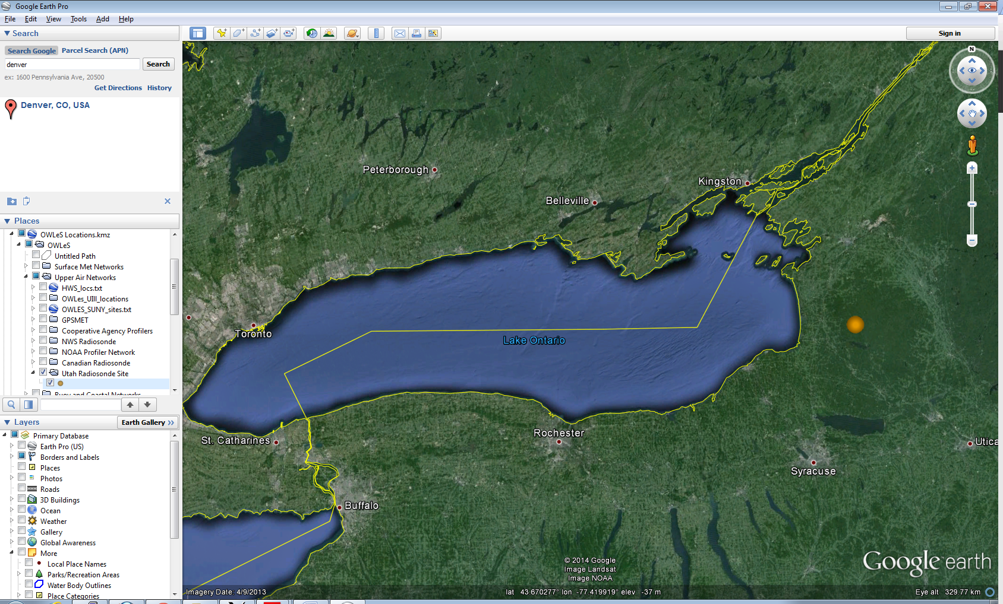

Figure 1. Location of the University of Utah radiosonde North Redfield site.

The Ontario Winter Lake-effect Systems (OWLeS) was a field campaign aimed at investigating the formation mechanisms, cloud microphysics, boundary layer processes, and dynamics of lake-effect systems (LeS) using new observational tools capable of detailing LeS characteristics not observed in previous LeS field experiments. Observations were focused around Lake Ontario because of its geometry and size, the influence of upstream lakes, the frequency of LeS, nearby orography, and its proximity to several participating universities. The University of Wyoming King Air aircraft took part in the experiment as well as several mobile radars and five mobile radiosonde sites. Further information on OWLeS is available at the OWLeS web site: <https://www.eol.ucar.edu/field_projects/owles> and information on OWLeS operations is available at the OWLeS Field Catalog: <http://catalog.eol.ucar.edu/owles/>.

**3.0 EOL Sounding Composite (ESC) File Format Description**

The ESC is a columnar ASCII format consisting of 15 header records for each sounding followed by the data records with associated data quality flags.

**3.1 Header Records**

The header records (15 total records) contain a variety of metadata about the sounding (i.e. location, time, radiosonde type, etc). The first five header lines contain information identifying the sounding, and have a rigidly defined form. The following 7 header lines are used for auxiliary information and comments about the sounding, and may vary from dataset to dataset. The last 3 header records contain header information for the data columns. Line 13 holds the field names, line 14 the field units, and line 15 contains dashes ('-' characters) delineating the extent of the field.

The file standard header lines are as follows:

|  |  |  |
| --- | --- | --- |
| **Line** | **Label (padded to 35 char)** | **Contents** |
| 1 | Data Type: | Description of the type and resolution of data |
| 2 | Project ID: | Short name for the field project |
| 3 | Release Site Type/Site ID: | Description of the release site. |
| 4 | Release Location (lon,lat,alt): | Location of the release site. |
| 5 | UTC Release Time (y,m,d,h,m,s): | Time of release. |

The release location is given as:

lon (deg min), lat (deg min), lon (dec. deg), lat (dec. deg), alt (m)

Longitude in deg min is in the format: ddd mm.mm'W where ddd is the number of degrees (with leading zeros if necessary), mm.mm is the decimal number of minutes, and W represents W or E for west or east longitude, respectively. Latitude has the same format as longitude, except there are only two digits for degrees and N or S for north/south latitude.

The time of release is given as: yyyy, mm, dd, hh:nn:ss.

Where yyyy is the year, mm is the month, dd is the day of month, and hh:nn:ss are the UTC hour, minute, and second respectively.

The seven non-standard header lines may contain any label and contents. The labels are padded to 35 characters to match the standard header lines. Records for this data set include the following non-standard header lines:

|  |  |  |
| --- | --- | --- |
| **Line** | **Label (padded to 35 char)** | **Contents** |
| 6 | Sonde Id/Sonde Type | Serial number and type of sonde |
| 7 | Ground Station Software |  |
| 8 | Surface Data Source |  |

The nominal release time for these soundings is the same as the actual time.

**3.2 Data Records**

The data records each contain time from release, pressure, temperature, dew point, relative humidity, U and V wind components, wind speed and direction, ascent rate, balloon position data, altitude, and quality control flags (see the QC code description). Each data line contains 21 fields, separated by spaces, with a total width of 130 characters. The data are right-justified within the fields. All fields have one decimal place of precision, with the exception of latitude and longitude, which have three decimal places of precision. The contents and sizes of the 21 fields that appear in each data record are as follows:

|  |  |  |  |  |  |
| --- | --- | --- | --- | --- | --- |
| **Field** | **Width** | **Format** | **Parameter** | **Units** | **Missing**  **Value** |
| 1 | 6 | F6.1 | Time since release | Seconds | 9999.0 |
| 2 | 6 | F6.1 | Pressure | Millibars | 9999.0 |
| 3 | 5 | F5.1 | Dry-bulb Temperature | Degrees C | 999.0 |
| 4 | 5 | F5.1 | Dew Point Temperature | Degrees C | 999.0 |
| 5 | 5 | F5.1 | Relative Humidity | Percent | 999.0 |
| 6 | 6 | F6.1 | U Wind Comp | m/s | 9999.0 |
| 7 | 6 | F6.1 | V Wind Comp | m/s | 9999.0 |
| 8 | 5 | F5.1 | Wind speed | m/s | 999.0 |
| 9 | 5 | F5.1 | Wind direction | Degrees | 999.0 |
| 10 | 5 | F5.1 | Ascent Rate | m/s | 999.0 |
| 11 | 8 | F8.3 | Longitude | Degrees | 9999.0 |
| 12 | 7 | F7.3 | Latitude | Degrees | 999.0 |
| 13 | 5 | F5.1 | Elevation Angle | Degrees | 999.0 |
| 14 | 5 | F5.1 | Azimuth Angle | Degrees | 999.0 |
| 15 | 7 | F7.1 | Altitude | Meters | 99999.0 |
| 16 | 4 | F4.1 | QC for Pressure | Code | 99.0 |
| 17 | 4 | F4.1 | QC for Temperature | Code | 99.0 |
| 18 | 4 | F4.1 | QC for Humidity | Code | 99.0 |
| 19 | 4 | F4.1 | QC for U Wind | Code | 99.0 |
| 20 | 4 | F4.1 | QC for V Wind | Code | 99.0 |
| 21 | 4 | F4.1 | QC for Ascent Rate | Code | 99.0 |

Fields 16 through 21 contain the data quality flags from the NCAR/Earth Observing Laboratory (EOL) sounding quality control procedures. The data quality flags are defined as follows:

|  |  |
| --- | --- |
| **Code** | **Description** |
| 1.0 | Checked, datum seems physically reasonable. (“GOOD”) |
| 2.0 | Checked, datum seems questionable on a physical basis. (“MAYBE”) |
| 3.0 | Checked, datum seems to be in error. (“BAD”) |
| 4.0 | Checked, datum is interpolated. (“ESTIMATED”) |
| 9.0 | Checked, datum is missing. (“MISSING”) |
| 99.0 | Unchecked (QC information is “missing”.) (“UNCHECKED”) |

**3.3 Data Specifics**

The files contain data at one-second intervals.

The data are in files by day, so all soundings for a particular day are concatenated into a single file ordered by time. The file naming convention is:

UUtah_Mobile_yyyymmdd.cls where yyyy is the year, mm is the month, and dd is the day of the month.

The University of Utah utilized GRAW DFM-09 radiosondes with GPS windfinding during OWLeS for all but the final four releases which used the Graw DFM-06 radiosonde also with GPS. GRAWmet version 5.0.8 ground station software was used. The surface data were obtained from the North Redfield Snow Study weather station that was co-located with the radiosonde release site.

**3.4 University of Utah Data Notes**

Sounding data was automatically quality controlled and smoothed during the launch with the GrawMet software defaults.

Additional field notes from Utah are included in the northredfield_soundings_fieldnotes.pdf file included with this data set.

**3.5 Sample Data**

The following is a sample of the OWLeS University of Utah high resolution radiosonde data in ESC format.

Data Type: University of Utah Mobile Radiosonde/Ascending

Project ID: OWLeS

Release Site Type/Site ID: North Redfield, NY

Release Location (lon,lat,alt): 075 52.68'W, 43 37.50'N, -75.878, 43.625, 385.0

UTC Release Time (y,m,d,h,m,s): 2013, 12, 07, 17:17:00

Sonde Id/Sonde Type: 312241/GRAW DFM-09 GPS Radiosonde

Ground Station Software: GrawMet version 5.0.8

Surface Data Source: North Redfield Snow Study Weather Station

/

/

/

Nominal Release Time (y,m,d,h,m,s):2013, 12, 07, 17:17:00

Time Press Temp Dewpt RH Ucmp Vcmp spd dir Wcmp Lon Lat Ele Azi Alt Qp Qt Qrh Qu Qv QdZ

sec mb C C % m/s m/s m/s deg m/s deg deg deg deg m code code code code code code

------ ------ ----- ----- ----- ------ ------ ----- ----- ----- -------- ------- ----- ----- ------- ---- ---- ---- ---- ---- ----

0.0 977.1 -3.4 -7.0 76.0 2.1 -0.5 2.2 283.0 999.0 -75.878 43.625 999.0 999.0 385.0 99.0 99.0 99.0 99.0 99.0 9.0

1.0 976.5 -3.5 -7.1 76.0 2.3 -0.5 2.4 283.0 4.0 -75.878 43.625 999.0 999.0 389.0 99.0 99.0 99.0 99.0 99.0 99.0

2.0 975.8 -3.6 -7.2 76.0 2.6 -0.6 2.7 283.0 3.9 -75.878 43.625 999.0 999.0 392.9 99.0 99.0 99.0 99.0 99.0 99.0

**3.6 Station List**

|  |  |  |  |  |  |  |
| --- | --- | --- | --- | --- | --- | --- |
| **Site ID** | **WMO ID** | **Site Name** | **State** | **Latitude** | **Longitude** | **Elev (m)** |
| UUtah | N/A | North Redfield | NY | -75.878 | 43.625 | 385 |

**4.0 Data Quality Control Procedures**

1. Each sounding was converted from its original format into the ESC format described above.
2. Each sounding was passed through a set of automated data quality checks which included basic gross limit checks as well as rate of change checks. This is further described in Section 4.1.
3. Each sounding was visually examined utilizing the NCAR/EOL XQC sounding quality control software. This is further described in Section 4.2.

**4.1 Automated Data Quality Checks**

This data set was passed through a set of automated data quality checks. This procedure includes both gross limit checks on all parameters as well as rate-of-change checks on temperature, pressure, and ascent rate. A version of these checks is described in Loehrer et al. (1996) and Loehrer et al. (1998).

**4.1.1 Gross Limit Checks**

These checks were conducted on each sounding and the data quality flags in the ESC files were adjusted as appropriate. Only the data point under examination was flagged. All checks also produced warning messages that specified the location of the problem and the severity of the issue. These warning messages where then summarized statistically and examined to determine any consistent issues.

For this data set NCAR/EOL conducted the following gross limit checks. In the table P = pressure, T = temperature, RH = relative humidity, U = U wind component, V = V wind component, B= bad, and Q = questionable.

|  |  |  |  |
| --- | --- | --- | --- |
| **Parameter** | **Check** | **Parameter(s) Flagged** | **Flag Applied** |
| Pressure | <0 or > 1050 | P | B |
| Altitude | < 0 or >40000 | P, T, RH | Q |
| Temperature | < -90 or > 45 | T | B |
| Dew Point | < -99.9 or > 33  > T | RH  T, RH | Q  Q |
| Wind Speed | < 0 or > 100  > 150 | U, V  U, V | Q  B |
| U Wind | < 0 or > 100  > 150 | U  U | Q  B |
| V Wind | < 0 or > 100  > 150 | V  V | Q  B |
| Wind Direction | < 0 or > 360 | U, V | B |
| Ascent Rate | < -10 or > 10 | P, T, RH | Q |

**4.1.2 Vertical Consistency Checks**

These checks were conducted on each sounding and the data quality flags in the ESC files were adjusted as appropriate. These checks were started at the surface and compared each neighboring data record. In the case of checks that ensured that the values increased/decreased as expected, only the data point under examination was flagged. However, for the other checks, all of the data points used in the examination were flagged. All items within the table are as previously defined. All checks also produced warning messages that specified the location of the problem and the severity of the issue. These warning messages where then summarized statistically and examined to determine any consistent issues.

|  |  |  |  |
| --- | --- | --- | --- |
| **Parameter** | **Check** | **Parameter(s) Flagged** | **Flag Applied** |
| Time | Decreasing/equal | None | None. |
| Altitude | Decreasing/equal | P, T, RH | Q |
| Pressure | Increasing/equal  > 1mb/s or < -1mb/s  > 2mb/s or < -2mb/s | P, T, TH  P, T, TH  P, T, TH | Q  Q  B |
| Temperature | < -15oC/km  < -30oC/km  > 50oC/km  > 100oC/km | P, T, RH  P, T, RH  P, T, RH  P, T, RH | Q  B  Q  B |
| Ascent Rate | > 3m/s or < -3m/s  > 5m/s or < -5m/s | P  P | Q  B |

**4.2 Visual Data Quality Checks**

Each sounding was visually examined using the NCAR/EOL XQC sounding data quality control software. This software allows the user to view a skew-t/log-p diagram of each sounding and apply data quality flags as appropriate. The user can zoom in on sections of soundings for detailed examination and can adjust the data quality flags for an individual point, sections of soundings, or entire soundings for each parameter individually. The software also allows the user to override the quality flags applied by the automated procedure.

**4.3 Data Quality Issues of Note**

The data quality control procedures outlined above allows us to identify and, in some cases, resolve issues that could potentially impact research performed using these data sets. The following issues were noted in these soundings.

1. Several files had periods of bad temperature and RH data

201312071717 – above 190mb

201312072015 – 267-226mb

201312110215 – 511-437mb and questionable 437-323mb

201312110515 – questionable from 325-305mb

201312111141 – above 367mb

201312112019 – above 365mb

201401192315 – 497-428mb

1. One file had a couple of questionable RH spikes

201312071717 – 292-280mb and 332-317mb

1. Several files had periods of questionable winds a couple are noted here:

201312072015 – above 240mb

201312112342 – above 102mb

**5.0 References**

Loehrer, S. M., T. A. Edmands, and J. A. Moore, 1996: TOGA COARE upper-air sounding data archive: development and quality control procedures. Bull. Amer. Meteor. Soc., 77, 2651-2671.

Loehrer, S. M., S. F. Williams, and J. A. Moore, 1998: Results from UCAR/JOSS quality control of atmospheric soundings from field projects. Preprints, Tenth Symposium on Meteorological Observations and Instrumentation, Phoenix, AZ, Amer. Meteor. Soc., 1-6.