1. **Contacts:**

**NCAR/EOL/CDS Processing and Quality Control:**

Scot Loehrer (NCAR/EOL)

[loehrer@ucar.edu](mailto:loehrer@ucar.edu)

**Original Data Source and Quality Control:**

Kate Young

NCAR/EOL

[kbeierle@ucar.edu](mailto:kbeierle@ucar.edu)

1. **NCAR/EOL/CDS Processing and Quality Control**

Scot Loehrer and Linda Echo-Hawk

1. **Dataset Overview**

The National Center for Atmospheric Research/Earth Observing Laboratory (NCAR/EOL) flew the NSF/NCAR Gulfstream-V HAIPER aircraft in the region around New Zealand and released dropsondes (Figure 1) as part of the DEEPWAVE field project. Dropsondes were released as requested during the field phase. This data set includes the quality controlled NSF/NCAR GV HAIPER dropsonde data released for the DEEPWAVE field phase (6 June to 20 July 2014). A total of 282 quality-controlled, high vertical resolution (0.25-second wind and 0.5 second pressure/temperature/humidity) soundings are contained in the final DEEPWAVE data set.

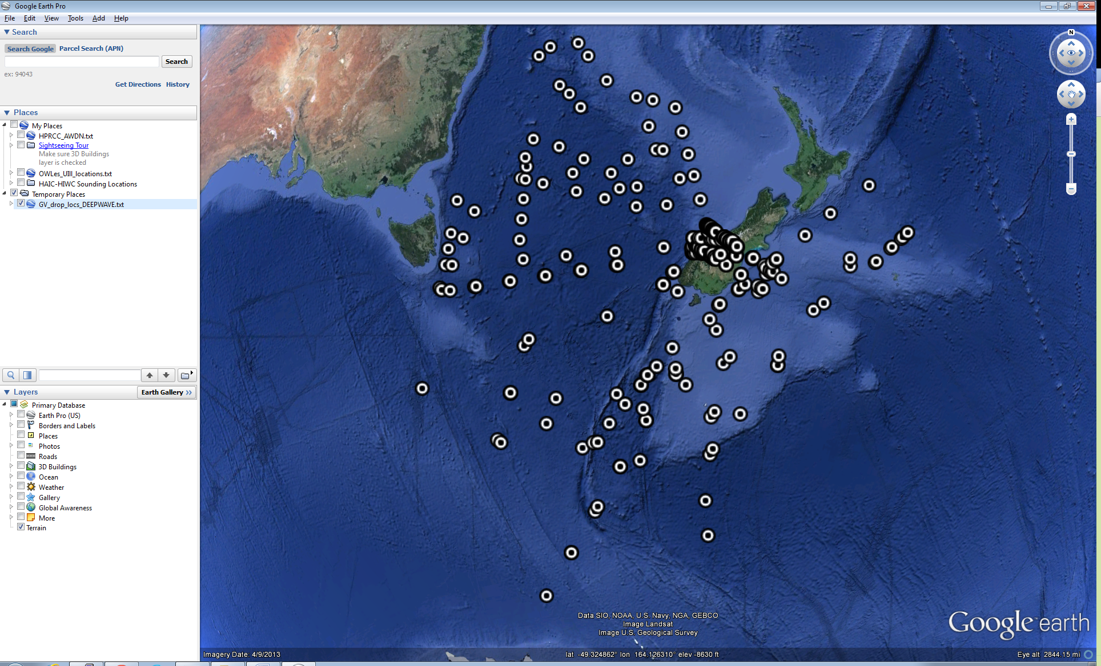

Figure 1. Location of the NSF/NCAR GV HAIPER dropsonde release points.

The Deep-Propagating Gravity Wave Experiment (DEEPWAVE) was a field campaign aimed at examining the dynamics of gravity waves from the surface of the Earth to the mesosphere and lower thermosphere. The NSF/NCAR HIAPER Gulfstream-V and DLR Falcon research aircraft were deployed along with a variety of surface-based instrumentation including surface meteorological networks, radars and lidars, sounding systems and regional models. Observations were focused around New Zealand due to it being an ideal natural laboratory to study deep propagating gravity waves and being one of the global gravity wave hot-spots in the upper stratosphere. Further information on DEEPWAVE is available at the DEEPWAVE web site: <https://www.eol.ucar.edu/field_projects/deepwave> and information on DEEPWAVE operations is available at the DEEPWAVE Field Catalog: <http://catalog.eol.ucar.edu/deepwave/>.

**3.0 EOL Sounding Composite (ESC) File Format Description**

The ESC is a columnar ASCII format consisting of 15 header records for each sounding followed by the data records with associated data quality flags.

**3.1 Header Records**

The header records (15 total records) contain a variety of metadata about the sounding (i.e. location, time, radiosonde type, etc). The first five header lines contain information identifying the sounding, and have a rigidly defined form. The following 7 header lines are used for auxiliary information and comments about the sounding, and may vary from dataset to dataset. The last 3 header records contain header information for the data columns. Line 13 holds the field names, line 14 the field units, and line 15 contains dashes ('-' characters) delineating the extent of the field.

The file standard header lines are as follows:

|  |  |  |
| --- | --- | --- |
| **Line** | **Label (padded to 35 char)** | **Contents** |
| 1 | Data Type: | Description of the type and resolution of data |
| 2 | Project ID: | Short name for the field project |
| 3 | Release Site Type/Site ID: | Description of the release site. |
| 4 | Release Location (lon,lat,alt): | Location of the release site. |
| 5 | UTC Release Time (y,m,d,h,m,s): | Time of release. |

The release location is given as:

lon (deg min), lat (deg min), lon (dec. deg), lat (dec. deg), alt (m)

Longitude in deg min is in the format: ddd mm.mm'W where ddd is the number of degrees (with leading zeros if necessary), mm.mm is the decimal number of minutes, and W represents W or E for west or east longitude, respectively. Latitude has the same format as longitude, except there are only two digits for degrees and N or S for north/south latitude.

The time of release is given as: yyyy, mm, dd, hh:nn:ss.

Where yyyy is the year, mm is the month, dd is the day of month, and hh:nn:ss are the UTC hour, minute, and second respectively.

The seven non-standard header lines may contain any label and contents. The labels are padded to 35 characters to match the standard header lines. Records for this data set include the following non-standard header lines:

|  |  |  |
| --- | --- | --- |
| **Line** | **Label (padded to 35 char)** | **Contents** |
| 6 | Sonde Id/Sonde Type | Serial number and type of radiosonde |
| 7 | Reference Launch Data Source/Time |  |
| 8 | System Operator/Comments |  |
| 9 | Post Processing Comments |  |

The nominal release time for these soundings is the same as the actual time.

**3.2 Data Records**

The data records each contain time from release, pressure, temperature, dew point, relative humidity, U and V wind components, wind speed and direction, ascent rate, balloon position data, altitude, and quality control flags (see the QC code description). Each data line contains 21 fields, separated by spaces, with a total width of 130 characters. The data are right-justified within the fields. All fields have one decimal place of precision, with the exception of latitude and longitude, which have three decimal places of precision. The contents and sizes of the 21 fields that appear in each data record are as follows:

|  |  |  |  |  |  |
| --- | --- | --- | --- | --- | --- |
| **Field** | **Width** | **Format** | **Parameter** | **Units** | **Missing**  **Value** |
| 1 | 6 | F6.1 | Time since release | Seconds | 9999.0 |
| 2 | 6 | F6.1 | Pressure | Millibars | 9999.0 |
| 3 | 5 | F5.1 | Dry-bulb Temperature | Degrees C | 999.0 |
| 4 | 5 | F5.1 | Dew Point Temperature | Degrees C | 999.0 |
| 5 | 5 | F5.1 | Relative Humidity | Percent | 999.0 |
| 6 | 6 | F6.1 | U Wind Comp | m/s | 9999.0 |
| 7 | 6 | F6.1 | V Wind Comp | m/s | 9999.0 |
| 8 | 5 | F5.1 | Wind speed | m/s | 999.0 |
| 9 | 5 | F5.1 | Wind direction | Degrees | 999.0 |
| 10 | 5 | F5.1 | Ascent Rate | m/s | 999.0 |
| 11 | 8 | F8.3 | Longitude | Degrees | 9999.0 |
| 12 | 7 | F7.3 | Latitude | Degrees | 999.0 |
| 13 | 5 | F5.1 | Elevation Angle | Degrees | 999.0 |
| 14 | 5 | F5.1 | Azimuth Angle | Degrees | 999.0 |
| 15 | 7 | F7.1 | Altitude | Meters | 99999.0 |
| 16 | 4 | F4.1 | QC for Pressure | Code | 99.0 |
| 17 | 4 | F4.1 | QC for Temperature | Code | 99.0 |
| 18 | 4 | F4.1 | QC for Humidity | Code | 99.0 |
| 19 | 4 | F4.1 | QC for U Wind | Code | 99.0 |
| 20 | 4 | F4.1 | QC for V Wind | Code | 99.0 |
| 21 | 4 | F4.1 | QC for Ascent Rate | Code | 99.0 |

Fields 16 through 21 contain the data quality flags from the NCAR/Earth Observing Laboratory (EOL) sounding quality control procedures. The data quality flags are defined as follows:

|  |  |
| --- | --- |
| **Code** | **Description** |
| 1.0 | Checked, datum seems physically reasonable. (“GOOD”) |
| 2.0 | Checked, datum seems questionable on a physical basis. (“MAYBE”) |
| 3.0 | Checked, datum seems to be in error. (“BAD”) |
| 4.0 | Checked, datum is interpolated. (“ESTIMATED”) |
| 9.0 | Checked, datum is missing. (“MISSING”) |
| 99.0 | Unchecked (QC information is “missing”.) (“UNCHECKED”) |

**3.3 Data Specifics**

The files contain wind data at 0.25 second and all other parameters at 0.5 second vertical intervals.

The data are in files by day, so all soundings for a particular day are concatenated into a single file ordered by time. The file naming convention is:

NCAR_GV_N677F_yyyymmdd.cls where yyyy is the year, mm is the month, and dd is the day of the month.

The NSF/NCAR GV HAIPER utilized Vaisala RD94 dropsondes using GPS for windfinding during DEEPWAVE.

**3.4 Sample Data**

The following is a sample of the NSF/NCAR GV HAIPER high resolution dropsonde data in ESC format.

Data Type: AVAPS SOUNDING DATA, Channel 1/Descending

Project ID: DEEPWAVE

Release Site Type/Site ID: NCAR GV, N677F RF01

Release Location (lon,lat,alt): 168 47.70'E, 42 57.61'S, 168.795, -42.960, 12436.0

UTC Release Time (y,m,d,h,m,s): 2014, 06, 06, 06:47:23

Sonde Id/Sonde Type: 102035134/Vaisala RD94

Reference Launch Data Source/Time: IWGADTS Format (IWG1)/06:47:23

System Operator/Comments: Remote Operator/none, none

Post Processing Comments: Aspen Version 3.1-7741; Created on 03 Feb 2015 00:15 UTC; Configuration mini-dropsonde

/

/

Nominal Release Time (y,m,d,h,m,s):2014, 06, 06, 06:47:23

Time Press Temp Dewpt RH Ucmp Vcmp spd dir Wcmp Lon Lat Ele Azi Alt Qp Qt Qrh Qu Qv QdZ

sec mb C C % m/s m/s m/s deg m/s deg deg deg deg m code code code code code code

------ ------ ----- ----- ----- ------ ------ ----- ----- ----- -------- ------- ----- ----- ------- ---- ---- ---- ---- ---- ----

233.0 1017.4 13.7 12.7 93.7 9999.0 9999.0 999.0 999.0 999.0 9999.000 999.000 999.0 999.0 0.0 1.0 1.0 1.0 9.0 9.0 9.0

232.5 9999.0 999.0 999.0 999.0 2.2 -7.7 8.0 343.7 999.0 9999.000 999.000 999.0 999.0 99999.0 9.0 9.0 9.0 99.0 99.0 9.0

232.2 1013.5 13.6 12.6 93.4 0.9 -9.8 9.9 354.5 -40.4 168.818 -42.973 999.0 999.0 32.0 2.0 1.0 1.0 1.0 1.0 99.0

**3.5 Station List**

|  |  |  |  |  |  |  |
| --- | --- | --- | --- | --- | --- | --- |
| **Site ID** | **WMO ID** | **Site Name** | **Country** | **Latitude** | **Longitude** | **Elev (m)** |
| N677F | N/A | GV HAIPER | N/A | Mobile | Mobile | Mobile |

**4.0 Data Quality Control Procedures**

1. Data underwent significant quality control at NCAR/EOL prior to what is described below. For full details on that quality control processing see [Young, et al 2014](http://data.eol.ucar.edu/datafile/nph-get/379.033/readme.Deepwave2014.GVdropsonde.pdf).
2. Each sounding was converted from its original format into the ESC format described above.
3. Each sounding was passed through a set of automated data quality checks which included basic gross limit checks as well as rate of change checks. This is further described in Section 4.1.
4. Each sounding was visually examined utilizing the NCAR/EOL XQC sounding quality control software. This is further described in Section 4.2.

**4.1 Automated Data Quality Checks**

This data set was passed through a set of automated data quality checks. This procedure includes both gross limit checks on all parameters as well as rate-of-change checks on temperature, pressure, and ascent rate. A version of these checks is described in Loehrer et al. (1996) and Loehrer et al. (1998).

**4.1.1 Gross Limit Checks**

These checks were conducted on each sounding and the data quality flags in the ESC files were adjusted as appropriate. Only the data point under examination was flagged. All checks also produced warning messages that specified the location of the problem and the severity of the issue. These warning messages where then summarized statistically and examined to determine any consistent issues.

For this data set NCAR/EOL conducted the following gross limit checks. In the table P = pressure, T = temperature, RH = relative humidity, U = U wind component, V = V wind component, B= bad, and Q = questionable.

|  |  |  |  |
| --- | --- | --- | --- |
| **Parameter** | **Check** | **Parameter(s) Flagged** | **Flag Applied** |
| Pressure | <0 or > 1050 | P | B |
| Altitude | < 0 or >40000 | P, T, RH | Q |
| Temperature | < -90 or > 45 | T | B |
| Dew Point | < -99.9 or > 33  > T | RH  T, RH | Q  Q |
| Wind Speed | < 0 or > 100  > 150 | U, V  U, V | Q  B |
| U Wind | < 0 or > 100  > 150 | U  U | Q  B |
| V Wind | < 0 or > 100  > 150 | V  V | Q  B |
| Wind Direction | < 0 or > 360 | U, V | B |
| Ascent Rate | < -10 or > 10 | P, T, RH | Q |

**4.1.2 Vertical Consistency Checks**

These checks were conducted on each sounding and the data quality flags in the ESC files were adjusted as appropriate. These checks were started at the surface and compared each neighboring data record. In the case of checks that ensured that the values increased/decreased as expected, only the data point under examination was flagged. However, for the other checks, all of the data points used in the examination were flagged. All items within the table are as previously defined. All checks also produced warning messages that specified the location of the problem and the severity of the issue. These warning messages where then summarized statistically and examined to determine any consistent issues.

|  |  |  |  |
| --- | --- | --- | --- |
| **Parameter** | **Check** | **Parameter(s) Flagged** | **Flag Applied** |
| Time | Decreasing/equal | None | None. |
| Altitude | Decreasing/equal | P, T, RH | Q |
| Pressure | Increasing/equal  > 1mb/s or < -1mb/s  > 2mb/s or < -2mb/s | P, T, TH  P, T, TH  P, T, TH | Q  Q  B |
| Temperature | < -15oC/km  < -30oC/km  > 50oC/km  > 100oC/km | P, T, RH  P, T, RH  P, T, RH  P, T, RH | Q  B  Q  B |
| Ascent Rate | > 3m/s or < -3m/s  > 5m/s or < -5m/s | P  P | Q  B |

**4.2 Visual Data Quality Checks**

Each sounding was visually examined using the NCAR/EOL XQC sounding data quality control software. This software allows the user to view a skew-t/log-p diagram of each sounding and apply data quality flags as appropriate. The user can zoom in on sections of soundings for detailed examination and can adjust the data quality flags for an individual point, sections of soundings, or entire soundings for each parameter individually. The software also allows the user to override the quality flags applied by the automated procedure.

**4.3 Data Quality Issues of Note**

The data quality control procedures outlined above allows us to identify and, in some cases, resolve issues that could potentially impact research performed using these data sets. The following issues were noted in these soundings.

Six soundings were classified as “fast fall drops” where the parachute failed to properly deploy leading to the dropsonde falling at an accelerated rate. Within these soundings the GPS wind measurements can be unreliable due to the irregular motion of the dropsonde and there may also be a lag in the response of the temperature and relative humidity sensors. Caution is urged in using the data from these soundings:

20140606064723

20140606073059

20140606113051

20140616093504

20140616114948

20140624064129

One sounding includes a period of data from its release where the dropsonde was still acclimatizing to the air outside the launch tube, thus the temperature data are too warm for the first ~15mb of the data:

20140624064129

The 64 dropsondes that were released over land are identified within the comments section of the header (“Drops Over Land”). For these soundings the geopotential height calculation was computed from the aircraft downward to the surface.

**5.0 References**

Loehrer, S. M., T. A. Edmands, and J. A. Moore, 1996: TOGA COARE upper-air sounding data archive: development and quality control procedures. Bull. Amer. Meteor. Soc., 77, 2651-2671.

Loehrer, S. M., S. F. Williams, and J. A. Moore, 1998: Results from UCAR/JOSS quality control of atmospheric soundings from field projects. Preprints, Tenth Symposium on Meteorological Observations and Instrumentation, Phoenix, AZ, Amer. Meteor. Soc., 1-6.

Young, K., T. Hock and C. Martin, 2014: DEEPWAVE 2014 Dropsonde Data Quality Report. Accessed at: <http://data.eol.ucar.edu/datafile/nph-get/379.033/readme.Deepwave2014.GVdropsonde.pdf>