1. **Contacts:**

**NCAR/EOL Processing and Quality Control:**

Scot Loehrer (NCAR/EOL)

[loehrer@ucar.edu](mailto:loehrer@ucar.edu)

**Original Data Source:**

John Braun

UCAR/COSMIC

[braunj@ucar.edu](mailto:braunj@ucar.edu)

1. **Dataset Overview**

The Constellation Observing System for Meteorology, Ionosphere, and Climate (COSMIC) mission is a constellation of six microsatellites in a 512 km orbit that provide radio occultation soundings throughout the globe. This data set includes select COSMIC soundings from the region around New Zealand and southeastern Australia (Figure 1) during the DEEPWAVE field season (6 June to 20 July 2014). A total of 68 soundings are contained in the final DEEPWAVE data set.

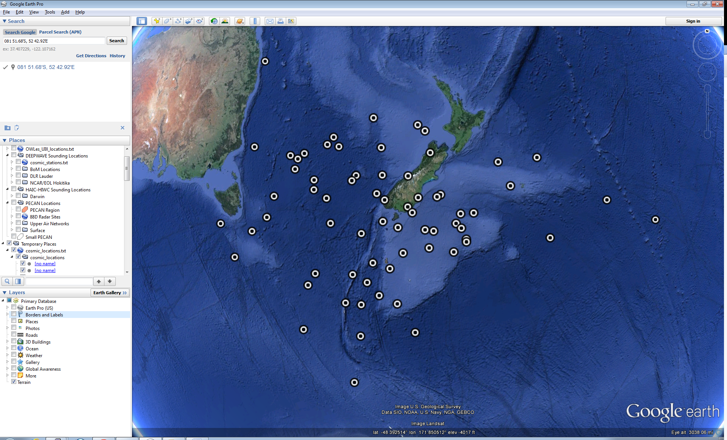

Figure 1. Location of the COSMIC radio occultation soundings in this data set.

The Deep-Propagating Gravity Wave Experiment (DEEPWAVE) was a field campaign aimed at examining the dynamics of gravity waves from the surface of the Earth to the mesosphere and lower thermosphere. The NSF/NCAR HIAPER Gulfstream-V and DLR Falcon research aircraft were deployed along with a variety of surface-based instrumentation including surface meteorological networks, radars and lidars, sounding systems and regional models. Observations were focused around New Zealand due to it being an ideal natural laboratory to study deep propagating gravity waves and being one of the global gravity wave hot-spots in the upper stratosphere. Further information on DEEPWAVE is available at the DEEPWAVE web site: <https://www.eol.ucar.edu/field_projects/deepwave> and information on DEEPWAVE operations is available at the DEEPWAVE Field Catalog: <http://catalog.eol.ucar.edu/deepwave/>.

**3.0 EOL Sounding Composite (ESC) File Format Description**

The ESC is a columnar ASCII format consisting of 15 header records for each sounding followed by the data records with associated data quality flags.

**3.1 Header Records**

The header records (15 total records) contain a variety of metadata about the sounding (i.e. location, time, radiosonde type, etc). The first five header lines contain information identifying the sounding, and have a rigidly defined form. The following 7 header lines are used for auxiliary information and comments about the sounding, and may vary from dataset to dataset. The last 3 header records contain header information for the data columns. Line 13 holds the field names, line 14 the field units, and line 15 contains dashes ('-' characters) delineating the extent of the field.

The file standard header lines are as follows:

|  |  |  |
| --- | --- | --- |
| **Line** | **Label (padded to 35 char)** | **Contents** |
| 1 | Data Type: | Description of the type and resolution of data |
| 2 | Project ID: | Short name for the field project |
| 3 | Release Site Type/Site ID: | Description of the release site. |
| 4 | Release Location (lon,lat,alt): | Location of the release site. |
| 5 | UTC Release Time (y,m,d,h,m,s): | Time of release. |

The release location is given as:

lon (deg min), lat (deg min), lon (dec. deg), lat (dec. deg), alt (m)

Longitude in deg min is in the format: ddd mm.mm'W where ddd is the number of degrees (with leading zeros if necessary), mm.mm is the decimal number of minutes, and W represents W or E for west or east longitude, respectively. Latitude has the same format as longitude, except there are only two digits for degrees and N or S for north/south latitude.

The time of release is given as: yyyy, mm, dd, hh:nn:ss.

Where yyyy is the year, mm is the month, dd is the day of month, and hh:nn:ss are the UTC hour, minute, and second respectively.

The seven non-standard header lines may contain any label and contents. The labels are padded to 35 characters to match the standard header lines. Records for this data set include the following non-standard header lines:

|  |  |  |
| --- | --- | --- |
| **Line** | **Label (padded to 35 char)** | **Contents** |
|  |  |  |

The nominal release time for these soundings is the same as the actual time.

**3.2 Data Records**

The data records each contain time from release, pressure, temperature, dew point, relative humidity, U and V wind components, wind speed and direction, ascent rate, balloon position data, altitude, and quality control flags (see the QC code description). Each data line contains 21 fields, separated by spaces, with a total width of 130 characters. The data are right-justified within the fields. All fields have one decimal place of precision, with the exception of latitude and longitude, which have three decimal places of precision. The contents and sizes of the 21 fields that appear in each data record are as follows:

|  |  |  |  |  |  |
| --- | --- | --- | --- | --- | --- |
| **Field** | **Width** | **Format** | **Parameter** | **Units** | **Missing**  **Value** |
| 1 | 6 | F6.1 | Time since release | Seconds | 9999.0 |
| 2 | 6 | F6.1 | Pressure | Millibars | 9999.0 |
| 3 | 5 | F5.1 | Dry-bulb Temperature | Degrees C | 999.0 |
| 4 | 5 | F5.1 | Dew Point Temperature | Degrees C | 999.0 |
| 5 | 5 | F5.1 | Relative Humidity | Percent | 999.0 |
| 6 | 6 | F6.1 | U Wind Comp | m/s | 9999.0 |
| 7 | 6 | F6.1 | V Wind Comp | m/s | 9999.0 |
| 8 | 5 | F5.1 | Wind speed | m/s | 999.0 |
| 9 | 5 | F5.1 | Wind direction | Degrees | 999.0 |
| 10 | 5 | F5.1 | Ascent Rate | m/s | 999.0 |
| 11 | 8 | F8.3 | Longitude | Degrees | 9999.0 |
| 12 | 7 | F7.3 | Latitude | Degrees | 999.0 |
| 13 | 5 | F5.1 | Elevation Angle | Degrees | 999.0 |
| 14 | 5 | F5.1 | Azimuth Angle | Degrees | 999.0 |
| 15 | 7 | F7.1 | Altitude | Meters | 99999.0 |
| 16 | 4 | F4.1 | QC for Pressure | Code | 99.0 |
| 17 | 4 | F4.1 | QC for Temperature | Code | 99.0 |
| 18 | 4 | F4.1 | QC for Humidity | Code | 99.0 |
| 19 | 4 | F4.1 | QC for U Wind | Code | 99.0 |
| 20 | 4 | F4.1 | QC for V Wind | Code | 99.0 |
| 21 | 4 | F4.1 | QC for Ascent Rate | Code | 99.0 |

Fields 16 through 21 contain the data quality flags from the NCAR/Earth Observing Laboratory (EOL) sounding quality control procedures. The data quality flags are defined as follows:

|  |  |
| --- | --- |
| **Code** | **Description** |
| 1.0 | Checked, datum seems physically reasonable. (“GOOD”) |
| 2.0 | Checked, datum seems questionable on a physical basis. (“MAYBE”) |
| 3.0 | Checked, datum seems to be in error. (“BAD”) |
| 4.0 | Checked, datum is interpolated. (“ESTIMATED”) |
| 9.0 | Checked, datum is missing. (“MISSING”) |
| 99.0 | Unchecked (QC information is “missing”.) (“UNCHECKED”) |

**3.3 Data Specifics**

The files contain data at one hundred meter vertical intervals up to 39900 m.

The data are in files by individual sounding. The file naming convention is:

COSMIC_yyyymmddhhnn.cls.qc where yyyy is the year, mm is the month, dd is the day of the month, hh is the hour, and nn is the minute. All dates and times are UTC.

The altitudes in these files are the geometric altitudes provided by COSMIC.

The relative humidity and dew point were derived from the vapor pressure data provided by COSMIC using the saturation vapor pressure formulation from WMO (2008). Dew point values less than -99.9 C are reset to the missing value (999.0) as they exceed the format width.

The dates, times, and locations used in the header are taken from the global attributes of the COSMIC netCDF data files.

The wind parameters are entirely missing in this data set.

**3.4 Sample Data**

The following is a sample of the COSMIC radio occultation sounding data in ESC format.

Data Type: COSMIC Radiosonde/Ascending

Project ID: DEEPWAVE

Release Site Type/Site ID: COSMIC

Release Location (lon,lat,alt): 177 42.29'E, 46 39.46'S, 177.705, -46.658, 0.0

UTC Release Time (y,m,d,h,m,s): 2014, 06, 06, 06:11:40

Sonde Type: COSMIC Radio Occultation Soundings

/

/

/

/

/

Nominal Release Time (y,m,d,h,m,s):2014, 06, 06, 06:11:40

Time Press Temp Dewpt RH Ucmp Vcmp spd dir Wcmp Lon Lat Ele Azi Alt Qp Qt Qrh Qu Qv QdZ

sec mb C C % m/s m/s m/s deg m/s deg deg deg deg m code code code code code code

------ ------ ----- ----- ----- ------ ------ ----- ----- ----- -------- ------- ----- ----- ------- ---- ---- ---- ---- ---- ----

9999.0 918.4 5.6 -5.3 45.3 9999.0 9999.0 999.0 999.0 999.0 9999.000 999.000 999.0 999.0 900.0 99.0 99.0 99.0 9.0 9.0 9.0

9999.0 907.3 5.7 -6.1 42.6 9999.0 9999.0 999.0 999.0 999.0 9999.000 999.000 999.0 999.0 1000.0 99.0 99.0 99.0 9.0 9.0 9.0

9999.0 896.2 5.6 -6.8 40.6 9999.0 9999.0 999.0 999.0 999.0 9999.000 999.000 999.0 999.0 1100.0 99.0 99.0 99.0 9.0 9.0 9.0

**4.0 Data Quality Control Procedures**

1. Each sounding was converted from its original format into the ESC format described above.
2. Each sounding was visually examined utilizing the NCAR/EOL XQC sounding quality control software. This is further described in Section 4.1.

**4.1 Visual Data Quality Checks**

Each sounding was visually examined using the NCAR/EOL XQC sounding data quality control software. This software allows the user to view a skew-t/log-p diagram of each sounding and apply data quality flags as appropriate. The user can zoom in on sections of soundings for detailed examination and can adjust the data quality flags for an individual point, sections of soundings, or entire soundings for each parameter individually. Only data up to 50 mb is checked in this fashion.

**4.2 Data Quality Issues of Note**

The data quality control procedures outlined above allows us to identify and, in some cases, resolve issues that could potentially impact research performed using these data sets. The following issues were noted in these soundings.

A few soundings have data that stops well above the surface:

201406111140 – 868mb

201406130750 – 434mb

201406140719 – 363mb

201406190635 – 783mb

201406240620 – 810mb

201407040731 – 763mb

**5.0 References**

COSMIC Web Site - <http://www.cosmic.ucar.edu>