1. **Contacts:**

**NCAR/EOL Processing and Quality Control:**

Scot Loehrer (NCAR/EOL)

[loehrer@ucar.edu](mailto:loehrer@ucar.edu)

**Original Data Source:**

Russ Schumacher (CSU)

[russ.schumacher@colostate.edu](mailto:russ.schumacher@colostate.edu)

**2.0 Dataset Overview**

Colorado State University (CSU) operated a mobile radiosonde system during the Mesoscale Predictability Experiment (MPEX) during the period from 10 May to 14 June 2013. Soundings were taken intermittently as determined by the weather situation, with a focus on the pre-convective and convectively disturbed environments near deep convective storms in the central United States. Soundings were coordinated with releases from the mobile teams from Purdue University and the National Severe Storms Laboratory (NSSL). This data set includes a total of 55 quality controlled, high vertical resolution (2 second) soundings are contained in the final MPEX data set (Figure 1).

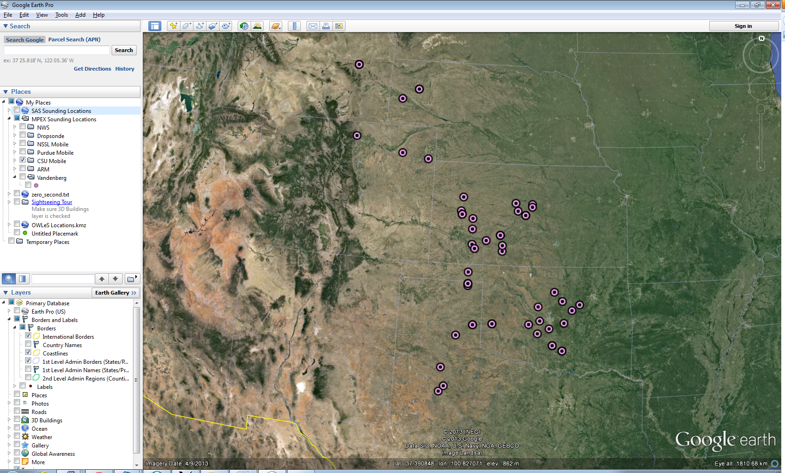

Figure 1. CSU Mobile radiosonde release locations during MPEX.

The Mesoscale Predictability Experiment (MPEX) was a field campaign aimed at investigating if experimental sub-synoptic observations can extend convective-scale predictability and otherwise enhance sill in regional numerical weather prediction over a 6-24 hour time span. The NSF/NCAR Gulfstream-V (GV) aircraft deploying dropsondes was the primary platform used in the experiment. There were also three groups on the ground releasing radiosondes from mobile platforms. Further information on MPEX is available at the MPEX web site: <http://www.eol.ucar.edu/projects/mpex/> and information on MPEX operations are available at the MPEX Field Catalog: <http://catalog.eol.ucar.edu/mpex/>.

**3.0 EOL Sounding Composite (ESC) File Format Description**

The ESC is a columnar ASCII format consisting of 15 header records for each sounding followed by the data records with associated data quality flags.

**3.1 Header Records**

The header records (15 total records) contain a variety of metadata about the sounding (i.e. location, time, radiosonde type, etc). The first five header lines contain information identifying the sounding, and have a rigidly defined form. The following 7 header lines are used for auxiliary information and comments about the sounding, and may vary from dataset to dataset. The last 3 header records contain header information for the data columns. Line 13 holds the field names, line 14 the field units, and line 15 contains dashes ('-' characters) delineating the extent of the field.

The file standard header lines are as follows:

|  |  |  |
| --- | --- | --- |
| **Line** | **Label (padded to 35 char)** | **Contents** |
| 1 | Data Type: | Description of the type and resolution of data |
| 2 | Project ID: | Short name for the field project |
| 3 | Release Site Type/Site ID: | Description of the release site. |
| 4 | Release Location (lon,lat,alt): | Location of the release site. |
| 5 | UTC Release Time (y,m,d,h,m,s): | Time of release. |

The release location is given as:

lon (deg min), lat (deg min), lon (dec. deg), lat (dec. deg), alt (m)

Longitude in deg min is in the format: ddd mm.mm'W where ddd is the number of degrees (with leading zeros if necessary), mm.mm is the decimal number of minutes, and W represents W or E for west or east longitude, respectively. Latitude has the same format as longitude, except there are only two digits for degrees and N or S for north/south latitude.

The time of release is given as: yyyy, mm, dd, hh:nn:ss.

Where yyyy is the year, mm is the month, dd is the day of month, and hh:nn:ss are the UTC hour, minute, and second respectively.

The seven non-standard header lines may contain any label and contents. The labels are padded to 35 characters to match the standard header lines. Records for this data set include the following non-standard header lines:

|  |  |  |
| --- | --- | --- |
| **Line** | **Label (padded to 35 char)** | **Contents** |
| 6 | Sonde Type: | Radiosonde type |
| 7 |  |  |
| 8 |  |  |
| 9 |  |  |
| 10 |  |  |
| 11 |  |  |
| 12 | Nominal Release Time (y,m,d,h,m,s): | Nominal release time |

The nominal release time is 1200 UTC for these soundings.

**3.2 Data Records**

The data records each contain time from release, pressure, temperature, dew point, relative humidity, U and V wind components, wind speed and direction, ascent rate, balloon position data, altitude, and quality control flags (see the QC code description). Each data line contains 21 fields, separated by spaces, with a total width of 130 characters. The data are right-justified within the fields. All fields have one decimal place of precision, with the exception of latitude and longitude, which have three decimal places of precision. The contents and sizes of the 21 fields that appear in each data record are as follows:

|  |  |  |  |  |  |
| --- | --- | --- | --- | --- | --- |
| **Field** | **Width** | **Format** | **Parameter** | **Units** | **Missing**  **Value** |
| 1 | 6 | F6.1 | Time since release | Seconds | 9999.0 |
| 2 | 6 | F6.1 | Pressure | Millibars | 9999.0 |
| 3 | 5 | F5.1 | Dry-bulb Temperature | Degrees C | 999.0 |
| 4 | 5 | F5.1 | Dew Point Temperature | Degrees C | 999.0 |
| 5 | 5 | F5.1 | Relative Humidity | Percent | 999.0 |
| 6 | 6 | F6.1 | U Wind Comp | m/s | 9999.0 |
| 7 | 6 | F6.1 | V Wind Comp | m/s | 9999.0 |
| 8 | 5 | F5.1 | Wind speed | m/s | 999.0 |
| 9 | 5 | F5.1 | Wind direction | Degrees | 999.0 |
| 10 | 5 | F5.1 | Ascent Rate | m/s | 999.0 |
| 11 | 8 | F8.3 | Longitude | Degrees | 9999.0 |
| 12 | 7 | F7.3 | Latitude | Degrees | 999.0 |
| 13 | 5 | F5.1 | Elevation Angle | Degrees | 999.0 |
| 14 | 5 | F5.1 | Azimuth Angle | Degrees | 999.0 |
| 15 | 7 | F7.1 | Altitude | Meters | 99999.0 |
| 16 | 4 | F4.1 | QC for Pressure | Code | 99.0 |
| 17 | 4 | F4.1 | QC for Temperature | Code | 99.0 |
| 18 | 4 | F4.1 | QC for Humidity | Code | 99.0 |
| 19 | 4 | F4.1 | QC for U Wind | Code | 99.0 |
| 20 | 4 | F4.1 | QC for V Wind | Code | 99.0 |
| 21 | 4 | F4.1 | QC for Ascent Rate | Code | 99.0 |

Fields 16 through 21 contain the data quality flags from the NCAR/Earth Observing Laboratory (EOL) sounding quality control procedures. The data quality flags are defined as follows:

|  |  |
| --- | --- |
| **Code** | **Description** |
| 1.0 | Checked, datum seems physically reasonable. (“GOOD”) |
| 2.0 | Checked, datum seems questionable on a physical basis. (“MAYBE”) |
| 3.0 | Checked, datum seems to be in error. (“BAD”) |
| 4.0 | Checked, datum is interpolated. (“ESTIMATED”) |
| 9.0 | Checked, datum is missing. (“MISSING”) |
| 99.0 | Unchecked (QC information is “missing”.) (“UNCHECKED”) |

**3.3 Data Specifics**

The files contain data at 2-second vertical levels

The data are in files by day, so all soundings for a particular day are concatenated into a single file ordered by time. The file naming convention is:

CSU_Mobile_yyyymmdd.cls where yyyy is the year, mm is the month, and dd is the day of the month.

The CSU Mobile platform utilized Vaisala RS-92 radiosondes with GPS windfinding during MPEX. The ground station software was the Digicora MW21 system running V3.64 software. Radiosonde serial numbers were not noted by the data source.

These data include the proprietary processing performed by the Vaisala Digicora software which includes corrections for standard known biases of the instrument.

The surface observations were manually entered for each sounding, taking into account the readings from a handheld weather station and the most recent observations from the nearest ASOS/AWOS/METAR station.

The sounding from 2349 UTC on 16 May 2013 does not have latitude/longitude information above the surface.

Additional information can be found in the readme for the original Vaisala format version of this data set provided by CSU:

<http://data.eol.ucar.edu/codiac/dss/id=371.011>

**3.4 Sample Data**

The following is a sample of the MPEX CSU Mobile high resolution radiosonde data in ESC format.

Data Type: CSU Mobile Radiosonde/Ascending

Project ID: MPEX

Release Site Type/Site ID: CSU Mobile

Release Location (lon,lat,alt): 105 09.00'W, 40 35.40'N, -105.150, 40.590, 1594.0

UTC Release Time (y,m,d,h,m,s): 2013, 05, 10, 23:33:00

Sonde Id/Sonde Type: J1544025/Vaisala RS-92 with GPS Windfinding

Ground Station Software: Digicora MW21 V3.64

Surface Data Source: Handheld weather station and/or most recent obs from nearest METAR station

/

/

/

Nominal Release Time (y,m,d,h,m,s):2013, 05, 10, 23:33:00

Time Press Temp Dewpt RH Ucmp Vcmp spd dir Wcmp Lon Lat Ele Azi Alt Qp Qt Qrh Qu Qv QdZ

sec mb C C % m/s m/s m/s deg m/s deg deg deg deg m code code code code code code

------ ------ ----- ----- ----- ------ ------ ----- ----- ----- -------- ------- ----- ----- ------- ---- ---- ---- ---- ---- ----

0.0 846.2 16.9 -0.8 30.0 6.5 -0.3 6.5 273.0 999.0 -105.150 40.590 999.0 999.0 1594.0 3.0 3.0 3.0 1.0 1.0 9.0

2.0 845.3 17.9 -0.3 29.0 2.0 -1.8 2.7 311.0 5.0 -105.150 40.590 999.0 999.0 1604.0 3.0 3.0 3.0 1.0 1.0 99.0

4.0 844.1 17.8 -0.8 28.0 1.6 -1.8 2.4 318.0 5.5 -105.150 40.590 999.0 999.0 1615.0 1.0 1.0 1.0 1.0 1.0 99.0

**3.5 Station List**

|  |  |  |  |  |  |
| --- | --- | --- | --- | --- | --- |
| **ID** | **Site Name** | **State** | **Longitude** | **Latitude** | **Elev (m)** |
| N/A | CSU Mobile | Mobile | Mobile | Mobile | Mobile |

**4.0 Data Quality Control Procedures**

1. Each sounding was converted from its original format (columnar ASCII) into the ESC format described above.
2. Each sounding was passed through a set of automated data quality checks which included basic gross limit checks as well as rate of change checks. This is further described in Section 4.1.
3. Each sounding was visually examined utilizing the NCAR/EOL XQC sounding quality control software. This is further described in Section 4.2.

**4.1 Automated Data Quality Checks**

This data set was passed through a set of automated data quality checks. This procedure includes both gross limit checks on all parameters as well as rate-of-change checks on temperature, pressure, and ascent rate. A version of these checks is described in Loehrer et al. (1996) and Loehrer et al. (1998).

**4.1.1 Gross Limit Checks**

These checks were conducted on each sounding and the data quality flags in the ESC files were adjusted as appropriate. Only the data point under examination was flagged. All checks also produced warning messages that specified the location of the problem and the severity of the issue. These warning messages where then summarized statistically and examined to determine any consistent issues.

For this data set NCAR/EOL conducted the following gross limit checks. In the table P = pressure, T = temperature, RH = relative humidity, U = U wind component, V = V wind component, B= bad, and Q = questionable.

|  |  |  |  |
| --- | --- | --- | --- |
| **Parameter** | **Check** | **Parameter(s) Flagged** | **Flag Applied** |
| Pressure | <0 or > 1050 | P | B |
| Altitude | < 0 or >40000 | P, T, RH | Q |
| Temperature | < -90 or > 45 | T | B |
| Dew Point | < -99.9 or > 33  > T | RH  T, RH | Q  Q |
| Wind Speed | < 0 or > 100  > 150 | U, V  U, V | Q  B |
| U Wind | < 0 or > 100  > 150 | U  U | Q  B |
| V Wind | < 0 or > 100  > 150 | V  V | Q  B |
| Wind Direction | < 0 or > 360 | U, V | B |
| Ascent Rate | < -10 or > 10 | P, T, RH | Q |

**4.1.2 Vertical Consistency Checks**

These checks were conducted on each sounding and the data quality flags in the ESC files were adjusted as appropriate. These checks were started at the surface and compared each neighboring data record. In the case of checks that ensured that the values increased/decreased as expected, only the data point under examination was flagged. However, for the other checks, all of the data points used in the examination were flagged. All items within the table are as previously defined. All checks also produced warning messages that specified the location of the problem and the severity of the issue. These warning messages where then summarized statistically and examined to determine any consistent issues.

|  |  |  |  |
| --- | --- | --- | --- |
| **Parameter** | **Check** | **Parameter(s) Flagged** | **Flag Applied** |
| Time | Decreasing/equal | None | None. |
| Altitude | Decreasing/equal | P, T, RH | Q |
| Pressure | Increasing/equal  > 1mb/s or < -1mb/s  > 2mb/s or < -2mb/s | P, T, TH  P, T, TH  P, T, TH | Q  Q  B |
| Temperature | < -15oC/km  < -30oC/km  > 50oC/km  > 100oC/km | P, T, RH  P, T, RH  P, T, RH  P, T, RH | Q  B  Q  B |
| Ascent Rate | > 3m/s or < -3m/s  > 5m/s or < -5m/s | P  P | Q  B |

**4.2 Visual Data Quality Checks**

Each sounding was visually examined using the NCAR/EOL XQC sounding data quality control software. This software allows the user to view a skew-t/log-p diagram of each sounding and apply data quality flags as appropriate. The user can zoom in on sections of soundings for detailed examination and can adjust the data quality flags for an individual point, sections of soundings, or entire soundings for each parameter individually. The software also allows the user to override the quality flags applied by the automated procedure.

**4.3 Data Quality Issues of Note**

N/A

**5.0 References**

Loehrer, S. M., T. A. Edmands, and J. A. Moore, 1996: TOGA COARE upper-air sounding data archive: development and quality control procedures. Bull. Amer. Meteor. Soc., 77, 2651-2671.

Loehrer, S. M., S. F. Williams, and J. A. Moore, 1998: Results from UCAR/JOSS quality control of atmospheric soundings from field projects. Preprints, Tenth Symposium on Meteorological Observations and Instrumentation, Phoenix, AZ, Amer. Meteor. Soc., 1-6.