Sounding Comparison Software (SCT)
Monica Jacobs
July 2011
Description
The purpose of the Sounding Comparison Software is to allow a user to compare the data from up to five soundings. It would be used by scientific staff to view plots of temperature, relative humidity, wind speed, wind direction, and ascension rate vs. pressure (as well as longitude, latitude, U winds and V winds with one of the extensions). This allows for improved sounding quality control processing.

Investigation

After investigation of languages for the XQC software, java appeared to be the best choice. It is cross-platform compatible and can easily be made into executable software (“Language Comparison: Sheet1”). Java is also well-known for its graphical user interfaces, and thus was clearly the best option.

There do not appear to be any preexisting tools similar to this one.

There are several tools that can be used to generate plots from datasets. However, gnuplot immediately stood out because it is already installed on the network. After some research, it was discovered that gnuplot is heavily command-line-driven, so integrating it into a java program would be somewhat difficult(“gnuplot homepage”). Nonetheless, there are packages made to aid this issue. Javaplot is one, and gnujavaplot is another. These allow gnuplot commands to called directly from java (“About JavaPlot”). Unfortunately, after some technical difficulties installing gnuplot and javaplot on my local computer, I determined that it would be easier to forgo Javaplot and implement the software on the network (since gnuplot was already there and this would allow for access from any EOL computer). Still, this left the problem of accessing gnuplot from java.

After looking at some gnuplot skew-t code in perl, it became obvious that a solution existed. I talked to Janine Aquino, who explained that one can edit and then call a script in gnuplot. I implemented this, and thus found that this software is best written on the network.

Software Requirements
Mandatory
    - This tool should allow the user a windows-style interface for file selection.
    - The tool should allow the user to select up to five soundings to be displayed together on(temperature, relative humidity, wind speed, wind direction, and ascension rate vs. pressure).
    - This tool should allow the user to quit with a Quit button
    - The user should be able to clear the selected data files and select new ones without exiting the software.
    - The user should be able to select one of the smaller plots and view it larger.
    - The tool should handle errors and die gracefully when necessary.
    - There should be a legend for the plots in order to differentiate between different datasets.
    - The plots should be properly scaled.
    - When pressure is the y-variable, the scale should be reversed (with the largest value near the x-axis and 0 at the top).

Desired
    - The user should be able to change the y-axis-variable between pressure, time and altitude.
    - The user should have the choice between the plots of the parameters vs. pressure or the soundings displayed on a skew-T.
    - The user should be able to drag and drop to zoom in on a plot or feature.
    - The user should be able to view a second pane of plots (of longitude, latitude, U wind and V wind).
    - The option to reverse the y-axis for dropsondes when plotting time as the y-variable.

Rough Schedule
June 23- SCT Project assigned
June 25- Research and basic java GUI completed
June 28- Official project write-up released
June 30- Be able to plot data with gnuplot
July 1- Display all five plots in GUI
July 5- Display multiple datasets on each plot
July 15- Finish debugging and fixing requested changes
July 22- Finish all documentation
July 29- Have completed any extensions
August 3- Finalized and practiced final presentation
August 5- Final Presentation!

Software Description
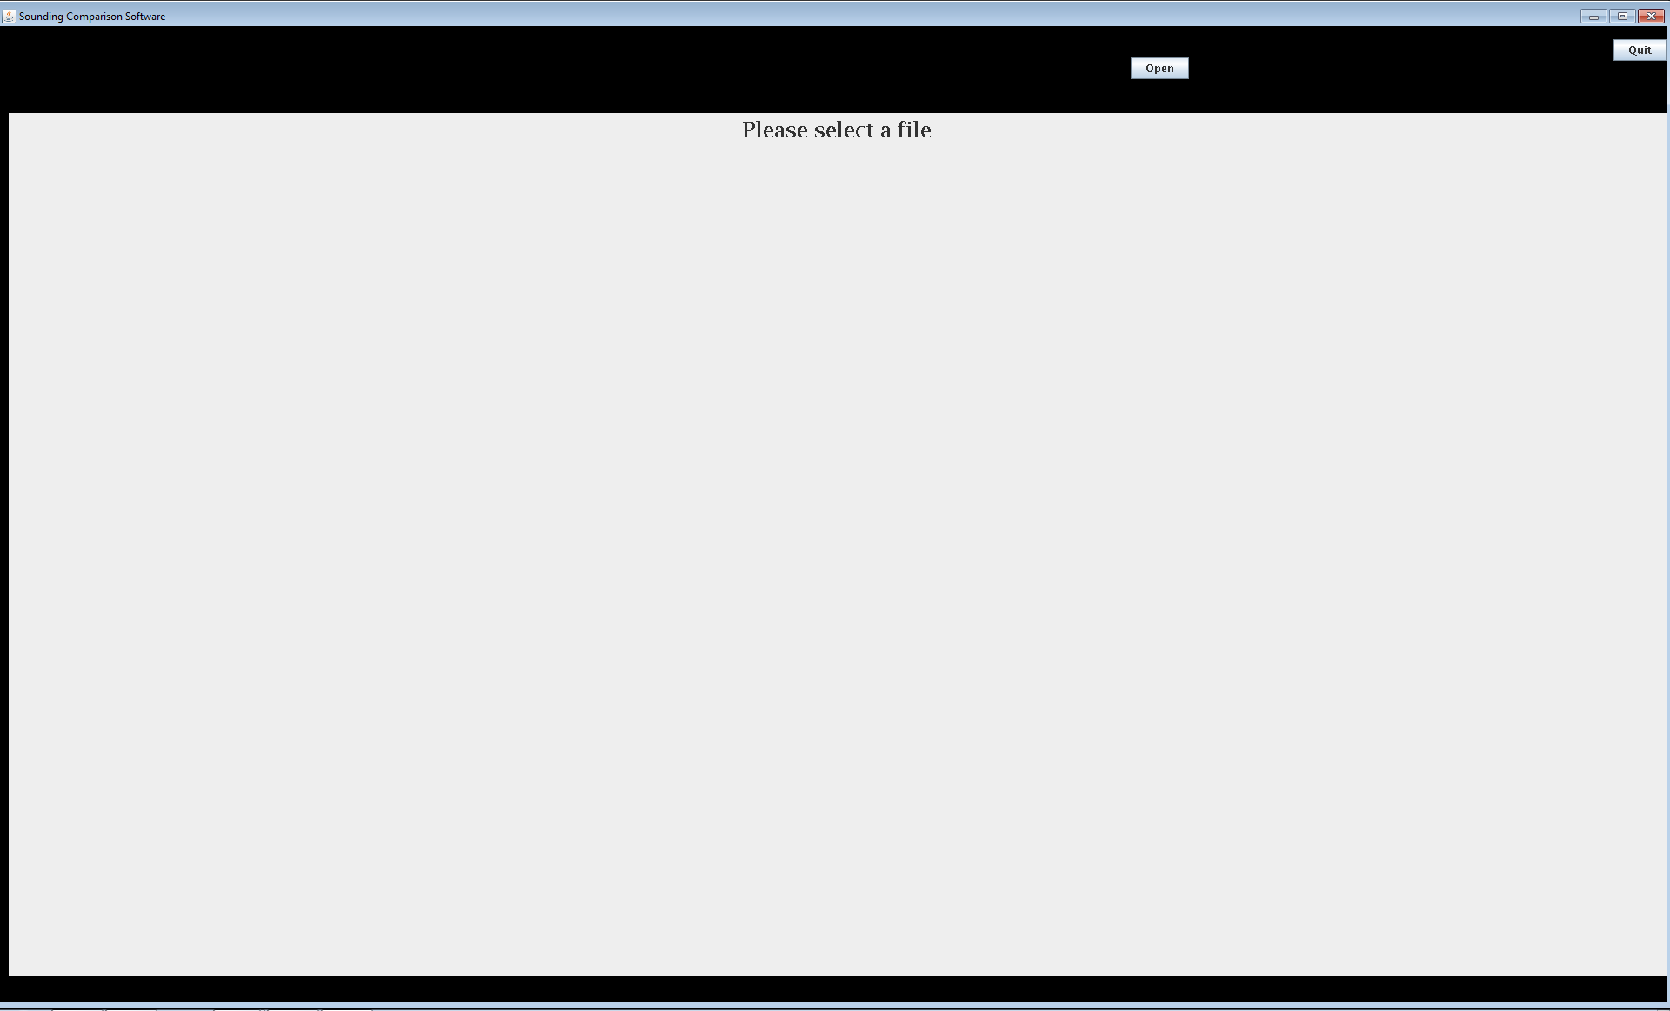Illustration 1: View at program start-up
The Sounding Comparison Tool (SCT) gets the input files the user selects with the JFileChooser (from the “Open” button- visible in the upper right corner in Illustration 1). This JFileChooser used SCT_DataFilter.java to only allow files ending in “.cls” or “.qc” to be visible. DO NOT TURN THE FILTERS OFF AND OPEN A .sct FILE IN THE SAME DIRECTORY AS SCT. Also, only select complete data files; empty files of files that end mid-line do not plot. The selected datafiles are read and rewritten into the current directory such that the missing data values are all replaced with a “?”. If the name of a file is repeated (more than one file with the same name is being used), an integer is added to the end. The integer increments after every duplicate, so the numbers are not always in order. For instance, if a user selected “dataA.cls”, “dataA.cls”, “dataB.cls”, and “dataB.cls” the intermediate datafiles generated in the current directory would be “dataA.sct”, “dataA1.sct”, “dataB.sct”, and “dataB2.sct”. However, these file names are only visible in the plot legend visible in the full-screen plots (see below). The original file names appear in the header at the top of the interface (Illustration 2).
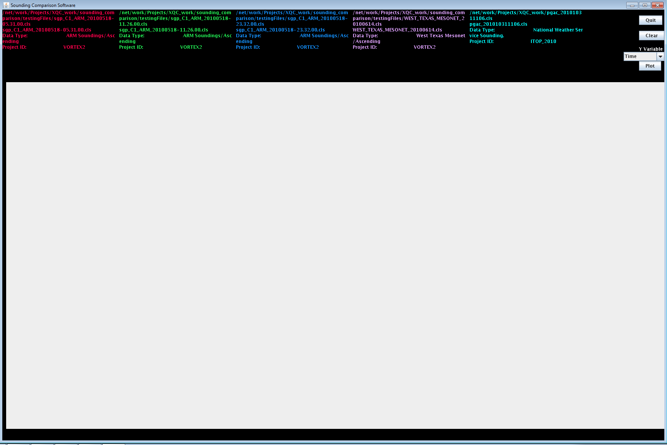Illustration 2: View after opening five files
When the “Plot” button is pressed, sct_gnuTemplate.gnu is read and file1.gnu and file2.gnu are written for each of the five plots with the y-variable selected in the “Y-Variable” menu. If “Pressure” or “Time (Dropsonde)” happens to be selected, the y-axis is plotted in reverse (with 0 at the top). file1.gnu is run and creates the small plots as .gif files. file2.gnu creates the zoomed full-screen plots as .gif files when run. These image files are displayed as ImageIcons in JPanels in the user interface (Illustration 3). The user can then select the “More Plots” button to display another four plots (Illustration 4). Once the user selects a plot and presses the “Zoom” button, the selected plot is displayed larger (Illustration 5). To return to the normal interface view from here, the “Exit” button must be selected.

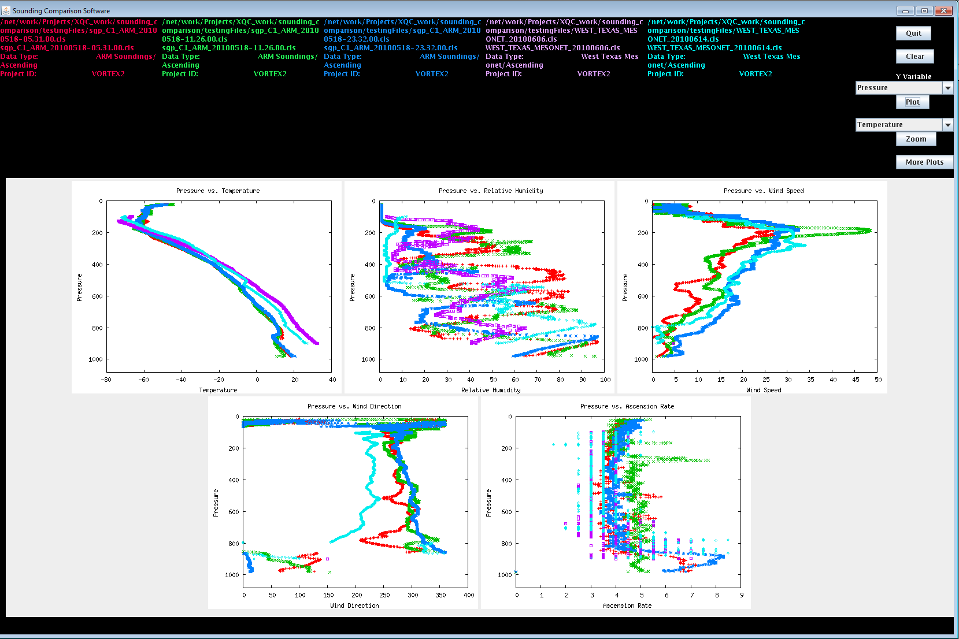Illustration 3: View after “Plot” button is pressed

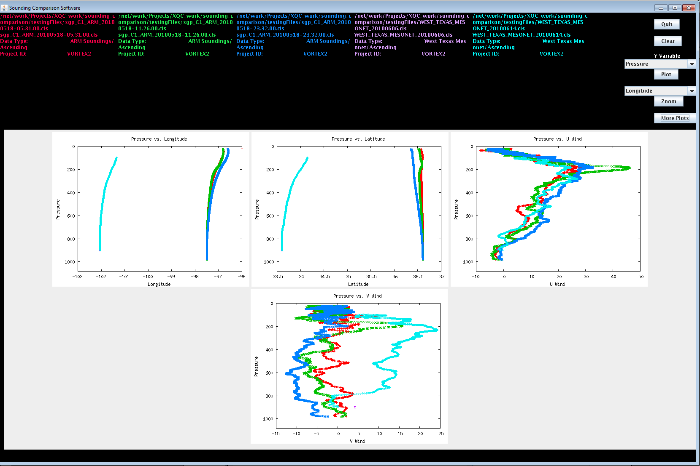Illustration 4: View of second pane of plots (after pressing “More Plots” button)

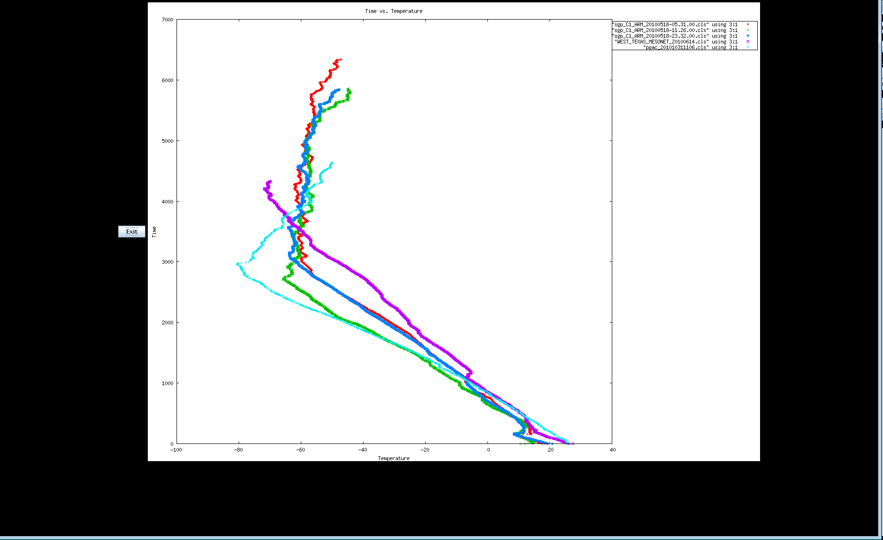Illustration 5: Zoom view
When the “Clear” button or “Quit” button is pressed, the intermediate datafiles are deleted individually. Also, sct_quit.sh is run, which removes the generated gifs as well as file1.gnu and file2.gnu. The screen is reset to its original appearance with only the “Open” and “Quit” buttons visible. “Quit” also closes the frame and exits the program.

Exceptions
The following error messages are displayed in a pop-up window for each exception thrown by the software.
Containing Method | Type of Exception | Output in Error Pop-up Window
getHeader | FileNotFoundException | “Please select a valid file”
initGUI | Exception
writeData | IOException | “Unsuccessful file write. Please try again”
writeData | NumberFormatException
callGnuplot | Exception | “Unsuccessful runtime operation”
callGnuplot | IOException | “Problem reading file”
updateTemplate | IOException | “Input Stream Error”
updateTemplate | FileNotFoundException | “File Not Found”
updateTemplate | Exception | “Error in writing file2.gnu”

Documentation

All documentation stored in dmg/tools/upper_air/SCT

Description of Testing
There is a regression testing suite with instructions in howto_sct_regression_testing.html. These tests should be performed after any updates to the SCT.

-July 7 Demo for Scot Loehrer and Steve Williams: reverse variables on axes but otherwise good
-July 11 Demo for Linda Cully
-July 13 Demo for Linda Cully and Scot Loehrer
-July 18+ User feedback from Scot Loehrer

References
Investigation
“About JavaPlot” http://gnujavaplot.sourceforge.net/JavaPlot/About.html Date Accessed: 7/6/11
“Calling gnuplot from java? (ubuntu)”
http://stackoverflow.com/questions/3196563/calling-gnuplot-from-java-ubuntu Date Accessed: 7/6/11
“gnuplot homepage” http://www.gnuplot.info/ Date Accessed” 7/6/11
“GNUplot under java” http://old.nabble.com/GNUPlot-under-Java-td14333230.html Date Accessed 7/6/11
“Java vs C# vs Python vs Ruby: an “objective” analysis” http://jasonmbaker.wordpress.com/2009/04/21/java-vs-c-vs-python-vs-ruby-an-objective- analysis/ Date Accessed: 6/9/11
“Language-comparison: Sheet1”
https://spreadsheets.google.com/pub?key=p7efJLoHuYE-iw6JxBmpSQg&hl=en
Date Accessed: 6/9/11

Coding
“Checking Empty File” http://www.coderanch.com/t/279224/Streams/java/Checking-empty-file Date Accessed: 7/21/11
“Convert String to Double”
http://www.java2s.com/Code/Java/Language-Basics/Convertstringtodouble.htm Date Accessed: 7/19/11
“Delete File using Java IO API”
http://www.java2s.com/Code/Java/File-Input-Output/DeletefileusingJavaIOAPI.htm Date Accessed: 7/12/11
“Executing Shell script from Java code”
http://www.daniweb.com/software-development/java/threads/82596 Date Accessed: 7/6/11
"GNUPLOT 4.2- A Brief Manual and Tutorial” http://www.duke.edu/~hpgavin/gnuplot.html Date Accessed: 7/1/11
“Gnuplot demo script: key.dem” http://gnuplot.sourceforge.net/demo/key.html Date Accessed: 7/18/11
“Gnuplot: not so Frequently Asked Questions” http://t16web.lanl.gov/Kawano/gnuplot/index-e.html Date Accessed: 7/1/11
“How to Make JLabel automatically wrap to next line” http://www.coderanch.com/t/336273/GUI/java/Make-JLabel-automatically-wrap-next Date Accessed: 7/21/11
“How to prevent a long JLabel from affecting its container size” http://www.codeguru.com/forum/archive/index.php/t-419858.html Date Accessed: 7/6/11
“How to run Unix shell script from java code”
http://stackoverflow.com/questions/525212/how-to-run-unix-shell-script-from-java-code Date Accessed: 7/6/11
“How to use Combo Boxes” http://download.oracle.com/javase/tutorial/uiswing/components/combobox.html Date Accessed: 7/6/11
“How to use Text Areas” http://download.oracle.com/javase/tutorial/uiswing/components/textarea.html Date Accessed: 7/14/11
“HTML Images” http://www.w3schools.com/html/html_images.asp Date Accessed: 7/25/11
“Java Platform, Standard Edition 6 API Specification” http://download.oracle.com/javase/6/docs/api/
“Java Tip 85: Fun and games with JfileChooser”
http://www.javaworld.com/javaworld/javatips/jw-javatip85.html Date Accessed: 7/8/11
“My vi/vim cheatsheet” http://www.worldtimzone.com/res/vi.html Data Accessed: 7/5/11
“The Other RGB Color Chart” http://www.tayloredmktg.com/rgb/ Date Accessed: 7/12/11
“Reverse Y-Axis” http://old.nabble.com/Reverse-Y-Axis-td31075953.html Date Accessed: 7/18/11
“Set datafile missing” http://gnuplot.sourceforge.net/docs_4.2/node172.html Date Accessed: 7/11/11
“Setting the Font and Color of Text in a JTextPane Using Styles” http://www.exampledepot.com/egs/javax.swing.text/style_HiliteWords2.html Date Accessed: 7/12/11
“Some Fun with GNUPLOT” http://www.dynamicnetservices.com/~will/gnuplot/ Date Accessed: 6/28/11
“Updating a JLabel's icon-Urgent” http://www.thatsjava.com/java-essentials/75008/ Date Accessed: 7/8/11
“Using JfileChooser” mcs.drury.edu/ssigman/C261f08/Handouts/UsingJFileChooser.pdf Date Accessed: 7/6/11
“Using Runtime.exec()” http://www.rgagnon.com/javadetails/java-0014.html Date Accessed: 7/8/11

