- Contacts:

NCAR/EOL Processing and Quality Control:
Scot Loehrer (NCAR/EOL)
loehrer@ucar.edu

- Dataset Overview

This data set contains a composite of upper air sounding data from all sources for the Verification of the Origins of Rotation in Thunderstorms Experiment-Southeast (VORTEX-SE) Meso18-19 project interpolated to 5hPa vertical levels. The composite includes a total of 5629 soundings from the following radiosonde systems: Mississippi State University (MSU; 129 soundings), the University of Louisiana at Monroe (ULM; 134 soundings), NOAA/ATDD (50 soundings), NOAA/NSSL (71 soundings), Texas A&M University (TAMU; 71 soundings), the University of Alabama Huntsville (190 soundings), the University of South Alabama (70 soundings), and the National Weather Service soundings from 13 stations (4914 soundings) in the region (twelve stations have 1 second vertical resolution data and one has mandatory/significant level vertical resolution data). See Figure 1 for a location of all radiosonde releases.
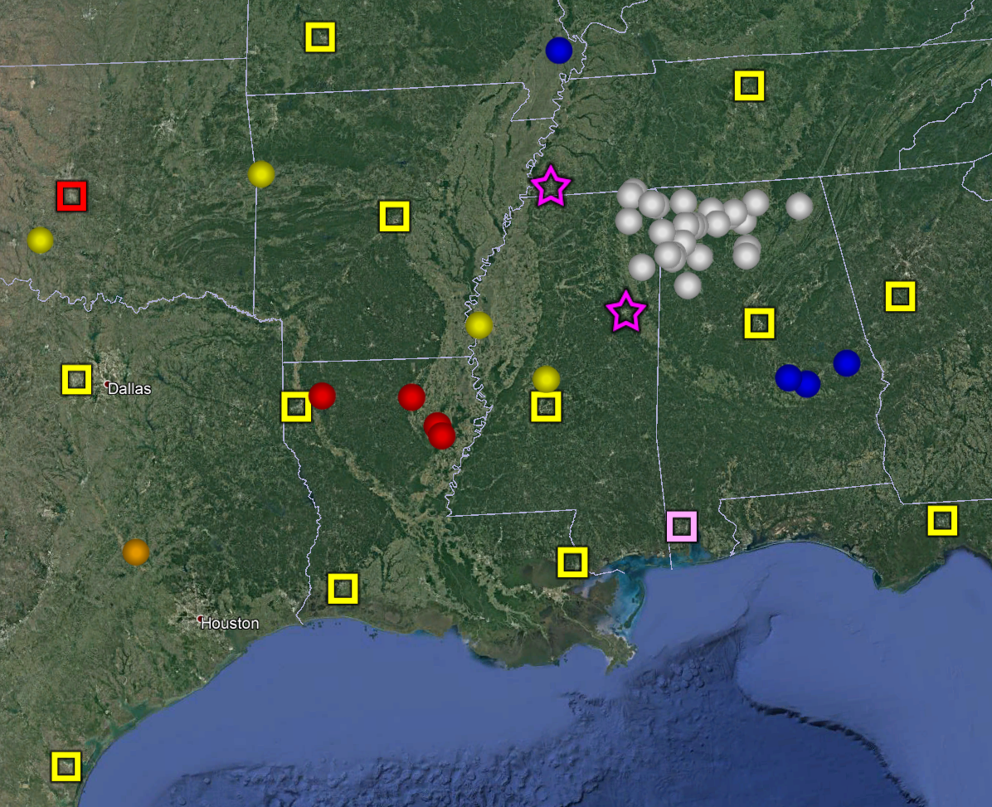
Figure 1. Locations of the soundings included in the Meso18-19 composite data set. The NWS 1 second resolution sites are the yellow squares, the NWS mandatory-significant level site is the red square, ULM are red circles, NOAA/ATDD are blue circles, NOAA/NSSL are yellow circles, UAH are white circles, MSU are purple stars, USA is pink square, and TAMU is the orange circle.
- Project Overview

The Verification of the Origins of Rotation in Tornadoes Experiment-Southeast (VORTEX-SE) is a research program to understand how environmental factors characteristic of the southeastern United States affect the formation, intensity, structure, and path of tornadoes in this region. VORTEX-SE will also determine the best methods for communicating forecast uncertainty related to these events to the public, and evaluate public response. For the Meso18-19 field season a large array of 10 research radiosonde systems were deployed throughout the southeastern United States and a smaller scale set of profiling instrumentation and surface meteorological stations were deployed around northern Alabama from 1 November 2018 to 20 April 2019. Further information on VORTEX-SE is available at the VORTEX-SE web site at NCAR/EOL: https://www.eol.ucar.edu/field_projects/vortex-se and information on the Meso18-19 deployments is available at the Meso18-19 Field Catalog: http://catalog.eol.ucar.edu/meso18-19.

4.0 EOL Sounding Composite (ESC) File Format Description

The ESC is a columnar ASCII format consisting of 15 header records for each sounding followed by the data records with associated data quality flags.

4.1 Header Records

The header records (15 total records) contain a variety of metadata about the sounding (i.e. location, time, radiosonde type, etc). The first five header lines contain information identifying the sounding, and have a rigidly defined form. The following 7 header lines are used for auxiliary information and comments about the sounding, and may vary from dataset to dataset. The last 3 header records contain header information for the data columns. Line 13 holds the field names, line 14 the field units, and line 15 contains dashes ('-' characters) delineating the extent of the field.

The file standard header lines are as follows:

Line | Label (padded to 35 char) | Contents
1 | Data Type: | Description of the type and resolution of data
2 | Project ID: | Short name for the field project
3 | Release Site Type/Site ID: | Description of the release site.
4 | Release Location (lon,lat,alt): | Location of the release site.
5 | UTC Release Time (y,m,d,h,m,s): | Time of release.

The release location is given as:
lon (deg min), lat (deg min), lon (dec. deg), lat (dec. deg), alt (m)

Longitude in deg min is in the format: ddd mm.mm'W where ddd is the number of degrees (with leading zeros if necessary), mm.mm is the decimal number of minutes, and W represents W or E for west or east longitude, respectively. Latitude has the same format as longitude, except there are only two digits for degrees and N or S for north/south latitude.

The time of release is given as: yyyy, mm, dd, hh:nn:ss.
Where yyyy is the year, mm is the month, dd is the day of month, and hh:nn:ss are the UTC hour, minute, and second respectively.

The seven non-standard header lines may contain any label and contents. The labels are padded to 35 characters to match the standard header lines. Records for this data set include the following non-standard header lines:

Line | Label (padded to 35 char) | Contents
6 | Radiosonde Type | Type of radiosonde
7 | Radiosonde Serial Number
8 | Ground Station Software

The nominal release time for these soundings is the same as the actual time.

4.2 Data Records

The data records each contain time from release, pressure, temperature, dew point, relative humidity, U and V wind components, wind speed and direction, ascent rate, balloon position data, altitude, and quality control flags (see the QC code description). Each data line contains 21 fields, separated by spaces, with a total width of 130 characters. The data are right-justified within the fields. All fields have one decimal place of precision, with the exception of latitude and longitude, which have three decimal places of precision. The contents and sizes of the 21 fields that appear in each data record are as follows:

Field | Width | Format | Parameter | Units | Missing  Value
1 | 6 | F6.1 | Time since release | Seconds | 9999.0
2 | 6 | F6.1 | Pressure | Millibars | 9999.0
3 | 5 | F5.1 | Dry-bulb Temperature | Degrees C | 999.0
4 | 5 | F5.1 | Dew Point Temperature | Degrees C | 999.0
5 | 5 | F5.1 | Relative Humidity | Percent | 999.0
6 | 6 | F6.1 | U Wind Comp | m/s | 9999.0
7 | 6 | F6.1 | V Wind Comp | m/s | 9999.0
8 | 5 | F5.1 | Wind speed | m/s | 999.0
9 | 5 | F5.1 | Wind direction | Degrees | 999.0
10 | 5 | F5.1 | Ascent Rate | m/s | 999.0
11 | 8 | F8.3 | Longitude | Degrees | 9999.0
12 | 7 | F7.3 | Latitude | Degrees | 999.0
13 | 5 | F5.1 | Elevation Angle | Degrees | 999.0
14 | 5 | F5.1 | Azimuth Angle | Degrees | 999.0
15 | 7 | F7.1 | Altitude | Meters | 99999.0
16 | 4 | F4.1 | QC for Pressure | Code | 99.0
17 | 4 | F4.1 | QC for Temperature | Code | 99.0
18 | 4 | F4.1 | QC for Humidity | Code | 99.0
19 | 4 | F4.1 | QC for U Wind | Code | 99.0
20 | 4 | F4.1 | QC for V Wind | Code | 99.0
21 | 4 | F4.1 | QC for Ascent Rate | Code | 99.0

Fields 16 through 21 contain the data quality flags from the NCAR/Earth Observing Laboratory (EOL) sounding quality control procedures. The data quality flags are defined as follows:

Code | Description
1.0 | Checked, datum seems physically reasonable. (“GOOD”)
2.0 | Checked, datum seems questionable on a physical basis. (“MAYBE”)
3.0 | Checked, datum seems to be in error. (“BAD”)
4.0 | Checked, datum is interpolated. (“ESTIMATED”)
9.0 | Checked, datum is missing. (“MISSING”)
99.0 | Unchecked (QC information is “missing”.) (“UNCHECKED”)

4.3 Data Specifics

Details on the radiosonde systems included in this data set are included in this section. Links are included to the documentation for the individual sounding data sets for details on processing and quality control.

National Weather Service RRS Radiosondes
4539 total radiosondes at 1 second vertical resolution

KBMX, KFFC, KFWD, KJAN, KLZK, KOHX, KSHV, and KTAE utilized the Lockheed Martin Sippican LMS-6 Radiosonde with the capacitance RH sensor and GPS windfinding

KCRP, KLCH, KLIX, and KSGF utilized the Vaisala RS92-NGP radiosonde with twin alternatively heated Humicap capacitance RH sensors and GPS windfinding

https://doi.org/10.26023/5GJZ-C4F2-F20C

National Weather Service GTS Radiosondes
375 total radiosondes at mandatory and significant level vertical resolution

KOUN utilized the Lockheed Martin Sippican LMS6 with the chip thermistor, external boom mounted capacitance relative humidity sensor, and derived pressure from GPS height.

https://doi.org/10.26023/5GJZ-C4F2-F20C

University of Louisiana at Monroe Radiosondes
134 radiosondes at 5 second vertical resolution (62 at Breaux Bridge, LA and 72 at Monroe, LA)

ULM utilized InterMet’s iMet-4 radiosondes and iMet-OS-II radiosonde system

https://doi.org/10.26023/TNQ9-VT30-WA0J

NOAA/ATDD Radiosondes
50 radiosondes at 1 second vertical resolution (7 at Auburn, AL; 17 at Montgomery, AL; 18 at SE Montgomery, AL; and 8 at Sikeston, MO)

ULM utilized GRAW DFM-09 radiosondes and the GRAW radiosonde system version 5.10.12.3.

https://doi.org/10.26023/247H-CF68-0Z11

Texas A&M Radiosondes
71 radiosondes at 5 second vertical resolution all from College Station TX

TAMU utilized iMet-4 radiosondes and iMet-OS-II radiosonde system

https://doi.org/10.26023/RGGX-G8BC-GS04

Mississippi State University Radiosondes
129 radiosondes at 10 second vertical resolution all from College Station TX

MSU utilized iMet-4 radiosondes and iMet-OS-II radiosonde system

https://doi.org/10.26023/3579-Q663-BD0D

University of South Alabama Radiosondes
70 radiosondes at 5 second vertical resolution all from Mobile AL

USA utilized iMet-4 radiosondes and iMet-OS-II radiosonde system

https://doi.org/10.26023/MFJW-VMNS-MF11

University of Alabama Huntsville Radiosondes
90 Windsond S1H radiosondes at 3 second vertical resolution
141 (4) iMet-1-ABxn radiosondes at 5 (1) second vertical resolution

Soundings were taken from locations all around northern Alabama and northeastern Mississippi.

UAH utilized Windsond S1H radiosondes with the Windsond WS-250 radiosonde system as well as the iMet-1-ABxn radiosondes with the i-Met-OS-II radiosonde system

https://doi.org/10.26023/QTZD-ARJ1-Z310

High Resolution Radiosonde Composite
This data set contains soundings from the High Resolution Radiosonde Composite interpolated to 5 mb vertical levels.

The data are in files by day, so all soundings for a particular day are concatenated into a single file ordered by time. The file naming convention is:

Meso18-19_5hpa_yyyymmdd.cls where yyyy is the year, mm is the month, and dd is the day of the month.

4.4 Sample Data

The following is a sample of the high resolution radiosonde data in ESC format.

Data Type: NOAA ATDD2 Mobile Sounding Data/Ascending
Project ID: VORTEX-SE_2017
Release Site Type/Site ID: Cullman, AL
Release Location (lon,lat,alt): 086 47.82'W, 34 11.67'N, -86.797, 34.195, 245.0
UTC Release Time (y,m,d,h,m,s): 2017, 03, 25, 15:10:00
Radiosonde Type: GRAW DFM-09
Ground Station Software: Version 5.10.12.3
/
/
/
/
Nominal Release Time (y,m,d,h,m,s):2017, 03, 25, 15:10:00
Time Press Temp Dewpt RH Ucmp Vcmp spd dir Wcmp Lon Lat Ele MixR Alt Qp Qt Qrh Qu Qv QdZ
sec mb C C % m/s m/s m/s deg m/s deg deg deg g/kg m code code code code code code
------ ------ ----- ----- ----- ------ ------ ----- ----- ----- -------- ------- ----- ----- ------- ---- ---- ---- ---- ---- ----
0.0 9999.0 999.0 999.0 999.0 9999.0 9999.0 999.0 999.0 999.0 -86.797 34.194 999.0 999.0 245.0 9.0 9.0 9.0 9.0 9.0 9.0
1.0 992.2 18.5 8.8 53.1 -0.1 4.2 4.2 179.0 6.0 -86.797 34.194 999.0 7.2 251.0 1.0 1.0 1.0 1.0 1.0 99.0
2.0 991.5 18.6 9.4 55.1 -0.1 4.3 4.3 178.0 6.0 -86.797 34.194 999.0 7.6 257.0 1.0 1.0 1.0 1.0 1.0 99.0

4.5 Station List

Site ID | WMO ID | Site Name | State | Latitude | Longitude | Elev (m)
KBMX | 72230 | Birmingham | AL | 33.180 | -86.783 | 174
KCRP | 72251 | Corpus Christi | TX | 27.779 | -97.505 | 15
KFFC | 72215 | Peachtree City | GA | 33.356 | -84.567 | 245
KFWD | 72249 | Fort Worth | TX | 32.835 | -97.298 | 195
KJAN | 72235 | Jackson | MS | 32.320 | -90.080 | 91
KLCH | 72240 | Lake Charles | LA | 30.126 | -93.217 | 5
KLIX | 72233 | Slidell | LA | 30.338 | -89.825 | 10
KLZK | 72340 | Little Rock | AR | 34.836 | -92.260 | 173
KOHX | 72327 | Nashville | TN | 36.247 | -86.562 | 180
KOUN | 72357 | Norman | OK | 35.230 | -97.470 | 362
KSGF | 72440 | Springfield | MO | 37.236 | -93.402 | 391
KSHV | 72248 | Shreveport | LA | 32.452 | -93.842 | 85
KTAE | 72214 | Tallahassee | FL | 30.446 | -84.300 | 53
ULM |  | Monroe | LA | 32.528 | -92.074 | 58
ULM |  | Breaux Bridge | LA | 30.301 | -91.921 | 7
ATDD |  | Auburn | AL | 32.579 | -85.497 | 188
ATDD |  | Montgomery | AL | 32.461 | -86.404 | 118
ATDD |  | SE Montgomery | AL | 32.363 | -86.138 | 65
ATDD |  | Sikeston | MO | 36.890 | -89.537 | 94
NSSL |  | Fort Smith | AR | 35.460 | -94.347 | 171
NSSL |  | Greenville | MS | 33.400 | -91.011 | 37
NSSL |  | Canton | MS | 32.669 | -90.044 | 77
NSSL |  | Marlow | OK | 34.662 | -97.959 | 393
UAH |  | Mobile | AL or MS | Mobile | Mobile | Mobile

5.0 Data Quality Control Procedures

- Each sounding was converted from its original format into the ESC format described above.

- Each sounding was passed through a set of automated data quality checks which included basic gross limit checks as well as rate of change checks. This is further described in Section 4.1.

- Each sounding was visually examined utilizing the NCAR/EOL XQC sounding quality control software. This is further described in Section 4.2.

- Each sounding was interpolated to 5 hPa vertical resolution.

5.1 Automated Data Quality Checks

This data set was passed through a set of automated data quality checks. This procedure includes both gross limit checks on all parameters as well as rate-of-change checks on temperature, pressure, and ascent rate. A version of these checks is described in Loehrer et al. (1996) and Loehrer et al. (1998).

5.1.1 Gross Limit Checks

These checks were conducted on each sounding and the data quality flags in the ESC files were adjusted as appropriate. Only the data point under examination was flagged. All checks also produced warning messages that specified the location of the problem and the severity of the issue. These warning messages where then summarized statistically and examined to determine any consistent issues.

For this data set NCAR/EOL conducted the following gross limit checks. In the table P = pressure, T = temperature, RH = relative humidity, U = U wind component, V = V wind component, B= bad, and Q = questionable.

Parameter | Check | Parameter(s) Flagged | Flag Applied
Pressure | <0 or > 1050 | P | B
Altitude | < 0 or >40000 | P, T, RH | Q
Temperature | < -90 or > 45 | T | B
Dew Point | < -99.9 or > 33  > T | RH  T, RH | Q  Q
Wind Speed | < 0 or > 100  > 150 | U, V  U, V | Q  B
U Wind | < 0 or > 100  > 150 | U  U | Q  B
V Wind | < 0 or > 100  > 150 | V  V | Q  B
Wind Direction | < 0 or > 360 | U, V | B
Ascent Rate | < -10 or > 10 | P, T, RH | Q

5.1.2 Vertical Consistency Checks

These checks were conducted on each sounding and the data quality flags in the ESC files were adjusted as appropriate. These checks were started at the surface and compared each neighboring data record. In the case of checks that ensured that the values increased/decreased as expected, only the data point under examination was flagged. However, for the other checks, all of the data points used in the examination were flagged. All items within the table are as previously defined. All checks also produced warning messages that specified the location of the problem and the severity of the issue. These warning messages where then summarized statistically and examined to determine any consistent issues.

Parameter | Check | Parameter(s) Flagged | Flag Applied
Time | Decreasing/equal | None | None.
Altitude | Decreasing/equal | P, T, RH | Q
Pressure | Increasing/equal  > 1mb/s or < -1mb/s  > 2mb/s or < -2mb/s | P, T, TH  P, T, TH  P, T, TH | Q  Q  B
Temperature | < -15ºC/km  < -30ºC/km  > 50ºC/km  > 100ºC/km | P, T, RH  P, T, RH  P, T, RH  P, T, RH | Q  B  Q  B
Ascent Rate | > 3m/s or < -3m/s  > 5m/s or < -5m/s | P  P | Q  B

5.2 Visual Data Quality Checks

Each sounding was visually examined using the NCAR/EOL XQC sounding data quality control software. This software allows the user to view a skew-t/log-p diagram of each sounding and apply data quality flags as appropriate. The user can zoom in on sections of soundings for detailed examination and can adjust the data quality flags for an individual point, sections of soundings, or entire soundings for each parameter individually. The software also allows the user to override the quality flags applied by the automated procedure.

5.3 5 hPa Interpolation Procedures

The surface data point was kept as the initial level in each sounding. The first interpolated data point was at the next lowest pressure evenly divisible by 5 and then every 5 hPa pressure level beyond that point to either 50 hPa or the lowest pressure level reached by the radiosonde, whichever came first. The first 15 lines of each file (the header information) were kept without change.

For the interpolation, the software searched for two data points around the desired pressure level. The search was conducted by looking for two valid (i.e. non-missing) data points around the desired pressure level, while also paying attention to the time difference between the two data points as well as their quality control flags. There was a search for the two best possible data points to use in the interpolation. If the desired pressure level was within the original dataset, that data point was used without interpolation.

There was first a search for values flagged as good within some time range (50 sec for temperature, humidity, and wind and 100 sec for pressure; hereafter termed the ARANGE) and the interpolated data point was flagged as good. Failing that, it searched for values flagged as estimated within the same time range and the interpolated data point was flagged as estimated. Then the search went for good values within a wider time range (100 sec for temperature, humidity, and wind and 200 sec for pressure; hereafter termed the BRANGE) the flag for the interpolated data point here was then degraded (even though two `good' data points were used there was a significant time difference between them) to questionable. Then, in turn, estimated values within the BRANGE were used (flag set to questionable), questionable values within the BRANGE (flag set to bad), good values greater than the BRANGE apart (flag set to bad), estimated values greater than BRANGE apart (flag set to bad), questionable values greater than BRANGE apart (flag set to bad), finally any bad values (flag set to bad). This search was conducted separately for each interpolated variable (pressure, temperature, relative humidity, and the u and v wind components.

Thus for each interpolated data point, the quality control flag was set to the worst case among the data points used in the interpolation, except, for each time range apart, the quality control flag was degraded one level (i.e. good to questionable, etc).

The quality control flags should be carefully heeded in these files. While some of the data may look good, it may have been interpolated over large pressure intervals, and thus be suspect.

For each interpolated data point the dew point was calculated from the temperature and relative humidity (Bolton 1980) and the total wind speed and direction were calculated from the interpolated u and v component values. Also, the altitude and time were interpolated using the same data points used for the pressure interpolation. The ascension rate was recalculated based on the time and altitude values from the two data points used to interpolate the 5 hPa data point. Thus the ascension rate values do not reflect the values based on the interpolated data. The latitude and longitude values were interpolated using the same data points used in the wind component interpolation.

5.4 Data Quality Issues of Note

See the high resolution composite readme file linked above for details on the data quality issues in each individual sounding data set.

6.0 References
Brown, M. 2019. Mississippi State University (MSU) Radiosonde Data. Version 1.0. UCAR/NCAR - Earth Observing Laboratory. https://doi.org/10.26023/3579-Q663-BD0D. Accessed 14 Feb 2020.
Lee, T., Buban, M. 2019. NOAA/ATDD Radiosonde Data. Version 1.1. UCAR/NCAR - Earth Observing Laboratory. https://doi.org/10.26023/247H-CF68-0Z11. Accessed 14 Feb 2020.
Loehrer, S. M., T. A. Edmands, and J. A. Moore, 1996: TOGA COARE upper-air sounding data archive: development and quality control procedures. Bull. Amer. Meteor. Soc., 77, 2651-2671. https://doi.org/10.1175/1520-0477(1996)077%3C2651:TCUASD%3E2.0.CO;2
Loehrer, S. M., S. F. Williams, and J. A. Moore, 1998: Results from UCAR/JOSS quality control of atmospheric soundings from field projects. Preprints, Tenth Symposium on Meteorological Observations and Instrumentation, Phoenix, AZ, Amer. Meteor. Soc., 1-6.
Murphy, T. 2019. University of Louisiana Monroe Radiosonde Data. Version 1.1. UCAR/NCAR - Earth Observing Laboratory. https://doi.org/10.26023/TNQ9-VT30-WA0J. Accessed 14 Feb 2020.
Nowotarski, C., Conlee, D. 2019. Texas A&M University Radiosonde Data. Version 1.0. UCAR/NCAR - Earth Observing Laboratory. https://doi.org/10.26023/RGGX-G8BC-GS04. Accessed 14 Feb 2020.
Pangle, P., Wade, R. 2019. University of Alabama Huntsville Radiosonde Data. Version 1.0. UCAR/NCAR - Earth Observing Laboratory. https://doi.org/10.26023/QTZD-ARJ1-Z310. Accessed 14 Feb 2020.
Terwey, W. 2019. University of South Alabama Radiosonde Data. Version 1.0. UCAR/NCAR - Earth Observing Laboratory. https://doi.org/10.26023/MFJW-VMNS-MF11. Accessed 14 Feb 2020.
UCAR/NCAR - Earth Observing Laboratory. 2019. National Weather Service High Resolution Radiosonde Data. Version 1.0. UCAR/NCAR - Earth Observing Laboratory. https://doi.org/10.26023/5GJZ-C4F2-F20C. Accessed 14 Feb 2020.
Waugh, S. 2019. NOAA/NSSL Mobile Radiosonde Data. Version 1.0. UCAR/NCAR - Earth Observing Laboratory. https://doi.org/10.26023/9VN9-C5D8-XV12. Accessed 14 Feb 2020.

