- Contacts:

NCAR/EOL Processing and Quality Control:
Scot Loehrer (NCAR/EOL)
loehrer@ucar.edu

- Dataset Overview

This data set contains a composite of the highest vertical resolution (i.e. the “native resolution”) upper air sounding data from all sources for the Verification of the Origins of Rotation in Thunderstorms Experiment-Southeast (VORTEX-SE) Meso18-19 project. The composite includes a total of 5629 soundings from the following radiosonde systems: Mississippi State University (MSU; 129 soundings), the University of Louisiana at Monroe (ULM; 134 soundings), NOAA/ATDD (50 soundings), NOAA/NSSL (71 soundings), Texas A&M University (TAMU; 71 soundings), the University of Alabama Huntsville (190 soundings), the University of South Alabama (70 soundings), and the National Weather Service soundings from 13 stations (4914 soundings) in the region (twelve stations have 1 second vertical resolution data and one has mandatory/significant level vertical resolution data). See Figure 1 for a location of all radiosonde releases.
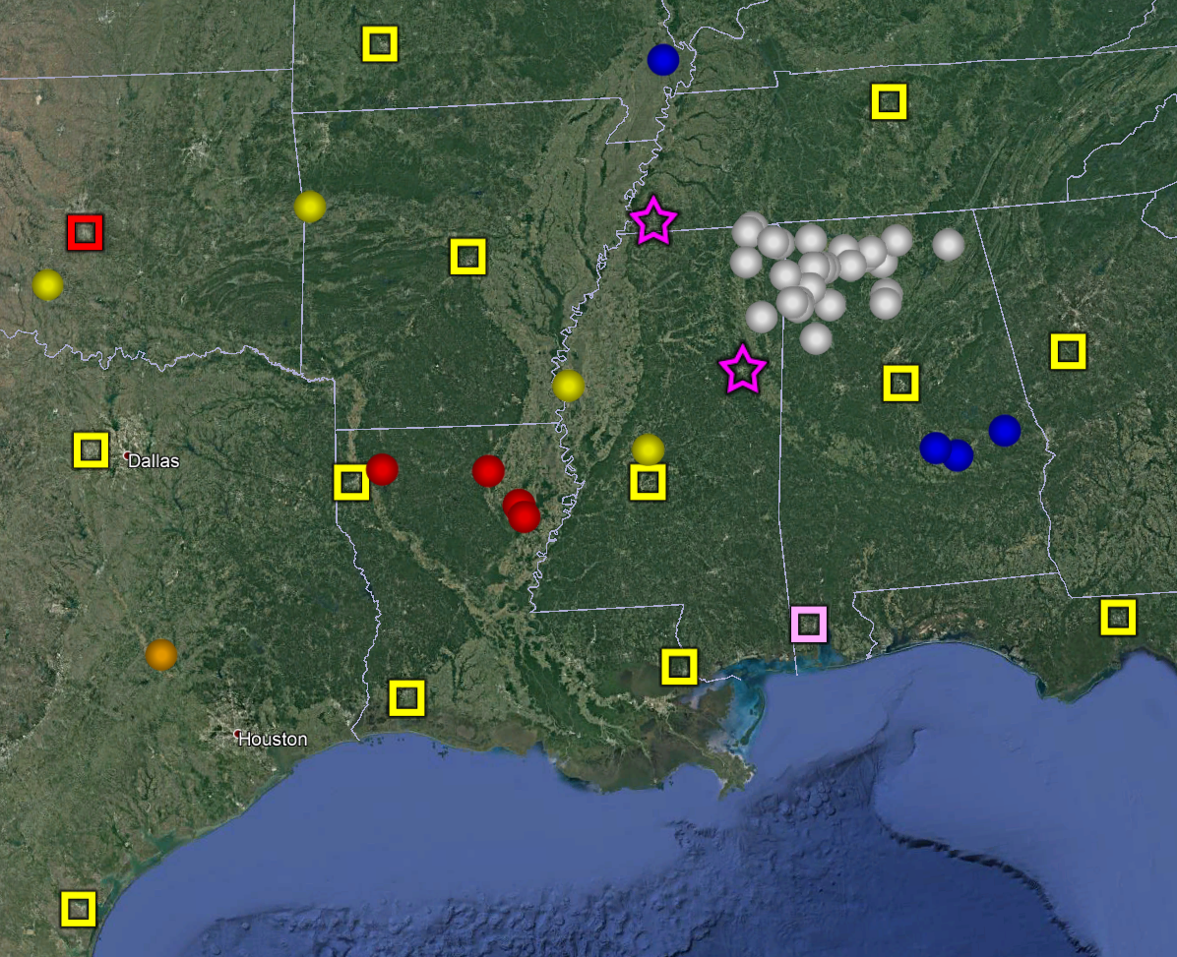
Figure 1. Locations of the soundings included in the Meso18-19 composite data set. The NWS 1 second resolution sites are the yellow squares, the NWS mandatory-significant level site is the red square, ULM are red circles, NOAA/ATDD are blue circles, NOAA/NSSL are yellow circles, UAH are white circles, MSU are purple stars, USA is pink square, and TAMU is the orange circle.
- Project Overview

The Verification of the Origins of Rotation in Tornadoes Experiment-Southeast (VORTEX-SE) is a research program to understand how environmental factors characteristic of the southeastern United States affect the formation, intensity, structure, and path of tornadoes in this region. VORTEX-SE will also determine the best methods for communicating forecast uncertainty related to these events to the public, and evaluate public response. For the Meso18-19 field season a large array of 10 research radiosonde systems were deployed throughout the southeastern United States and a smaller scale set of profiling instrumentation and surface meteorological stations were deployed around northern Alabama from 1 November 2018 to 20 April 2019. Further information on VORTEX-SE is available at the VORTEX-SE web site at NCAR/EOL: https://www.eol.ucar.edu/field_projects/vortex-se and information on the Meso18-19 deployments is available at the Meso18-19 Field Catalog: http://catalog.eol.ucar.edu/meso18-19.

4.0 EOL Sounding Composite (ESC) File Format Description

The ESC is a columnar ASCII format consisting of 15 header records for each sounding followed by the data records with associated data quality flags.

4.1 Header Records

The header records (15 total records) contain a variety of metadata about the sounding (i.e. location, time, radiosonde type, etc). The first five header lines contain information identifying the sounding, and have a rigidly defined form. The following 7 header lines are used for auxiliary information and comments about the sounding, and may vary from dataset to dataset. The last 3 header records contain header information for the data columns. Line 13 holds the field names, line 14 the field units, and line 15 contains dashes ('-' characters) delineating the extent of the field.

The file standard header lines are as follows:

Line | Label (padded to 35 char) | Contents
1 | Data Type: | Description of the type and resolution of data
2 | Project ID: | Short name for the field project
3 | Release Site Type/Site ID: | Description of the release site.
4 | Release Location (lon,lat,alt): | Location of the release site.
5 | UTC Release Time (y,m,d,h,m,s): | Time of release.

The release location is given as:
lon (deg min), lat (deg min), lon (dec. deg), lat (dec. deg), alt (m)

Longitude in deg min is in the format: ddd mm.mm'W where ddd is the number of degrees (with leading zeros if necessary), mm.mm is the decimal number of minutes, and W represents W or E for west or east longitude, respectively. Latitude has the same format as longitude, except there are only two digits for degrees and N or S for north/south latitude.

The time of release is given as: yyyy, mm, dd, hh:nn:ss.
Where yyyy is the year, mm is the month, dd is the day of month, and hh:nn:ss are the UTC hour, minute, and second respectively.

The seven non-standard header lines may contain any label and contents. The labels are padded to 35 characters to match the standard header lines. Records for this data set include the following non-standard header lines:

Line | Label (padded to 35 char) | Contents
6 | Radiosonde Type | Type of radiosonde
7 | Radiosonde Serial Number
8 | Ground Station Software

The nominal release time for these soundings is the same as the actual time.

4.2 Data Records

The data records each contain time from release, pressure, temperature, dew point, relative humidity, U and V wind components, wind speed and direction, ascent rate, balloon position data, altitude, and quality control flags (see the QC code description). Each data line contains 21 fields, separated by spaces, with a total width of 130 characters. The data are right-justified within the fields. All fields have one decimal place of precision, with the exception of latitude and longitude, which have three decimal places of precision. The contents and sizes of the 21 fields that appear in each data record are as follows:

Field | Width | Format | Parameter | Units | Missing  Value
1 | 6 | F6.1 | Time since release | Seconds | 9999.0
2 | 6 | F6.1 | Pressure | Millibars | 9999.0
3 | 5 | F5.1 | Dry-bulb Temperature | Degrees C | 999.0
4 | 5 | F5.1 | Dew Point Temperature | Degrees C | 999.0
5 | 5 | F5.1 | Relative Humidity | Percent | 999.0
6 | 6 | F6.1 | U Wind Comp | m/s | 9999.0
7 | 6 | F6.1 | V Wind Comp | m/s | 9999.0
8 | 5 | F5.1 | Wind speed | m/s | 999.0
9 | 5 | F5.1 | Wind direction | Degrees | 999.0
10 | 5 | F5.1 | Ascent Rate | m/s | 999.0
11 | 8 | F8.3 | Longitude | Degrees | 9999.0
12 | 7 | F7.3 | Latitude | Degrees | 999.0
13 | 5 | F5.1 | Elevation Angle | Degrees | 999.0
14 | 5 | F5.1 | Azimuth Angle | Degrees | 999.0
15 | 7 | F7.1 | Altitude | Meters | 99999.0
16 | 4 | F4.1 | QC for Pressure | Code | 99.0
17 | 4 | F4.1 | QC for Temperature | Code | 99.0
18 | 4 | F4.1 | QC for Humidity | Code | 99.0
19 | 4 | F4.1 | QC for U Wind | Code | 99.0
20 | 4 | F4.1 | QC for V Wind | Code | 99.0
21 | 4 | F4.1 | QC for Ascent Rate | Code | 99.0

Fields 16 through 21 contain the data quality flags from the NCAR/Earth Observing Laboratory (EOL) sounding quality control procedures. The data quality flags are defined as follows:

Code | Description
1.0 | Checked, datum seems physically reasonable. (“GOOD”)
2.0 | Checked, datum seems questionable on a physical basis. (“MAYBE”)
3.0 | Checked, datum seems to be in error. (“BAD”)
4.0 | Checked, datum is interpolated. (“ESTIMATED”)
9.0 | Checked, datum is missing. (“MISSING”)
99.0 | Unchecked (QC information is “missing”.) (“UNCHECKED”)

4.3 Data Specifics

Details on the radiosonde systems included in this data set are included in this section. Links are included to the documentation for the individual sounding data sets for details on processing and quality control.

National Weather Service RRS Radiosondes
4539 total radiosondes at 1 second vertical resolution

KBMX, KFFC, KFWD, KJAN, KLZK, KOHX, KSHV, and KTAE utilized the Lockheed Martin Sippican LMS-6 Radiosonde with the capacitance RH sensor and GPS windfinding

KCRP, KLCH, KLIX, and KSGF utilized the Vaisala RS92-NGP radiosonde with twin alternatively heated Humicap capacitance RH sensors and GPS windfinding

https://doi.org/10.26023/5GJZ-C4F2-F20C

National Weather Service GTS Radiosondes
375 total radiosondes at mandatory and significant level vertical resolution

KOUN utilized the Lockheed Martin Sippican LMS6 with the chip thermistor, external boom mounted capacitance relative humidity sensor, and derived pressure from GPS height.

https://doi.org/10.26023/5GJZ-C4F2-F20C

University of Louisiana at Monroe Radiosondes
134 radiosondes at 5 second vertical resolution (62 at Breaux Bridge, LA and 72 at Monroe, LA)

ULM utilized InterMet’s iMet-4 radiosondes and iMet-OS-II radiosonde system

https://doi.org/10.26023/TNQ9-VT30-WA0J

NOAA/ATDD Radiosondes
50 radiosondes at 1 second vertical resolution (7 at Auburn, AL; 17 at Montgomery, AL; 18 at SE Montgomery, AL; and 8 at Sikeston, MO)

ULM utilized GRAW DFM-09 radiosondes and the GRAW radiosonde system version 5.10.12.3.

https://doi.org/10.26023/247H-CF68-0Z11

Texas A&M Radiosondes
71 radiosondes at 5 second vertical resolution all from College Station TX

TAMU utilized iMet-4 radiosondes and iMet-OS-II radiosonde system

https://doi.org/10.26023/RGGX-G8BC-GS04

Mississippi State University Radiosondes
129 radiosondes at 10 second vertical resolution all from College Station TX

MSU utilized iMet-4 radiosondes and iMet-OS-II radiosonde system

https://doi.org/10.26023/3579-Q663-BD0D

University of South Alabama Radiosondes
70 radiosondes at 5 second vertical resolution all from Mobile AL

USA utilized iMet-4 radiosondes and iMet-OS-II radiosonde system

https://doi.org/10.26023/MFJW-VMNS-MF11

University of Alabama Huntsville Radiosondes
90 Windsond S1H radiosondes at 3 second vertical resolution
141 (4) iMet-1-ABxn radiosondes at 5 (1) second vertical resolution

Soundings were taken from locations all around northern Alabama and northeastern Mississippi.

UAH utilized Windsond S1H radiosondes with the Windsond WS-250 radiosonde system as well as the iMet-1-ABxn radiosondes with the i-Met-OS-II radiosonde system

https://doi.org/10.26023/QTZD-ARJ1-Z310

The data are in files by day, so all soundings for a particular day are concatenated into a single file ordered by time. The file naming convention is:

Meso18-19_yyyymmdd.cls where yyyy is the year, mm is the month, and dd is the day of the month.

4.4 Sample Data

The following is a sample of the high resolution radiosonde data in ESC format.

Data Type: ULM Mobile Sounding Data/Ascending
Project ID: VORTEX-SE_2018
Release Site Type/Site ID: Gilbert, LA
Release Location (lon,lat,alt): 091 38.78'W, 32 01.44'N, -91.646, 32.024, 23.0
UTC Release Time (y,m,d,h,m,s): 2018, 04, 06, 20:33:00
Radiosonde Type: iMet-1-ABxn
Ground Station Software: iMetOS-II software version 03.90.0C.
/
/
/
/
Nominal Release Time (y,m,d,h,m,s):2018, 04, 06, 20:33:00
Time Press Temp Dewpt RH Ucmp Vcmp spd dir Wcmp Lon Lat Ele MixR Alt Qp Qt Qrh Qu Qv QdZ
sec mb C C % m/s m/s m/s deg m/s deg deg deg g/kg m code code code code code code
------ ------ ----- ----- ----- ------ ------ ----- ----- ----- -------- ------- ----- ----- ------- ---- ---- ---- ---- ---- ----
0.0 9999.0 999.0 999.0 999.0 9999.0 9999.0 999.0 999.0 999.0 -91.646 32.024 999.0 999.0 23.0 9.0 9.0 9.0 9.0 9.0 9.0
33.0 1004.0 25.1 20.1 74.0 2.6 4.4 5.1 210.0 0.0 -91.646 32.024 999.0 999.0 23.0 3.0 3.0 3.0 99.0 99.0 99.0
38.0 1001.6 24.0 18.1 69.7 3.7 7.3 8.2 207.0 4.2 -91.646 32.024 999.0 999.0 44.0 3.0 3.0 3.0 99.0 99.0 99.0

4.5 Station List

Site ID | WMO ID | Site Name | State | Latitude | Longitude | Elev (m)
KBMX | 72230 | Birmingham | AL | 33.180 | -86.783 | 174
KCRP | 72251 | Corpus Christi | TX | 27.779 | -97.505 | 15
KFFC | 72215 | Peachtree City | GA | 33.356 | -84.567 | 245
KFWD | 72249 | Fort Worth | TX | 32.835 | -97.298 | 195
KJAN | 72235 | Jackson | MS | 32.320 | -90.080 | 91
KLCH | 72240 | Lake Charles | LA | 30.126 | -93.217 | 5
KLIX | 72233 | Slidell | LA | 30.338 | -89.825 | 10
KLZK | 72340 | Little Rock | AR | 34.836 | -92.260 | 173
KOHX | 72327 | Nashville | TN | 36.247 | -86.562 | 180
KOUN | 72357 | Norman | OK | 35.230 | -97.470 | 362
KSGF | 72440 | Springfield | MO | 37.236 | -93.402 | 391
KSHV | 72248 | Shreveport | LA | 32.452 | -93.842 | 85
KTAE | 72214 | Tallahassee | FL | 30.446 | -84.300 | 53
ULM |  | Monroe | LA | 32.528 | -92.074 | 58
ULM |  | Breaux Bridge | LA | 30.301 | -91.921 | 7
ATDD |  | Auburn | AL | 32.579 | -85.497 | 188
ATDD |  | Montgomery | AL | 32.461 | -86.404 | 118
ATDD |  | SE Montgomery | AL | 32.363 | -86.138 | 65
ATDD |  | Sikeston | MO | 36.890 | -89.537 | 94
NSSL |  | Fort Smith | AR | 35.460 | -94.347 | 171
NSSL |  | Greenville | MS | 33.400 | -91.011 | 37
NSSL |  | Canton | MS | 32.669 | -90.044 | 77
NSSL |  | Marlow | OK | 34.662 | -97.959 | 393
UAH |  | Mobile | AL or MS | Mobile | Mobile | Mobile

5.0 Data Quality Control Procedures

- Each sounding was converted from its original format into the ESC format described above.

- Each sounding was passed through a set of automated data quality checks which included basic gross limit checks as well as rate of change checks. This is further described in Section 4.1.

- Each sounding was visually examined utilizing the NCAR/EOL XQC sounding quality control software. This is further described in Section 4.2.

5.1 Automated Data Quality Checks

This data set was passed through a set of automated data quality checks. This procedure includes both gross limit checks on all parameters as well as rate-of-change checks on temperature, pressure, and ascent rate. A version of these checks is described in Loehrer et al. (1996) and Loehrer et al. (1998).

5.1.1 Gross Limit Checks

These checks were conducted on each sounding and the data quality flags in the ESC files were adjusted as appropriate. Only the data point under examination was flagged. All checks also produced warning messages that specified the location of the problem and the severity of the issue. These warning messages where then summarized statistically and examined to determine any consistent issues.

For this data set NCAR/EOL conducted the following gross limit checks. In the table P = pressure, T = temperature, RH = relative humidity, U = U wind component, V = V wind component, B= bad, and Q = questionable.

Parameter | Check | Parameter(s) Flagged | Flag Applied
Pressure | <0 or > 1050 | P | B
Altitude | < 0 or >40000 | P, T, RH | Q
Temperature | < -90 or > 45 | T | B
Dew Point | < -99.9 or > 33  > T | RH  T, RH | Q  Q
Wind Speed | < 0 or > 100  > 150 | U, V  U, V | Q  B
U Wind | < 0 or > 100  > 150 | U  U | Q  B
V Wind | < 0 or > 100  > 150 | V  V | Q  B
Wind Direction | < 0 or > 360 | U, V | B
Ascent Rate | < -10 or > 10 | P, T, RH | Q

5.1.2 Vertical Consistency Checks

These checks were conducted on each sounding and the data quality flags in the ESC files were adjusted as appropriate. These checks were started at the surface and compared each neighboring data record. In the case of checks that ensured that the values increased/decreased as expected, only the data point under examination was flagged. However, for the other checks, all of the data points used in the examination were flagged. All items within the table are as previously defined. All checks also produced warning messages that specified the location of the problem and the severity of the issue. These warning messages where then summarized statistically and examined to determine any consistent issues.

Parameter | Check | Parameter(s) Flagged | Flag Applied
Time | Decreasing/equal | None | None.
Altitude | Decreasing/equal | P, T, RH | Q
Pressure | Increasing/equal  > 1mb/s or < -1mb/s  > 2mb/s or < -2mb/s | P, T, TH  P, T, TH  P, T, TH | Q  Q  B
Temperature | < -15ºC/km  < -30ºC/km  > 50ºC/km  > 100ºC/km | P, T, RH  P, T, RH  P, T, RH  P, T, RH | Q  B  Q  B
Ascent Rate | > 3m/s or < -3m/s  > 5m/s or < -5m/s | P  P | Q  B

5.2 Visual Data Quality Checks

Each sounding was visually examined using the NCAR/EOL XQC sounding data quality control software. This software allows the user to view a skew-t/log-p diagram of each sounding and apply data quality flags as appropriate. The user can zoom in on sections of soundings for detailed examination and can adjust the data quality flags for an individual point, sections of soundings, or entire soundings for each parameter individually. The software also allows the user to override the quality flags applied by the automated procedure.

5.3 Data Quality Issues of Note

See the readme files linked above for details on the data quality issues in each individual sounding data set.

ATDD Montgomery 201902210000 – temperature bad from 360-315
ATDD SE Montgomery 201903100000 – temperature bad from 590-500mb
NSSL Canton MS 201904132308 – there is a large change in winds, lat/lon and altitude with very small change in pressure between independent surface data and first sonde data. Seems likely independent surface pressure is incorrect and some near surface radiosonde data was lost.
ULM Breaux Bridge 201812011200 – winds above 250 mb bad with long periods of constant wind speed and direction.
ULM Breaux Bridge 201812020000 – winds above 362 mb questionable with long period of constant wind speed and direction.
ULM Breaux Bridge 201902061200 – winds above 191 mb questionable with long period of constant wind speed and direction.
ULM Breaux Bridge 201902191800 – winds above 187 mb questionable with long period of constant wind speed and direction.
ULM Breaux Bridge 201903090000 – winds above 208 mb questionable with long period of constant wind speed and direction.
ULM Monroe 201811060600 – wetbulbing ~524 mb
ULM Monroe 201902201200 – winds above 205mb questionable
ULM Monroe 201903031200 – no data above 789mb
ULM Monroe 201904181800 – no data above 901mb
TAMU College Station TX 201811301800 – winds above 135mb flagged bad
TAMU College Station TX 201902230600 – winds above 180mb flagged bad
UAH has many soundings that do not reach at least 500 mb due to the frequency of their releases.
UAH Burnsville MS 201904140630 – wetbulbing 519mb
UAH Cullman AL 201904182000 – bad winds 320-290mb
UAH Huntsville AL 201902231745 – all data above 253 mb bad, wind interpolated and temperature too cold
UAH Huntsville AL 201902232200 – sounding completely saturated above 733mb
UAH Huntsville AL 201903091730 – wind interpolated 250-190mb flagged bad
UAH Huntsville AL 201904141115 – wind interpolated above 130mb flagged bad
UAH Huntsville AL 201904180500 – wind interpolated above 202mb flagged bad
UAH Huntsville AL 201904190145 – temp/rh interpolated above 860mb flagged bad

6.0 References
Brown, M. 2019. Mississippi State University (MSU) Radiosonde Data. Version 1.0. UCAR/NCAR - Earth Observing Laboratory. https://doi.org/10.26023/3579-Q663-BD0D. Accessed 14 Feb 2020.
Lee, T., Buban, M. 2019. NOAA/ATDD Radiosonde Data. Version 1.1. UCAR/NCAR - Earth Observing Laboratory. https://doi.org/10.26023/247H-CF68-0Z11. Accessed 14 Feb 2020.
Loehrer, S. M., T. A. Edmands, and J. A. Moore, 1996: TOGA COARE upper-air sounding data archive: development and quality control procedures. Bull. Amer. Meteor. Soc., 77, 2651-2671. https://doi.org/10.1175/1520-0477(1996)077%3C2651:TCUASD%3E2.0.CO;2
Loehrer, S. M., S. F. Williams, and J. A. Moore, 1998: Results from UCAR/JOSS quality control of atmospheric soundings from field projects. Preprints, Tenth Symposium on Meteorological Observations and Instrumentation, Phoenix, AZ, Amer. Meteor. Soc., 1-6.
Murphy, T. 2019. University of Louisiana Monroe Radiosonde Data. Version 1.1. UCAR/NCAR - Earth Observing Laboratory. https://doi.org/10.26023/TNQ9-VT30-WA0J. Accessed 14 Feb 2020.
Nowotarski, C., Conlee, D. 2019. Texas A&M University Radiosonde Data. Version 1.0. UCAR/NCAR - Earth Observing Laboratory. https://doi.org/10.26023/RGGX-G8BC-GS04. Accessed 14 Feb 2020.
Pangle, P., Wade, R. 2019. University of Alabama Huntsville Radiosonde Data. Version 1.0. UCAR/NCAR - Earth Observing Laboratory. https://doi.org/10.26023/QTZD-ARJ1-Z310. Accessed 14 Feb 2020.
Terwey, W. 2019. University of South Alabama Radiosonde Data. Version 1.0. UCAR/NCAR - Earth Observing Laboratory. https://doi.org/10.26023/MFJW-VMNS-MF11. Accessed 14 Feb 2020.
UCAR/NCAR - Earth Observing Laboratory. 2019. National Weather Service High Resolution Radiosonde Data. Version 1.0. UCAR/NCAR - Earth Observing Laboratory. https://doi.org/10.26023/5GJZ-C4F2-F20C. Accessed 14 Feb 2020.
Waugh, S. 2019. NOAA/NSSL Mobile Radiosonde Data. Version 1.0. UCAR/NCAR - Earth Observing Laboratory. https://doi.org/10.26023/9VN9-C5D8-XV12. Accessed 14 Feb 2020.

