- Contacts:

NCAR/EOL Processing and Quality Control:
Scot Loehrer (NCAR/EOL)
loehrer@ucar.edu

- Dataset Overview

This data set contains a composite of the highest vertical resolution (i.e. the “native resolution”) upper air sounding data from all sources for the Targeted Observation by Radars and UAS of Supercells (TORUS) 2019 field season. The composite includes a total of 1457 soundings from the following radiosonde systems: NOAA/NSSL (114 soundings) and the National Weather Service soundings from 18 stations (1343 soundings) in the region (fifteen stations have 1 second vertical resolution data and three have mandatory/significant level vertical resolution data). See Figure 1 for a location of all radiosonde releases.
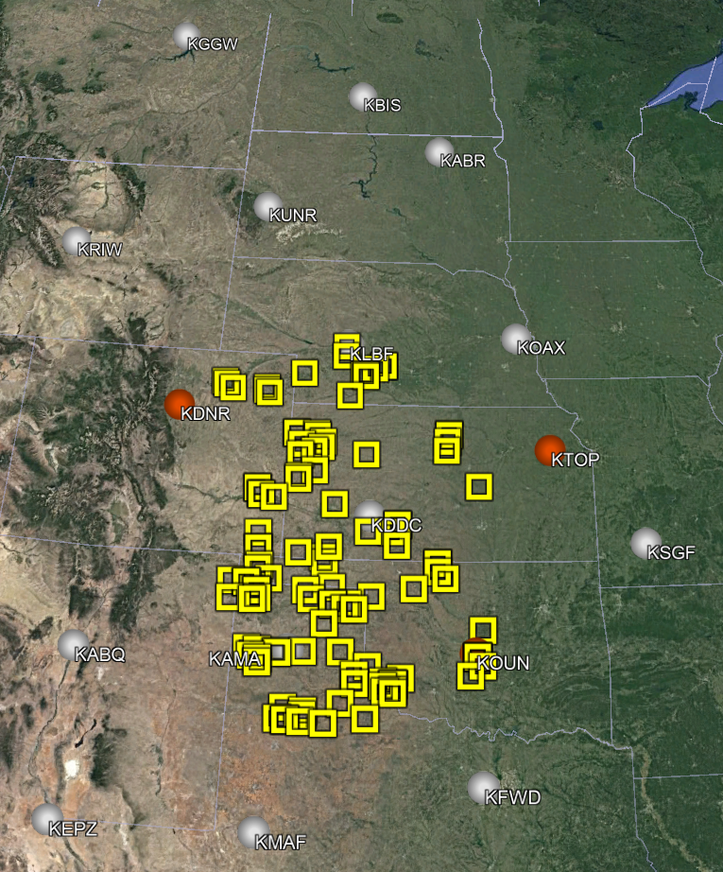
Figure 1. Locations of the soundings included in the TORUS_2019 composite data set. The NWS 1 second resolution sites are the white circles, the NWS mandatory-significant level sites are the red circles, and NOAA/NSSL are yellow squares.
3.0 Project Overview

The Targeted Observation by Radars and UAS of Supercells (TORUS) project is a nomadic field campaign during the spring storm seasons (May and June) of 2019 and 2020 over a domain covering much of the central United States where there exists significant point probabilities of tornado-bearing supercell storms. TORUS aims to use the data collected to improve the conceptual model of supercell thunderstorms (the parent storms of the most destructive tornadoes) by exposing how small-scale structures within these storms might lead to tornado formation. These structures are hypothesized to be nearly invisible to all but the most precise research-grade instruments. But by revealing the hidden composition of severe storms and associating it to known characteristics of the regularly-observed larger scale environment, the TORUS project could improve supercell and tornado forecasts. For the 2019 field season the field instrumentation included the NOAA P-3 aircraft, unmanned aircraft systems from the University of Colorado Boulder and the University of Nebraska-Lincoln, Ka band mobile radars from Texas Tech University, the NOAA X-band Polarimetric (NOXP) mobile radar, mobile mesonets as well as a mobile radiosonde and lidar system from NOAA/NSSL. Further information on TORUS is available at the TORUS web site at NCAR/EOL: https://www.eol.ucar.edu/field_projects/torus and information on the TORUS_2019 deployments is available at the TORUS_2019 Field Catalog: http://catalog.eol.ucar.edu/torus_2019.

4.0 EOL Sounding Composite (ESC) File Format Description

The ESC is a columnar ASCII format consisting of 15 header records for each sounding followed by the data records with associated data quality flags.

4.1 Header Records

The header records (15 total records) contain a variety of metadata about the sounding (i.e. location, time, radiosonde type, etc). The first five header lines contain information identifying the sounding, and have a rigidly defined form. The following 7 header lines are used for auxiliary information and comments about the sounding, and may vary from dataset to dataset. The last 3 header records contain header information for the data columns. Line 13 holds the field names, line 14 the field units, and line 15 contains dashes ('-' characters) delineating the extent of the field.

The file standard header lines are as follows:

Line | Label (padded to 35 char) | Contents
1 | Data Type: | Description of the type and resolution of data
2 | Project ID: | Short name for the field project
3 | Release Site Type/Site ID: | Description of the release site.
4 | Release Location (lon,lat,alt): | Location of the release site.
5 | UTC Release Time (y,m,d,h,m,s): | Time of release.

The release location is given as:
lon (deg min), lat (deg min), lon (dec. deg), lat (dec. deg), alt (m)

Longitude in deg min is in the format: ddd mm.mm'W where ddd is the number of degrees (with leading zeros if necessary), mm.mm is the decimal number of minutes, and W represents W or E for west or east longitude, respectively. Latitude has the same format as longitude, except there are only two digits for degrees and N or S for north/south latitude.

The time of release is given as: yyyy, mm, dd, hh:nn:ss.
Where yyyy is the year, mm is the month, dd is the day of month, and hh:nn:ss are the UTC hour, minute, and second respectively.

The seven non-standard header lines may contain any label and contents. The labels are padded to 35 characters to match the standard header lines. Records for this data set include the following non-standard header lines:

Line | Label (padded to 35 char) | Contents
6 | Radiosonde Type | Type of radiosonde
7 | Radiosonde Serial Number
8 | Ground Station Software

The nominal release time for these soundings is the same as the actual time.

4.2 Data Records

The data records each contain time from release, pressure, temperature, dew point, relative humidity, U and V wind components, wind speed and direction, ascent rate, balloon position data, altitude, and quality control flags (see the QC code description). Each data line contains 21 fields, separated by spaces, with a total width of 130 characters. The data are right-justified within the fields. All fields have one decimal place of precision, with the exception of latitude and longitude, which have three decimal places of precision. The contents and sizes of the 21 fields that appear in each data record are as follows:

Field | Width | Format | Parameter | Units | Missing  Value
1 | 6 | F6.1 | Time since release | Seconds | 9999.0
2 | 6 | F6.1 | Pressure | Millibars | 9999.0
3 | 5 | F5.1 | Dry-bulb Temperature | Degrees C | 999.0
4 | 5 | F5.1 | Dew Point Temperature | Degrees C | 999.0
5 | 5 | F5.1 | Relative Humidity | Percent | 999.0
6 | 6 | F6.1 | U Wind Comp | m/s | 9999.0
7 | 6 | F6.1 | V Wind Comp | m/s | 9999.0
8 | 5 | F5.1 | Wind speed | m/s | 999.0
9 | 5 | F5.1 | Wind direction | Degrees | 999.0
10 | 5 | F5.1 | Ascent Rate | m/s | 999.0
11 | 8 | F8.3 | Longitude | Degrees | 9999.0
12 | 7 | F7.3 | Latitude | Degrees | 999.0
13 | 5 | F5.1 | Elevation Angle | Degrees | 999.0
14 | 5 | F5.1 | Azimuth Angle | Degrees | 999.0
15 | 7 | F7.1 | Altitude | Meters | 99999.0
16 | 4 | F4.1 | QC for Pressure | Code | 99.0
17 | 4 | F4.1 | QC for Temperature | Code | 99.0
18 | 4 | F4.1 | QC for Humidity | Code | 99.0
19 | 4 | F4.1 | QC for U Wind | Code | 99.0
20 | 4 | F4.1 | QC for V Wind | Code | 99.0
21 | 4 | F4.1 | QC for Ascent Rate | Code | 99.0

Fields 16 through 21 contain the data quality flags from the NCAR/Earth Observing Laboratory (EOL) sounding quality control procedures. The data quality flags are defined as follows:

Code | Description
1.0 | Checked, datum seems physically reasonable. (“GOOD”)
2.0 | Checked, datum seems questionable on a physical basis. (“MAYBE”)
3.0 | Checked, datum seems to be in error. (“BAD”)
4.0 | Checked, datum is interpolated. (“ESTIMATED”)
9.0 | Checked, datum is missing. (“MISSING”)
99.0 | Unchecked (QC information is “missing”.) (“UNCHECKED”)

4.3 Data Specifics

Details on the radiosonde systems included in this data set are included in this section. Links are included to the documentation for the individual sounding data sets for details on processing and quality control.

National Weather Service RRS Radiosondes
1128 total radiosondes at 1 second vertical resolution

The KABQ, KABR, KAMA, KBIS, KDDC, KDRT, KFWD, KGGW, KLBF, KMAF, KOAX, KRIW, and KUNR stations utilized the Lockheed Martin Sippican LMS-6 Radiosonde with the capacitance RH sensor and GPS windfinding.

The KEPZ and KSGF stations utilized the Vaisala RS92-NGP radiosonde with twin alternatively heated Humicap capacitance RH sensors and GPS windfinding.

https://doi.org/10.26023/BAY2-R62Z-E107

National Weather Service GTS Radiosondes
215 total radiosondes at mandatory and significant level vertical resolution

KDNR, KOUN, and KTOP utilized the Lockheed Martin Sippican LMS6 with the chip thermistor, external boom mounted capacitance relative humidity sensor, and derived pressure from GPS height.

https://doi.org/10.26023/BAY2-R62Z-E107

NOAA/NSSL Radiosondes
114 radiosondes at 1 second vertical resolution

NSSL utilized Vaisala RS41-SGP radiosondes.
https://doi.org/10.26023/MDEM-SG4J-5P10

The data are in files by day, so all soundings for a particular day are concatenated into a single file ordered by time. The file naming convention is:

TORUS19_yyyymmdd.cls where yyyy is the year, mm is the month, and dd is the day of the month.

4.4 Sample Data

The following is a sample of the high resolution radiosonde data in ESC format.

Data Type: NSSL Sounding Data/Ascending
Project ID: TORUS 2019
Release Site Type/Site ID: Far Field
Release Location (lon,lat,alt): 097 26.35'W, 35 10.89'N, -97.439, 35.182, 455.6
UTC Release Time (y,m,d,h,m,s): 2019, 05, 16, 21:28:35
Radiosonde Type: Vaisala RS41-SGP
Radiosonde Serial Number: P2210144
/
/
/
/
Nominal Release Time (y,m,d,h,m,s):2019, 05, 16, 21:28:35
Time Press Temp Dewpt RH Ucmp Vcmp spd dir Wcmp Lon Lat Ele Azi Alt Qp Qt Qrh Qu Qv QdZ
sec mb C C % m/s m/s m/s deg m/s deg deg deg deg m code code code code code code
------ ------ ----- ----- ----- ------ ------ ----- ----- ----- -------- ------- ----- ----- ------- ---- ---- ---- ---- ---- ----
0.0 918.5 32.3 13.3 30.7 -1.0 6.9 7.0 172.0 999.0 -97.439 35.181 999.0 999.0 455.6 3.0 3.0 3.0 1.0 1.0 9.0
1.0 906.8 30.0 11.1 30.4 1.3 11.4 11.5 186.4 3.7 -98.945 37.328 999.0 999.0 459.2 3.0 3.0 3.0 1.0 1.0 99.0
2.0 906.5 30.1 11.1 30.4 2.4 13.6 13.8 189.9 3.5 -99.674 38.367 999.0 999.0 462.8 1.0 1.0 1.0 1.0 1.0 99.0

4.5 Station List

Site ID | WMO ID | Site Name | State | Latitude | Longitude | Elev (m)
KABQ | 72365 | Albuquerque | NM | 35.038 | -106.623 | 1619
KABR | 72659 | Aberdeen | SD | 45.455 | -98.414 | 398
KAMA | 72363 | Amarillo | TX | 35.233 | -101.709 | 1095
KBIS | 72764 | Bismarck | ND | 46.772 | -100.762 | 506
KDDC | 72451 | Dodge City | KS | 37.762 | -99.969 | 790
KDNR | 72469 | Denver | CO | 39.770 | -104.880 | 1611
KDRT | 72261 | Del Rio | TX | 29.375 | -100.918 | 314
KEPZ | 72364 | El Paso | TX | 31.873 | -106.697 | 1254
KFWD | 72249 | Fort Worth | TX | 32.835 | -97.298 | 195
KGGW | 72768 | Glasgow | MT | 48.206 | -106.627 | 693
KLBF | 72562 | North Platte | NE | 41.134 | -100.700 | 849
KMAF | 72265 | Midland | TX | 31.943 | -102.190 | 874
KOAX | 72558 | Omaha | NE | 41.320 | -96.366 | 351
KOUN | 72357 | Norman | OK | 35.230 | -97.470 | 362
KRIW | 72672 | Riverton | WY | 43.065 | -108.477 | 1699
KSGF | 72440 | Springfield | MO | 37.236 | -93.402 | 391
KTOP | 72456 | Topeka | KS | 39.070 | -95.620 | 268
KUNR | 72662 | Rapid City | SD | 44.073 | -103.210 | 1029
NSSL | N/A | Mobile | Mobile | Mobile | Mobile | Mobile

5.0 Data Quality Control Procedures

- Each sounding was converted from its original format into the ESC format described above.

- Each sounding was passed through a set of automated data quality checks which included basic gross limit checks as well as rate of change checks. This is further described in Section 4.1.

- Each sounding was visually examined utilizing the NCAR/EOL XQC sounding quality control software. This is further described in Section 4.2.

5.1 Automated Data Quality Checks

This data set was passed through a set of automated data quality checks. This procedure includes both gross limit checks on all parameters as well as rate-of-change checks on temperature, pressure, and ascent rate. A version of these checks is described in Loehrer et al. (1996) and Loehrer et al. (1998).

5.1.1 Gross Limit Checks

These checks were conducted on each sounding and the data quality flags in the ESC files were adjusted as appropriate. Only the data point under examination was flagged. All checks also produced warning messages that specified the location of the problem and the severity of the issue. These warning messages where then summarized statistically and examined to determine any consistent issues.

For this data set NCAR/EOL conducted the following gross limit checks. In the table P = pressure, T = temperature, RH = relative humidity, U = U wind component, V = V wind component, B= bad, and Q = questionable.

Parameter | Check | Parameter(s) Flagged | Flag Applied
Pressure | <0 or > 1050 | P | B
Altitude | < 0 or >40000 | P, T, RH | Q
Temperature | < -90 or > 45 | T | B
Dew Point | < -99.9 or > 33  > T | RH  T, RH | Q  Q
Wind Speed | < 0 or > 100  > 150 | U, V  U, V | Q  B
U Wind | < 0 or > 100  > 150 | U  U | Q  B
V Wind | < 0 or > 100  > 150 | V  V | Q  B
Wind Direction | < 0 or > 360 | U, V | B
Ascent Rate | < -10 or > 10 | P, T, RH | Q

5.1.2 Vertical Consistency Checks

These checks were conducted on each sounding and the data quality flags in the ESC files were adjusted as appropriate. These checks were started at the surface and compared each neighboring data record. In the case of checks that ensured that the values increased/decreased as expected, only the data point under examination was flagged. However, for the other checks, all of the data points used in the examination were flagged. All items within the table are as previously defined. All checks also produced warning messages that specified the location of the problem and the severity of the issue. These warning messages where then summarized statistically and examined to determine any consistent issues.

Parameter | Check | Parameter(s) Flagged | Flag Applied
Time | Decreasing/equal | None | None.
Altitude | Decreasing/equal | P, T, RH | Q
Pressure | Increasing/equal  > 1mb/s or < -1mb/s  > 2mb/s or < -2mb/s | P, T, TH  P, T, TH  P, T, TH | Q  Q  B
Temperature | < -15ºC/km  < -30ºC/km  > 50ºC/km  > 100ºC/km | P, T, RH  P, T, RH  P, T, RH  P, T, RH | Q  B  Q  B
Ascent Rate | > 3m/s or < -3m/s  > 5m/s or < -5m/s | P  P | Q  B

5.2 Visual Data Quality Checks

Each sounding was visually examined using the NCAR/EOL XQC sounding data quality control software. This software allows the user to view a skew-t/log-p diagram of each sounding and apply data quality flags as appropriate. The user can zoom in on sections of soundings for detailed examination and can adjust the data quality flags for an individual point, sections of soundings, or entire soundings for each parameter individually. The software also allows the user to override the quality flags applied by the automated procedure.

5.3 Data Quality Issues of Note

See the readme files linked above for details on the data quality issues in each individual sounding data set.

KABR 201906152307 – wetbulbing 608mb
KAMA 201905232131 – updraft sounding
KAMA 201905240006 – no data above 775mb
KAMA 201906152301 – period of falling 315mb
KDDC 201905232302 – no data above 603mb, no RH 906-784mb, ascent rate oscillation up to 800mb.
KDDC 201905262354 – no data below 836mb.
KDDC 201905281102 – no GPS/wind data
KDDC201906142300 – no GPS/wind data
KDNR 201905201200 – temperature spikes ~564 and 500mb flagged bad
KDNR 201905301200 – no data below 77mb
KDNR 201906102320 – temperature bad 700mb
KGGW 201905222301 – no GPS/wind data above 420mb
KMAF 201906131113 – no GPS/wind data
KMAF 201906132342 – several temperature spikes above 230mb
KOAX 201905190006 – no data above 653mb
KRIW 201905311124 – no data below 740mb
KTOP 201906162303 – no data above 613mb
KUNR 201905302322 – no GPS/wind data
NSSL Far Field 201905162128 – geopotential height data questionable entire sounding
NSSL Far Field 201905172355 – updraft sounding
NSSL Far Field 201905272050 – updraft sounding
NSSL Far Field 201906140210 – geopotential height has periods of zero change followed by large change throughout sounding.
NSSL LIDAR1 201905202323 – updraft sounding
NSSL LIDAR1 201906082121 – updraft sounding
NSSL LIDAR2 201905262141 – updraft sounding
NSSL LIDAR2 201906090149 – updraft sounding
NSSL LIDAR2 201906152230 – updraft sounding

6.0 References
Loehrer, S. M., T. A. Edmands, and J. A. Moore, 1996: TOGA COARE upper-air sounding data archive: development and quality control procedures. Bull. Amer. Meteor. Soc., 77, 2651-2671. https://doi.org/10.1175/1520-0477(1996)077%3C2651:TCUASD%3E2.0.CO;2
Loehrer, S. M., S. F. Williams, and J. A. Moore, 1998: Results from UCAR/JOSS quality control of atmospheric soundings from field projects. Preprints, Tenth Symposium on Meteorological Observations and Instrumentation, Phoenix, AZ, Amer. Meteor. Soc., 1-6.
UCAR/NCAR - Earth Observing Laboratory. 2019. National Weather Service High Resolution Radiosonde Data. Version 1.0. UCAR/NCAR - Earth Observing Laboratory. https://doi.org/10.26023/BAY2-R62Z-E107. Accessed 26 Feb 2020.
Waugh, S. 2020. NSSL Mobile Quality Controlled (QC) Radiosonde Data. Version 1.0. UCAR/NCAR - Earth Observing Laboratory. https://doi.org/10.26023/MDEM-SG4J-5P10. Accessed 28 Feb 2020.

