- Contacts:

NCAR/EOL Processing and Quality Control:
Scot Loehrer (NCAR/EOL)
loehrer@ucar.edu

- Dataset Overview

This data set contains a composite of the highest vertical resolution (i.e. the “native resolution”) radiosonde data from all sources for the Deep-Propagating Gravity Wave Experiment (DeepWave). The composite includes 571 soundings from four sources around New Zealand and the surrounding ocean (Figure 1):
- Australian Bureau of Meteorology (BoM) radiosondes from Hobart (137 soundings) and Macquarie Island (140 soundings)
- NIWA (National Institute of Water and Atmospheric Research) radiosondes from Haast, New Zealand (51 soundings)
- DLR radiosondes from Lauder, New Zealand (98 soundings)
- NCAR/EOL radiosondes from Hokitika, New Zealand (145 soundings)

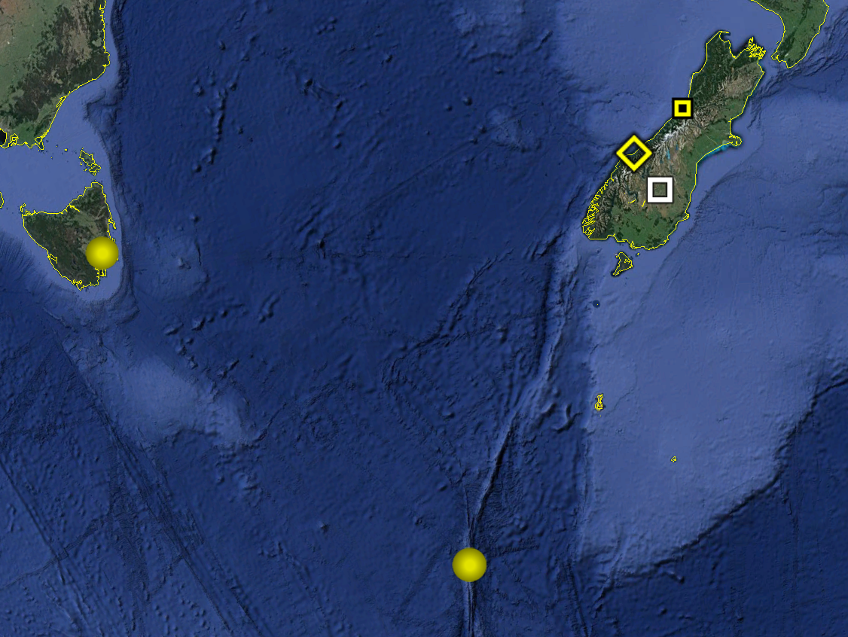
Figure 1. Locations of the soundings included in the DeepWave composite data set. BoM soundings are yellow circles, Hokitika is the yellow square, Lauder is the white square, and Haast is the yellow diamond.

The Deep-Propagating Gravity Wave Experiment (DeepWave) was a field campaign aimed at examining the dynamics of gravity waves from the surface of the Earth to the mesosphere and lower thermosphere. The NSF/NCAR HIAPER Gulfstream-V and DLR Falcon research aircraft were deployed along with a variety of surface-based instrumentation including surface meteorological networks, radars and lidars, sounding systems and regional models. Observations were focused around New Zealand due to it being an ideal natural laboratory to study deep propagating gravity waves and being one of the global gravity wave hot-spots in the upper stratosphere. Further information on DeepWave is available at the DeepWave web site: https://www.eol.ucar.edu/field_projects/deepwave and information on DeepWave operations is available at the DeepWave Field Catalog: http://catalog.eol.ucar.edu/deepwave/.

3.0 EOL Sounding Composite (ESC) File Format Description

The ESC is a columnar ASCII format consisting of 15 header records for each sounding followed by the data records with associated data quality flags.

3.1 Header Records

The header records (15 total records) contain a variety of metadata about the sounding (i.e. location, time, radiosonde type, etc). The first five header lines contain information identifying the sounding, and have a rigidly defined form. The following 7 header lines are used for auxiliary information and comments about the sounding, and may vary from dataset to dataset. The last 3 header records contain header information for the data columns. Line 13 holds the field names, line 14 the field units, and line 15 contains dashes ('-' characters) delineating the extent of the field.

The file standard header lines are as follows:

Line | Label (padded to 35 char) | Contents
1 | Data Type: | Description of the type and resolution of data
2 | Project ID: | Short name for the field project
3 | Release Site Type/Site ID: | Description of the release site.
4 | Release Location (lon,lat,alt): | Location of the release site.
5 | UTC Release Time (y,m,d,h,m,s): | Time of release.

The release location is given as:
lon (deg min), lat (deg min), lon (dec. deg), lat (dec. deg), alt (m)

Longitude in deg min is in the format: ddd mm.mm'W where ddd is the number of degrees (with leading zeros if necessary), mm.mm is the decimal number of minutes, and W represents W or E for west or east longitude, respectively. Latitude has the same format as longitude, except there are only two digits for degrees and N or S for north/south latitude.

The time of release is given as: yyyy, mm, dd, hh:nn:ss.
Where yyyy is the year, mm is the month, dd is the day of month, and hh:nn:ss are the UTC hour, minute, and second respectively.

The seven non-standard header lines may contain any label and contents. The labels are padded to 35 characters to match the standard header lines. Records for this data set include the following non-standard header lines:

Line | Label (padded to 35 char) | Contents
6 | Radiosonde Type | Type of radiosonde
7 | Radiosonde Serial Number
8 | Ground Station Software

The nominal release time for these soundings is the same as the actual time.

3.2 Data Records

The data records each contain time from release, pressure, temperature, dew point, relative humidity, U and V wind components, wind speed and direction, ascent rate, balloon position data, altitude, and quality control flags (see the QC code description). Each data line contains 21 fields, separated by spaces, with a total width of 130 characters. The data are right-justified within the fields. All fields have one decimal place of precision, with the exception of latitude and longitude, which have three decimal places of precision. The contents and sizes of the 21 fields that appear in each data record are as follows:

Field | Width | Format | Parameter | Units | Missing  Value
1 | 6 | F6.1 | Time since release | Seconds | 9999.0
2 | 6 | F6.1 | Pressure | Millibars | 9999.0
3 | 5 | F5.1 | Dry-bulb Temperature | Degrees C | 999.0
4 | 5 | F5.1 | Dew Point Temperature | Degrees C | 999.0
5 | 5 | F5.1 | Relative Humidity | Percent | 999.0
6 | 6 | F6.1 | U Wind Comp | m/s | 9999.0
7 | 6 | F6.1 | V Wind Comp | m/s | 9999.0
8 | 5 | F5.1 | Wind speed | m/s | 999.0
9 | 5 | F5.1 | Wind direction | Degrees | 999.0
10 | 5 | F5.1 | Ascent Rate | m/s | 999.0
11 | 8 | F8.3 | Longitude | Degrees | 9999.0
12 | 7 | F7.3 | Latitude | Degrees | 999.0
13 | 5 | F5.1 | Elevation Angle | Degrees | 999.0
14 | 5 | F5.1 | Azimuth Angle | Degrees | 999.0
15 | 7 | F7.1 | Altitude | Meters | 99999.0
16 | 4 | F4.1 | QC for Pressure | Code | 99.0
17 | 4 | F4.1 | QC for Temperature | Code | 99.0
18 | 4 | F4.1 | QC for Humidity | Code | 99.0
19 | 4 | F4.1 | QC for U Wind | Code | 99.0
20 | 4 | F4.1 | QC for V Wind | Code | 99.0
21 | 4 | F4.1 | QC for Ascent Rate | Code | 99.0

Fields 16 through 21 contain the data quality flags from the NCAR/Earth Observing Laboratory (EOL) sounding quality control procedures. The data quality flags are defined as follows:

Code | Description
1.0 | Checked, datum seems physically reasonable. (“GOOD”)
2.0 | Checked, datum seems questionable on a physical basis. (“MAYBE”)
3.0 | Checked, datum seems to be in error. (“BAD”)
4.0 | Checked, datum is interpolated. (“ESTIMATED”)
9.0 | Checked, datum is missing. (“MISSING”)
99.0 | Unchecked (QC information is “missing”.) (“UNCHECKED”)

3.3 Data Specifics

The vertical resolution varies by data source:
BoM – 2 seconds
DLR – 1 or 2 seconds
NCAR/EOL Hokitika – 1 second
NIWA Haast – 2 seconds

The data are in files by day, so all soundings for a particular day are concatenated into a single file ordered by time. The file naming convention is:

DeepWave_yyyymmdd.cls where yyyy is the year, mm is the month, and dd is the day of the month.

The DLR Lauder station utilized a combination of Vaisala RS92-SGPL (68 soundings) and Graw DFM-09 (30 soundings) radiosondes both using GPS for windfinding during DEEPWAVE. Vaisala DigiCORA ground station was used for the Vaisala radiosondes and Grawmet version 5.9.2.18 was used for the Graw radiosondes. The Graw soundings have 1-second vertical resolution and the Vaisala 2-second. The multiple radiosonde types were used to allow more frequent radiosonde releases during the Intensive Observing Periods.

The BoM stations utilized the Vaisala RS92-K radiosondes with radar windfinding during DeepWave. The Vaisala DigiCORA MKIII version 3.64.1 ground station was used.

The NCAR/EOL Hokitika stations utilized the Vaisala RS92-SGP radiosondes using GPS for windfinding during DeepWave.

The NIWA Haast station utilized Vaisala RS92 radiosondes using GPS for windfinding during DeepWave. The Vaisala DigiCORA MW41 ground station was used.

3.4 Sample Data

The following is a sample of the high resolution radiosonde data in ESC format.

Data Type: DLR Lauder Radiosonde/Ascending
Project ID: DEEPWAVE
Release Site Type/Site ID: Lauder, New Zealand
Release Location (lon,lat,alt): 169 40.80'E, 45 02.40'S, 169.680, -45.040, 370.0
UTC Release Time (y,m,d,h,m,s): 2014, 06, 19, 05:33:00
Radiosonde Type: Vaisala RS92-SGPL
Radiosonde Serial Number: K1143171
Ground Station Software: Vaisala DigiCora Sounding System
/
/
/
Nominal Release Time (y,m,d,h,m,s):2014, 06, 19, 05:33:00
Time Press Temp Dewpt RH Ucmp Vcmp spd dir Wcmp Lon Lat Ele Azi Alt Qp Qt Qrh Qu Qv QdZ
sec mb C C % m/s m/s m/s deg m/s deg deg deg deg m code code code code code code
------ ------ ----- ----- ----- ------ ------ ----- ----- ----- -------- ------- ----- ----- ------- ---- ---- ---- ---- ---- ----
0.0 956.1 7.6 -3.4 45.6 6.2 -1.1 6.3 280.4 999.0 169.680 -45.040 0.0 100.4 370.0 99.0 99.0 99.0 99.0 99.0 9.0
2.0 954.8 7.9 -5.2 38.8 3.1 0.6 3.2 258.8 5.6 169.680 -45.040 8.2 291.9 381.1 3.0 3.0 3.0 99.0 99.0 99.0
4.0 953.6 9.0 -5.8 34.6 3.4 0.7 3.5 258.6 5.4 169.680 -45.040 16.9 294.0 392.0 3.0 3.0 3.0 99.0 99.0 99.0

3.5 Station List

Site ID | WMO ID | Site Name | Country | Latitude | Longitude | Elev (m)
N/A | N/A | Lauder | New Zealand | -45.038 | 169.684 | 370
Haast | N/A | Haast | New Zealand | -43.940 | 168.860 | 3
HOKI | N/A | Hokitika | New Zealand | -42.715 | 170.985 | 69
YMMQ | 94998 | Macquarie Island | Australia | -54.500 | 158.940 | 6
YMHB | 94975 | Hobart | Australia | -42.840 | 147.500 | 22

4.0 Data Quality Control Procedures

- Each sounding was converted from its original format into the ESC format described above.

- Each sounding was passed through a set of automated data quality checks which included basic gross limit checks as well as rate of change checks. This is further described in Section 4.1.

- Each sounding was visually examined utilizing the NCAR/EOL XQC sounding quality control software. This is further described in Section 4.2.

4.1 Automated Data Quality Checks

This data set was passed through a set of automated data quality checks. This procedure includes both gross limit checks on all parameters as well as rate-of-change checks on temperature, pressure, and ascent rate. A version of these checks is described in Loehrer et al. (1996) and Loehrer et al. (1998).

4.1.1 Gross Limit Checks

These checks were conducted on each sounding and the data quality flags in the ESC files were adjusted as appropriate. Only the data point under examination was flagged. All checks also produced warning messages that specified the location of the problem and the severity of the issue. These warning messages where then summarized statistically and examined to determine any consistent issues.

For this data set NCAR/EOL conducted the following gross limit checks. In the table P = pressure, T = temperature, RH = relative humidity, U = U wind component, V = V wind component, B= bad, and Q = questionable.

Parameter | Check | Parameter(s) Flagged | Flag Applied
Pressure | <0 or > 1050 | P | B
Altitude | < 0 or >40000 | P, T, RH | Q
Temperature | < -90 or > 45 | T | B
Dew Point | < -99.9 or > 33  > T | RH  T, RH | Q  Q
Wind Speed | < 0 or > 100  > 150 | U, V  U, V | Q  B
U Wind | < 0 or > 100  > 150 | U  U | Q  B
V Wind | < 0 or > 100  > 150 | V  V | Q  B
Wind Direction | < 0 or > 360 | U, V | B
Ascent Rate | < -10 or > 10 | P, T, RH | Q

4.1.2 Vertical Consistency Checks

These checks were conducted on each sounding and the data quality flags in the ESC files were adjusted as appropriate. These checks were started at the surface and compared each neighboring data record. In the case of checks that ensured that the values increased/decreased as expected, only the data point under examination was flagged. However, for the other checks, all of the data points used in the examination were flagged. All items within the table are as previously defined. All checks also produced warning messages that specified the location of the problem and the severity of the issue. These warning messages where then summarized statistically and examined to determine any consistent issues.

Parameter | Check | Parameter(s) Flagged | Flag Applied
Time | Decreasing/equal | None | None.
Altitude | Decreasing/equal | P, T, RH | Q
Pressure | Increasing/equal  > 1mb/s or < -1mb/s  > 2mb/s or < -2mb/s | P, T, TH  P, T, TH  P, T, TH | Q  Q  B
Temperature | < -15ºC/km  < -30ºC/km  > 50ºC/km  > 100ºC/km | P, T, RH  P, T, RH  P, T, RH  P, T, RH | Q  B  Q  B
Ascent Rate | > 3m/s or < -3m/s  > 5m/s or < -5m/s | P  P | Q  B

4.2 Visual Data Quality Checks

Each sounding was visually examined using the NCAR/EOL XQC sounding data quality control software. This software allows the user to view a skew-t/log-p diagram of each sounding and apply data quality flags as appropriate. The user can zoom in on sections of soundings for detailed examination and can adjust the data quality flags for an individual point, sections of soundings, or entire soundings for each parameter individually. The software also allows the user to override the quality flags applied by the automated procedure.

4.3 Data Quality Issues of Note

The data quality control procedures outlined above allows us to identify and, in some cases, resolve issues that could potentially impact research performed using these data sets. The following issues were noted in these soundings.

4.3.1 DLR Lauder Notes

201406190331 – There are several spikes in the wind speed (380-367mb, 257-250mb, and 203-180mb), the first two were flagged as bad and the other as questionable. There were also two periods where the temperature was overly warm (655-400mb and 240-220mb) and these have been flagged bad. Also above 203mb the radiosonde goes through several periods where the radiosonde is falling and all parameters have been flagged questionable during this period.

201406241737 – All parameters were flagged questionable from 850-740mb.

201407311126 – Above 150mb there are several periods where the radiosonde is falling.

201408011124 – The radiosonde fell for a period from 671-708mb.

4.3.2 BoM Hobart Notes

201406181715 – contains no temperature or relative humidity data
201406262315 – contains no wind data above 670mb
201407102315 – the relative humidity data cycles from the surface to 340 mb these
data have been flagged bad and should be used with caution.
4.3.3 BoM Macquarie Island Notes

No issues of note.

4.3.4 NCAR/EOL Hokitika Notes

201406140509 – No data above 630mb.
201406161102 – No data above 980mb.
201406172259 – Wetbulbing at 684mb.
201406241119 – No RH data. Contains a period of descending data from 459-
516mb during which the temperature is much warmer until the radiosonde reaches
back up to ~400mb.
201406241414 – No temperature or RH data above the surface due to a broken
sensor.
Page | 7
201406242002 – The temperature data are missing up to ~465mb.
201406291404 – A couple of descending periods around 440mb.
201406300800 – Has a short period of descent around 680mb.
201406301045 – No data above 747mb.
201407010501 – No data above 608mb and no wind data above the surface.

See http://data.eol.ucar.edu/datafile/nph-get/379.028/readme.Deepwave-2014.ISS.radiosondes.pdf for additional processing and quality control information.

5.0 References
Loehrer, S. M., T. A. Edmands, and J. A. Moore, 1996: TOGA COARE upper-air sounding data archive: development and quality control procedures. Bull. Amer. Meteor. Soc., 77, 2651-2671.
Loehrer, S. M., S. F. Williams, and J. A. Moore, 1998: Results from UCAR/JOSS quality control of atmospheric soundings from field projects. Preprints, Tenth Symposium on Meteorological Observations and Instrumentation, Phoenix, AZ, Amer. Meteor. Soc., 1-6.

