Select a ~10-minute period during your flight where the aircraft is flying in a straight line and at a constant altitude. Ideally, this 10-minute period is (1) in clear weather, where the ground shows up clearly in the reflectivity field and is not masked by other echoes; and (2) over land, where we know that the ground isn’t moving. But, some light rain and/or while the aircraft is over the ocean is still acceptable. In hurricane reconnaissance flights, outbound or inbound legs are typically good. You will need to know the exact number of sweep files in that 10-minute period.

Install the navigation correction package from <https://github.com/mmbell/Airborne-Radar-QC>.

Below is an example of how I applied the navigation correction on a NOAA43 flight into Hurricane Ophelia (2005) on September 11, 2005.

Set up your navigation correction directory as follows. Let’s call this directory “navcorr”:



file folder/directory executable

Store the sweep files from the 10-minute period in the swp folder

**Initial Navigation Correction**

In this example, radar reflectivity is DZ, spectrum width is SPEC_WDT, and Doppler velocity is VE.

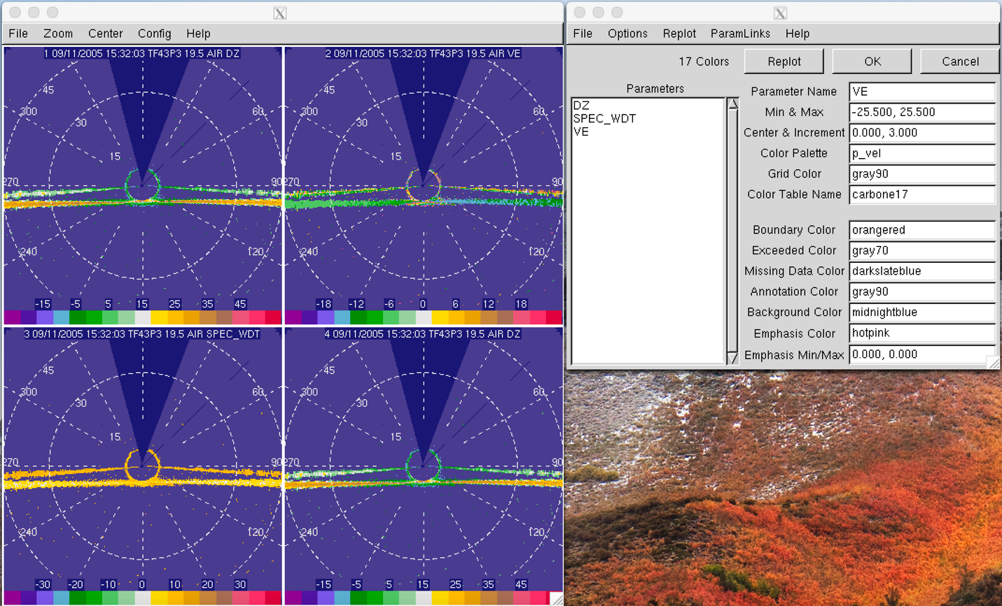

FOR NEW DATA:

Copy VEL to VG

Remove-aircraft-motion in VG

Copy VG to VR

Copy WIDTH to SW

Copy SQI to NCP

I copied these fields to a new field with their common names (copy VE to VEL; copy DZ to DBZ; copy SPEC_WDT to WIDTH; copy WIDTH to SW). Again, depending on how your data was unpacked, you may not need to do this step. However, you would need to create a field called NCP and assign a value of 1 to it (copy DBZ to NCP; assign-value 1 to NCP)

The actual initial navigation correction is in the command

copy VEL to VG

remove-aircraft-motion in VG

copy VG to VR

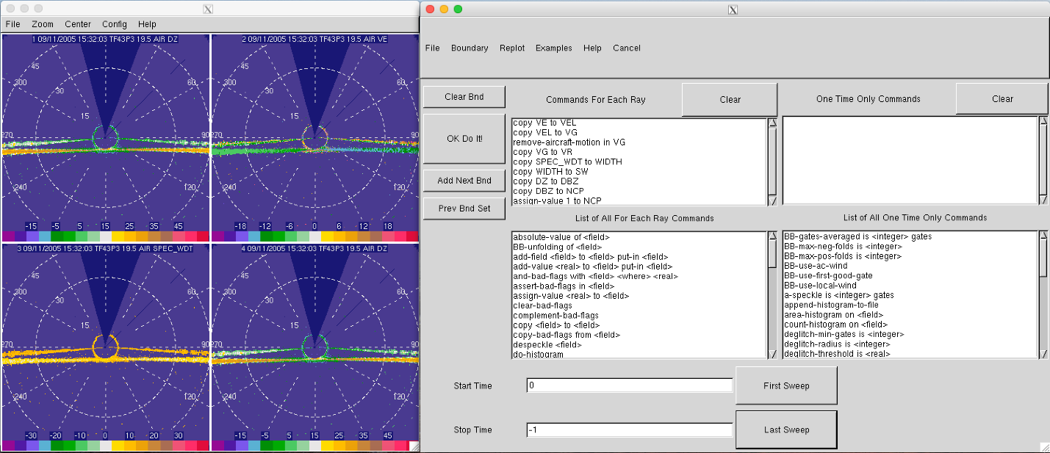

Make sure to apply the corrections to all sweep files by clicking on “First Sweep” and “Last Sweep,” and also to both the fore sweeps and the aft sweeps.

**Main Navigation Correction**

In the main navigation correction steps, you would have to run the software on the whole set of sweep files that you have, but apply the correction factor to the fore sweeps and aft sweeps individually. Rather than moving the files back and forth between the swp folder and the fore/aft folders, you can just create a symlink in the fore/aft folders that point toward the respective files in the swp folder.

Now, you want to convert *all* the sweep files in the swp folder into cfradial in a folder called cfradial in the main directory:

RadxConvert -f /navcorr/swp/swp.1050911* -outdir /navcorr/cfradial

Radx will convert the sweep files into cfradial files in /navcorr/cfradial/20050911. Go to the directory with the cfradial files:

cd /navcorr/cfradial/20050911/

Now, create a list file of all the generated cfradial files called “filelist”

ls * > filelist

You will need to insert the number of sweep/cfradial files that you have in the top line, like this:

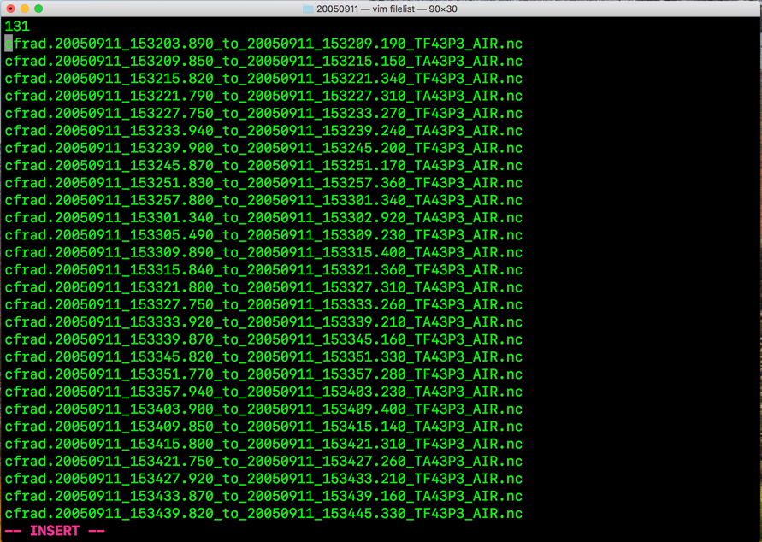

Close filelist and run:

./navcorr/readnetcdf_DBZ_VR filelist

Your terminal should start spitting out things like this:

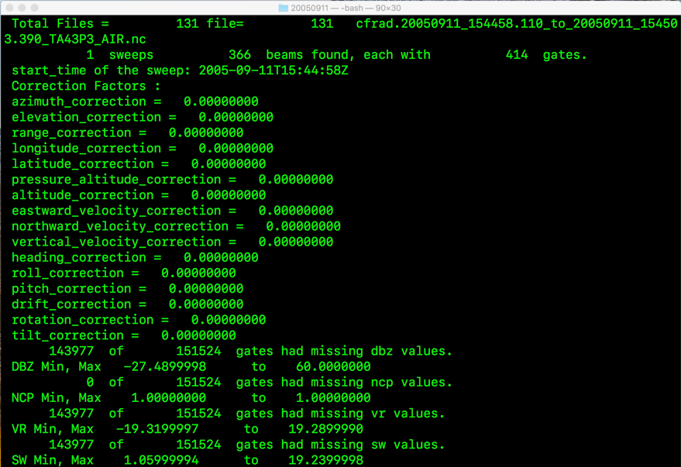

After it is done running, a bunch of text files will be created in the same directory as the cfradial files.

Go back to the main directory: cd /navcorr

Move the folder containing the cfradial files in the /navcorr directory (or anywhere but the cfradial folder). In this example, I moved it into the /navcorr directory. Now, move the generated text files into the cfradial folder

mv 20050911/*.txt cfradial

This is where the navigation correction software will look for the generated text files (second line in DATA_cns_run). Of course, you can change this by changing the second line in DATA_cns_run. You can also change the name of the output directory in the DATA_cns_run file instead of “corrections”

Now, edit the fields in the DATA_cns_run text file. Highlighted are the things that you would need to change according to the details of your own flight:

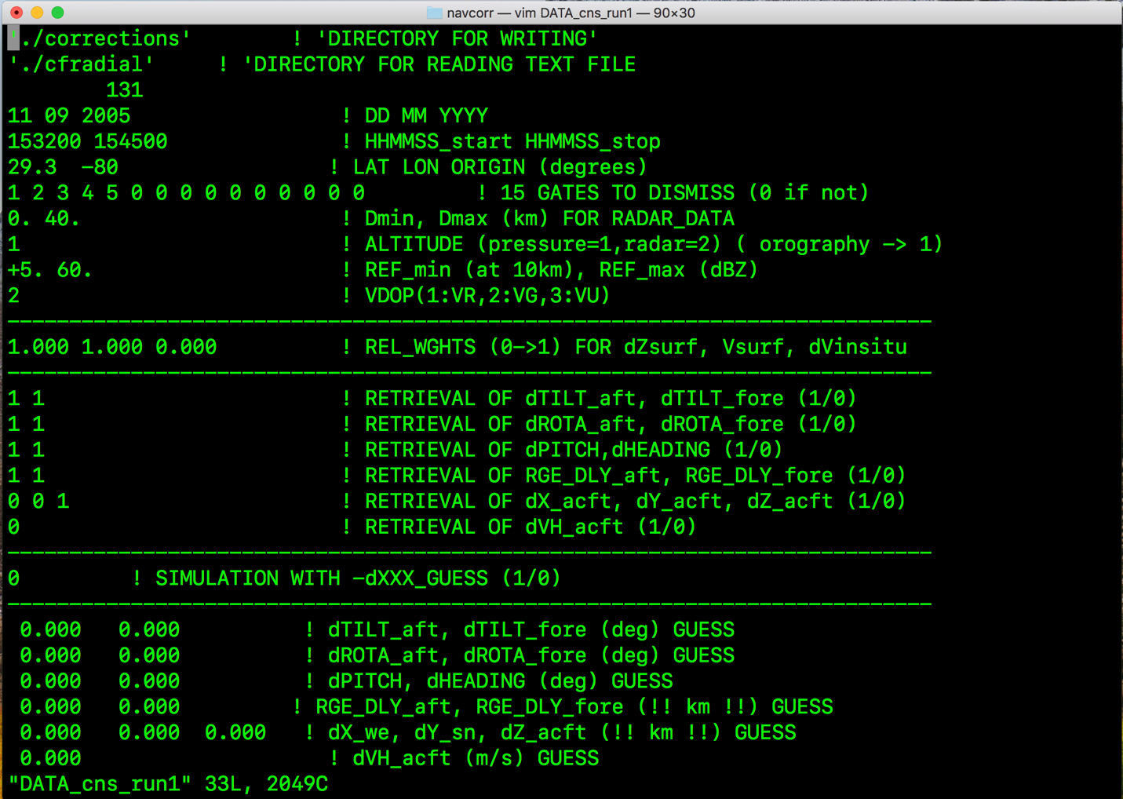

Approx. lat and lon of 10-min leg

Flight time

Flight date

Number of swp/cfradial files

Generate correction factors file

./cns_eldo_cai DATA_cns_run

The program should run and list a bunch of things. cfac files should be in “corrections”

Copy cfac.aft/cfac.fore into archive as cfac.aft1/cfac.fore1

More importantly, copy cfac.aft into /navcorr/aft and cfac.fore into /navcorr/fore

Go into either the fore or aft directory. In this case, I went into the fore directory. Export the cfac file before opening solo. Note that the sweep files have designation for fore sweeps and aft sweeps. In this example, I exported the cfac file cfac.fore to be read-in when the fore sweeps **TF**43P3 were accessed.



FOR NEW DATA:

Export CFAC_FILES=”N42RF-TM > cfac.fore” -> Fore

To ensure that the cfac file was read-in, when you open solo, you should have this notification:

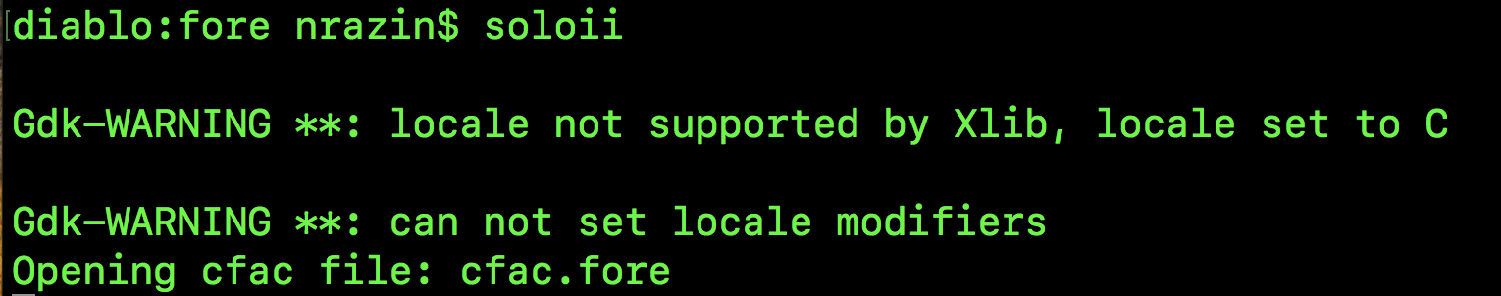

Now, run these commands in the editor. Remember to apply the commands to all the sweeps by clicking “First Sweep” and “Last Sweep.”

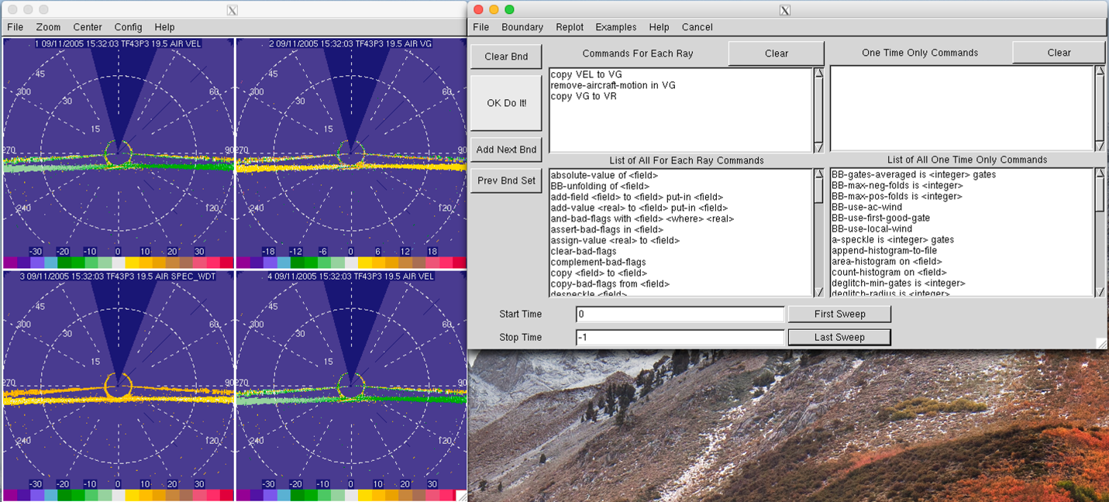

It should say “Finished!” in the terminal. After this, whatever you do on solo, it will crash. Best to close it either way since you have nothing else to do with solo.

Now go to the other directory and repeat the same thing. Since I was in the fore directory last, we’ll go into the aft directory.

Again, when exporting cfac files, make sure you have the correct file designation. Since I’m working on the aft files, the file name should be **TA**43P3



If the cfac files were not properly exported, solo will just open without the “Opening cfac file” notification

Repeat the same commands in solo as I did in the fore sweeps. Solo will crash. If you try to open solo to view other things, and the cfac file is not in the same directory, it won’t open because it won’t be able to find the cfac file. You would need to unset the cfac file using the command:

unset CFAC_FILES

Now remove everything in the corrections folder (you’ve saved the cfac files in “archive”), remove the folders containing the generated text files and cfradial files.

rm corrections/*

rm -r cfradial

rm -r 20050911

Repeat the whole process from converting the sweep files into cfradial.

cd /navcorr/swp

RadxConvert -f swp* -outdir ../cfradial

Once you’ve run the navigation correction again, you should see the correction values decrease relative to the first navigation correction that you did

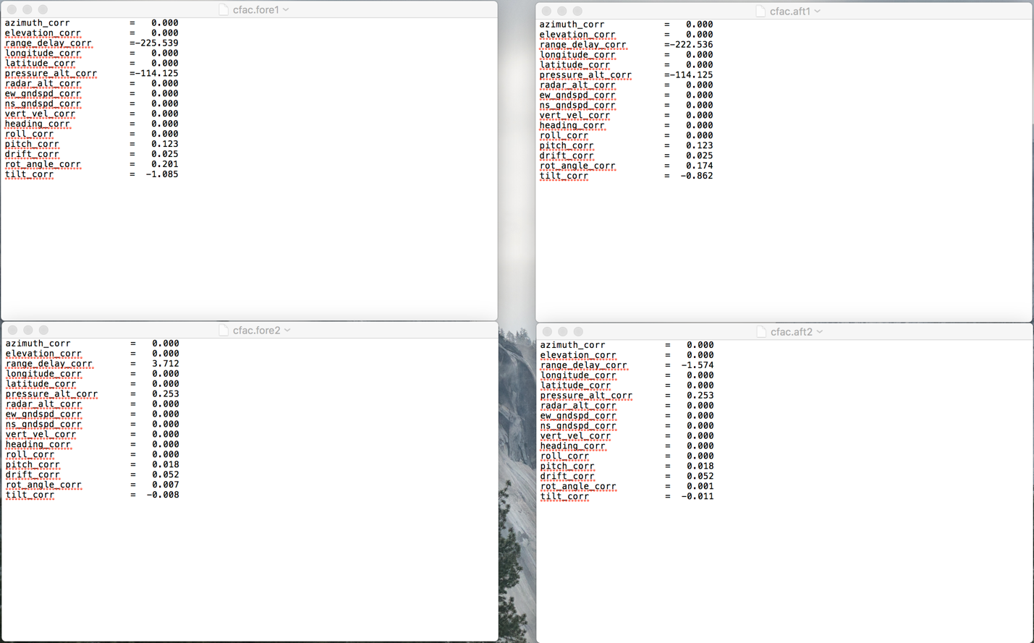

You typically want to run the navigation correction to the point where the correction values are close to zero. What you do beyond this point is to add the correction values in the second round of navigation correction to the correction values in the first round of navigation correction, export the “new” cfac file to solo and repeat the commands in solo. Then run the navigation correction again and you would see that the correction values will approach zero more than in the second round of navigation correction. The cfac files that you exported that resulted in correction factors closest to zero (before you stop) is the one you want to apply to the rest of the sweeps.