MDV FORMAT
Interface Control Document (ICD)
Mike Dixon
Research Applications Laboratory (RAL)
National Center for Atmospheric Research (NCAR)
Boulder, Colorado, USA
November 2006
Overview
MDV history
The Meteorological Data Volume (MDV) format for gridded data was developed by the Research Applications Laboratory at NCAR in the early 1990s. At the time a number of gridded data formats were in use at RAL. To simplify the data systems, it was decided to standardize on a single gridded data type for internal use.
No public data standard available at the time was considered suitable in terms of data encapsulation and internal compression. MDV evolved as a data format unique to RAL and NCAR. It is an effective format for gridded data, with good meta-data support and an efficient internal compression capability which allows for selected decompression of a single plane from a single data field.
Data imported from, and exported to, organizations outside RAL is frequently in formats such as NetCDF, GRIB and HDF5. To the extent possible, converters have been developed to allow transformation between MDV and these other data formats.
An XML/binary version of MDV is under development. The header information will be stored as ASCII in an XML file and the field data will be stored as binary information in a secondary file.
Mdv concepts
MDV is a general purpose data file format for storing two- and three-dimensional gridded data.
MDV is a single-time format - each MDV data set contains data for a single time. Time searching and retrieval is handled by a time-based file naming convention. This is described in detail later in this document.
MDV provides capabilities for managing multiple data fields in a single file. For example, one MDV file might contain radar data with fields of reflectivity and radial velocity, or model data with temperature, humidity and wind speed as separate fields.
In the (x,y) dimension, MDV supports a number of projection types, including Lambert Conformal Conic, Stereographic, the simple Latitude-Longitude grid (also known as Simple Cylindrical) and polar coordinates for radar data.
In the vertical dimension, MDV supports a number of vertical coordinate types, including height in km or ft, pressure levels, flight levels for aviation, sigma levels for numerical models and elevation angles for radar data.
Data fields may be represented as 4-byte floating point, 2- and 1-byte scaled integers and 4-byte RGBA image pixels.
Internal compression is supported, with each plane of each field individually compressed, for speed of access.
The MDV format is extensible in that it provides space and access capabilities for optional generic “chunk” data defined by the MDV user. Chunk data allows MDV users to attach to the data set additional information that is not suitable for storage in the MDV headers or data fields. As examples, the user may wish to store the elevation angles from which a Cartesian radar grid was derived, or the navigation header for satellite data.
Other features of the MDV file format include:
- a FORTRAN-compatible I/O structure (for non-compressed data);
- date/time stamping for creation, expiration, and forecasting;
- byte swapping to handle cross-platform data representation schemes.
Overview of the MDV file format
The MDV data set structure is organized as follows:
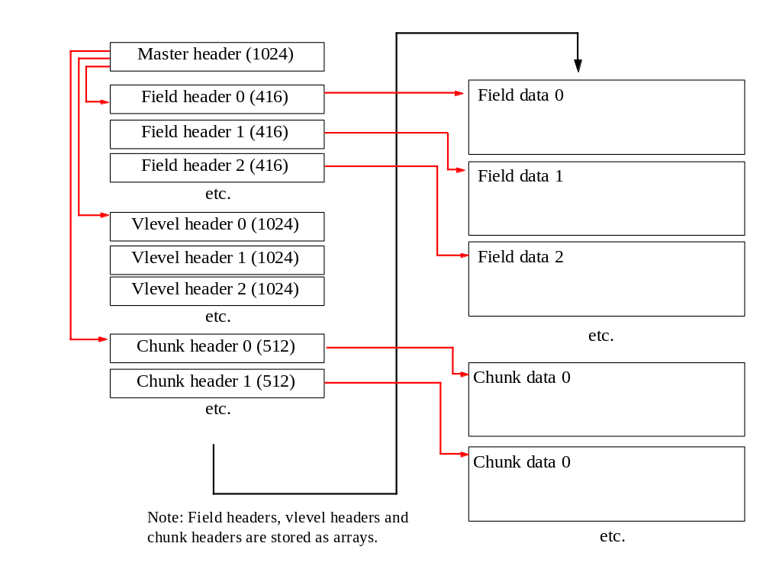
All MDV header information appears at the beginning of the file followed by the field data and any chunk data. In the figure, header lengths are given in bytes.
The master header contains file offsets to the field header array, vlevel header array and (optional) chunk header array.
The field headers contain file offsets to the field data.
Vlevel headers are used to store the details of the third dimension data, e.g. Cartesian plane heights, radar elevation angles, etc.
The (optional) chunk headers contain file offsets to the chunk data.
Binary data types
The header structures in MDV use the following data types:
- 1-byte ASCII characters
- signed 4-byte integers
- IEEE 4-byte floating point values
The data fields in MDV use the following data types:
- unsigned 1-byte integers
- unsigned 2-byte integers
- unsigned 4-byte integers
- IEEE 4-byte floating point values
Byte ordering
For data types with a length of more than 1 byte, the ordering of the data bytes is important in interpreting the data.
All MDV binary data is stored in so-called big-endian or network-byte-order. This is the native byte ordering for platforms such as SUN, and the opposite of that used by INTEL and AMD processors common to LINUX and Windows systems.
When reading MDV data on a little-endian platform, the multi-byte values will require byte-swapping.
MDV file naming convention
For meteorological data, one of the most important attributes is time. Each MDV file contains data for a single time.
MDV files are named according to the time of the data stored in the file. As a general rule, UTC times are used in all MDV data.
A number of times may be applicable:
- valid time - the time at which an observation was made. This is also referred to as ‘observation time’;
- generate time - the time at which a model was run or a forecast was generated;
- forecast time - the time at which a forecast is valid;
- lead time - the time difference between the forecast time and generate time for a forecast.
MDV files are named in two ways, as follows.
- By valid time:
data_dir/yyyymmdd/hhmmss.mdv
- By generate time and lead time:
data_dir/yyyymmdd/g_hhmmss/f_llllllll.mdv
Most data sets are stored using valid time. The files for a single day are stored in a subdirectory (yyyymmdd), named after the year, month and day. The files within the directory are named according to the hour, minute and second (hhmmss.mdv).
For forecast-style data, you can choose whether to use the valid-time naming convention above, or whether to use the more complicated generate-time and lead-time convention. The former is simpler, but can lead to over-writing of data sets if forecast results from different generate times have the same valid time. For example, for a model run at 0 UTC and 6 UTC, the 9-hour forecast from the 0 UTC run will be over-written by the 3-hour forecast from the 6 UTC run because they will both be valid at 09 UTC.
To avoid over-writing, use the second naming convention. There are 2 levels of sub-directory. The name of the upper one is based on the year, month and day of the generate time (yyyymmdd). The lower one is named g_hhmmss, based on the hour, minute and second of the generate time.The files themselves are named using an 8-digit lead time in seconds (f_llllllll.mdv). For example, the 6-hour (21600 second) forecast for the 9 UTC model run on 1 July 2005 will be named:
20050701/g_090000/f_00021600.mdv

MDV Headers
C-style syntax
MDV was originally developed for reading and writing in the C and C++ languages. The most comprehensive library support is in C++. Therefore, this document is written with a C++ programmer in mind, and C-style syntax is used because this provides an exact and well-understood way to describe the data format.
However, there is nothing in the MDV format specific to the C language. Readers and writers for MDV have been developed in FORTRAN, Java and IDL.
Portable data types
The following portable C-style data types are defined for use in MDV:

typedef unsigned char ui08; // 1 byte unsigned int
typedef unsigned short ui16; // 2 byte unsigned int
typedef signed int si32; // 4 byte signed int
typedef unsigned int ui32; // 4 byte unsigned int
typedef float fl32; // 4 byte IEEE float

These data types are used in the remainder of the document.
Time representation
Times are represented as 4-byte signed integers.
Time values are computed as the number of seconds since 0 UTC on 1 January 1970. This is so-called UNIX time. (This representation will wrap in the year 2038. Hence the need an XML format.)
Constants
The following constants are defined as part of the MDV format:

#define MDV_CHUNK_INFO_LEN 480
#define MDV_INFO_LEN 512
#define MDV_LONG_FIELD_LEN 64
#define MDV_MAX_PROJ_PARAMS 8
#define MDV_MAX_VLEVELS 122
#define MDV_NAME_LEN 128
#define MDV_SHORT_FIELD_LEN 16
#define MDV_TRANSFORM_LEN 16
#define MDV_UNITS_LEN 16
#define MDV_N_COORD_LABELS 3
#define MDV_COORD_UNITS_LEN 32
Master header
A single master header is placed at the start of the file.
The master header has a length of 1024 bytes.
The master header is defined by the following C-style structure:

typedef struct {
si32 record_len1;
si32 struct_id;
si32 revision_number;
si32 time_gen;
si32 user_time;
si32 time_begin;
si32 time_end;
si32 time_centroid;
si32 time_expire;
si32 num_data_times;
si32 index_number;
si32 data_dimension;
si32 data_collection_type;
si32 user_data;
si32 native_vlevel_type;
si32 vlevel_type;
si32 vlevel_included;
si32 grid_orientation;
si32 data_ordering;
si32 n_fields;
si32 max_nx;
si32 max_ny;
si32 max_nz;
si32 n_chunks;
si32 field_hdr_offset;
si32 vlevel_hdr_offset;
si32 chunk_hdr_offset;
si32 field_grids_differ;
si32 user_data_si32[8];
si32 time_written;
si32 unused_si32[5];
fl32 user_data_fl32[6];
fl32 sensor_lon;
fl32 sensor_lat;
fl32 sensor_alt;
fl32 unused_fl32[12];
char data_set_info[MDV_INFO_LEN];
char data_set_name[MDV_NAME_LEN];
char data_set_source[MDV_NAME_LEN];
si32 record_len2;
} master_header_t;

Details of the entries in the master header are as follows:
si32 record_len1
Used by FORTRAN applications, value = 1016.
This is the size of the structure in bytes, not including the record_len integers. (1024 - 2 * 4).
si32 struct_id
Magic cookie. Value = 14142.
si32 revision_number
Revision number of the format, value = 1.
si32 time_gen
Generate time for forecast data sets.
Not used for non-forecast data, in which case value = 0.
si32 user_time
User-application-specified data. Not used by MDV. Normally 0.
si32 time_begin
Start time of data set, if applicable. Often set equal to time_centroid.
si32 time_end
End time of data set, if applicable. Often set equal to time_centroid.
si32 time_centroid
Valid time of the data set. This is the principal time used for the data set, to name the files, retrieve data, etc. For observation data, this is normally set to the observation time. For model data, this is set to time_gen plus forecast_delta (see field header).
si32 time_expire
Not used. Included for backward compatibility.
si32 num_data_times
Not used. Value = 1. Included for backward compatibility.
si32 index_number
Not used. Value = 0. Included for backward compatibility.
si32 data_dimension
2 if all fields contain 2D data, 3 if any fields contain 3D data.
si32 data_collection_type
Used as information on how the data was obtained or generated. This is for information only, it is not used by MDV.
DATA_MEASURED = 0, measured from some instrument.
DATA_EXTRAPOLATED = 1, extrapolated by an algorithm.
DATA_FORECAST = 2, forecast by an algorithm or model
DATA_SYNTHESIS = 3, combination of measured and modelled data
DATA_MIXED = 4, different types of data in data set
DATA_IMAGE = 5, photograph, RGB Image
DATA_GRAPHIC = 6, synthetically Rendered RGB Image
si32 user_data
User-application-specified data. Not used by MDV. Normally 0.
si32 native_vlevel_type
The native vertical data types of the data, before translation into MDV. See vlevel_type.
Used for information only, not used by MDV.
si32 vlevel_type
This is the vertical level type of the data in the fields. VERT_TYPE_VARIABLE applies if the vertical level types differ between fields.
- VERT_TYPE_SURFACE = 1, earth surface field, 2D
- VERT_TYPE_SIGMA_P = 2, sigma pressure levels
- VERT_TYPE_PRESSURE = 3, pressure levels, units = mb
- VERT_TYPE_Z = 4, constant altitude, units = km MSL
- VERT_TYPE_SIGMA_Z = 5, model sigma Z levels
- VERT_TYPE_ETA = 6, model eta levels
- VERT_TYPE_THETA = 7, isentropic surface, units = Kelvin
- VERT_TYPE_MIXED = 8, any hybrid vertical grid, not used much
- VERT_TYPE_ELEV = 9, elevation angles - radar
- VERT_TYPE_COMPOSITE = 10, composite, i.e., max value at any height
- VERT_TYPE_CROSS_SEC = 11, cross sectional view of a set of planes
- VERT_SATELLITE_IMAGE = 12, satellite data
- VERT_FLIGHT_LEVEL = 15, ICAO flight level (100’s of ft)
- VERT_EARTH_IMAGE = 16, image, conformal to the surface of the earth
- VERT_TYPE_AZ = 17, azimuth angles - radar RHI
- VERT_TYPE_TOPS = 18, Echo or cloud tops
- VERT_TYPE_ZAGL_FT = 19, constant altitude above ground, units = ft
- VERT_TYPE_VARIABLE = 99, if variable types in fields
si32 vlevel_included
Always 1.
Included for backward compatibility.
si32 grid_orientation
Always 1. The data in the grids is always stored South-to-North and West-to-East.
Included for backward compatibility.
si32 data_ordering
Always 0. The data ordering is always XYZ, meaning that X varies the fastest and Z the slowest in the data arrays.
Included for backward compatibility.
si32 n_fields
Number of data fields.
si32 max_nx
Maximum nx in all fields.
si32 max_ny
Maximum ny in all fields.
si32 max_nz
Maximum nz in all fields.
si32 n_chunks
Number of chunks.
si32 field_hdr_offset
Offset of field header array, from start of file, in bytes.
si32 vlevel_hdr_offset
Offset of vlevel header array, from start of file, in bytes.
si32 chunk_hdr_offset
Offset of chunk header array, from start of file, in bytes.
si32 field_grids_differ
0 if all fields in the file have the same geometry, 1 if not.
si32 user_data_si32[8]
User-application-specified data. Not used by MDV. Normally 0.
si32 time_written
Time at which the file was written.
si32 unused_si32[5]
Unused - for future expansion. All 0.
fl32 user_data_fl32[6]
User-application-specified data. Not used by MDV. Normally 0.
fl32 sensor_lon
Longitude of the sensor, in degrees, if applicable. Otherwise 0.
An example would be the location of a radar.
fl32 sensor_lat
Latitude of the sensor, in degrees, if applicable. Otherwise 0.
fl32 sensor_alt
Altitude of the sensor, in km, if applicable. Otherwise 0.
fl32 unused_fl32[12]
Unused - for future expansion. All 0.
char data_set_info[512]
Data set information in ASCII.
char data_set_name[128]
Data set name, in ASCII.
char data_set_source[128]
Data set source, in ASCII.
si32 record_len2
Used by FORTRAN applications, value = 1016.
Field header
The field headers are stored as an array following the master header.
There are n_fields field headers - see master header.
The offset of the start of the array from the start of the file, in bytes, is given by the field_hdr_offset in the master header.
Each field header is 416 bytes in length.
The field header is defined by the following C-style structure:

typedef struct {
si32 record_len1;
si32 struct_id;
si32 field_code;
si32 user_time1;
si32 forecast_delta;
si32 user_time2;
si32 user_time3;
si32 forecast_time;
si32 user_time4;
si32 nx;
si32 ny;
si32 nz;
si32 proj_type;
si32 encoding_type;
si32 data_element_nbytes;
si32 field_data_offset;
si32 volume_size;
si32 user_data_si32[10];
si32 compression_type;
si32 transform_type;
si32 scaling_type;
si32 native_vlevel_type;
si32 vlevel_type;
si32 dz_constant;
si32 data_dimension;
si32 zoom_clipped;
si32 zoom_no_overlap;
si32 unused_si32[4];
fl32 proj_origin_lat;
fl32 proj_origin_lon;
fl32 proj_param[MDV_MAX_PROJ_PARAMS];
fl32 vert_reference;
fl32 grid_dx;
fl32 grid_dy;
fl32 grid_dz;
fl32 grid_minx;
fl32 grid_miny;
fl32 grid_minz;
fl32 scale;
fl32 bias;
fl32 bad_data_value;
fl32 missing_data_value;
fl32 proj_rotation;
fl32 user_data_fl32[4];
fl32 min_value;
fl32 max_value;
fl32 min_value_orig_vol;
fl32 max_value_orig_vol;
fl32 unused_fl32;
char field_name_long[MDV_LONG_FIELD_LEN];
char field_name[MDV_SHORT_FIELD_LEN];
char units[MDV_UNITS_LEN];
char transform[MDV_TRANSFORM_LEN];
char unused_char[MDV_UNITS_LEN];
si32 record_len2;
} field_header_t;

Details of the entries in the field header are as follows:
si32 record_len1
Used by FORTRAN applications, value = 408.
This is the size of the structure in bytes, not including the record_len integers. (416 - 2 * 4).
si32 struct_id
Magic cookie. Value = 14143.
si32 field_code
Grib-table field code, if set. Otherwise 0.
Not used by MDV, for information only.
si32 user_time1
User-application-specified data. Not used by MDV. Normally 0.
si32 forecast_delta
Forecast lead time, in seconds. The forecast_time in the field header (time_centroid in the master header) is the gen_time plus the forecast_delta.
si32 user_time2
User-application-specified data. Not used by MDV. Normally 0.
si32 user_time3
User-application-specified data. Not used by MDV. Normally 0.
si32 forecast_time
Time at which the forecast is valid. Set equal to the time_centroid in the master_header.
si32 user_time4
User-application-specified data. Not used by MDV. Normally 0.
si32 nx
Number of grid cells in X, or W-E dimension.
si32 ny
Number of grid cells in the Y, or S-N dimension.
si32 nz
Number of vertical levels.
si32 proj_type
Projection type. Supported types are:
- PROJ_LATLON = 0, (x,y) in degrees. Simple latitude-longitude grid.
Also known as the Simple Cylindrical or Platte Carree projection.
- PROJ_LAMBERT_CONF = 3, (x,y) in km. Lambert Conformal Conic projection.
- PROJ_POLAR_STEREO = 5, (x,y) in km. Polar Stereographic projection.
- PROJ_FLAT = 8, Cartesian, (x,y) in km. This is a simple line-of-sight projection used for single radar sites. The formal name is Oblique Lambert Azimuthal projection.
- PROJ_POLAR_RADAR = 9, radar data in native Plan Position Indicator (PPI) coordinates of range, azimuth angle and elevation angle. x is radial range (km), y is azimuth angle (deg), z is elev angle (deg).
- PROJ_OBLIQUE_STEREO = 12, (x,y) in km. Oblique Stereographic projection.
- PROJ_RHI_RADAR = 13, radar data in native Range Height Indicator (RHI) coordinates.
x is radial range (km), y is elev angle (deg), z is az angle (deg).
si32 encoding_type
This is the encoding type of the field data. MDV supports scaled 1-byte and 2-byte integers, 4-byte floating point and 4-byte RGBA image data.
- ENCODING_INT8 = 1, unsigned 8 bit integer
- ENCODING_INT16 = 2, unsigned 16 bit integer
- ENCODING_FLOAT32 = 5, 32 bit IEEE floating point
- ENCODING_RGBA32 = 7, RGBA image (4 x 8 bits) - same as TIFF RGBA
See scale and bias below for how to convert scaled integers into floats.
si32 data_element_nbytes
1, 2 or 4, depending on the encoding_type above.
si32 field_data_offset
Offset to the start of the data for this field, from the start of the file, in bytes.
si32 volume_size
Length of the field, in bytes.
For non-compressed data, this is nx * ny * nz * data_element_nbytes.
For compressed data, this is the size of the compressed data buffer. See ‘Field data’ section.
si32 user_data_si32[10]
User-application-specified data. Not used by MDV. Normally 0.
si32 compression_type
Compression type for the field data.
Supported types are:
- COMPRESSION_NONE = 0, no compression
- COMPRESSION_ZLIB = 3, Lempel-Ziv
- COMPRESSION_BZIP = 4, bzip2
- COMPRESSION_GZIP = 5, Lempel-Ziv in gzip format
GZIP is the most common compression scheme used now. Other compression options are for backward compatibility.
See the ‘Field data’ section for details on the compression scheme.
si32 transform_type
- DATA_TRANSFORM_NONE = 0
- DATA_TRANSFORM_LOG = 1, natural log
If data is to be transformed and then stored as scaled integers, the floating point data is first transformed using the natural logarithm function, and the scaling is then applied to convert the floating point numbers into scaled integers.
si32 scaling_type
Scaling_type only applies to ui08 and ui16 data. For floating point data, the scaling information is irrelevant.
- SCALING_ROUNDED = 1, scaling factors were computed from the dynamic range of the data and then rounded to reasonable values.
- SCALING_INTEGRAL = 2, scaling factors are integers.
- SCALING_DYNAMIC = 3, scaling factors were computes from the dynamic range of the data.
- SCALING_SPECIFIED = 4, scaling factors were specified by the writer of the file.
The scaling type is included for information only - it is not relevant to readers of the data, since the supplied scaling factors are supplied. (See scale and bias below).
si32 native_vlevel_type
This is the vlevel type of the data from which the data in the file was derived.
For example, the vlevel_type in the file could be VERT_TYPE_COMPOSITE, but the original data may have been a radar volume, in which case the native_vlevel_type could be VERT_TYPE_Z.
See vlevel_type for details on the various types.
si32 vlevel_type
This is the vertical level type of the data in the field, as follows:
- VERT_TYPE_SURFACE = 1, earth surface field, 2D
- VERT_TYPE_SIGMA_P = 2, sigma pressure levels, 3D
- VERT_TYPE_PRESSURE = 3, pressure levels, units = mb, 3D
- VERT_TYPE_Z = 4, constant altitude, units = km MSL, 3D
- VERT_TYPE_SIGMA_Z = 5, model sigma Z levels, 3D
- VERT_TYPE_ETA = 6, model eta levels, 3D
- VERT_TYPE_THETA = 7, isentropic surface, units = Kelvin, 3D
- VERT_TYPE_MIXED = 8, any hybrid vertical grid, not used much, 3D
- VERT_TYPE_ELEV = 9, elevation angles - radar, 3D
- VERT_TYPE_COMPOSITE = 10, composite, i.e., max value at any height, 2D
- VERT_TYPE_CROSS_SEC = 11, cross sectional view of a set of planes, 2D
- VERT_SATELLITE_IMAGE = 12, satellite data, 2D
- VERT_FLIGHT_LEVEL = 15, ICAO flight level (100’s of ft), 3D
- VERT_EARTH_IMAGE = 16, image, conformal to the surface of the earth, 2D
- VERT_TYPE_AZ = 17, azimuth angles - radar RHI, 2D
- VERT_TYPE_TOPS = 18, Echo or cloud tops, 2D
- VERT_TYPE_ZAGL_FT = 19, constant altitude above ground, units = ft , 2D
si32 dz_constant
1 if the difference between successive vlevels is constant, 0 if not.
si32 data_dimension
2 for 2D data, 3 for 3D data.
si32 zoom_clipped
Not applicable to data in a file.
Set to 1, on read, if the data returned is clipped, i.e. does not cover the full domain in the file. Otherwise 0.
si32 zoom_no_overlap
Not applicable to data in a file.
Set to 1, on read, if there is no spatial overlap between the data in the file and the area requested. Otherwise 0.
si32 unused_si32[4]
Unused, for future expansion. All 0.
fl32 proj_origin_lat
Latitude of the projection origin, in degrees.
In other words, this is the latitude of the (x = 0, y = 0) point in the projection.
Applicable to all projections except LATLON.
fl32 proj_origin_lon
Longitude of the projection origin, in degrees.
In other words, this is the longitude of the (x = 0, y = 0) point in the projection.
Applicable to all projections except LATLON.
fl32 proj_param[8]
Projection parameters for the various projections.
- PROJ_FLAT: not used.
- PROJ_LATLON: not used
- PROJ_LAMBERT_CONF: proj_param[0] = lat1, proj_param[1] = lat2.
- PROJ_POLAR_STEREO: proj_param[0] = tangent_lon, proj_param[1] = pole_type, 0 for North pole, 1 for South pole.
- PROJ_OBLIQUE_STEREO: proj_param[0] = tangent_lat, proj_param[1] = tangent_lon.
fl32 vert_reference
Not used, value = 0. Included for backward compatibility.
fl32 grid_dx
Resolution of the grid, in the X or W-E direction.
The units are km for all projections except LATLON, for which the units are degrees.
fl32 grid_dy
Resolution of the grid, in the Y or S-N direction.
The units are km for all projections except LATLON, for which the units are degrees.
fl32 grid_dz
Resolution of the grid in the vertical dimension.
This only makes sense if dz_constant is 1. Included for backward compatibility. Use vlevels instead.
fl32 grid_minx
The X, or W-E, coordinate of the center of the grid cell at the SW corner of the grid.
For the LATLON projection, this is the longitude, in degrees, of the center of the grid cell at the SW corner of the grid.
For all other projections, this is the X coordinate, in km, of the center of the grid cell at the SW corner of the grid, relative to the projection origin.
fl32 grid_miny
The Y, or S-N, coordinate of the center of the grid cell at the SW corner of the grid.
For the LATLON projection, this is the latitude, in degrees, of the center of the grid cell at the SW corner of the grid.
For all other projections, it is the Y coordinate, in km, of the center of the grid cell at the SW corner of the grid, relative to the projection origin.
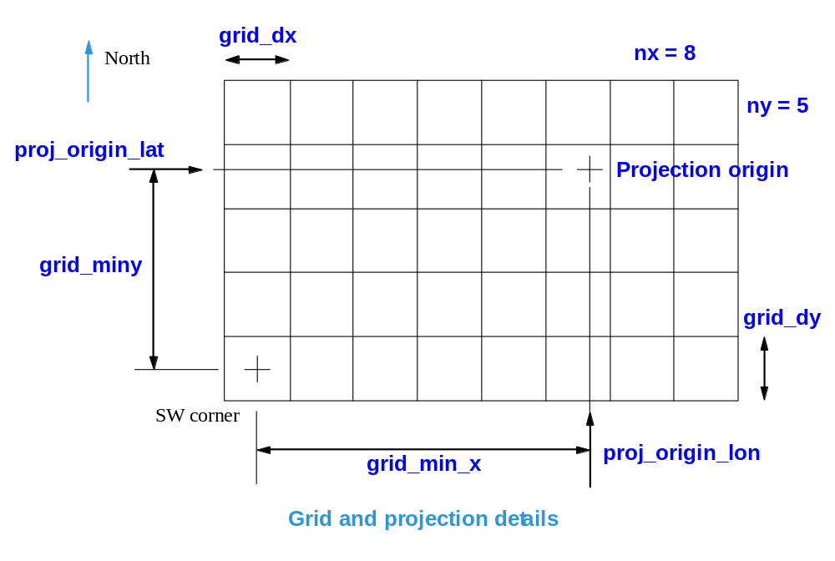
fl32 grid_minz
The value of the lowest vlevel.
Included for backward compatibility - use vlevels instead.
fl32 scale
The scale value for computing floating point values from scaled integers. See bias.
fl32 bias
The bias value for computing floating point values from scaled integers.
To compute floating point values from scaled integers:
float = (scaled_integer * scale) + bias
fl32 bad_data_value
Value to identify a bad data value.
For fl32 data, the comparison can be made directly:
fl32 value = x;
if (value == bad_data_value) {
// we have bad data
}
For scaled integers, the comparison is made BEFORE scaling is applied. We need to cast the value to a floating point value and then perform the comparison:
ui16 value = x;
if ((fl32) value == bad_data_value) {
// we have bad data
}
fl32 missing_data_value
Value to flag missing data.
For fl32 data, the comparison can be made directly:
fl32 value = x;
if (value == missing_data_value) {
// we have missing data
}
For scaled integers, the comparison is made BEFORE scaling is applied. We need to cast the value to a floating point value and then perform the comparison:
ui16 value = x;
if ((fl32) value == missing_data_value) {
// we have missing data
}
fl32 proj_rotation
Applies to PROJ_FLAT projection only. This is the rotation of the grid relative to True North, in degrees.
Can be used to align FLAT grids with Magnetic North.
fl32 user_data_fl32[4]
User-application-specified data. Not used by MDV. Normally 0.
fl32 min_value
Minimum value in the field.
fl32 max_value
Maximum value in the field.
fl32 min_value_orig_vol
Not applicable to data in the file. Applies to read operations.
Minimum value in the data field before reading from the file. If a subset of the data is read and returned to the client, then min_value will apply to the data returned, and min_value_orig_vol will apply to the data in the file.
fl32 max_value_orig_vol
Not applicable to data in the file. Applies to read operations.
Maximum value in the data field before reading from the file. If a subset of the data is read and returned to the client, then max_value will apply to the data returned, and max_value_orig_vol will apply to all of the data in the file.
fl32 unused_fl32
Unused, for future expansion. All 0.
char field_name_long[64]
Long field name, in ASCII.
char field_name[16]
Short field name, in ASCII.
char units[16]
Field units, in ASCII.
char transform[16]
Field transform, in ASCII. For example, “dB” for radar reflectivity. Normally “none”.
char unused_char[16]
Unused, for future expansion. All 0.
si32 record_len2
Used by FORTRAN applications, value = 408.
Vlevel header
The vertical level headers are stored as an array following the field headers.
There is one vlevel header per field, so the number of vlevel headers is equal to the number of fields - see n_fields in the master header.
The offset of the start of the array from the start of the file, in bytes, is given by the vlevel_hdr_offset in the master header.
Each vlevel header is 1024 bytes in length.
The vlevel header is defined by the following C-style structure:

typedef struct {
si32 record_len1;
si32 struct_id;
si32 type[MDV_MAX_VLEVELS];
si32 unused_si32[4];
fl32 level[MDV_MAX_VLEVELS];
fl32 unused_fl32[5];
si32 record_len2;
} vlevel_header_t;

Details of the entries in the vlevel header are as follows:
si32 record_len1
Used by FORTRAN applications, value = 1016.
This is the size of the structure in bytes, not including the record_len integers. (1024 - 2 * 4)
si32 struct_id
Magic cookie. Value = 14144.
si32 type[122]
Array of vertical level types. Refer to vlevel_type in the field header.
Only the first nz values will be set, the rest can be ignored.
For most data sets, the type will be constant and set equal to the vlevel_type in the field header.
Occasionally, a data set will be of the VERT_TYPE_MIXED type and the vertical level types will vary with height. This is very rare.
si32 unused_si32[4]
Unused, for future expansion. All 0.
fl32 level[122]
Array of vertical level values.
Only the first nz values will be set, the rest can be ignored.
fl32 unused_fl32[5]
Unused, for future expansion. All 0.
si32 record_len2
Used by FORTRAN applications, value = 1016.
Chunk header
The chunk headers, if they exist, are stored as an array following the vlevel headers.
The number of chunks is specified by n_chunks in the master header.
The offset of the start of the array from the start of the file is given by the chunk_hdr_offset in the master header.
Chunks contain data the format of which is unknown to MDV. The reader and writer must have agreement on how for encode/decode the chunk data.
Each chunk header is 512 bytes in length.
The chunk header is defined by the following C-style structure:

typedef struct {
si32 record_len1;
si32 struct_id;
si32 chunk_id;
si32 chunk_data_offset;
si32 size;
si32 unused_si32[2];
char info[MDV_CHUNK_INFO_LEN];
si32 record_len2;
} chunk_header_t;

Details of the entries in the chunk header are as follows:
si32 record_len1
Used by FORTRAN applications, value = 504.
This is the size of the structure in bytes, not including the record_len integers. (512 - 2 * 4)
si32 struct_id
Magic cookie. Value = 14145.
si32 chunk_id
This is a user-application-specified ID for the chunk. The MDV format does not specify the ID convention. The reader and writer must agree on a convention for the IDs.
si32 chunk_data_offset
Offset of the chunk data, from the start of the file, in bytes.
si32 size
Length of the chunk data, in bytes.
si32 unused_si32[2]
Unused, for future expansion. All 0.
char info[480]
Chunk info, in ASCII.
si32 record_len2
Used by FORTRAN applications, value = 504.

MDV Field Data
Field data location and size
The field data location is found using the field_data_offset entry in the field header. This specifies the offset of the field data, in bytes, from the start of the file.
Also in the field header is the volume_size entry, which specifies the length of the field data in bytes.
Field data types
MDV supports 4 data types for field data:
- ui08 - unsigned 1-byte scaled integers
- ui16 - unsigned 2-byte scaled integers
- fl32 - IEEE 4-byte floating point
- ui32 - unsigned 4-byte integers for RGBA image data.
See the field header section on how to convert the scaled integers to floating point values.
Note that the fl32 floating point values and ui32 RGBA values are not scaled - they can be used as is.
Byte order
The 2-byte and 4-byte data is stored in big-endian byte ordering.
On a small-endian machine, the bytes will need to be swapped.
Storage order
The field data is stored in an array, packed in X-Y-Z ordering, meaning that X varies the fastest, Y next and Z slowest.
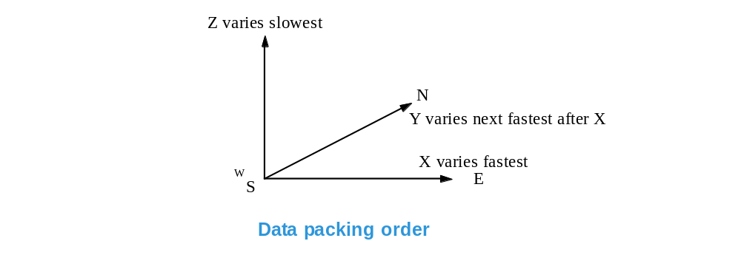
The first byte in the array is at the SW corner of the grid and at the lowest vertical level.
To start unpacking the data, begin at the SW corner of the grid and at the lowest vertical level.
Move first in the X dimension from West to East in the first row along the South edge of the grid, for the lowest vertical level, incrementing X as you go.
Once one row in X is completed, increment Y and go back to the West edge.
Then, repeat the process from West to East, this time in the second row.
Continue until the first vertical level is unpacked.
Then, the process repeats for each vlevel in turn, from the bottom to the top.
Data compression
MDV data may be stored internally in uncompressed or compressed form.
For exporting the data, non-compressed data is obviously the easiest to deal with.
If compression is used for file size or bandwidth considerations, GZIP compression is recommended.
Uncompressed data
For uncompressed data, the field is stored in a contiguous array.
The length of the array - volume_size in the field header - is equal to
nx * ny * nz * data_element_nbytes.
Unpack the array as specified in the ‘Storage Order’ section above.
Compressed data buffer containing multiple vlevels
Compressed data is stored in a buffer, the length of which is given by volume_size in the field header.
The data for each vertical level is compressed individually, to allow for efficient retrieval of a single level.
The compressed data for the vlevels is concatenated into a single buffer.
At the start of the compressed buffer are two arrays:
ui32 vlevel_offsets[nz]
ui32 vlevel_nbytes[nz]
These arrays allow you to find the compressed data for the vlevel you need.
The vlevel_offsets array contains the offsets, in bytes, of the compressed data for each vlevel, from the start of the field buffer (not the file!).
The vlevel_nbytes array contains the size of the compressed data for each individual vlevel.
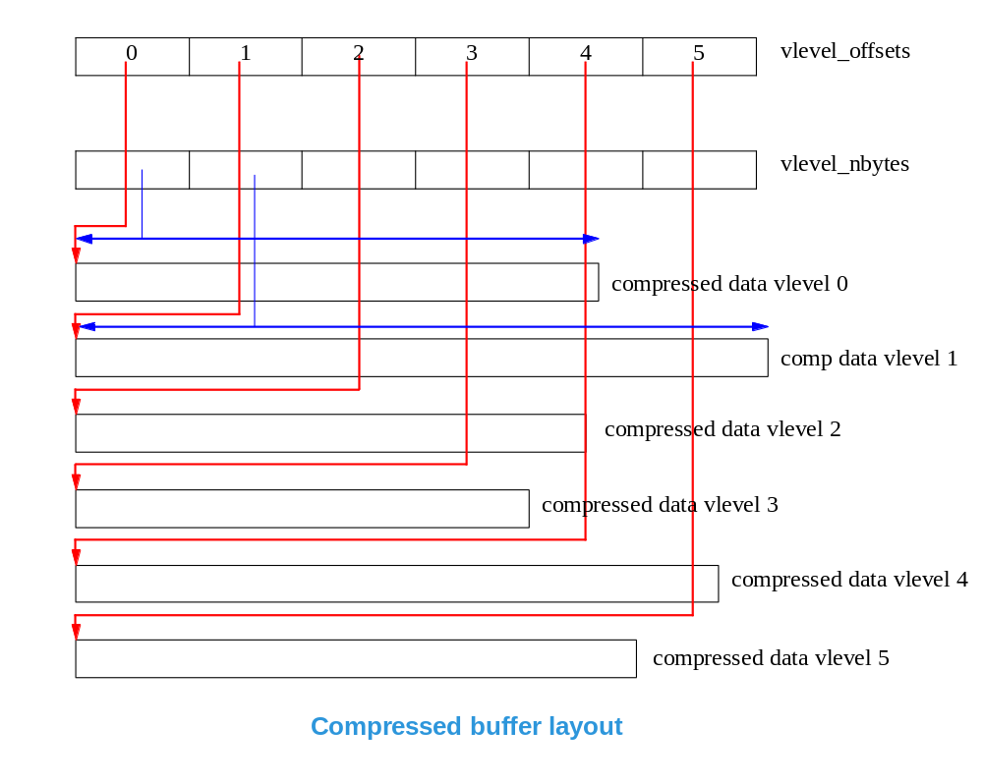
Compressed vlevel buffer
Each compressed vlevel buffer has a 24-byte header at the start, and then the compressed data.
The header is as follows:
typedef struct {
ui32 magic_cookie;
ui32 nbytes_uncompressed;
ui32 nbytes_compressed; /* including this header */
ui32 nbytes_coded; /* nbytes_compressed - sizeof(hdr) */
ui32 spare[2];
} compress_buf_hdr_t;
ui32 magic_cookie
The magic_cookie identifies the scheme used for compression.
An important point here is that sometimes a compression scheme may fail - it may produce a buffer which is larger than the uncompressed data. In that case, the magic cookie will be set accordingly and the vlevel buffer will contain the original data in uncompressed form.
The magic cookies are as follows. They are specified in hexa-decimal.
TA_NOT_COMPRESSED = 0x2f2f2f2f
The data is not compressed. Use as is it.
GZIP_COMPRESSED = 0xf7f7f7f7
The data was compressed using GZIP.
Uncompressed appropriately.
GZIP_NOT_COMPRESSED = 0xf8f8f8f8
GZIP compression was tried, but it failed.
The data is not compressed. Use as it is.
BZIP_COMPRESSED = 0xf3f3f3f3
The data was compressed with BZIP2 version 0.9.0c.
Uncompress appropriately.
BZIP_NOT_COMPRESSED = 0xf4f4f4f4
BZIP2 compression was tried, but it failed.
The data is not compressed. Use it as it is.
ZLIB_COMPRESSED = 0xf5f5f5f5
The data was compressed with ZLIB compression.
This is the same as GZIP but without the GZIP header structure.
Uncompress appropriately.
ZLIB_NOT_COMPRESSED = 0xf6f6f6f6
ZLIB compression was tried, but it failed.
Data is not compressed, us it as it is.
ui32 nbytes_uncompressed
Number of bytes uncompressed.
ui32 nbytes_compressed
Number of bytes compressed, including the 24-byte header.
ui32 nbytes_coded
Number of bytes compressed, not including the 24-byte header.
ui32 spare[2]
For later use.

