NCAR/EOL
Earth Observing Laboratory

Algorithm System Description for
Quantitative Precipitation Estimation from RADAR (QPE)

Status Update
2017-01-25

Mike Dixon
Scott Ellis
Jim Wilson
Tammy Weckwerth
Dave Albo

Algorithm System for
Quantitative Precipitation Estimation from RADAR (QPE)
Status Update

Introduction
During 2014 a QPE method was developed and tested at EOL, using data from the FRONT network of radars.
The QPE algorithm is really a suite of algorithms run in a specified order, the end result of which is an accumulated precipitation grid.
The accumulated precipitation product was compared with both precipitation gauges and the similar product produced by NOAA.
Learning from that analysis, the algorithms will be updated and retested. This report details the updated algorithms.
The main steps in the QPE procedure are:
- Estimate KDP;
- Run the particle identification (PID) algorithm;
- Estimate the precipitation rate in 3D;
- Compute beam blockage for each radar;
- Compute the QPE at the ground;
- Accumulate the precipitation estimate over time.

Radar platforms
Seven radars were used in this testing:
- SPOL at Firestone (40.123333N, -104.89133E)
- CHILL at Greeley (40.4463N, -104.637E)
- KFTG NEXRAD at Denver (39.7866N, -104.546E)
- KCYS NEXRAD at Cheyenne (41.1519N, -104.806E)
- KPUX NEXRAD at Pueblo (38.4595N, -104.181E)
- KGLD NEXRAD at Goodland Kansas (39.3667N, -101.700E)
- KGJX NEXRAD at Grand Junction (39.0622N, -108.213E)
Only the NEXRAD radars were considered in the comparison with the NOAA product, since NOAA only uses the NEXRADs.

Step 1 – estimate KDP
KDP is required by both the particle identification (PID) algorithm and the precipitation rate algorithms.
For KDP, we use a modified version of the Hubbert FIR filter method (Hubbert et al. , 1993).

Step 2 – run PID
For the PID algorithm, we need a temperature profile from which to estimate the 0-degree isotherm. Because routine soundings only occur every 12 hours, and are not located close to the radar sites, we use a model-based sounding, derived from the RUC Rapid 13 km model. This arrives mapped on pressure levels. We interpolate onto height levels, and then compute a vertical profile of temperature at each of the radar locations.
Recent work on hydrometeor classification has shown that it is preferable to use the wet-bulb temperature rather than the dry-bulb temperature for the temperature profile. (need a reference here – ERAD 2014?). Therefore wet-bulb temperature is used in the current version of the PID algorithm.
Experience during the 2014 season showed that it is sometimes necessary to correct the freezing level, relative to the data the model provides. Our intention is to try to automate this process by analyzing the errors from PID and adjusting the freezing level to minimize the errors.

Step 3 - computing precip rate at each location in the3-D volume
For each gate with an SNR exceeding 3 dB, we compute a number of precipitation estimators.
In all of these estimators, the following units apply:
zh: mm⁶m⁻³
kdp: deg/km
zdr: unitless ratio
In addition to the individual estimators, we compute 4 compound (or hybrid) estimators. The most important of these are the NCAR Hybrid and PID-based estimators. We also include versions of Bringi’s algorithm and the CSU HIDRO algorithm that have been modified to make use of the PID results.

Rate from Zh in rain
11\* MERGEFORMAT ()
where:
a = 0.017
b = 0.714
This is equivalent to the following ZR:
22\* MERGEFORMAT ()

Rate from Zh, in dry snow (i.e. above the melting layer)
In snow, we use a modification to the rain ZR. We will follow the NOAA suggestion to use a rate which is ratio of the rain ZR. NOAA uses a rate of 2.8 times that in rain.
Therefore the relationship is:
33\* MERGEFORMAT ()
where:
a = 0.0953
b = 0.5
which is equivalent to the following:
Z = 110R^{2.0} 44\* MERGEFORMAT ()

Rate from Zh, in mixed phase (i.e. in the melting layer)
In the melting layer, we use a modification to the rain ZR. We will follow the NOAA suggestion to use a rate which is ratio of the rain ZR. NOAA uses a rate of 0.6 times that in rain.
Therefore the relationship is:
55\* MERGEFORMAT ()
where:
a = 0.0102
b = 0.714
which is equivalent to the following:
Z = 500R^{1.4} 66\* MERGEFORMAT ()

Rate from Z and Zdr
Following NOAA, we use:
77\* MERGEFORMAT ()
where:
a = 0.0067
b = 0.927
c = -3.43

Rate from Kdp
Following NOAA, we use:
88\* MERGEFORMAT ()
where:
a = 44.0
b = 0.822

Rate from Kdp and Zdr
The relationship for rate from both Kdp and Zdr is:
99\* MERGEFORMAT ()
where:
a = 90.8
b = 0.93
c = -2.86
This is only used by the CSU HIDRO algorithm.

Limits
In computing the above estimators, we apply the following limits to keep the results within reasonable bounds:
dBZ <= 53: if the reflectivity exceeds 53, we cap it at 53 dBZ, to avoid excessive values in the presence of hail.
R < 150 mm/hr: if the rate exceeds 150 mm/hr, we cap it at 150. This seems a reasonable climatological upper bound for Colorado.

Summary
1010\* MERGEFORMAT ()

Modified NCAR Hybrid method
The NCAR HYBRID method has been modified to make use of the PID for decisions on which relationship to use.

We are currently using:
zdr_threshold: 0.5

NCAR PID-based precipitation rate estimator
This is a new estimator in which the rate is computed as a weighted sum of the various precipitation estimators. The weights are determined from the interest values of the various particles identified in the PID algorithm.

Modified HIDRO method (CSU)
See Cifelli et al., 2011.
The original algorithm has been modified to use PID for some of the decisions.

We are currently using:
dbz_threshold: 40
kdp_threshold: 0.3
zdr_threshold: 0.5

Modified Bringi method
See Bringi et al., 2009.
This has been modified to use PID for some decision making.

We are currently using:
dbz_threshold: 40
kdp_threshold: 0.3
zdr_threshold: 0.5

Step 4 - Beam blockage computations per radar
For each radar, we run the BeamBlock algorithm to compute the blockage at the lower elevation angles. The low-level code for BeamBlock was obtained through our collaboration with the Australian Bureau of Meteorology. We wrapped that code in an NCAR application, with the normal NCAR-style command line parameters etc.
The calculations make use of 30-m resolution digital elevation data obtained from one of the shuttle missions. This data comes in 1-deg x 1-deg tiles. We downloaded the relevant tiles from the web.
The method is reasonably sophisticated and takes account of atmospheric propagation effects, and the convolution of the beam pattern with the terrain features. It produces a CfRadial file of beam blockage percentage, for elevation angles spaced at 0.2 degrees up to an angle at which no blockage is evident
As an example, Figure 1 (below) shows the observed clutter power at each gate, at a 0.5 degree elevation angle. This is determined by running the clutter filter and computing the power removed by the filter.
By way of comparison, Figure 2 shows the beam blockage at each gate, for the 0.4 degree elevation angle at SPOL. The clutter patterns in figures 1 and 2 show clear correlation.
Figure 3 shows the accumulated beam blockage along each radial, also at 0.4 degrees elevation. This is the field that is used by the QPE algorithm for handling beam blockage.
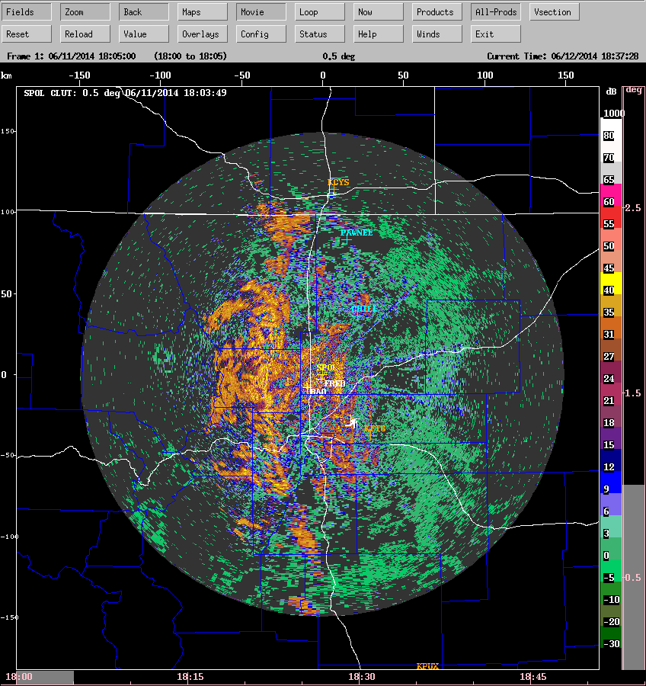
Figure 1: observed clutter power – SPOL 0.5 deg
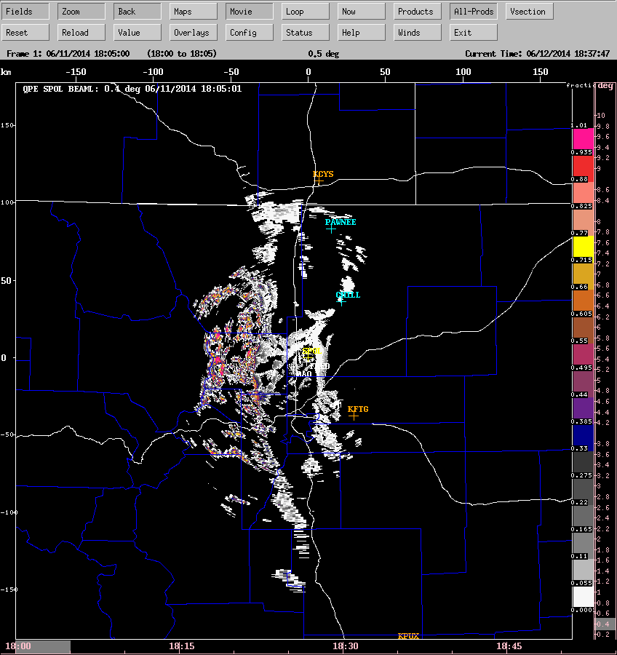
Figure 2: computed beam blockage fraction at a gate – SPOL 0.4 deg
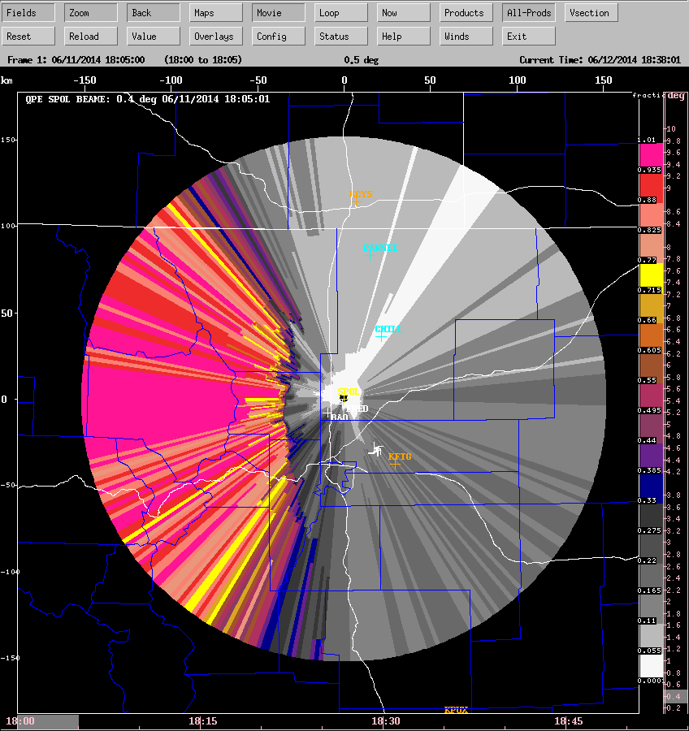
Figure 3: accumulated blockage fraction, SPOL, 0.4 deg.
(In the algorithm we discard all gates from dark gray upwards).

Step 5 - computing the QPE at the ground
For hydrology, it is important to estimate the precipitation rate at the ground rather than at some height above the ground in the radar volume.
Our new RadxQpe algorithm performs this function, as shown:

We are currently using:
SNR threshold = 5dB
Max valid height = 7 km
So in terms of beam blockage, if a gate has less than 25% blockage, we treat it as unblocked and view it as a candidate for precipitation estimation. If the blockage exceeds 25%, we move up to the next elevation angle. The 25% value is a parameter that is easily changed. We picked this as a reasonable starting value, because with 75% of the power available, the computed reflectivity will only be reduced by 1.2 dB, so any incurred errors will be moderate. So far 25% seems to be a suitable value.
There is one important point to make about the QPE logic. In sections 5.8 and 5.9, you will notice that if hail is the predominant particle type and KDP is not available, we set the rate to missing. KDP sometimes cannot be calculated because of clutter contamination. In this case, the algorithm will move to the next higher elevation angle in search of a precipitation rate. Since clutter contamination generally reduces with height, frequently the KDP estimate is better higher up than at the lowest elevation angle.

Single-radar example
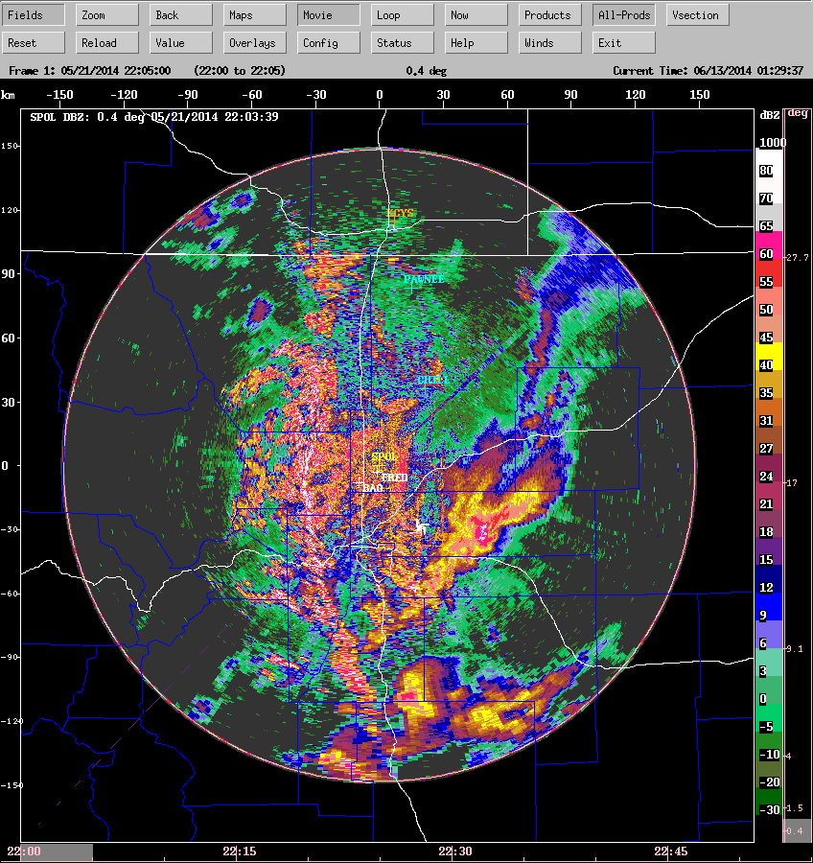
Figure 4: example of SPOL low-level reflectivity
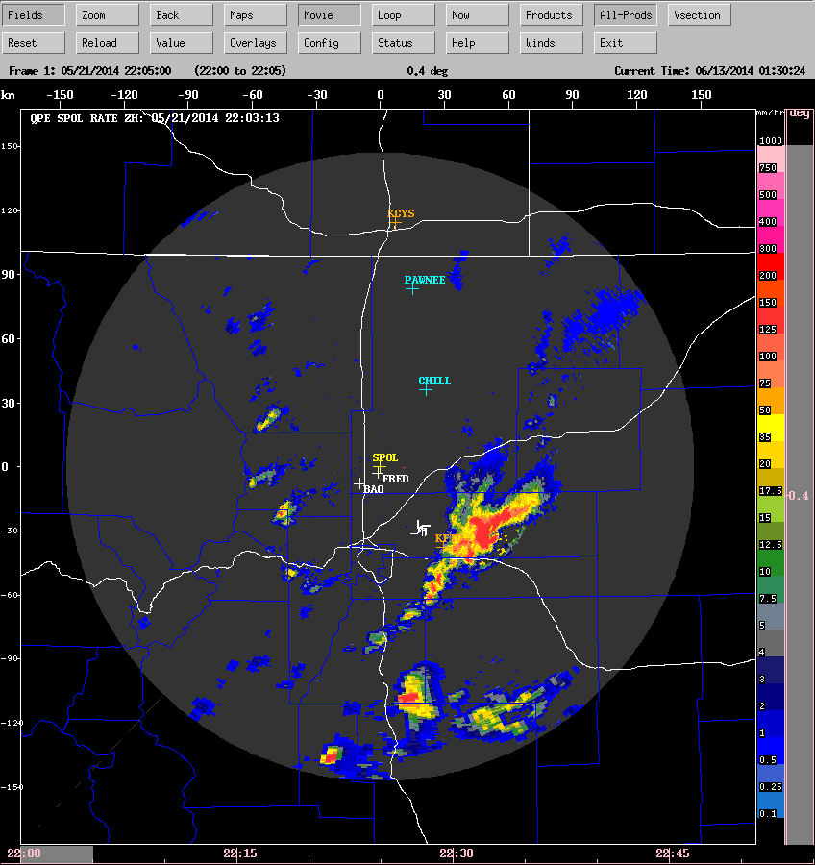
Figure 5: corresponding precip rate from Zh.

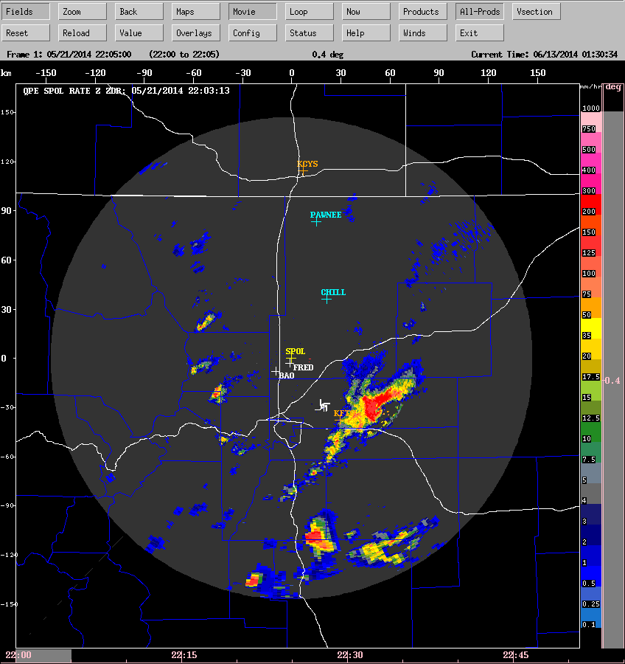
Figure 6: corresponding precip rate from ZZdr.
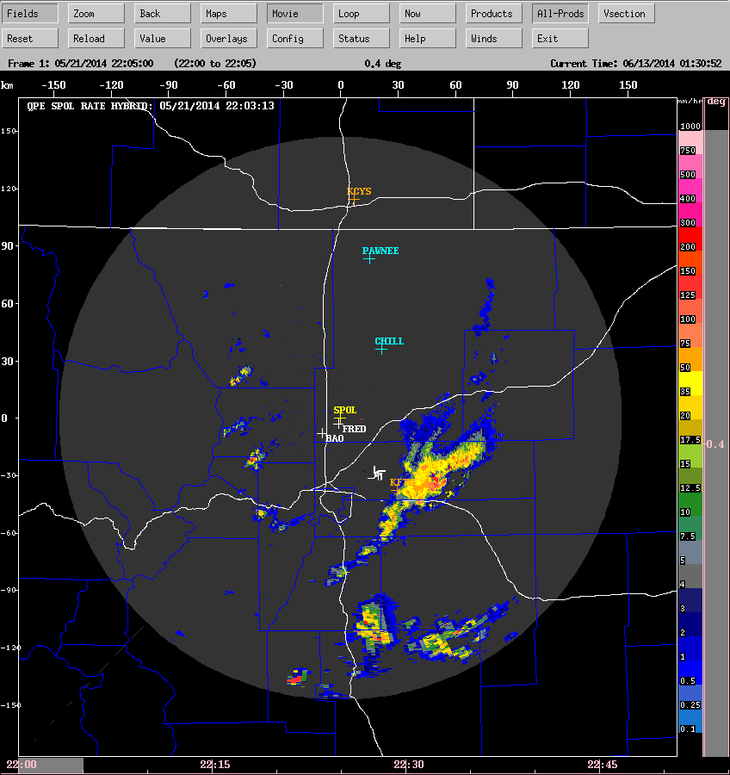
Figure 7: corresponding precip rate from NCAR Hybrid.

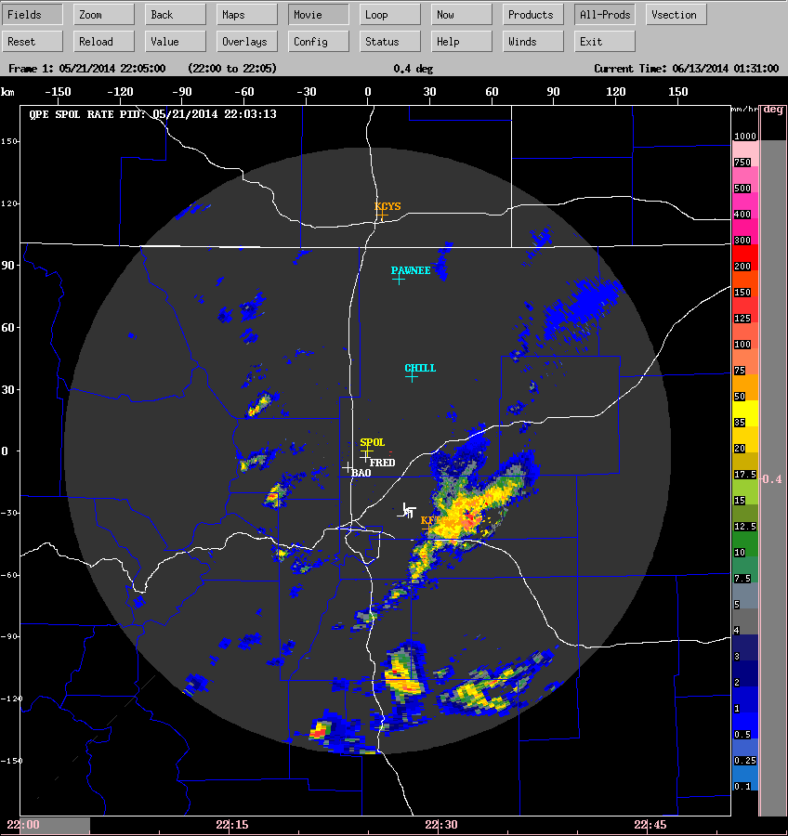
Figure 8: Corresponding precip rate from NCAR PID-based algorithm

Step 6 - merged QPE rate and accumulation
To produce the regional QPE product, we merge the individual QPE grids from all of the radars. Where overlap occurs we use the value from the CLOSEST radar.
We then compute the 1-hour, 2-hour, 3-hour and 24-hour precipitation accumulation. The 24-hour accumulation is reset to 0 at 12:00 UTC, i.e. 6 am MDT.
The following are examples of the merged products.
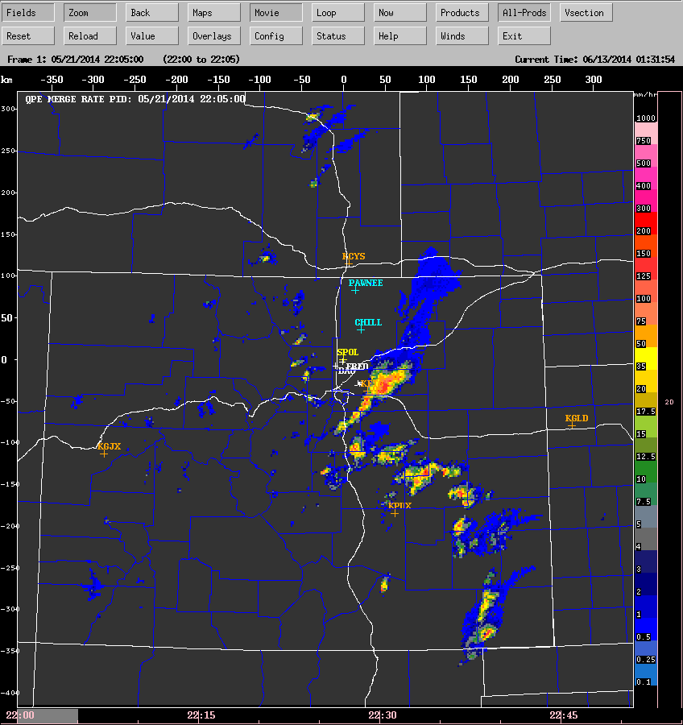
Figure 9: merged precip rate product, using the NCAR PID-based algorithm
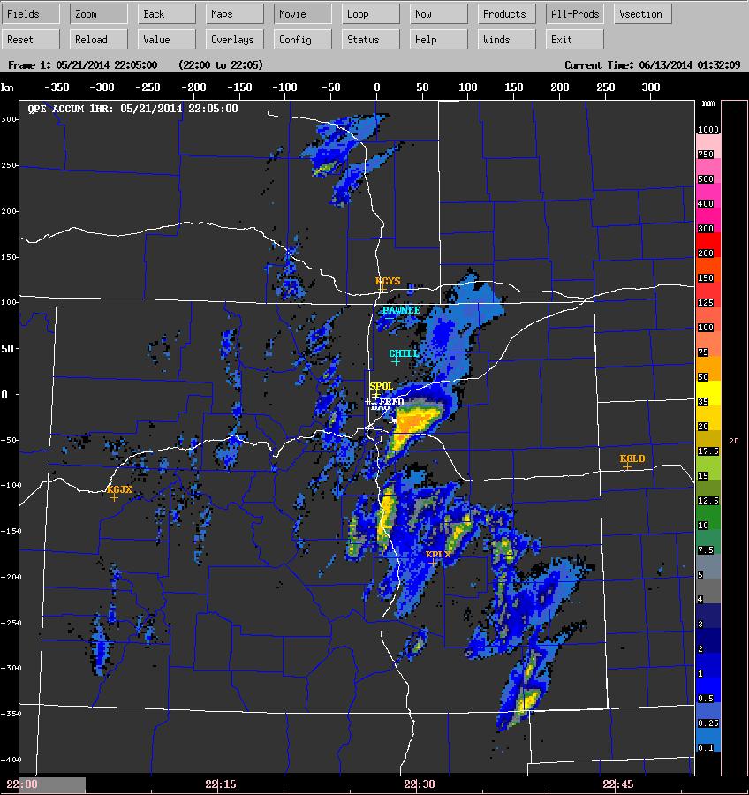
Figure 10: merged 1-hour running accumulation
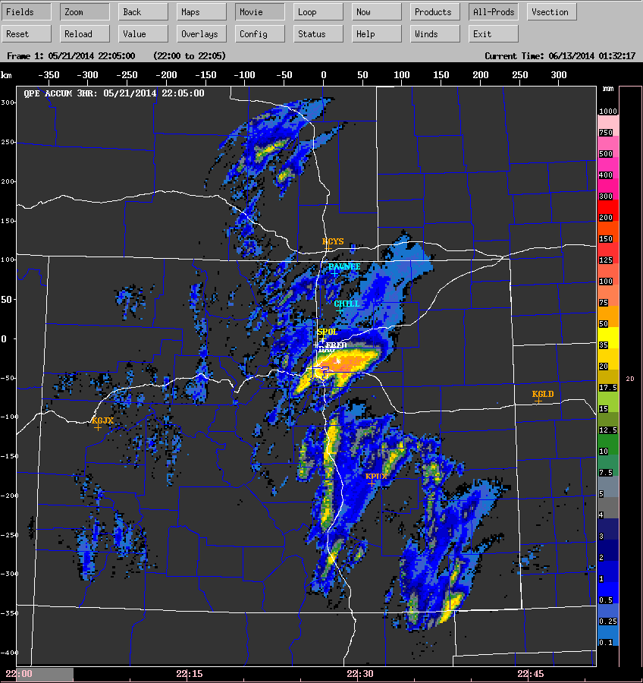
Figure11: merged 3-hour accumulation
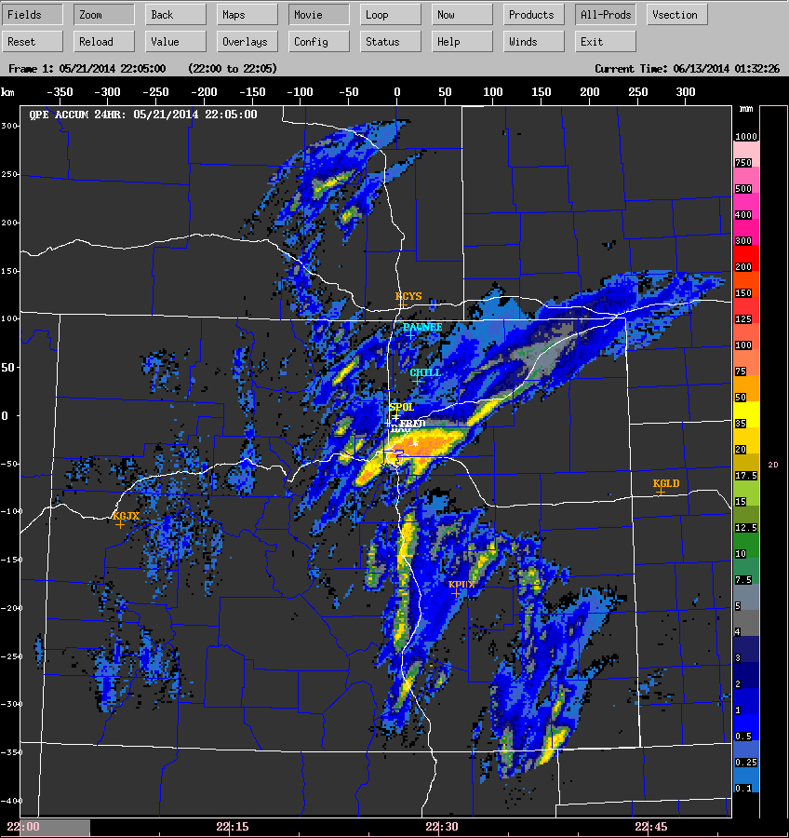
Figure 12: merged 24-hour accumulation

References
Bringi, V. N., C. R. Williams, M. Thurai, P. T. May, 2009: Using Dual-Polarized Radar and Dual-Frequency Profiler for DSD Characterization: A Case Study from Darwin, Australia. J. Atmos. Technol, Vol 26, No 10, October, 2107–2122.
Cifelli, R., V. Chandrasekar, S. Lim, P. C. Kennedy, Y. Wang, S. A. Rutledge, 2011: A New Dual-Polarization Radar Rainfall Algorithm: Application in Colorado Precipitation Events. J. Atmos. Technol, Vol 28, No 3, March, 352-364.
Hubbert, J., V Chandrasekar and V. N. Bringi, 1993: Processing and Interpretation of Coherent Dual-Polarized Radar Measurements. J. Atmos. Technol, Vol 10, No 2, April, 156-164.

