DOppler RAdar Data Exchange Format
DORADE

Wen-Chau Lee Craig Walther Richard Oye
National Center for Atmospheric Research
P. O. Box 3000, Boulder, CO 80307

October 1994

Revised 27 January 2003

Table of Contents

1. Introduction 1

2. Physical Description 2

2.1 Definitions 3

2.1.1 Data Elements 3

2.1.2 Format Elements 3

2.2. General Guidelines 5

3. Data Structures 7

4. Reference 13

List of Figures

Figure 1 - Physical Tape Layout 2

Figure 2 - Proposed Doppler Radar Data Exchange Format 4

Figure 3 - Roll 14

Figure 4 - Pitch 14

Figure 5 - Heading and Drift 15

Figure 6 - Aircraft Coordinate System 15

Figure 7 - Rotation Angle 16

Figure 8 - Tilt 16

Figure 9 - Azimuth and Elevation 17

Figure 10 - Earth’s Reference Frame 18
1. Introduction

The Common Doppler Radar Exchange Format, generally referred to as Universal Format (UF) and introduced in 1980 (Barnes 1980), has been used extensively in the research community in the past decade as a medium to exchange Doppler radar data. The UF was designed primarily to accommodate data for a single ground-based radar.

The advent of airborne Doppler radar (NOAA WP-3D tail Doppler radar) in the early 1980s opened a new arena in mesoscale research. These data have been stored in NOAA internal format because of the different geometry and data characteristics between an airborne and ground-based radar. Attempts have been made to convert NOAA internal format into UF by introducing additional entries in the local use header that accommodate the navigation information unique to a moving platform. Due to the geometry of an airborne Doppler radar, about 70% of the total data are either below ground or above troposphere, having little or no meteorological interest. However, the redundant header information at the beginning of each ray and inflexibility in implementing the data reduction scheme create a huge overhead in the amount of data created during the transformation process (Wakimoto, personal communication). Also, the differences in terminology between airborne and ground-based radar (for example, azimuth and elevation angle) create additional problems for the user.

The development of the ELDORA/ASTRAIA airborne dual-Doppler radar system poses another problem for the UF. When ELDORA/ASTRAIA runs at its full design capability, it can transmit five different frequencies and multiple PRFs by the fore and aft radars. In addition, the antennas will rotate at a maximum rate of 144 degrees per second, which is about 10 times faster than a typical ground-based radar and 3 times faster than the NOAA WP-3D airborne Doppler radar. The data rate will be 6 to 20 times of that generated by a typical airborne or ground-based radars, even before taking into account the multiple frequencies and PRFs. It became clear that a new exchange format was needed to accommodate ELDORA/ASTRAIA data.

The design goals of the new Doppler radar exchange format are:

(1) To be a general purpose radar exchange format used not only for radars on a fixed platform (e.g. ground-based radar), but also for radars on a moving platform (airborne and shipborne radars).

(2) To accommodate data from multiple radars or even data from multiple instruments (e.g. radar data and aircraft data).

(3) To be efficient at keeping redundant header information to a minimum, and to implement a data compression scheme.

(4)To be flexible for future expansion, without changing its basic structure.

(5) To be flexible with recording media (e.g. 9-track or Exabyte).

A proposal of the Doppler Radar Data Exchange (DORADE) format was discussed in April 1991, in Miami at NOAA/AOML/HRD, among representatives from potential data producers—CRPE (France), NCAR, and NOAA. In addition to discussing the structure of the format, we agreed upon the coordinate systems and terminologies that will be used in the DORADE format. (All these will be defined in the format description section.) The structure and contents of the DORADE format were further discussed during the 25th AMS Radar Conference held June 1991 in Paris, France, by the same group of people who attended the April meeting.

The first draft of the format was distributed in July 1991, to gather comments from an expanded group including scientists and programmers who would use the data. Many comments on the format from five different groups were received. The second draft was distributed for comments in November 1991. In the meantime, the ELDORA development group at NCAR started to integrate this format into the data system. Data collected from the ELDORA test-bed radar were recorded in DORADE. In addition, a routine was written to convert data from UF to DORADE format and vice versa. These efforts were taken to prevent practical difficulties in implementing the DORADE format.

The purpose of this article is to document the DORADE format version 1, which will be used to exchange data collected by the ELDORA/ASTRAIA airborne Doppler radar and the NCAR ground-based radars. The physical description and definitions of the DORADE format are in Section 2. Section 3 describes the data structure. Appendix A provides the schematics of the terminologies used in Section 3. For the purposes of this document, only detailed formats for radar data recording are discussed. Exchanged data should always be corrected as best as the facility making the tape can do, i.e., aircraft motion removed, range delay corrected, etc.

2. Physical Description

The intent in defining this format is not to tie it physically to a specific type of recording media, but rather to allow applications to all types of recording media. This is an admirable goal, but there are physical limitations to all types of recording devices. Therefore, a set of general guidelines will be established in this section and these guidelines should be strictly adhered to when creating a DORADE tape.
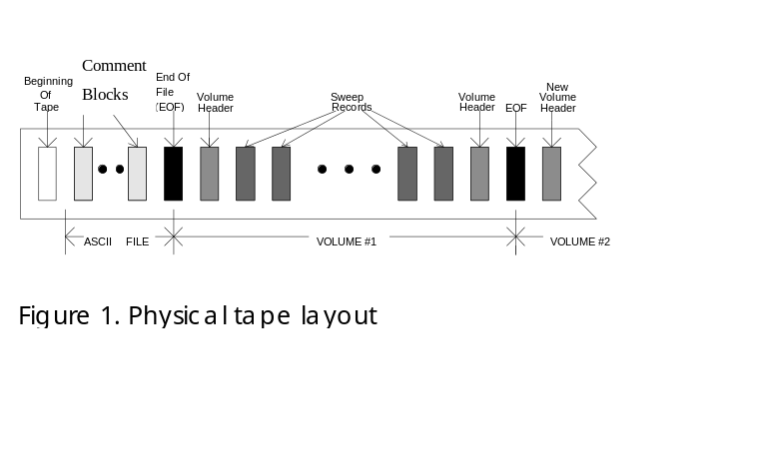

An alternative way of illustrating this proposed Doppler radar exchange format is shown in Figure 2. Areas enclosed by dotted lines indicate logical groupings of physical data blocks. Areas enclosed by solid lines indicate physical, defined data blocks. The following subsections contains definitions of various format components and general guidelines that should be followed when creating a DORADE dataset.

2.1 Definitions

Below are definitions for the various data elements (gate, cell, ray, sweep,volume etc.) and format components (block, descriptor, header, etc.).

2.1.1 Data elements

Gate: A sampling element of the radar itself.

Cell: A data point recorded on the recording media. It can be a gate or an average of several gates.

Ray: A logical unit of data which contains all data cells (from a single "radar") taken during a single dwell time.

Sweep: A number of rays with similar characteristics, i.e. rays within a 360° rotation, PPI, or RHI

Volume: a number of sweeps with similar characteristics.

2.1.2 Format elements

Comment Block: contains any number of ASCII characters describing or commenting on anything that the generator of the data set feels is appropriate.

Volume Header: contains a number of descriptors to define the characteristic of the instrumentation(s) and the corresponding parameters.

Volume Descriptor: contains information unique to the volume described.

Sensor Descriptor: contains information defining the particular sensor and its operational parameters.

Parameter Descriptor: contains information describing each parameter.

Correction Factor Descriptor: contains the correction factors needed to be applied to various parameters before using them.
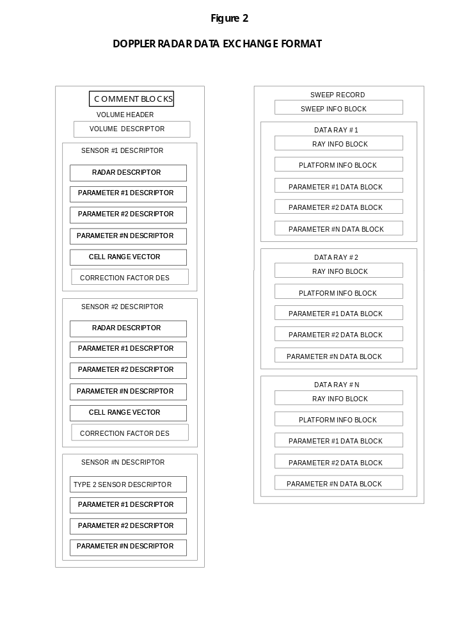
Cell Range Vector: contains the distance from the radar to the center of each recorded data cell.

Sweep Info Block: contains information unique to this sweep.

Data Ray: contains information and data of a ray.

Ray Info Block: contains unique information about this ray.

Platform Info Block: contains the navigation information for this ray.

Parameter Data Block: contains the actual data for a single parameter corresponding to those described in the parameter descriptor.

Net Info Block: contains information necessary for transferring data over a network in real time.

2.2. General guidelines

Every tape should begin with a file containing one or more comment blocks. The first comment block should contain the ASCII 6-character tape identifier “DORADE” starting in character one or two of the data part of the comment block (the first character can be a new line). This comment block or subsequent comment blocks should also contain a description of the tape format (i.e., something very similar to what you are now reading). If a compression scheme is used, it should be described. The FORTRAN or "C" code used to decompress the data should also be written here.

We recommend that a flag of -999 (for 2- and 4-byte integer entries), -256 (for 1-byte integer entries), or -999.0 (for real entries) be used to denote all entries not applicable, missing data, bad data or deleted data. Positive Doppler velocity is defined as velocity receding from the aircraft.

All blocks (user defined or defined here) begin with four ASCII characters describing the block and then a 32-bit integer giving the length of the block in bytes. The lengths of all blocks or descriptors should be evenly divisible by 4.

All floating point numbers follow the IEEE 32 bit floating point standard. All 4 byte numbers (floats or 32 bit integers) must begin on a boundary that is evenly divisible by 4. The use of place holders should be adopted to accomplish this. All integers should be in "Big Endin" notation (the first byte is the most significant byte).

In general a volume is a file. On a standard 9-track tape or an Exabyte tape, a volume should always begin and end with a volume header. The end is denoted with a file marker. When recording on media with variable physical record lengths, the size of the largest physical record should be documented in the fifth entry in the volume descriptor (bytes 12-15). A volume contains many sweeps of data. It can be a leg (in airborne radars), a sector scan (in ground based radars) or any other user selected block of data. A volume always begins and ends with identical volume headers. A volume may contain data from multiple sensors;.for example, the fore and aft radars in ELDORA/ASTRAIA. To define a volume is relatively straight forward for ground based radar, since a well defined scan sequence (either from bottom to top in the PPI mode or from left to right in the RHI mode) is usually in place. This is not the case for an airborne Doppler radar where a typical straight-line leg can last 30 minutes or more. In other flight patterns such as a circular pattern around a hurricane eye wall, it is very difficult to define a “leg” or volume. Therefore, it is the data producer's responsibility to define a block of data which is suitable to work with as a volume.

A mandatory volume header is always the first (and last) record of a volume. It is written whenever there is a change in the radar parameters (e.g. PRT, cell spacing, or calibration) and at the beginning and end of a mission. A user would normally not want to combine data across a mandatory volume header, or else do so with caution. The volume header contains a volume descriptor and as many sensor descriptors as there are different sensors. In large volumes it is acceptable to place multiple, identical intermediate volume headers (there should always be two volume headers with a file mark in between them) in other locations in the volume for redundancy and speed of access. The volume number should remain the same for all intermediate volume headers. Analysis software should be written to process data across intermediate volume headers with ease.

A sensor descriptor is a logical grouping of descriptors that define specifically how the data from a particular sensor is recorded on the media. Many of these sensors will be "radars," and hence a specific sensor descriptor for radars is defined in this document. It is possible, however, that the media may also contain data from other sensors. For example, the ELDORA/ASTRAIA field tapes will contain data from the in-situ measurement system. The data format for each of these other sensors should be described with a unique sensor descriptor.

A sweep record should only be considered as a logical means of assembling data that may very well consist of multiple physical records on a computer tape. However, a ray of data should not cross physical boundaries. All sweep records should start on a physical boundary, and the physical records inside of the sweep record should always contain an integer number of data rays. In this way, there is a guarantee that the first four characters of all physical records on the media will have an identifier. The sweep number in the Sweep Info Block should be the sequence number from the beginning of the volume.

The correction factors should be applied to the various parameters before using them. This permits adjustments to the correction factors without having to regenerate the whole tape or dataset. The numbers in this descriptor should be added (mathematically) to the data that is written in the exchange format. Some of the correction factors in this descriptor may not be applicable to all radars.

A data ray will always contain a ray info block and the data for every parameter associated with the "radar" that created the ray. For moving platform radars, a platform info block has been defined that contains all parameters associated with the calculation of antenna location and pointing angles. When radar data is passed over a network, there are many parameters that need to be passed with each ray of data to make it possible to turn on a net computer and begin displaying data immediately. The net info block should be defined by net users to provide these parameters.

3. Data Structures

The following tables describe the detailed data structures for the proposed data exchange format. All 4-byte entries will begin on memory boundary divisible by 4.

Comment block

Byte
0 Code identifier the comment block (4 ASCII "COMM")
4 Length of the comment block (4 byte int)
8 Comments (N byte ASCII N divisible by 4)

Volume descriptor

Byte
0 Code identifier for the volume descriptor (4 ASCII "VOLD")
4 Length of the volume descriptor (4 byte int)
8 Version number of the format (2 byte int)
10 Volume number from the beginning of the data set (2 byte int)
12 Maximum number of bytes in a data record (4 byte int)
16 Project name (20 ASCII)
36 Date (beginning of the volume)-- Year (2 byte int, e.g. 1991)
38 Date -- Month (2 byte int, e.g. 7)
40 Date -- Day (2 byte int, e.g. 15)
42 Time -- Hour [UTC] (2 byte int, e.g. 15)
44 Time -- Minute (2 byte int)
46 Time -- Second (2 byte int)
48 Flight number (8 ASCII) for airborne radar or IOP number for ground based radars etc.
56 Generation facility name (8 ASCII)
64 Generation date of this volume -- year (2 byte int)
66 Generation date of this volume -- month (2 byte int)
68 Generation date of this volume -- day (2 byte int)
70 Number of sensor descriptors to follow (2 byte int)

Radar Descriptor
(The First Block of a Sensor Descriptor for Radars)

Byte
0 Code identifier for radar descriptor (4 ASCII, "RADD")
4 Length of the radar descriptor (4 byte int)
8 Radar name (8 ASCII)
16 Radar constant (float)
20 Nominal Peak power [kw] (float)
24 Nominal Noise power [dBm] (float)
28 Receiver gain [dB] (float)
32 Antenna gain [dB] (float)
36 Radar System Gain [dB] (float)
40 Horizontal beam width [deg] (float)
44 Vertical beam width [deg] (float)
48 Radar type (2 byte int):
0--Ground
1--Airborne fore
2--Airborne aft
3--Airborne tail
4--Airborne lower fuselage
5--Shipborne
50 Scan mode (2 byte int):
0--Calibration
1--PPI (Constant elevation)
2--Coplane
3--RHI (Constant azimuth)
4--Vertical pointing
5--Target (Stationary, not vertical pointing)
6--Manual
7--Idle (out of control)
8--Surveillance
9--Vertical sweep (rotation axis parallels the fuselage)
52 Nominal scan rate [deg/sec] (float)
56 Nominal start angle [deg] (float) {The meaning of the following three angles depends on the scan mode specified above}
60 Nominal stop angle [deg] (float)
64 Total number of parameter descriptors for this radar (2 byte int)
66 Total number of descriptors for this radar (2 byte int)
68 Data compression format code (2 byte int):
0--no compression
1--data compression (compression algorithm should be described in the ASCII file at the beginning of the file.
70 Data Reduction Algorithm in Use (2 byte int)
0 => No data reduction
1 => Data recorded between two rotation angles
2 => Data recorded between two concentric circles
3 => Data record between two altitudes
4-N => Other Types of Data Reduction
72 Data reduction specific parameter #1 (float)
1 => Smallest positive angle [deg]
2 => Inner circle diameter [km]
3 => Minimum altitude [Km]
4-N => Will be defined if other types created.
76 Data reduction specific parameter #2 (float)
1 => Largest positive angle [deg]
2 => Outer circle diameter [km]
3 => Maximum altitude [Km]
4-N => Will be defined if other types created.
80 Radar longitude [deg] (float) {for airborne radar only this should be the airport longitude}
84 Radar latitude [deg] (float) {for airborne radar only this should be the airport latitude}
88 Radar altitude above mean sea level (msl) [km] (float) {for airborne radar only this should be the airport altitude}
92 Effective unambiguous velocity [m/s] (float)
96 Effective unambiguous range [km] (float)
100 Number of frequencies transmitted (2 byte int)
102 Number of different inter-pulse periods (IPP's) transmitted (2 byte int)
104 Frequency #1 [GHz] (float)
108 Frequency #2 [GHz] (float)
112 Frequency #3 [GHz] (float)
116 Frequency #4 [GHz] (float)
120 Frequency #5 [GHz] (float)
124 Interpulse Period #1 [ms] (float)
128 Interpulse Period #2 [ms] (float)
132 Interpulse Period #3 [ms] (float)
136 Interpulse Period #4 [ms] (float)
140 Interpulse Period #5 [ms] (float)

Correction Factor Descriptor

Byte
0 Code identifier for correction factor descriptor (4 ASCII, "CFAC")
4 Length of the correction factor descriptor (4 byte int)
8 Correction for azimuth [deg] (float)
12 Correction for elevation [deg] (float)
16 Correction for range delay [m] (float)
20 Correction for Radar longitude [deg] (float)
24 Correction for Radar latitude [deg] (float)
28 Correction for Radar pressure altitude (msl) [km] (float)
32 Correction for Radar altitude above ground level (agl) [km] (float)
36 Correction for Radar Platform ground speed (East--West) [m/s] (float)
40 Correction for Radar Platform ground speed (North--South) [m/s] (float)
44 Correction for Radar Platform vertical velocity [m/s] (float)
48 Correction for Radar Platform heading [deg] (float)
52 Correction for Radar Platform roll [deg] (float)
56 Correction for Radar Platform pitch [deg] (float)
60 Correction for Radar Platform drift [deg] (float)
64 Correction for Radar rotation angle [deg] (float)
68 Correction for Radar tilt angle [deg] (float)

Parameter Descriptor

Byte
0 Code identifier for parameter descriptor (4 ASCII, "PARM")
4 Length of the parameter descriptor (4 byte int)
8 Name of the parameter (8 ASCII)
16 Description of the parameter (40 ASCII)
56 Units (8 ASCII)
64 Inter-pulse period(s) (IPP's) (2 byte int)
Bit 0 set to 1 indicates IPP #1 is used in this parameter.
Etc. for Bits 1,2,3 and 4 and IPP's 2,3,4 and 5
66 Transmitted frequencies (2 byte int)
Bit 0 set to 1 indicates Frequency #1 is used in this parameter.
Etc. for Bits 1,2,3 and 4 and Frequencies 2,3,4 and 5
68 Receiver bandwidth [MHz] (float)
72 Pulse width [m] (2 byte int)
74 Polarization (2 byte int):
0--Horizontal
1--Vertical
2--Circular, Right Handed
3--Elliptical
4--Circular, Left Handed
5--Dual Polarization
76 Number of samples in the dwell time (2 byte int)
78 Parameter type (2 byte int)
1--8 bit integer
2--16 bit integer
3--32 bit integer
4--floating point (32 bit IEEE)
80 Threshold field (8 ASCII)
88 Threshold value [units depend on the threshold field] (float)
92 Scale factor (float)
96 Offset factor (float) [meteorological value = (recorded value - offset factor) / scale factor]
100 Deleted or missing data flag (4 byte int) {It is recommended that - 256 is used for byte entries and -999 used for all other entries}

Cell Range Vector

Byte
0 Code identifier for cell range vector (4 ASCII, "CELV")
4 Length of the cell range vector (4 byte int)
8 Number of cells defined in this vector (4 byte int)
12 Distance from the radar to cell 1 [m] (float)
4*n+12 Distance from the radar to cell n [m] (float)

Sweep Info Block

Byte
0 Code identifier for sweep info block (4 ASCII, "SWIB")
4 Length of the sweep info block (4 byte int)
8 Radar name (8 ASCII)
16 Sweep number from beginning of volume (4 byte int)
20 Number of rays recorded in this sweep (4 byte int)
24 True start angle [deg] (float)
28 True stop angle [deg] (float)
32 Fixed angle [deg] (float)
36 Filter Flag (4 byte int)
0--No filtering in use
1--On (Filtering algorithm should be described in the ASCII file at the beginning of the file)

Ray Info Block

Byte
0 Code identifier for ray info block (4 ASCII, "RYIB")
4 Length of the ray info block (4 byte int)
8 Sweep number (4 byte int)
12 Julian day (4 byte int)
16 Hour (2 byte int)
18 Minute (2 byte int)
20 Second (2 byte int)
22 Millisecond (2 byte int)
24 Azimuth [deg] (float) {see fig. 9}
28 Elevation [deg] (float) {see fig. 9}
32 Peak Transmitted Power [kw] (float)
36 Radar true scan rate [deg/sec] (float)
40 Ray status (4 byte int)
0 -- Normal
1 -- Transition (antenna repositioning)
2 -- Bad
3 -- Questionable

Platform Info Block
(This is Used Especially For Moving Radars)

Byte

0 Code identifier for aircraft/ship info block (4 ASCII, "ASIB")
4 Length of the aircraft/ship info block (4 byte int)
8 Radar longitude [deg] (float) {East is positive, West is negative}
12 Radar latitude [deg] (float) {North is positive, South is negative}
16 Radar pressure altitude (msl) [km] (float)
20 Radar altitude above ground level (agl) [km] (float)
24 Platform ground speed (East--West) [m/s] (float)
28 Platform ground speed (North--South) [m/s] (float)
32 Platform vertical velocity [m/s] (float)
36 Platform heading [deg] (float) {see fig. 5}
40 Platform roll [deg] (float) {see fig. 3}
44 Platform pitch [deg] (float) {see fig. 4}
48 Platform drift [deg] (float) {see fig. 5}
52 Radar rotation angle [deg] (float) {see fig. 7}
56 Radar tilt angle [deg] (float) {see fig. 8}
60 Horizontal wind speed at radar (East--West) [m/s] (float)
64 Horizontal wind speed at radar (North--South)[m/s] (float)
68 Vertical wind speed at radar [m/s] (float)
72 Heading change rate [deg/sec] (float)
76 Pitch change rate [deg/sec] (float)

Parameter Data Block

Byte
0 Code identifier for radar parameter data block (4 ASCII, "RDAT")
4 Length of the parameter data block (4 byte int)
8 Name of parameter (corresponds directly to the name given in the parameter descriptor (8 ASCII)
16-- Data (length as described in parameter data descriptor)

4. Reference

Barnes, S. L., 1980: Report on a meeting to establish a common Doppler radar exchange format. Bull. Amer. Meteor. Soc., 61, 1401-1404.

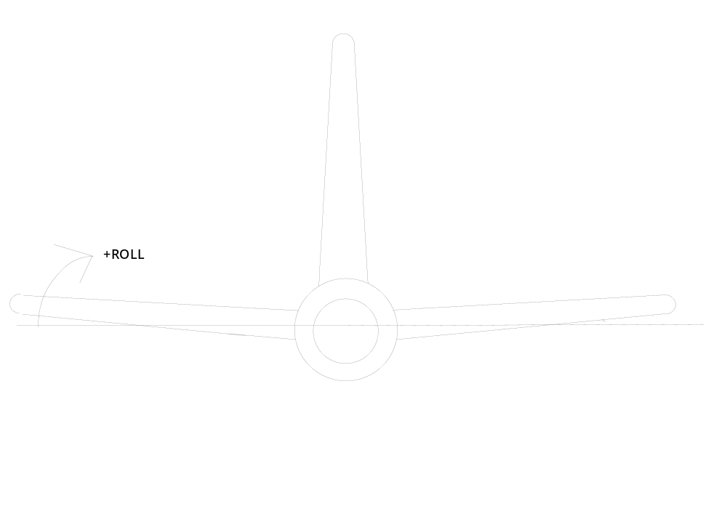 Figure 3. ROLL: Zero is Horizontal, Left Wing Up is Positive Looking Forward

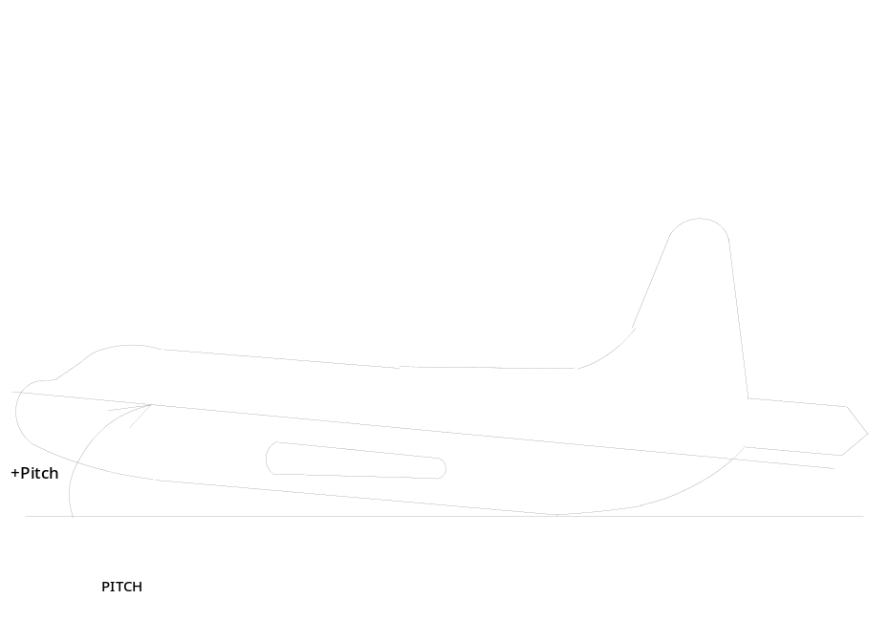 Figure 4. PITCH Horizontal is Zero, Nose Up is Positive
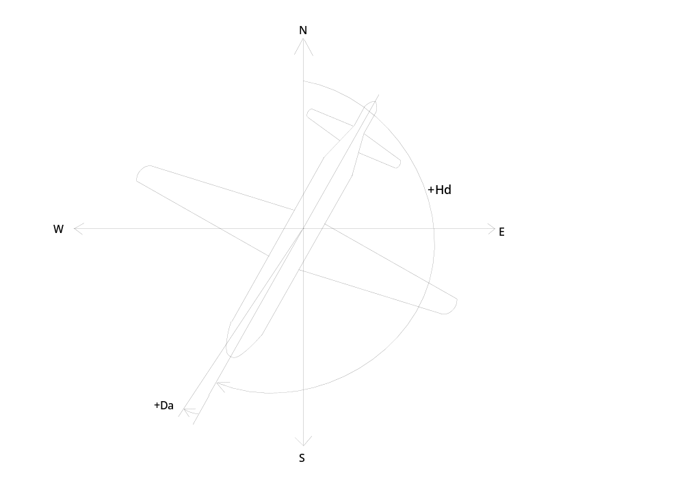 Figure 5. HEADING and DRIFT: Zero heading is True North, Positive is Clockwise While Looking Down. Zero drift is equal to heading, positive drift is aircraft's motion vector more clockwise than heading.
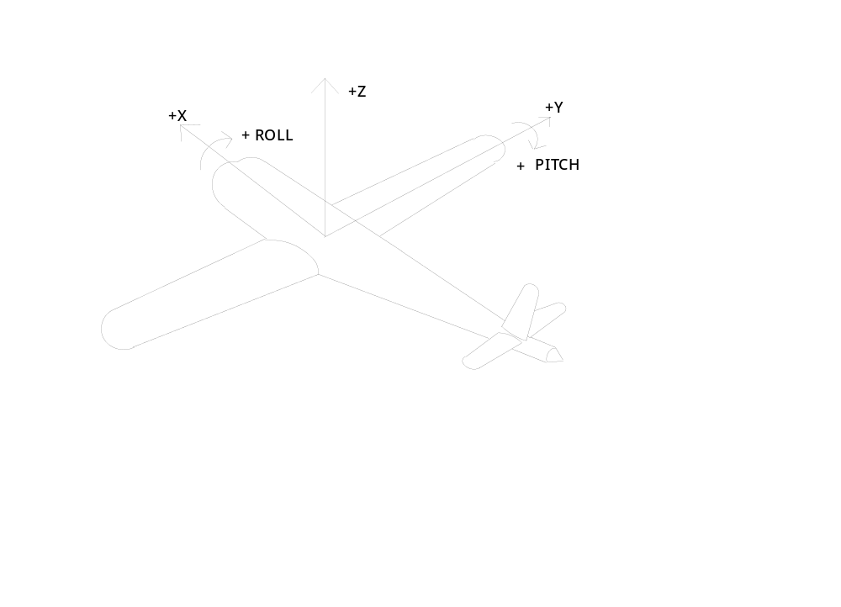 Figure 6. AIRCRAFT COORDINATE SYSTEM: X axis is along longitudinal axis of aircraft, positive is out of nose. Y axis is along lateral axis of aircraft, positive is out right wing. Z axis is positive up and perpendicular to the other two axis.
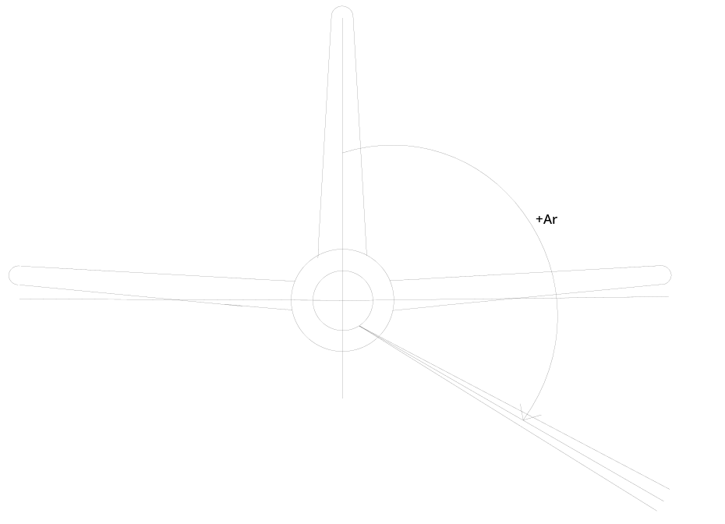 Figure 7. ROTATION ANGLE: Angle Between the Radar Beam and the Vertical Axis of the Aircraft, Zero is along vertical stabilizer, Positive is Clockwise Looking Forward.
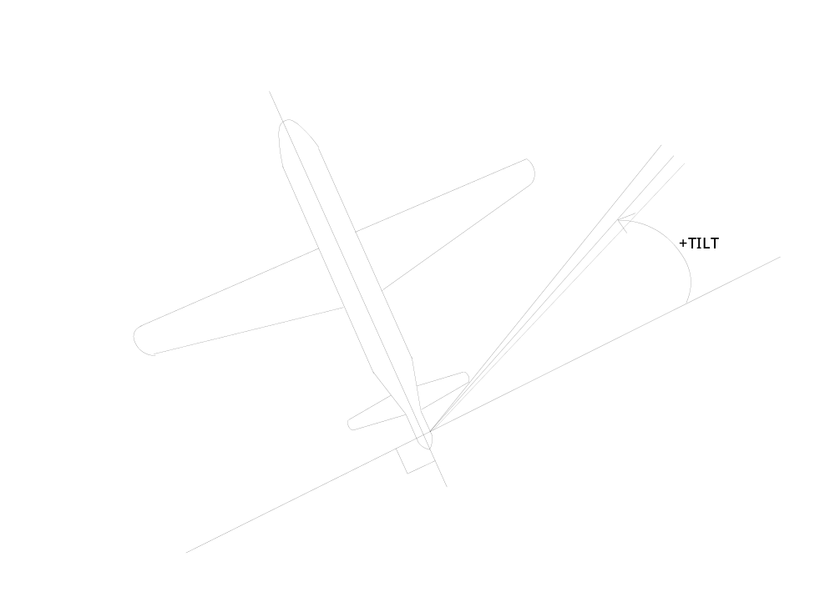 Figure 8. TILT: Angle Between Radar Beam (When it is In a Plane Containing the Longitudinal Axis of the Aircraft) and a Line Perpendicular to the Longitudinal Axis. Zero is Perpendicular to Longitudinal Axis, Positive is Towards Nose of Aircraft.
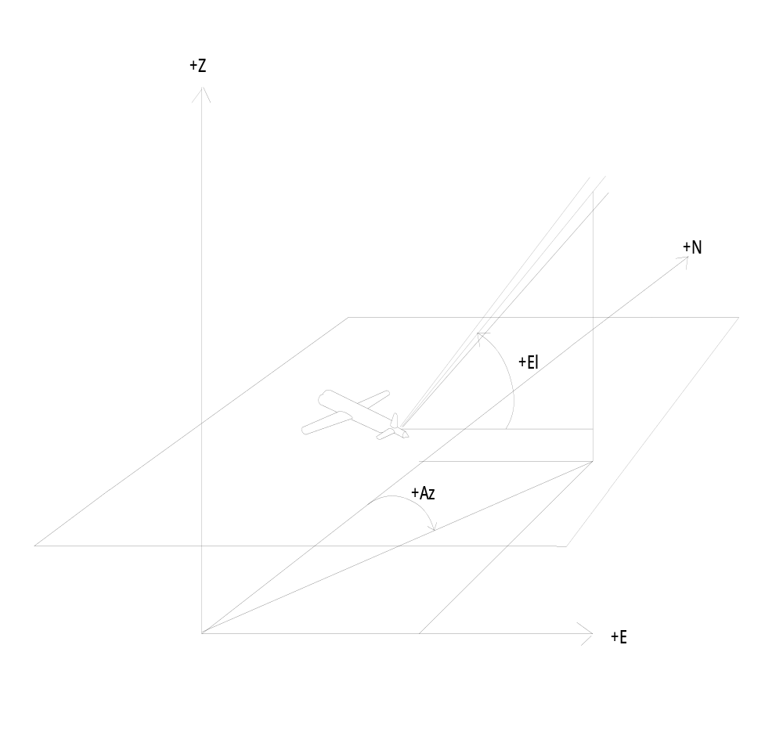 Figure 9. AZIMUTH AND ELEVATION: Azimuth is Angle Between Projection of Radar Beam into Horizontal Plane and True North, Positive is Clockwise Looking Down. Elevation is Angle Between Radar Beam and Horizontal Plane, Positive is Above the Plane.
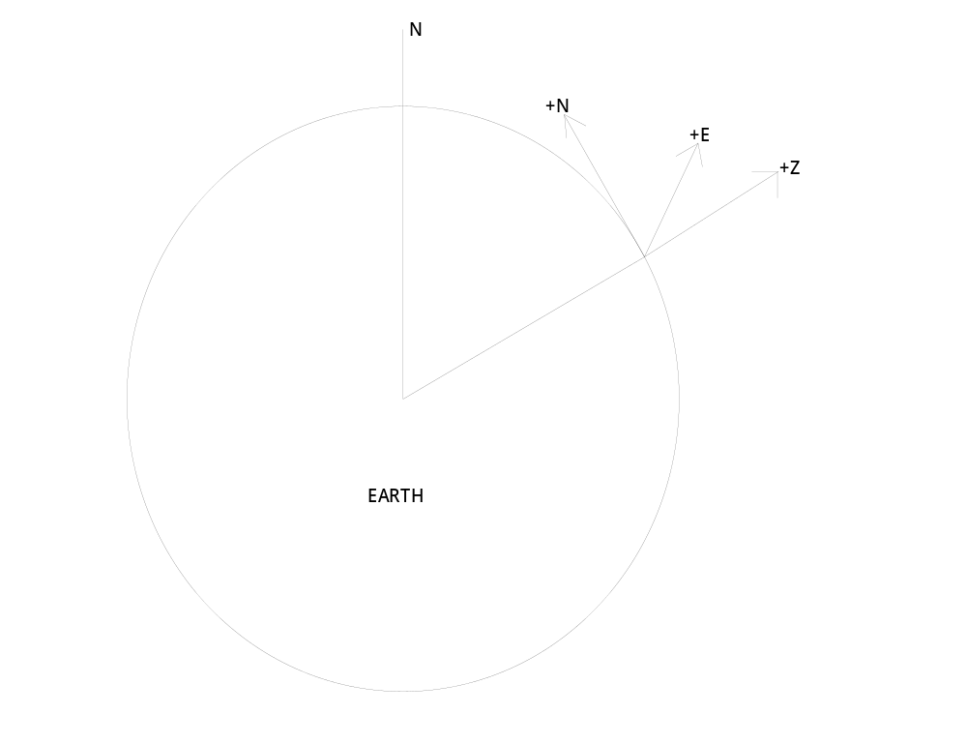 Figure 10. EARTH'S REFERENCE FRAME: The Topocentric Frame is Right Handed and Orthonormal With its Origin at Some Fixed Latitude and Longitude on the Earth's Surface. Positive is East(x or u), North(y or v) and Up(z or w).

