NCAR/EOL  
Earth Observing Laboratory

Algorithm System Description for

Quantitative Precipitation Estimation from RADAR (QPE)

2019-02-23

Mike Dixon

Scott Ellis

Jim Wilson  
Tammy Weckwerth  
Dave Albo

Algorithm System for

Quantitative Precipitation Estimation from RADAR (QPE)

# Introduction

The QPE algorithm is really a suite of algorithms run in a specified order, the end result of which is an accumulated precipitation grid.

The main steps in the QPE procedure are:

1. Estimate KDP;
2. Run the particle identification (PID) algorithm;
3. Estimate the precipitation rate in 3D;
4. Compute beam blockage for each radar;
5. Compute the QPE at the ground;
6. Accumulate the precipitation estimate over time.

# Step 1 – estimate KDP

KDP is required by both the particle identification (PID) algorithm and the precipitation rate algorithms.

For KDP, we use a modified version of the Hubbert FIR filter method (Hubbert et. al, 1993).

# Step 2 – run PID

For the PID algorithm, we need a temperature profile from which to estimate the 0-degree isotherm. Because routine soundings only occur every 12 hours, and are not located close to the radar sites, it is better to use model-based soundings. We interpolate the model onto height levels, and then compute a vertical profile of temperature at each of the radar locations.

Recent work on hydrometeor classification has shown that it is preferable to use the wet-bulb temperature rather than the dry-bulb temperature for the temperature profile. Therefore wet-bulb temperature is used in the current version of the PID algorithm.

# Step 3 - computing precip rate at each location in the3-D volume

For each gate with an SNR exceeding 3 dB, we compute a number of precipitation estimators.

In all of these estimators, the following units apply:

zh: mm6m-3

kdp: deg/km

zdr: unitless ratio

In addition to the individual estimators, we compute 4 compound (or hybrid) estimators. The most important of these are the NCAR Hybrid and PID-based estimators. We also include versions of Bringi’s algorithm and the CSU HIDRO algorithm that have been modified to make use of the PID results.

## Rate from Zh in rain



where:

a = 0.017

b = 0.714

This is equivalent to the following ZR:



## Rate from Zh, in dry snow (i.e. above the melting layer)

In snow, we use a modification to the rain ZR. We will follow the NOAA suggestion to use a rate which is ratio of the rain ZR. NOAA uses a rate of 2.8 times that in rain.

Therefore the relationship is:



where:

a = 0.0953

b = 0.5

which is equivalent to the following:

Z = 110R2.0

## Rate from Zh, in mixed phase (i.e. in the melting layer)

In the melting layer, we use a modification to the rain ZR. We will follow the NOAA suggestion to use a rate which is ratio of the rain ZR. NOAA uses a rate of 0.6 times that in rain.

Therefore the relationship is:



where:

a = 0.0102

b = 0.714

which is equivalent to the following:

Z = 500R1.4

## Rate from Z and Zdr

Following NOAA, we use:



where:

a = 0.0067

b = 0.927

c = -3.43

## Rate from Kdp

Following NOAA, we use:



where:

a = 44.0

b = 0.822

## Rate from Kdp and Zdr

The relationship for rate from both Kdp and Zdr is:



where:

a = 90.8

b = 0.93

c = -2.86

This is only used by the CSU HIDRO algorithm.

## Limits

In computing the above estimators, we apply the following limits to keep the results within reasonable bounds:

dBZ <= 53: if the reflectivity exceeds 53, we cap it at 53 dBZ, to avoid excessive values in the presence of hail.

R < 150 mm/hr: if the rate exceeds 150 mm/hr, we cap it at 150. This seems a reasonable climatological upper bound for Colorado.

## Modified NCAR Hybrid method

The NCAR HYBRID method has been modified to make use of the PID for decisions on which relationship to use.



We are currently using:

zdr_threshold: 0.5

## NCAR PID-based precipitation rate estimator

This is a new estimator in which the rate is computed as a weighted sum of the various precipitation estimators. The weights are determined from the interest values of the various particles identified in the PID algorithm.



## Modified HIDRO method (CSU)

See Cifelli et al., 2011.

The original algorithm has been modified to use PID for some of the decisions.



We are currently using:

dbz_threshold: 40  
 kdp_threshold: 0.3  
 zdr_threshold: 0.5

## Modified Bringi method

See Bringi et al., 2009.

This has been modified to use PID for some decision making.



We are currently using:

dbz_threshold: 40

kdp_threshold: 0.3

zdr_threshold: 0.5

# Step 4 - Beam blockage computations per radar

For each radar, we run the BeamBlock algorithm to compute the blockage at the lower elevation angles. The low-level code for BeamBlock was obtained through our collaboration with the Australian Bureau of Meteorology. We wrapped that code in an NCAR application, with the normal NCAR-style command line parameters etc.

The calculations make use of 30-m resolution digital elevation data obtained from one of the shuttle missions. This data comes in 1-deg x 1-deg tiles. We downloaded the relevant tiles from the web.

The method is reasonably sophisticated and takes account of atmospheric propagation effects, and the convolution of the beam pattern with the terrain features. It produces a CfRadial file of beam blockage percentage, for elevation angles spaced at 0.2 degrees up to an angle at which no blockage is evident

As an example, Figure 1 (below) shows the observed clutter power at each gate, at a 0.5 degree elevation angle. This is determined by running the clutter filter and computing the power removed by the filter.

By way of comparison, Figure 2 shows the beam blockage at each gate, for the 0.4 degree elevation angle at SPOL. The clutter patterns in figures 1 and 2 show clear correlation.

Figure 3 shows the accumulated beam blockage along each radial, also at 0.4 degrees elevation. This is the field that is used by the QPE algorithm for handling beam blockage.

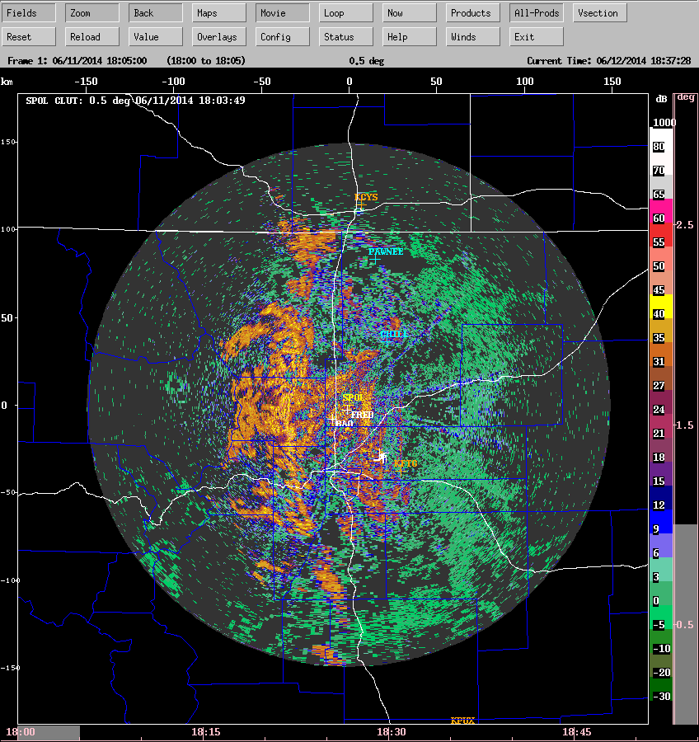

Figure 1: observed clutter power – SPOL 0.5 deg

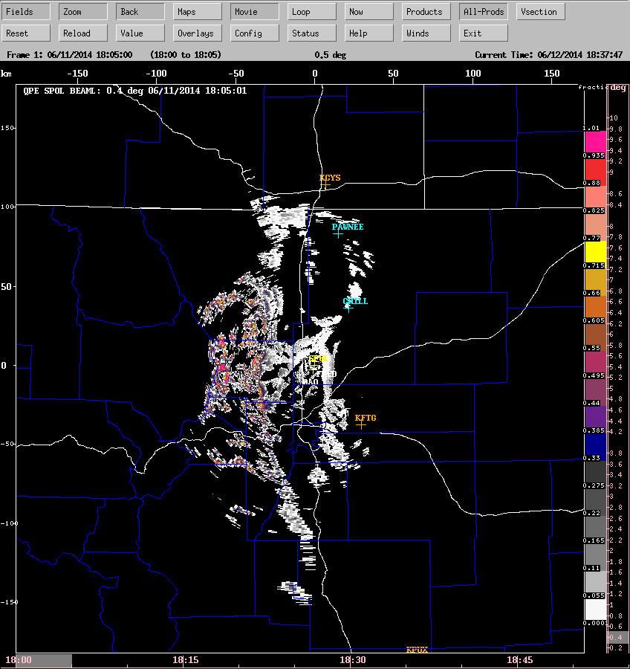

Figure 2: computed beam blockage fraction at a gate – SPOL 0.4 deg

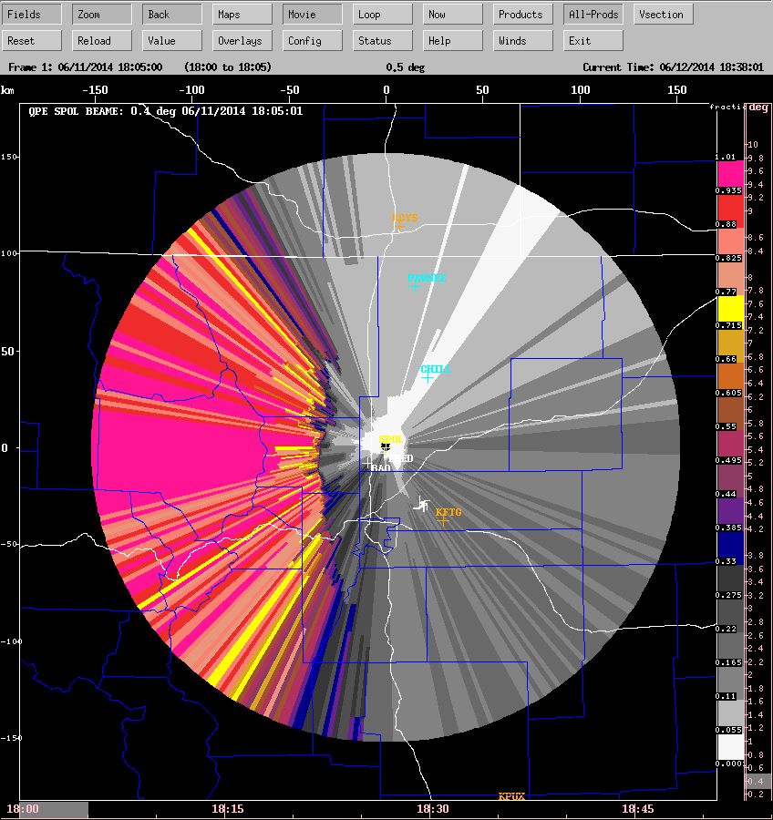

Figure 3: accumulated blockage fraction, SPOL, 0.4 deg.  
(In the algorithm we discard all gates from dark gray upwards).

# Step 5 - computing the QPE at the ground

For hydrology, it is important to estimate the precipitation rate at the ground rather than at some height above the ground in the radar volume.

Our new RadxQpe algorithm performs this function, as shown:



We are currently using:  
SNR threshold = 5dB  
Max valid height = 7 km

So in terms of beam blockage, if a gate has less than 25% blockage, we treat it as unblocked and view it as a candidate for precipitation estimation. If the blockage exceeds 25%, we move up to the next elevation angle. The 25% value is a parameter that is easily changed. We picked this as a reasonable starting value, because with 75% of the power available, the computed reflectivity will only be reduced by 1.2 dB, so any incurred errors will be moderate. So far 25% seems to be a suitable value.

There is one important point to make about the QPE logic. In sections 4.8 and 4.9, you will notice that if hail is the predominant particle type and KDP is not available, we set the rate to missing. KDP sometimes cannot be calculated because of clutter contamination. In this case, the algorithm will move to the next higher elevation angle in search of a precipitation rate. Since clutter contamination generally reduces with height, frequently the KDP estimate is better higher up than at the lowest elevation angle.

## Single-radar example

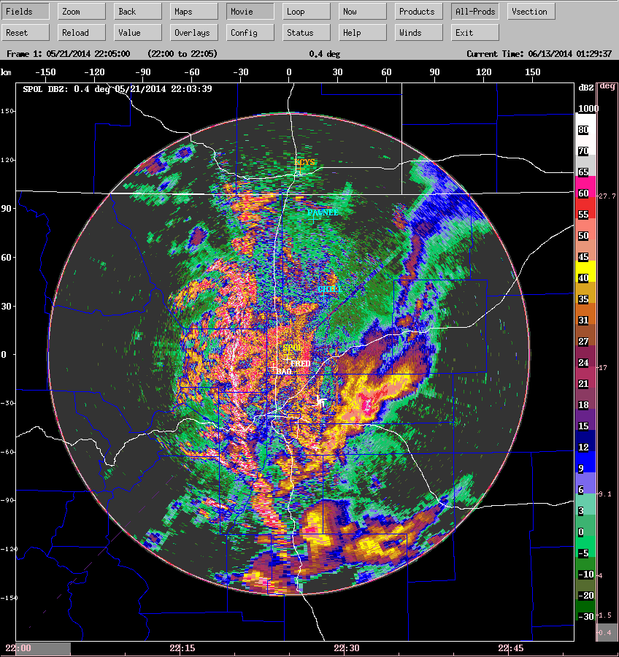

Figure 4: example of SPOL low-level reflectivity

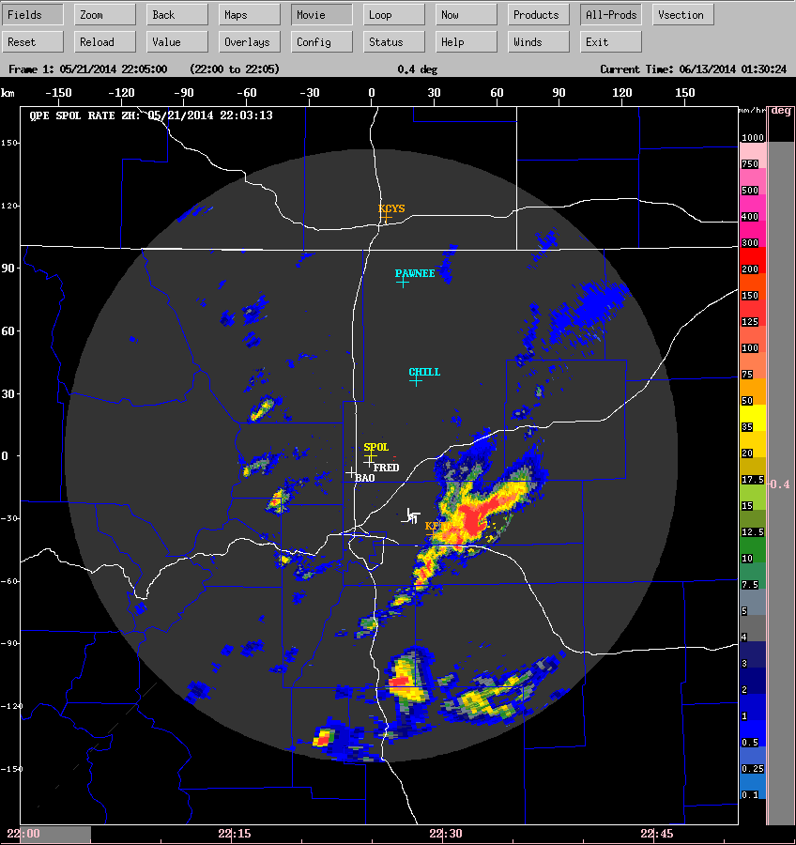

Figure 5: corresponding precip rate from Zh.

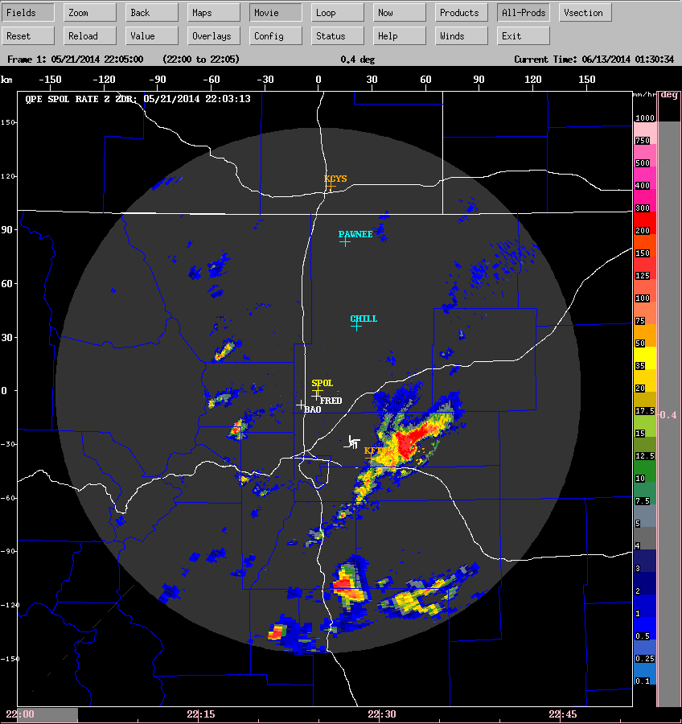

Figure 6: corresponding precip rate from ZZdr.

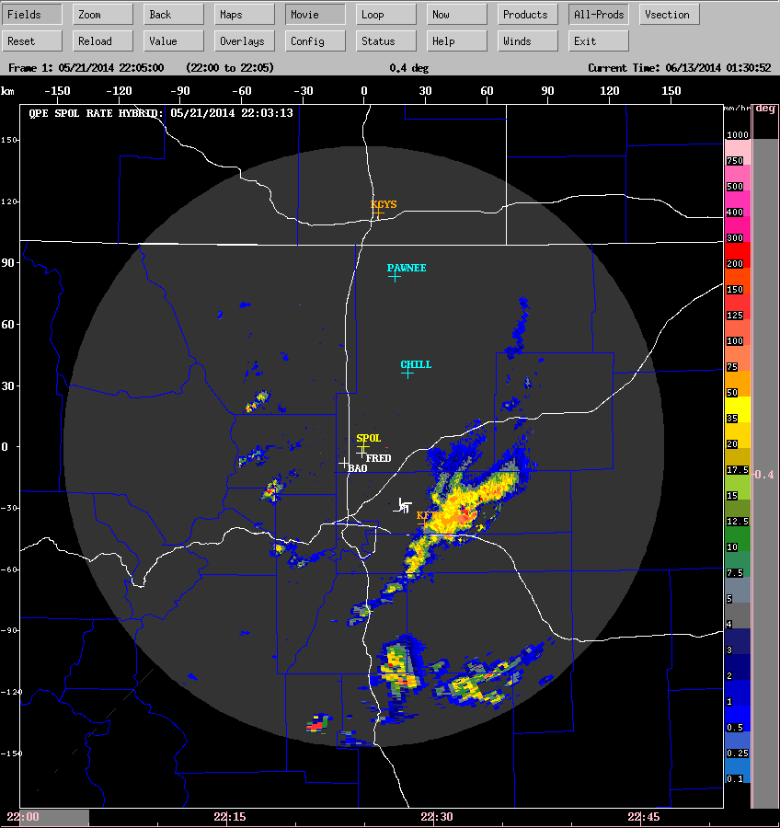

Figure 7: corresponding precip rate from NCAR Hybrid.

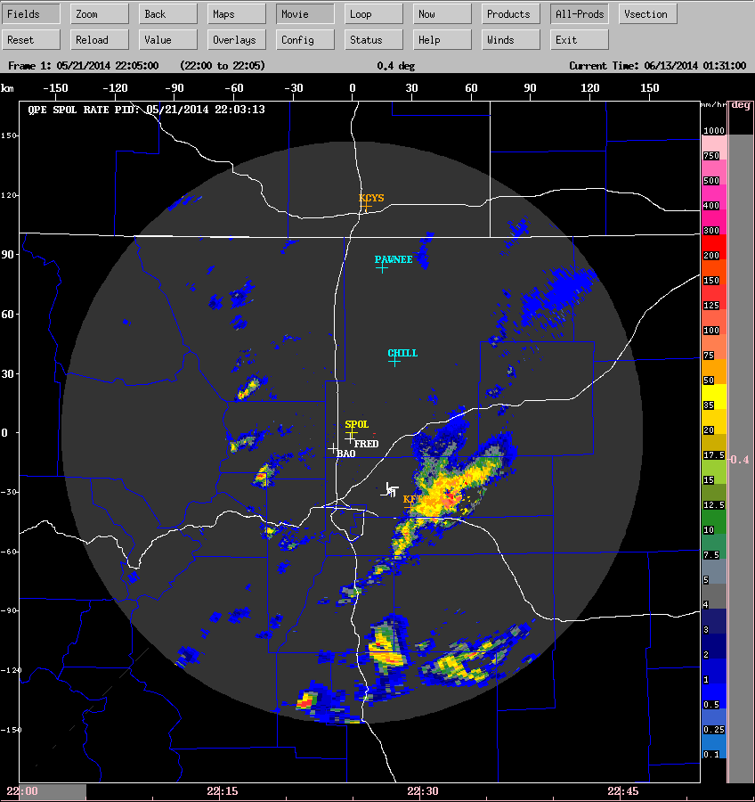

Figure 8: Corresponding precip rate from NCAR PID-based algorithm

# Step 6 - merged QPE rate and accumulation

For the purposes of this example, seven radars were used:

* SPOL at Firestone (40.123333N, -104.89133E)
* CHILL at Greeley (40.4463N, -104.637E)
* KFTG NEXRAD at Denver (39.7866N, -104.546E)
* KCYS NEXRAD at Cheyenne (41.1519N, -104.806E)
* KPUX NEXRAD at Pueblo (38.4595N, -104.181E)
* KGLD NEXRAD at Goodland Kansas (39.3667N, -101.700E)
* KGJX NEXRAD at Grand Junction (39.0622N, -108.213E)

Only the NEXRAD radars were considered in the comparison with the NOAA product, since NOAA only uses the NEXRADs.

To produce the regional QPE product, we merge the individual QPE grids from all of the radars. Where overlap occurs we use the value from the CLOSEST radar.

We then compute the 1-hour, 2-hour, 3-hour and 24-hour precipitation accumulation. The 24-hour accumulation is reset to 0 at 12:00 UTC, i.e. 6 am MDT.

The following are examples of the merged products.

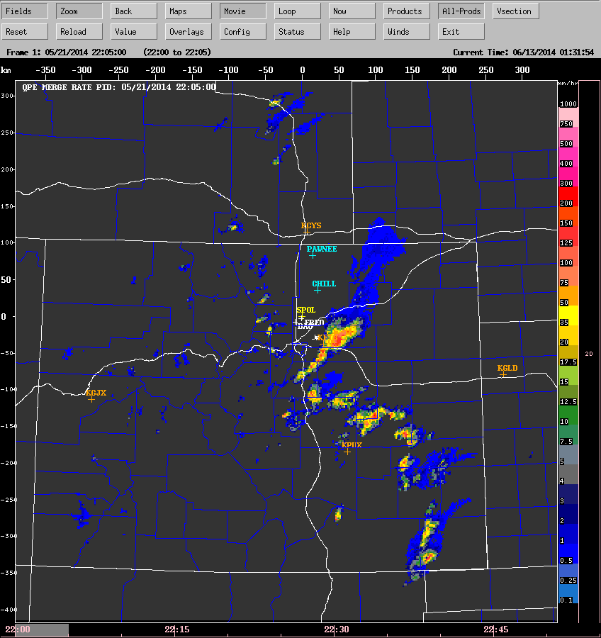

Figure 9: merged precip rate product, using the NCAR PID-based algorithm

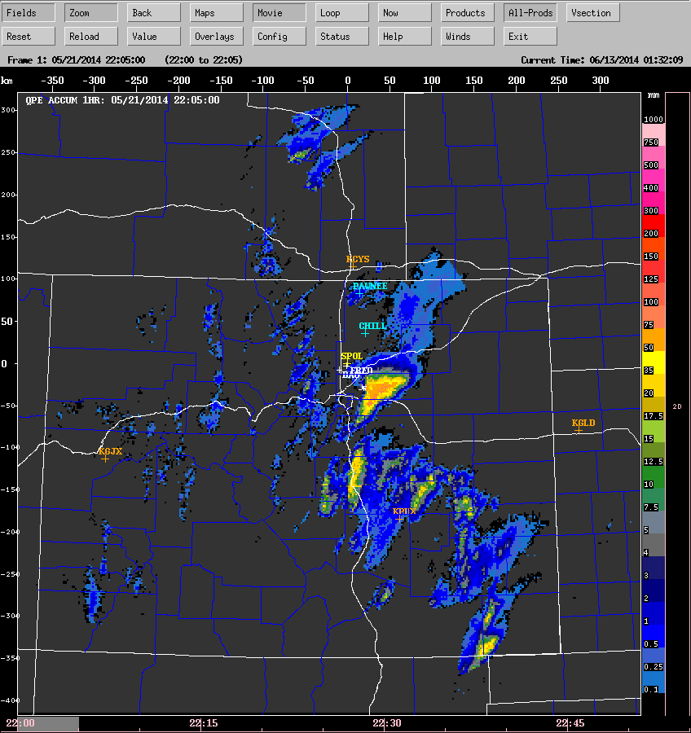

Figure 10: merged 1-hour running accumulation

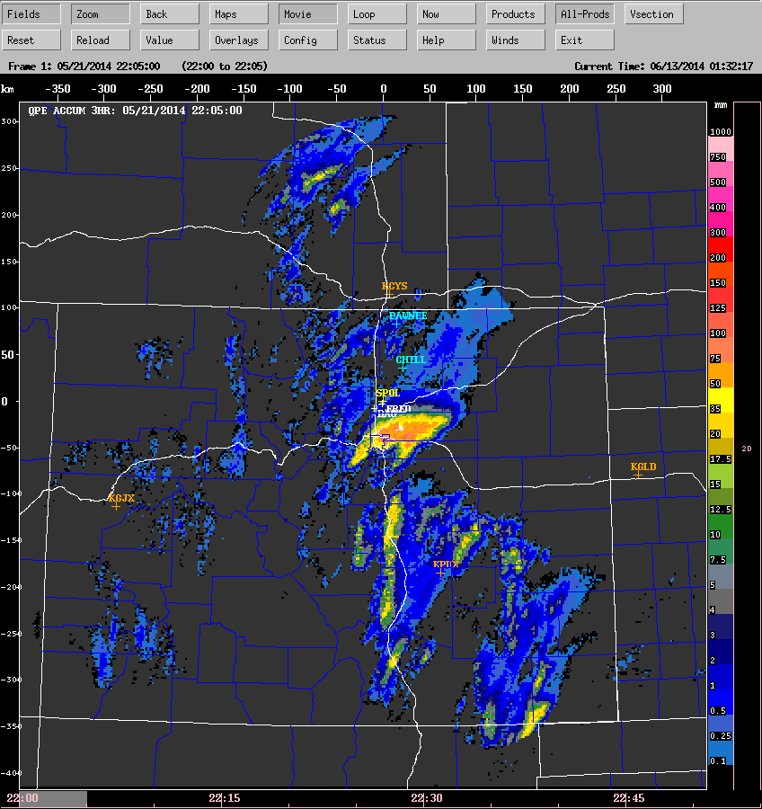

Figure11: merged 3-hour accumulation

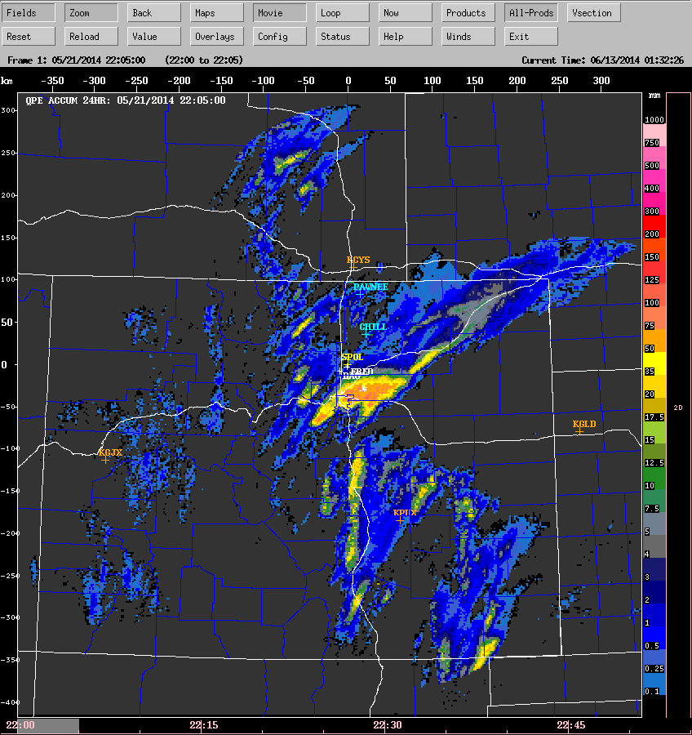

Figure 12: merged 24-hour accumulation

# References

Bringi, V. N., C. R. Williams, M. Thurai, P. T. May, 2009: Using Dual-Polarized Radar and Dual-Frequency Profiler for DSD Characterization: A Case Study from Darwin, Australia. J. Atmos. Technol, Vol 26, No 10, October, 2107–2122.

Cifelli, R., V. Chandrasekar, S. Lim, P. C. Kennedy, Y. Wang, S. A. Rutledge, 2011: A New Dual-Polarization Radar Rainfall Algorithm: Application in Colorado Precipitation Events*. J. Atmos. Technol*, Vol 28, No 3, March, 352-364.

Hubbert, J., V Chandrasekar and V. N. Bringi, 1993: Processing and Interpretation of Coherent Dual-Polarized Radar Measurements*. J. Atmos. Technol*, Vol 10, No 2, April, 156-164.