Steps for Installing LROSE on Windows

1. Install the Windows Linux Subsystem manually by following the steps for the manual install here: <https://docs.microsoft.com/en-us/windows/wsl/install-win10>. For choosing your Linux distribution, I recommend Ubuntu. (**DO NOT** join the Windows Insider Program and attempt the automatic install method, it can introduce instability to your computer).

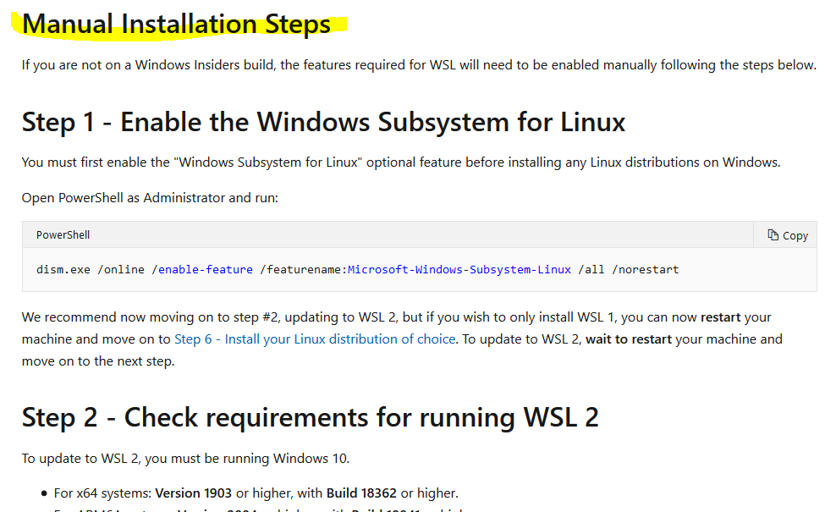

1. Create a folder named “git” where you wish to install LROSE and follow the instructions from here to install dependencies for LROSE: <https://github.com/NCAR/lrose-core/blob/master/docs/build/lrose_package_dependencies.linux.md>. Follow the manual install method and make sure to follow the instructions for the Linux distribution you chose in step 1.

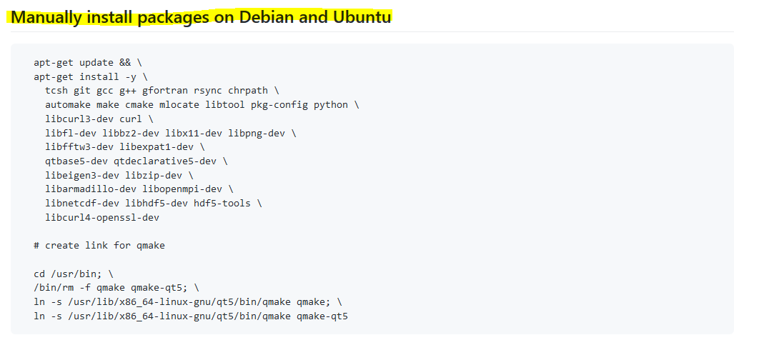

1. To install LROSE, follow the instructions here from step 3 onwards: <https://github.com/NCAR/lrose-core/blob/master/docs/build/LROSE_cmake_build.auto.md>. (The default options worked fine for me). 