How to restore a partition using CloneZilla

1. Collect the Clonezilla CD from the CD folder (there should be one above SCI1 and another folder in the Small Grey Box in the Dish Container 9-009). Also retrieve one of the USB backup drives from 9-009.
2. Insert the CD into the server. Plug the USB drive into one of the USB ports.
3. Reboot the server. On bootup, make sure to boot from the CD.
4. Select “Clonezilla Live”

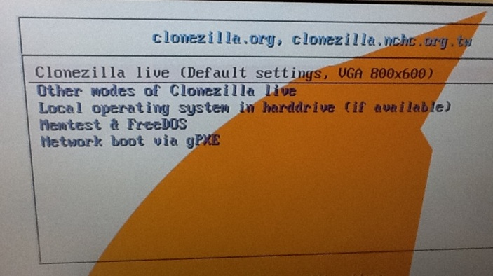

1. Chose “English”

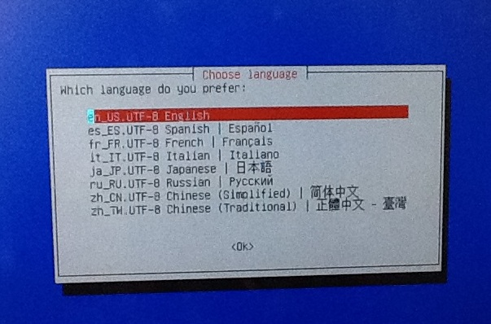

1. Select “Don’t Touch Keymap”

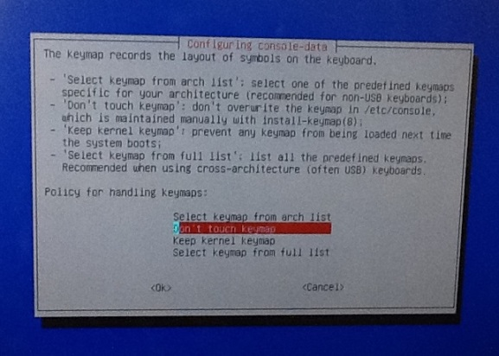

1. Select “Start Clonezilla”

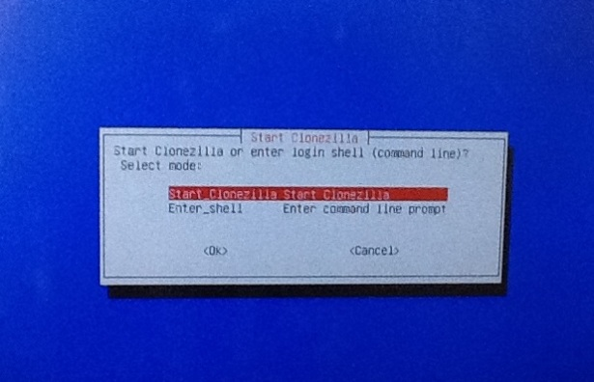

1. Select “Device – Image”

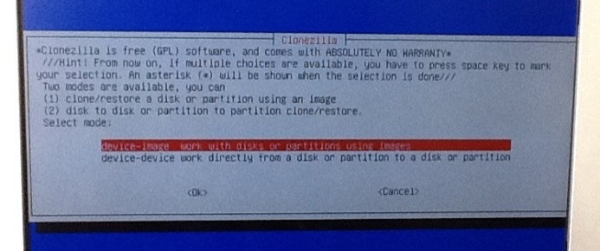

1. Clonezilla Select Mode – Choose “restoreparts”

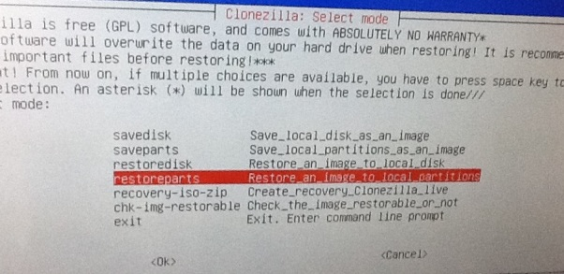

1. When it asks which mode to run the wizard, select “Beginner to Beginner”

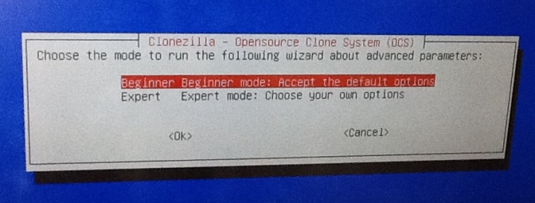

1. Select “local_dev”

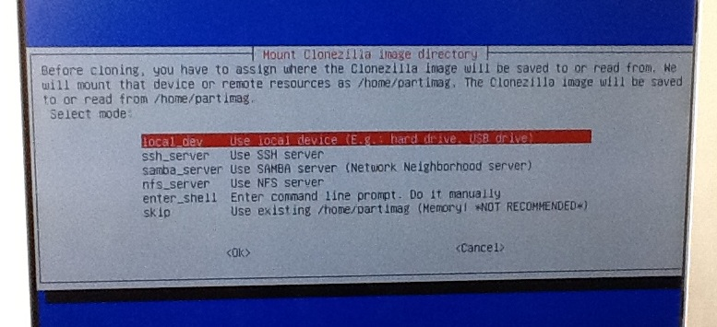

1. Make sure the USB backup drive is inserted and press “enter”.

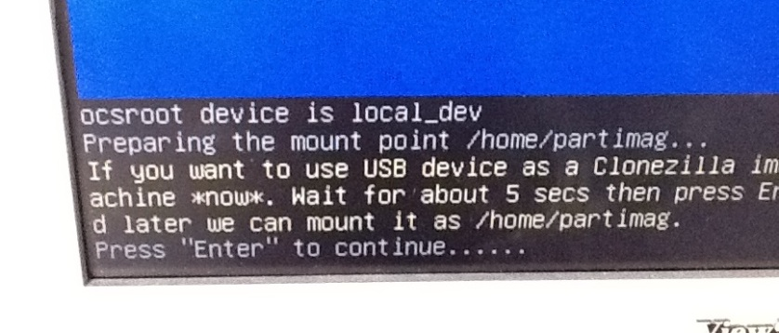

1. When it asks which drive to mount as /home/partimage - Select “1000GB_ext3 (In_FreeAgent_GoFlex)”

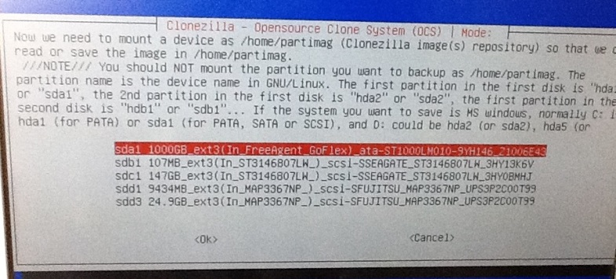

1. When it asks which directory is for the Clonezilla image, select “/”

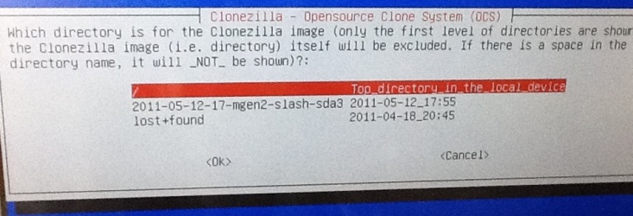

1. When it asks you for which image to restore, select the correct image. They are listed by date cloned, then by server name, then by partition (slash or boot) and then by SDA order. For PGEN1, PGEN2, Control1, Control2, Control3, MGEN1, MGEN2 we have cloned the / and the /boot drives. We have a full disk image of kadrx

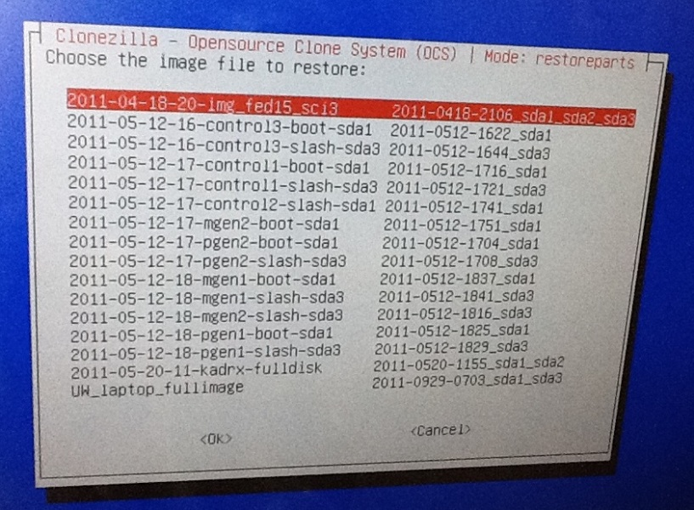

**Types of Drives:**

SPOL GATE - 2 73 GB SAS 10K

RAID2/PGEN2 - 6 750 GB SATA 7.2

CONTROL 1 - 2 2 TB SATA 7.2

ATE -1 300 GB 10K SCSI

MGEN - 5 250 7.2K SATA

PGEN - 5 250 7.2K SATA

MGEN1 - 4 2 TB SATA 7,.2

1 TB sata2 drives in triton raid.

**Output of DF:**

SPOL-GATE (Control3.gate.rtf)

Filesystem Size Used Avail Use% Mounted on

/dev/sda3 64G 39G 22G 65% /

/dev/sda1 99M 25M 69M 27% /boot

tmpfs 1004M 0 1004M 0% /dev/shm

tmpfs 1004M 28K 1004M 1% /opt/omd/sites/prod/tmp

tmpfs 1004M 24K 1004M 1% /opt/omd/sites/old_prod/tmp

RAID2 (pgen2.gate.rtf)

Filesystem Size Used Avail Use% Mounted on

/dev/sda3 90G 6.1G 80G 8% /

/dev/sda2 190G 1.3G 179G 1% /home

/dev/sda1 4.8G 161M 4.4G 4% /boot

tmpfs 3.9G 0 3.9G 0% /dev/shm

/dev/sdb2 6.9T 230G 6.4T 4% /data

CONTROL1 (control1.gate.rtf)

Filesystem Size Used Avail Use% Mounted on

/dev/sda3 38G 8.7G 28G 24% /

/dev/sda2 48G 1.4G 44G 4% /home

/dev/sda1 4.8G 174M 4.4G 4% /boot

tmpfs 5.9G 0 5.9G 0% /dev/shm

/dev/sdb1 1.7T 4.7G 1.6T 1% /data

tmpfs 5.9G 880K 5.9G 1% /opt/omd/sites/prod/tmp

tmpfs 5.9G 732K 5.9G 1% /opt/omd/sites/v0_46/tmp

ATE (control2.gate.rtf)

Filesystem Size Used Avail Use% Mounted on

/dev/sda1 95G 6.3G 84G 7% /

/dev/sda3 176G 1.5G 165G 1% /home

tmpfs 1014M 0 1014M 0% /dev/shm

tmpfs 1014M 568K 1013M 1% /opt/omd/sites/prod/tmp

/dev/hda 8.9M 8.9M 0 100% /media/CentOS

control1:/data/src 1.7T 4.7G 1.6T 1% /net/src

MGEN2 (mgen2.gate.rtf)

Filesystem Size Used Avail Use% Mounted on

/dev/sda3 29G 14G 13G 52% /

/dev/sda1 4.8G 163M 4.4G 4% /boot

/dev/sda6 593G 430G 133G 77% /data

tmpfs 3.9G 0 3.9G 0% /dev/shm

/dev/sda2 48G 1.3G 44G 3% /home

PGEN1 (pgen1.gate.rtf)

Filesystem Size Used Avail Use% Mounted on

/dev/sda3 29G 16G 12G 58% /

/dev/sda1 4.8G 156M 4.4G 4% /boot

/dev/sda6 593G 339G 224G 61% /data

tmpfs 3.9G 0 3.9G 0% /dev/shm

/dev/sda2 48G 3.6G 42G 8% /home

/dev/sdc1 6.3T 857G 5.4T 14% /mnt/triton1

/dev/sdb1 6.3T 1009G 5.3T 16% /mnt/triton2

MGEN (mgen1.gate.rtf)

Filesystem Size Used Avail Use% Mounted on

/dev/sda3 38G 7.5G 29G 21% /

/dev/sda2 48G 1.3G 44G 3% /home

/dev/sda1 4.8G 164M 4.4G 4% /boot

tmpfs 5.8G 0 5.8G 0% /dev/shm

/dev/sdb1 7.1T 1.5T 5.2T 22% /data

**List of Backups:**

spol-gate - /dev/sda1 /dev/sda3 - 65GB

raid2 - /dev/sda3 /dev/sda1 - 95GB

control1 - /dev/sda3 /dev/sda1 - 43GB

ate - /dev/sda1 - 95GB

mgen2 - /dev/sda3 /dev/sda1 - 35GB

pgen1 - /dev/sda1 /dev/sda3 - 35GB

mgen - /dev/sda1 /dev/sda3 - 43GB

Total space needed: 411GB