**START-UP**

* Power on master PC – switch on front panel (or rear) – blue light comes on
* Enter password in PC: hiaper
* **If using PC card**, put PC card into Applanix
* Power on Applanix at least 60 minutes before flight by pressing and holding the green button in the upper right until the sys light flashes
* Use VNC to display desktop on aeros laptop:
  + Double click tiger vnc
  + When prompted for server name, enter applanix-pc
  + Press OK; vnc connection should then open
* Click POS-AV icon (lower left)
* Wait to see address 128.46.118.136 in the window
* Click connect (green plug icon at top) - standby icon should turn red

**Standby Icon**

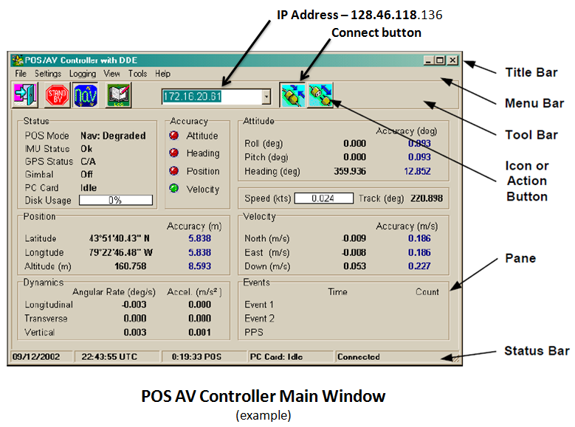

**Starting Data Logging**

* Data logging is started up as near to doors close as possible
* INT light on Applanix unit should be green before starting logging (See pg. 4 for diagram)
* If using PC card, start PC card logging before Ethernet logging
* To Start PC Card Logging:
* Pull-down menu Logging => PC card logging
  + If the Applanix has started logging, stop logging then restart with the proper groups and file name
* Press POSPac and verify which groups are selected and change frequency to 10Hz
* Change File name to PROJRF##.000 and then press start logging
* start Ethernet logging AFTER logging is successfully started to PC card
* To Start Ethernet Logging:
* Pull-down menu Logging => Ethernet logging => Secondary tab (log file will show “Default2”) => Browse
* Click on 2014.152_DEEPWAVE folder; type in file name: DWAVxxxx (the xxxx represents flight type and number)
* Verify that the append button is checked
* Press POSPac, verify appropriate groups are checked and change frequency to 10 Hz
* Press Start logging
* Minimize logging status window (shows that data is logging)
* IF NOT USING PC CARD: POSAV error : logging device error => OK

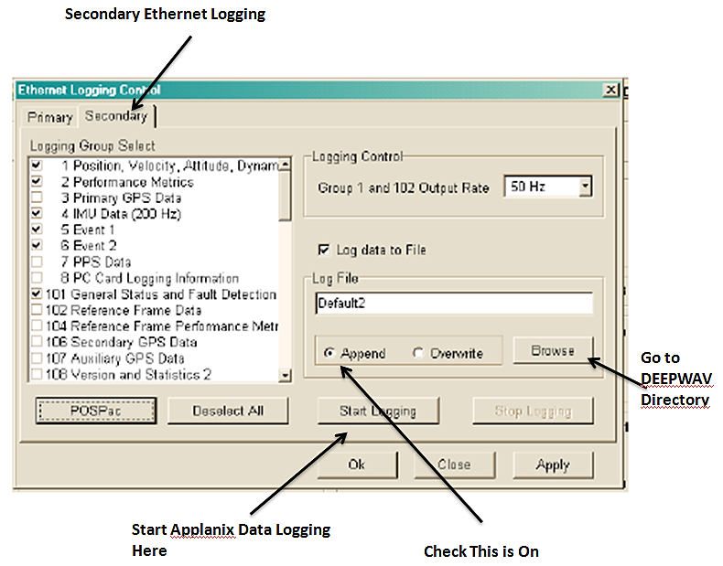

**Monitoring**

* PC Card: Writing (On main POS-AV display)
* Check installation parameters:

Settings => Installation => Lever arms

* 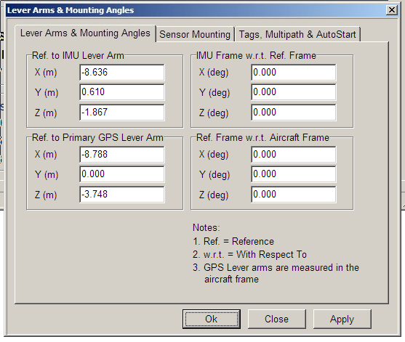

EXAMPLE

* Settings => Installation => Tags

Check Time Tag 1 = GPSTime

And also all other time tags are GPS Time

* View => GPS data and verify we have greater than 8 satellites
* verify the SNR for all satellites are > 30 for L1 and > 18 for L2
* In normal operations, IMU status goes from failure to OK,

GPS Status goes from not available to C/A

**Applanix Indicator lights - After Applanix is properly initialized**

SYS – GREEN (flash or steady)

IMU – GREEN

GPS – YELLOW (steady)

PPS – GREEN (flash)

LAN – GREEN (flash)

PWR – GREEN (steady)

INT –**GREEN**

EXT **GREEN (if PC Card present & writing)**

**Applanix Controller Front Panel Switches and Indicators**

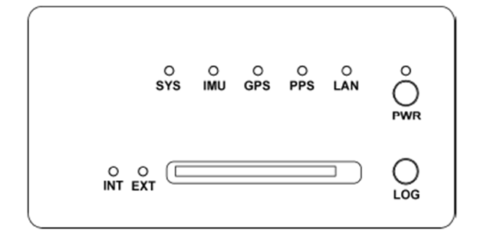

**SHUTDOWN**

* After plane has stopped, continue logging with POS-AV software on for at least 10 minutes.
* After 10 minutes, stop logging

Logging => Ethernet logging => stop logging and note time on log sheet

* Close POS-AV software

File => exit

Message log has changed, would you like to save it? => yes

=> TF/RFXX_log.txt => okay

* Insert the flash drive in front of CPU
* Go to **D:**/gpsdata/2014.152_DEEPWAVE
* Copy file DWAVxxxx and rfxx_log.txt to USB drive
* Turn off computer
* Turn off Applanix => press and hold power button on the front until power button starts blinking.