**GV Applanix Operations Checklist**

**(DEEPWAVE 2014)**

Power on Applanix at least 30 minutes before flight, if possible.

Power on master PC – switch on front panel (or rear) – blue light comes on

Enter password in PC: hiaper

Click POS-AV icon (lower left)

Wait for to see address 128.46.118.136 in the window that indicates LAN Ethernet is active

Click connect (green plug icon at top) - standby icon should turn red

POSAV error : logging device error => OK

*(Note: logging should not be started until the GV is near door closed and take off)*

Logging => Ethernet logging => Secondary tab (log file will show “Default2”) => Browse

Click on **2014.152_DEEPWAVE** folder; type in file name: DWAVxxxx

(the xxxx represents flight type and number, e.g., TF, FF, RF 01, 02, ….)

=>(check append button is set) start logging

(should be default 10 Hz)

POS sec Ethernet logging status window shows that data is logging => then minimize

Check installation parameters:

Settings => Installation => Lever arms

Check Reference to IMU Lever arms are what was noted on the diagram

Check Reference to Primary GPS are

=> okay

Settings => Installation => Tags

Check Time Tag 1 = GPSTime

And also all other time tags are GPS Time

=> okay

*(“Accuracy “ displays for Attitude and Velocity can be ignored)*

IMU status:

Check GPS Status: C/A

Write on log sheet the time when GPS status went to C/A

View => GPS data

Verify we have greater than 8 satellites

Note on log sheet the time the SNR for all satellites are > 30 for L1 and > 18 for L2

When Normal operations

IMU stats goes from failure to OK

GPS Status goes from not available to C/A (This normally 2 minutes)

(On a bad day when it could take 15 minutes)

Screen should show green light for Position first, then green light for velocity, then after a long time green light for Attitude, then after an S turn green light for heading

Disregard accuracy settings.

Leave window open, close Keyboard, get off plane

After plane has stopped, leave it running for at least 10 minutes.

Logging => Ethernet logging => stop logging and note time on log sheet

* close

File => exit

Message log has changed, would you like to save it? => yes

=> TF/RFXX_log.txt

=> okay

Insert the flash drive in front of CPU

Go to D:/gpsdata/2014.152_DEEPWAVE

Copy file from default name to DWAVxxxx and copy to USB drive

Turn off computer

Turn off Applanix => press and hold power button on the front until power button starts blinking.

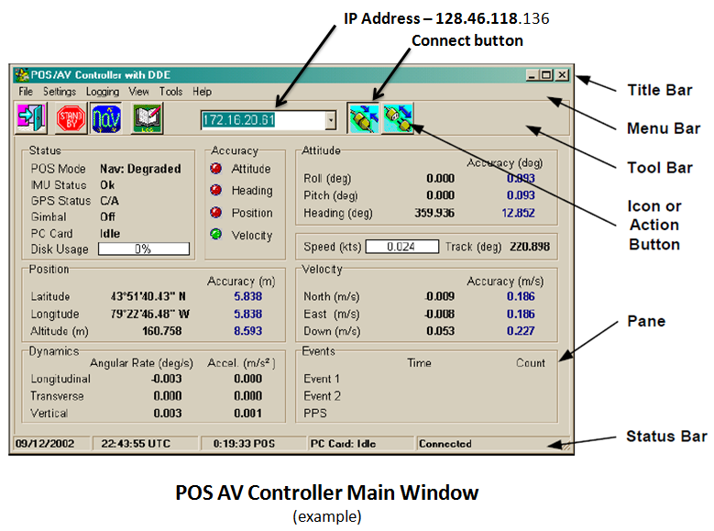

**Applanix Controller Front Panel Switches and Indicators**

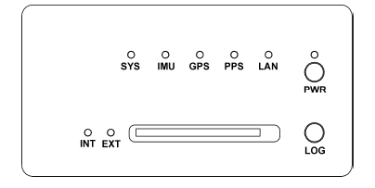

**Applanix Indicator lights**

(A few minutes after power is turned on)

SYS – GREEN (flash or steady)

IMU – GREEN

GPS – YELLOW (steady)

PPS – GREEN (flash)

LAN – GREEN (flash)

PWR – GREEN (steady)

INT – GREEN (steady)

EXT – GREEN (steady)

