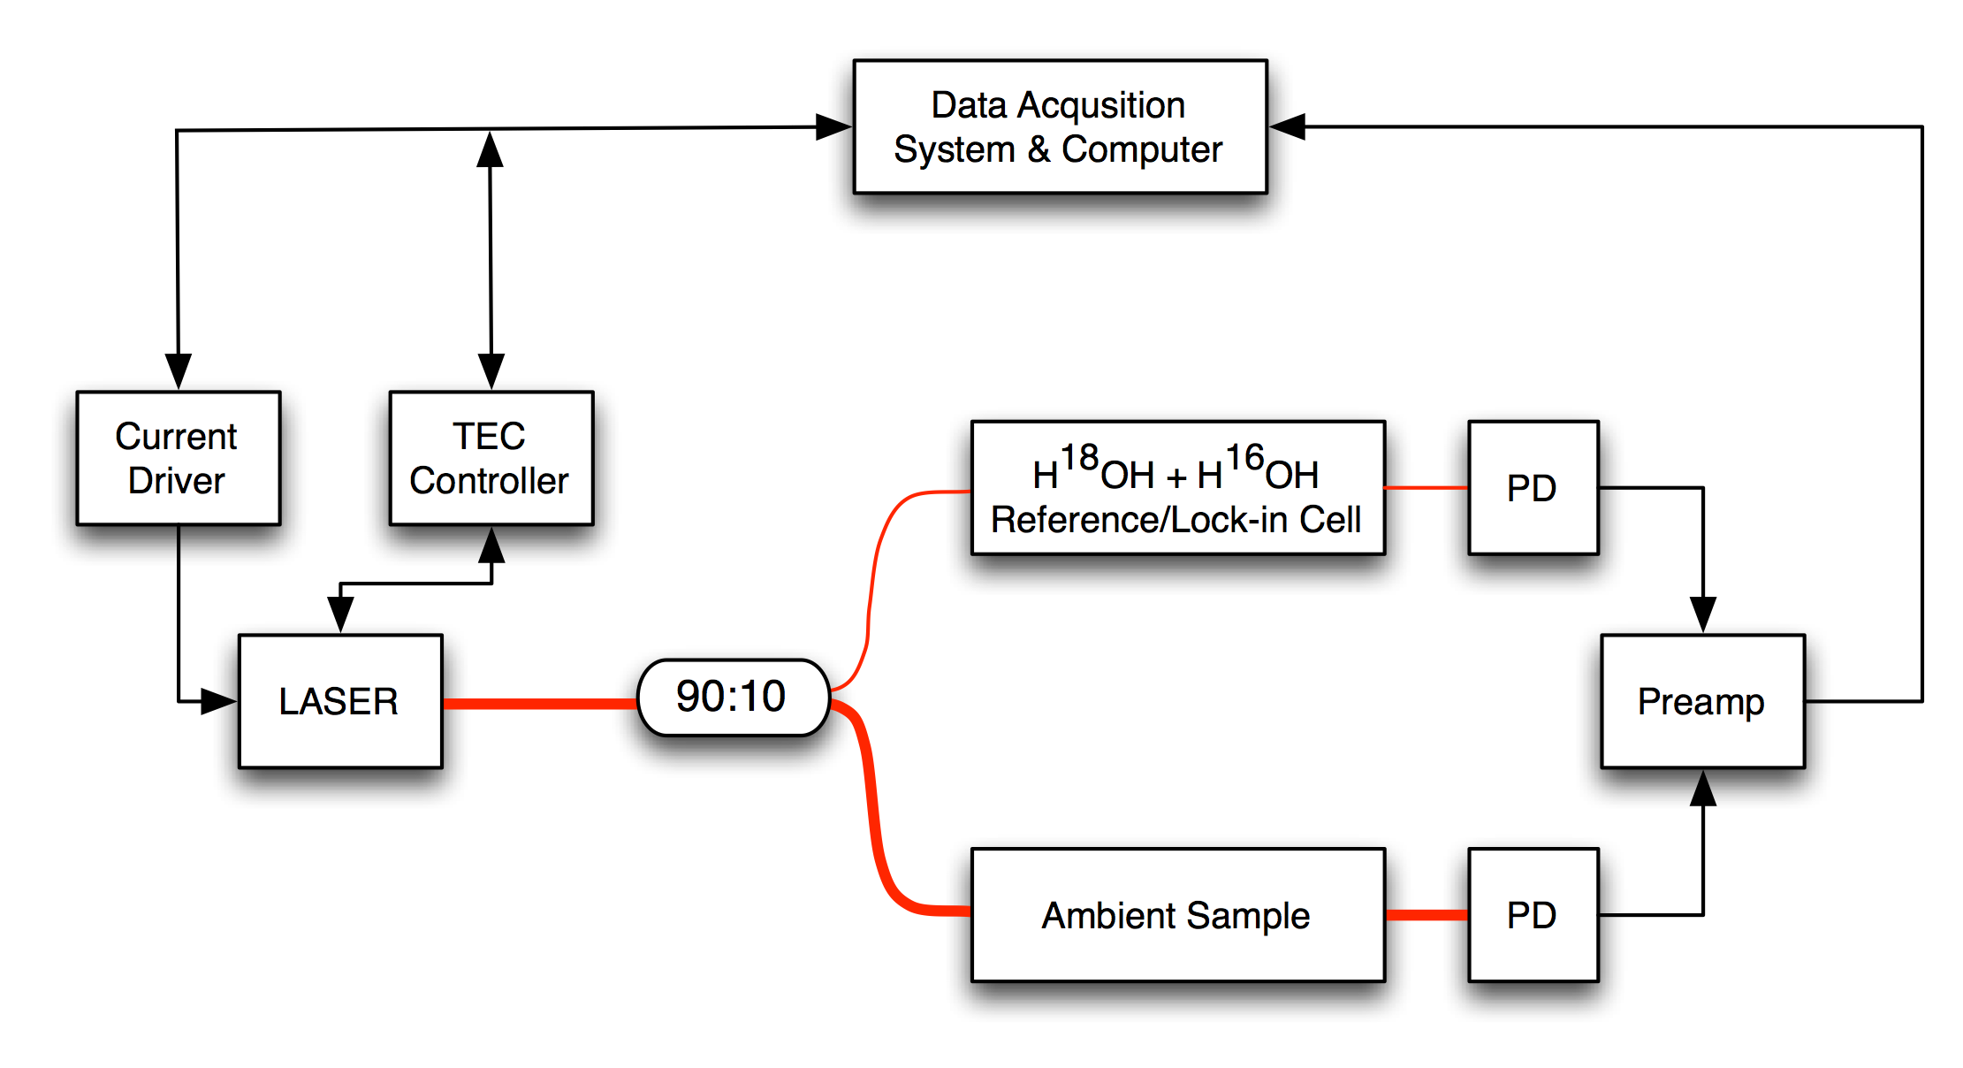

*VXL2 System Diagram*

Optical & electrical diagram of core components. A 90:10 fiber splitter directs the majority of the laser power through the multi-pass open-path optical cell. A small amount of light is directed through a mixed H18OH and H16OH reference/lock-in cell. The signal from both detectors is passed to a dual-channel preamp before the signal is digitized and the acquired spectra is stored and fit. The data acquisition system drives laser through a current driver. Laser drift can be compensated for by the DAQ system based on the position of the H16OH lines in the lock-in cell. The H18OH signal from the reference is used to compensate for any electronic drift in the system downstream from the photodetectors (PD).

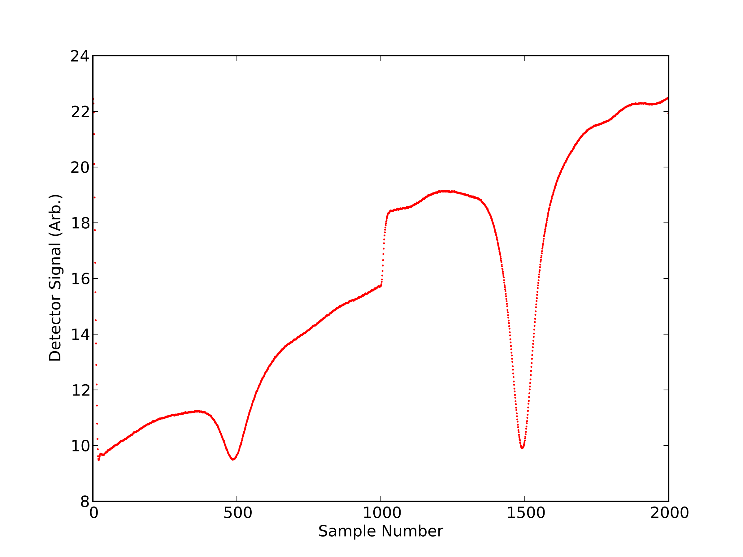

*25 Hz Coadded Jump Scan Spectrum*

A sample spectrum showing 2 water vapor lines (1853.038 & 1854.034 nm). The laser is is ramped at 1 kHz. While the scanning range of a vcsel is large (> 2 nm), the large line separation between these two water vapor lines reduces the number of samples available for peak fitting for fast acquisitions. The fast time response (high bandwidth) of a vcsel allows for a nearly instantaneous "jump" in wavelength by rapidly changing the current. This technique allows for simultaneous detection of multiple lines as shown here.

The spectrum above is of ambient water vapor (293 K; 1010 mbar) with a path length of 38 cm. The laser is continuously scanned at 1 kHz with a acquisition sampling rate of 2 MS/s. Co-addition of 40 individual scans increases S/N and yields 25 Hz data. Increased scan rates are possible, yielding improvements in S/N, but come with a decrease in the number of samples per scan.

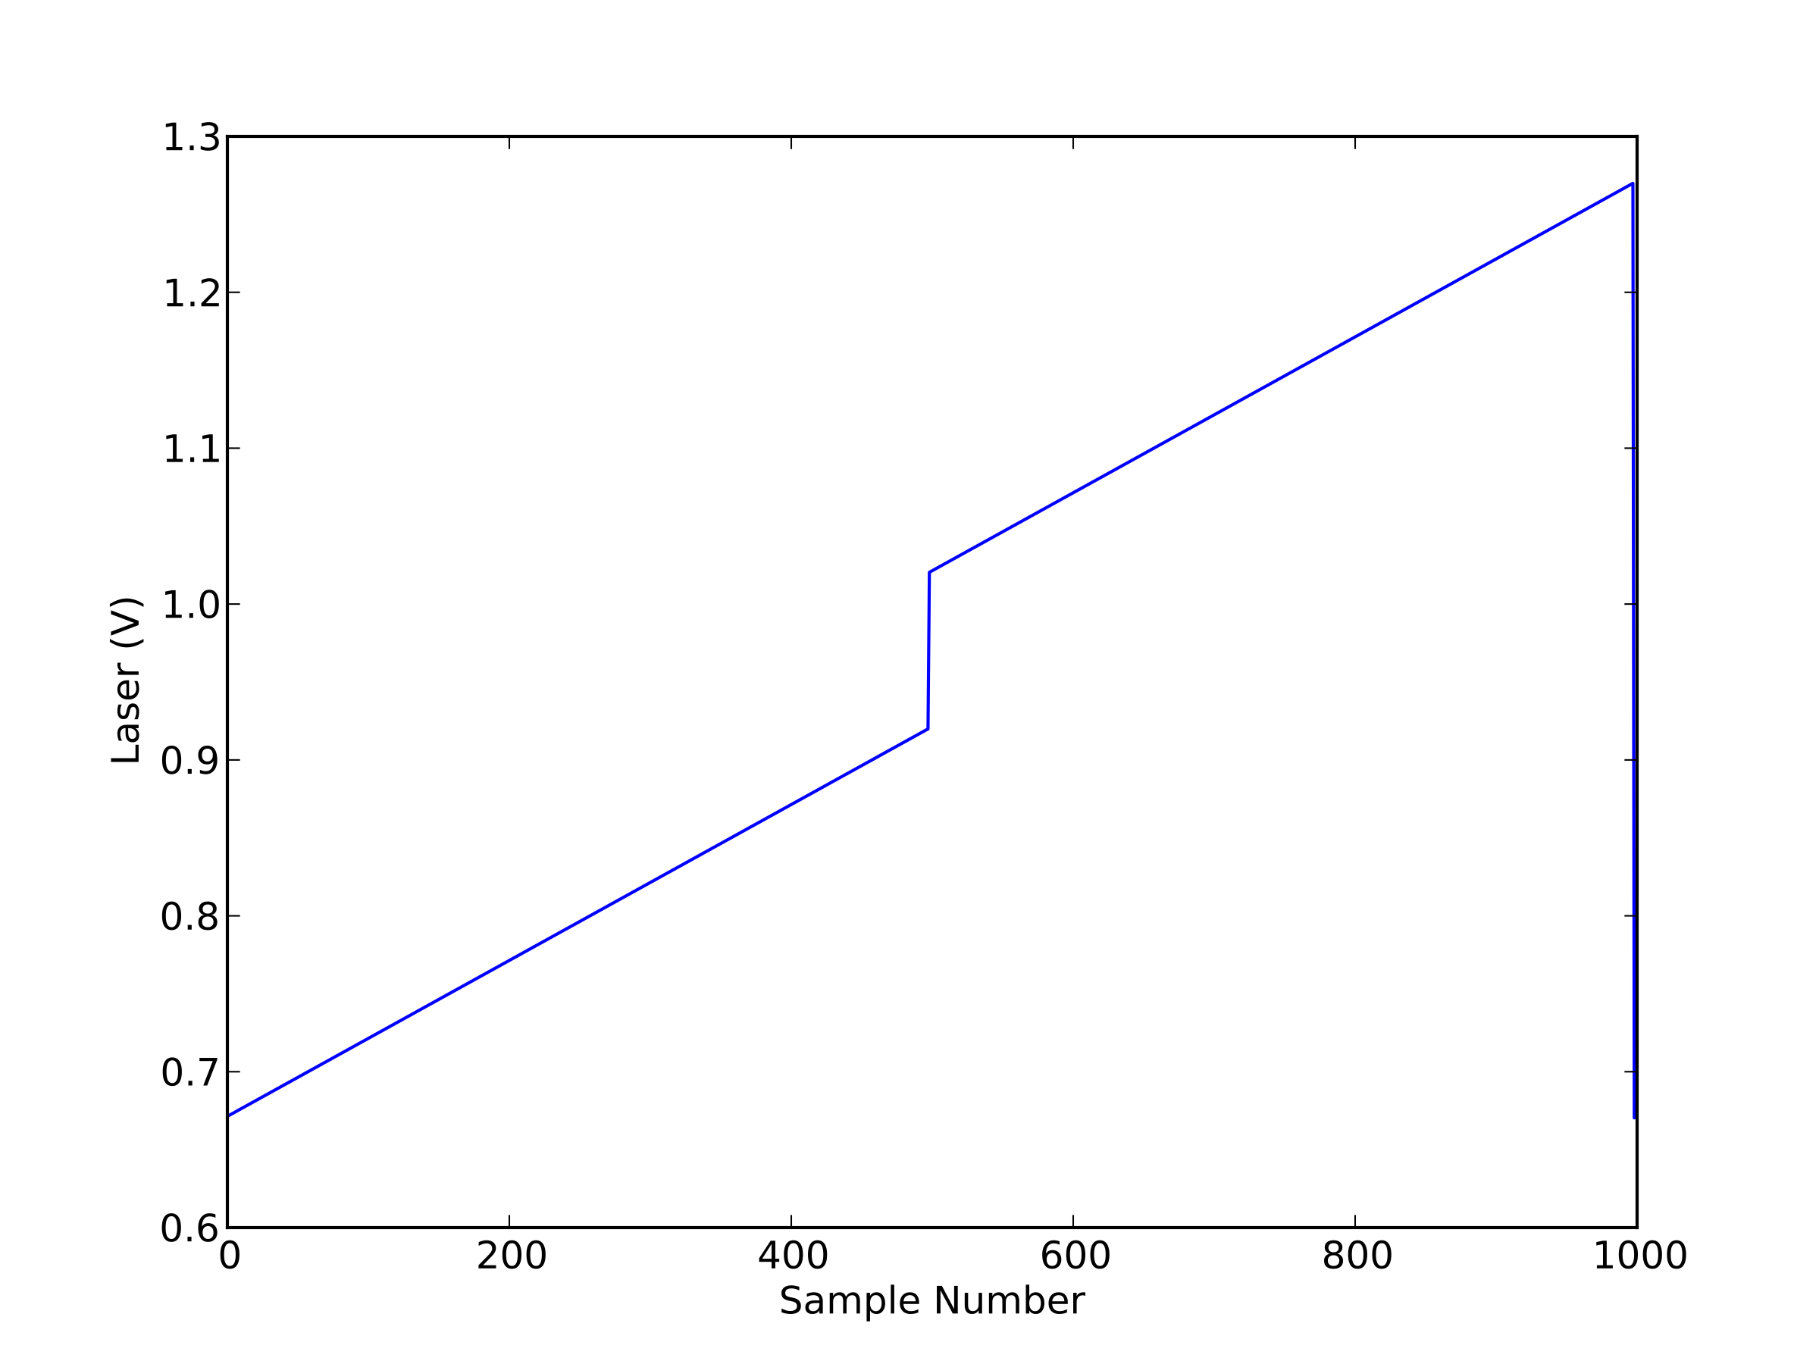

*Laser Output Waveform*

The use of a DAC allows for arbitrary waveforms to such as this to be programmed in software. This technique allows for the waveform to be continuously updated and for feedback based on the acquired signal. The maximum sample rate of the DAC is 1 MS/s.

Arbitrary output waveforms allow the system to acquire multiple lines simultaneously, or for a scan over a single absorption feature. Discreet jumps in the laser current are possible because of the large bandwidth of the vcsel.

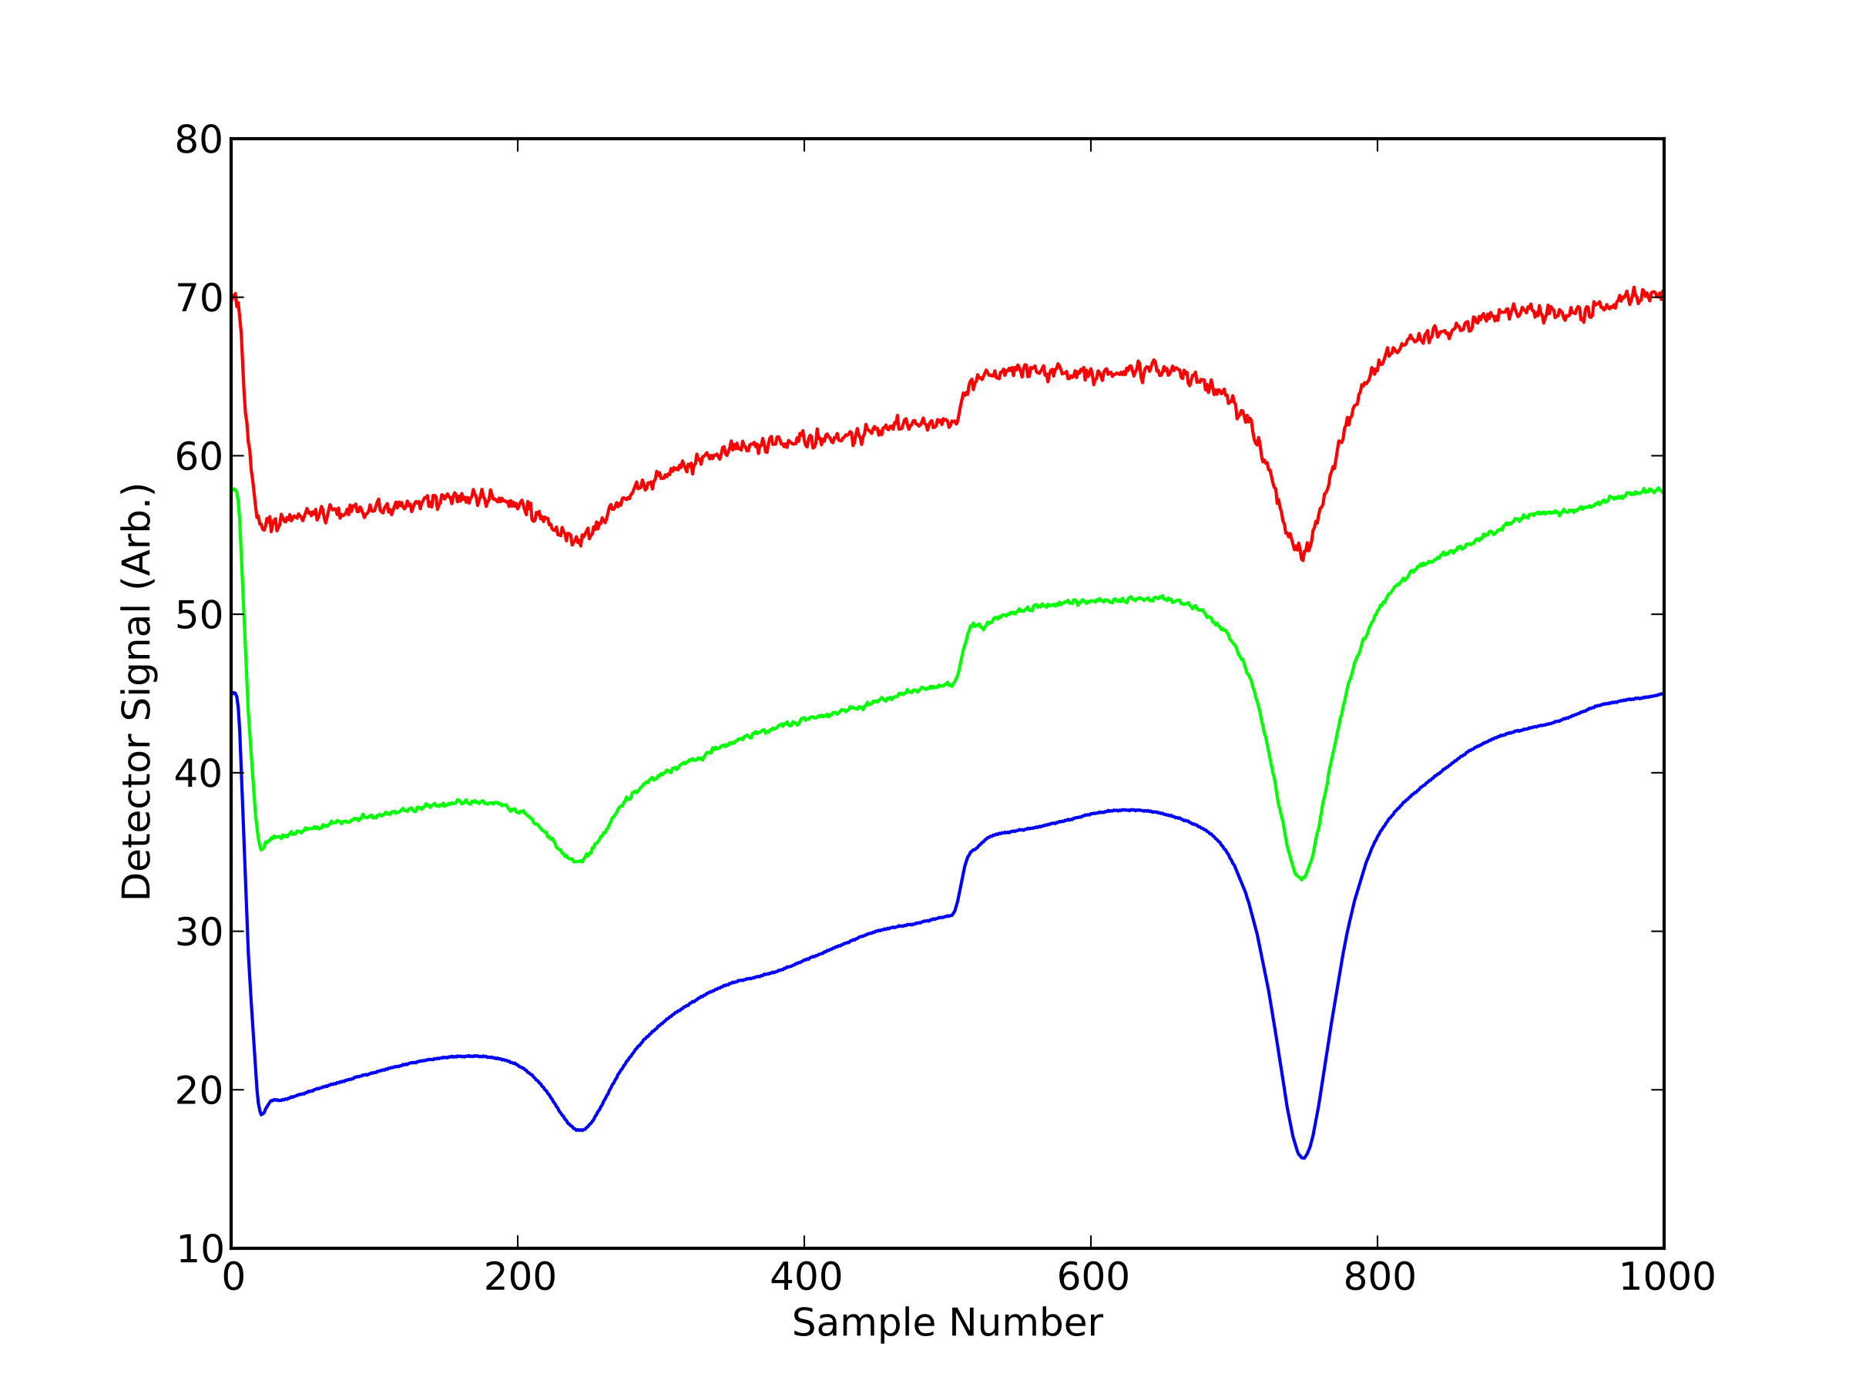

*signal-to-noise (direct absorption) -- 25 Hz data*

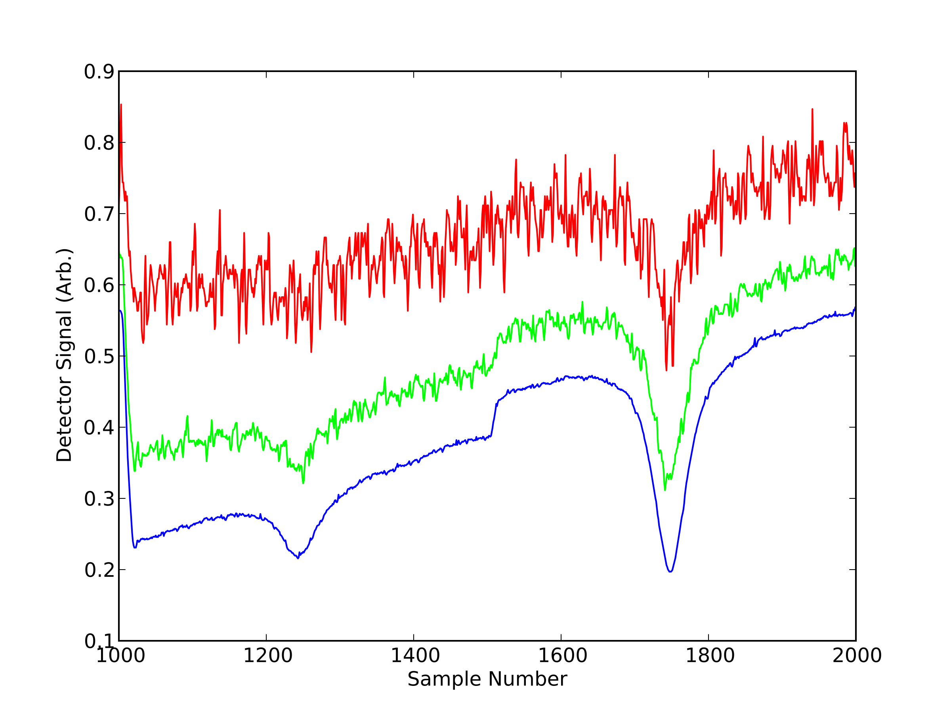

*signal-to-noise (direct absorption) -- 2 kHz data*

Sample spectra for differing laser intensities. The top panel shows 25 Hz data obtained from co-adding individual scans (80 samples) of the 2 kHz data in the bottom sample. Unattenuated data is shown by the blue line, with an attenuation factor of approximately a factor of 6 and 20 for the green and red lines, respectively.

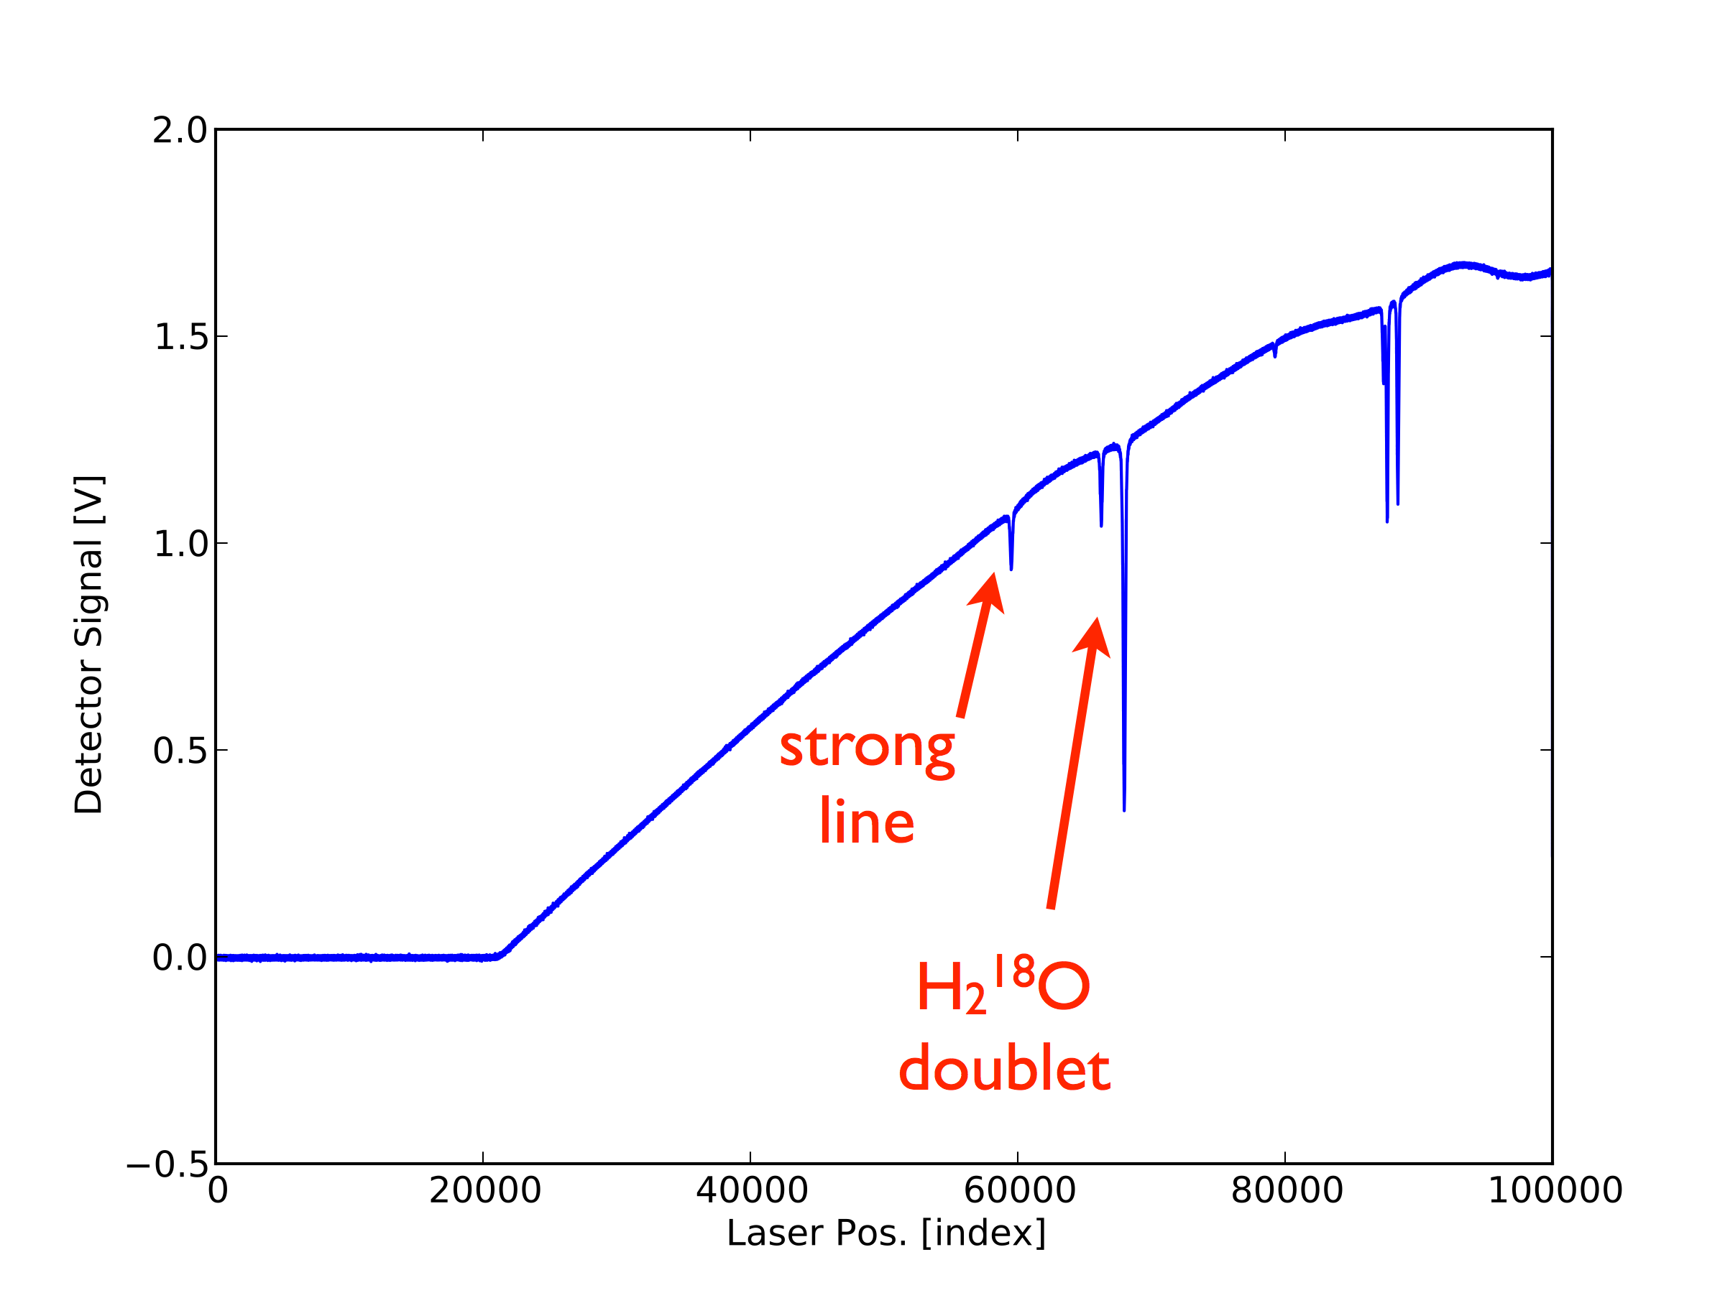

*Isotopic Reference Cell*

Spectrum of 97 % H18OH cell filled to 5 Torr. The "strong" H16OH line sits nearby the H18OH doublet.

In an external reference / lock-in cell configuration, the H18OH isotope lines can be used as a reference/calibration signal while the narrow (reduced pressure) H16OH lines provide a sharp wavelength reference to lock the laser wavelength to.

Since the H18OH is concentrated nearly 500 times above ambient, it is not subject to background interferences that the H16OH lines are from changes in ambient water vapor mixing ratios, and therefore provides a much more stable source by which the instrumental response can be normalized by.

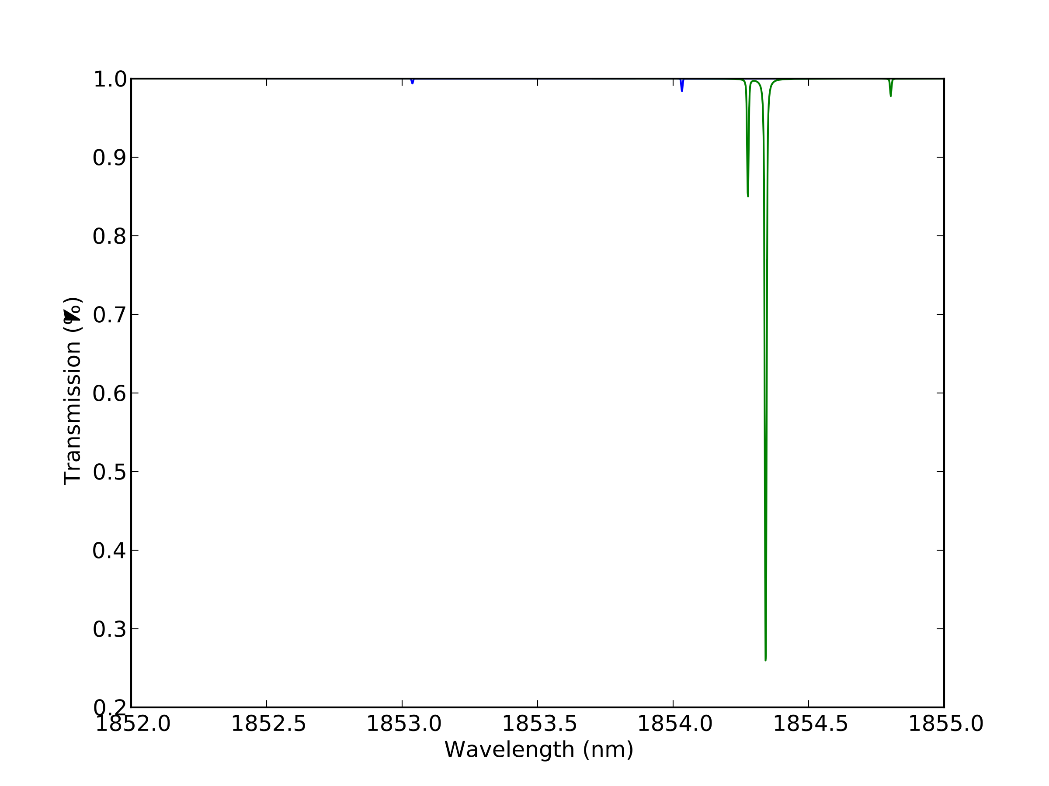

*H18OH reference cell with 1% H16OH spectrum*

Enhanced H18OH can be used as reference species. A spectra of 99% (commercially available) H18OH, with the remainder consisting of H16OH, at 4 Torr inside a 7.6 cm reference cell is shown above. H18OH is available at concentrations 495 times more concentrated than its natural variability.

While the contribution of H16OH to the total signal is small compared to H18OH, it's use in an inline configuration can pose challenges, particularly at the low mixing ratios that are characteristic of the upper troposphere [see: Ref Cell Contamination].

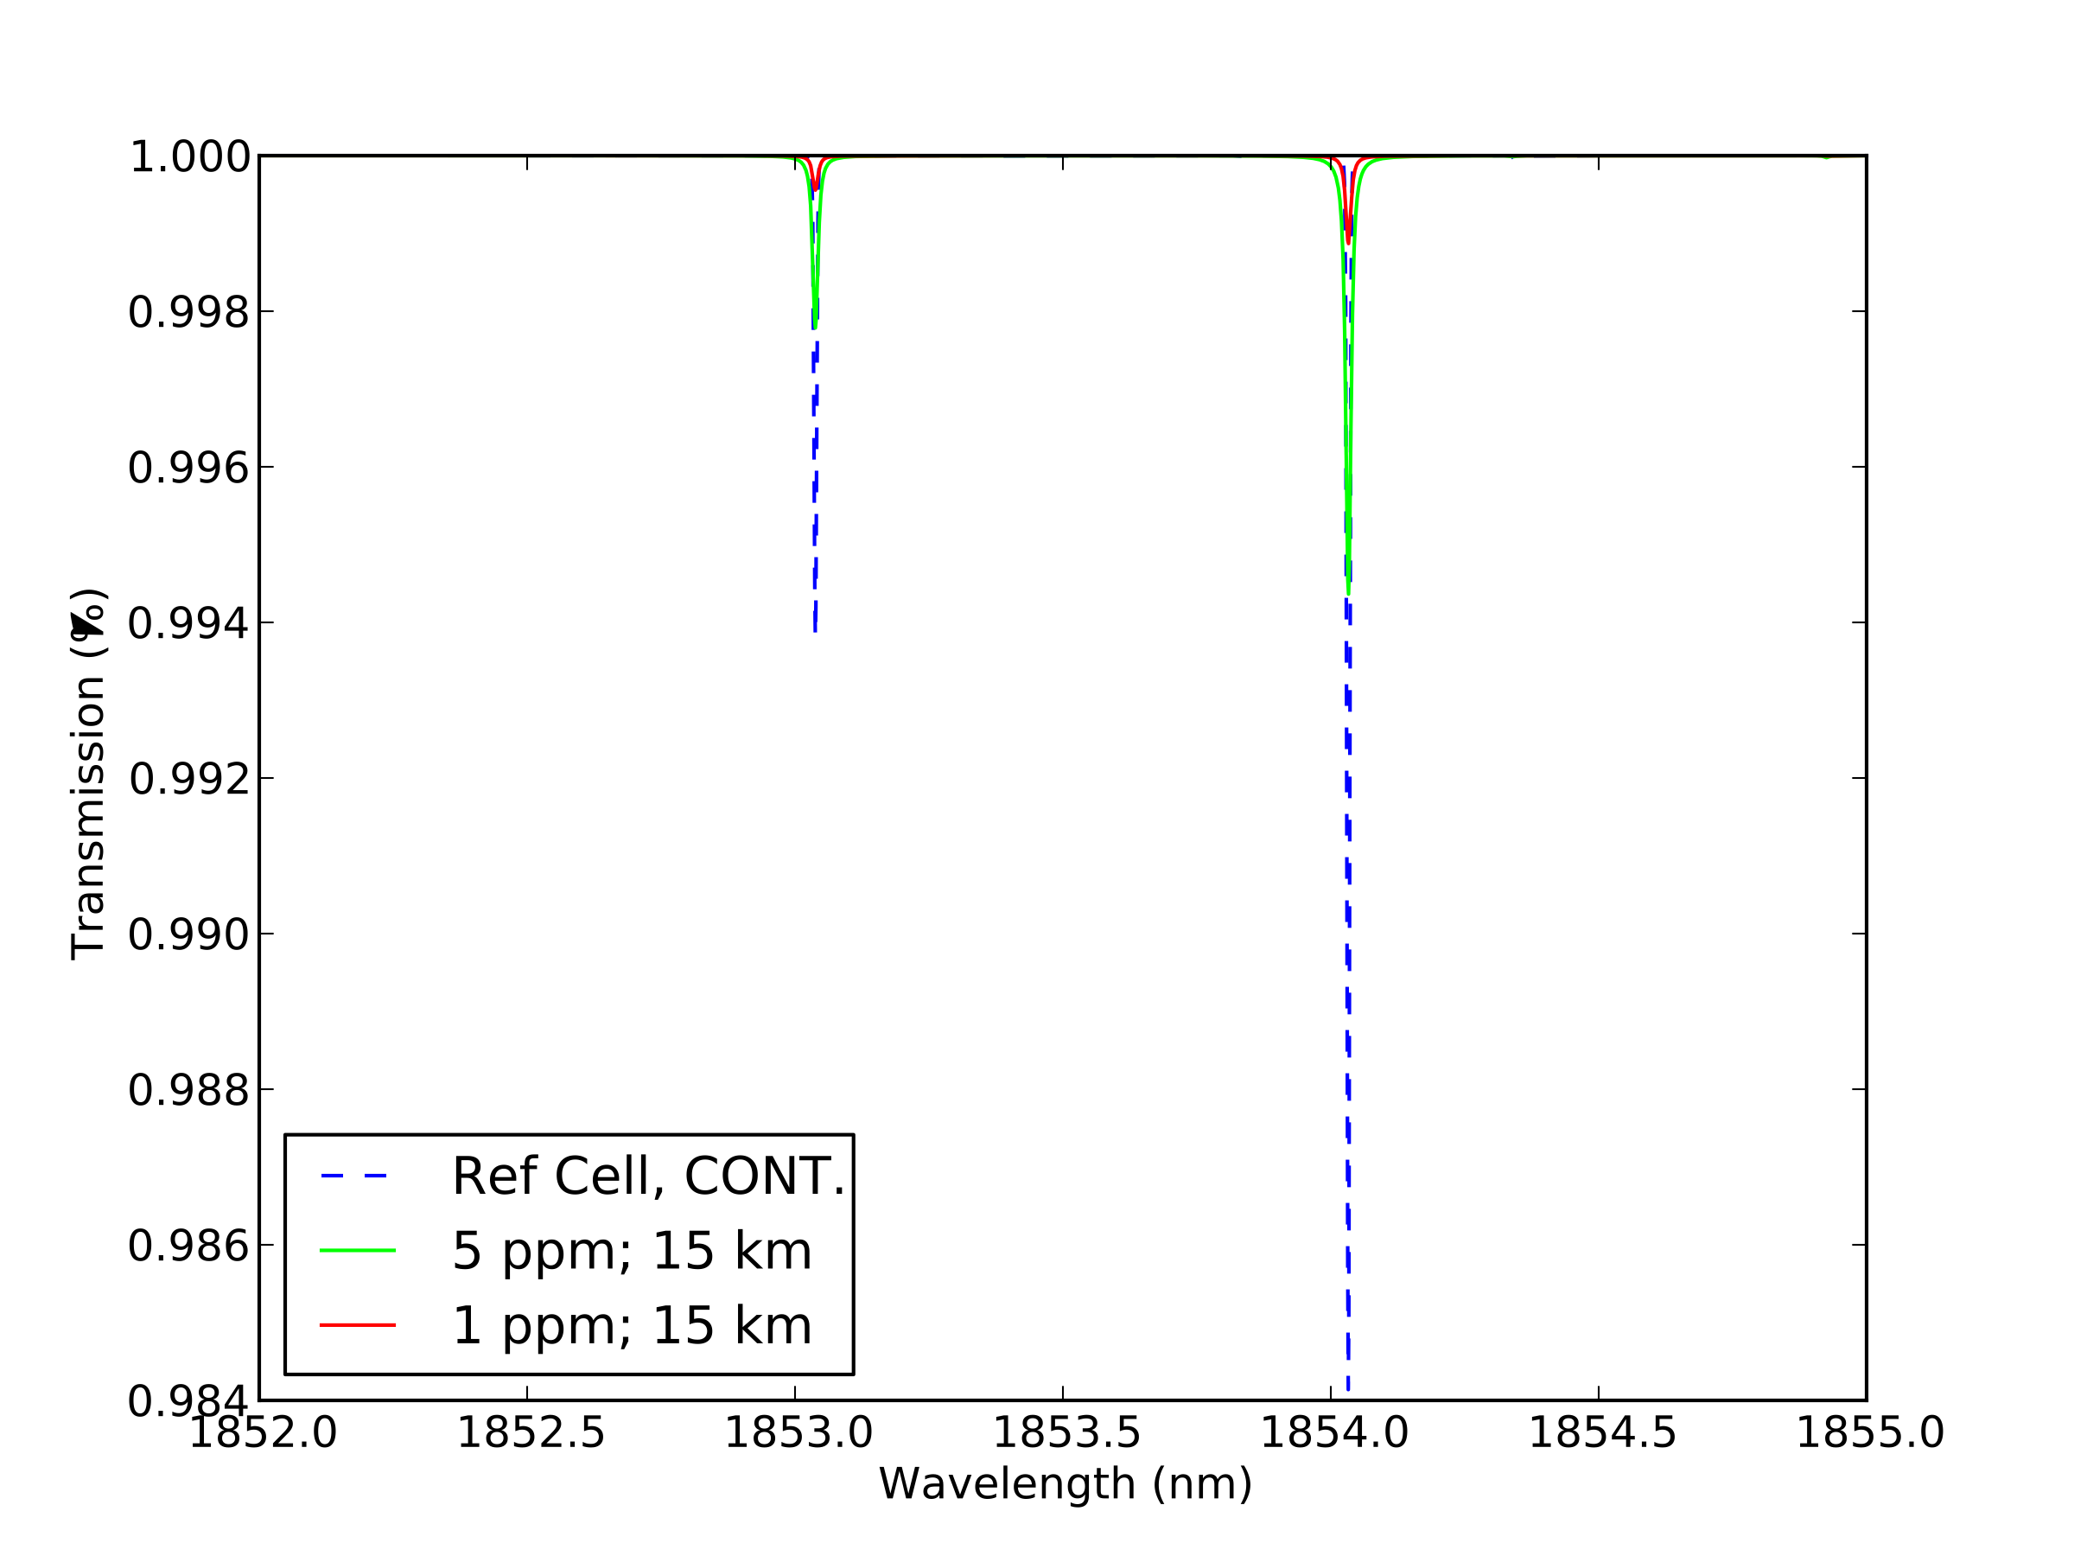

*Reference cell contamination at water vapor mixing ratios in the upper troposphere*

Residual H16OH in the reference cell is a strong interference of ambient H16OH. The H16OH contamination signal (blue dashed line) shown here is for a reference cell made of 99 % H18OH : 1 % H16OH at a pressure of 4 Torr, temperature of 293 K, and a path length of 76 mm. Ambient H16OH signals measured across a 4 m path for conditions typical of the upper troposphere are shown for reference.

The ratio of the line strength of H18OH : H16OH is 50 for the lines near 1.85 micron. At 1 ppmv at 15 km a 0.001 % transmission is obtained for the ambient H16OH "strong" line over a 4 m path length. In order to reduce the H16OH contamination to an order of magnitude below this ambient signal, the concentration of water in the reference must be reduced by a factor of 160. This corresponds to an absolute pressure of 0.023 Torr in the reference cell--equivalent to saturation mixing ratio obtained over ice at 221 K--and would still result in H18OH transmission of 0.009 % in the reference cell to be used as the reference signal.

Since the ambient H16OH signal changes significantly throughout the troposphere, and while the potential H16OH contamination can be mitigated, it becomes difficult to match the absorbance in the reference cell (H18OH) with the ambient H16OH signal in a single reference cell that would be suitable for use throughout the troposphere.

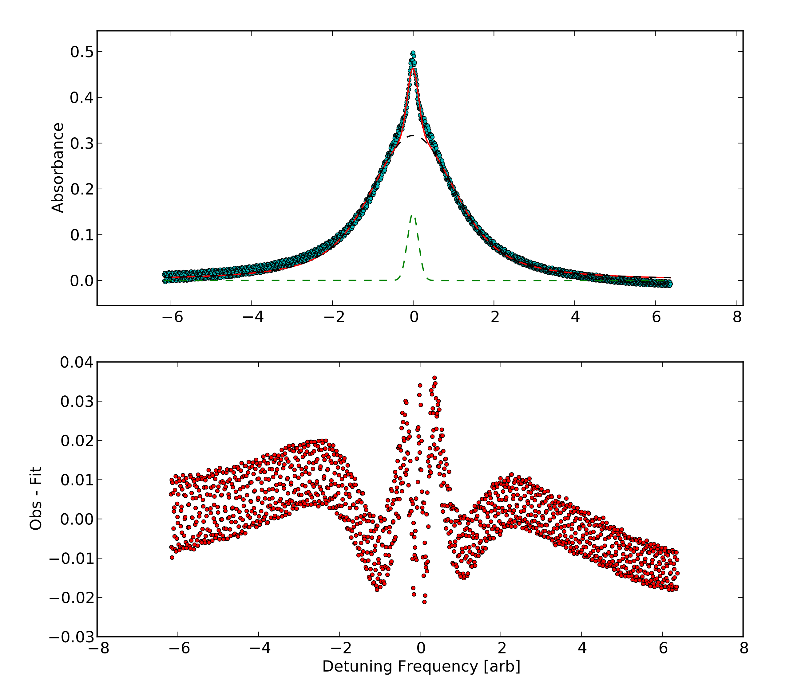

*Inline ref cell with ambient air (broadened) component -- fit and residual*

A spectrum of an ambient water line (P = 760 Torr) superimposed by one at reduced pressure (P = 10 Torr) acquired with an inline reference cell. Since the line-widths are very different, the two water vapor lines can be fit simultaneously. The full fit of a Gaussian superimposed on a larger Voigt background is shown by the solid red line; the individual Gaussian and Voigt components are shown by the dashed green and black lines, respectively; the acquired data is shown by the green circles. The bottom panel shows the residuals between the acquired data and the full fit.