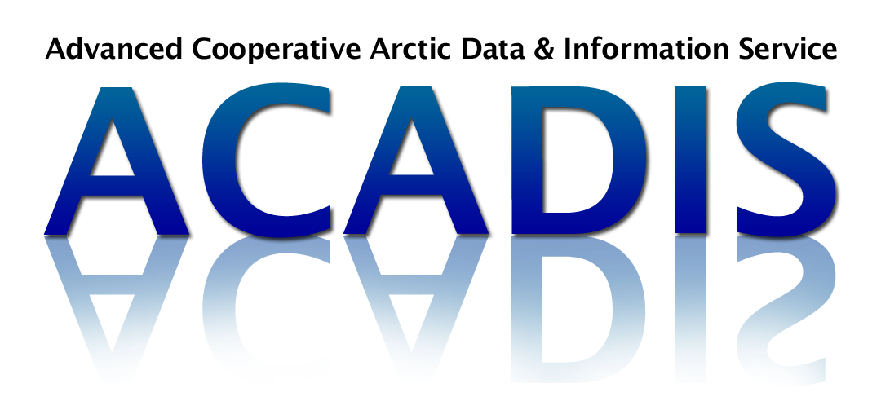
ACADIS Documentation Template

(Replace the text above with your dataset title)

Title
- This should match the dataset title
- Sufficiently descriptive (i.e. general content of dataset can be determined from title)
- Special characters allowed: $ - _ . ! * ' ( ) ,
- No more than 255 characters

Author(s):
- Full name(s) of authors of the dataset, listed in order, for use in a citation
- Full name(s) of any relevant associated personnel, if applicable
- For each author and associated person:
  - Include complete contact information: e-mail address, telephone number, mailing address and web page
  - Indicate his/her role (i.e. PI, Co-PI, Contributor, Metadata Contact, etc.)
  - Indicate his/her title, if available (e.g. Associate Scientist, Research Associate, Professor)
- Indicate corresponding author for data questions

Funding Source and Grant Number:
- List all funding agencies and associated award numbers (e.g. NSF xxxxxx)

Dataset Overview:
- Introduction or abstract - summarize the “who, where, what, when, and why” of the dataset
- Time period covered by the data
- Physical location of the measurements or platform, including:
  - Latitude (-90, 90)
  - Longitude (-180, 180)
  - Elevation/Depth
- Data source (e.g. for operational data include agency)
- Background information (e.g. is this dataset part of a larger experiment or collection? If so, please provide specific details)
- Any web address references (i.e. additional documentation such as Project web site, alternative data archive site)

Platform(s):
- Describe the platform(s) or site(s) from which the data were collected
- Include maps, images and links

Instrument(s):
- Describe each instrument with references, including:
  - Make, year, model, vendor, calibration and maintenance history, deployment information, geo-location
  - Table of specifications (i.e. accuracy, precision, frequency, etc.)
  - Table of operational periods as well as “down” periods (see Data Remarks below)
- Include figures, diagrams and links

Data Format:

File Information & Organization
- Data file type (e.g. column delimited ASCII, NetCDF, GIF, JPEG, etc.)
- File naming conventions (e.g. cruise_year_instrument_data-type_version.txt, instrument_data-type_begindate_enddate.nc)
- Data format and layout (e.g. description of header/data records, sample records)
Parameters, Flags & Codes
- List of parameters with units, sampling intervals, frequency, range
  - e.g. Climate and Forecast (CF) Metadata Convention standard names (http://cf-pcmdi.llnl.gov/documents/cf-standard-names/standard-name-table/25/cf-standard-name-table.html) for measurement types
- Description of flags, codes used in the data, and definitions (i.e. good, questionable, missing, estimated, etc.)
Version
- Data version number and date

Data Collection, Processing & Methodology:
- Description of:
  - Data collection and processing techniques and software used
  - Derived parameters and methods
  - Quality assurance and quality control procedures

Data Remarks:
- PI's assessment of the data (i.e. disclaimers, instrument problems, uncertainty information, data limitations, quality issues, etc.)
- Missing data periods
- Software compatibility (i.e. list of existing software (include version number if applicable) to view/manipulate the data)
  - Include web page, copy of code or reference for less common and/or home-grown software

References:
- List references for materials cited in this dataset documentation
- List publication references that make use of these data in scientific study
- Include any DOIs or links to online resources

