**Description of hbin.ctl and isotope.ctl file contents for Sfit4 v1.0**

**Update : November 2018 -JWH**

Now accommodates HITRAN 16

1. CO2 has 12 isotopes , we map these:
   1. 0 -> 10
   2. A -> 11
   3. B -> 12

**Update : 4 December 2012- JWH**

***For beta version b003.991 beta and higher.***

***Note don’t mix input files and the HITRAN directory tree of different versions. Use only b3.991 or later!***

This document describes the files and directories required to create the binary hitran data input file for sfit4.

Components:

Hbin.f90 – FORTRAN code that creates a binary hitran linelist file for a specific sfit4 run. It is compiled along with sfit4. It uses many of the same modules. It compiles to hbin.

Input:

1. hbin.ctl – a list of the HITRAN and Galatry input files
2. sfit4.ctl - defines the bandpasses
3. isotope.input – if this is engages via logical switch in sfit4.ctl then it is read too. Isotopes are separated at this level so sfit4 does not perform this task.
4. Linelist/ - is a fixed directory structure providing for 99 gases (don’t mix versions)

Output:

1. LLLLL.llllll-HHHHH.hhhhhh.hbin – this is a binary file with all HITRAN data, line-mixing data, Galatry data and separated isotopes for this run of sfit. LLLLL.llllll is the lowest wavenumber from all bandpasses and HHHHH.hhhhhh is the highest.
2. LLLLL.llllll-HHHHH.hhhhhh.hasc – this is for a sanity check to see what lines are in the .hbin file – someday we’ll make its creation an option.

hbin builds a linelist file from HITRAN by-molecule files, pseudo line list files, line-mixing data files and Galatry beta files. It reads faster then previous ascii files. It will contain only lines required for the bandpasses in a given fit. It does not require rerunning for each sfit run, if the microwindows are not changed. Please compare figure 1 for how the xxx-xxx.hbin file is structured.

The extra space is calculated :

d_out = 10.5/band.x.opd_max + 4.0 [1/cm]

F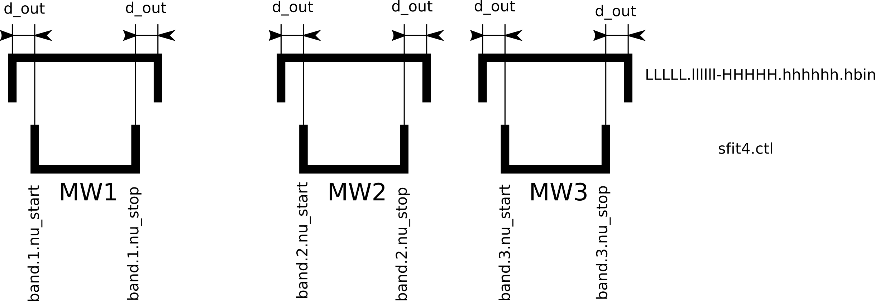igure 1: Structure of LLLLL.llllll-HHHHH.hhhhhh.hbin. For the definition of d_out see text.

A new xxx-xxx.hbin needs to be calculated if the microwindows in sfit4.ctl get beigger than the ones in the xxx-xxx.hbin file.

Directory structure

Dirs look like this:

001_H2O/01_hit09.par

002_CO2/02_hit08_f53.par

.

.

.

The first 3 digits of the molecule sub-directory in the linelist directory structure is the key to the gas names and the molecule id numbers and need to match the HITRAN gas file in that directory and the gas ID in the reference.prf file and in molcparam.f90 and vibfcn.f90. For some gases the ‘HITRAN’ ID in the by-molecule file is not the same as the SFIT ID. Hbin will change it to these 3 digits from the directory name. All this is correct if you keep versions together and don’t change anything.

Data files for O2 CIA, CO2 line-mixing and HCl & HF Galatry parameters are included. See switches in sfit4.ctl to engage these parameters.

Tips:

See the hbin.input file for more details. hbin.input should be in the local directory where hbin is run. Its name is fixed and read only by hbin.f90.

To include/exclude certain gases from a fit include/exclude those pathnames from the hbin.input file. Change the number of gases at the top to reflect the new number of by-molecule files to search through.

Or to exclude looking at a file put a blank after the ‘/’ at the end of the sub-directory name in hbin.ctl.

hbin.ctl:

# hbin.input for Testing HITRAN 2016

#

# implemented in version b3.99:

# the linelist directory structure is the key to the gas names and the molecule id numbers

# those id's and names must be the same in the reference.prf file

# eg a files containing hitran lines is read from one subdir in linelist then the molid will be changed

# to the 2digit integer 0NN of the subdir name and assumed to be for gas 'abcdef' from subdir 0NN_abcdef

#

# Save an ascii (HITRAN format) list file (True / False)

file.out.ascii = T

#

# Path to the directory tree where the gas subdirectories are

#

#file.in.linelist = /home/mathias/linelist-core/

file.in.linelist = /Users/jamesw/FDP/sfit/400/linelist-core/

#

# Then the next lines are paths to each gas file that will be searched for lines in the

# desired wavenember region. The id numbers are in sfit order - not HITRAN, BUT KEEP

# these directory names the files are in HITRAN format. File names can be anything.

#

# Tip: put a blank after the '/' to skip that gas or just remove it (and decrease hitran.nr)

#

# 049_O2CIA/o2cia_20060420.101 - this file is a special case, molid & isotope

# ids are dealt with differently

#

# Number of path/files to look for

hitran.nr = 99

#

#

hitran.files =

001_H2O/001_H2O.hit16.20181107

002_CO2/002_CO2.hit16.20181107

003_O3/003_O3.hit16.20181107

004_N2O/004_N2O.hit16.20181107

005_CO/005_CO.hit16.20181107

006_CH4/006_CH4.hit16.20181107

007_O2/007_O2.hit16.20181107

008_NO/008_NO.hit16.20181107

009_SO2/009_SO2.hit16.20181107

010_NO2/010_NO2.hit16.20181107

011_NH3/011_NH3.hit16.20181107

012_HNO3/012_HNO3.hit16.20181107

013_OH/013_OH.hit16.20181107

014_HF/014_HF.hit16.20181107

015_HCL/015_HCl.hit16.20181107

016_HBR/016_HBR.hit16.20181107

017_HI/017_HI.hit16.20181107

018_CLO/018_ClO.hit16.20181107

019_OCS/019_OCS.hit16.20181107

020_H2CO/020_H2CO.hit16.20181107

021_HOCL/021_HOCl.hit16.20181107

022_HO2/033_HO2.hit16.20181107

023_H2O2/025_H2O2.hit16.20181107

024_HONO/

025_HO2NO2/

026_N2O5/2007.sudo.n2o5

027_CLONO2/2007.sudo.clono2

028_HCN/023_HCN.hit16.20181107

029_CH3F/

030_CH3CL/024_CH3Cl.hit16.20181107

031_CF4/2007.sudo.cf4

032_CCL2F2/2007.sudo.ccl2f2

033_CCL3F/2007.sudo.ccl3f

034_CH3CCL3/

035_CCL4/2007.sudo.ccl4

036_COF2/029_COF2.hit16.20181107

037_COCLF/2007.sudo.coclf

038_C2H6/027_C2H6.hit16.20181107

039_C2H4/038_C2H4.hit16.20181107

040_C2H2/026_C2H2.hit16.20181107

041_N2/022_N2.hit16.20181107

042_CHF2CL/2007.sudo.chf2cl

043_COCL2/049_COCl2.hit16.20181107

044_CH3BR/040_CH3Br.hit16.20181107

045_CH3I/

046_HCOOH/032_HCOOH.hit16.20181107

047_H2S/031_H2S.hit16.20181107

048_CHCL2F/

049_O2CIA/o2cia_20060420.101

050_SF6/2007.sudo.sf6

051_NF3/nf3.101.511.txt

052_N2CIA/

053_OTHER/

054_OTHER/

055_OTHER/

056_OTHER/

057_OTHER/

058_OCLO/

059_F134A/

060_C3H8/2005ppn.sudo.c3h8

061_F142B/2007.sudo.f142b

062_CFC113/2007.sudo.f113

063_F141B/

064_CH3OH/039_CH3OH.hit16.20181107

065_OTHER/

066_OTHER/

067_PAN/2007.sudo.pan

068_CH3CHO/2007.sudo.ch3cho

069_CH3CN/041_CH3CN.hit16.20181107

070_OTHER/

071_CH3COOH/ch3cooh_1100_pll.txt

072_C5H8/c5h8_885_pll.txt

073_MVK/mvk_910_pll.txt

074_MACR/macr_890_pll.txt

075_C3H6/c3h6_850_pll.txt

076_C4H8/c4h8_750_pll.txt

077_OTHER/

078_OTHER/

079_OTHER/

080_OTHER/

081_OTHER/

082_OTHER/

083_OTHER/

084_OTHER/

085_OTHER/

086_OTHER/

087_OTHER/

088_OTHER/

089_OTHER/

090_OTHER/

091_OTHER/

092_OTHER/

093_OTHER/

094_OTHER/

095_OTHER/

096_OTHER/

097_OTHER/

098_OTHER/

099_OTHER/

#

#

# Galatry parameters

# molecule id numbers in these files have to match the sfit molecule id

aux = gal sdv

# gal sdv lm

aux.gal.nr = 2

aux.gal.files =

014_HF/14_hit16_Galatry.txt

015_HCL/15_hit16_Galatry.txt

#

# Speed Dependent Voigt parameter files

aux.sdv.nr = 1

aux.sdv.files =

005_CO/05_hit16_SDV.txt

#

#

# Line mixing parameters

aux.lm.nr = 1

aux.lm.files =

002_CO2/002_CO2.hit16_LM1ST.par

#

#