Heating and Cooling terms not included in the current write up

Note the 1.602 x 10⁻¹² is to convert from electron volts to ergs

Heating as a result of dissociation of O₂

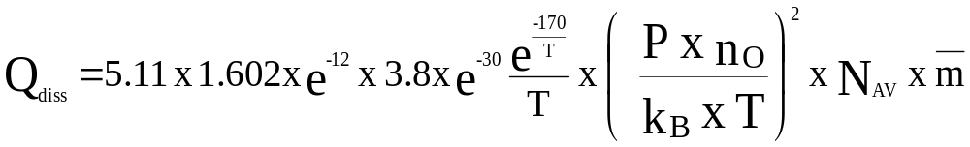
Where N_{av} is Avagadros number, P is pressure, n_{O} is the number density of O, k_{B} is Boltzman’s constant, T is temperature and m¯ is the mean molecular mass

Photoelectron Heating

Where q_{ioniz} is the ionization rate

Where q_{ioniz} is the ionization rate

Heating resulting from ion chemistry is of the type:

Where n_{neutral} is the number density of the neutral species, n_{i} is the number density of the ion species, r_{k} is the reaction rate, and heat is the heat emitted by the reaction (see the Chemistry section). Note the factor 10¹⁰ is included to remove the 10⁻¹⁰ in the Chemistry section

Heating resulting from the neutral chemistry of the minor species

Where β is the reaction rate

Heating from electron-neutral and electron-ion collisions

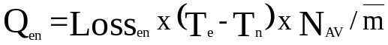

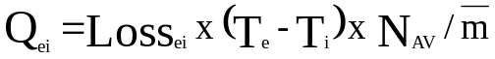

Loss Terms

NO Cooling

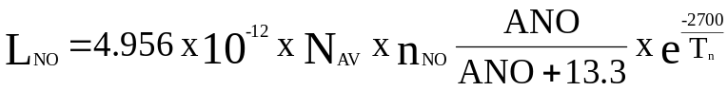

Where

CO₂ Cooling

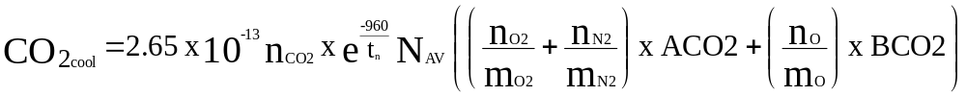

Where

ACO2 = 2.5 x 10⁻¹⁵ ^{T}_{n} < 200 K (needs checking)
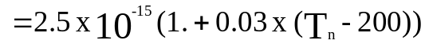 ^{T}_{n} > 200 K

BCO2 = 1.0 x 10⁻¹² ^{T}_{n} < 300 K

BCO2 = 1.0 x 10⁻¹² x T_{n}/300 ^{T}_{n} > 300 K

O(³P) Cooling (this in particular may be quite different now?)

XO is a pressure level dependent set of coefficients (may have changed)

XO = {3 x 0.01, 0.05, 0.1, 0.2, 0.4, 0.55, 0.7, 0.75, 15 x 0.0}

ANO3P is a 3 element array of constants

ANO3P = {1.67 x 10⁻¹⁸ , 0.6, 0.2)

BNO3P is a 3 element array of constants

BNO3P = {228, 228, 325)

