DRAFT

The NCAR Distributed Hydrological Modeling System (NDHMS)
User’s Guide and Technical Description

Version 1.1

Originally Created:
March 10, 2010

Updated:
March 26, 2012

David J. Gochis
Wei Yu
David N. Yates

DRAFT

Table of Contents

ACKNOWLEDGEMENTS

Introduction:
Brief History
Model requirements

Model Physics Description:
Overview
Land model description
Terrain routing descriptions
Channel and lake routing description
Baseflow/Groundwater model description

Model Technical Description and User Guide:
Description of code
Setup and execution of uncoupled NDHMS code
Comment on Cold start (arbitrary initial conditions vs. RESTART)
Setup and execution of coupled WRF-NDHMS code

NDHMS Input and Output Data structures:
Domain processing
Description of input files
Description of output files
Description of parameter files
Description of namelist file

APPENDICES:
NDHMS model namelist description
Vegetation parameter table (VEGPARM.TBL)
Soil parameter table (SOILPARM.TBL)
General parameters table (GENPARM.TBL)
Channel parameters table (CHANPARM.TBL)
Lake parameters table (LAKEPARM.TBL)
Groundwater/baseflow bucket model parameters table (GWBUCKPARM.TBL)
Forcing data netcdf file header
Land model output netcdf file header
High-resolution terrain model netcdf file header
Channel observation point netcdf file header
Channel network point netcdf file header
Lake point netcdf file header
Land fluxes ASCII output file (lnd_fluxes.txt)
Channel inflow ASCII output file (chan_inflow.txt)
Forecast/observation point ASCII output file (frxst_pts.txt)
Groundwater inflow ASCII output file (GW_inflow.txt)
Groundwater outflow ASCII output file (GW_outflow.txt)
Groundwater level ASCII output file (GW_zlevtxt)

ACKNOWLEDGEMENTS

The development of the NCAR Distributed Hydrological Modeling System (NDHMS) has been significantly enhanced through numerous collaborations. The following persons are graciously thanked for their contributions to this effort:

John McHenry and Carlie Coats of Baron Advanced Meteorological Services
Martyn Clark and Fei Chen, National Center for Atmospheric Research
Zong-Liang Yang, Cedric David and David Maidment of the University of Texas at Austin
Harald Kuntsmann, Benjamin Firsch and Thomas Rummler of Karlsruhe Institute of
Technology, Garmisch-Partenkirchen, Germany
Ismail Yucel (XXX Turkey)
Erick Fredj and Amir Givati, XXXX, Israel
Antonio Parodi, CIMA, Genoa, Italy
Blaine XXXX (U.S. Bureau of Reclamation)

Funding support for the development and application of the NDHMS has been provided by:

The National Science Foundation and the National Center for Atmospheric Research
Baron Advanced Meteorological Services
National Aeronautics and Space Administration (NASA)
National Oceanic and Atmospheric Administration (NOAA) Office of Hydrological Development (OHD)
Introduction
The purpose of this technical note is to describe the physical parameterizations, numerical implementation, coding conventions and software architecture for the NCAR Distributed Hydrological Modeling System (NDHMS). Chapters 1-4 provide the historical development of the NDHMS along with descriptions of the currently configured land surface model (Chapter 2), terrain routing algorithms (Chapter 3), channel and reservoir routing algorithms (Chapter 4) and a simple, empirical baseflow algorithm (Chapter 5). Chapters 6-10 provide detailed descriptions of the input and output datasets, procedures for pre-processing model input fields required for routing operations and model parameter and namelist datafiles. Coding conventions, steps for model implementation in both uncoupled NDHMS and coupled WRF-NDHMS are provided in Chapters 11-13 respectively. Lastly, examples and descriptions of all major input, output, parameter and namelist files are provided in the Appendices.

Brief History
The NCAR Distributed Hydrological Modeling System is a fully distributed, 3-dimensional, variably-saturated flow model built upon a modularized FORTRAN90 software architecture. Initially, the implementation of terrain routing and, subsequently, channel and reservoir routing functions into the 1-dimensional Noah land surface model was motivated by the need to account for increased complexity in land surface states and fluxes and to provide physically-consistent land surface flux and stream channel discharge information for hydrometeorological applications. The original implementation of the surface overland flow and subsurface saturated flow modules into the Noah land surface model were described by Gochis and Chen (2003). In that work, a simple subgrid disaggregation-aggregation procedure was employed as a means of mapping land surface hydrological conditions from a ‘coarsely’ resolved land surface model grid to a much more finely resolved terrain routing grid capable of adequately resolving the dominant local landscape gradient features responsible for gravitational redistribution of terrestrial moisture. Since then numerous improvements to the Noah-distributed model have occurred including optional selection for 2-dimensional (in x and y) or 1-dimensional (‘steepest descent’ or so-called ‘D8’ methodologies) terrain routing, a 1-dimensional, grid-based routing model, a reservoir routing model, and a simple empirical baseflow estimation routine. Furthermore the entire new modeling system, now referred to as the NCAR Distributed Hydrological Modeling System (NDHMS) has recently been coupled to the Weather Research and Forecasting (WRF) mesoscale meteorological model (Skamarock et al., 2005) thereby permitting a physics-based, fully coupled land surface hydrology-regional atmospheric modeling capability for use in hydrometeorological and hydroclimatological research and applications. The code has been fully parallelized for high-performance computing applications. During late 2011 and early 2012, the NDHMS code underwent a major re-configuration of its coding structures to facilitate greater and easier extensibility and upgradability. The new code and directory structure implemented is reflected in this document.

As additional changes and enhancements to the NDHMS occur they will be documented in future versions of this document.

Model Requirements
The 3-dimensional, NDHMS has been developed to represent the spatial redistribution of overland flow and shallow saturated subsurface soil moisture. Switch-activated modules enable treatments of terrestrial hydrological physics (see Figure 2), which have etiher been created or have been adapted from existing distributed hydrological models.

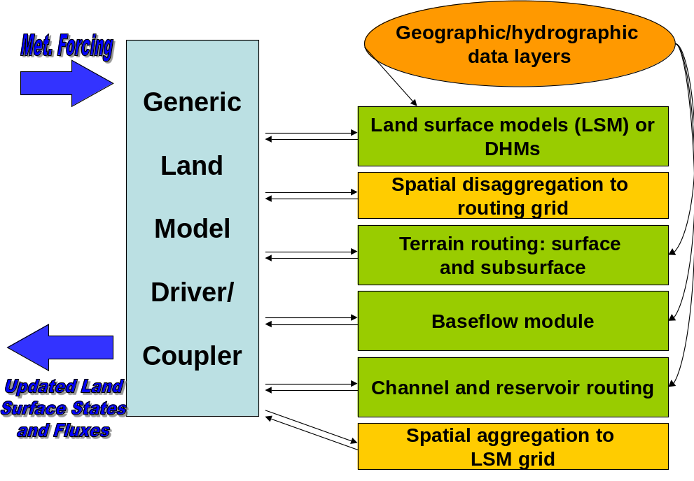

Figure 1. Schematic of the Noah-distributed model architecture showing the various model components.

The NDHMS is designed to simulate land surface hydrology and energy states and fluxes at a fairly high spatial resolution (typically 1 km or less) using physics based approaches. As such, it is intended to be used as a land surface model in both stand-alone (‘uncoupled’ or ‘offline’) and fully-coupled (to and atmospheric model) configurations. Both time-evolving (‘forcing’) and static input datasets are required for model operation. The exact specification of both forcing and static data depends greatly on the selection of model physics options to be used. The principle model physics options include:

Table 1. Model physics options
- 1-dimensional land surface parameterization (currently only the ‘Noah’ LSM is available)
- surface overland flow option
- saturated subsurface option
- channel routing option
- reservoir routing option
- empirical baseflow option

Since only one land surface model option is available for use in the current version of the NDHMS, the rest of this document will focus on its implementation. Future versions will include other land surface model options.

Like nearly all current land surface models, the one-dimensional Noah land surface parameterization requires a few basic meteorological forcing variables including:

Table 2. Input forcing data for the Noah LSM

Incoming shortwave radiation (W/m²)
Incoming longwave radiation (W/m²)
Specific humidity (kg/kg)
Air temperature (K)
Surface pressure (Pa)
Near surface wind in the u- and v-components (m/s)
Liquid water precipitation rate (mm/s)

[Different land surface models may require other or additional forcing variables or the specification of forcing variables in different units.]

When coupled to the WRF regional atmospheric model the forcing data is provided by the atmospheric model with a frequency dictated by the land surface model time-step specified in WRF. When run in a stand-alone mode, these forcing data must be provided as gridded input time series. External, third party, Geographic Information System (GIS) tools are used to delineate a stream channel network, open water (i.e., lake, reservoir, and ocean) grid cells and baseflow basins. Water features are mapped onto the high-resolution terrain-routing grid and post-hoc consistency checks are performed to ensure consistency between the coarse resolution Noah land model grid and the fine resolution terrain and channel routing grid. Further details on the preparation of forcing data for stand-alone NDHMS execution is provided in Chapter XX.

The NDHMS calculates fluxes of energy and moisture either back to the atmosphere or as stream and river channel fluxes. Depending on the physics options selected, the primary output variables include:

Table 3. Output data from the NDHMS:

Surface latent heat flux
Surface sensible heat flux
Ground surface and/or canopy skin temperature
Surface evaporation components (soil evaporation, transpiration, canopy water evaporation, snow sublimation and ponded water evaporation)
Soil moisture
Soil temperature
Deep soil drainage
Surface runoff
Canopy moisture content
Snow depth
Snow liquid water equivalent
Stream channel inflow (optional with terrain routing)
Channel flow rate (optional with channel routing)
Channel flow depth (optional with channel routing)
Reservoir height (optional with channel routing)

The NDHMS utilizes a combination of netcdf and flat ASCII file formats for input and output and therefore requires that netcdf libraries be installed on the local machine executing the simulations. For information regarding netcdf data structures and where to obtain netcdf libraries please visit the official netcdf website hosted by UNIDATA at:

Computational/Hardware Requirements
The NDHMS has been developed on a LINUX-based computing platform using Portland Group FORTRAN90 compilers. To date the only other platform the model has been ported to is the IBM supercomputer ‘bluefire’ located at NCAR and not been rigorously tested on other platforms. When run in full hydrologic simulation mode, with all attendant process modules activated (e.g. overland and subsurface routing, channel and reservoir routing, and baseflow) the NDHMS is a moderately computationally-intensive modeling system with respect to other physics-based environmental modeling systems (e.g. weather models climate models, catchment hydrology models and other geophysical fluid dynamics models). However, computational requirements scale exponentially as functions of domain size and spatial resolution. Thus there are no firm rules on minimum computational requirements in terms of processor speed or memory allocation. Indeed it is possible and relatively straightforward to set up and execute simple runs over small basins using a single processor machine with a few hundred megabytes of disk space. However, the NDHMS was designed for large domain, high-resolution applications which require significant computational, memory and disk storage resources. With these applications in mind, the NDHMS has been fully parallelized to run on high performance computing systems. Detailed information of parallel computing applications is provided in Chapter XXX.

The Fortran90 modular architecture of Noah-d allows for extensibility and compatibility of existing and newly developed parameterizations. Input/output is handled using netCDF data protocols, which enable easy visualization and analysis using an array of readily available software packages (e.g. GrADS, Unidata’s IDV, IDL, MATLAB, ncl). The open architecture is highly advantageous for community-based modeling systems where development occurs in geographically disparate locations. Details on the computational requirements of Noah-d are discussed in Section 2 and details on the compilation and makefile structures are provided in Sections 4 and 7 for sequential (single processor) and parallel (multiple processor) applications, respectively.

Model Physics Description
This chapter describes the physics behind each of the modules of the NDHMS, which include the 1-dimensional land surface model, the overland routing routine, the saturated subsurface routing routine, the 1-dimensional channel routing routine, the reservoir routing module and a simple empirical baseflow routing routine. Details on the use of these modules within the NDHMS are discussed in Chapter XXXX.

General Description
As of this writing, only the Noah-distributed land surface model has been coupled into the NDHMS. The 1D Noah LSM calculates the vertical fluxes of energy (sensible and latent heat, net radiation) and moisture (canopy interception, infiltration, infiltration-excess, deep percolation, ponded water depth) and soil thermal and moisture states. Infiltration excess, ponded water depth and soil moisture are subsequently disaggregated from the 1D Noah LSM grid, typically of O(1–4 km) spatial resolution, to a high-resolution, O(30–100 m) routing grid using a time-step weighted method (Gochis and Chen, 2003) and are passed to the subsurface and overland flow terrain-routing modules. In typical U.S. applications, land cover classifications for the 1D Noah LSM are provided by the USGS 24-type land cover product of Loveland et al. (1995); soil classifications are provided by the 1-km STATSGO database (Miller and White, 1998); and soil hydraulic parameters that are mapped to the STATSGO soil classes are specified by the soil analysis of Cosby et al. (1984). As discussed in Chapter XX, it is possible to use other land cover and soils datasets.

Subsurface lateral flow in the NDHMS is calculated prior to the routing of overland flow (Figure 3) to allow exfiltration from fully saturated grid cells to be added to the infiltration excess calculated from the LSM. The method used to calculate the lateral flow of saturated soil moisture is that of Wigmosta et al. (1994) and Wigmosta and Lettenmaier (1999), implemented in the Distributed Hydrology Soil Vegetation Model (DHSVM). It calculates a quasi-3D flow, which includes the effects of topography, saturated soil depth, and depth-varying saturated hydraulic conductivity values. Hydraulic gradients are approximated as the slope of the water table between adjacent grid cells in either the steepest descent or in both x- and y-directions. The flux of water from one cell to its down-gradient neighbor on each time-step is approximated as a steady-state solution.

The saturated subsurface routing of Wigmosta et al. (1994) has no explicit information on soil layer structure: it treats the soil as a single homogeneous column. Typically, a minimum of eight soil layers are used in a 2-meter soil column used in NDHMS; the original Noah LSM has four. The additional discretization permits improved resolution of a time-varying water table height. NDHMS specifies the water table depth according the depth of the top of the saturated soil layer that is nearest to the surface.
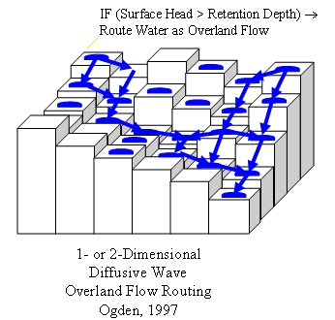
Figure 3: Overland flow outing modules in Noah-d

The fully unsteady, spatially explicit, diffusive wave formulation of Julien et al. (1995-CASC2D) with later modification by Ogden (1997) represents overland flow, which is calculated when the depth of water on a model grid cell exceeds a specified retention depth. A schematic representation of the grid-cell routing process is shown in Figure 3. The diffusive wave equation accounts for backwater effects and allows for flow on adverse slopes (Ogden, 1997). As in Julien et al. (1995), the continuity equation for an overland flood wave is combined with the diffusive wave formulation of the momentum equation. Manning’s equation is used as the resistance formulation for momentum and requires specification of an overland flow roughness parameter. Values of the overland flow roughness coefficient used in NDHMS were obtained from Vieux (2001) and were mapped to the existing land cover classifications provided by the USGS 24-type land-cover product of Loveland et al. (1995), which is the same land cover classification dataset used in the 1D Noah LSM.

Additional modules have also been implemented to represent stream channel flow processes, lakes and reservoirs and stream baseflow. In NDHMS v1.1 inflow into the stream network and lake and reservoir objects is a one-way process. This current formulation implies that stream and lake inflow is always positive to the stream or lake element. There currently are no channel or lake loss functions where water can move from channels or lakes back to the landscape. Channel flow in NDHMS is represented by routing a 1-dimensional diffusive wave through a gridded channel network. Water passing into and through lakes and reservoirs is routed using a simple level pool routing scheme. Baseflow, to the stream network, is represented using a simple, empirically-based bucket model which obtains ‘drainage’ flow from the spatially-distributed landscape. Discharge from baseflow buckets is input directly into the stream using an empirically-derived storage-discharge relationship. Each of these process options are enabled through the specification of switches in the model namelist file.

Noah land surface model description
The Noah land surface model is a state of the art, community, 1-dimensional land surface model that simulates soil moisture (both liquid and frozen), soil temperature, skin temperature, snowpack depth, snowpack water equivalent, canopy water content and the energy flux and water flux terms at the earth’s surface (Mitchell et al., 2002; Ek et al., 2003). The model has a long heritage, with legacy versions extensively tested and validated, most notably within the Project for Intercomparison of Land surface Paramerizations (PILPS), the Global Soil Wetness Project (Dirmeyer et al. 1999), and the Distributed Model Intercomparison Project (Smith, 2002). Mahrt and Pan (1984) and Pan and Mahrt (1987) developed the earliest predecessor to Noah at Oregon State University (OSU) during the mid-1980’s. The original OSU model calculated sensible and latent heat flux using a two-layer soil model and a simplified plant canopy model. Recent development and implementation of the current version of Noah has been sustained through the community participation of various agency modeling groups and the university community (e.g. Chen et al., 2005). Ek et al. (2003) detail the numerous changes that have evolved since its inception including, a four layer soil representation (with soil layer thicknesses of 0.1, 0.3, 0.6 and 1.0 m), modifications to the canopy conductance formulation (Chen et al., 1996), bare soil evaporation and vegetation phenology (Betts et al., 1997), surface runoff and infiltration (Schaake et al., 1996), thermal roughness length treatment in the surface layer exchange coefficients (Chen et al., 1997a) and frozen soil processes (Koren et al., 1999). More recently refinements to the snow-surface energy budget calculation (Ek et al., 2003) and seasonal variability of the surface emmissivity (Tewari et al., 2005) have been implemented.

The Noah land surface model has been tested extensively in both offline (e.g., Chen et al., 1996, 1997; Chen and Mitchell, 1999; Wood et al., 1998; Bowling et al., 2003) and coupled (e.g. Chen et el., 1997, Chen and Dudhia, 2001, Yucel et al., 1998; Angevine and Mitchell, 2001; and Marshall et al., 2002) modes. The most recent version of Noah is currently one of the operational LSP’s participating in the interagency NASA-NCEP real-time Land Data Assimilation System (LDAS, 2003, see Mitchell et al., 2004 for details). Gridded versions of the Noah model are currently coupled to real-time weather forecasting models such as the National Center for Environmental Prediction (NCEP) North American Model (NAM), the National Center for Atmospheric Research/Pennsylvania State University (NCAR/PSU) MM5 and the Weather Research and Forecasting (WRF) model.

Users are referred to Ek et al. (2003) and earlier works for more detailed descriptions of the 1-dimensional land surface model physics of the Noah LSM.

Subgrid disaggregation-aggregation
The disaggregation-aggregation algorithms described below are found in (module_Noah_distr_routing.F).

This section details the implementation of a subgrid aggregation/disaggregation scheme in the NDHMS. The disaggregation-aggregation routines are activated when routing of overland flow or subsurface flow is active and the specified routing grid increment is different from that of the land surface model grid. Routing in the NDHMS is ‘switch-activated’ through the declaration of parameter switches in the primary model namelist that are described in Chapter XXXX. In the NDHMS subgrid aggregation/disaggregation is used to represent overland and subsurface flow processes on grid scales much finer than the native Noah land surface model grid. Hence, only routing is represented within a subgrid framework. Although not currently implemented, it is feasible to use the same subgrid methodology to run the entire land surface model and routing schemes at finer resolutions than those at which forcing data, either from analyses or numerical models, is provided. Therefore, this following section describes the aggregation/disaggregation methodology in the context of a ‘subgrid’ or ‘nested’ routing implementation.

In the NDHMS the routing portions of the code have been structured so that it is simple to perform both surface and subsurface routing calculations on gridcells that differ from the native land surface model gridsizes provided that each land surface model gridcell is divided into integer portions for routing. Hence routing calculations can be performed on comparatively high-resolution land surfaces (e.g. a 250 m digital elevation model) while the native land surface model can be run at much larger (e.g. 1 km) grid sizes. (In this example, the integer multiple of disaggregation in this example would be equal to 4.) This procedure adds considerable flexibility in the implementation of the NDHMS. However, it is well recognized that surface hydrological responses exhibit strongly scale-dependent behavior such that simulations at different scales, run with the same model forcing may yield quite different results.

The aggregation/disaggregation routines are currently activated by specifying either the overland flow or subsurface flow routing switches in the model namelist file and prescribing terrain grid dimensions (IXR,JXR) which differ from the land surface model dimensions (IX,JX). Additionally, the model sub-grid size (DXRT), the routing time-step (DTRT), and the integer divisor (AGGFACTR), which determines how the aggregation/disaggregation routines will divide up a native model grid square, all need to be specified in the model namelist file.

If IXR=IX, JXR=JX and AGGFACTR=1 the aggregation/disaggregation schemes will be activated but will not yield any effective changes in the model resolution between the land surface model grid and the terrain routing grid. Specifying different values for IXR, JXR and AGGFACTR≠1 will yield effective changes in model resolution between the land model and terrain routing grids.

[NOTE: As described in the Overland Flow Routing section below, DXRT and DTRT must always be specified in accordance with the routing grid even if they are the same as the native land surface model grid.]

The disaggregation/aggregation routines are implemented in the NDHMS as two separate loops that are executed after the main land surface model loop. The disaggregation loop is run prior to routing of saturated subsurface and surface water. The main purpose of the disaggregation loop is to divide up specific hydrologic state variables from the land surface model grid square into integer portions as specified by AGGFACTR. An example disaggregation (where AGGFACTR=4) is given in Figure XX:

Figure XX. Example of the routing sub-grid implementation within the regular land surface model grid for an aggregation factor = 4.
Noah land surface
model grid
Routing Subgrids
AGGFACTR = 4

Four model variables are required to be disaggregated for higher resolution routing calculations:

SMCMAX - maximum soil moisture content for each soil type
INFXS - infiltration excess
LKSAT - lateral saturated conductivity for each soil type
SMC - soil moisture content for each soil layer

In the model code, fine-grid values bearing the same name as these with an ‘R’ extension are created for each native land surface model grid cell (e.g. INFXSR vs INFXS).

To preserve the structure of the spatial variability of ponded water depth and soil moisture content on the sub-grid from one model time step to the next, simple, linear sub-grid weighting factors are assigned. These values indicate the fraction of the of total land surface model grid value that is partitioned to each sub-grid pixel.

After disaggregation, the routing schemes are executed using the fine grid values.

Following execution of the routing schemes the fine grid values are aggregated back to the native land surface model grid. The aggregation procedure used is a simple linear average of the fine gird components. For example the aggregation of surface head (SFHEAD) from the fine grid to the native land surface model grid would be:

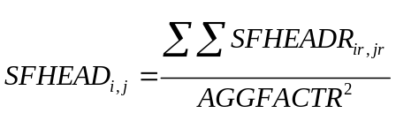 (XX)

where, i_{r} and j_{r} are the indices of all of the gridcells residing within the native land model grid cell i,j. The following variables are aggregated and, where applicable, update land surface model variable values:

SFHEAD - surface head (or, equivalently, depth of ponded water)
SMC - soil moisture content for each soil layer

These updated values are then used on the next iteration of the land surface model.

Subsurface Routing
Subsurface lateral flow is calculated prior to the routing of overland flow. This is because exfiltration from a supersaturated soil column is added to infiltration excess from the land surface model, which, ultimately, updates the value of surface head prior to routing of overland flow. A supersaturated soil column is defined as a soil column that possesses a positive subsurface moisture flux which when added to the existing soil water content is in excess of the total soil water holding capacity of the entire soil column. Figure XX illustrates the lateral flux and exfiltration processes in Noah-router.

In the current implementation of the NDHMS, there are eight soil layers, whereas the original Noah land surface model upon which the NDHMS was original based only has four. The depth of the soil layers in the NDHMS can be manually specified in the model namelist file under the ??ZSOIL1?? variable. Users must be aware that, in the present version of the NDHMS, total soil column depth and individual soil layer thicknesses are constant throughout the entire model domain. Future versions will attempt to relax this constraint.

A common 8-layer default configuration of the soil column is provided in Table XX where top and lowest layers are 100 mm thick while the other layers are 300 mm thick. However, the model is capable of using a different distribution of soil column layer depths and these simply need to be specified in the model namelist file. Assuming a 2 m soil profile the soil layer depths (and associated water table depths) are:

Table XX: Depths of 8 soil layers in Noah-router

Layer z (depth to top of layer, mm)
- 0
- 100
- 400
- 700
- 1000
- 1300
- 1600
- 1900

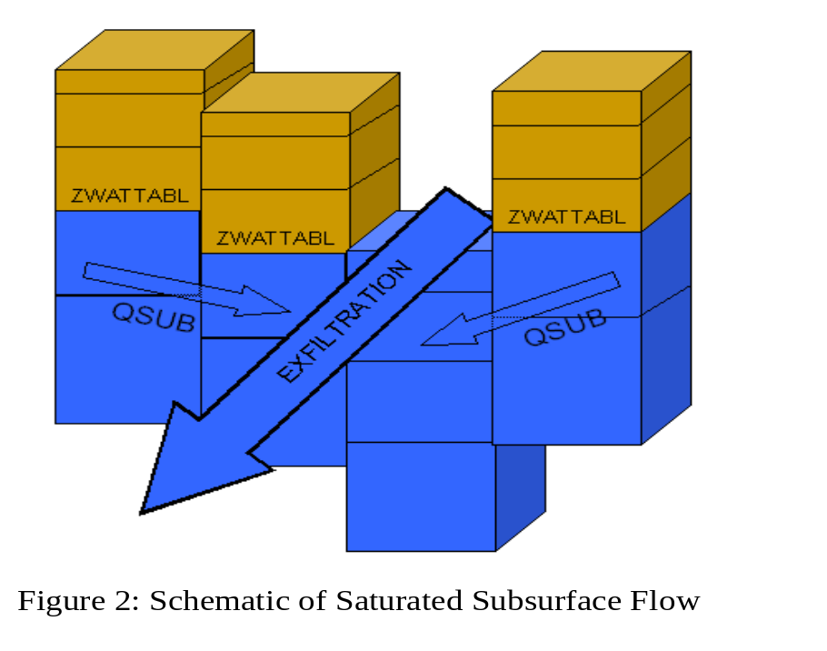

The method used to calculate the lateral flow of saturated soil moisture employs a quasi three-dimensional flow representation, which include the effects of topography, saturated soil depth (in this case layers), and saturated hydraulic conductivity. Hydraulic gradients are approximated as the slope of the water table between adjacent gridcells in the x- and y-directions. In each cell, the flux of water from one cell to its down-gradient neighbor on each time-step is approximated as a steady-state solution. The looping structure through the model grid performs flux calculations separately the x- and y-directions. A second alternative, using the path of steepest descent, is also available in Noah-distributed.

Using Dupuit-Forcheimer assumptions the rate of saturated subsurface flow at time t can be calculated as:

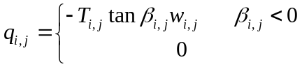 (5)

where, q_{i,j} is the flow rate from cell i,j, T_{i,j} is the transmissivity of cell i,j, β_{i,j} is the water table slope and w_{i,j} is the width of the cell which is fixed for a regular grid. β_{i,j} is calculated as the difference in water table depths between two adjacent gridcells divided by the grid spacing. The method by which the water table depth is determined is provided below. Transmissivity is a power law function of saturated hydraulic conductivity (Ksat _{i,j}) and soil thickness (D_{i,j}) given by:

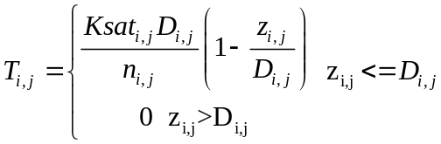 (6)

where, z_{i,j} is the depth to the water table. n_{i,j} in Eq. (6) is defined as the local power law exponent and is a tunable parameter that dictates the rate of decay of Ksat_{i,j} with depth. When Eq. (6) is substituted into (5) the flow rate from cell i,j to its neighbor in the x-direction can be expressed as

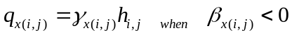 (7)

where,

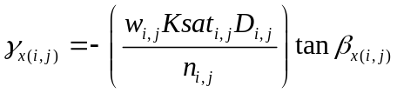 (8)

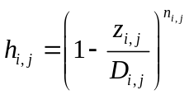 (9)

This calculation is repeated for the y-direction when using the two-dimensional routing method. The net lateral flow of saturated subsurface moisture (Q_{net}) for cell i,j then becomes:

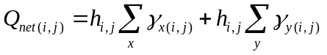 (10)

The mass balance for each cell on a model time step (Δt) can then be calculated in terms of the change in depth to the water table (Δz):

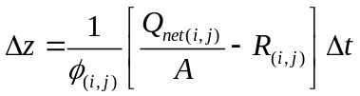 (11)

where, φ is the soil porosity, R is the soil column recharge rate from infiltration or deep subsurface injection and A is the grid cell area. In the NDHMS, R, is implicitly accounted for during the land surface model integration as infiltration and subsequent soil moisture increase. Assuming there is no deep soil injection of moisture (i.e. pressure driven flow from below the lowest soil layer), R, in NDHMS is set equal to 0.

The methodology outlined in Equations 5-11 has no explicit information on soil layer structure, as the method treats the soil as a single homogeneous column. Therefore, changes in water table depth (Δz) can yield water table depths, which fall within a particular soil layer. The NDHMS specifies the water table depth according the depth of the top of the highest (i.e. nearest to the surface) saturated layer. The residual saturated water above the uppermost, saturated soil layer is then added to the overall soil water content of the overlying unsaturated layer. This computational structure requires accounting steps to be performed prior to calculating Q_{net}.

Version 1.1 of the NDHMS introduces a model option to perform a fully-saturated initialization and ‘drainage’ simulation. This activity, activated through a switch () in the model namelist file, conducts a long term-simulation where initial saturated soil conditions are allowed to drain over time in response to gravitational flow. As such the model is integrated forward in time and all land surface model and hydrological routing physics are active. A drainage simulation capability is particularly useful for attempting to develop subsequent initial conditions for unconfined aquifers within the model domain. However, given the timescale for groundwater movement and limitations in the model structure there is significant uncertainty in the ‘correctness’ of such activities. The main things to consider when conducting ‘drainage’ simulation or ‘groundwater spinup’ runs within the HDMS include 1) the specified depth of soil and number and thickness of the soil vertical layers and 2) the prescription of the model bottom boundary condition. Typically, for simulations with deep soil profiles (e.g. > 10m) the bottom boundary condition is set to a ‘no-flow’ boundary (SLOPETYP = 8) in the GENPARM.TBL parameter file (see Appendix XX, for a description).

Terrain routing of overland flow
The terrain routing algorithms described below are found in (module_Noah_distr_routing.F).

Overland flow in NDHMS is calculated using a fully-unsteady, explicit, finite-difference, diffusive wave formulation (Figure 1) similar to that of Julien et al. (1995) and Ogden et al. (1997). The diffusive wave equation, while slightly more complicated, is, under some conditions, superior to the simpler and more traditionally used kinematic wave equation, because it accounts for backwater effects and allows for flow on adverse slopes. The overland flow routine described below can be implemented in either a 2-dimensional (x and y direction) or 1-dimension (steepest descent or ‘D8’) method. While the 2-dimensional method may provide a more accurate depiction of water movement across some complex surfaces it is more expensive in terms of computational time compared with the 1-dimensional method. While the physics of both methods are identical we have presented the formulation of the flow in equation form below using the 2-dimensional methodology.

Figure 1: Conceptual representation of terrain elements. Flow is routed across terrain elements until it intersects a “channel” grid cell indicated by the blue line where it becomes ‘in-flow’ to the stream channel network.

The diffusive wave formulation is a simplification of the more general St. Venant equations of continuity and momentum for a shallow water wave. The two-dimensional continuity equation for a flood wave flowing over the land surface is

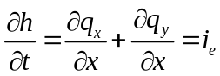 (1)

where, h is the surface flow depth; q_{x} and q_{y} are the unit discharges in the x- and y-directions, respectively; and i_{e} is the infiltration excess. The momentum equation used in the diffusive wave formulation for the x-dimension is

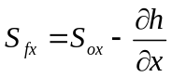 (2)

where, S_{fx} is the friction slope (or slope of the energy grade line) in the x-direction, S_{ox} is the terrain slope in the x-direction and ∂h/∂x is the change in depth of the water surface above the land surface in the x-direction.

In the 2-dimensional option, flow across the terrain grid is calculated first in the x- then in the y-direction. In order to solve Eq. 1 values for q_{x} and q_{y} are required. In most hydrological models they are typically calculated by use of a resistance equation such as Manning’s equation or the Chezy equation, which incorporates the expression for momentum losses given in Eq. 2. In the NDHMS, a form of Manning’s equation is implemented:

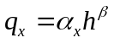 (3)

where,

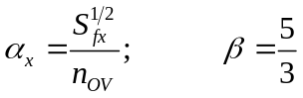 (4)

where, n_{OV} is the roughness coefficient of the land surface and is a tunable parameter and β is a unit dependent coefficient expressed here for SI units.

The overland flow formulation has been used effectively at fine terrain scales ranging from 30-1000 m. There has not been rigorous testing to date, in the NDHMS, at larger length-scales (> 1 km). This is due to the fact that typical overland flood waves possess length scales much smaller than 1 km. Micro-topography can also influence the behavior of a flood wave. Correspondingly, at larger grid sizes (e.g. > 500 m) there will be poor resolution of the flood wave and the small-scale features that affect it. Also, at coarser resolutions, terrain slopes between gridcells are lower due to an effective smoothing of topography as grid size resolution is decreased. Each of these features will degrade the performance of dynamic flood wave models to accurately simulate overland flow processes. Hence, it is generally considered that finer resolutions yield superior results.

The selected model time step is directly tied to the grid resolution. In order to prevent numerical diffusion of a simulated flood wave (where numerical diffusion is the artificial dissipation and dispersion of a flood wave) a proper time step must be selected to match the selected grid size. This match is dependent upon the assumed wave speed or celerity (c). The Courant Number, C_{n}= c(Δt/Δx), should be close to 1.0 in order to prevent numerical diffusion. The value of the C_{n} also affects the stability of the routing routine such that values of C_{n} should always be less than 1.0. Therefore the following model time steps are suggested as a function of model grid size:

Table 1: Suggested routing time steps for various grid spacings

x (m) t (s)
30 2
100 6
250 15
500 30
- 60

The overland flow routing option is activated using a switch parameter (OVRTSWTCH) in the NDHMS model namelist. If activated the following terrain fields and model namelist parameters must be provided:

- Terrain grid or Digital Elevation Model (DEM) Note: this grid may provided at resolutions equal to or finer than the native land model resolution
- Channel network grid identifying the location of stream channel grid cells
- Specification of the routing grid cell spacing (DXRT), routing grid time step (DTRT) and subgrid aggregation factor (AGGFACTR-defined as the ratio of the subgrid resolution to the native land model resolution, see Section XXXX above.)

Channel Inflow
Currently there is no explicit sub-grid representation of overland flow discharging into a stream channel. Instead, a simple mass balance calculation is performed. Inflow to stream channels occurs when the ponded water depth (or surface head, ‘SFHEADRT’) of stream channel grid cells exceeds a pre-defined retention depth (‘RETDEPRT’). As indicated above, the depth of surface head on any grid cell is a combination of the local infiltration excess, the amount of water flowing onto the grid cell from over land flow, and exfiltration from groundwater flow (described below). The quantity of surface head in excess of the retention depth is accumulated as stream channel inflow and is added to the channel routing routine (described below).

When routing is activated any overland flow in excess of the local retention depth, reaching a stream channel grid cell will be effectively ‘discharged’ into the stream channel network. In the NDHMS, values of ‘channel inflow’ are accumulated on the channel grid. Users can keep track of the total channel network channel inflow volume by setting the namelist file option ‘HIRES_OUT’ = 1, which produces an ASCII-formatted timeseries file of channel inflow volume in units of millions of cubic meters (Mm³). The name of the file produced will be ‘chan_inflow.txt’ and it will be written to the local run directory. Users can also output the spatial distribution of channel inflow on a high-resolution, netcdf-formatted terrain grid along with the ‘chan_inflow.txt’ file by setting the HIRES_OUT = 2 in the model namelist file.
Stream and River Channel routing
The channel routing module (module_Noah_channel_routing.F) allows for the one-dimensional, distributed routing of streamflow across the domain. An optional, switch-activated, level-pool lake/reservoir algorithm is also available and is described below. Channel routing is performed on a pixel-by-pixel basis along a predefined channel network grid that is input to the model within the high-resolution terrain routing grid file (see Section XXX for details). Within each channel grid cell there is an assumed channel reach of trapezoidal geometry as depicted in Figure XX. Channel parameters side slope, bottom width and roughness are currently prescribed as functions of Strahler stream order which is also input within the high-resolution terrain routing grid file. As discussed above in Section XX, channel elements receive lateral inflow from overland flow. There is currently no overbank flow so flow into the channel model is effectively one-way and the vertical dimension of the channel is effectively infinite. Future enhancements will attempt to relax these assumptions. Therefore, the NDHMS does not presently explicit represent inundation areas. Uncertainties in channel geometry parameters and the lack of an overbank flow representation result in significant uncertainty for users wishing to compare model flood stages versus those from observations. It is strongly recommended that users compare model versus observed streamflow discharge values and use observed stage-discharge relationships or ‘rating curves’ when wishing to relate modeled/predicted streamflow values to actual river levels and potential inundation areas.

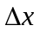
Q
1
z
T_{b}
S_{o}
n
h
Q’
h’

- Channel Slope, S_{o}
- Channel Length, (m)
- Channel side slope, z (m)
- Constant bottom width, T_{b} (m)
- Manning’s roughness coefficient, n

Figure XX: Schematic of Channel Routing Terms

Channel flow down through the gridded channel network is performed using an implicit, one-diemnsional, variable time-stepping diffusive wave formulation. As mentioned above in Section XX, the diffusive wave formulation is a simplification of the more general St. Venant equations for shallow water wave flow. Similarly, for channel routing, the mass and momentum continuity equations are given as:

Continuity: 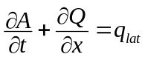 (XX)
Momentum: 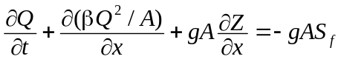 (XX)
where t is the time, is the streamwise coordinate, A is in the flow area of the cross section, and q_{lat} is the lateral flow rate. In the momentum equation, Q is the flow rate, β is a momentum correction coefficient, Z is the water surface elevation, and S_{f} is the friction slope computed as:
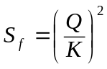
where K is the conveyance, computed from the Manning’s equation:
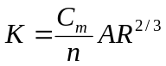
where n is the Manning’s roughness coefficient, A is the cross-sectional area, R is the hydraulic radius (A/P), P is the wetted perimeter, and C_{m} is dimensional constant (1.486 for English units or 1.0 for SI units).
Ignoring the convective terms in the momentum equation gives the diffusive wave approximation of open channel flow. The momentum equation then simplifies to:
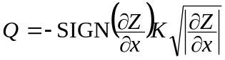
where the substitution for friction slope has been made and the SIGN function is 1 for 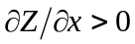 and -1 for 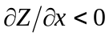.
The numerical solution is obtained by discretizing the continuity equation over a raster cell as:
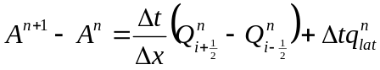
where 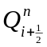 is the flux across the cell face between point i and i+1, and is computed as:
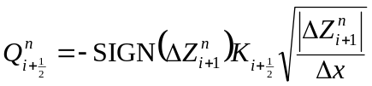
where:
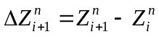
Presently a first-order, Newton-Raphson (N-R) solver is used to integrate the diffusive wave flow equations. Under certain streamflow conditions (e.g. typically low gradient channel reaches) the first-order solver method can produce some instabilities resulting in numerical oscillations in calculated streamflow values. To address this issue, higher order solver methods will be implemented in future versions of the NDHMS.

Variable time-stepping in the diffusive wave channel routing module in order to satisfy Courant constraints and avoid numerical dispersion and instabilities in the solutions. Unlike typical overland flow flood waves which have very shallow flow depths, on the order of millimeters or less, channel flood waves have appreciably greater flow depths and wave amplitudes, which can potentially result in strong momentum gradients and strong accelerations in a propagating wave. To properly characterize the dynamic propagation of such highly variable flood waves it is often necessary to decrease model time-steps in order to satisfy Courant conditions. Therefore the NDHMS utilizes a variable time-step methodology. The initial value of the channel routing time-step is set equal to that of the overland flow routing timestep which is a function of grid spacing. If, during model integration the N-R convergence criteria for upstream-dowsntream streamflow discharge values is not met, the channel routing time-step is decreased by a factor of one-half and the N-R solver is called again.

It is important to note that use of variable time-stepping can significantly affect model computational performance resulting in much slower solution times for rapidly evolving streamflow conditions such as those occurring during significant flood events. Therefore, selection of the time-step decrease factor (default value set to 0.5) and the N-R convergence criteria can each affect model computational performance.

Uncertainty in channel routing parameters also can have a significant impact on the accuracy of the model solution which implies that model calibration is often required upon implementation in a new domain. Presently, all of the channel routing parameters are prescribed as functions of stream order in a channel routing parameter table ‘CHANPARM.TBL’. The structure of this file is described in detail in Section XX. It should be noted that prescription of channel flow parameters as functions of stream order is likely to be a valid assumption over relatively small catchments and not over large regions. Future versions of the NDHMS will incorporate options to prescribe spatially distributed channel routing parameters (side slope, bottom width and roughness) within the high-resolution terrain routing grid file.

The channel flow routing option is activated using a switch parameter (CHRTSWTCH) in the NDHMS model namelist. If activated the following terrain fields and model namelist parameters must be provided:

- Terrain grid or Digital Elevation Model (DEM) Note: this grid may provided at resolutions equal to or finer than the native land model resolution
- Channel network grid identifying the location of stream channel grid cells
- Strahler stream order grid identifying the stream order for all channel pixels within the channel network
- Channel flowdirection grid. This grid explicitly defines flow directions along the channel network.
- Optional: Forecast point grid. This grid is a grid of selected channel pixels for which channel discharge and flow depth are to be output within a netcdf point file and an ASCII timeseries file.

Lake/Reservoir Routing Module:
A simple mass balance, level-pool lake/reservoir routing module allows for an estimate of the inline impact of small and large reservoirs on hydrologic response. A lake/reservoir or series of lakes/reservoirs are identified in the channel routing network, and lake/reservoir storage and outflow are estimated using a level-pool routing scheme. The only conceptual difference between lakes and reservoirs as represented in the NDHMS is that reservoirs contain both orifice and weir outlets for reservoir discharge while lakes only contain weirs.

Fluxes into a lake/reservoir object occur through the channel network and when surface overland flow intersects a lake object. Fluxes from lake/reservoir objects are made only through the channel network and no fluxes from lake/reservoir objects to the atmosphere or the land surface are currently represented (i.e. there is currently no lake evaporation or subsurface exchange between the land surface and lakes and reservoirs). The Level Pool scheme tracks water elevation changes over time, h(t) where water from the reservoir can exit either through weir overflow (Q_{w}) and/or a gate-controlled flow (Q_{o}), where these outflows are functions of the water elevation and spillway parameters. Weir flow is given as 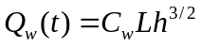 when h>h_{max} or Qw(t) = 0.0 when h≤h_{max} where, h_{max} is the maximum height before the weir begins to spill (m), C_{w} is a weir coefficient, and L is the length of the weir (m). Orifice flow is given as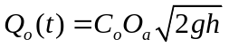, where C_{o} is the orifice coefficient, O_{a} is the orifice area (m²), and g is the acceleration of gravity (m/s²). In addition, the level pool scheme is designed to track each reservoir’s surface area, Sa (km²) as a function of water depth and the area at full storage, As (km²). Presently, lake/reservoir object is assumed to have vertical side walls, such that the surface area is always constant.
h_{max}
Weir flow
Inflow
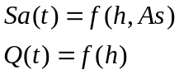
h(t)
Orifice flow

Figure 3. Schematic of Level Pool Routing

The following lake/reservoir parameters are required for level-pool routing and are defined in the ‘LAKEPARM.TBL’ parameter table:

- Weir and Orifice Coefficients (Co, Cw)
- Weir Length, L (m)
- Orifice Area, O_{a} (m²)
- Reservoir Area, As (km²)
- Maximum reservoir height at full storage, h_{max} (m)

The lake/reservoir flow routing option is activated when lake objects are defined and properly indexed as a data field in the high resolution terrain routing grid file. If lake/reservoir objects are present in the lake grid (and also within the channel network) then routing through those objects will occur. There are several special requirements for the lake grid and channel routing grids when lakes/reservoirs are to be represented and these are discussed in detail in Section XXX. The following input data variables and parameter files are required for level-pool routing:

- LAKEPARM.TBL parameter file (described in the Appendix)
- LAKEGRID
- CHANNELGRID

Conceptual Baseflow Model Description
Aquifer processes contributing baseflow often operate at depths greater than well below ground surface. As such, there are often conceptual shortcomings in current land surface models in their representation of groundwater processes. Because these processes contribute to streamflow (typically as ‘baseflow’) a parameterization is often used in order to simulate total streamflow values that are comparable with observed streamflow from gauging stations. Therefore, a switch-activated baseflow module ‘module_Noah_gw_baseflow.F’ has been created which conceptually (i.e. not physically-explicit) represents baseflow contributions to streamflow. This model option is particularly useful when the NDHMS is used for long-term streamflow simulation/prediction and baseflow or ‘low flow’ processes must be properly accounted for. Besides potential calibration of the Noah land surface model parameters the conceptual baseflow model does not directly impact the performance of the land surface model scheme. The new baseflow module is linked to the NDHMS through the discharge of ‘deep drainage’ from the land surface soil column (sometimes referred to as ‘underground runoff’). The basic methodology employed into NDHMS is described below along with results from some preliminary sensitivity tests for the Santee River basin.

The baseflow parameterization in the NDHMS uses spatially-aggregated drainage from the soil profile as recharge to a conceptual groundwater reservoir (Fig. XX). The unit of spatial aggregation is often taken to be that of a sub-basin within a watershed where streamflow data is available for the sub-basin. Each sub-basin has a groundwater reservoir (‘bucket’) with a conceptual depth and associated conceptual volumetric capacity. The reservoir operates as a simple bucket where outflow (= ‘baseflow’ or ‘stream inflow’) is estimated using an empirically-derived function of recharge. The functional type and parameters are determined empirically from offline tests using the estimated of baseflow from stream gauge observations and model-derived estimates of bucket recharge provided by the NDHMS. Presently, the NDHMS uses an exponential function (See Fig. XX) for estimating the bucket discharge as a function of a conceptual depth of water in the bucket. Note that because this is a highly conceptualized formulation that the depth of water in the bucket in no way infers the actual depth of water in a real aquifer system. Estimated baseflow discharged from the bucket model is then combined with lateral inflow from overland flow from Noah-distributed and is input directly into the stream network as ‘stream inflow’. Presently, the total basin baseflow flux to the stream network is equally distributed among all channel pixels within a basin. Lacking more specific information on regional groundwater basins, the groundwater/baseflow basins in the NDHMS are assumed to match those of the surface topography.

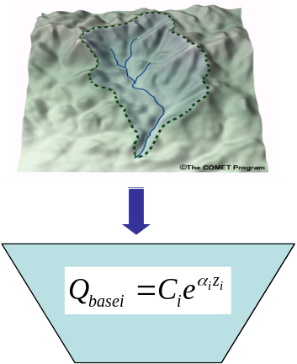
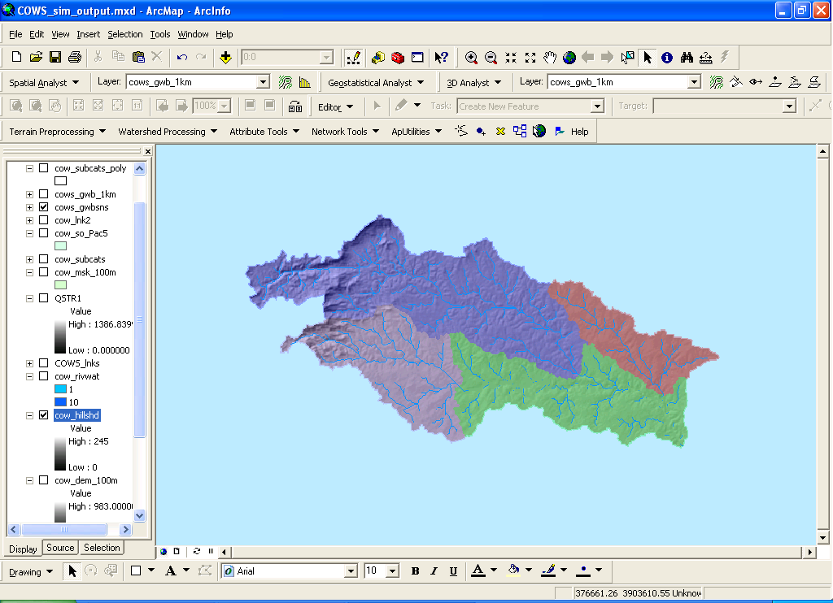

Figure XX: Conceptualization of baseflow ‘bucket’ parameterization in the NDHMS and hypothetical map of groundwater/baseflow sub-basins within a watershed.
A groundwater/baseflow bucket model parameter file (GWBUCKPARM.TBL) specifies the empirical parameters governing the behavior of the bucket model parameterization for each groundwater/baseflow basin specified within the model domain. An example parameter file with 4 groundwater basins will look like:

Coeff.,Expon.,Zinit
0.4898,25.0,0.03867
0.8925,0.1394,2.0
2.1388,0.1359,1.0
0.0332,0.1615,0.5

where, ‘Coeff.’ is the bucket model coefficient, ‘Expon.’ is the bucket model exponent and ‘Zinit’ is the initial depth of water in the bucket model. It is important to remember that a simple bucket model is a highly abstracted and conceptualized representation of groundwater processes and therefore the depth of water values in the bucket have no real physical basis. As mentioned above, initial values of the groundwater bucket model parameters, including ‘Zinit’ are typically derived analytically or ‘offline’ from the NDHMS and then are fine-tuned through model calibration. A description of the procedure to derive initial groundwater bucket model parameters is provided in the Appendix XX.

To activate the simple baseflow bucket model in the NDHMS the user must do each of the following:

- Set the model namelist variable GWBASESWC = 1
- Properly assign the groundwater/baseflow bucket model parameters within the GWBUCKPARM.TBL file. Suggested steps for deriving the bucket model parameters are provided in the Appendix A.X.
- Define groundwater/baseflow basins as data layers within the high resolution terrain routing grid file. Steps to generate these data layers assuming an identical match between surface and subsurface basins is provided in Section XX.

If activated, three ASCII-formatted, time-series, output files are generated by the bucket model parameterization that contain timeseries values of the flow into the bucket (‘gw_inflow.txt’), flow out of the bucket (‘gw_outflow.txt’) and the conceptual depth of water in the groundwater/baseflow bucket (‘gw_zlev.txt’).

Model Technical Description and User Guide

This portion of the document presents the technical description of the NDHMS model code including:

1. Coding structure and programming conventions
2. Directory structures
3. Description of modules
4. Setup and execution of uncoupled NDHMS code
5. Setup and execution of coupled WRF-NDHMS code
6. Setup of model domain grids

The following, final section of the document presents the NDHMS input and output data structures and descriptions of the various model namelists and parameter tables.

1. Coding Structure and Programming Conventions
The NDHMS is written in a modularized, Fortran90 coding structure whose routing physics modules are switch activated through a single model namelist file. The code has been parallelized for execution on high-performance, parallel computing architectures including LINUX commodity clusters and multi-processor desktops as well as the IBM blue gene supercomputers.

The code has been compiled using the Portland Group FORTRAN (for use with Linux-based operating systems on desktops and clusters), the IBM IFORT FORTRAN compilers (for supercomputers) and the public license GNU Fortran compiler ‘gfort’.

Because the NDHMS relies on NETCDF input and output file conventions, NETCDF FORTRAN libraries must be installed and properly compiled on the system upon which the NDHMS is to be executed. Not doing so will result in error numerous ‘…undefined reference to netcdf library …’ or similar messages upon compilation.

Parallelization of the NDHMS code utilizes domain decomposition and ‘halo’ array passing structures similar to those used in the WRF atmospheric model. Message passing between processors is accomplished using ‘MPICH’ protocols. Therefore the relevant ‘mpich’ libraries must be installed and properly compiled on the system upon which the NDHMS is to be executed in parallel mode. Separate compilations, and therefore executables, of the NDHMS code are required

(See Section XXX for a ‘Steps to Install’ guide of procedures required to install and run the NDHMS in each sequential, parallel and WRF-coupled modes).

2. Directory Structures
The top level directory structure of the code is provided below and Subdirectory structures are described thereafter. Code descriptions in bold italics indicate code that is relevant to routing modeling and/or more frequently modified routines.

This is the top level directory present immediately following untarring of the NDHMS file tar package:

This section provides a brief description of the file contents of each directory where the model code resides. Code descriptions in bold italics indicate code that is relevant to routing modeling and/or more frequently accessed or modified routines.

arc/ - directory containing macro files reside which specify the compile configurations, compiler options, links to netcdf libraries, etc.

CLM_cpl/ - directory containing CLM related coupling files and compile options reside

Data_Rec/ - ???

lib/ - directory containing various include and data initialization and allocation modules reside

LIS_cpl/ - directory where NASA Land Information System (LIS) related coupling files and compile options reside

Main/ - directory where high level drivers and model executable resides

mod/ - ????

MPP/ - directory containing parallel model code

NDHMS_drv/ - directory containing various NDHMS model couplers reside

module_RTLAND.F - main model driver
Noah_driver_wrfcode.F - high level driver

NoahLand/ - directory containing Noah LSM code and various Noah LSM utilities as they are organized in the NCAR HRLDAS:

WRF_code directory:
This directory contains the Noah LSM.

Makefile - Noah LSM makefile
module_sf_noahlsm_rt.F - Noah land surface model
old_module_noahlsm.F -OBSOLETE

Noah_code directory:
This directory contains several utility modules used in the Noah LSM.

Makefile - Noah code utilities directory makefile
module_date_utilities_rt.F - Utility module for date creation/tracking
module_model_constants_rt.F - Utility module for specification of some constants
module_Noahlsm.F - OBSOLETE
module_Noahlsm_param_init_rt.F - Utility module for reading Noah LSM parameter tables
module_Noahlsm_utility_rt.F - Utility module for the Noah LSM

LandDrive/ - directory that links the specified land model to that land model’s source code

Routing/ - directory containing modules and drivers related to routing processes in the NDHMS

This directory contains the model drivers, the model input/output modules and most of the model physics modules related to routing.

drive_rtland.F - surrogate land model driver used when coupled to WRF
DRIVE_RTLAND.F - surrogate land model driver used when coupled to WRF
Makefile - directory makefile
module_Noah_channel_routing.F - model physics module for channel routing
module_Noah_chan_param_init_rt.F - module for initializing channel parameters
module_Noah_distr_routing.F - model physics module for terrain routing
module_Noah_gw_baseflow.F - model physics module for gw/baseflow
module_Noahlsm_wrf_input_rt.F - module for most input/output

Run/ - directory containing the parameter tables and namelist files required to run the NDHMS. The contents of this directory need to be present for the NDHMS to execute. It is recommended to copy this directory into an alternate pathway, separate from the code and then link the compiled executable to the new directory from which the model will be executed.

wrf_cpl/ - directory containing WRF model related coupling files and compile options reside
3. Description of Physics Modules
The basic structure of the NDHMS is diagrammatically illustrated in Figure XX. High level job management is handled by the land model driver, which has previously been referred to as the NCAR High Resolution Land Data Assimilation System (HRLDAS). Upon initialization static land surface and terrain data are read into the land model driver and the model domain and computational arrays are established. Next forcing data is read in. As the model integrates in time the calling structure of the physics modules proceeds as 1) the 1-D, gridded land surface model, 2) disaggregation to the high resolution terrain routing grids (if routing is activated), 3) sub-surface and surface routing (if active), 4) the conceptual baseflow model (if active), 5) channel and reservoir routing (if active), 6) aggregation from the high resolution terrain routing grid to the land surface model grid (if routing is active). Results from these integrations are then written to the model output files or, in the case of a coupled WRF-NDHMS simulation, passed back to the WRF model.

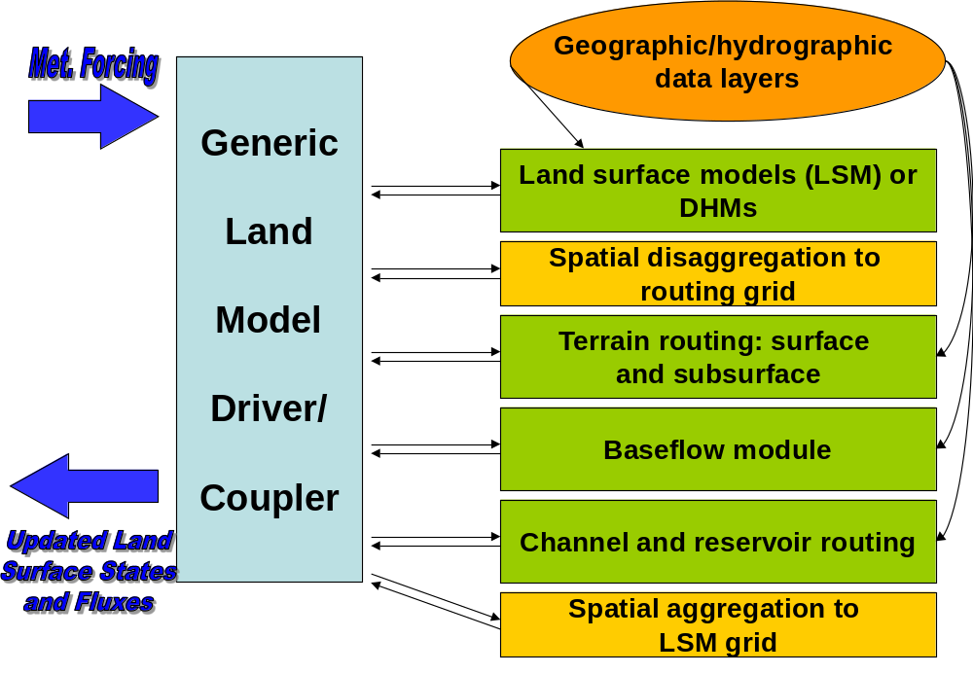

4. Setup and execution of uncoupled NDHMS

- Get code and set up necessary libraries:
The NDHMS code is available via the internet or directly via an subversion control (‘svn’) code repository for those directly within the NCAR RAL domain:
  - Download web site (GET FROM WEI, add tech note to web site)
  - Update from local svn repository (GET COMMAND FROM WEI)
  - Unzip and/or Untar code if necessary
  - Set up libraries:
- Set up appropriate links to netcdf INCLUDE and LIB directories on the users system. IMPORANT: The NDHMS code has been built with netcdf version 3.6.3 or lower. It has not yet been built with netcdf v4.0. If the netcdf library and linclude files have not yet been created these can be set up in a local directory by the user and linked to in the proper macro file.
- Verify that all of the variables that need to be specified in the arc/macros file are properly linked (e.g. COMPILER90, CPP, NETCDFINC, NETCDFLIB)

- Directory Structures:
The top level directory structure of the code is provided below and subdirectory structures are described thereafter. Code descriptions in bold italics indicate code that is relevant to routing modeling and/or more frequently modified routines.

This is the top level directory present immediately following untarring of the NDHMS file tar package:

arc/ - directory containing macro files reside which specify the compile configurations, compiler options, links to netcdf libraries, etc.
CLM_cpl/ - directory containing CLM related coupling files and compile options reside
configure* - command line script to configure the model compilation
Data_Rec/ - ???
lib/ - directory containing various include and data initialization and allocation modules reside
link.csh - c-shell scrip to link some directories and files during configuration
LIS_cpl/ - directory where NASA Land Information System (LIS) related coupling files and compile options reside
Main/ - directory where high level drivers and model executable resides
mod/ - ????
MPP/ - directory containing parallel model code
NDHMS_drv/ - directory containing various NDHMS model couplers reside
NoahLand/ - directory containing Noah LSM code and various Noah LSM utilities
LandDrive/ - directory that links the specified land model to that land model’s source code
note.txt - ????
Routing/ - directory containing modules and drivers related to routing processes in the NDHMS
Run/ - directory containing the parameter tables and namelist files required to run the NDHMS. The contents of this directory need to be present for the NDHMS to execute. It is recommended to copy this directory into an alternate pathway, separate from the code and then link the compiled executable to the new directory from which the model will be executed.
wrf_cpl/ - directory containing WRF model related coupling files and compile options reside

3. Configure and compile:
To configure the model one needs to run the ‘./configure’ script. There are several options for configuring the model build which have been created. New executables will be placed in the ‘Main/’ directory upon successful compilation.

IMPORTANT: If you desire to keep old executables you need to create a backup copy of the existing executable prior to running the configuration script.

saudi-c1-int1:/d1/gochis/WRF_COUPLE_NDHMS/phys/RTLAND% ./configure

Please select from following supported options.

1. Linux PGI compiler sequential
2. Linux PGI compiler mpp
3. Linux PGI compiler mpp (debug)
4. Linux PGI compiler sequential, with boundary check
5. IBM AIX compiler sequential, xlf90_r
6. IBM AIX compiler mpp
7. Linux PGI compiler mpp, lib only (to be coupled with WRF)
8. Linux gfort compiler sequential
0. exit only

Enter selection [1-5] :

Most users will be using options 1 (for single processor, sequential runs) or 2 (parallel processor runs) on typical LINUX cluster machines. Option 3 ad 4 simply contains additional runtime boundary checks which is useful for debugging. Options 5 and 6 are available if the IBM AIX compiler is used (Use this for NCAR IBM supercomputers such as ‘bluefire’). Option 7 is used when the Noah-distributed hydrological model will be coupled to WRF and run on a LINUX platform. Option 8 designates configuration options for the open source GNU Fortran (‘gfort’) compiler in sequential mode. Upon hitting <RETURN> after selecting a configuration option, you will be returned to the command line.

To then compile the code type ‘make’ and hit <RETURN> again. If you are re-compiling the code after making changes or switching configuration options, such as changing from a sequential to a parallel (mpp) run it is good practice to type ‘make clean’ before typing ‘make’ to remove all old object files.

Successful compilation of options 1-6 or 8 will result in the creation of a new model executable which resides within the Main/ directory. For sequential and parallel runs the executable will be:

Noah_wrfdriver_beta

NOTE: If there are compilation errors, oftentimes error messages will be provided with module names and line numbers. These module line numbers are ONLY relevant to lowercase (*.f) files and NOT uppercase (*.F) files. Since the *.f files are scrubbed within the Makefile upon compilation they are not available to view. To not scrub the .f files one needs to make the appropriate edit to the appropriate Makefile. This means determining which make file needs to be edited and commenting out the ‘rm *.f’ line under the appropriate module.

Be sure to check the date on the executable to make sure that you have compiled successfully. Again, if you experience problems compiling or if it is your first time compiling you might try typing 'make clean' to remove old object files. Thus far, the NDHMS has been successfully compiled only on LINUX and MAC-OS platforms.

- Model setup and execution:
Once the proper model executable file has been created users will need to create and populate a run directory from which the model will be executed. As stated above, all of the appropriate parameter tables, model namelist file and model executable need to be placed in this directory and can be copied from the ‘Run/’ directory listed above and also have the model executable linked into it. The next steps to execute the model are suggested as follows (Keeping voluminous terrain data, forcing data and model output data separate from the model code and executables can make backup, storage or transfer of NDHMS model code between systems much simpler):

ii) Create/place routing files in a ‘terrain/’ directory. Place the LSM terrain grid file (a.k.a. ‘geogrid_d0X.nc’) and, if routing is to be performed, the high-resolution netcdf terrain grid into a ‘terrain/’ directory. Construction of these netcdf files is described in Chapter XXXX.

iii) Create/place meteorological forcing data files in ‘forcing/’ directory. These are the data that “drive” the hydrologic simulation. The NDHMS uses a netcdf I/O convention similar to the Weather Research and Forecasting (WRF) model and, therefore, it is fairly easy to adapt WRF output to drive the NDHMS. There are seven meteorological variables that are required: 2 m air temperature, 2 m specific humidity, 10 wind speed (u and v components), surface pressure, precipitation rate, incoming short and longwave radiation. These variables are stored within a single netcdf file where one file is specified for each model time-step. Specific details on the units and formats of these data at given in Chapter XXXX and an example netcdf header from a forcing data file is provided in the Appendix. These data are often placed in within a ‘forcing/’ directory.

iv) Edit the namelist. Open and edit 'noah_wrfcode.namelist' to set up a simulation to your specifications. The namelist is fairly well commented. The directory for input forcing data must be specified (INDIR), as must the pathway and filename to the WRFSTATIC file (WRFSI_STATIC_FLNM, aka a ‘geogrid’ file which is created from WRF pre-processing software) and type of forcing data (FORC_TYP). Be sure to activate only those routing switches for which you have the required data. Routing timestep 'DTRT' must be set in accordance with the routing grid spacing in order to satisfy Courant constraints (see Chapter XXXX for a discussion on Courant constraints). Be sure to include the full path and directory when specifying Routing Input Files. Description of the terms in the namelist are given in Chapter XXXX.

v) Execute the model. Type './Noah_wrfdriver_beta' at the command line to execute the sequential version the model. For parallel runs the command may differ according the specifications of the parallel-processing software on individual machines but a common execution command may look like ‘mpirun –np # Noah_wrfdriver_beta_mpp’, where # is the number of processors to be used. If run successfully, output will be generated as a series of netcdf files with associated time and date information in the filenames. Depending on the runtime options selected a number of ASCII output files may also be created. Users seeking to perform simulations where the NDHMS model is coupled to WRF should refer to Chapter XXXX.

5. Setup and execution of the coupled WRF-NDHMS
(see/update document and get material from ppt slides)
Before beginning, make sure that both uncoupled WRF model and the uncoupled version of the Noah-distributed/NDHMS have been properly installed, configured, compiled and executed on the desired system. It will be much easier to debug problems with the coupled model once each component of the uncoupled models have been properly installed compiled and executed. Also, if any changes or model developments are made to the Noah-distributed model (such as routing functions or I/O modules) it is strongly suggested that you recompile and perform test executions of the uncoupled Noah-distributed run in offline mode before attempting to directly perform a coupled model simulation. These steps will help ensure that the coupled version will compile and execute successfully and will help with troubleshooting any problems that may arise.

To install, compile and execute the coupled WRF/NDHMS do the following:

- Obtain, unzip and unpack the coupled model tarfile

- Upon first installation or if you change something in the Noah-distributed portion of the coupled model, recompile and test the uncoupled model:
  - Under WRF_COUPLE/phys/RTLAND, run "csh batch.csh", and choose option 2 (Linux mpp option). Successful completion of this step will create an ‘uncoupled’ Noah-distributed/NDHMS model executable set up to run in parallel mode.
  - Copy or link the WRF_COUPLE/phys/RTLAND/Run/Noah_wrfdriver_beta_mpp to WRF_COUPLE/run/RT (This RT directory is where the Noah-distributed model is executed from in both uncoupled and coupled modes.) Make sure that all the necessary Noah-d/NDHMS files (e.g. .TBL and namelist files) are there.
  - Test the stand alone there as if it were a normal simulation. You can test using previous WRF output (FORC_TYP=2 in the namelist) or with constant/idealized forcing (FORC_TYP=4). Execute the model using a typical NDHMS execution: command for parallel systems. (e.g. ‘mpirun –np 8 Noah_wrfdriver_beta_mpp > log.txt &)

  - Once the model successfully runs in uncoupled mode proceed to Step #3.

- If above passed, you want to run couple. Do following:
  - Clean out all old compiles from both WRF and the uncoupled model. Goto the ‘WRF_COUPLE/’ directory and type ‘clean –a’ (this should clear all old executables, libraries, object files, etc.)
  - Under ‘WRF_COUPLE/phys/RTLAND’:
    - Perform a ‘make clean’ and remove all old exectuables in ‘WRF_COUPLE/phys/RTLAND/Run/’
    - As in step 2a above, run "csh batch.csh", and choose 6. (This setting will compile the Noah-distributed model for coupling to WRF. This compile WILL NOT generate an executable but will instead generate a new library file called ‘librtland.a’ so that "compile em_real" can compile the file as part of its full WRF compile.
  - cd to ‘WRF_COUPLE/main/’ and double check to remove any ‘WRF_COUPLE/main/*.exe’ files
  - Under ‘WRF_COUPLE/’, execute ‘./compile em_real’ to make a complete new wrf.exe which will have the Noah-distributed library compiled within. You will need to select the proper compile option based on your individual system. Usually this will be a distributed memory, parallel compile (‘dmpar’). As with a typical WRF compile this will take several minutes to complete.
  - If successful a new ‘wrf.exe’ executable file will be created in ‘WRF_COUPLE/main/’. Copy or link this executable to the directory where you will run the coupled WRF/Noah-d model such as the ‘WRF_COUPLE/run/ ‘directory. It is also a good idea to give a new name for the coupled model executable to distinguish it from regular ‘uncoupled’ wrf.exe executable files (e.g. ‘wrf_couple.exe’).
  - If not already present, create a ‘RT/’ directory in the ‘WRF_COUPLE/run/’ directory. Make sure that all of the usual Noah-d files (.TBLs and Noah-d namelist files) are there. Edit the namelist such that FORC_TYP=2 so that the NDHMS will assume WRF-formatted forcing data. However, the ‘INDIR’ variable in the namelist becomes irrelevant for coupled WRF/NDHMS runs.
  - Link the ‘noah_wrfcode_namelist’ from ‘RT/’ into the ‘WRF_COUPLE /run/’ directory so that WRF will find these upon execution.
  - Execute the model using a typical wrf execution command for parallel systems. e.g. mpirun –np 16 wrf_couple.exe > log.txt &

- Domain Processing

- General Overview
Utilizing the netcdf data convention, there are two files that need to be created in order to run the NCAR distributed hydrological modeling system (NDHMS). The two files specify the data layers that are used for modeling on the land surface model grid (or coarse grid) and the terrain routing grid (or high-resolution grid). Data contained in the land surface model grid is highly dependent upon the specific land surface model (LSM) used in the NDHMS. As of the preparation of this document only the Noah LSM (Ek et al., 2003, Mitchell et al. 200X) has been coupled into the NDHMS though future versions may incorporate additional LSMs such as the Community Land Model (CLM, Oleson et al., 200X). Conversely, because of the modular structure of the NDHMS, data for the terrain routing grid should remain fairly consistent even when different LSMs are coupled into the system. Lastly, preparation of the LSM grid and the terrain grid are required and these grids are the same, whether or not the NDHMS is executed in a coupled mode with the Weather Research and Forecasting (WRF) model. In the sections below, the data requirements for model execution are provided as are an example set of processing steps that would create the required LSM and terrain routing grids. The last two sections describe the required attributes that must be specified, via parameter tables, to enable channel routing, reservoir routing and a simple baseflow parameterization.

One key requirement in setting up the LSM and terrain grids is that the spatial extent of the two grids must be identical and that the spatial resolution of the terrain grid must be an integer multiple of the LSM grid. This is because the terrain grid operates on a fine mesh overlain onto the LSM and that in the NDHMS selected model state and flux variables are disaggregated/aggregated between the LSM and terrain grids. This internal nesting in Gochis and Chen (2003) allows the LSM to run at one spatial resolution while the terrain and stream channel routing routines are executed on a much more finely resolved grid. While the model can operate when both grids have equal spatial resolution (e.g. 100m or finer) this sub-grid nesting capability is particularly useful in minimizing computational demands when the NDHMS is coupled to WRF.

- Land Surface Model Grid Setup
The data required to execute a spatially-distributed, or gridded, 1-dimensional (vertical) LSM is specified on the Land Surface Model grid (hereafter referred to as the ‘LSM grid’ data file). The data contained within LSM grid data file are dependent on the specific choice of LSM used in the NDHMS. In this section, we will use the example of the Noah LSM as this model has already been coupled to the NHDMS and because this model is already coupled into the WRF model. First, use of the WRF pre-processor ‘geogrid’ to build the LSM grid data file will be discussed. The ‘geogrid’ tool is extremely useful since it automates the entire procedure of defining in space, geo-referencing and attributing most of the land surface parameter data required to execute the Noah LSM. Users familiar with the WRF model or desiring to run the NHDMS coupled to the WRF model will most likely use this approach. Second, we present a methodology to develop a ‘custom’ LSM grid data file in netcdf format using a set of tools known as netcdf command operators (or NCO commands). Users not familiar with the WRF modeling framework and who do not desire to use the NHDMS may choose to use this second method. Either method can produce a useable LSM grid data file.

    - WRF Pre-processor ‘GEOGRID’:
The WRF modeling system contains a set of data ‘pre-processors’ that prepare both land surface and atmospheric data for use in the WRF mesoscale atmospheric model. Combined the suite of pre-processors are referred to as the WRF Pre-processing System (WPS). The land surface model pre-processor component of WPS is known as ‘geogrid’ and it acquires and interpolates land surface terrain, soils and vegetation data from standard, readily available data products (such as the USGS National Elevation Dataset or the STATSGO Soils Database) to the WRF modeling grid. Complete documentation and user instructions for use of the WPS-geogrid system are provided online by NCAR and are updated regularly and, thus, are not discussed in great detail here (please visit the WPS Documentation Website: http://www.mmm.ucar.edu/wrf/users/docs/user_guide_V3.1/users_guide_chap3.htm for complete details). For installation and execution of the ‘geogrid’ WRF pre-processor users are referred to that documentation. However, here we will discuss the structure of the netcdf LSM grid data file that is produced by geogrid focusing on the data fields required by the Noah LSM. The following is a listing only of the data fields contained within the geogrid output file that are required by the Noah LSM (other fields contained in the file are not discussed here).

HGT_M : Topographic elevation (units of meters) on the ‘mass grid’. (NOTE: WRF uses both centered and staggered grid systems but only the centered ‘mass’ grid is required by the land model.)
XLAT_M : Latitude coordinates, in decimal degrees, on the mass grid.
XLONG_M : Longitude coordinates, in decimal degrees, on the mass grid.
LANDUSEF : Land use fraction, in units of fraction. This is a 3- dimensional array in x, y, and land use category where each land use category is expressed as a fractional amount of area per spatial grid cell. During execution of the Noah LSM the dominant land cover type for each spatial grid cell is determined and assigned as the single land cover type for the entire LSM grid cell (i.e. there is no sub-grid mosaicking of land cover type.)
SOILCTOP: Top layer soil texture category, in units of fraction. This is a 3-dimensional array in x, y, and soil texture category where each soil texture category is expressed as a fractional amount of area per spatial grid cell. During execution of the Noah LSM the dominant soil texture type for each spatial grid cell is determined and assigned as the single soil texture type for the entire LSM grid cell (i.e. there is no sub-grid mosaicking of soil texture type.)
GREENFRAC : Monthly mean green vegetation fraction values (units of fraction). This is a 3-dimensional array in x, y and time. During execution of the Noah LSM, the monthly values of green vegetation fraction are interpolated to daily values and are updated daily.
ALBEDO12M : Monthly mean surface albedo values (units of %) not including snow effects. This is a 3-dimensional array in x, y and time. During execution of the Noah LSM, the monthly values of land surface albedo are interpolated to daily values and are updated daily.

It is important to remember the above listed data fields are those that are required to run the Noah LSM. while the geogrid pre-processor creates an LSM grid data file that contains other data fields which may not be required to run the Noah LSM in an ‘offline’ or ‘uncoupled’ (i.e. un-coupled to the WRF model) mode. Therefore, users seeking to create their own LSM input datafiles only need to create those fields listed above. An example procedure to do this within the netdf framework is described below.

    - Custom netcdf file development:
As described above, the data required to run a gridded implementation of the Noah LSM within the NDHMS include topographic elevation (units of meters, ‘HGT_M’), latitude of each grid cell (units of decimal degrees, ‘XLAT_M’), longitude of each grid cell (units of decimal degrees, ‘XLONG_M’) land use fraction (units of fraction, ‘LANDUSEF’), soil texture class (units of fraction, ‘SOILCTOP’), monthly mean vegetation greenness fraction (units of fraction, ‘GREENFRAC’) and monthly mean albedo values (units of %, ‘ALBEDO12M). Users creating their own LSM grids (i.e. those users not using the WRF geogrid pre-processors need to create netcdf files containing the proper data with the proper units and specified filenames (filenames are case sensitive). Once the user has created the individual netcdf data layers (either through code or a third party piece of software like ArcGIS or MATLAB), the individual datefiles con be concatenated together into a single netcdf datafile using netcdf command operators (‘NCO’-commands – see http://nco.sourceforge.net/) the ‘concatenate.csh’ utility script contained within the /utils/ directory distributed with the NDHMS tarfile. Use of this script is described below towards the end of the section describing the terrain grid setup and is also contained in the comment lines of the script.

The most critical thing to remember when creating a custom LSM grid data file is that the vegetation type index and the soils type index must be consistent with the indices that will be defined in the vegetation and soils parameter tables described below and in the Appendix. Native data for the LSM grid can come from any number of different sources. Therefore, it is also important to remember that in order to run a gridded implementation of the LSM all data must be mapped to single, consistent grid and that the spatial increment or resolution of the terrain grid must be an integer multiple of the resolution of the LSM grid. The reason for this requirement is discussed above in the General Overview section.

iii. Land surface model parameter specification:
Land surface parameters in the Noah LSM are specified in three different files:
VEGPARM.TBL : contains vegetation parameters indexed by land use/land cover categories.
SOILPARM.TBL : contains soil physical parameters indexed by soil textural classes.
GENPARM.TBL : contains miscellaneous model parameters that are applied globally. Examples of these files and description of their parameters is given in the Appendix.

- Terrain Grid Setup
    - Overview
The high-resolution terrain routing grid specifies the data that are necessary to route water across the landscape (via overland and saturated surbsurface flow) and through stream channels and lakes. Options also exist to specify baseflow values for stream channel routing based on an empirical bucket model formulation (see Section XXXX). The data layers contained within the high-resolution terrain grid include:

- Topography (required - in units of meters)
- Channel grid (required)
- Flow direction (required - using the ArcGIS direction convention)
- Stream Order (required for channel routing – using the Strahler (1952) stream order convention)
- Lakes (optional)
- Groundwater Basin Mask (optional)
- Grid of monitoring points or stations (optional)
- Grid of latitude and longitude values (often required for proper geo-referencing of irregular gridded data in netcdf – in units of decimal degrees)

Simple examples of each one of these grids are provided in XXXX. Data is passed to/from the LSM grid to the terrain routing grid via a disaggregation/aggregation scheme described in Gochis and Chen (2003). The main requirement to enable the coarse-fine grid functionality is that terrain grid must exactly match the extent of the LSM grid and its dimensions must be integer multiples of the LSM grid. Given the need to interpolate, georeference and clip grids from different sources, resolutions and spatial projections, it is highly advantageous to use a Geographical Information System (GIS). In the following paragraphs we provide an example procedure to create these grids, in netcdf format using the ESRI ArcGIS system. Many other methods could be used as well so long as care is taken to accurately map the LSM and terrain grids to one another.
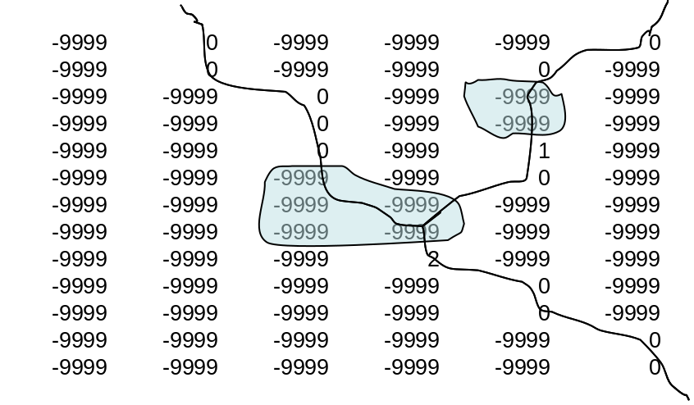
Figure 1. Example of final channel grid format with 2 lake objects present. Note that the main channel identifier index is 0 but that this number changes at lake/reservoir outlet to correspond with the index value of each reservoir shown in Figure 2 below. Also, all channel grid cells underneath a lake are assigned as -9999.

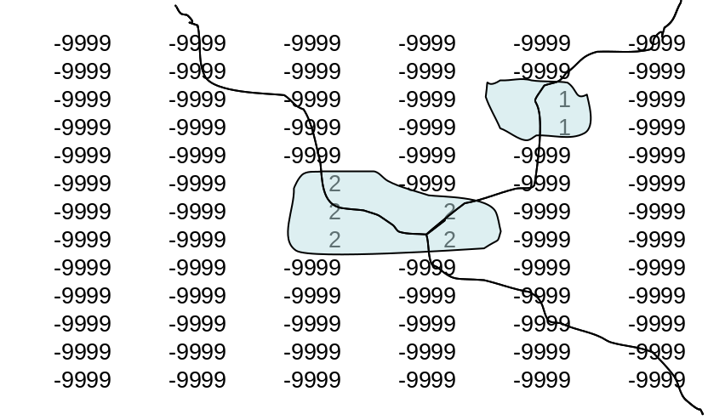

Figure 2. Example of final lake grid format with 2 lake objects present.

Figure 3. Example of final groundwater basin format with 2 groundwater basins present.

Figure 4. Example of final forecast data point format with 4 forecast points present.

    - Import the LSM Grid into ArcGIS:
A step-by-step procedure to ingest and georeference the LSM geogrid file created by the wrf pre-processors (described above) into ArcGIS is given as follows (other methods may well be possible):

      - Using ArcGIS v9.3 or higher, import the geogrid netcdf file using the Spatial Analyst -> Multidimension Tools -> Create Raster Layer tool. Select the LSM terrain elevation values on the ‘mass grid’ (HGT_M) data layer from the geogrid file for import. Specify the ‘x-dimension’ to be ‘east_west’ and the ‘y-dimension’ to be ‘north-south’.
      - Export/Save the elevation data layer as a raster (see Figure X for an example of how to set-up this export:

Figure X. Export layer data to raster window in ArcGIS:
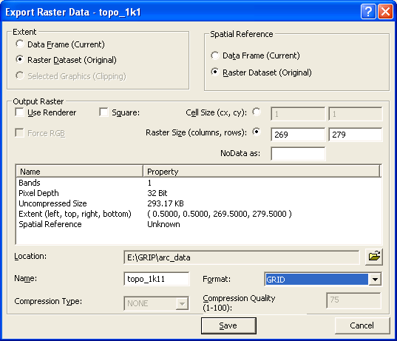

      - Export the raster to an ascii data file.
      - Obtain the lat/lon value (in decimal degrees) of the center point of the lower-left most point of the grid. This can be done a number of ways but the simplest method is to extract the first value in each of the ‘corner_lats’ and ‘corner_lons’ data arrays in the ‘global attributes’ section of the geogrid netcdf file header. This can easily be done using the ‘ncdump’ utility and scrolling down to the ‘global attributes’ section of the netcdf file header.
      - Create a single point data file in a spreadsheet for import into ArcGIS with the coordinates of the lower leftmost grid cell extracted from Step 4 above.
      - Import the point file intor ArcGIS and define the projection as geographic (e.g. WGS 84).
      - Project the point file to the desired projection specified in the WRF geogrid file (e.g. Lambert Conic Conformal) using the projection parameters provided in the ‘global attributes’ section of the netcdf file header.
      - Use the Data Management -> Features -> Add X/Y Data tool to add the x and y coordinates of the point to the point attribute table in the projected (e.g. Lambert Conic Conformal) coordinate system.
      - Edit the header in the ascii data file created in Step 3 above to specify the correct xllcenter and yllcenter values and the correct cell size values extracted from Step 4. Also set the cellsize to the appropriate values (e.g. 1000 for 1000 meters). An example based on the raster data from Fig. XX above is as follows:

ncols 269
nrows 279
xllcenter -134332.118354
yllcenter -138760.799122
cellsize 1000
NODATA_value -9999

Note: The xll… and yll… parameter names have been changed to xllcenter and yllcenter to specify that the coordinate values given represent centerpoint values of the lower leftmost gridcell. The values listed here for xllcenter and yllcenter are in units of meters and are relative to the Lambert Conic Conformal projection specified in the geogrid netcdf file.
      - Import the ascii file back into ArcGIS as a raster datafile.
      - Define the projection of the raster using the ‘Import’ option in the Projection Definition menu and set the new grid projection to the desired projection specified in the WRF geogrid file (e.g. Lambert Conic Conformal) using the projection parameters provided in the ‘global attributes’ section of the netcdf file header.
      - Verify that the data is properly georeferenced by overlaying several additional datasets of known and verified projection.

Successful completion of these steps should create an ArcGIS raster of terrain elevation which is properly projected according to the geographic projection specified in the geogrid file and in the WRF/WPS pre-processing system.

    - Processing High Resolution (~100m or less) DEM:
Once the LSM grid has been defined within ArcGIS work can proceed on setting up the high-resolution grid. The steps to create the grids shown in Figs. XX-XX are as follows:

      - Obtain a high-resolution digital elevation model (DEM). A near-global (Arctic/Antarctic excepted) high resolution DEM developed through a joint project of the World Wildlife Fund and the U.S. Geological Survey called Hydrosheds (http://hydrosheds.cr.usgs.gov/) provides a reasonably high quality terrain dataset which is based on Shuttle Radar Topography Mission (SRTM) data. The resolution of this dataset is 90m although gaps in SRTM data are filled coarser resolution data which results in some artifacts. Additionally, the Hydrosheds data set offers a ‘hydrologically-conditioned’ DEM which provides a more continuous flow field for use in hydrologic modeling. (See the Hydrosheds website and documentation for full details).

The Hydrosheds data is served in 5deg by 5deg lat/lon tiles. These tiles must be mosaicked to a single raster in ArcGIS and its spatial projection must be defined (the initial definition of spatial project must be that of the Hydrosheds DEM which is specified in the Hydrosheds documentation). Following definition of spatial projection, the data must be re-projected into the LSM grid projection which is specified in the geogrid file. Following projection one must then clip, interpolate and grid-match the high-resolution data to the LSM grid. Through much trial and error we have found the following process to be the most effective and efficient:

        - In the Spatial Analyst drop-down menu, specify the domain ‘extent’ to that of the LSM grid and define the ‘cell size’ (resolution) to be the desired resolution of the high-resolution terrain grid. For example, if the geogrid datafile has a 1km spatial resolution a common resolution for the terrain routing grid is 100m. Thus, 100m would be set as the cell size in the Spatial Analyst options ‘cell size’ tab.
        - Using the ‘Raster Calculator’ function in the Spatial Analyst drop-down menu, create the high resolution terrain grid using a simple equation:

new_grid = 90m_DEM_grid
(where the 90m_DEM_grid is the mosaicked and projected Hydrosheds DEM.)
Because the extent and cell size have already been defined in the Spatial Analyst options sections the ‘new_grid’ will exactly match in spatial extent and grid cell edges the LSM grid. Although other methods in ArcGIS may be used (e.g. raster ‘Clip’ function) we have found those to be unreliable with regard to exactly matching cell size, grid cell edges and overall extent.

      - Once the high-resolution DEM has been defined one can proceed with deriving flow direction, channel grid and stream order grids. These tasks exist as pre-defined functions in the Spatial Analyst->Hydrology toolbox or as part of the ArcHydro toolbox available through (http://www.crwr.utexs.edu/giswr/ydro/ArcHOSS/index.cfm) The steps to derive the these fields using ArcGIS are as follows:

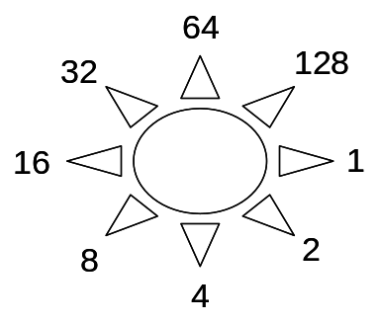
        - Create a ‘Flow Direction’ grid using the Spatial Analyst -> Hydrology -> FlowDirection tool. If successful, the output grid should have integer values of 1, 2, 4, 8, 16, 32, 64 and 128 and be oriented in the following directions:

        - Create a ‘Flow Accumulation’ grid using the Spatial Analyst -> Hydrology -> FlowAccumulation

        - Define the channel grid using either the ‘Stream Definition’ tool from the ArcHydro toolbox or using a logical operation in the Spatial Analyst Raster Calculator or Spatial Analyst Raster toolbox. Essentially, one simply needs to specify the minimum threshold of flow accumulation upon which a stream channel will be defined. There is little reliable guidance for this value in a ‘global’ sense since climate, soils, geology, vegetation and geomorphic processes all combine to define channel networks. However, typical values often range between 1-10 sq. km for many temperate or humid climates.

        - (Optional for channel routing) If channel routing is to be performed, one must specify stream order as many channel parameters in the NDHMS are defined on the basis of stream order. To create a grid of stream order use the ‘Stream Order’ tool within the Spatial Analyst -> Hydrology toolbox.

        - (Optional for lake/reservoir routing) If specification of lakes and/or reservoirs are desired one must define these as a lake grid and, subsequently, update the channel grid to that the channel network accurately interacts with the specified reservoirs. The basic steps to do this include masking out the stream channel network where reservoirs exist (accomplished using spatial analyst logical operators and/or the ‘Reclassify’ tool) and defining the outlet of each reservoir on the channel grid as an integer index that matches the associated reservoir. An example of what the lake grid and channel grid with a reservoir looks like is shown in Figs. XX above. The steps to do this are as follows:

          - Obtain a good quality lake coverage (e.g. shapefile), project it to the proper projection (e.g. Lambert Conic Conformal) and assign a proper index for each lake ranging from 1 to n-# of lakes.
          - Convert the lake coverage or shapefile to a grid using the Spatial Analyst -> Feature to Raster tool. Make sure that the proper spatial analyst options for domain extent and cell size have been properly set so that the output grid will perfectly match the other gridded data layers.
          - Create a ‘reverse’ or ‘negative’ lake mask by re-classifying all ‘lake grid cells’ (e.g. those that have data values) to ‘NoData’ and all ‘NoData’ values equal to 1.
          - In the Spatial Analyst -> Raster Calculator tool, multiply the existing channel grid by the ‘negative’ lake mask to create a new channel grid.
          - Convert the new channel grid file to a point dataset using the Raster to Point tool in the Conversions From Raster toolbox.
          - Manually edit the output grid cell points to have a proper lake index value associated with the adjacent lake. Use the flow direction grid to help trace the proper flow path if it is not initially obvious.
          - Convert the channel points file back to grid using the Point to Raster tool in the Conversions to Raster toolbox.
          - Reclassify all no data values to -9999 and verify that all non-outlet channel gridcells have values of ‘0’ and all channel outlet grid cells have values according to the adjacent lake.

        - (Optional for simple Groundwater/Baseflow implementation, additional details are provided in Section XXX) To permit use of the groundwater/baseflow module in the NDHMS, one must define a groundwater basin that receives drainage from the LSM soil column (i.e. ‘recharge’) and feeds the stream channel network (i.e. ‘discharge’). Generally, there is very little information on the spatial extent of aquifers or their actual connectivity with surface channel networks. Thus, we have adopted an overly-simple approach by defining a groundwater basin that is the same as the surface watershed defined solely by topography. (However, other methods can be used and users are encouraged to experiment.) To create a watershed function one needs to define a basin outlet or ‘pour point’ in ArcGIS. Typically, this point is a gauging station or some location where data is being or has been collected which allows for an empirical determination of baseflow values (see Section XXXX). Once a pour point has been defined this point bust be ‘snapped’ to the FlowAccumulation grid defined above in c) using the Spatial Analyst -> Hydrology toolbox. [One can create a grid of pour points either using the ‘Snap Pour Points’ tool or using the Spatial Analyst ‘Feature to Raster’ tool. In either case care must be taken to make sure that the proper spatial analyst options have been specified so that the grid of pour points created perfectly matches the flow accumulation grid.] Next the watershed can be defined using the ‘Watershed’ tool in the Spatial Analyst -> Hydrology toolbox. The process can be repeated for several watersheds to create multiple groundwater/baseflow basins within the modeling domain where each basin has an integer index value.

        - The final GIS processing step before data export to netcdf format is to re-classify or re-assign all grids so that they possess proper ‘no-data’ values. This can be accomplished using Spatial Analyst logical operators and/or the ‘Reclassify’ tool so that the grids EXACTLY follow the numbering convention shown in Figures XXX-XXX. Not following these numbering conventions will likely result in runtime errors of the NDHMS such as a ‘Segmentation Fault’.

        - Export of the newly created high-resolution terrain fields to netcdf is accomplished using the Spatial Analyst -> Multidimensional Tools -> Raster to Netcdf tool. When using this tool the proper variable names for each data layer must be specified or else the NDHMS will not be able to properly input the data. The correct variable names for each data layer are as follows (these are case sensitive):

LATITUDE
LONGITUDE
TOPGRAPHY
FLOWDIRECTION
CHANNELGRID
STREAMORDER
LAKEGRID
frxst_pts
gw_basns

Once all data layers have been properly exported to netcdf format, the final step is to merge or ‘concatenate’ all of the individual netcdf files into a single netcdf file. There are a variety of netcdf command operators (NCO commands) that can be utilized to do this and we have placed these into a simple c-shell script called ‘concatenate.csh’ which is typically distributed with the NDHMS. Following the command line structure provided within the script the user simply needs to issue the script execution command followed by the list of individual netcdf files given as command line arguments and lastly an output file name. An example execution statement with command line arguments is given as follows:

csh concatenate.csh file1.nc file2.nc file3.nc outfile.nc

Upon successful completion of the concatenate.csh script the outfile.nc file will be created which contains all of the individual data layers specified in the command line. The most likely reason the concatenate.csh fails is because the individual netcdf files do not all have the exact same dimension values. This serves as one valuable check to ensure that all of the high-resolution data layers have the same dimensions.

Helpful notes on high-resolution grid preparation:
- The performance and computational stability of physically-based hydrologic simulation models is often dependent on the characteristics and quality of the underlying terrain fields upon which routing calculations are performed. Thus, anomalous artifacts in DEMs can have deleterious impacts on model stability, computational performance and/or simulation accuracy. Thus preparation of the high-resolution terrain fields can often be an iterative process where successive manipulations of the DEM can be made to reduce or eliminate large flat areas, change the density of the channel network or add/remove lakes/reservoirs. Thus when setting up a new domain, it is not uncommon to experiment with different thresholds and techniques during the DEM processing stages described above.
- Large water bodies (the ocean, inland seas, etc) are somewhat distinct from typical lakes and reservoirs. For most applications, one large inland seas are treated as water sinks and not necessarily lakes/reservoirs and the oceans are always treated as sinks. These large water bodies are typically defined as ‘water’ grid points in the LSM. However, in the processing of the DEM data we have adopted a convention for specifying elevation where all ocean and large inland water bodies have either an elevation of 0 meters or a constant elevation of the mean lake surface elevation. Assigning these water body elevation values will help ensure the model does not crash since the model expects to find valid terrain elevation values everywhere in the simulation domain (i.e. there are no ‘No Data’ or -9999 values in the topography data layer).

- Channel Attributing
In addition to preparing the high-resolution data layers as described above, if one desires to perform channel routing in their simulation then parameters characterizing the channel network must be defined. These parameters are defined in a parameter file called CHANPARM.TBL which is placed in the run directory. These parameters are described in more detail in Section XXXX which describes the channel and lake routing schemes but they are also briefly defined here. The values are related, or ‘indexed’, to the channel network via stream order values which are defined above. Thus, in the present version of the model all stream pixel values of similar stream order will have identical channel parameter values. This assumption is likely not valid in many regions, and future versions of the model will likely include spatially-distributed specifications of channel parameters that are assigned on the full high-resolution terrain grids. Nevertheless, the parameters in the CHANPARM.TBL file along with a range of possible values are defined as follows and in the Appendix:

Channel Parameters
StreamOrder
10,1, 'Bw HLINK ChSSlp MannN'
1, 5., 0.02, 1.0, 0.14
2, 10., 0.02, 0.6, 0.12
3, 20., 0.02, 0.3, 0.09
4, 30., 0.03, 0.18, 0.09
5, 40., 0.03, 0.05, 0.07
6, 60., 0.03, 0.05, 0.06
7, 60., 0.03, 0.05, 0.03
8, 60., 0.10, 0.05, 0.03
9, 60., 0.30, 0.05, 0.03
10, 60., 0.30, 0.05, 0.03

where, the first column is the Strahler stream order, ‘Bw’ is the channel bottom width (unit of meters), ‘HLINK’ is the initial depth of water in the channel (unit of meters), ‘ChSSlp’ is the channel side slope (units of rise/run) and ‘MannN’ is the Manning’s roughness coefficient for that stream order.

It is important to keep in mind that there is large uncertainty associated with these parameters. Therefore, model calibration is almost always warranted.

Also, because fully-distributed estimates of flow depth (HLINK) are not available for model initialization, it is almost always necessary to use a small initial value of HLINK and let the model come to its own equilibrium (i.e. ‘spin-up’) after several hours of integration.

- Reservoir Attributing
In addition to preparing the high-resolution data layers as described above, if one desires to perform level-pool /lake reservoir routing in their simulation then parameters characterizing each reservoir must be defined. These parameters are defined in a parameter file called LAKEPARAM.TBL which is placed in the run directory. These parameters are described in more detail in Section XXXX which describes the channel and lake routing schemes but they are also briefly defined here. If lake/reservoirs are not being simulated one can just assign bogus values for each parameter in the LAKEPARAM.TBL file. Failure to put any value in the file may result in crashing the model and receiving an I/O error message.

As described above and as shown in Fig. XX each reservoir in the lake/reservoir data layer is assigned an integer index value ranging from 1-# of lake objects. The rest of the lake/reservoir parameters required for level-pool reservoir routing are as follows and in the Appendix:

lake lake index (consecutively from 1 to n # of lakes)
LkArea lake area (square meters)
LkMxH elevation of maximum lake height(in meters MSL)
WeirC weir coefficient
WeirL weir length (units of meters)
OrificC orifice coefficient
OrificeA orifice area (units of square meters)
OrificeE orifice elevation (units of meters MSL)
Lat latitude of center of mass of lake (decimal degrees)
Long latitude of center of mass of lake (decimal degrees)
Elevation mean elevation of the lake surface (units of meters MSL)

These lake parameter values are specified for each one of the lake objects defined in the lake grid data layer contained within the high resolution terrain grid. Typically, several of these parameters are derived within the high-resolution terrain pre-processing stages described above using tools such as ArcGIS. Values for the weir and orifice coefficients and sizes can be drawn from standard engineering hydraulics textbooks (e.g. Chow et al., 1964). Weir parameters are specified for reservoir ‘overflow’ or ‘spill’ and orifice parameters are specified for design operations. Obviously, the behavior of the reservoir to store and release water is highly dependent on these parameters and that parameter values and reservoir operations data are often not available.

- Groundwater/Baseflow Basin Attributing:
In addition to preparing the high-resolution data layers as described above, if one desires to include the representation of groundwater discharge/baseflow in their simulation then parameters characterizing the simple baseflow bucket model must be defined. These parameters are defined in a parameter file called GWBUCKPARM.TBL which is placed in the run directory. These parameters are described in more detail in Section XXXX which describes the groundwater/baseflow scheme but they are also briefly defined here. The values in the table are related, or ‘indexed’, to each groundwater basin which is specified in the high-resolution terrain grid described above. The parameter values in GWBUCKPARM;TBL are defined as follows and in the Appendix:

Coeff.,Expon.,Zinit
0.4898,25.0,0.03867
0.8925,0.1394,2.0
2.1388,0.1359,1.0
0.0332,0.1615,0.5

where, ‘Coeff.’ is the bucket model coefficient, ‘Expon.’ is the bucket model exponent and ‘Zinit’ is the initial depth of water in the bucket model. It is important to remember that a simple bucket model is a highly abstracted and conceptualized representation of groundwater processes and therefore the depth of water values in the bucket have no real physical basis. Initial values of the groundwater bucket model parameters, including ‘Zinit’ are typically derived analytically or ‘offline’ from the NDHMS and then are fine-tuned through model calibration. Full description of the procedure to derive initial groundwater bucket model parameters are presented in Section XXX.

Description of Output Files from the NDHMS

- Land surface model output (YYYYMMDDHHMM.LDASOUT_DOMAINX)

When the Noah LSM is used (only option currently available), model output on the land surface model grid is written to a multi-dimensional netcdf data file using the file naming convention ‘YYYYMMDDHHMM.LDASOUT_DOMAINX’.

where:
YYYY – year
MM – month
DD – day
HH – hour
MM – minutes
DOMAINX – the domain number that is specified in the noah_namelist input file (also matches the domain number of the geogrid input file).

The west_east and north_south dimensions of the output file match those of the geogrid input file. Model output is created for every model time step. However, the length of the time dimension in each netcdf output data file can vary depending on the value of ‘SPLIT_OUTPUT_COUNT’ specified in the noah_namelist input file.

The names and definitions for each output variable in the LSM output file are generally consistent with those output from standard Noah LSM coupled to WRF. An example header of the netcdf output file is provided in the Appendix (see ‘LDASOUT_header.txt’). Only three new output variables are created and output on the LSM grid as a result of the routing implementation. These variables are:

ETPNDX : Accumulated ponded water evaporation (units of mm)
INFXS : Time-step values of infiltration excess (units of mm)
SFCHEAD : Time-step values of the depth of water ponded on the soil surface of an LSM grid cell (units of mm)

In addition to the gridded LSM output variables selected land surface variables are output in an ASCII-formatted, basin-average, timeseries format in the ‘lnd_fluxes.txt’ file. These variables can be helpful with understanding and calibrating the gross hydrologic partitioning of land surface flux variables. One line of output is given for each land surface model timestep. In ‘lnd_fluxes.txt’ three variables are currently output:

column 1: accumulated, basin-average, total evapotranspiration (units - mm)
column 2: accumulated, basin-average, total precipitation (units - mm)
column 3: basin-average, column-integrated soil water content (units - mm)

An example of ‘lnd_fluxes.txt’ is provided in the Appendix.

Output file description Routing output

Terrain Routing
When routing modules are activated additional output datasets are created. Here we distinguish these datasets between those that are created when only the terrain (overland and/or subsurface) routing is activated versus those datasets that are created when channel routing is activated. For all datasets, one output is provided for each LSM time-step, not each routing model time-step. These output data include the following:

  - ‘chan_inflow.txt’: This is an ASCII formatted, timeseries data file of the channel network total accumulated, channel inflow (in units of cubic meters). Essentially, this value is the volume of water that is moving into the entire channel network from overland flow. A switch in the noah_namelist file (HIRES_OUTPUT = 1) activates the generation of this output. An example of ‘chan_inflow.txt’ is provided in the Appendix.
  - (Optional) Netcdf high-resolution terrain grid output file: A gridded dataset of selected variables on the high-resolution terrain grid output to a netcdf file using the following file naming convention: YYYYMMDGHHMM.RTOUT_DOMAINX, where the convention terms are defined above in the LSM output file description. Due to the shear size of these data layers, care should be used in deciding when to output high-resolution terrain data and which variables to output. Users desiring this output presently need to edit the source code and remove the comments blocking the call to the subroutine to perform this output. Default output variables provided in this file are listed in the ‘RTOUT_header.txt’ file in the Appendix and include:

LATITUDE
LONGITUDE
SOIL_M : Volumetric soil moisture content (units of m^3/m^3)
ZWATTABLRT : Depth to saturated layers where saturated subsurface routing may be occurring. This value will equal the total soil column depth (typically 2m) when no saturation is occurring. (units of m)
QSTRMVOLRT : Accumulated depth of stream channel inflow (units of mm)
SFCHEADSUBRT : Instantaneous value of depth of water ponded on the surface (units of mm)

Additional variables can be added to this file through changes in source code. As with the LSM output datafiles, the number of time slices per datafile are controlled through specification of the ‘SPLIT_OUTPUT_COUNT’ parameter specified in the noah_namelist input file.

Channel Routing (only output when channel routing is active)
  - ‘frxst_pts.txt’: This is an ASCII-formatted data file that provides time series of streamflow discharge at selected ‘forecast’ points along the channel network. The forecast points are specified within the ‘frxst_pts’ data layer contained within the high-resolution terrain netcdf data file. Points are listed in sequential order by station index (numbered 1 to n # of stations) and by time. Many users will find this data file and format useful for streamflow forecasting and model calibration. An example of ‘frxst_pts.txt’ is provided in the Appendix. The format for each data record is as follows:

column 1 : time (in seconds) into simulation
column 2 : date and time as YYYY-MM-DD_HH:MM:SS
column 3 : station number index (numbered 0 to n-1 stations)
column 4 : station longitude (in decimal degrees)
column 5 : station latitude (in decimal degrees)
column 6 : streamflow discharge (in cubic meters per second)
column 7 : streamflow discharge (in cubic feet per second)
column 8 : flow depth/river stage (in meters above channel bottom)

  - Netcdf forecast point output : (YYYYMMDGHHMM_CHANOBS_DOMAINX)
This is a netcdf point file which contains streamflow discharge, flow depth (i.e. ‘stage’ or ‘head’), longitude, latitude, forecast point index and stream order value for each forecast point specified in the ‘frxst_pts’ data layer of the high-resolution terrain data file. It ONLY contains data from the forecast points and, thus, is small in file size. Users wishing to overlay numeric streamflow values on top of other data layers such as topography or precipitation in data visualization tools (e.g. ArcGIS, matlab, IDV, etc.) will find this format useful. As with the LSM output datafiles, the number of time slices per datafile are controlled through specification of the ‘SPLIT_OUTPUT_COUNT’ parameter specified in the noah_namelist input file. An example of the netcdf data file header is provided in the Appendix (see ‘CHANOBS_header.txt’).

  - Netcdf full channel point output (YYYYMMDGHHMM_CHRTOUT_DOMAINX)
This is a netcdf point file which is identical to the forecast point netcdf data file except that it contains streamflow discharge, flow depth (i.e. ‘stage’ or ‘head’), longitude, latitude, forecast point index and stream order value for all channel pixels within the high-resolution terrain data file. Because it contains data from all channel pixels within the high-resolution terrain grid, file sizes can become quite large. Users wishing to overlay spatially continuous numeric streamflow values on top of other data layers such as topography or precipitation in data visualization tools (e.g. ArcGIS, matlab, IDV, etc.) will find this format useful. As with the LSM output datafiles, the number of time slices per datafile are controlled through specification of the ‘SPLIT_OUTPUT_COUNT’ parameter specified in the noah_namelist input file. An example of the netcdf data file header is provided in the Appendix (see ‘CHRTOUT_header.txt’)

Lake/Reservoir Output
  - Netcdf lake point output (YYYYMMDGHHMM_LAKES_DOMAINX)
When one or more lakes/reservoirs are specified within the LAKEGRID data layer of the high-resolution netcdf input file, a netcdf point data file is created which contains values of several state and flux variables to/from the lake/reservoir. An example of the header from the LAKEGRID netcdf file is provided in the Appendix (see ‘LAKEOUT_header.txt’) and some of the most commonly used variable names are defined as follows:

ELEVATION : elevation of the lake/reservoir water surface (units of meters above MSL)
INFLOW : total inflow to the reservoir from all channel tributaries intersecting the lake/reservoir (units of m^3/s)
OUTFLOW : total outflow from the reservoir to a specified outlet on the channel network (units of m^3/s)
STATION_ID : integer index of the lake numbered from 0 to n-1 lakes/reservoirs as specified in the high-resolution terrain input file.

Groundwater flux files:

When the groundwater/baseflow bucket model is activated, three additional ASCII data files are created which help characterized the state of (bucket depth) and fluxes (input and output) to/from the conceptual bucket. Each datafile contains time series of values where output values are provided for each groundwater basin. The format of each datafile is described by the following:

  - GW_inflow.txt : Contains time-step values of drainage fluxes from the soil column to the groundwater bucket integrated over each groundwater basin specified in the high-resolution terrain input file. Units of these fluxes are in meters^3.
  - GW_outflow.txt : Contains time-step values of groundwater/baseflow bucket discharge fluxes from the bucket to the channel network. Discharge flux values are a single value for each groundwater basin specified in the high-resolution terrain input file. As described in the Section XXXX the bucket discharge values are spatially distributed across all channel pixels contained within each groundwater basin. Units of these fluxes are m^3/s.
  - GW_zlev.txt : Contains time-step values of the conceptual depth of water within each bucket model. For the purposes of mass conservation units of these fluxes are meters. However, as mentioned previously, these values are conceptual, are specific to the calibrated parameters of each groundwater/baseflow bucket and do not reflect an actual depth of water in any ‘natural’ aquifer system.

REFERENCES

Chen… recent Noah doc…

Chow, V.T. and co-authors, 1964: Applied Hydrology. McGraw-Hill, Inc.

Ek…Noah doc

Gochis and Chen…

Mitchell…Noah doc…

Oleson et al…CLM doc

APPENDICES

