Xpol Calibration

Technical Document

November 23, 2011

ProSensing Inc.
107 Sunderland Road
Amherst, MA 01002-1098, USA

Contact:
Andrew L. Pazmany
T: (413) 549-4402 x 11
pazmany@prosensing.com

1. CALIBRATION THEORY

1.1 Point Scattering
The transmitted power density, S, of a radar can be expressed as
(1) 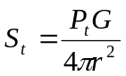 , (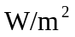),
where 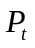is the transmitted power in (W), G is the antenna gain and is the distance to the point target reflector in (m).
The power density captured by the reflector and re-radiated towards the radar is
(2) 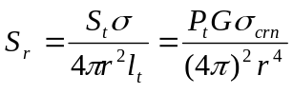 , ().
The received power at the antenna feed is the product of the antenna effective aperture and the incident power density of the scattered field according to
(3) 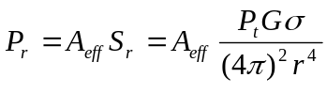 ,
and since
(4) 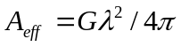,
the received power can be written in the standard form of the radar range equation for a point target as

(5) 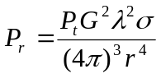, (W).
The power measured by the radar data system at the output of the radar receiver is the received power at the antenna feed, 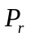 and amplified by the receiver gain, 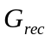, so the power measured by the radar data system can be expressed as
(6) 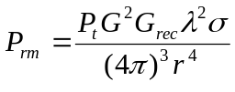.

By solving for , the expression for the maximum reflector cross section can be obtained as a function of range and the maximum measurable power (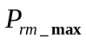):
(7) 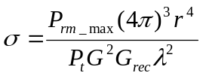

1.2 Corner Reflector Calibration
The “Far-Field” range of an antenna is approximated as
(8) 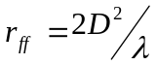,
where D is the antenna diameter and is the radar wavelength. Beyond this range the antenna pattern is well established and the antenna gain is effectively independent of range, and thus if a reflector is used to calibrate the radar, then it is convenient to place it at or beyond this distance. Inside this distance the range dependence of the antenna gain has to be taken in consideration. For the Xpol, with a 1.8 m diameter antenna, this minimum range is approximately:
(9) 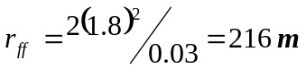,
We can consider using a corner reflector as a calibration target outside these far filed distances. The radar cross section of a corner reflector is given by
(10) 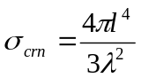 (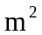),
where is the length of the inside corner of the reflector, and is the radar wavelength, both in units of meters.

The reflector calibration measures the overall system gain at the center of the antenna beam. The fixed radar parameters and constants can be lumped into the radar calibration constant, C_{crn}, such that
(11) 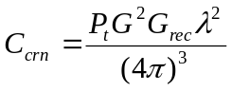, resulting the following expression for the received power:
(12) 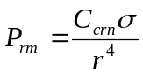.
This calibration constant can be expressed in terms of the corner reflector measurement data according to

(13) 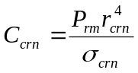.

1.3 Volume Scatterering

The radar range equation for a point target can be extended to a volume target by replacing with the product of volume reflectivity, (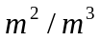) and the volume of a range cell, V. The range cell volume of a pulsed radar, with an approximately Gaussian shaped antenna pattern, may be approximated as
(14) 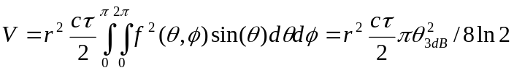, (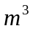),
where,
r is the range to the center of the volume cell in meters,
(15) 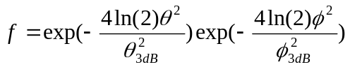
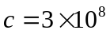 m/s, speed of light in free space,
transmit pulse length (sec.), and
for the Xpol antenna half power beamwidths in elevation and azimuth may be approximated to be equal so 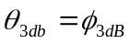 (radians).
The resulting expression for the measured power from a volume target is [Ref. 2, page 75, Eq. 4.16]:
(16) 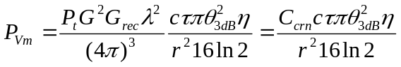.
Solving for the volume reflectivity and combining the fixed variables into a new constant, 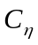,
(17) 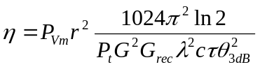.

So the following expression can be used to estimate the volume reflectivity at some range r from the measured power (in units of dBm):
(18) ,
where
(19) 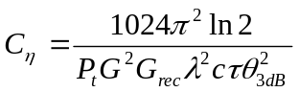 and here r is in units of meters.
A more common measure of volume reflectivity is the radar reflectivity factor, Z, defined as the sixth moment of the drop diameter concentration in a volume according to
(20) 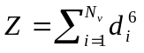,
where
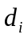is the i th particle out of 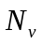total number of particles in the volume cell.
If the particle size is much smaller than the incident wave, so that
(21) 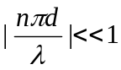,
where
n is the complex refractive index of the particle,
then Z may be related to as
(22) 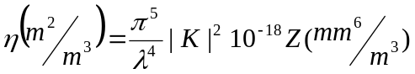, so 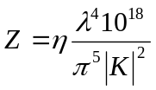
where
(23) 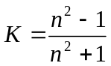 at 9.4 GHz 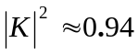.
By substituting Z in place of in Eq. (17), the following expression can be obtained for the measured power from a volume scatterer:

(24) 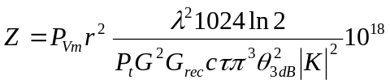.
The radar reflectivity factor can be expressed in terms of the and the measured power as
(25) 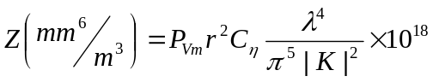.
We can define a new calibration constant, 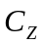, by combining 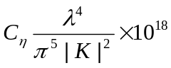 and converting the units of r to km (all other lengths remain in meters):

(26) 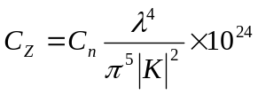.

(27) 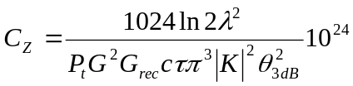, where
(28) .

2. MEASURED RESULTS
The Xpol radar has the following set of typical calibration parameters:

V: 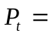 70.7 dBm -0.9 dB (waveguide loss) = 69.8 dBm,
H: 70.5 dBm -0.8 dB (waveguide loss) = 69.7 dBm,

V: 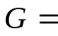 42.2 dB; from antenna test report
H: 42.1 dB; from antenna test report

V: 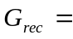 31.0 dB – 0.9 dB (waveguide loss) = 30.1 dB
H: 31.6 dB – 0.8 dB (waveguide loss) = 30.8 dB

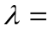 0.032 m

V: 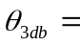 0.023 rad (~ 1.3 deg); from antenna test report.
V: 0.024 rad (~ 1.35 deg); from antenna test report.

Using Equation (27) and substituting the range resolution (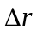) for 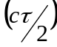:
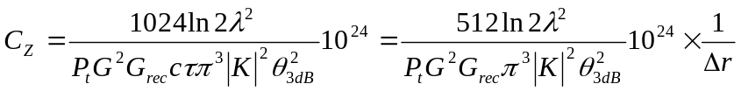,
V: 10log(C_{Z}) = 67.6 dB -10log(),
H: 10log(C_{Z}) = 67.4 dB -10log().
The following expression is the final equation for the radar reflectivity factor, Z in units of mm⁶/m³ is

V: ,
H: ,

where is the range resolution (30, 75, 105, 150) in units of meters.

Note that this calibration analysis is an approximation, as it assumes no atmospheric attenuation, no signal loss in the digital receiver filter, and a constant receiver gain.

3. REFERENCES
[1] Ulaby, More and Fung, 1989: “Microwave Remote Sensing”, Vol. 2, Artech House.
[2] Doviak and Zrnic, 1984: “Doppler Radar and Weather Observations”, Academic Press.

