XPOL Radar Data System
Statement of Work

Prepared for

Internal Use

ProSensing Inc.
107 Sunderland Road
Amherst, MA 01002-1098, USA

Project Summary
ProSensing Inc. is developing a polarimetric X-band weather radar system shown in Figure 1.
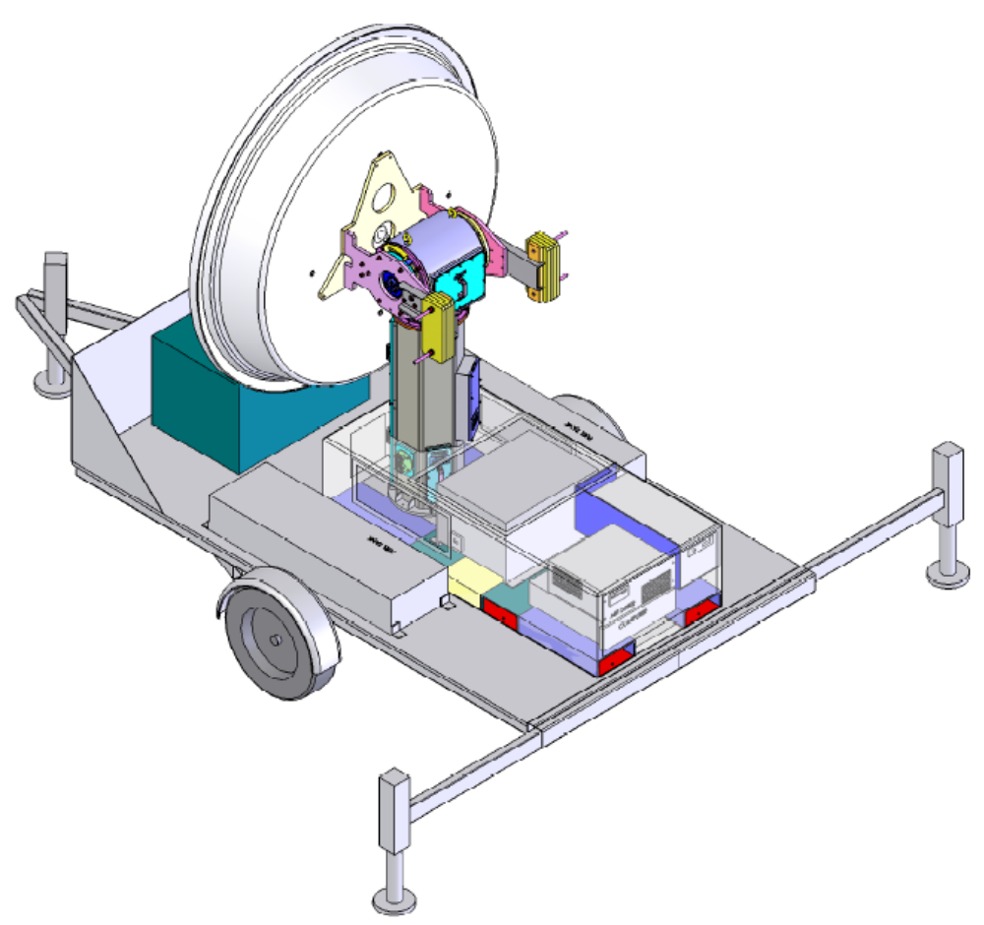
Figure 1. The ProSensing polarimetric X-band weather radar system (Xpol) mounted on a trailer with a diesel generator.

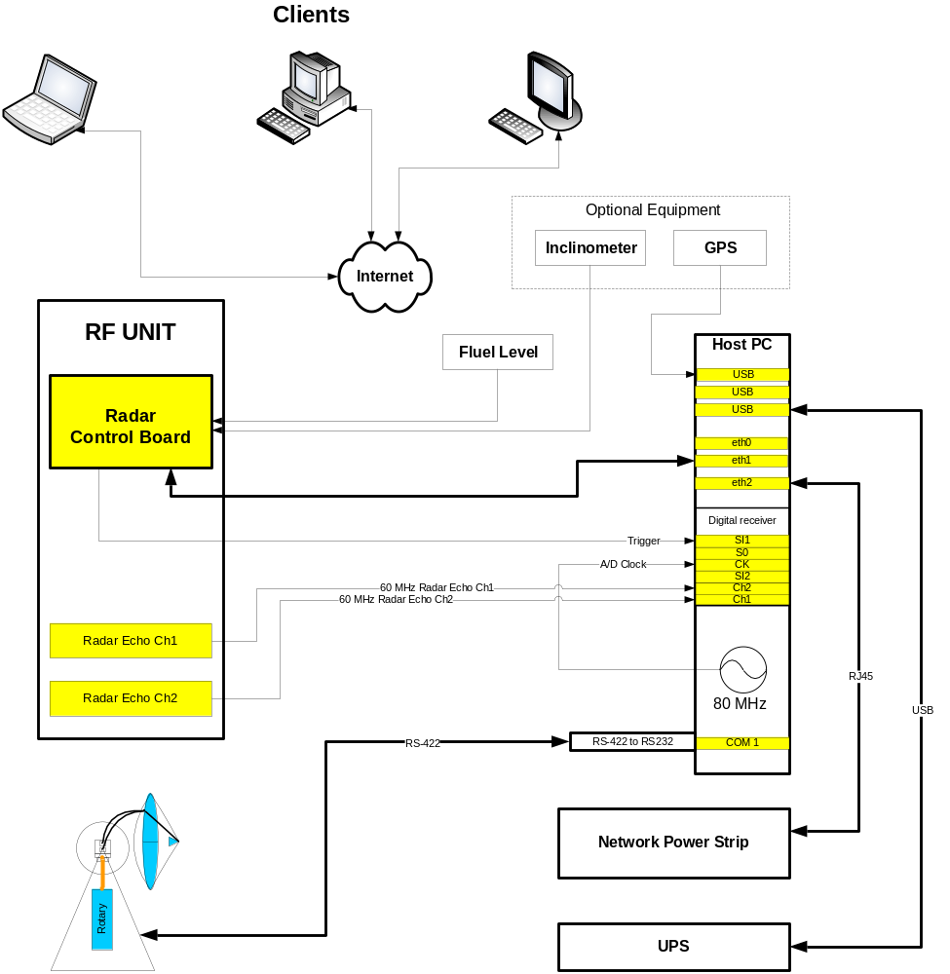
Figure 2. Xpol data system logical connection diagram.
The data system and external device connections are shown in Figure 2. The host PC is an industrial rack-mountable computer with the Linux operating system. The digital receiver and (if necessary) an Ethernet expansion card is housed in the Host PC. The following external devices provide data or control signals to the data system: 1) Radar Control Card (RCB) via an Intranet connection, housed in the radar RF section, 2) a pair of radar receiver channels provide the radar signal to the data system for sampling and processing, 3) an elevation over azimuth pedestal is controlled and the elevation and azimuth position and speed data acquired over an RS422 bus; converted to RS-232 at the data system, 4) the status of a UPS (uninterruptible power supply) is monitored over a USB link, 5) a network power strip terminals are turned on and off via the Intranet, 6) data from a GPS or a digital compass are acquired via USB ports, and 7) clients over the Internet can power on and off the Host PC, control the data acquisition program and monitor the data.

Controlled Devices:
- RCB: the RCB board is the master timing system for the radar switches and pulsed devices. It controls the radar switches and triggers the transmitter and digital receiver AD converters. Radar modes of operation include: pulse pair (PP) - 2 or 3 staggered pulses per group, or FFT - 1 or 2 FFT blocks. The data system implements specific algorithms in PP or FFT modes or can record Raw IQ samples in either pulsing mode.
- Pedestal: the pedestal is controlled via an RS422 bus. Command options include:
  - PPI: fixed elevation (El_0), continuous azimuth (Az_vel)
  - RHI: fixed azimuth (Az_0), elevation scan between El_0 and El_1 and El_vel speed.
  - Spriral: elevation scan between El_0 and El_1 at El_vel speed, while continuously scan in Azimuth at Az_vel speed.
  - Point: scan to El_0 and Az_0 pointing direction.
  - Roster: scan between El_0 and El_1 at El_vel speed, while scan between Az_0 and Az_1 at Az_vel speed.
- Digital receiver
- Network Power strip: turn off devices if the UPS indicates a power outage.
- (UPS: Put it in power saving mode until line power comes back on?)

Data Sources:
- Client PC-s running the Control and or Display GUI program, communication over the Internet.
- RCB: the RCB board monitors temperature (5 channels) and analog signals (2 channels: fuel level indicator, digital inclinometer) and transmits this data to the data system over the Intranet. This data is recorded in the record header block.
- Digital receiver: the digital receiver samples the V and H receiver IF signals, digitally computes the complex envelop of the signal (I and Q samples), bandpass filters and decimates the data before transmitting the data blocks to the Host PC via the PCI bus.
- USP: the uninterruptible power supply signals the Host PC is the line power fails beyond some programmed time interval. If this occurs, then the Host PC shuts down the radar system including the Host PC.
- GPS (optional): serial data source with one (location) or two (location and heading) antennas.

Data System Functional Description
The flow-chart of the main data processing loop is illustrated in Figure 3.. The radar operator can configure the radar operation and data processing and recording parameters through a Control GUI program. Based on these control parameters, the data acquisition program configures the RCB board (radar operation), digital receiver (data block size, digital IF frequency, filter bandwidth, decimation), data processing algorithm (Pulse Pair=PP or FFT), and recording (Processed or Raw).
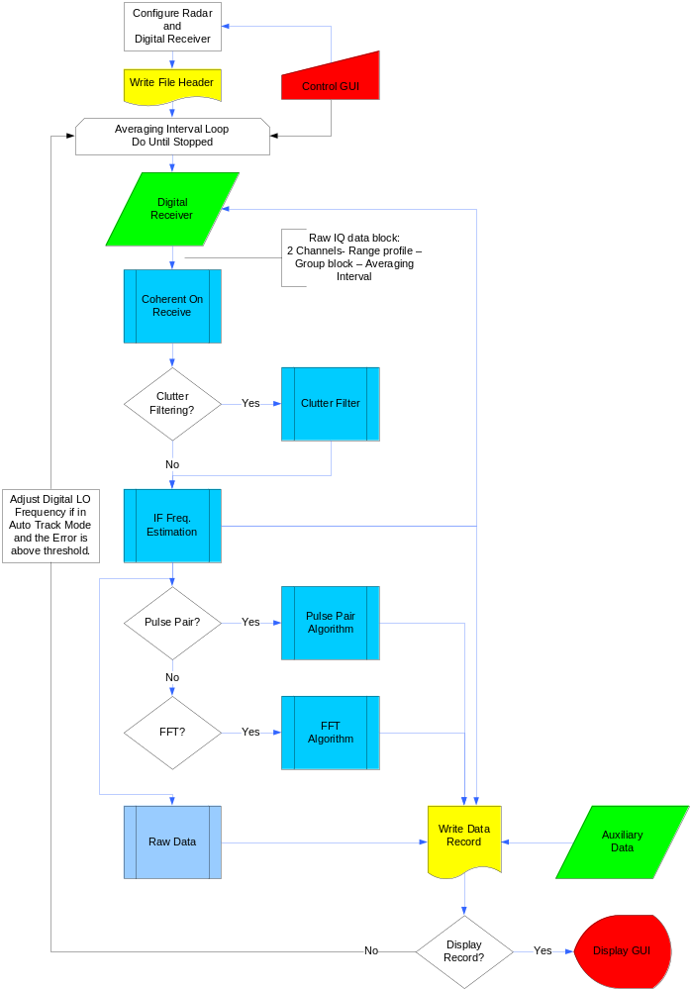
Figure 3. Xpol Data System data flow chart through the main data processing loop.

RCB Control Parameters
The Radar Control Board (RCB) is the master timer of all the switches and trigger enabled components like the digital receiver A/D converters. The host PC sends the configuration block to the RCB which determines the radar pulse length and pulse pattern, and the time spacing between the radar transmit trigger pulse and the start of the digital receiver range profile samples. The five different Xpol pulsing modes are illustrated in Figure 4. PP and DPP modes are standard pulse pair modes with two and three pulses per group respectively. There are two different FFT pulsing schemes (FFT and FFT2), but three different processing methods: FFT (constant PRI FFT), FFT2 (dual PRI FFT), and FFT2I (dual PRI, interleaved FFT). In all the FFT modes L represents the FFT length and cave is the number of FFT Blocks that correspond to the clutter filtering interval, pave is post averaging and nave is the total number of FFT Spectrum Blocks averaged (nave=cave*pave). In the FFT pulsing mode clutter filtering is implemented by first coherently averaging L*cave sample vector, then subtracting this average (DC DFT bin) component from every sample of that vector. Then the separate L sample blocks are FFT processed and the entire nave blocks averaged. FFT2 is essentially same as FFT, but two different PRIs are used for subsequent L*cave pulses. This allows a precise clutter filtering while the staggered PRI extends the maximum unambiguous velocity of the radar measurement. FFT2I is the interleaved version of FFT2. The clutter filtering in this mode is less precise, but the two different PRI spectrums are better correlated leading to a more reliable unfolding of the Doppler velocity.
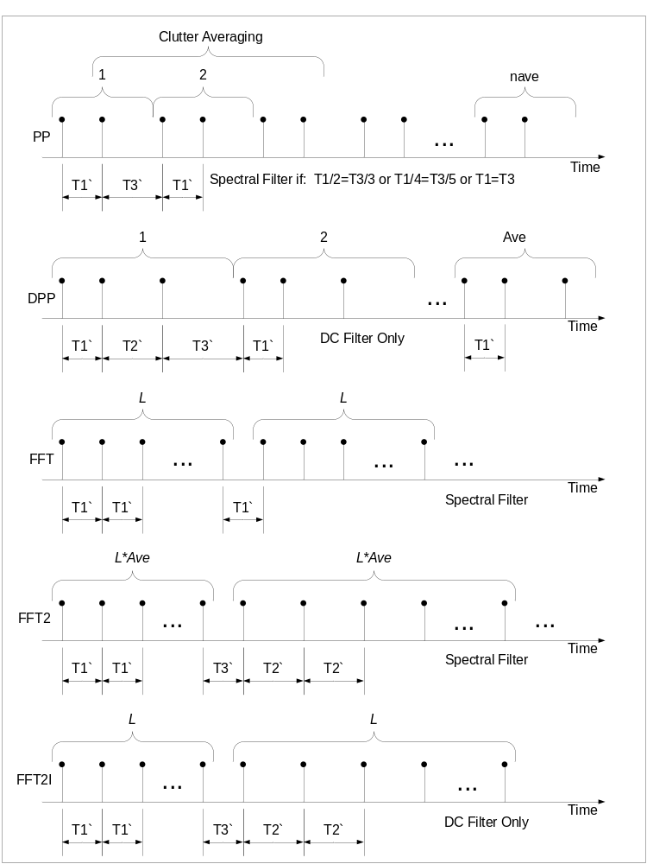
Figure 4. Xpol pulsing modes.
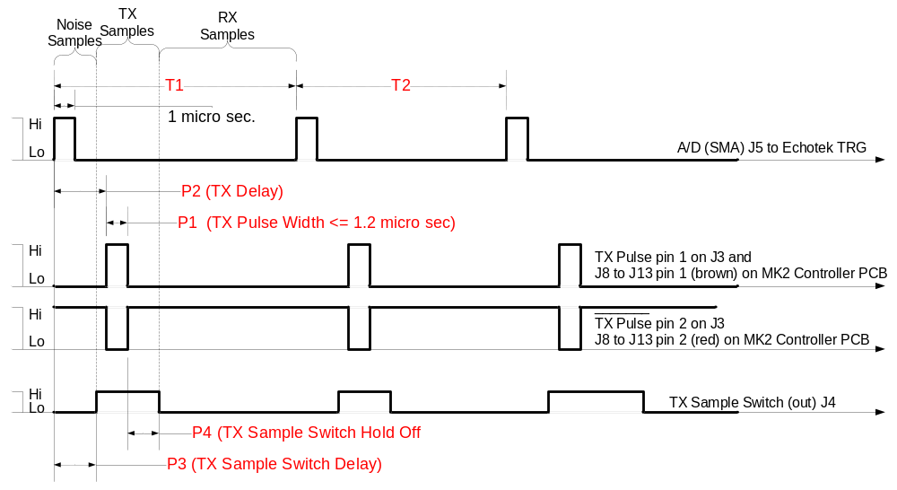
Figure 5. Timing of the various RCB trigger signals during a transmit pulse event.

Digital Receiver Control Parameters
The first step inside the data acquisition loop is to read the data receiver data block of raw IQ samples. The size of this data block depends on operating mode (PP or FFT), the Number of Range Gates (nrg), the Number of Pulses (nps) per group (in PP) or FFT Length (fftlen) times the Number of FFT Blocks (fftblocks)per group (in FFT), and Number of Averaged (nave) groups:
Mode | Data Points per Gate (I/Q) | No. of Channels (V/H) | Range Gates | Number of Pulses or Blocks per Group | FFT Length | Number of Averaged Groups
PP | 2 | 2 | nrg | nps | 1 | nave
FFT | 2 | 2 | nrg | fftblocks | fftlen | nave
Table 1. Digital receiver data block size parameters.

TX Pulse | Receiver | Gate 1 | Gate 2 | … | Gate nrg
Range Sample Profile #1 | V | I(1,1),Q(1,1) | I(1,2),Q(1,2) | … | I(1,nrg),Q(1,nrg)
Range Sample Profile #1 | H | I(1,1),Q(1,1) | I(1,2),Q(1,2) | … | I(1,nrg),Q(1,nrg)
Range Sample Profile #2 | V | . | . | … | .
Range Sample Profile #2 | H | . | . | … | .
. | V | . | . | … | .
. | H | . | . | … | .
Range Sample Profile #Ns | V | I(Ns,1),Q(Ns,1) | . | … | I(Ns,nrg),Q(Ns,nrg)
Range Sample Profile #Ns | H | I(Ns,1),Q(Ns,1) | . | … | I(Ns,nrg),Q(Ns,nrg)
Table 2. Digital receiver data block. Each row represents a profile of samples collected from a transmit pulse. Ns is the total number of pulses in an averaging interval: 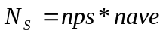 in PP mode and 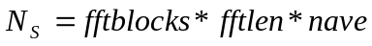 in FFT mode.

Other key digital receiver parameters are:
- Digital LO frequency – this will be adjusted periodically to track the drift of the magnetron transmitter frequency. The default frequency will be 20 MHz. This digital LO frequency will have to be kept close to the difference between the IF signal frequency (will drift with the magnetron frequency) and the A/D clock frequency (fixed at 80 MHz).
- Bandwidth – the taps for various 128 point fir filter bandwidths will be programmed. The radar operator will be able to select any one of the preprogrammed filters with 10, 5, 4, 2 or 1 MHz bandwidth. The selection of the filter bandwidth (BW) should be limited to be greater than one over the transmit pulse length (PL): 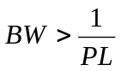 .
- Decimation – there are two decimation stages in the digital receiver. The first stage (CIC) decimation can be fixed at 4, so the maximum I/Q data rate is 80/4=20 MHz. The radar operator will be able to select the post decimation (Dec) to reduce the data rate, but only to a limit of 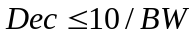. So the following range of post-decimation values can be selected for a given filter filter bandwidth:
BW (MHz) | 20 | 10 | 5 | 4 | 2 | 1
Post Decimation (Dec) | 1 | 1 | 2 | 2 | 4 | 10
Table 3. Post decimation options based on receiver filter bandwidth.

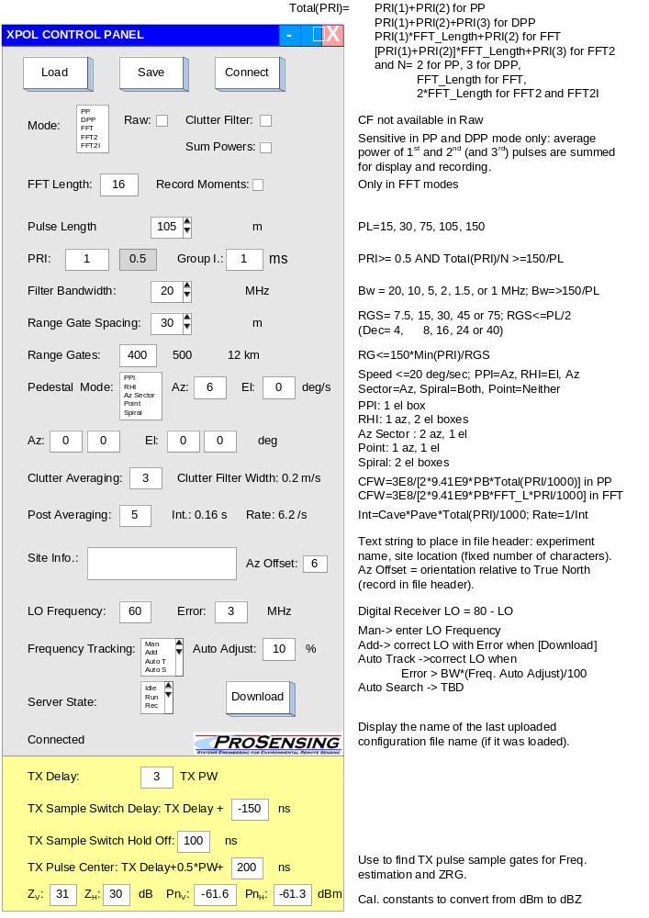
Figure 6. The Xpol radar control GUI. The yellow area can be configured in the server program or hidden in the GUI for use only during initial set-up.

Data Processing Algorithms

Definitions
A range gate sample (S) is a complex (I/Q) data point.
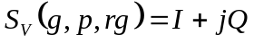, where the subscript is V or H indicating the receiver channel, the g index is the group number between 0 and nave-1, the p index is the pulse number within the group (0 to nps-1), and rg is the range gate count between 0 and nrg-1.

A pulse pair cross-correlation (C) at a range gate rg between the p and p+1 pulse samples is:
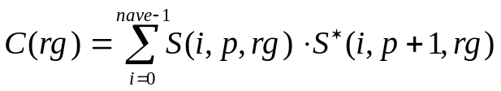
where 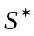 is the complex conjugate of S. C(rg) can be expressed in terms of I and Q samples as:
,
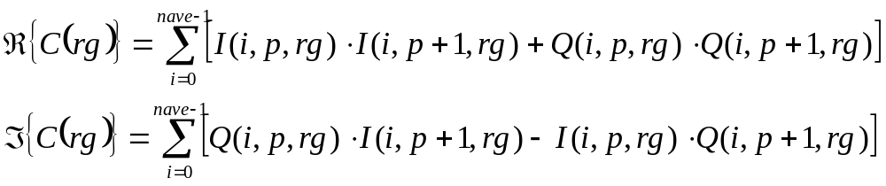

In the FFT modes, block of I/Q samples are Fast Fourier Transformed (FFT):
, where again g is the group index, rg is the range gate index and the FFT processing is implemented on an FFT Block containing L pulses (see Figure 9).

Coherent on Receive Phase Correction:
The is the first data processing step, executed on all the range sample profile is all modes(PP, DPP, and FFTs). The phase of each transmit pulse will be measured by the Tx_gate range gate of the V receiver channel: 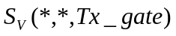. This TX sample phaser, normalized to unity magnitude is used to correct the phase of all the samples collected from that TX pulse:
V channel: 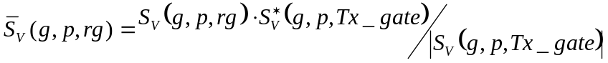
and
H channel: 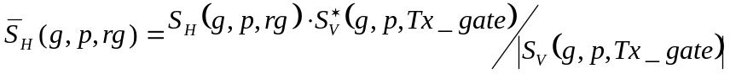,
where g is the group number (0 to nave-1) , p is the pulse number (0 or 1) and rg is the range gate number (0 to nrg-1)
Note that the V channel Tx pulse sample is used for both the V and H sample profile phase correction!

IF Frequency Error Estimation:
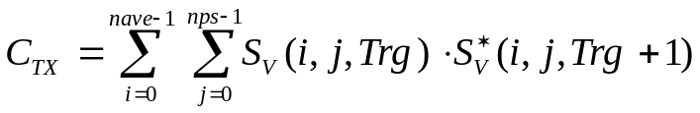
This is the pulse pair phaser corresponding to a single averaging interval. To improve this estimate, it is smoothed over several averaging intervals:
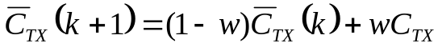, where
w is the smoothing parameter between 0 and 1, (1=no smoothing, 0 infinite smoothing interval),
k is the averaging interval count (record count) and
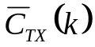 is IF frequency error phaser estimate after k averaging blocks (records).
The IF frequency error is:
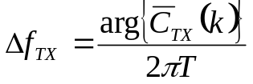 in units of MHz, where
T is the range gate spacing in milliseconds:
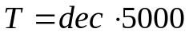 (ms) and dec is the post decimation (after 80 -> 20 MHz sampling CIC decimation).

Clutter Filtering:
If the Clutter Filtering checkbox is set then the next data processing operation is a coherent subtraction of the mean (DC) of the data in cave number of sample groups. The DC component for each clutter filtering interval (cave number of groups) is
V channel: 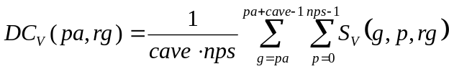
and
H channel: 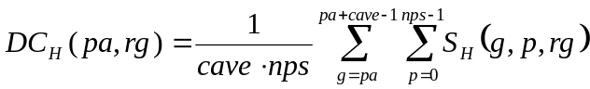,
where pa is the post averaging index (between 0 and pave-1).
The resulting DC phaser (complex number) is then subtracted from all the (complex) samples in the corresponding clutter averaging interval:
, and
where g is the group index corresponding to that clutter filter group interval: 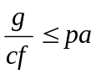.

PP Mode Data Processing
In PP Mode the radar TX pulse sequence is made up of pairs of pulses (nps=2):
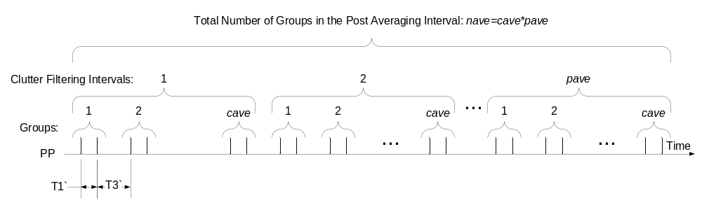
Figure 7. PP transmit pulse sequence with two pulses per group, showing the clutter filter interval and the total integration interval. The total number of averaged two pulse groups equals the number of groups in the clutter filtering interval (cave) times the post averaging factor (pave).
The pulse pair spacing is T1, and the group spacing is T3. The nave number of averaged groups is made up of a number of groups for clutter filtering (cf) , and post averaging (pave), such that the total number of averaged groups is the product of the number of clutter filtered groups times the post averaging: 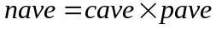.
In PP mode, like in all other modes, the Coherent on Receive algorithm is implemented first and then Clutter Filtering if the clutter filtering checkbox is set. The following radar parameters are calculated by averaging data through the entire nave averaging interval:
Power:
P_{V0}, P_{V1} , and P_{H0} and P_{H1} are calculated by averaging the first pulses of all the groups and the second pulses in each group separately,
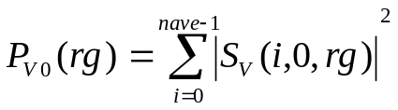
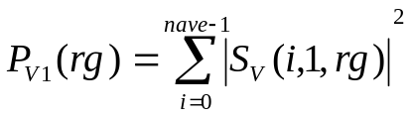
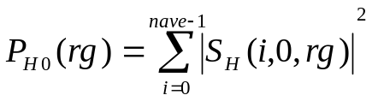
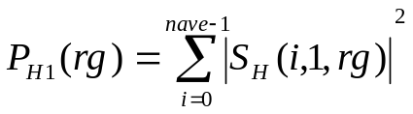

If Sum Powers checkbox is set then only calculate:
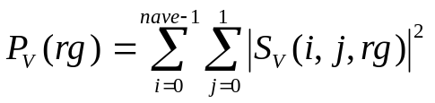
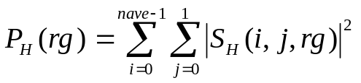

Doppler Pulse Pair:
HH and VV pulse pairs of each group.
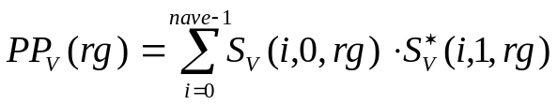
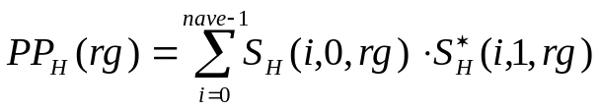
V-H Cross-Correlation (differential phase):
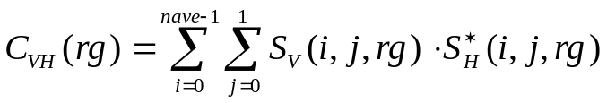

DPP Mode
In DPP Mode the radar TX pulse sequence is made up of groups of three pulses (nps=3; otherwise it is similar to PP Mode.
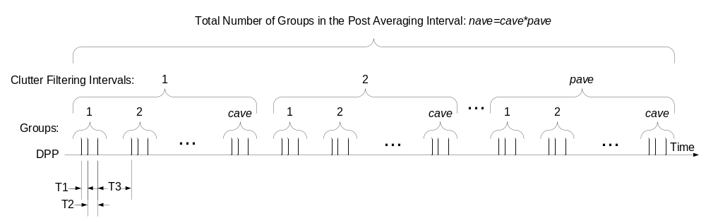
Figure 8. DPP transmit pulse sequence, showing the clutter filter interval and the total integration interval. The total number of averaged three pulse groups equals the number of groups in the clutter filtering interval (cave) times the post averaging factor (pave).
Power:
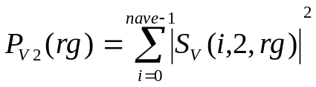
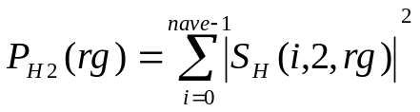
If the Sum Powers checkbox is set in the Control GUI then only calculate (display and record):
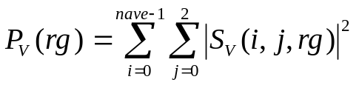
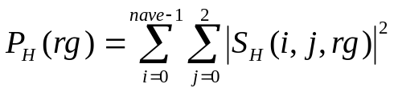
Doppler Pulse Pair:
HH and VV pulse pairs for both spacing:
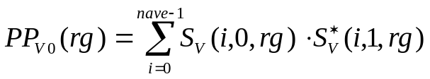
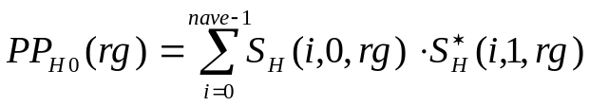
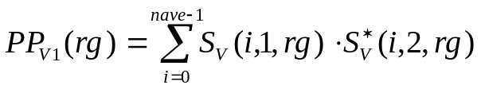
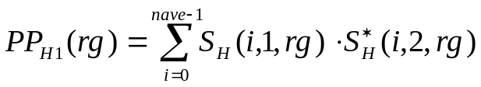
V-H Cross-Correlation (differential phase):
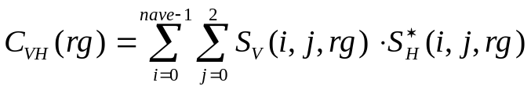

FFT Mode
In FFT Mode the radar TX pulse sequence, shown in Figure 9, is made up of a constant PRI sequence of pulses.

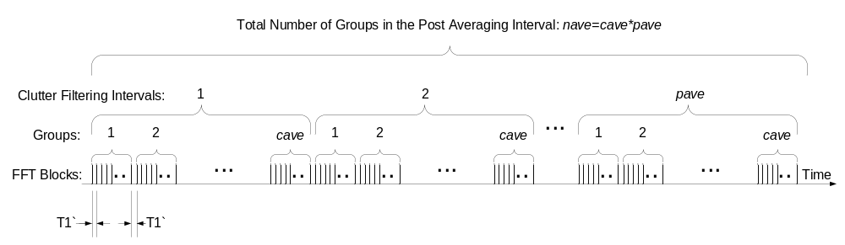
Figure 9. FFT mode pulsing sequence.
After the Coherent on Receive algorithm and IF Frequency Estimation , Clutter filtering is implemented on cave number of FFT Block data segments. Each FFT Block contains L pulses – this is the FFT Length (fftlen). After clutter filtering, each FFT Block is transformed to the frequency domain (FFT-ed):
Next, the following Power Spectra (PS) and Cross-Spectra (CS) products are computed:
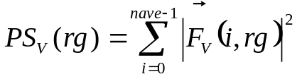
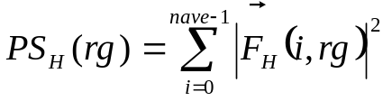
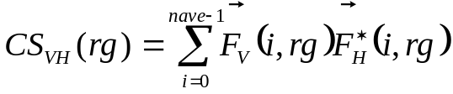

FFT2 Mode
In FFT2 Mode the radar TX pulse sequence, shown in Figure 10, is made up of alternating PRI FFT blocks. Here the blocks are much larger, each containing cave number of sub-blocks, each sub-block containing L pulses. Clutter filtering is done on each block, then the blocks are broken apart into smaller blocks of L pulses for FFT processing. The computed parameters are the same as in FFT2, but the two different PRI FFT blocks are interleaved.

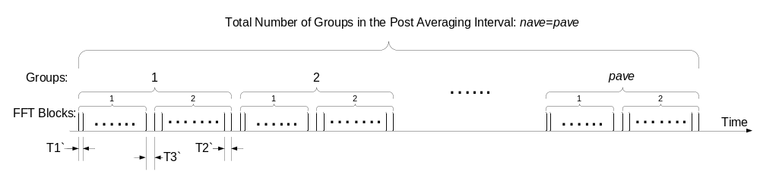
Figure 10. FFT2 mode pulsing sequernce.

where
g is the group index, b is the FFT Block index (0 or 1), sb is the sub-block index (between 0 and cave-1) and rg is the range gate index.
The following Power Spectra (PS) and Cross-Spectra (CS) products are computed in :
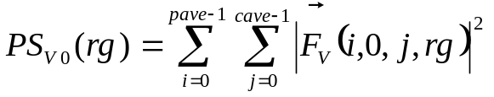
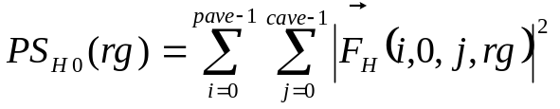
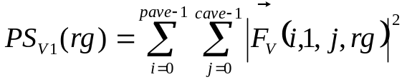
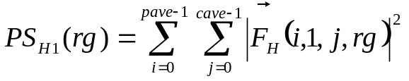
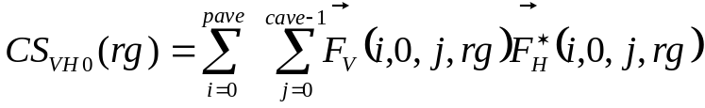
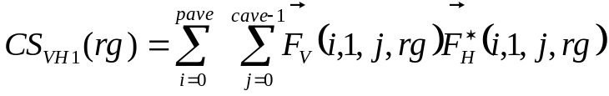

FFT2I Mode
In FFT2I (Interleaved Dual PRI FFT) Mode the radar TX pulse sequence, shown in Figure 11, is made up of interleaved alternating PRI FFT blocks. 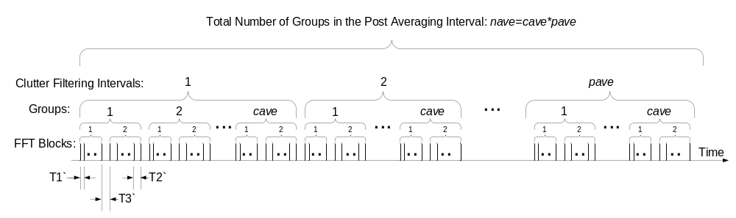
Figure 11. FFT2I mode pulsing sequence.

, where
g is the group index, b is the FFT Block index (0 or 1), and rg is the range gate index.
The following Power Spectra (PS) and Cross-Spectra (CS) products are computed in :
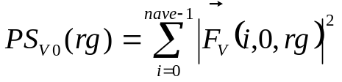
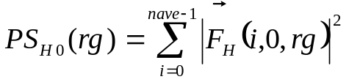
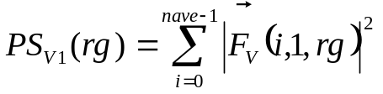
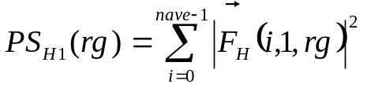
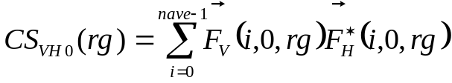
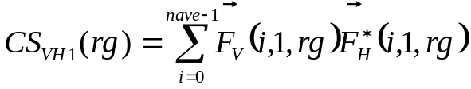

Display GUI
This program can run on client PC-s (more than one is allowed) and will request real time data from the Server PC. The Display program will acquire process and display data in real time. The following parameters will be available for display: received power (dBm), reflectivity (dBZ) (noise subtracted and thresholded) pulse pair phase (radians) (differential phase), pulse pair velocity mean and std (m/s), Zdr (dB) in the following display modes :
a) scope display (magnitude vs. range line plot)
b) range vs. time scrolling image
c) PPI image (polar image; azimuth vs. range at a fixed elevation)
d) RHI image (polar image; elevation vs. range at a fixed azimuth)
in FFT mode also:
e) FFT bin vs. range spectrum image
in FFT mode spectrum moments will be used for b, c and d displays.
This display program will also provide the radar operation information on the radar system: noise floor (dBm), Tx power (dBm), temperature at various points, pedestal status (TBD, scan type, az-pos, el-pos, az-speed, el-speed), dry air status.
An example IDL program (http://rsinc.com/idl/) will be developed to demonstrate how real-time data can be requested and received from the server so customers can develop their own custom display program.
Another example IDL program will be provided to show how the recorded data can be read back and displayed.

