When you first open Habplan from the R script, the following window will open. Note that you will be unable to run anything in your R session when Habplan has been opened via R. Additionally, your start-up screen may look slightly different – this is ok!

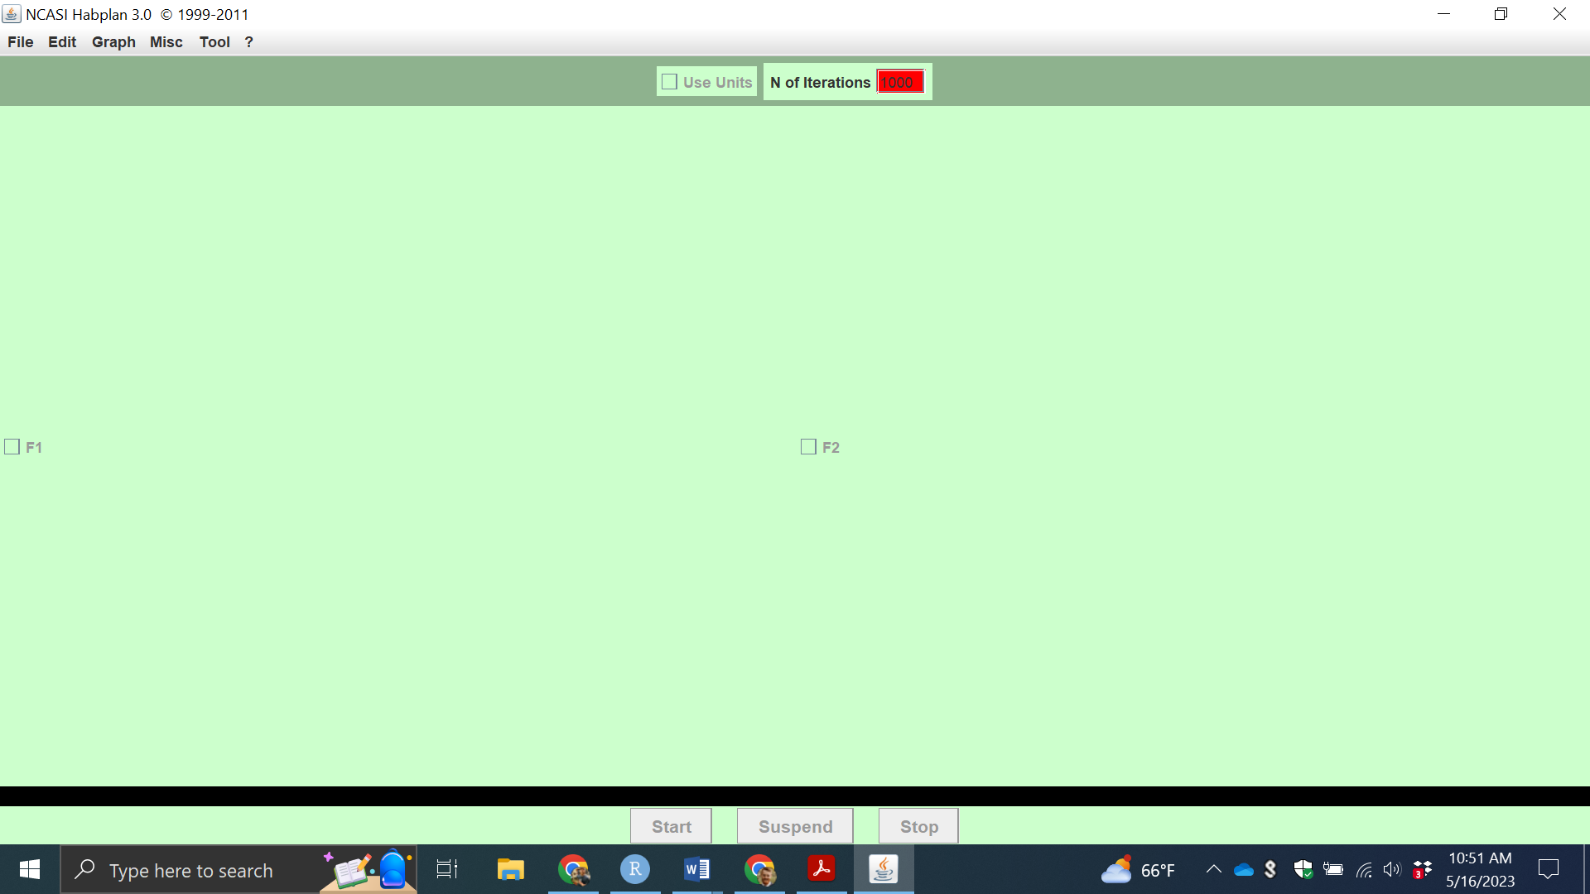

To open the project file we have just created, we can navigate to File > Open… Make sure to navigate to the correct project file (the one created via the R script) if there are multiple saved on your computer.

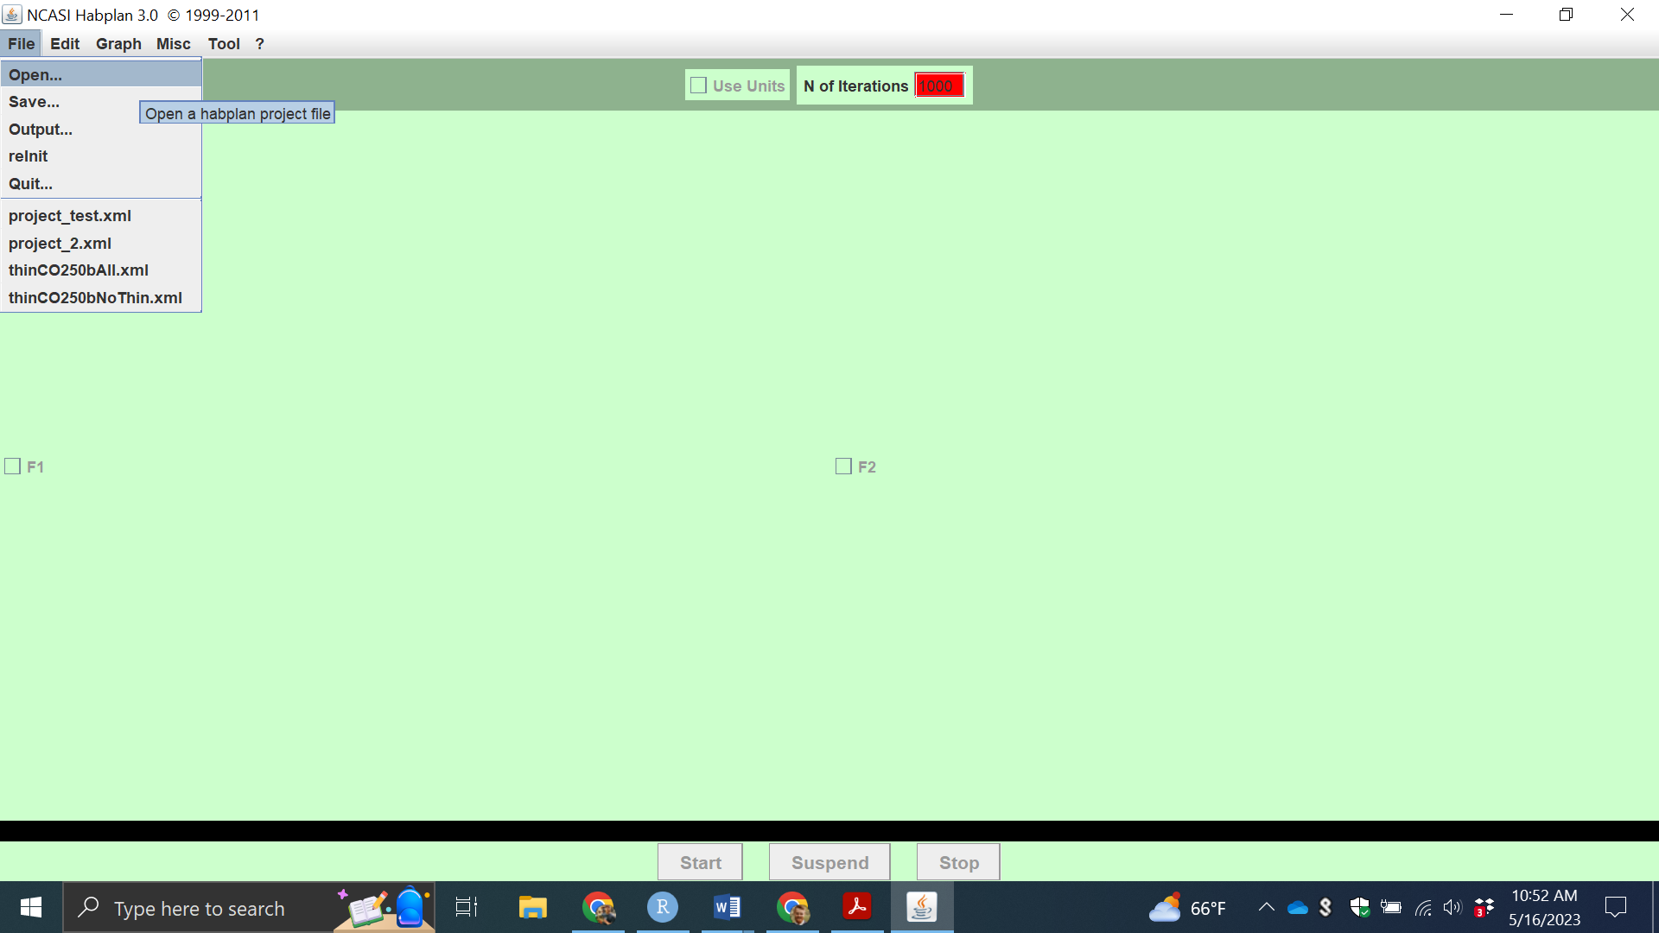

A new window will open to select the appropriate file, which will have saved in the set working directory as project.xml. Navigate to the project.xml file that was just created in R, select that file and click Open.

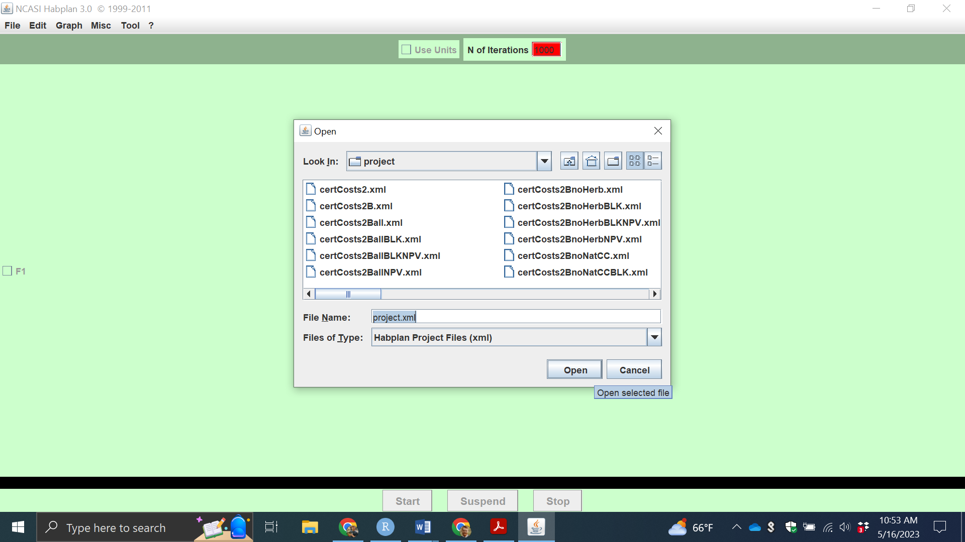

A new window will then open. Click OK to load the project file.

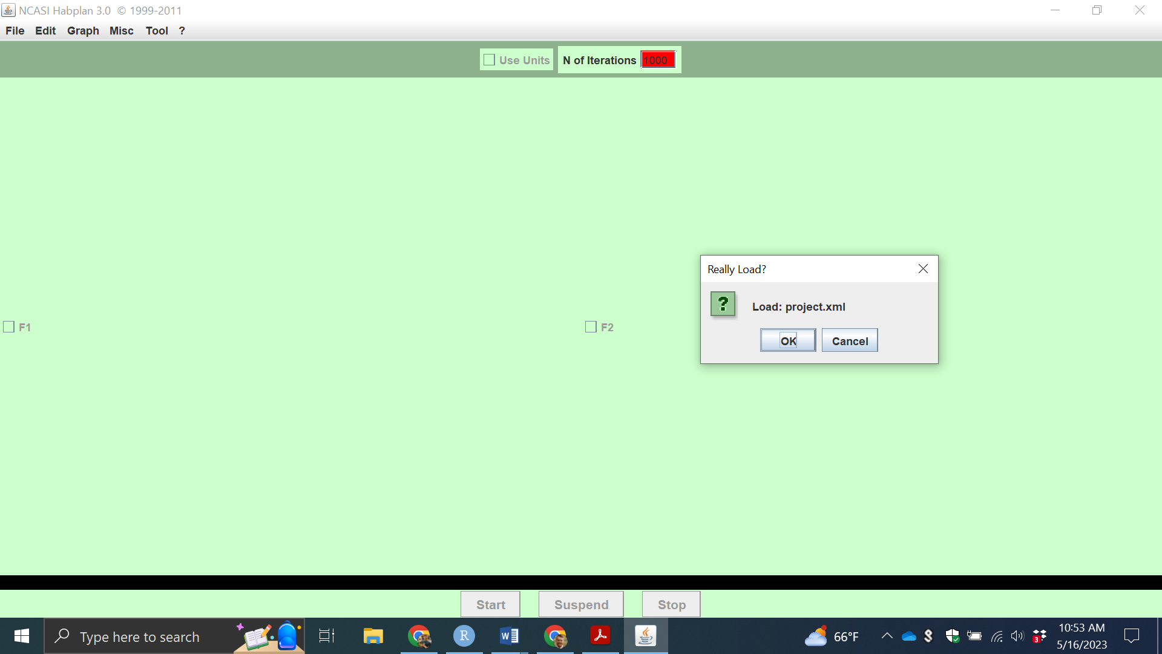

When opening the project file, you may encounter the following pop-up window. This means that the configuration file has a different configuration than the project file. In this circumstance, select ReConfigure and Quit, which will close Habplan. Once that happens, re-run the R code *shell("h", wait=TRUE)* and perform the above steps again once Habplan has reopened.

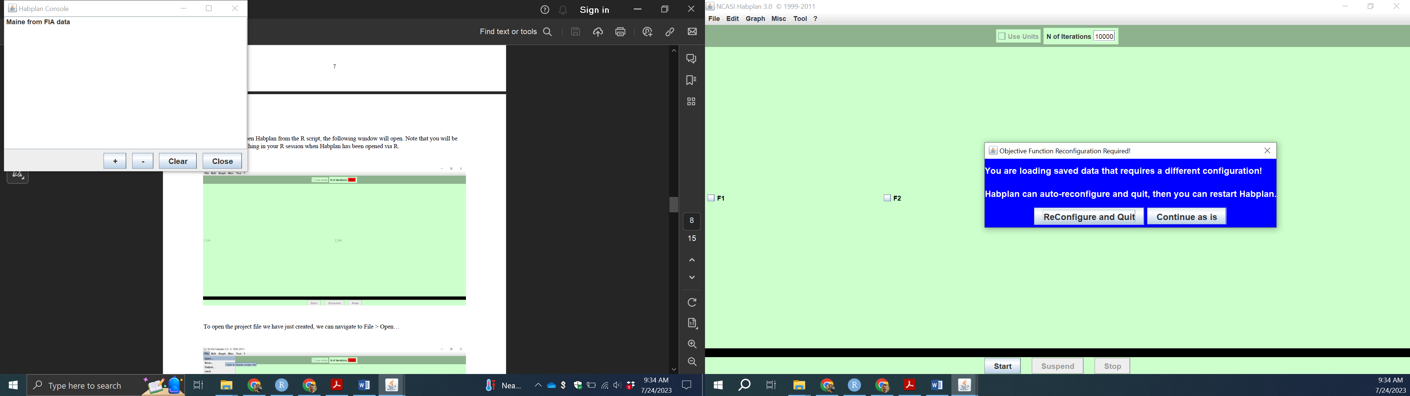

Another new window will now be available titled Habplan Console, where the program will provide updates and errors. We will also have the opportunity to select the flow components on the main window, named F1, F2, and Bio2-1 in our example. Including other flows in the project file will add new component check boxes. Go ahead and select the three check boxes on the main window so that they appear as below.

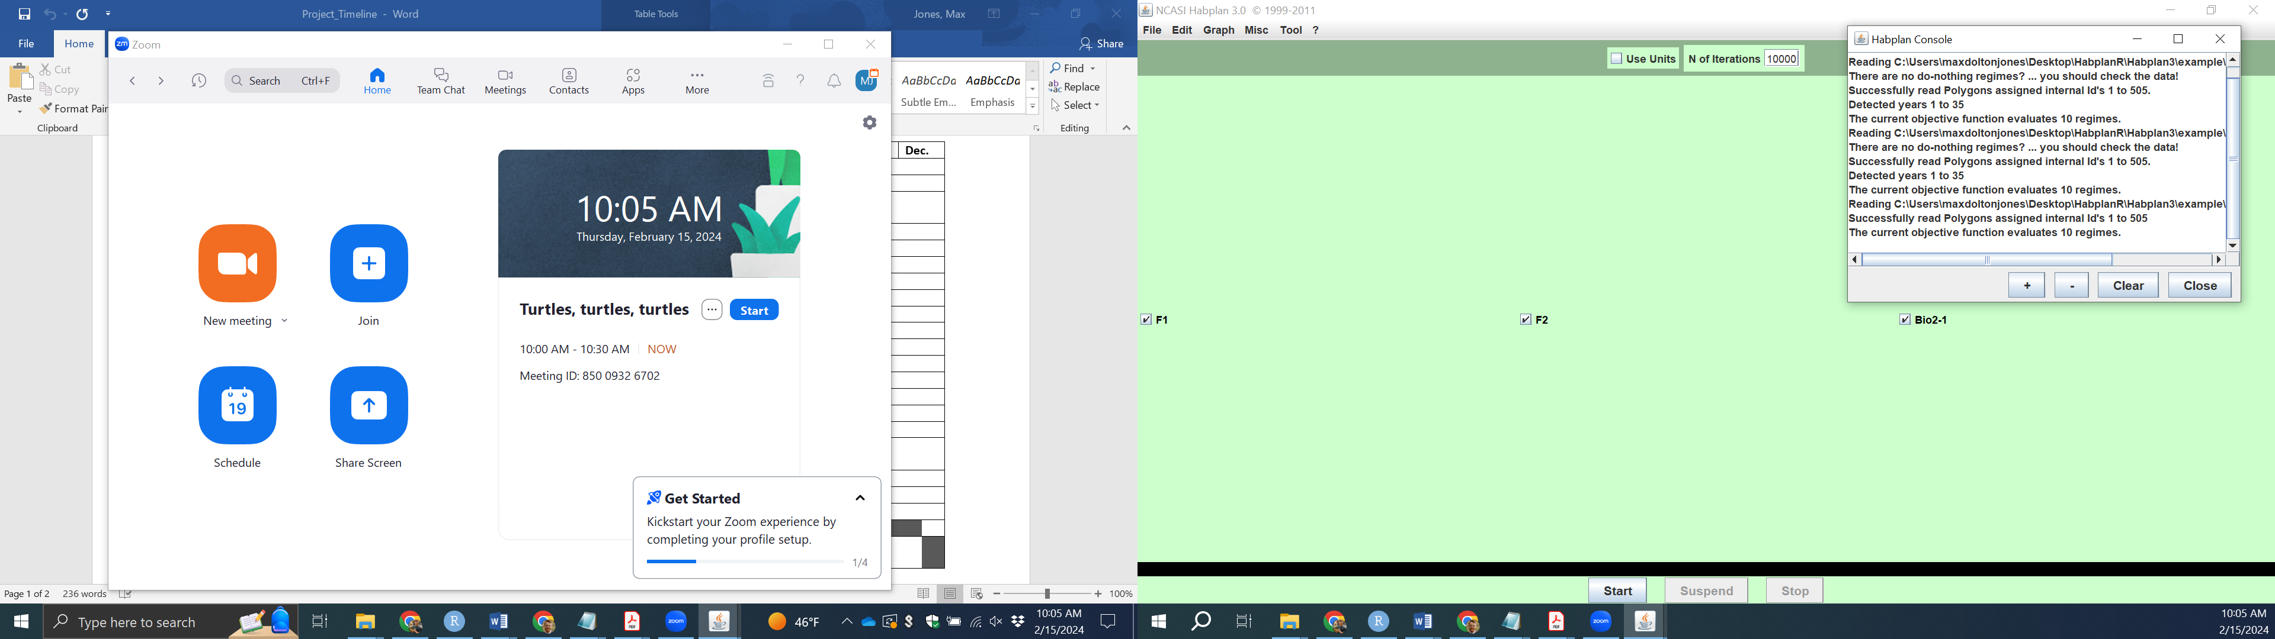

We will now navigate to Tool > LpMPS.

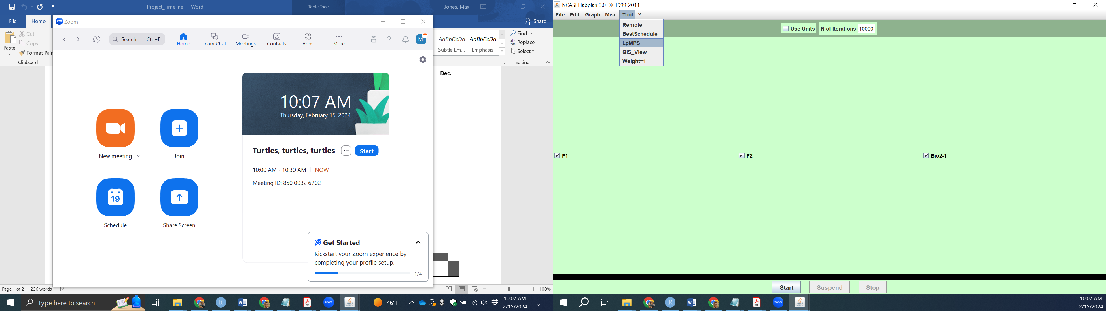

This will open a new window titled LP MPS Generator. As before, select the three check boxes on the new window so that they appear as below. To move forward we can click the “MPS” button, which will create a new MPS file based on the configurations that can be set using the three “Config” buttons. You can use these and create a new MPS file, which will be saved to the location in the top text box of the window. However, we have already created a file using the *lpMPS* function of ***HabplanR***.

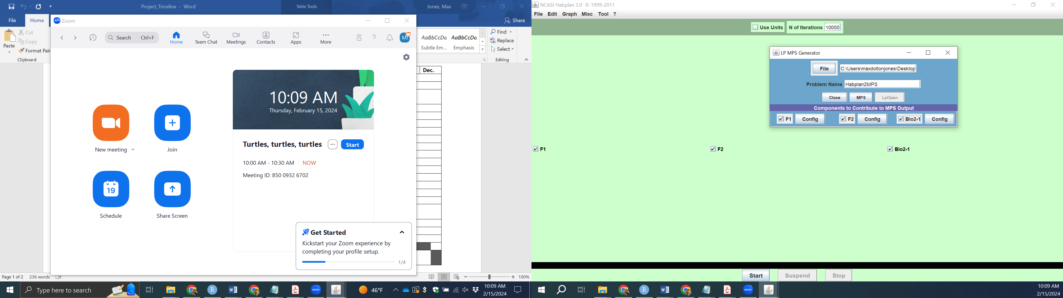

When the “MPS” button has been selected (which needs to be clicked to move forward), the “LpOpen” button will now become available, as shown below. Now click the “LpOpen” button.

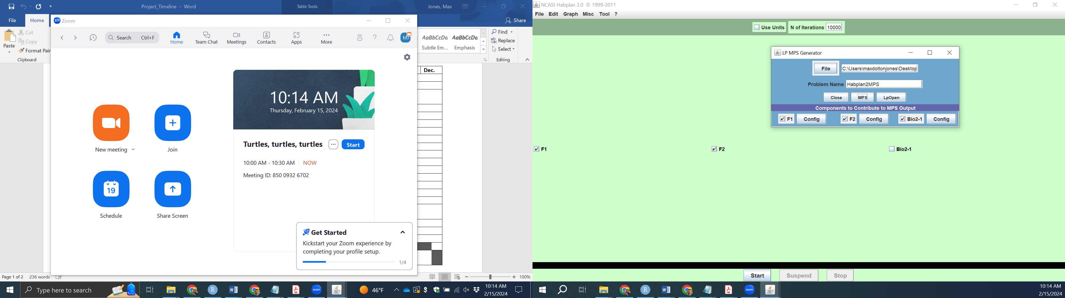

The “LpOpen” button will open a new window titled RUN LP SOLVER. When this first opens, there will be no information in the white space, and lp_solve will assign file inputs and outputs. We want to change the “Input File Name” to the MPS file we created in R, and then assign an “Output File Name” of your own preference. Click “LP” and this will run the LP solver. Once finished, click “Get” and this will transfer model results back into the Habplan main window.

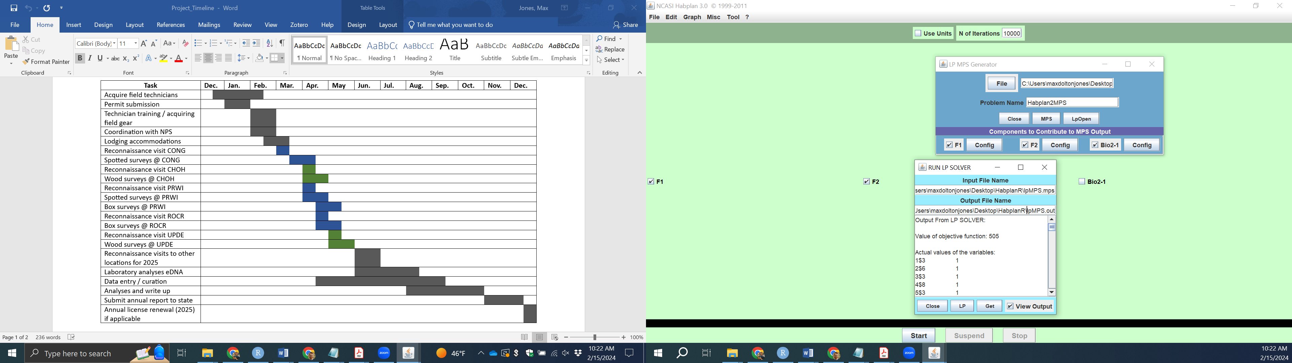

We can now save the output as we have done before. To do this navigate to File > Output…

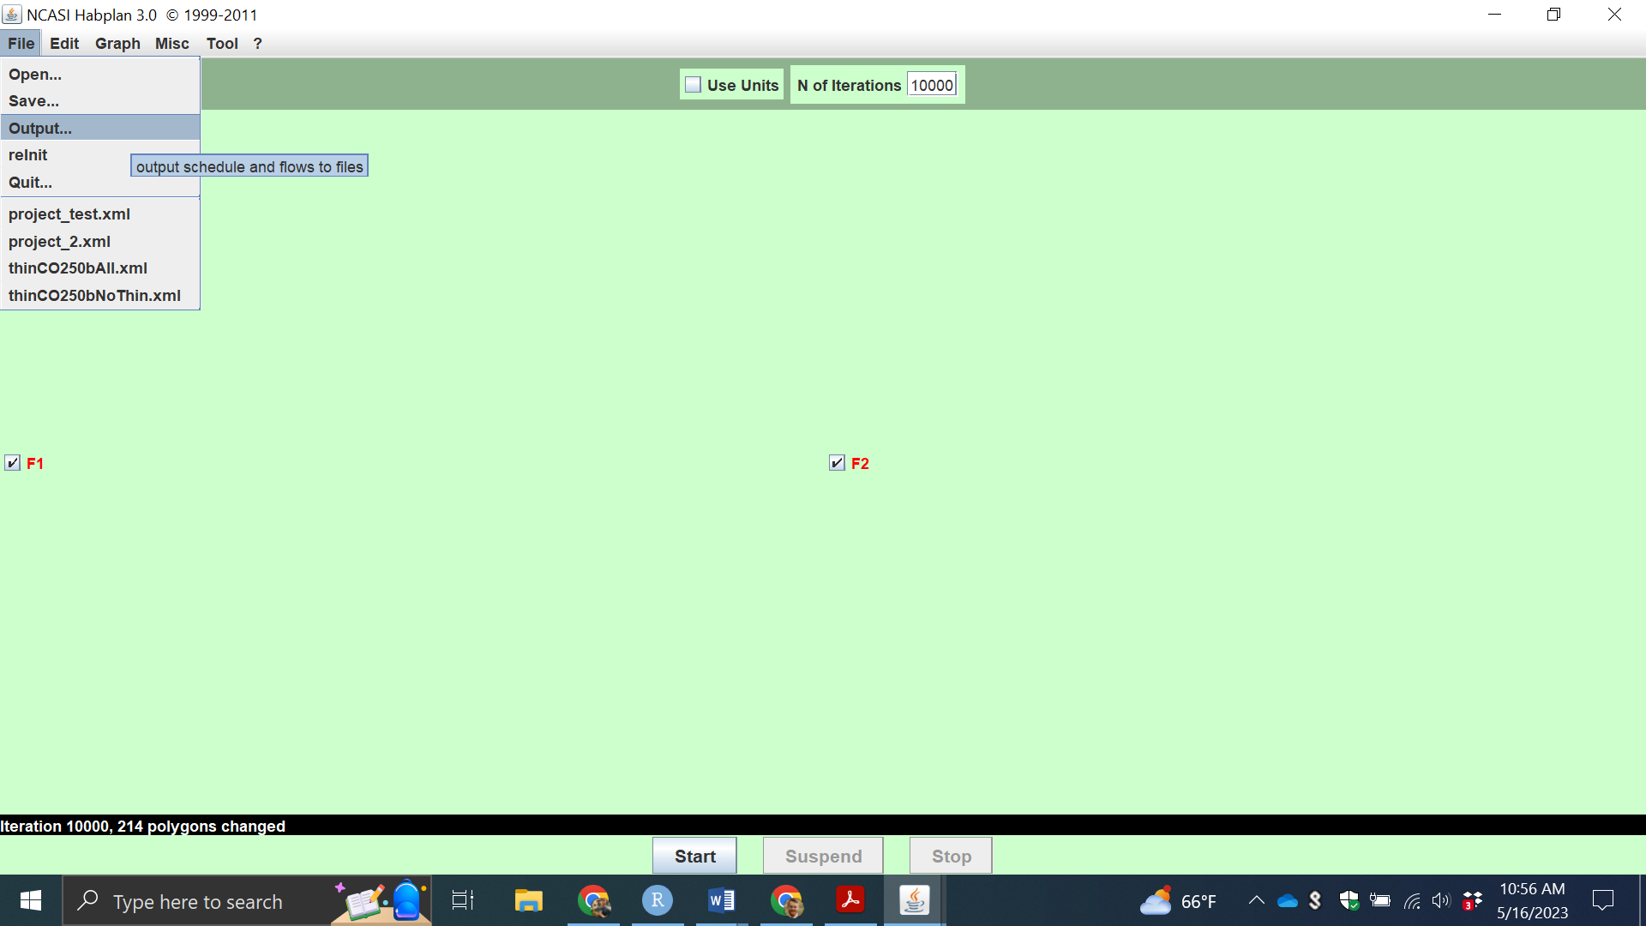

A new window will open titled Habplan Output Control. All of the check boxes will be pre-selected, so we can simply click “Save” to save the output flow files and recommended schedule. If an error is encountered when attempting to save, check the file directory in the Habplan Output Control window.

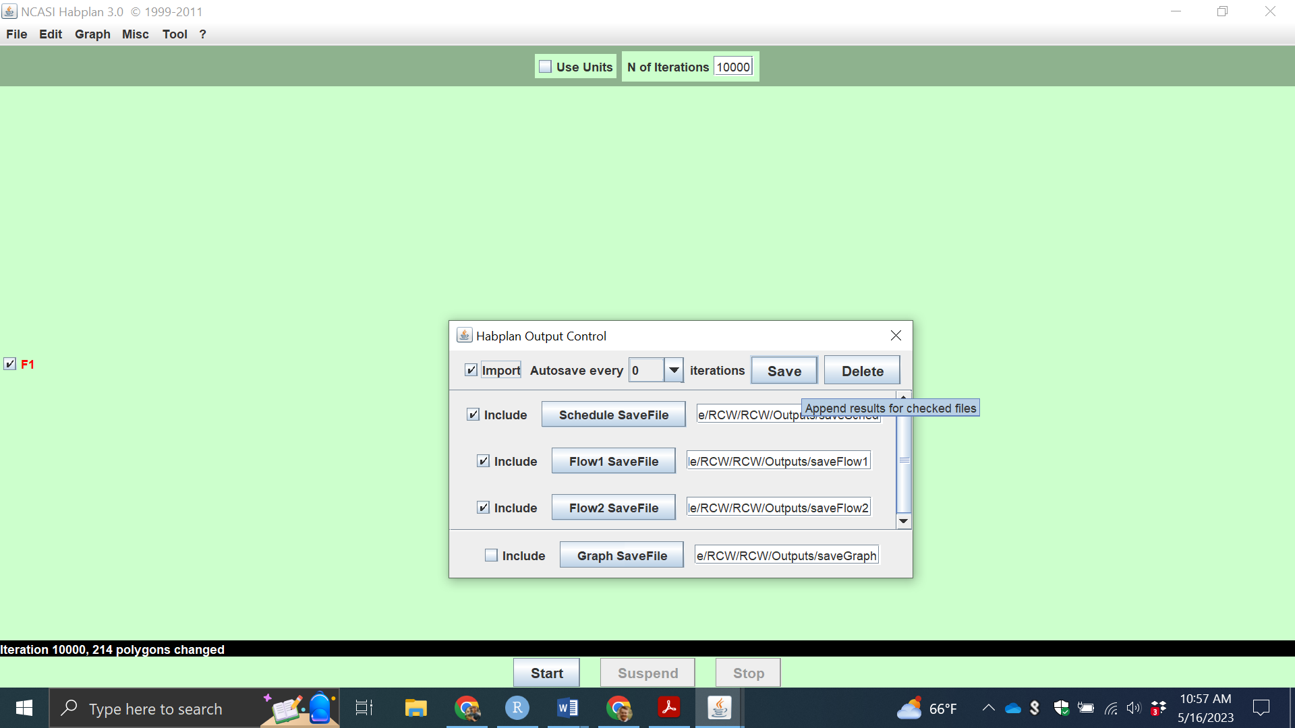

We are now finished with Habplan for the time being. We can either close all Habplan windows, or just go back into RStudio and select the red STOP button on the top right of the console to close Habplan.

