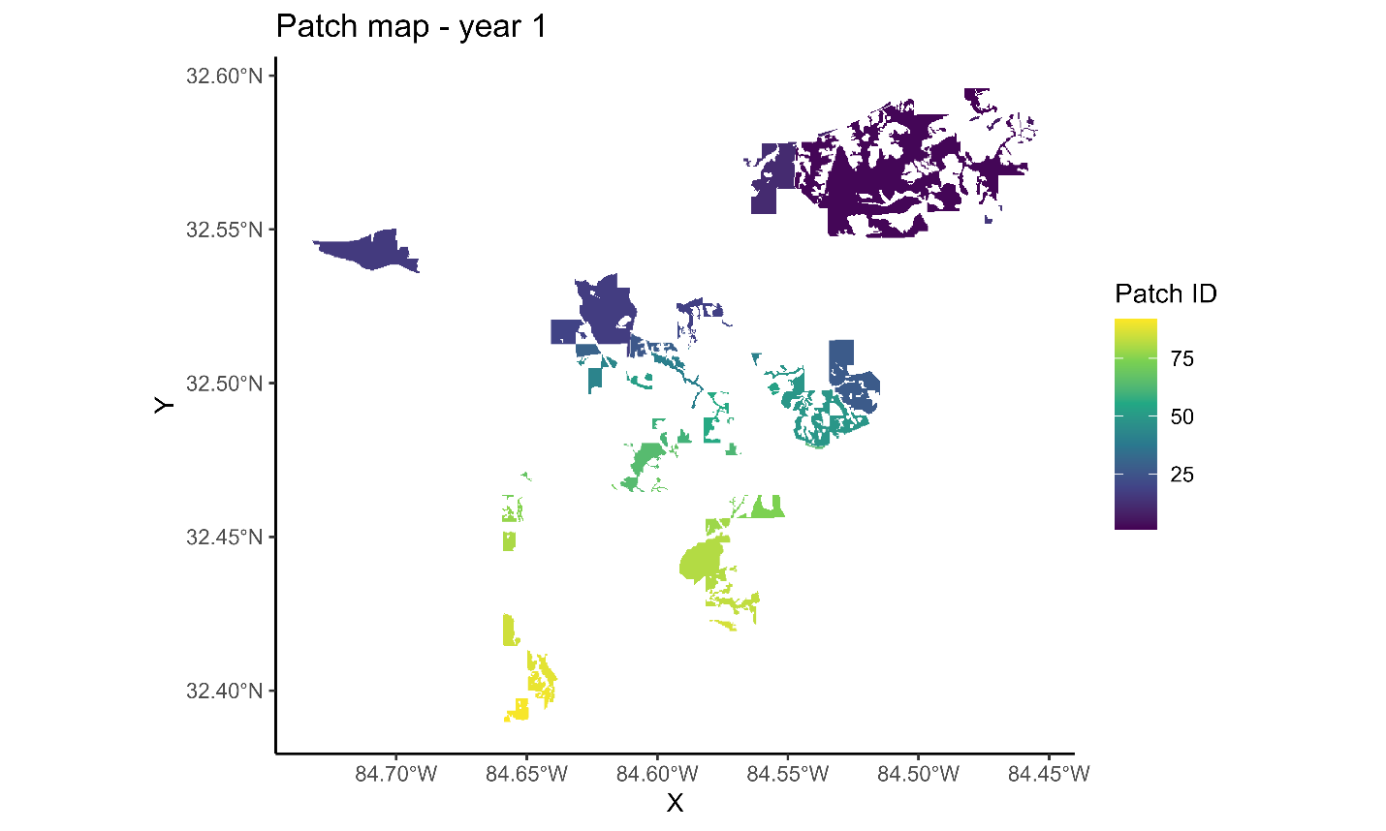

Figure 3. First year of landscape patches resulting from the Habplan management schedule.

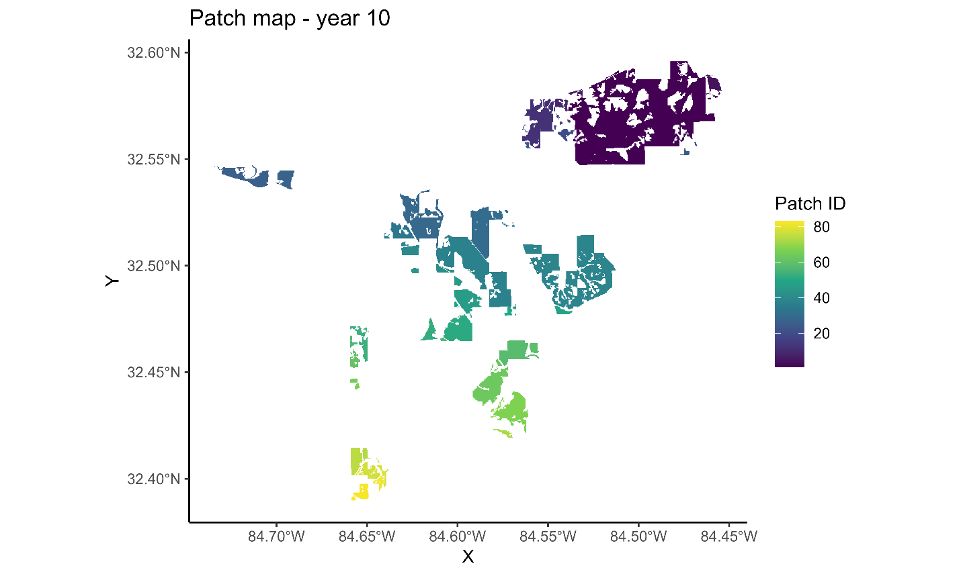

Figure 4. Tenth year of landscape patches resulting from the Habplan management schedule.

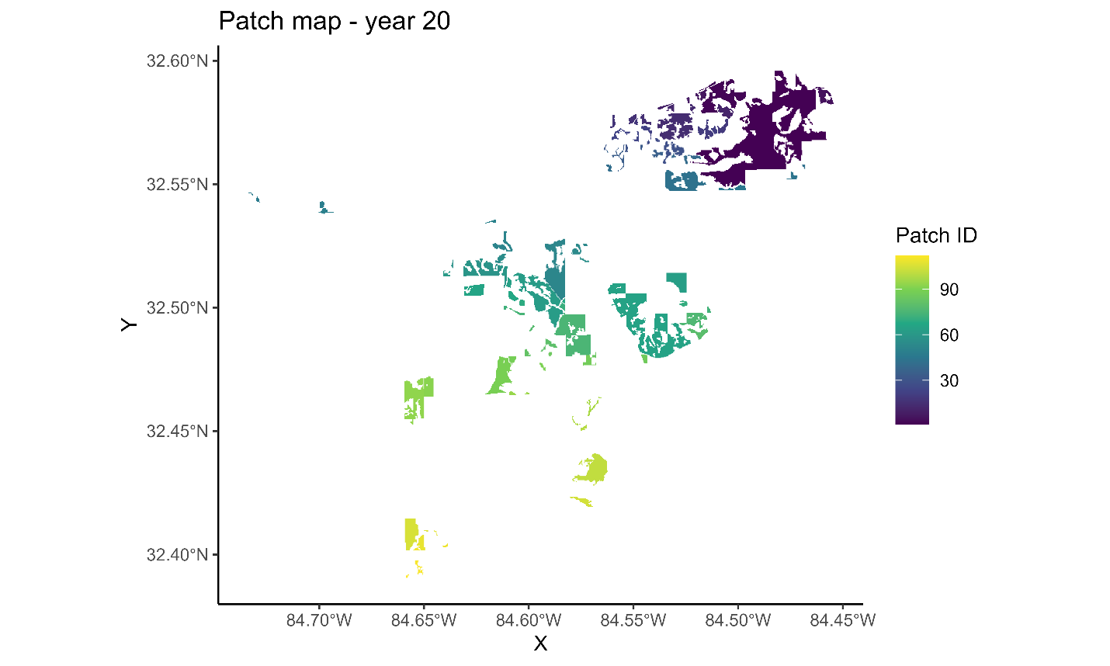

Figure 5. Twentieth year of landscape patches resulting from the Habplan management schedule.

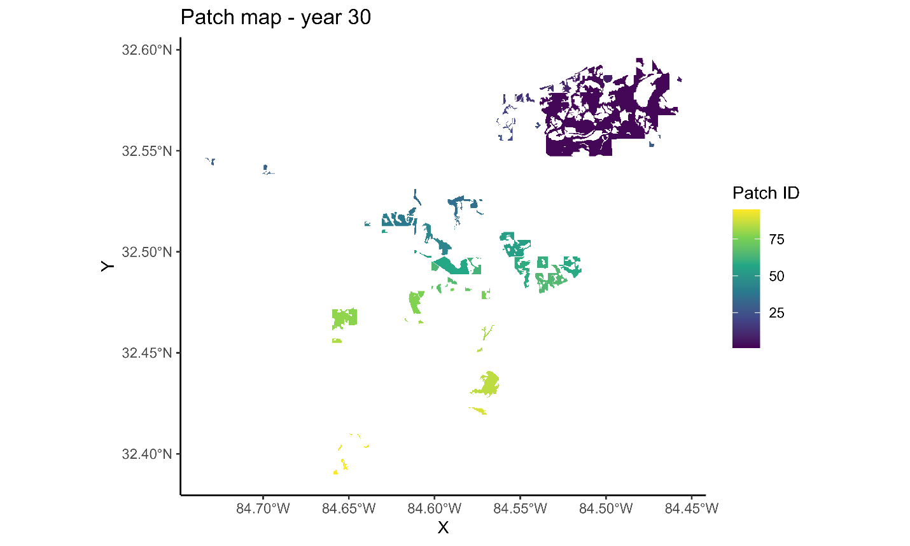

Figure 6. Thirtieth year of landscape patches resulting from the Habplan management schedule.

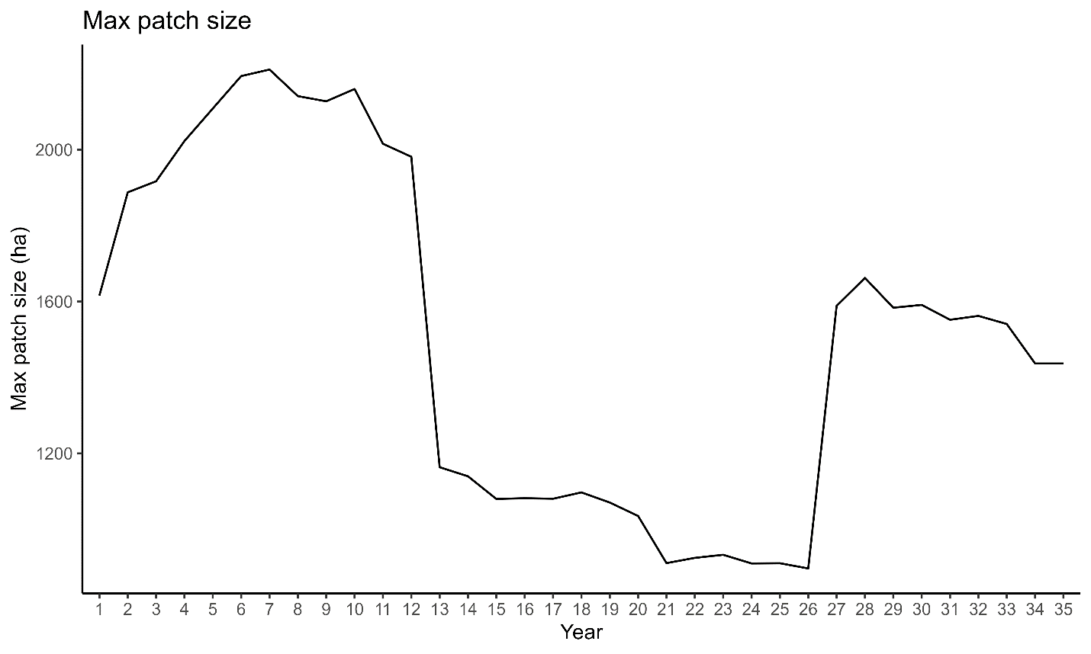

Figure 7. Size of the largest landscape patch across time resulting from the Habplan management schedule.

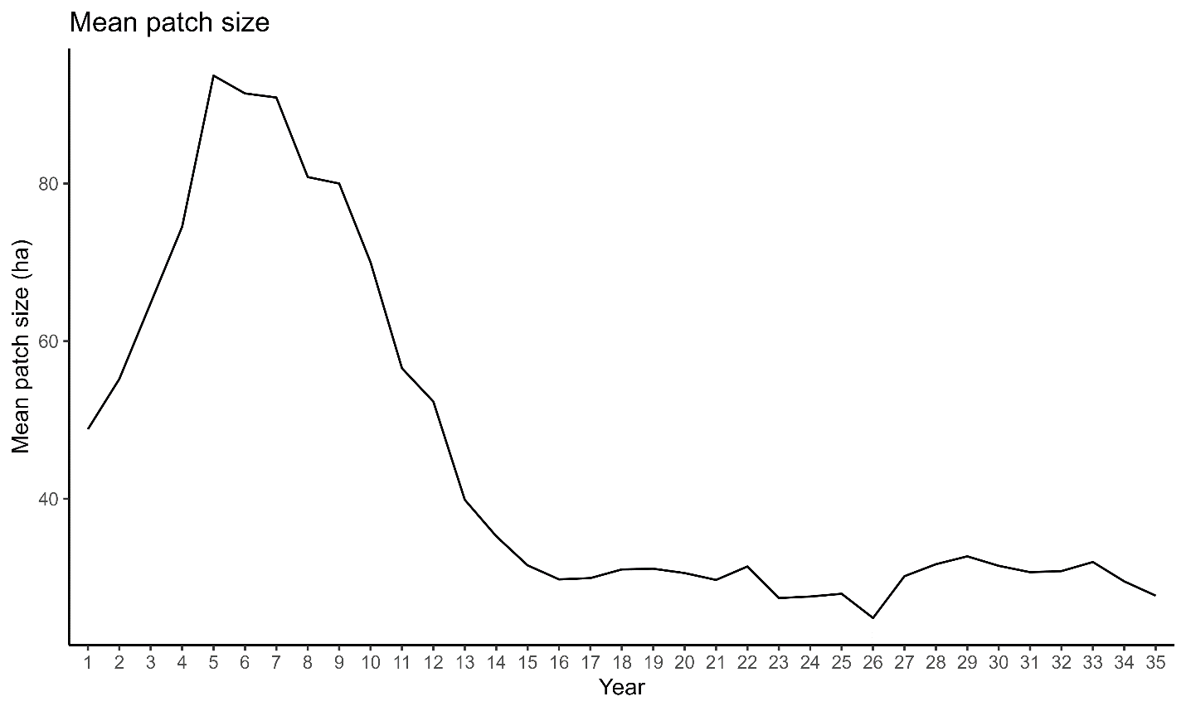

Figure 8. Average size of landscape patches across time resulting from the Habplan management schedule.

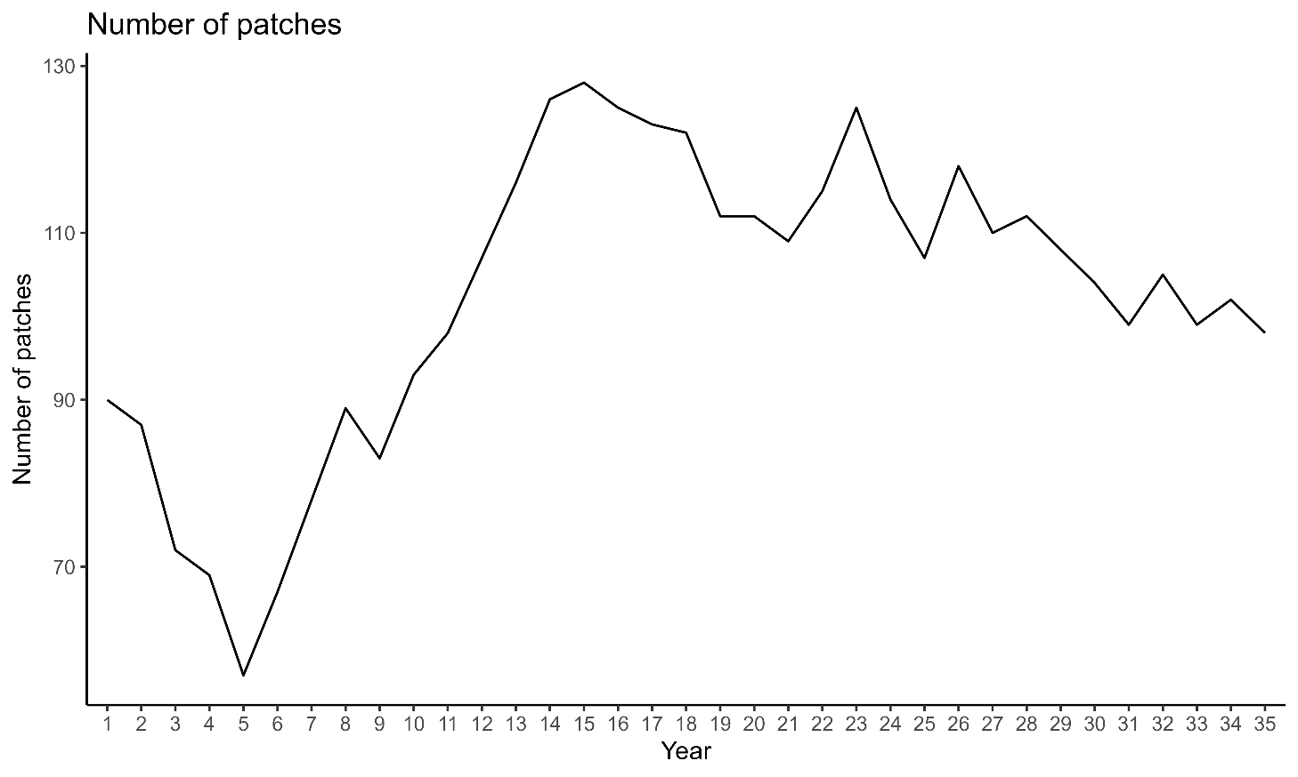

Figure 8. Number of landscape patches across time resulting from the Habplan management schedule.

Table 1. Example of landscape-level metrics output from the habSpace function (using the *landscapemetrics* package).

|  |  |  |
| --- | --- | --- |
| Level | Metric | Value |
| patch | area | 305.93 |
| patch | cai | 96.31615 |
| patch | circle | 0.767424 |
| patch | contig | 0.986315 |
| patch | core | 294.66 |
| patch | enn | 5022.848 |
| patch | frac | 1.09194 |
| patch | gyrate | 840.0852 |
| patch | ncore | 1 |
| patch | para | 0.004544 |
| patch | perim | 13900 |
| patch | shape | 1.986282 |