Because we have everything to assess the Habplan run, we are now going to adjust the thlo, thhi, and model objects. For our lower threshold, we are going to decrease this to 500 acres to prevent too much negative deviation from our target, but instead have a much higher thhi to allow more yield from the target if Habplan can find a schedule which permits that. Additionally, we will change the model targets to 500 in year 1, 2500 in year 20, and 7500 in year 30 (1,500;20,2500;30,7500). We will apply the same changes to both flow components.

#Info for f1 component ----  
f1.file <- paste0(wd,"HSI.dat")  
f1.bygone <- ""  
f1.time0 <- "10000"  
f1.goal0 <- "0.1"  
f1.thlo <- "500"  
f1.thhi <- "10000"  
f1.goalplus <- ".05"  
f1.goalf <- "0.5"  
f1.slope <- "0.0"  
f1.weightf <- "1.0"  
f1.weight0 <- "1.0"  
f1.model <- "1,500;20,2500;30,7500;"  
f1.title <- "Breed.dat"  
#Combine f1 components for writing  
f1.comp <- c('<flow title="F1 Component">',  
 paste0('<file value="', f1.file, '" />'),  
 paste0('<bygone value="', f1.bygone, '" />'),  
 paste0('<time0 value="', f1.time0, '" />'),  
 paste0('<goal0 value="', f1.goal0, '" />'),  
 paste0('<threshLo value="', f1.thlo, '" />'),  
 paste0('<threshHi value="', f1.thhi, '" />'),  
 paste0('<goalPlus value="', f1.goalplus, '" />'),  
 paste0('<goalF value="', f1.goalf, '" />'),  
 paste0('<slope value="', f1.slope, '" />'),  
 paste0('<weightF value="', f1.weightf, '" />'),  
 paste0('<weight0 value="', f1.weight0, '" />'),  
 paste0('<model value="', f1.model, '" />'),  
 paste0('<title value="', f1.title, '" />'),  
 '<bounds height="330" width="366" x="553" y="443" />',  
 "</flow>")  
  
  
#Info for f2 component ----  
f2.file <- paste0(wd, "Harv_P_Pulp_Tons.dat")  
f2.bygone <- ""  
f2.time0 <- "1000"  
f2.goal0 <- "0.1"  
f2.thlo <- "500"  
f2.thhi <- "10000"  
f2.goalplus <- ".05"  
f2.goalf <- "0.5"  
f2.slope <- "0.0"  
f2.weightf <- "1.0"  
f2.weight0 <- "1.0"  
f2.model.1 <- "1,500;20,2500;30,7500;"  
f2.title <- "Harv_P_Pulp_Tons.dat"  
#Combine f2 components for writing  
f2.comp <- c('<flow title="F2 Component">',  
 paste0('<file value="', f2.file, '" />'),  
 paste0('<bygone value="', f2.bygone, '" />'),  
 paste0('<time0 value="', f2.time0, '" />'),  
 paste0('<goal0 value="', f2.goal0, '" />'),  
 paste0('<threshLo value="', f2.thlo, '" />'),  
 paste0('<threshHi value="', f2.thhi, '" />'),  
 paste0('<goalPlus value="', f2.goalplus, '" />'),  
 paste0('<goalF value="', f2.goalf, '" />'),  
 paste0('<slope value="', f2.slope, '" />'),  
 paste0('<weightF value="', f2.weightf, '" />'),  
 paste0('<weight0 value="', f2.weight0, '" />'),  
 #paste0('<model value="1,', f2.target, ';', f2.next.year, ',',  
 # f2.next.target, '" />'),  
 paste0('<title value="', f2.title, '" />'),  
 '<bounds height="331" width="368" x="1260" y="440" />',  
 "</flow>")

We can re-run the writeProj function to create a new project file. The writeProj function will overwrite the project file in the working directory, so make sure to rename the existing project file if it needs to be saved.

#Provide each of these flow component objects to the function and run  
writeProj(f1.comp = f1.comp, f2.comp= f2.comp)

Now we have a project file saved to our working directory. Let’s open Habplan and see if this has worked. Follow the same instructions above for running Habplan once it has opened.

*IMPORTANT - USER MUST RENAME OR MOVE SAVEFLOW1 AND SAVESCHED FROM WORKING DIRECTORY IF THEY DO NOT WANT THE FILES TO BE DELETED*

#Open Habplan (if run from here, R functionality will cease until Habplan is closed)  
shell("h", wait=TRUE)

## Function: plotting an individual flow output - *FlowPlot*

After running Habplan, we will have several flows saved to our working directory. The option still exists to interactively watch the charts in a Habplan window. However, we provide a function to visualize each flow individually.

First read in the flow output file, and then feed this file into the function.

#Read in one of the flow files  
flow1 <- read.csv("./saveFlow1", sep="", header = F)  
flow2 <- read.csv("./saveFlow2", sep="", header = F)  
  
#Input the flow file into the function, and number of years  
flowPlot(flow.data = flow1, nyear = 35)  
flowPlot(flow.data = flow2, nyear = 35)

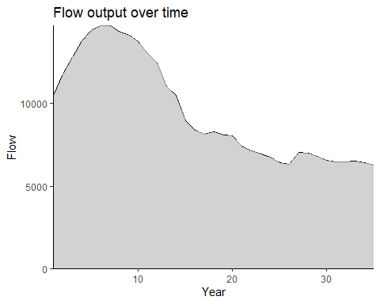

Figure 9. The amount of flow (habitat area) attained over time as a result of the suggested Habplan management schedule.

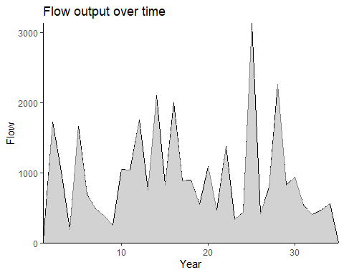

Figure 10. The amount of flow (harvested pine pulpwood) attained over time as a result of the suggested Habplan management schedule.

Again, the first figure above shows the output flow from our HSI component throughout our study period, and the second shows the hard pulpwood yield. From a first glance of these figures, it appears that the outputs have not changed substantially. Let’s re-run the HabSpace function to assess the spatial component of the recommended schedule.

## Function: spatial contiguity assessment - *HabSpace*

*The HabSpace function may take several minutes to complete!*

#Want to create a shapefile output for each year, to look at change  
#of regime for each stand over time.  
  
space.test <- HabSpace(site.shp = site.shp, flow = flow1, nyear = 35,  
 mode = "terrestrial", dist = 500, level = "patch")