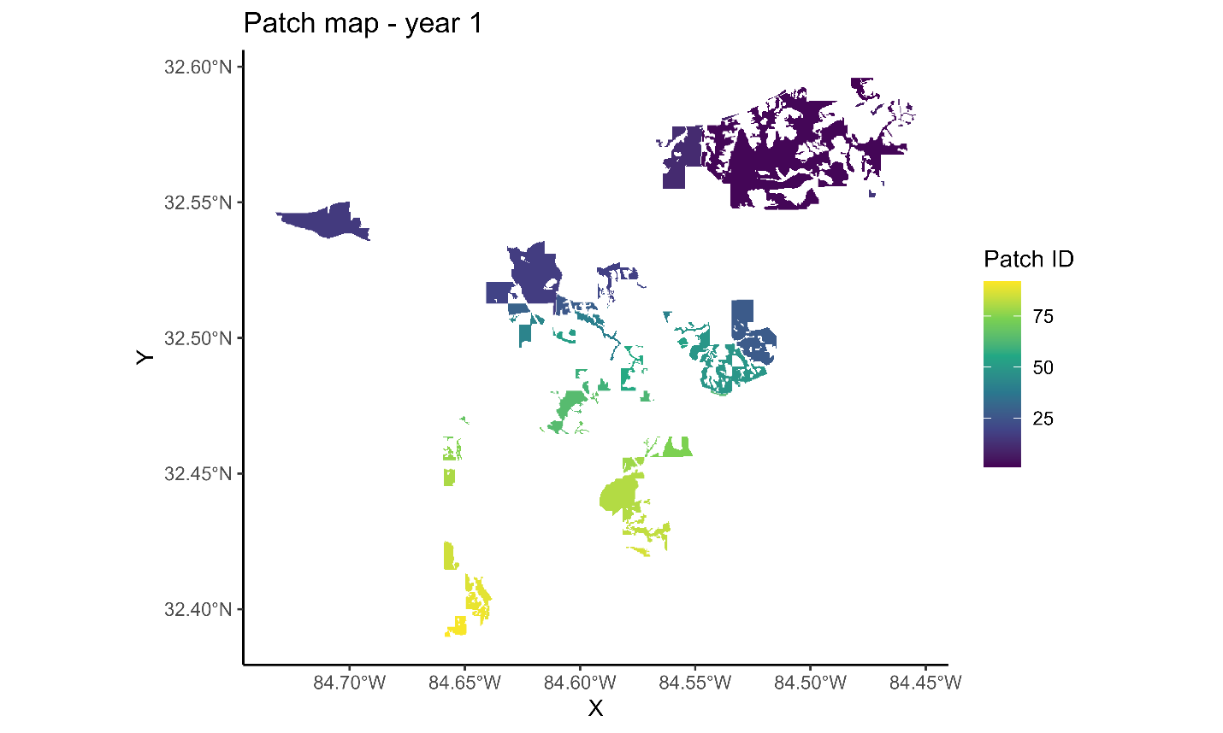

Figure 11. First year of landscape patches resulting from the Habplan management schedule.

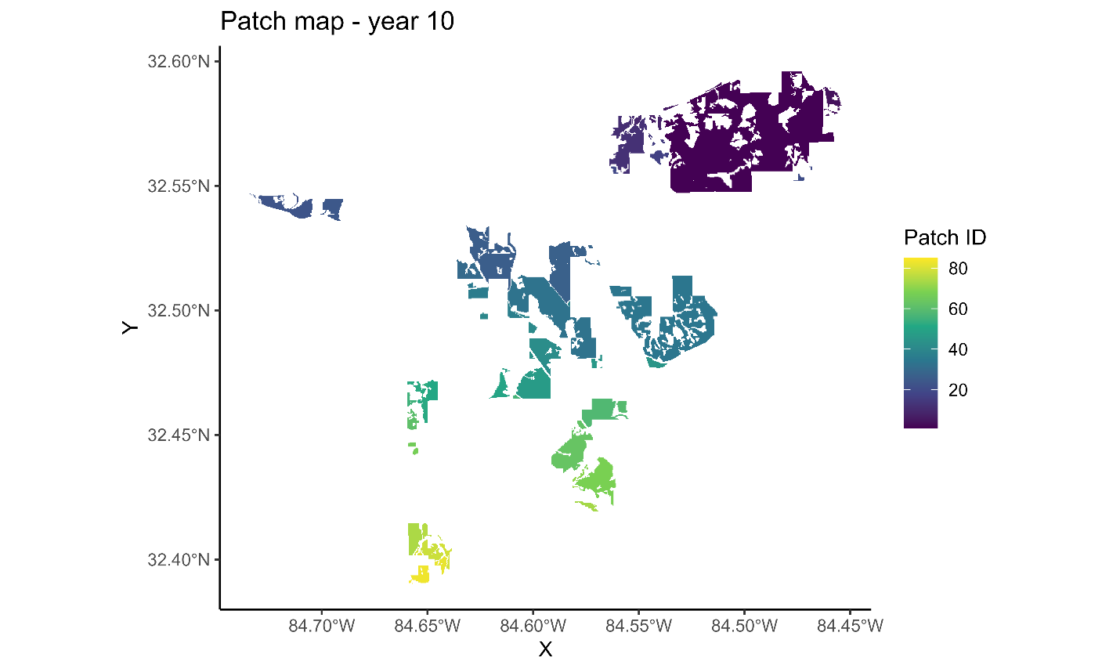

Figure 12. Tenth year of landscape patches resulting from the Habplan management schedule.

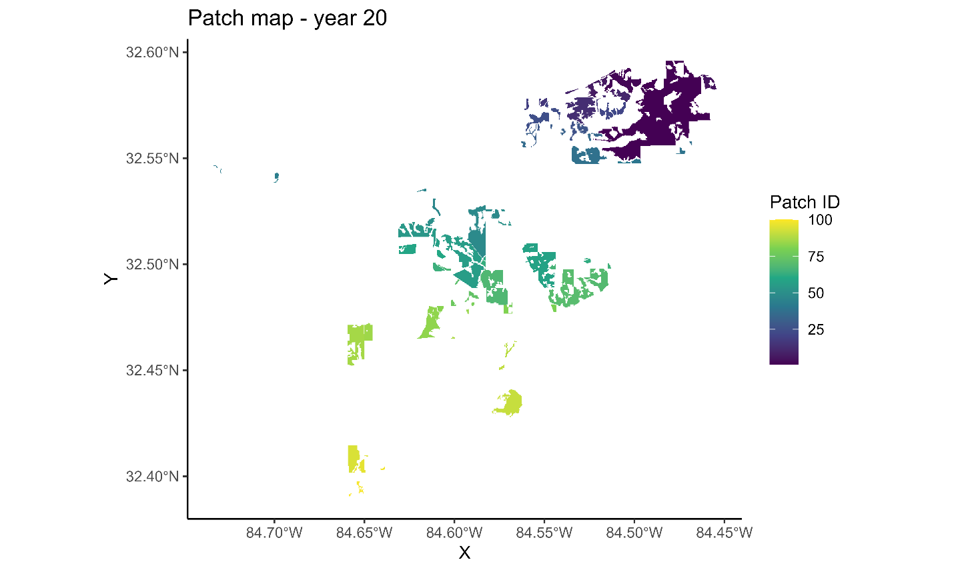

Figure 13. Twentieth year of landscape patches resulting from the Habplan management schedule.

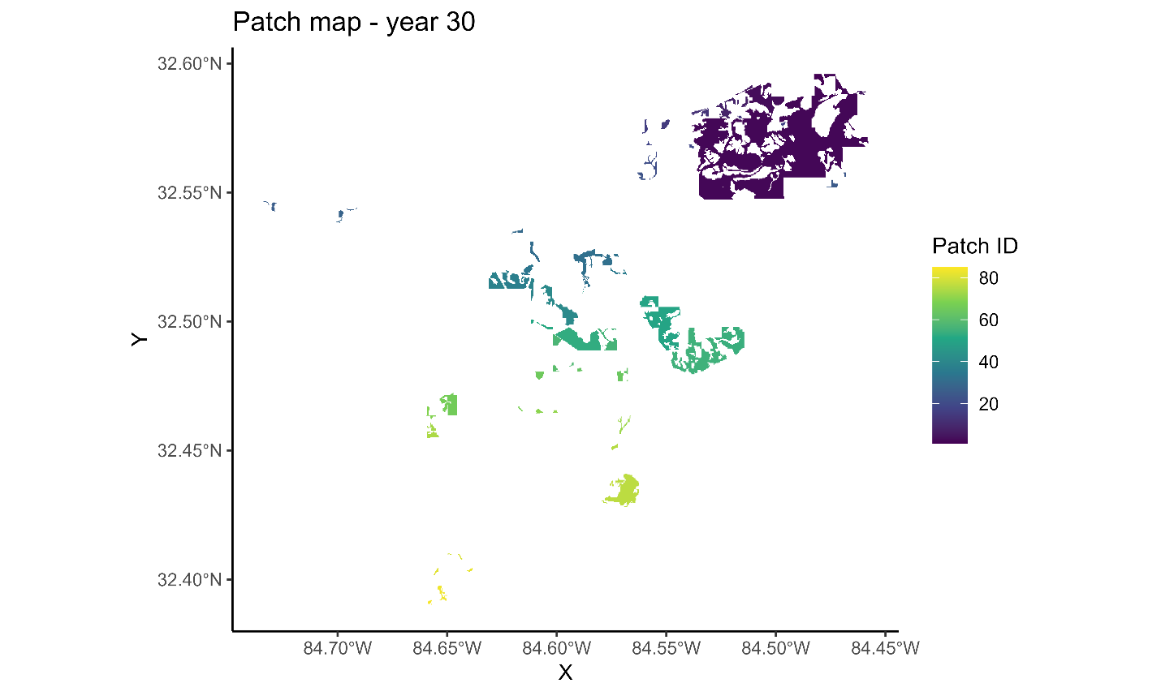

Figure 14. Thirtieth year of landscape patches resulting from the Habplan management schedule.

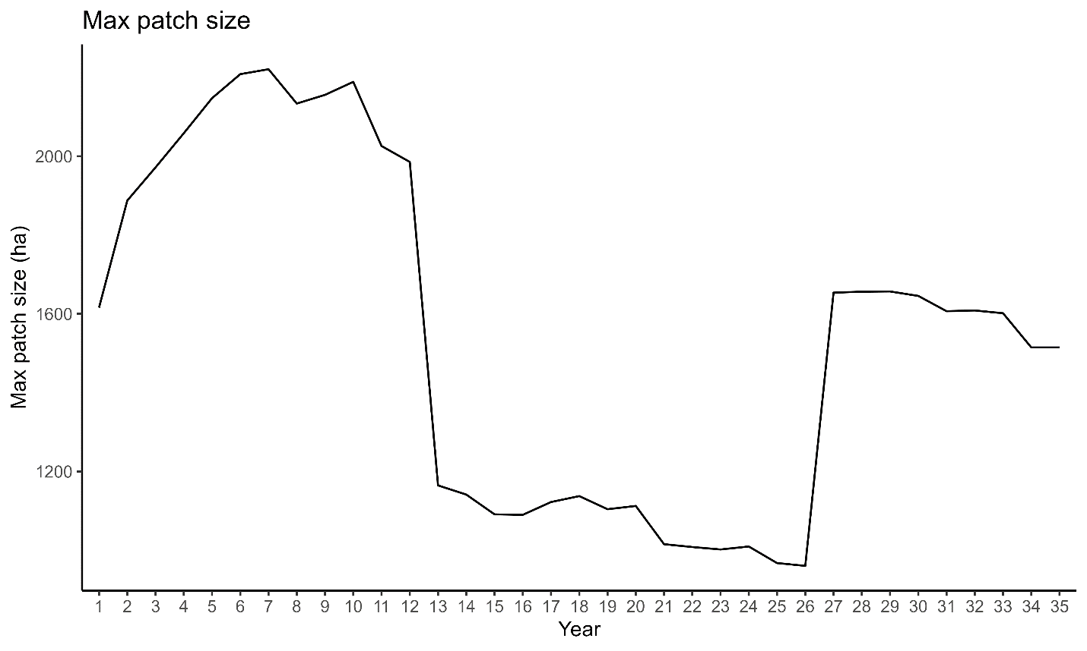

Figure 15. Size of the largest landscape patch across time resulting from the Habplan management schedule.

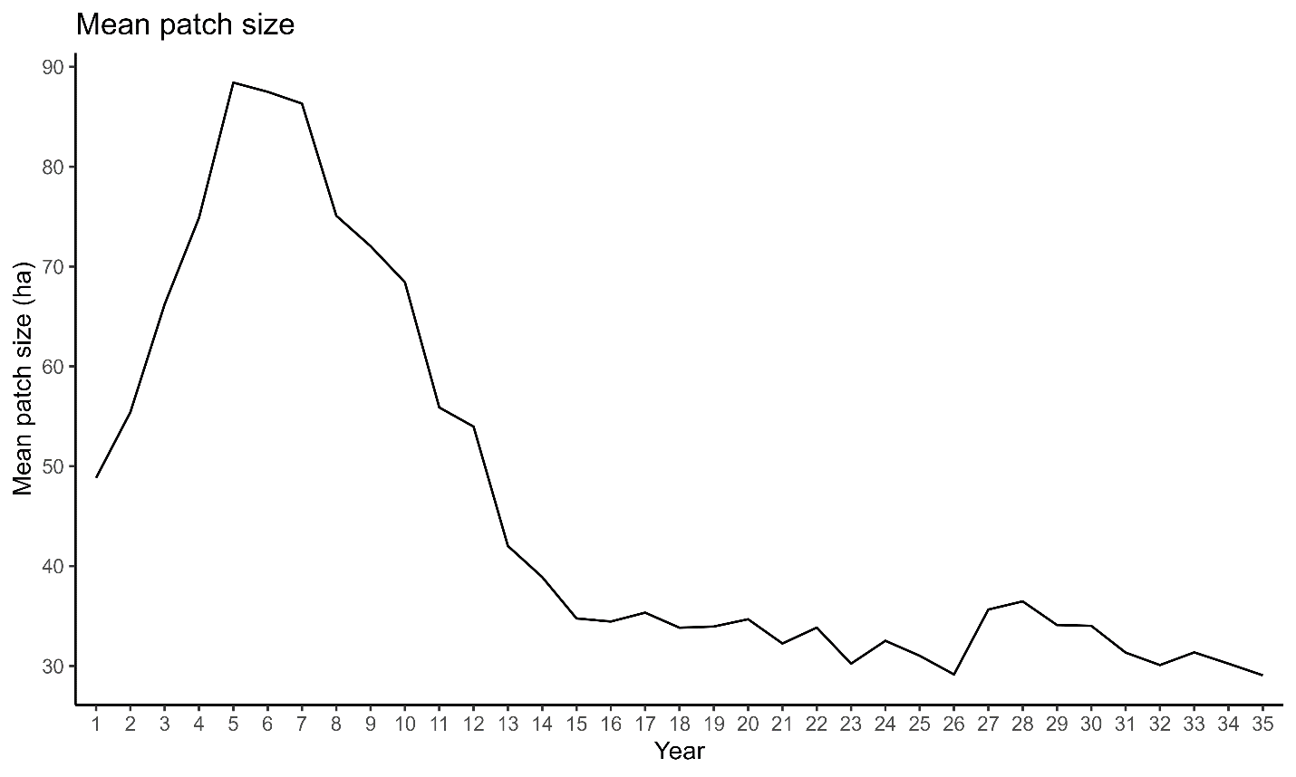

Figure 16. Average size of landscape patches across time resulting from the Habplan management schedule.

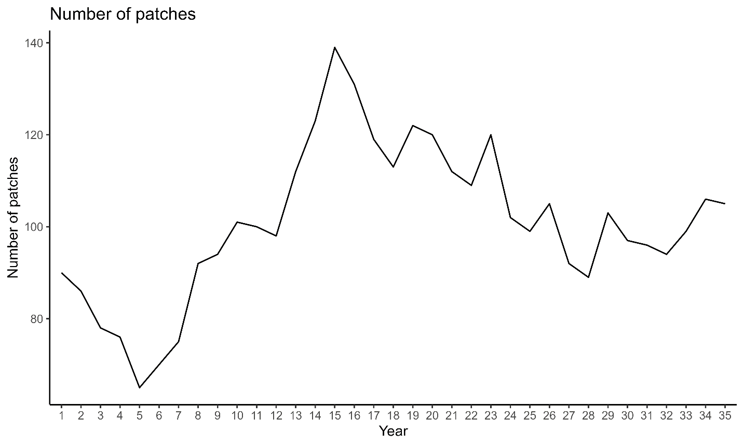

Figure 17. Number of landscape patches across time resulting from the Habplan management schedule.