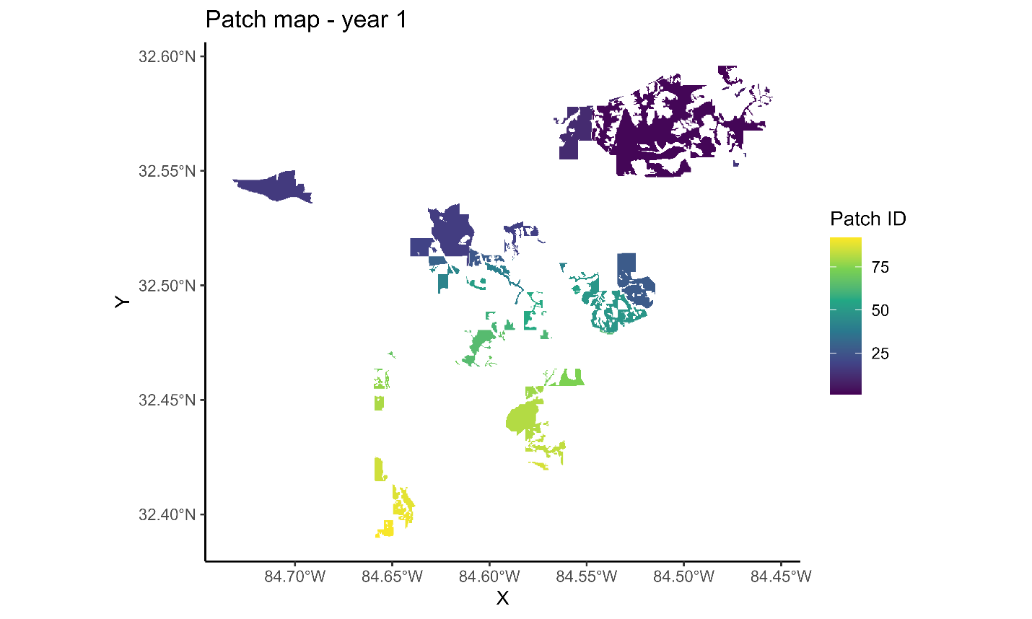

Figure 19. First year of landscape patches resulting from the Habplan management schedule.

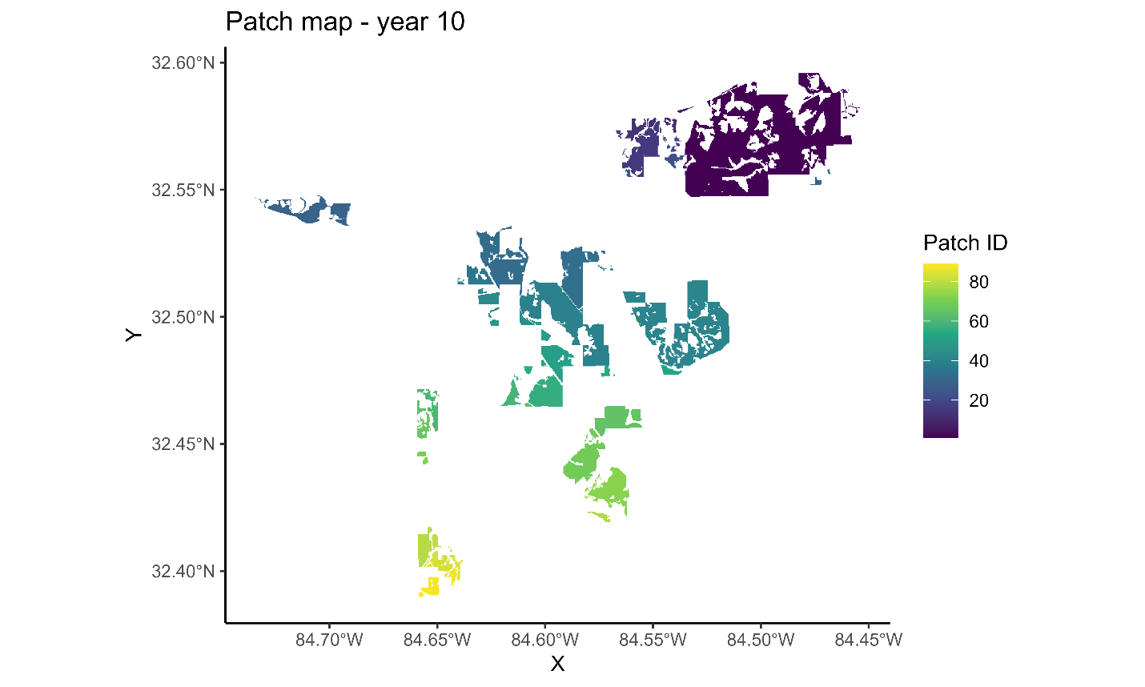

Figure 20. Tenth year of landscape patches resulting from the Habplan management schedule.

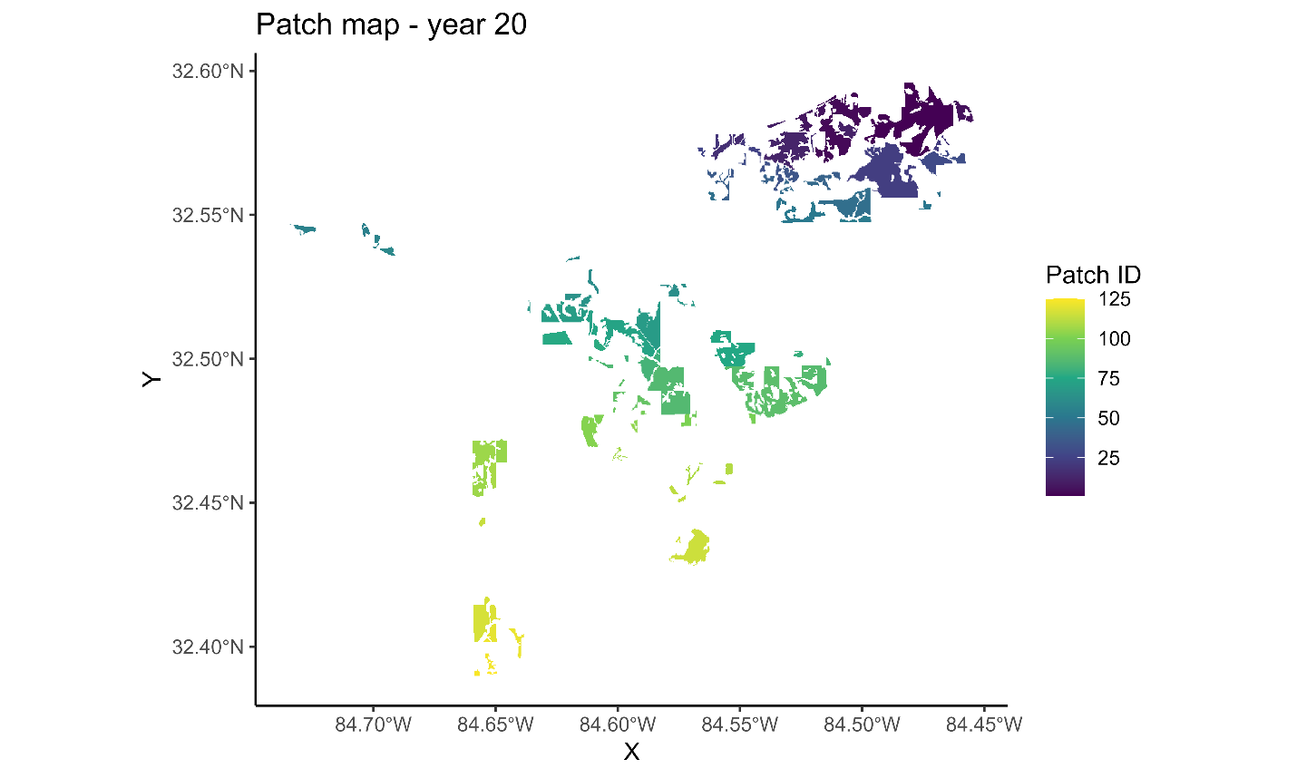

Figure 21. Twentieth year of landscape patches resulting from the Habplan management schedule.

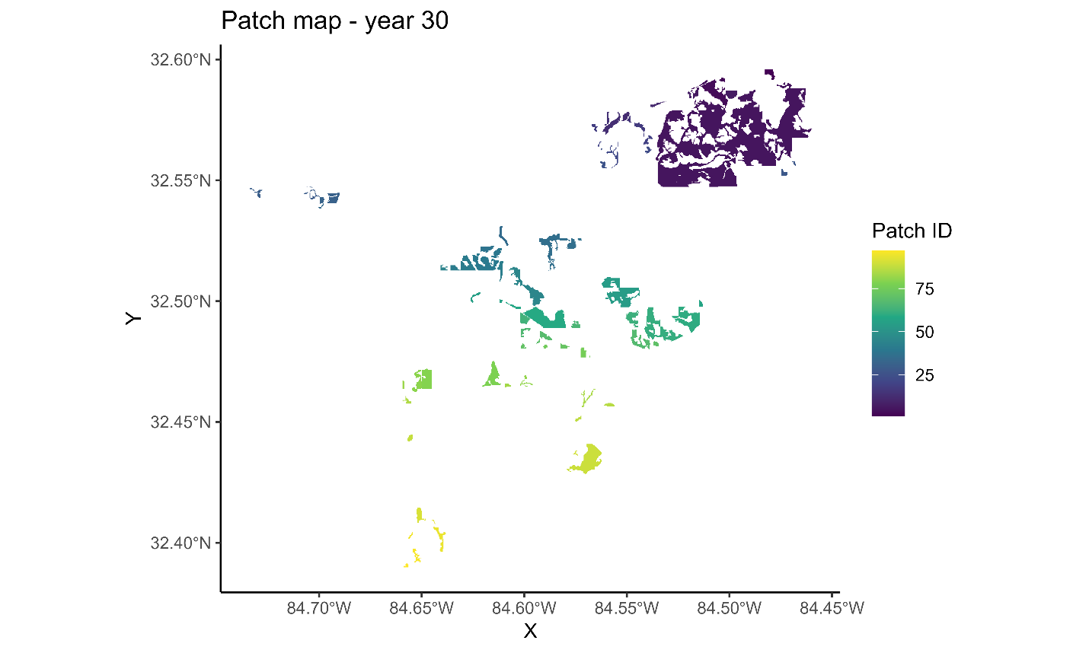

Figure 22. Thirtieth year of landscape patches resulting from the Habplan management schedule.

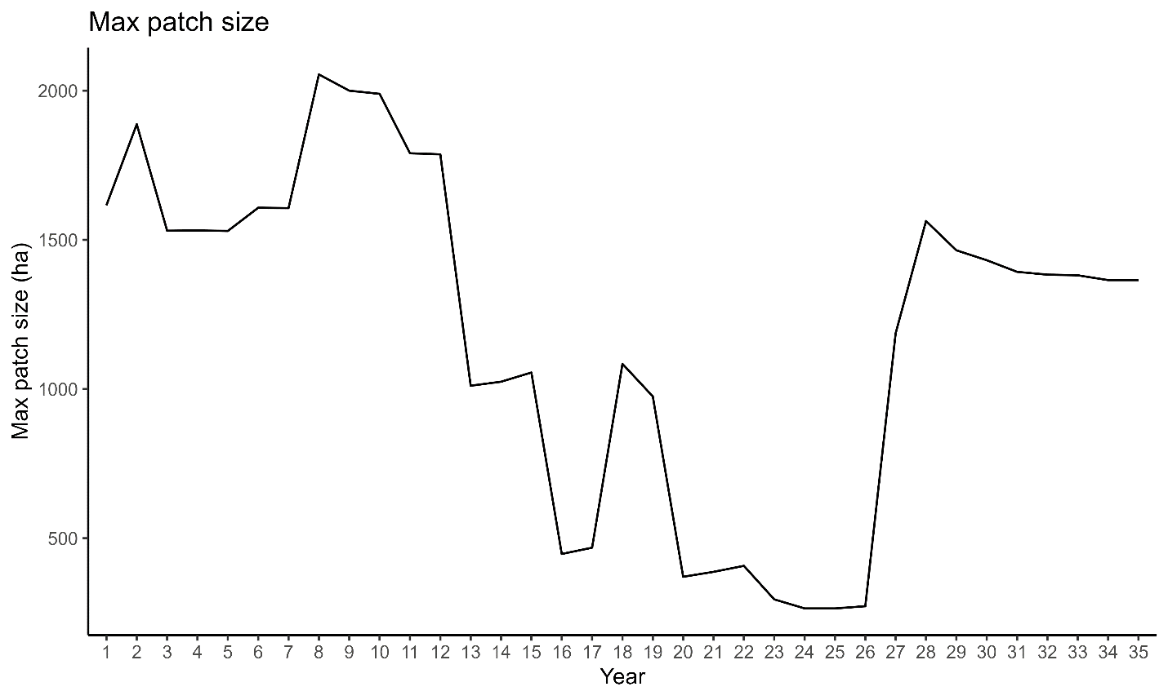

Figure 23. Size of the largest landscape patch across time resulting from the Habplan management schedule.

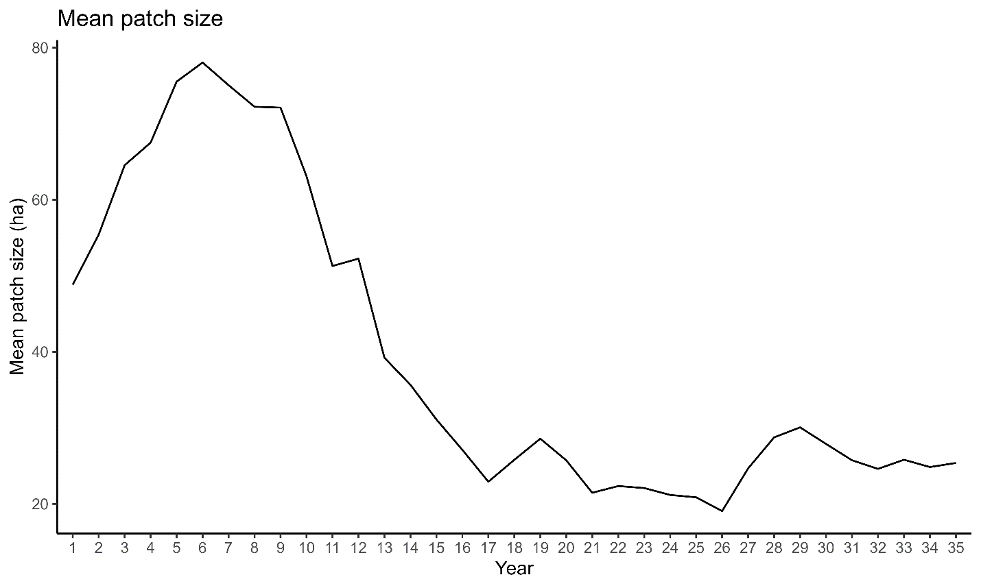

Figure 24. Average size of landscape patches across time resulting from the Habplan management schedule.

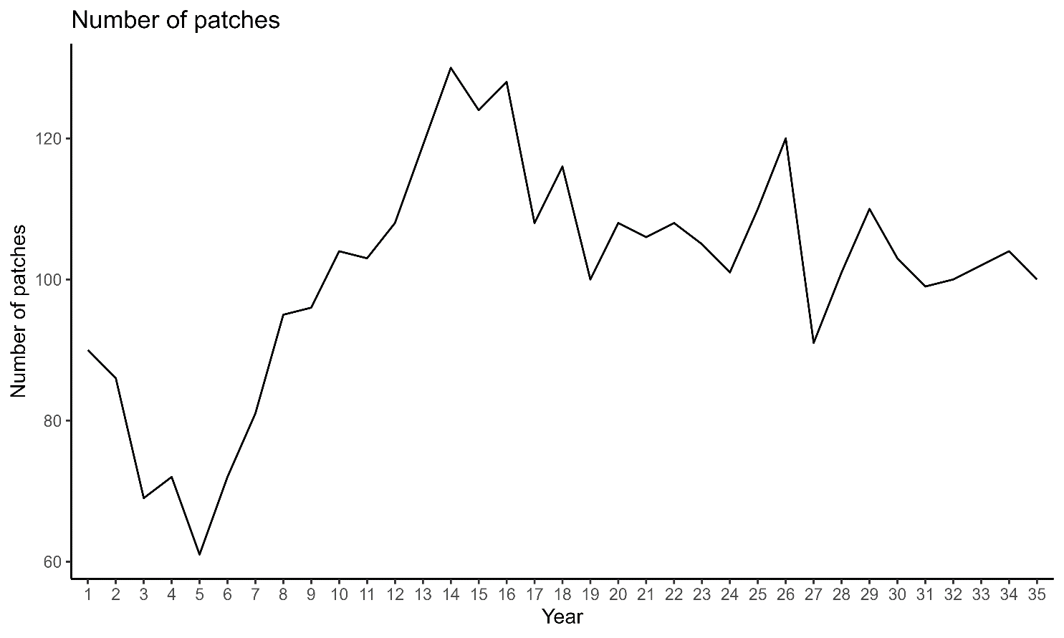

Figure 25. Number of landscape patches across time resulting from the Habplan management schedule.