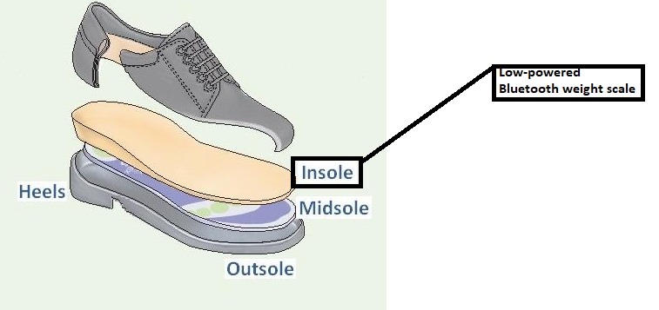

Figure 1: Prototype of insole with wireless weight sensor.

Figure 2: Simulated weight scale to collect data for analyze in database.